

“Has the death of Sarah Everard affected the trust in which the female demographic has in the police when reporting sexual offences”

Student Name: Carys Mason
Student Number: 1800707

BSc Professional Police Practice

Acknowledgements
I would like to thank my family, friends, colleagues and my supervisors for helping me complete this dissertation. I would also like to thank them for the support they have given me during this dissertation. This dissertation would have been extremely difficult without their help and support.
Declaration

Declaration - This work has not previously been accepted in substance for any degree and is not being concurrently submitted in candidature for any degree.
Signed: Carys Mason Date: 18/11/2021

Statement 1 - This dissertation is being submitted in partial fulfilment of the requirements for the degree of BSc.
Signed: Carys Mason Date: 18/11/2021

Statement 2 - This dissertation is the result of my own independent work/investigation, except where otherwise stated. Other sources are acknowledged by footnotes giving explicit references. A bibliography is appended.
Signed: Carys Mason Date: 18/11/2021

Statement 3 - I hereby give consent for my dissertation, if accepted, to be available for photocopying and for interlibrary loan, and for the title and summary to be made available to outside organisations.
Signed: Carys Mason Date: 18/11/2021

Statement 4 - I hereby give consent for my dissertation, if accepted, to be available on the university’s IT system to those who have consent to use the system.
Signed: Carys Mason Date: 18/11/2021

Abstract
The researcher has produced this study in relation to the trust between the female demographic and the police when reporting sexual offences following the death of a lone female namely Sarah Everard. The researcher set out aims and objectives surrounding the dissertation title and to answer this projects aims and objectives the researcher used a combination of quantitative data collection and inductive research methods. From using these methods, the researcher has produced four separate graphs showing the number of sexual offences reported to North Wales Police, South Wales Police, Gwent Police and Dyfed-Powys Police from March 2020 to March 2021. The researchers’ analysis of results found that there has been no decrease in the reports of sexual offences by the female demographic since the death of Sarah Everard in Wales only. However, the researcher has identified other studies that support these findings and other studies that do not support these findings. The researcher has also identified further research areas that they believe this project would benefit from and develop the existing research further.

Contents Page

Chapter One - Introduction…..7
  - Background…..7
  - Aims…..7
  - Objectives.....8
  - Structure…..8

Chapter Two - Literature Review.....10
2.1 Introduction…..10
2.2 Violence…..10
2.3 Rape…..11
2.4 Sexual Crime…..11
2.5 Statistics…..12
2.6 Reasons for not reporting sexual assaults…..14
2.7 #MeToo movement…..15
2.8 Broken Window Theory…..16
2.9 Sarah Everard…..16

Chapter Three – Research Methodology…..19
3.1 Introduction…..19
3.2 Research Questions…..19
3.3 Methodology…..19
3.4 The Researcher…..19
3.5 Study Participants…..20
3.6 Data Collection…..20
3.7 Data Analysis…..23
3.8 Summary…..24

Chapter Four – Analysis of Results…..25
4.1 Introduction…..25
4.2 Study Participants…..25
4.3 Information Request…..25
4.4 Statistics for North Wales Police…..27
4.5 Statistics for South Wales Police…..28
4.6 Statistics for Gwent Police…..29
4.7 Statistics for Dyfed-Powys Police…..30

Chapter Five – Findings and Conclusions…..32
5.1 Introduction…..32
5.2 Objectives…..32
5.3 North Wales Police…..32
5.4 South Wales Police…..33
5.5 Gwent Police…..34
5.6 Dyfed-Powys Police…..34
5.7 Limitations…..35
5.8 Conclusion…..35

Chapter Six – Recommendations…..37

Chapter One – Introduction
1.1 This research project consists of several chapters each contributing an individual part to answer the dissertation question. Has the death of Sarah Everard affected the trust between the female demographic and police when reporting sexual offences? A lone female by the name of Sarah Everard was murdered by a male by the name of Wayne Couzens, who at the time was a serving police officer. It is believed that there was a sexual motive behind this attack. On Wednesday 3rd March 2021 Sarah Everard was walking home when she was stopped by Wayne Couzens who showed her his warrant card, falsely arrested her and placed her in the back of a hire car. Analysis now shows that on 3rd March 2021 between 23:53hrs – 00:57hrs Wayne Couzens phone used cell sites in an area that he knew well. It is believed that it was then he raped and murdered Sarah Everard. On Thursday 4th March 2021 at 03:21hrs Wayne Couzens car passed a CCTV camera near Hoads Wood. The body of Sarah Everard was found here six days later. On Tuesday 9th March 2021 Wayne Couzens was arrested at his home address for the murder of Sarah Everard (The Guardian, 2021).

1.2 Aim
The aim of this research project is to critically examine whether the very recent incident involving the murder of Sarah Everard by a male who at the time was a serving police officer, has changed the female perception of the trust in police officers when reporting sexual offence.

1.3 Objectives
- To provide a background context of the history of the reporting of sexual offences by females
- To identify if the number of reported incidents for sexual assaults on females has decreased since the murder of Sarah Everard
- To identify if the trust and confidence of the female population has in the police has reduced and whether this would impact on future reporting of sexual offences
- To identify ways to improve public trust and confidence

1.4 The researcher has explored wider literature within chapter two which refers to violence, sexual violence, violence against women, statistics of violence against women, the #MeToo movement and specifically Sarah Everard. Within chapter three of this project the researcher explains what research questions they wish to answer and what research methodology they will use to answer those questions. Within that chapter the researcher also discusses their own personal links to the research project and the study participants they wish to use to evidence the answers to the research questions. Chapter four of this project highlights the statistics the researcher has accumulated from this study and each result is analysed individually. Following on from chapter four is chapter five which discusses the findings and conclusions the researcher accumulated from the statistics from the previous chapter. The researcher discusses any patterns the findings follow and any links to the other study participants. The researcher links the findings to other literature, some which agrees and some which disagrees. The researcher finishes this project with recommendations that would develop this piece of work further which would potentially allow more accurate results which would represent a larger population.

Chapter Two - Literature Review
2.1 So again, the question is, has the death of Sarah Everard affected the trust in which the female demographic have when reporting sexual offences to the police? As this is a very recent incident and is now an area of current interest, very little work has previously been done regarding this specific topic. However, similar research has been carried out on topics that link in with this question. In order to achieve objective one of this research investigation, this literature review will state definitions of ‘violence’, ‘sexual’ and ‘rape’. This literature review will discuss why women are subjected to sexual violence, violence in relation to men, attrition rates, changes in reporting of sexual offences and specifically previous articles that refer to Sarah Everard.

2.2 Violence is defined as ‘the exercise of physical force so as to inflict injury on, or cause damage to, persons or property; action or conduct characterized by this; treatment or usage tending to cause bodily injury or forcibly interfering with personal freedom’ (Oxford English Dictionary, 1989) or ‘Any behaviour by an individual that intentionally threatens, attempts to inflict or does cause physical, sexual or psychological harm to others or to him/herself’ (Lewis et al, 2000). Sexual is defined as ‘of, relating to, or associated with sex or the sexes such as sexual differentiation or sexual conflict’ or ‘having or involving sex, for example, sexual reproduction’ (Webster, 1828). Many sexual offences, including rape, are termed as sexual violence due to the force or coercion often used to commit the offence (World Health Organization, 2002).

2.3 Feminists view rape as a cultural product and a violent rather than sexual crime. According to Section 1 of the Sexual Offences Act 2003 the definition of Rape is ‘A person (A) commits an offence if— (a)he intentionally penetrates the vagina, anus or mouth of another person (B) with his penis, (b)B does not consent to the penetration, and (c)A does not reasonably believe that B consents’ (Legislation.gov, 2021). There has been criticism that many definitions of rape emphasise on the lack of consent rather than the force. Assumptions have been made that unless a female physically says ‘no’ then she consented to engaging in sexual activity with a male. It has also been highlighted that if a female does not fight back, she is in a sexual relationship with a male or married to a male or even if she said ‘yes’ (however, was in fear for her safety or life so befriended the male) then she consented to sexual intercourse with the male. This does not imply consent, some of the examples above, the female was coerced into engaging in sexual intercourse. The force used during sexual intercourse is usually justified by the male as ‘rough sex’ which the female consented to or as the female and male were in a marital relationship then he did simply not force any intercourse upon her as she agreed irrevocably due to the fact they were married (Whisnant, 2009).

2.4 What is identified as a sexual crime has changed over time due to changes in the standards of societies and cultures (Blackburn, 2001). Aggression, violence and power over women is culturally dominant of masculinity that many men feel they have to embody in order to fit in (Connell and Messerschmidt, 2005). Research conducted by (Stone, 1983) found that in previous centuries in England and Wales it was generally legal for a husband to subject his wife to brutal violence. Chief Justice Hale ruled in 1736 (Guardian, 1990) that a husband could not be guilty of raping his wife. Clearly these previous attitudes had an impact on the social construct of maleness. Marital rape only became a crime in England and Wales in 1991 when the case of R v R in 1991 abolished this previous exemption.

From the University Hospitals Plymouth NHS Trust article regarding violence against women, the author states “when gender based violence is raised, it highlights that violence against women is unique and entrenched in our society, where social structures perpetuate and maintain gender inequalities” (Dawson, 2020). Kerry Dungay who is the Chair of University Hospitals Plymouth Women’s network interpreted that as social inequalities are the consequences from violence towards women and in order to create prevention measure it needs to be addressed.

At the time of the researcher writing this dissertation there is currently a worldwide pandemic which is known as COVID-19. Since the COVID-19 pandemic began females have found that it has worsened their situation due to feeling afraid and isolated (Women’s Aid, 2020)

2.5 Rape is the penetration of either the vagina, anus or mouth by a penis, so this offence can only be committed by a male however this does not mean that the victim can only be a female. However, that being said 84% of 153,136 rape victims were female (The Guardian, 2021). In the 12 months leading up to March 2020 there were 153,136 reports of rape, so does this mean that males are more violent than females? Whilst there has been various research in respect of the greater aggressiveness in males in humans and animals (White, 1983) there are still no consistent findings to account for this difference in aggression levels between males and females.

According to (Rape Crisis, 2017) ‘sexual violence is still highly gendered’. Since turning 16 years of age, 20% of females compared to only 4% of males reported sexual assaults’ (Dungay, 2021). In 2017 in England and Wales 3.1% of women (510,000) and 0.8% of men (138,000) who are within the age category of 16 – 59 experienced some form of sexual assault with in that year alone. In 2013 only 15% of victims who had experienced some form of sexual assault, made a formal report to police. The percentage of females aged 18-24 reported that they had been sexually abused as a child was 31%. Approximately 90% of rape victims will say that they knew their perpetrator prior to being raped. When a rape or sexual assault victim makes a report to police, only 5.7% of reports end with the perpetrator being convicted of a rape or sexual assault offence. (Rape Crisis, 2021).

So, from these statistics it will be interesting to see the statistics reported from March 2020 to March 2021. As this timeframes falls within the current pandemic being COVID – 19, the researcher predicts that the number of rape or sexual assaults reported to police would have increased as from the statistics provided above, 90% of rape victims knew their perpetrator before being raped or sexually assaulted. However, the researcher is conscious that the trust may have been lost by the public towards the police following the death of Sarah Everard, so the statistics may well have decreased.

2.6 There are numerous reasons as to why a victim of rape or sexual assault may not report it to police and they are as follows, culture of disbelief, lack of evidence, victims are often younger, added stress of reporting which can lead to victim blaming and previously false cases. Previously false cases are highly publicised in the media. It difficult to estimate how many are false reports however previous research estimated that less than 10% of reported rapes are false (Theilade and Thomsen, 1986).

In a study conducted by Sable et al (2010) it was found that reluctance in reporting sexual offences is often due to feelings of shame and embarrassment felt by the victims.

Rape myths could also help understand why there historically has been an under-reporting of these types of offences. Burt (1980) explored these myths and found that many of them often shift the blame from the perpetrator of these offences and onto the victim. This is fairly unique when comparing sexual offence victims to victims of other crimes (Gravelin, Biernat, & Bucher, 2019) and offers one explanation towards why there has been under reporting in the past.

The victim is often blamed for having encouraged a male perpetrator to assault them by wearing revealing clothing, being drunk or flirting with them in the examples of stranger rapes. In 1999 in a supreme court in Italy, a rape conviction was overturned as the female victim was wearing tight jeans, so the offender must have needed her help to remove them. As a result of this decision females now wear a pair of denim jeans on a Wednesday in April to raise awareness of sexual assaults (Lubitz, 2016). If a female wears revealing clothing, 55% of males think that she is more likely to become a victim of harassment or assault (Oppenheim, 2019).

Not only is there this hurdle of blame to overcome when reporting, a victim would then be subjected to the publicising of her sexual history when going through the court process. Independent sexual violence advisers (ISVAs) support victims of rape or sexual assaults during the court process including the trial. 36 ISVAs took part in a survey and 75% said that they had witnessed their victim’s sexual history being interrogated by the defence during court cases between 2015 and 2017 (Crockett, 2018). It is illegal in almost every circumstance to cite a victim’s sexual history however, it can be allowed only in the circumstances whereby the allegation is similar to a previous allegation according to Section 41 of the Youth Justice Crime and Evidence Act 1999 (Crockett, 2018).

2.7 The #MeToo movement started to explode in around 2017 (Fraser et al, 2021) and became a place for women to vent and share their stories of sexual harassment and assault that they had encountered at various points during their lives. As a result of this wide-spread sharing it was noted that reports of sexual offences to law enforcement increased (Rotenberg & Cotter, 2018). A further study conducted by Levy & Mattson (2020) found that the reporting of sexual offences in approximately 30 countries had increased by around 10% in the first few months of the #MeToo movement. This is clearly a large increase and shows just how impactive social media has been in bringing together women who had probably felt very much alone prior to the movement and sought to raise the profile of sexual violence as a public health and social justice concern (Scurlock-Evans, 2019).

2.8 In 1982 an academic theory was proposed by James Q Wilson and George Kelling. The theory was introduced to tackle disorder within neighbourhoods. The theory was referred to as ‘The Broken Window Theory’. This theory did not tackle the most serious crime such as rape, robbery and murder, it tackled lower level disordered as they believed that the low level disorder led to more serious offences and by negating low level disorder would eliminate serious crime. However, critics will say that “there is little empirical evidence that disorder, when left unchallenged, causes crime” (McKee, 2018). Did this theory lead to less reporting of sexual offences and rape because there were fewer offences being committed?

2.9 In early March 2021 Sarah Everard was reported missing and a short while later human remains were found in a woodland area just outside of Kent in England. It was later confirmed that this was the body of Sarah Everard. An arrest was made of a male by the name of Wayne Couzens (who at the time of the arrest was a serving police officer) for the murder of Sarah Everard. At the time of the arrest it was believed that there was a sexual motive behind the kidnap and murder of the female however, it was yet to be proven. UK Prime Minister Boris Johnson stated “the horrific case of Sarah Everad has unleashed a wave of feeling about women not feeling safe at night”. UK Home Secretary Priti Patel posited “every women should feel safe to walk on our streets without fear of harassment or violence” (Bhattacharyya, 2021). One way to tackle the fear of safety for women was a 6pm curfew for all males. This was attributed to a green party peer (Brown, 2021).

Wayne Couzens pleaded guilty to the murder of Sarah Everard however, his sentencing does not commence until 29th September 2021. It has now been confirmed that Sarah Everard had been raped and strangled. Since pleading guilty Wayne Couzens has been linked to two counts of indecent exposure, meaning that a further 12 gross misconduct or misconduct notices has been served on police officers from numerous forces (BBC, 2021). Kent police are now being investigated by the Independent Office for Police Conduct (IOPC) in relation to an incident that occurred in 2015 whereby it was alleged that Wayne Couzens indecently exposed himself. The Metropolitan Police are also now being investigated by the IOPC for an incident which happened only days before the murder of Sarah Everard, where it is alleged that Wayne Couzens again indecently exposed himself at a fast food restaurant in South London (BBC, 2021).

In this particular incident the perpetrator was a serving police officer. As a result of this, the researcher believes that this will have an adverse effect on rape victims reporting crime.

It is now clear to see a pattern of behaviour started to emerge in relation to Wayne Couzens and sexually motivated incidents. Is it possible to say that if Wayne Couzens’ pattern of behaviour was noticed and acted upon sooner, would he have had the opportunity to commit the murder and rape on Sarah Everard?

In conclusion for this chapter it is clear to see that rape victims are highly gendered when it comes to females compared to males. As the previous figures showed 20% of females compared to only 4 % of males reported sexual assaults to police. Domestic assaults and rapes were previously labelled as ‘ok’ meaning it was not an offences to use violence or rape your wife however, martial rape did become an offence in 1991 in England and Wales. During the current pandemic that is Covid-19, females have stated that it has worsened their currently situation. Why don’t victims of rape report to police? Well there are many reasons however the main reasons are, victim blaming, previous false cases, victims are often younger and more vulnerable, the victims sexual history will be ‘dragged’ through the court process and the victims get blamed due to the ‘revealing’ clothing they were wearing. The #Metoo movement increased the number of rapes reported to police by 10% in just the first few months. It allowed females to have a voice on social media and share their stories in relation to sexual harassment or sexual assaults. Following the murder of Sarah Everard by a police officer, has this now broken the trust with the police and community when reporting sexual offences? Has all the previous work been undone due to this one incident alone?

Chapter Three - Research Methodology
3.1 In order to see if the death of Sarah Everard has affected the trust in which the female demographic have in the police when reporting sexual offences, the researcher will discuss the research methodology and methods used to conduct this study. The researcher will use both primary and secondary data sources along with conducting a mixture of quantitative and inductive research methods during this chapter. The researcher will also discuss issues that have risen during this study.

3.2 Q1: Has the death of Sarah Everard affected the trust between the female demographic and police?
Q2: Has there been a decrease in the reporting of sexual offences by the female demographic since the death of Sarah Everard?

3.3 To carry out this research project, the researcher must identify what research paradigm they will use. Both ontological and epistemological positions were taken into account by the researcher when identifying a philosophical stance. The researcher believes that given the nature of the study the interpretivism stance is most applicable in order to conduct this study.

3.4 The researcher is now in their third year of their Bachelor of Science (Honours) degree in Policing. Alongside the degree the researcher works for South Wales Police Force as a full time Police Constable specifically a response officer. In the future the researcher wishes to undertake a different career path within policing. The researcher is hoping to progress their career in an investigative role working as a detective constable for either Criminal Investigation Department (CID) or Public Protection Unit (PPU). Whilst undertaking this research project the researcher will have no direct relationships with the participants to avoid any conflict of interests. This will help ensure that the results are true and accurate.

3.5 As part of this research methodology the researcher has identified that an information request in the form of a questionnaire will be sent out to all Police Forces in Wales. The researcher originally planned to send a copy of the information request to all Police Forces across England and Wales however, upon reflection the researcher has acknowledged that given time implications and word limitations the data that would require analysing would be of a high quantity and it would not be possible to complete an in depth analysis. By only requesting data from Police Forces in Wales, it has reduced the sample size from 42 to 4. The four Police Forces that the researcher will request information from are, South Wales Police, Dyfed Powys Police, North Wales Police and Gwent Police. The researcher will firstly create an information request before disturbing it to the individual force control room by means of email. The force control room will then send the information request to the relevant department whereby either a police officer or a member of police staff will complete and return via email.

3.6 As mentioned in the introduction, the researcher plans to undertake both primary and secondary data and a mixture of both Quantitative and Inductive research methods.

Primary data is a research method used by many different researchers to collect direct data. The data is not collected from work completed by a previous researcher. An in-depth analysis is conducted on the direct data which has been collected by the researcher. Primary data can be collected in several different ways as follows; interviews (whether in person or via telephone), surveys, focus groups and observations. As with every research method there are advantages and disadvantages when it comes to the collection of the data. Advantages of collecting data using primary methods are; the data is likely to be more accurate given the fact it has been collected first hand meaning that it will be specifically focussed on the main problem. Along with the advantages come the disadvantages which are; just by using one of the four collection methods mentioned above may not provide a true and accurate account and it can be a very time consuming process. (Question Pro, 2021).

(Question Pro, 2021) will define quantitative data as “the value of data in the form of counts or numbers where each data-set has a unique numerical value associated with it”. Surveys and interviews can be used in order to collect quantitative research data. There is not one specific way of utilising a survey or interview as numerous types of surveys or interviews can be used depending on what works best in the circumstances. Advantages of using quantitative data are; it allows the researcher to conduct in-depth accurate research with very minimum bias. Disadvantages of using quantitative data are that the data collected can be restricted information and also depending on the question types used to gather the information/research can depend on the results (Byrne, 2002).

Inductive research approach is best suited when little to no researcher has previously been done on the research area. The researcher will adapt the inductive research approach in order to perform their investigation (Singapore Assignment Help, 2020). Inductive research starts with the collection of data and then develops a hypothesis from said data. The direction of inductive research is ‘bottom up’.

Using a mixture of primary data, quantitative data and inductive data as collections method, the researcher will create an information request in the form of a questionnaire and distribute it to police forces in Wales. This information request will ask the individual force to document the crime recording statistics for the number of sexual offences reported by females from May 2020 to May 2021. As mentioned above the researcher has reduced the sample size however, the researcher understands that by reducing the sample size may not give a true and accurate account especially as the murder of Sarah Everard occurred in England. The researcher is fully aware that some forces may not be able to separate the statistics for violent crime and sexual crime meaning that this will not show a true and accurate reflection on what has been asked. The researcher is also aware that some forces may not be able to separate female victims to male victims and again this will not show a true and accurate reflection. The researcher has piloted the information request to several colleagues and asked for feedback. The purpose of piloting the request is to ensure that the request is clear and concise and the person completing the request understands exactly what is being asked from them.

Secondary research is defined by (Question Pro 2021) as “a research method that involves using already existing data. Existing data is summarized and collated to increase the overall effectiveness of research”. Like primary data, secondary data can also be collected in more ways than one. Secondary data can be collected as follows; the internet, government and non-government agencies, public libraries, educational institutions and commercial information sources. Secondary data collection also has advantages and disadvantages. The advantages of collecting data via secondary research methods are; previous work has already been completed on the topic area meaning the research is readily available and by collecting data via ways of secondary research often means it is less time consuming and effectively costs less. The disadvantages of collecting data via secondary research methods are; as they may be a lot of previous work completed on the subject area, the researcher may not find the most up to date research meaning the information could be less accurate compared to newer research. Another disadvantage is that the researcher must perform a credible evaluation to understand the authenticity of the research (Riedel, 2000).

The researcher does not plan to use secondary data collection method during the next chapter which is Data Analysis however, the researcher has previously used secondary research methods during the Literature Review chapter in order to gather background information on this area of study.

3.7 At this stage of the study the data is yet to be collected and analysed however, the researcher will create four separate graphs which will display the crime recording statistics for each individual force. Each graph will be clearly labelled and will clearly show the statistics month by month. The researcher will also state what the graph shows for example, if it’s male and female victims or whether it shows just female victims and if the graph represents just sexual crime or whether it’s a combination of both sexual and violent crime. The researcher will then discuss the data.

3.8 This chapter set out to establish what research methods the researcher would use in order to answer the research questions. The researcher has broken down the research methodology and planning chapter into the following topics; introduction, research questions, methodology, the researcher, the study participants, data collection, data analysis and has concluded with this summary. Within these topics, the researcher has established what research paradigm they will use to conduct this study. The researcher has also identified that they will use a combination of primary data, secondary data and quantitative and inductive research methods. Lastly, the researcher has identified who the participants will be for the information request.

Chapter Four - Analysis of Results
4.1 This next chapter of the dissertation is the analysis of results. During this chapter the researcher will analyse the results from the information requests that were distributed across police forces in Wales. The researcher will discuss the participants of the request and discuss the request in detail. The researcher will then display the results in four separate graphs and discuss what the graphs show.

4.2 The participants for the information requests are North Wales Police Force, South Wales Police Force, Gwent Police Force and Dyfed – Powys Police Force. The information request was distributed via email to the individual force control room and then further distributed to the relevant department in order for the request to be completed. The request was then completed by the individual for the retrospective force and retuned via email to the researcher. The researcher originally planned to distribute the information request to all police forces across England and Wales however, upon reflection the researcher deemed that it would not be practically possible due to time implications and word limitations given the large quantity of data that would require analysing. This meant that the researcher’s participants decreased from 42 to 4 making the analysis much more achievable.

4.3 The information request was sent out to the researcher’s colleagues to allow it to be piloted. The researcher’s colleagues then provided feedback on the way the information request was designed. The researcher than made amendments to the information request before distributing it to all four Police Forces in Wales. By doing this it allowed the researcher to have a greater chance of gathering the correct information that was required for this dissertation. The information request was made up of three questions and one direct request and they are as follows;
- Which police force does this request refer to?
- What gender will the crime recording figures refer to?
- Will the results refer to sexual offences only?

- Document the number of sexual offences reported to police by female victims for May 2020-May 2021.

Question one of three was an important question as this allowed the researcher to identify which police force the crime recording statistic referred to. Question two of three was important as the objective for this dissertation was to identify if the trust of the female demographic had been affected when reporting sexual offences to police following the death of Sarah Everard. The researcher was aware that some police forces may not have been able to differentiate the statistics for male and female victims. The researcher still required the statistics however, it was important that the researcher understood what the statistics referred to in order to be able to complete a true and accurate analysis. Question three of three again was an important question as the researcher needed to identify what the statistics referred to in relation to what offence was shown in the statistics. The researcher was very much aware that some forces may not have been able to differentiate the statistics for sexual offences and violent offences. The direct request was asked and the results were sent back to the researcher in table format and are shown in the four separate graphs below.

4.4 Figure #1 – Number of sexual offences reported to North Wales Police by females.

Figure #1 (the graph above) is the number of sexual offences reported to North Wales Police from May 2020 – May 2021. The graph above specifically refers to female victims only and sexual offences only. North Wales Police Force covers the whole of North Wales and also covers surrounding areas such as Isle of Anglesey, Gwynedd, Conwy, Denbighshire, Flintshire and Wrexham. North Wales Police Force serves a population of 687,800 people and has a total of 1,450 police officers, 250 police community support officers and 800 police staff to serve and protect the public (North Wales PCC, 2021). The figures in the graph above do not follow any specific pattern however, from May 2020 – December 2020 the crime recording statistics are staggered before decreasing in January 2021 – February 2021. The crime recording statistics then increase significantly in March 2021 to the highest figure on the graph before then staggering out again. The lowest reports of sexual offences on the graph is January 2021 and the highest number of reports is March 2021. To clarify, in the early days of March, Sarah Everard was kidnapped, raped and murdered. The now ex-Police Officer was then arrested a short while later. The total number of sexual offences reported was 1,704.
4.5 Figure #2 – Number of sexual offences reported to South Wales Police by females.

Figure #2 (the graph shown directly above) is the number of sexual offences reported to South Wales Police Force from June 2020 – May 2021. An error has occurred during the completion of the information request by the individual as the crime recording statistics for May 2020 was not completed. The graph above refers to female victims only and sexual offences only. South Wales Police Force is the largest force in Wales however, not geographically. South Wales Police Force serves and protects a population of 1.3 million people with 3000 police officers and 2200 police staff and police community safety officers (South Wales Police, 2021). This graph also does not follow any specific pattern and the crime recording statistics are staggered throughout the year. The graph above does also decrease from December 2020 but increasing again from February 2021. The month with the fewest reports of sexual assaults is January 2021 and the month with the highest number of reports is May 2021. The total number of sexual offences reported to South Wales Police from June 2020 to May 2021 was 3,258.
4.6 Figure #3 – Number of sexual offences reported to Gwent Police Force by females.

Figure #3 (the graph directly above) is the number of sexual offences reported to Gwent Police Force from May 2020 – May 2021. The graph above refers to female victims only and sexual offences only. Gwent Police Force currently employs 2,500 staff which include police officers, police community support officers and police staff. The population size for Gwent Police Force is over 576,700 people. Gwent Police Force also have an additional 60 special officers. Gwent Police Force cover the following five local authority areas; Blaenau Gwent, Caerphilly, Monmouthshire, Newport and Torfaen (Gwent Police, 2021). Again, this graph is similar to the previous two as there is no direct pattern and the results are very much staggered. This graph decreases from August 2020 – September 2020 before increasing and staggering again. The graph then decreases again from January 2021 – February 2021 before increasing again in March 2021. The lowest number of sexual assaults reported to Gwent Police in the graph above is September 2020 and January 2021. The most number of sexual offences reported to Gwent Police in the graph above is April 2021. The total number of sexual offences reported to Gwent Police from May 2020 to May 2021 was 1,162.
4.7 Figure #4 – Number of sexual offences reported to Dyfed – Powys Police Force by females.

Figure #4 (the graph shown directly above) is the number of sexual assaults reported to Dyfed-Powys Police Force from May 2020 – May 2021. The system adopted by Dyfed – Powys Police Force in relation to the crime recording statistics has stated that the information may or may not be accurate. Based on that information the figures shown above are not to be compared with any other force in the United Kingdom. The graph above refers to female victims only and sexual offences only. Dyfed – Powys Police Force serves and protects a population of 515,000 people in the area including Carmarthenshire, Ceredigion, Pembrokeshire and Powys. In order to serve and protect the population Dyfed- Powys police forces employs 1145 police officers, 87 special constables, 143 police community support staff and 674 police staff (Dyfed-Powys Police, 2021). This particular graph starts to increase then decrease before increasing again. The lowest number of sexual offences reported to Dyfed-Powys Police on the graph above is February 2021. The highest number of sexual offences reported to Dyfed-Powys Police on the graph above is May 2021. The total number of sexual offences reported to Dyfed-Powys Police from May 2020 – May 2021 was 1,200.
This chapter was about analysing the graphs that the researcher created from the information requests. The next chapter will discuss the findings and conclusions from the information request and link them in with the literature review.

Chapter Five – Findings and Conclusions
5.1 This chapter is ‘Findings and Conclusions’. During this chapter the researcher will discuss the findings from the project so far and relate them to other pieces of literature that have already been conducted around the same subject area.

5.2 The main objectives for this piece of research were: to provide a background context of the history of the reporting of sexual offences by females; to identify if the number of reported incidents for sexual assaults on females have decreased since the murder of Sarah Everard; to identify if the trust and confidence of the female population have in the police has reduced and whether this would impact on future reporting of sexual offences and lastly, to identify ways to improve public trust and confidence. The research questions for this piece of research were: Has the death of Sarah Everard affected the trust between the female demographic and police? Has there been a decrease in the reporting of sexual offences by the female demographic since the death of Sarah Everard? In order to answer the research questions and address the research aims, the researcher will now discuss the findings and conclusions that this study has accumulated.

5.3 Figure #1 from the analysis of results chapter showed the number of sexual offences reported to North Wales Police by females from May 2020 – May 2021. As the researcher previously discussed the results for this individual force did not follow a specific pattern or structure however, the results did follow a similar pattern when compared to other results. From looking at the findings from these results alone, the death of Sarah Everad has not affected the trust with the female demographic when reporting sexual offences to North Wales Police as the month of May 2021 there were 166 reports of sexual offences. This was the highest statistic on the graph. There has not been a decrease in reporting of sexual offences to North Wales Police following the death of Sarah Everard as the number of sexual offences reported to North Wales Police were consistent with the previous year. Women’s Aid, (2020) stated that as a result of the COVID-19 pandemic females found their situation had worsened due to feeling afraid and isolated. This meant that females were trapped in their homes with their partner and perpetrator for a lengthy period of time. Stone (1983) found that in previous centuries domestic rape was not a crime in England or Wales. This has since changed. Women’s Aid (2020) and Stone (1983) supports these findings as the number of reports for sexual offences increased from 95 in February 2021 to 166 in March 2021.

5.4 Figure #2 from the previous chapter showed the number of sexual offences reported to South Wales Police by females from June 2020 – May 2021. Again the statistics did not follow any individual or specific pattern but when compared with other results a similar pattern was acknowledged. From South Wales Police statistics alone, the death of Sarah Everard has not affected the trust with the female demographic when reporting sexual offences to South Wales Police as the month’s March 2021, April 2021 and May 2021 include two of the highest number of reports followed closely by the fourth highest number of reports. The number of sexual offences reported to South Wales Police did not decrease following the death of Sarah Everard. Lubtiz (2016) stated that previously females were more likely to become a victim of rape or sexual assault if they wore tight or revealing clothing on a night out. This theory does not support these finding as the UK was in a national lockdown as a result of the COVID-19 pandemic and all bars and nightclubs were closed. This meant the females were not going out in ‘tight’ or ‘revealing’ clothing and the number of reports for sexual offences increased during this period.

5.5 Figure #3 from the previous chapter showed the number of sexual offences reported to Gwent Police by females from May 2020 – May 2021. This figure did not follow any specific pattern however, the results from March 2021 onwards were fairly higher than previous months. The trust of female victims of sexual offences within Gwent Police area was not affected following the death of Sarah Everard as the findings show that the results increased in the number of reports. Sable et al (2010) found that victims were reluctant in reporting sexual offences as a result of feeling shame and embarrassment. This theory does not support these findings as Gwent Police statistics fairly increased following the death of Sarah Everard even though the perpetrator at the time was a serving police officer. The researcher believes that this would have been more of a reason for victims of this type of crime not to report sexual offences to police but in fact the findings show the opposite.

5.6 Figure #4 from the analysis of results chapter showed the number of sexual offences reported to Dyfed-Powys Police by female victims from May 2020 – May 2021. The findings from Dyfed-Powys Police shows no specific pattern however, the results do increase significantly from March 2021 onwards. As a result of this, the researcher can say that the trust with the female demographic and police when reporting sexual offences to Dyfed-Powys Police has not been affected following the death of Sarah Everard and there has not been a decrease in reporting. Rape Crisis (2021) stated that 90% of rape victims knew their perpetrator prior to being raped. This evidences that the number of sexual offences reported to police following the death of Sarah Everard increased possibly as a result of the COVID-19 pandemic. The researcher believes that COVID-19 could be an explanation as to why the number of sexual offences reported increased supporting Rape Crisis’ findings that the victim already knew their perpetrator. These results may well include a high number of domestic rapes.

5.7 The researcher found that whilst conducting this research project there were limitations that restricted the ability to complete this project as originally wished. The researcher is currently undertaking a full time degree alongside working a full time challenging job which involves shifts. Time was very limited and one of the biggest limitations the researcher faced whilst conducting this study. The researcher originally planned to collect data from all police forces in England and Wales however, given the time implication and the word count limitation in the analysis of results chapter, it was not possible to complete this. A limitation that the researcher was aware of, was that some police forces may not have been able to differentiate the results for male and female victims and sexual offences and violent offences. However, the researcher overcame that limitation by asking the individual force to specify what the results referred to in the information request.

5.8 In conclusion for this chapter, it is apparent that from the findings discussed above there has not been a decrease in the number of reports for sexual offences following the death of Sarah Everard in Wales. The death of Sarah Everard has also not affected the trust between the female demographic and police when reporting sexual offences. Roesch et al (2020) will say that in Jianli County, Hubei province of China, police reports show that domestic violence cases tripled in February 2020 when compared to February 2019. An estimation was made that 90% of the reports were related to the COVID-19 epidemic. The researcher understands that these statistics were from China and not the UK however, COVID-19 was a pandemic which means its affects were worldwide. Roesch et al (2020) did however state that a project tackling violence against women was undertaken in the UK. The projects results found that domestic violence related deaths between 23rd March 2020 and 12th April 2020 had more than doubled when compared with the average rate from the previous ten years. A total number of 16 deaths were calculated. This evidences that the COVID-19 pandemic did in fact worsen situations of domestic violence for females, supporting the researcher’s belief that the pandemic accounted for an increase in the number of domestic related sexual offences reported to police. Sorenson et al (2021) states that violence against women is actually an endemic itself and most of the violence is caused by an intimate partner. A survey was undertaken in the United States involving the community residents. 36.4% of female residents which is 41.6 million females reported that at during some point in their life, they experienced sexual violence, physical violence or stalking by an intimate partner. Again the researcher is fully aware that these findings refer to the United States however, the findings put the number of female victims of sexual offences into perspective.

Chapter Six – Recommendations
From completing this research project the researcher has identified several recommendations in order to develop this research further. The researcher would suggest that if further studies were to be conducted surrounding this topic area in the future, the next researcher should collect data from police forces in England as well as police forces in Wales in order to get more of an accurate account as this incident occurred in England. The researcher would also suggest that future studies include more research specifically relating to the death of Sarah Everard that was not available at the time when the researcher began this study. The researcher would also suggest that future researchers collect crime recording statistics for sexual offences for female victims only over a different period of time. For example, January – May for five years prior to the death of Sarah Everard and up to the point of conducting the new study. The researcher feels that this would have been more beneficial as it would have compared crime recording statistics for at least five years prior to the incident for the same months instead of comparing each individual month to the next for a one year period.

The researcher would suggest that Police Forces in England and Wales make changes to the way in which they deal with lone female victims of any crime. The researcher would recommend that if any undercover or plain clothed officer whether it be a male or female, were to stop a lone female for whatever reason they must prove that a) they are a serving police officer by identifying themselves with their warrant card, b) prove that they are on duty, possibly by video calling a member of staff in the control room or any other way they feel will work and c) look at making lone females feel safer when walking the streets alone by lighting up dark areas, proactively patrolling areas with high crime rates with lone female victims and providing safe places for females to go for example, somewhere they can go to contact help and support should they need it.

From completing this research project, the researcher has identified several recommendations for further studies to be completed by future researchers. The researcher has also identified recommendations for police forces in England and Wales to help lone females feel safe in their communities. The recommendations that the researcher set out for police forces in England and Wales are not limited to just the forces in those areas, the recommendations can be utilised for any police force in any country. By undertaking the recommendations the researcher has suggested above, it may mean that future studies will come to a whole new conclusion and may have a very different outcome.

Reference List
BBC (2021) ‘Sarah Everard murder: Met PC Wayne Couzens pleads guilty’, BBC, 9th July. Available at: https://www.bbc.co.uk/news/uk-england-london-57774597 (Accessed: 17 July 2021).

BBC (2021) ‘Wayne Couzens: Sarah Everard killer linked to 2015 indecent exposure incident’, BBC, 9th July. Available at: https://www.bbc.co.uk/news/uk-england-london-57780723 (Accessed: 17 July 2021).

Bhattacharyya, R. (2021) ‘Sarah Everard & Nirbhaya: Comparisons and Commonalities’, Space and Culture, India, 8(4), pp. 1-7. Available at: https://papers.ssrn.com/sol3/papers.cfm?abstract_id=3833038 (Accessed: 17 July 2021).

Blackburn, R. (1997) The psychology of criminal conduct: theory, research and practise. Chichester Etc.: Wiley.

Brown, F. (2021) ‘Peer calls for all men to have 6pm curfew after Sarah Everard disappearance’, Metro, 11 March. Available: https://metro.co.uk/2021/03/11/sarah-everard-green-party-peer-suggests-6pm-curfew-for-men-14226971/?ico=related-posts#:~:text=A%206pm%20curfew%20should%20be%20imposed%20on%20men,night%20would%20make%20women%20feel%20%E2%80%98a%20lot%20safer%E2%80%99.
(Accessed: 17 July 2021).

Burt M. R. (1980). ‘Cultural myths and supports for rape’. Journal of personality and social psychology, 38(2), pp. 217–230. Available at: https://pubmed.ncbi.nlm.nih.gov/7373511/
(Accessed: 19 July 2021).

Byrne, D. (2002) Interpreting quantitative data. London: Sage. Available at: Interpreting Quantitative Data: EBSCOhost (uwtsd.ac.uk) (Accessed: 23 November 2021).

Connell, R.W. & Messerschmidt, J. W. (2005) Hegemonic Masculinity: Rethinking the Concept, Gender and Society, 19(6), pp. 829-859. Available at: https://www.jstor.org/stable/27640853 (Accessed: 19 July 2021).

Crockett, M. (2018) UK rape victims are having their sexual histories questioned in court, Stylist, n.d. Available at: UK rape victims are having their sexual histories questioned in court (stylist.co.uk) (Accessed: 20 July 2021).

Dungay, K. (2021) ‘Violence Against Women – What can be done?’, University Hospitals Plymouth NHS Trust [blog], 10 April. Available at: Violence Against Women – What can be done? – University Hospitals Plymouth NHS Trust (plymouthhospitalsblog.org) (Accessed: 08 July 2021).

Dyfed-Powys Police (2021) Who we serve and where Available at: https://www.dyfed-powys.police.uk/police-forces/dyfed-powys-police/areas/about-us/about-us/who-we-serve-and-where/ (Accessed: 04 October 2021).

Fraser, B., Pica, E., and Pozzulo, J. (2021) ‘The Effect of Delayed Reporting on Mock-Juror Decision-Making in the Era of #MeToo’, Journal of Interpersonal Violence, pp. 1-20.
Available at: https://journals.sagepub.com/doi/full/10.1177/0886260521997464
(Accessed: 19 July 2021).

Gravelin, C., Biernat, M. & Bucher, C,E. (2019) Blaming the Victim of Acquaintance Rape: Individual, Situational, and Sociocultural Factors, Frontiers in Psychology, 9, 2422.
Available at: https://www.semanticscholar.org/paper/Blaming-the-Victim-of-Acquaintance-Rape%3A-and-Gravelin-Biernat/3651d394f9173ef9969fd11f2f9afb1495ee7e30 (Accessed: 19 July 2021).

Guardian (1990) ‘Editorial: Rape and marriage’, The Guardian, 1st August, Available at: https://www.theguardian.com/theguardian/2009/aug/01/from-the-archive-rape-marriage
(Accessed: 20 July 2021).

Gwent Police (2021) Overview Available at: https://www.gwent.police.uk/police-forces/gwent-police/areas/about-us/about-us/overview/ (Accessed: 04 October 2021).

Legislation.gov (2021) Rape Available at: Sexual Offences Act 2003 (legislation.gov.uk)
(Accessed: 08 July 2021).

Levy, R., and Mattson, M. (2020). ‘The effects of social movements: Evidence from #MeToo’, SSRN, pp. 1-96. Available at: https://papers.ssrn.com/sol3/papers.cfm?abstract_id=3496903
(Acessed: 19 July 2021).

Lewis, G., Gewirtz, S. and Clarke, J. (2000) Rethinking Social Policy, London; Thousand Oaks, Calif : Open University in association with SAGE Publications. Available at: Rethinking Social Policy - Google Books (Accessed: 24 July 2021).

Lubitz, R. (2016) ‘Here are 9 times clothing was blamed for sexual assault – Rather than the obvious’ MIC, 27th April. Available at: Here Are 9 Times Clothing Was Blamed for Sexual Assault — Rather Than the Obvious (mic.com) (Accessed: 17 July 2021).

Mckee, A. J. (2018) Broken Window Theory, Available at: https://www.britannica.com/topic/broken-windows-theory (Accessed: 15 July 2021).

North Wales PCC (2021) About North Wales Police
Available at: https://www.northwales-pcc.gov.uk/en/About-the-Commissioner/About-North-Wales-Police.aspx (Accessed: 04 October 2021).

Oppenheim, M. (2019) ‘Majority of men believe women more likely to be sexually assaulted if wearing revealing clothes, study suggests’, The Independent, 23rd February. Available at: Majority of men believe women more likely to be sexually assaulted if wearing revealing clothes, study suggests | The Independent | The Independent (Accessed: 17 July 2021).

Oxford English Dictionary (1989) Violence, n. Available at :https://www.oed.com/oed2/00277885 (Accessed: 08 July 2021).

Question Pro (2021) Primary Research: Definition, Examples, Methods and Purpose
Available at: Primary Research: Definition, Examples, Methods and Purpose | QuestionPro
(Accessed: 27 July 2021).

Question Pro (2021) Secondary Research: Definitions Methods and Examples
Available at: Secondary Research- Definition, Methods and Examples. | QuestionPro (Accessed: 27 July 2021).

Question Pro (2021) Quantitative Data: Definition, Types, Analysis and Examples
Available at: https://www.questionpro.com/blog/quantitative-data/ (Accessed: 28 July 2021).

Rape Crisis (2021) Statistics – Sexual Violence Available at: Statistics about sexual violence | Rape Crisis England & Wales (Accessed: 09 July 2021).

Riedel, M. (2000) Research Strategies for Secondary Data: A Perspective for Criminology and Criminal Justice. London; Thousand Oaks, Calif : SAGE Publications
Available at: http://www.doi.org.ezproxy.uwtsd.ac.uk/10.4135/9781483327297 (Accessed: 23 November 2021).

Roesch, E., Amin, A., Gupta, J., and Garcia-Moreno, C. (2020) ‘Violence against women during covid-19 pandemic restrictions’. BMJ, 369(m1712), pp. 1-2. Available at: Violence against women during covid-19 pandemic restrictions | The BMJ (Accessed: 1 November 2021).

Rotenberg, C. and Cotter, A. (2018) Police-report sexual assaults in Canada before and after #MeToo, 2016 and 2017. Available at: https://www150.statcan.gc.ca/n1/pub/85-002-x/2018001/article/54979-eng.pdf (Accessed: 19 July 2021).

R v R (1991) 3 WLR 767 House of Lords, Available at: http://www.e-lawresources.co.uk/R-v-R-[1991].php (Accessed: 21 July 2021).

Sable, M. R., Danis, F., Mauzy, D. L., and Gallagher, S. K. (2010) ‘Barriers to reporting sexual assault for women and men: Perspectives of college students’, J Am Coll Health, 55(3), pp. 157-162. Available at: https://pubmed.ncbi.nlm.nih.gov/17175901/ (Accessed: 19 July 2021).

Scurlock-Evans, L. (2019) The role of victim and perpetrator gender in shaping rape myths and their impact on support services for adult survivors: insights from a socioecological approach. PhD Thesis, University of Worcester. Available at: https://eprints.worc.ac.uk/10371/ (Accessed: 19 July 2021).

Singapore Assignment Help (2020) ‘Inductive Research’, Research Paper Writing Guide [Blog] 24th April. Available at: An Inductive Approach to Research | A complete overview (singaporeassignmenthelp.com) (Accessed: 30 August 2021).

Sorenson, S.B., Sinko, L., and Berk, R.A. (2021) ‘The Endemic Amid the Pandemic: Seeking Help for Violence Against Women in the Initial Phases of COVID-19’, Journal of Inter Personal Violence, 36 (9-10), pp. 4899-4915. Available at: The Endemic Amid the Pandemic: Seeking Help for Violence Against Women in the Initial Phases of COVID-19 - Susan B. Sorenson, Laura Sinko, Richard A. Berk, 2021 (sagepub.com) (Accessed: 1 November 2021).

South Wales Police (2021) Overview Available at: https://www.south-wales.police.uk/police-forces/south-wales-police/areas/about-us/about-us/overview/ (Accessed: 04 October 2021).

Stone, L. (1983) Money, sex and murder in Eighteenth-Century England in I.P.H Duffy (Eds) Women and Society in the eighteenth century. Cambridge: Cambridge University Press.

The Guardian. (2021) ‘Epidemic of violence against women underway in England and Wales – report’, The Guardian, 7th July. Available at: Epidemic of violence against women under way in England and Wales – report | Crime | The Guardian (Accessed: 08 July 2021).

The Guardian. (2021) ‘Wayne Couzens timeline: footage shows movements before murdering Sarah Everard’, The Guardian, 29th September. Available at: Wayne Couzens timeline: footage shows movements before murdering Sarah Everard | Crime | The Guardian (Accessed: 23 November 2021).

Theilade, P., and Thomsen, J. L. (1986) ‘False allegations of rape’. Police Surgeon, 30, pp. 17-22

Webster, M. (1828) Sexual Available at: Sexual | Definition of Sexual by Merriam-Webster
(Accessed: 08 July 2021).

Whisnant, R. (2009) ‘Feminist perspectives on Rape’, Philosophy Faculty Publications, 86, pp. 1-30. Available at: Feminist Perspectives on Rape (udayton.edu) (Accessed: 08 July 2021).

White, J. W. (1983) ‘Sex and gender issues in aggression research’ in Green, R. G. and Donnerstein, E. I. (Eds) Aggression: Theoretical and Empirical Reviews. Volume 2. New York: Academic Press

Women’s Aid (2020) Impact of Covid-19 Available at: Impact of Covid-19 - Womens Aid
(Accessed: 1 November 2021).

World Health Organization, Geneva. (2002) World report of violence and health.
Available at: 9241545615_eng.pdf;jsessionid=311658545EC2C37793081F51103A0A0D (who.int) (Accessed: 08 July 2021).

Appendices
Appendix 1 – Information Request

In order to gather information to help ascertain if the death of Sarah Everard has affected the trust in which the female demographic have in the police when reporting sexual offences, I have decided to gather the crime recording statistics of the number of sexual offences reported to police by female victims across all police forces in Wales from May 2020 to May 2021. Along with other background research, combined with the results from this document, will help determine if the trust has been affected by the female demographic when reporting sexual offences to police.

Firstly, I would like to say thank you for taking the time to complete this document. Secondly, this document should not take any longer than 5-10 minutes to complete.

I understand that some forces may not be able to differentiate the statistics between male and female victims. I also understand that some forces may not be able to differentiate the statistic between violent crime and sexual crime. If either of the above issues apply, please specify in the appropriate box and then complete the following questions.

By completing this document and returning it via email will automatically consent to the results being analysed and included in the final dissertation which will be submitted to University Trinity Saint David. If you do not consent to the results being analysed and included, do not complete the document.

Please can this document be completed and returned via email by Wednesday 1st September 2021.

Which Police Force does this questionnaire refer to?
__________________________________________

What gender will the crime recording figures below refer to?
__________________________________________

Will the below figure refer to sexual offences only? If no, please specify what they refer to
__________________________________________
Please document below the number of sexual offences reported to police by female victims for:
MAY 2020
JUNE 2020
JULY 2020
AUGUST 2020
SEPTEMBER 2020
OCTOBER 2020
NOVEMBER 2020
DECEMBER 2020
JANUARY 2021
FEBRUARY 2021
MARCH 2021
APRIL 2021
MAY 2021

Again, thank you for completing this information request. Please return this via email below.
1800707@student.uwtsd.ac.uk

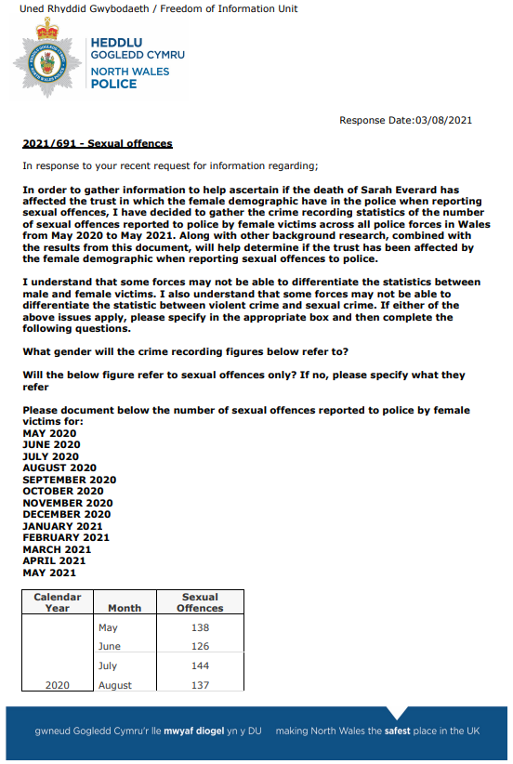
Appendix 2 – Information Request response from North Wales Police

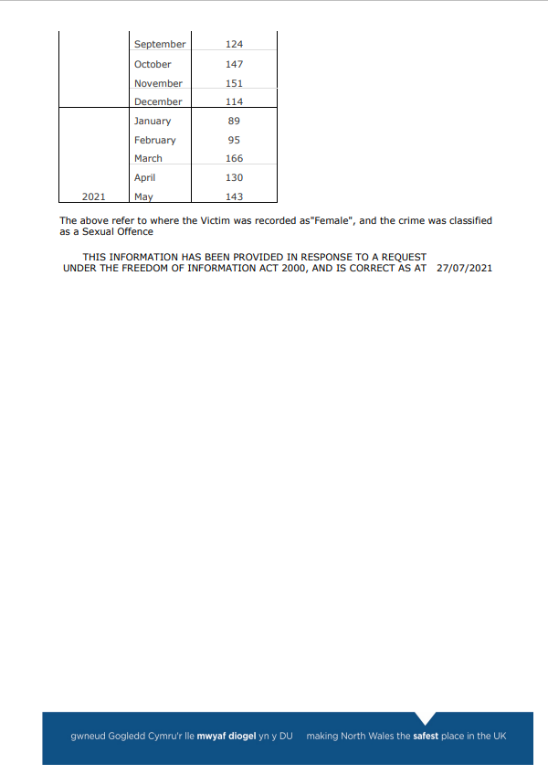

Appendix 3 - Information Request response from South Wales Police
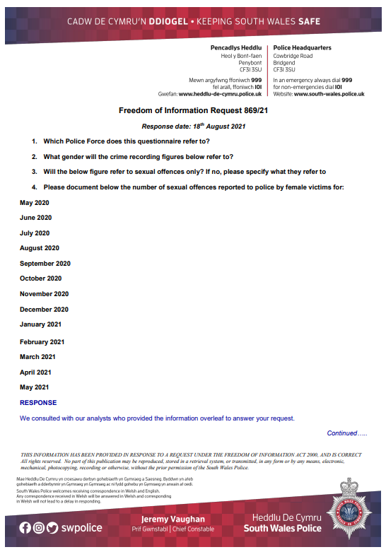

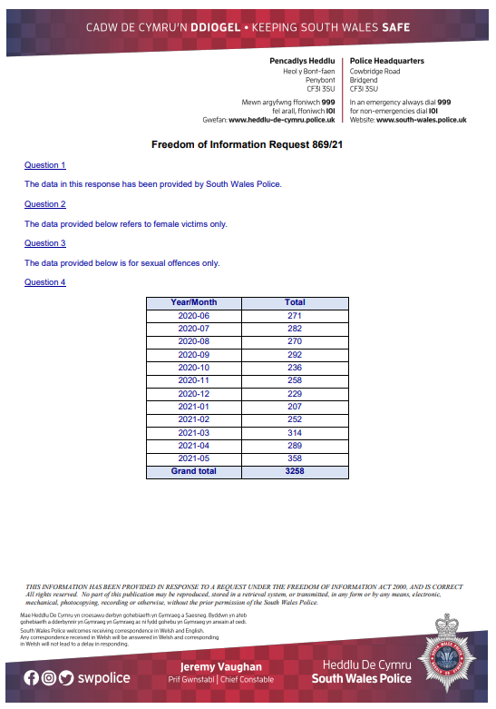

Appendix 4 - Information Request response from Gwent Police


FREEDOM OF INFORMATION REQUEST

FREEDOM OF INFORMATION REQUEST 2021/24340

Dear Sir/Madam

Thank you for your recent request under the Freedom of Information Act 2000.

Section 1 of the Freedom of Information Act 2000 (FOIA) places two duties on public authorities. Unless exemptions apply, the first duty at, Section 1(1) (a), is to confirm or deny whether the information specified in a request is held. The second duty at, Section1 (1) (b), is to disclose information that has been confirmed as being held.

The information that you are seeking is in relation to the following:

REQUEST

In order to gather information to help ascertain if the death of Sarah Everard has affected the trust in which the female demographic have in the police when reporting sexual offences, I have decided to gather the crime recording statistics of the number of sexual offences reported to police by female victims across all police forces in Wales from May 2020 to May 2021. Along with other background research, combined with the results from this document, will help determine if the trust has been affected by the female demographic when reporting sexual offences to police.

I understand that some forces may not be able to differentiate the statistics between male and female victims. I also understand that some forces may not be able to differentiate the statistic between violent crime and sexual crime. If either of the above issues apply, please specify in the appropriate box and then complete the following questions.

Which Police Force does this questionnaire refer to?
__________________________________________

What gender will the crime recording figures below refer to?
__________________________________________

Will the below figure refer to sexual offences only? If no, please specify what they refer to
__________________________________________

Please document below the number of sexual offences reported to police by female victims for:
MAY 2020
JUNE 2020
JULY 2020
AUGUST 2020
SEPTEMBER 2020
OCTOBER 2020
NOVEMBER 2020
DECEMBER 2020
JANUARY 2021
FEBRUARY 2021
MARCH 2021
APRIL 2021
MAY 2021

RESPONSE
Which Police Force Does This Questionnaire Refer To?
GWENT POLICE

What Gender Will The Crime Recording Figures Below Refer To?
Female

Will The Below Figure Refer To Sexual Offences Only? If No, Please Specify What They Refer To
Yes

Please Document Below The Number Of Sexual Offences Reported To Police By Female Victims For:
MAY 2020
82
JUNE 2020
96

JULY 2020
95

AUGUST 2020
73

SEPTEMBER 2020
72

OCTOBER 2020
85

NOVEMBER 2020
83

DECEMBER 2020
84

JANUARY 2021
72

FEBRUARY 2021
77

MARCH 2021
116

APRIL 2021
121

MAY 2021
106

Freedom of Information Act is a public disclosure regime, not a private regime. Any information disclosed under the Act is thereafter deemed to be in the public domain, and therefore freely available to the public and will be published on the Gwent Police website.

If you are not satisfied, you have the right to request an internal review into the response that you have received, or, to complain about our handling of your request.

Thank you for your interest in Gwent Police.

Appendix 5 - Information Request response from Dyfed-Powys Police
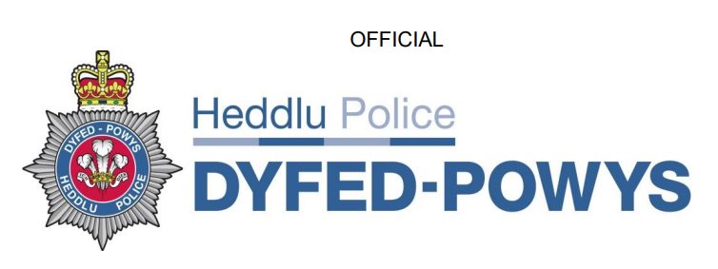

FOI Reference: 628/2021
Request:
In order to gather information to help ascertain if the death of Sarah Everard has affected the trust in which the female demographic have in the police when reporting sexual offences, I have decided to gather the crime recording statistics of the number of sexual offences reported to police by female victims across all police forces in Wales from May 2020 to May 2021. Along with other background research, combined with the results from this document, will help determine if the trust has been affected by the female demographic when reporting sexual offences to police.
Firstly, I would like to say thank you for taking the time to complete this document. Secondly, this document should not take any longer than 5-10 minutes to complete.
I understand that some forces may not be able to differentiate the statistics between male and female victims. I also understand that some forces may not be able to differentiate the statistic between violent crime and sexual crime. If either of the above issues apply, please specify in the appropriate box and then complete the following questions.
By completing this document and returning it via email will automatically consent to the results being analysed and included in the final dissertation which will be submitted to University Trinity Saint David. If you do not consent to the results being analysed and included, do not complete the document.
Please can this document be completed and returned via email by Wednesday 1st September 2021.
Which Police Force does this questionnaire refer to?
__________________________________________
What gender will the crime recording figures below refer to?
__________________________________________
Will the below figure refer to sexual offences only? If no, please specify what they refer to
__________________________________________
Please document below the number of sexual offences reported to police by female victims for:
MAY 2020
JUNE 2020
JULY 2020
AUGUST 2020
SEPTEMBER 2020
OCTOBER 2020
NOVEMBER 2020
DECEMBER 2020
JANUARY 2021
FEBRUARY 2021
MARCH 2021
APRIL 2021
MAY 2021

Response
I can confirm that Dyfed-Powys Police does hold the information requested, as outlined below.
Which Police Force does this questionnaire refer to?
Dyfed-Powys Police__________________________________________
What gender will the crime recording figures below refer to?
Female________________________________________

Will the below figure refer to sexual offences only? If no, please specify what they refer to
Crime recording statistics for the number of sexual offences reported by females from May 2020 - May 2021.
Please document below the number of sexual offences reported to police by female victims for:
MAY 2020
68
JUNE 2020
81
JULY 2020
83
AUGUST 2020
108
SEPTEMBER 2020
109
OCTOBER 2020
108
NOVEMBER 2020
88
DECEMBER 2020
76
JANUARY 2021
67
FEBRUARY 2021
60
MARCH 2021
100
APRIL 2021
110
MAY 2021
142
It should be noted that as a result of the systems adopted by Dyfed-Powys Police in
relation to the recording of such information that the information released may or may
not be accurate.
Furthermore, it should also be noted that Police forces in the United Kingdom are
routinely required to provide crime statistics to government bodies and the recording
criteria is set nationally. However, the systems used for recording these figures are
not generic, nor are the procedures used locally in capturing the crime data. It should
be noted that for these reasons this force's response to your questions should not be
used for comparison purposes with any other response you may receive.

(This is a response under the Freedom of Information Act 2000 and disclosed on
16/08/2021)

