ANA DZHIPOVA

Student Number: 2013882

Programme: MBA -Master of Business Administration
Module: Managing People
LCMB7011

Assessment

Module lecturer: Mary March

Current business situation is extremely complicated, and the overall management faces unexpected changes in the external environment. This creates needs of internal changes in the organisations in all aspects. Particularly, Human resource management, which is the most sensitive part of the overall management, is more challenging than ever and its importance increases caused by increasing importance of the adequate reply of the rapidly changing workforce needs of the businesses. In the current economic difficult environment and limits of Covid-19 pandemic and the consequences of it, many companies must make continuously difficult management decisions to survive and/or to ensure company success in the future. British gas – the biggest company in the industry it operates, has attracted the attention of the whole public with the long-lasting and deadlocked dispute with its employees. For long time this dispute was one of the mostly discussed hot points in the mass media.

What are the facts?
It happened in the middle of 2020. Centrica announced that is planning to reduce around 5000 jobs to "arrest the decline" of the company (BBC, 2021). The Group offered thousands of its employees to sign new employment contracts with worse conditions than the existing ones or, risk their jobs. Regarding the new terms and conditions, the overtime will be paid the same rate as regular hours /existing overtime rates go up to double normal rates/. Also, in the winter period the hours the engineers can be allocated are extended from 08:00 to 20:00 to 06:00 to 23:00 without extra payment.
About 80% of the Group’s 20 000 staff of the employees accepted new terms and signed new employment contracts but not small number of employees refused to do so. The employees in risk, represented by GMB – trade union decided to start a strike. Around 59% of the staff members took part in the vote, and 89% of them – or 4,830 workers – voted in favour of industrial action ( The Guardian, 2021). For them it is a “Huge slap in the face” (BBC, 2020).
In January 2021 five days strike took place and had no desired reaction by the Group. GMB announced new strike dates. On 25 March 2021 GMB national secretary announced that: “If Mr O’Shea goes ahead with this reckless action, GMB has agreed to declare an official national lockout dispute with British Gas from April. (GMB, 2021). On 29 March, many employees were given formal notices and after 43 days of strike about 300-400 people lost their jobs on 14 April.
Last months many homes are backlog for repairs and 300000 planned annual service visits have been axed.
Despite that the business faced serious problems with servicing and fixing the break downs of customer’s boilers, Centrica has not made step back. Moreover, British Gas stopped to offer standard insurances as it was before.

In order to analyse critically the dispute, it is necessary to see the situation from both points of view.

What says Centrica?
The Guardian citate Chris O’shea: “How did we get here? Our business has been declining for a number of years. We’ve lost a million customers in the last 10 years. Our productivity has declined substantially.” ( 2021)

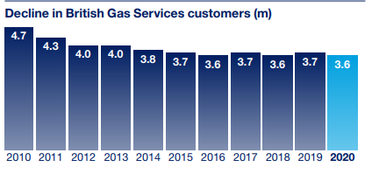

Resource: Centrica Annual Report 2020

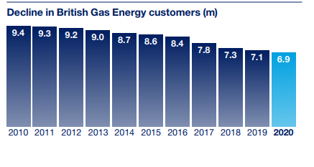
Resource: Centrica Annual Report 2020
According the CEO of Centrica: “over the past ten years we have lost two million energy customers and one million services customers in British Gas, over half our earnings, and more than three-quarters of our value. We have failed to adapt quickly enough to increased regulation, fierce competition, and low commodity prices. Agile challenger brands have taken customers from us with low-cost business models and technology platforms that make the customer experience seamless rather than cumbersome.” (Centrica Annual Report 2020). Statistic shows that the typical British Gas engineer salary is £38,035 shown on 15 April 2021 at Glass door web page which is higher than the average base salary at the sector - £ 35,812 per year.
The position of Centrica is that the Group cannot keep the highest levels of pay in the sector in this situation of financial difficulties and hard economic environment. Also, the company needs to recover productivity and to focus on customer needs. The Group position is that they have offered a fair deal and there were over 300 hours of negotiations with GMB.
CEO of Centrica explains that the changes are essential in order to protect the existing jobs and to open new positions in the future. The extending of working hours aims to improve the service and increase the customer’s loyalty. “We’re not changing base pay or pensions and we will reward increased productivity through additional bonuses. 83 per cent of our employees have already accepted the new terms - including the majority of our engineers. Our changes are ultimately to protect and create jobs for the future”, (Dorset Echo, 2021).
“Our business model is designed to allow us to focus on meeting the changing energy supply, services and solutions needs of our customers, helping them transition to a lower carbon future while positioning ourselves to deliver returns for shareholders and meet our broader obligations to society.” (Centrica Annual report 2020).

What say Employees /GMB?
Justin Bowden, GMB national secretary, said: "The months and months of fire and rehire pay cut threats from British Gas CEO Chris O'Shea have provoked thousands and thousands of GMB engineers and call centre staff to strike, the only option left to them by a business that made £901m operating profit yet still plans to sack them because they won't accept the scale of cuts it demands," he added: “Some British Gas workers have taken to social media to voice their support for the strike”. Mum shared with Mirror: “Because I cannot work these hours, they would have to deduct from my wages which will equate to losing an extra day of pay every month. The company said it can offer 10% of the workforce flexible working. I cannot apply for this until I return in January. My manager said he is uncertain I will get this” (2020).
During these months GMB reminded that is still time to pull back and to be done what is right for the business, customers and employees hoping that it will “take the April 1 deadline off the table.” ( GMB, 2021).
"Instead of making yet more redundancies, the priority should be to resolve the industrial action it has provoked from its loyal workforce with its hated fire and rehire plans” – says Justin Bowden. (GMB, 2021).
From the employees’ prospect, workforce is not valuated and respected by the employer. Many of people have been working more than 10 years. They have not stop working during the pandemic to ensure customer well servicing and their reward is fire and re-hire plan. They do not feel their interests are protected by employer and has been not paid any attention of their “Voice”. Moreover, they do not believe the employer had no other choice.
How have Centrica made the decision to apply this fire-and-rehire plan?
“Turning to the external environment, we are now beginning to see some of the adverse consequences of the temporary UK default tariff that we had predicted, including job losses, company failures, and other suppliers exiting the market.” (Centrica Annual Report, 2019).
In fact, the future of the using of gas use and gas boilers is limited, and expectations are consumers to move slightly from gas to electric boilers and this causes Many households will exchange to electric boilers, which means that the company must change slightly the employment structure.
Last 10 years British gas suffered from financial losses and has lost many customers. Analysis done by the managers of the group show that one of the main reasons for these results is the poor customer service they provide. The company performance was badly affected by numerous of external factors, most important of which Covid-19 pandemic and the economic consequences. “COVID-19 had a negative impact on business energy demand, led to higher bad debt provisions and restricted our ability to carry out as many in-home services as we wanted to. We were also impacted by falling commodity prices and warmer weather.” (Centrica Annual report 2020).
Chris O’Shea states in the strategic report: “I am convinced the changes are the right thing for us in the long term and that we will be able to move ahead with our colleagues and customers and put this behind us. Our new terms and conditions will make us more competitive by improving productivity, and I am delighted that this means we are recruiting 1,000 new apprentices in British Gas during 2021 and 2022, creating new, highly skilled, and well-paid British jobs, something our country needs now more than ever. By the end of this decade, we will have created 3,500 new apprenticeships, protecting existing jobs and creating future opportunities.”.
A Centrica spokeswoman said: "We've done everything we can with the GMB to avoid industrial action.( The Guardian, 2021).
The big question is how it happened that it has escalated into a dispute.
Commenting on the strike, CEO of Centrica said “83% of workers had already accepted its new terms and conditions, which it said protected base pay and pensions. He adds that "it show that most people clearly understand that the business needs to change in accordance with customer needs” (2021).
"GMB's mandate for strike action is weak; they are fighting against modernisation and changes which will help to protect well-paid jobs in the long-term and are doing so at a time that our country needs everyone to pull together." (Business Human Rights, 2021).
British Gas needs to change the business model and for sure, the company needs its engaged workforce. But first of all, Group must enable business recovery because basically, if no business, there will be not any jobs. Centrica explains its plans with needs to change the direction and to ensure better future performance protecting its employees.

Legal background and social performance of Centrica

Basically, the dispute is between Centrica as an employer and its employees but in fact, it involves all the stakeholders and has an impact to overall labour market and economic processes. Many of British Gas customers face problems with not services provided due to the strike. nevertheless, some of the customers do not blame the engineers for the strike.
Discussing different points of view, we see the things have two sides. It is such a dispute that attract the mass media attention because it will influence the behaviour of other companies and will impact the employment relations on national level. That is why it is so important to analyse critically this dispute. Society does not accept that kind of situations easily. Prime Minister has called the fire-and-rehire practice “unacceptable” but the truth is that the law must include option and to give an opportunity and flexibility to the employers to offer new contractual working terms and conditions when business needs this. If the agreement between employer and employees cannot be approached and the changes are absolutely needed, the employer can do fairly dismisses and offers for new contractual terms but as a last resort.
Employment law, which is the law governing employment regulations, includes an option for the employers to terminate the existing contracts of the employees and offer them new contracts with re-arranged terms and conditions. It settles what employers can expect from employees and employees' rights at work. If the Company breaches the express terms the employee can keep working and claim damages or leave the job and claim constructive dismissal.
“An employer may consider this option where changes cannot be agreed and where it appears too risky to impose the changes unilaterally. The employer must then offer re-engagement on the new terms immediately. Employers should be aware that in legal terms this may be considered a redundancy dismissal, so they should follow any rules around collective redundancy and consultation time limits. This course of action is not without risk: the employee may claim breach of contract or unfair dismissal, although any compensation will be limited as the employer is offering re-engagement.” (CIPD, 2020).
Varying the contract can be done three ways: after discussion to agree changes with the employee in writing; unilaterally changes (usually is very risky) and terminating the employment contract and offer re-signing of new one under the changed terms.
With other words it is necessary the law to give an opportunity for flexibility of the employers but only if the changes are absolutely needed and no agreement achievable.
Obviously, fire-and-rehire plans are legal but are they ethical and moral? Discussed dispute shows that employees pay very high price for the management negligence and mistakes in the past. Also, during the months of pressure, Centrica did not do any step back which is an indicator that the Group made its decisions without any discussion with the employees and without listening their voice. This defines the fire and rehire practice as unethical and unmoral. Of course, in many cases employees accept the new terms only because they need to avoid unemployment. This highlights the unethical characteristic of hire and rehire practice as well.
In our case some strange facts make public to think that Centrica managers did not do their best to cut other costs before to decide to go on hire and rehire plan. Some examples are the sharp increase of the remuneration of the CEO Mr Conn in 2019. Sun published an article under title: “British Gas boss gets 44% pay rise to £2.4MILLION despite hiking bills for millions and axing 4,000 jobs, Iain Conn's pay rise comes just days after British Gas raised standard tariffs by ten per cent to an average £1,254” (2019).
Other person appointed by Centrica is Joan Gillman who made £93,000 in total compensation as Non-Executive Director at Centrica PLC in 2019 – joined the Board on 11 October 2016 as Non-Executive Directors, “scrutinise the performance of management and constructively challenge and help develop our strategy” (Centrica webpage, 2016). She resigned on 8 February 2021. Not very good results for high price and no replacement of her.
The dispute has negative outcomes for both sides involved in. Some of employees will keep working but under worse terms. Other employees have lost their jobs. From the other side, the Group lost trust of its staff and customers and respectively company reputation.
If the organisation fires and rehires its workforce does not mean it is bad employer. If the Group has no other choice, they have to do it, but it is very important how they do it. Organisations have moral and ethical obligation in parallel with legal ones. By firing and rehiring, company destroys the employment relations for long term. In the current case they are destroyed, and people engagement is lost much earlier and evidence for this is the poor customer service, respectively poor performance of frontline employees and the poor management.
Centrica could discuss with the employees some ideas how to sort the problems out. Instead, the Group put its people in a position without many opportunities. Some of the employees will keep working in Centrica but because they have been forced to accept new working conditions, they will be not engaged. During the strike many of the British gas customers faced problems with the regular service and fixing the broken-down boilers. The Group did not make step back even in order to improve customer service. Treating people and customers this way harms company relationships with its stakeholders and causes difficulties for recovery of the business and future growth. The managers have a duty to ensure good relationships based on trust and confidence. Centrica failed in this. “The use of fire and rehire threats has been condemned across the political spectrum and caused huge anger among this dedicated workforce," Bowden said. (Mirror, 2021)”. Actually, it is the reason that so long time both sides could not manage to sit on the table and discuss some points and resolve some of the problems together. In order to develop its HRM through creating and maintaining good employment relationships, Centrica must find the way to recover the people’s trust and to improve the engagement.
"

Employee’s engagement

“Employee engagement goes beyond motivation and simple job satisfaction. It can be seen as a combination of commitment to the organisation and its values and a willingness to help colleagues”, (CIPD). According to Armstrong (2014), employee engagement is “at the heart” of the employment relationships and this defines its significance. In accordance with CIPD it is a combination of commitment to the business and its values and willingness to support the others. Employee’s engagement is good for both - employers, and employees. If there is high employees’ engagement, it will have a positive impact on productivity and respectively, on overall organization performance. At the same time, employees feel more satisfied and more motivated to develop and improve themselves within the company. With other words, engagement of people works for reinforcing of better company performance aligned with better people’s performance within the company and this makes the employees engagement to be considered as a key for achieving the company objectives through its human capital. All of this explains how important and beneficial for the business is to enhance the organizational engagement. Armstrong defines drivers of employee engagement as follows: job challenge, autonomy, variety, feedback, fit, opportunities, reward, and recognition (2014).

Employee engagement strategy might focus on:
- Motivation (intrinsic and extrinsic): how workers use their efforts to achieve objectives (CIPD, 2021).
- Organizational identification: aligning of how employees see themselves and the company (CIPD, 2021).
- Organisational commitment: refers to feeling attached to the company and dedication for work. (CIPD, 2021).

“The approaches that can be used to enhance organizational engagement consist of: 1) high-involvement management; (2) providing more scope for employee voice; (3) developing ‘the big idea’; and 4) tackling the work environment.” (Armstrong, 2014).

Human resource involvement

Before the dispute Centrica had a reputation of good employer (majority of employees have been working for the company for more than 10 years up to nearly 40 years). Why have the Group allowed this dispute to happen and to lose so many loyal employees? Why a company loses so easy the reputation which is so difficult to achieve? How Centrica will grow without engaged people and how they will attract new talents if they have lost the trust of their employees, customers, and their reputation?
The continuing trend to declining performance of British gas was caused not only by impact of external factors but also some internal in combination with not adequate management. Customer service is very poor and there are many complaints by loyal clients. But why the Board did not take earlier any actions to minimise the loses of the company and to create adequate strategy to stop this? Although Centrica is the biggest company at the industry, obviously not reliable managing of the people capital is not adequate to the business needs.
Human resource strategy always aligns with the overall business strategy of the companies. Current case is very indicative how important are the employment relationships. HRM is the bridge between the employer and employees, and this defines its key role for success of the business. To create and maintain good relationships is the challenging part of the HRM and it can be achieved by creating trust and aligning the people performance with the company performance. Ensuring good relationships is continuous process and human resource specialists should support managers at any levels and aspects of management because every management decision reflects and is dependent on the people in the organisation.
“Organizations consist of employers and employees who relate to one another” (Armstrong, 2014).
Basicly, there are two components of the employment relations: the legal /contractual relationship ( covers the written contract of employment setting all the terms and conditions like working time, pay rate and rewarding package, holiday pay etc) and the ‘Psychological contract’ - there is much more to the relationship. Psychological contract refers to unwritten expectations of the parties at workplace. As an employee you feel commitment with the business and do your best for the employer interest and at the same time you do expect the employer to care about you – to trust you; to train you; to respect you. This balance is fundamental for company performance in nowadays.
The purpose of the human resource management is concerned with how to gain employee’s engagement to the achievement of an organisation’s objectives. “Employee engagement takes place when people at work are interested in and positive, even excited about their jobs and are prepared to go the extra mile to get them done to the best of their ability”, (Armstrong, 2014).
HRM role is to support the management at all aspects in accomplishing its goals by developing and implementing human resource strategies. The current dispute is an example that traditional model is not appropriate to the requirements of modern business. It does not provide an adequate framework that enables businesses grow. There is no unique strategy for all the businesses, each company must compose own strategy regarding its specific needs. Modern business requires workforce management to get much more flexible and in order of this purpose, Centrica has to implement numerous of changes giving the management opportunities for flexible decision related to HRM in parallel with the new company strategy which is more focused on customers.
The only not predictable factor that had a bad impact of Centrica performance is the Covid-19 pandemic and its consequences. All the others were expected, but the Group was not ready with appropriate reply. The progressive approach of the modern management must ensure the employees’ voice will be heard at all the times, not only when problems became too deep.
As above – mentioned, agreement between Centrica and its Human force is unachievable because the employment relationship is broken-down, and communication is limited. In the core of this problem is lack of trust. Centrica as an employer failed to manage to go over critical situation, even allowed the conflict to escalate into a dispute. The Group was closed for discussion and did not show any respect to its employees, exactly opposite and as a result people feel not evaluated. The critical analysis of the situation shows that the HR model cannot provide an adequate framework and changes are essential for effective people management.
“Human resource management approach” is something qualitatively different from a “personal management approach” (Torrington, Hall and Taylor, 2008). Centica understates the importance of organisation relations and the dependency of the business of engaged people. Distinction of the approach of modern HRM is people-oriented organizational activities.

Some of the most popular models of HRM are:

Storey’s model - HRM is seen as a more humane approach to employment management and consist 4 components: Beliefs, Strategic qualities, Role of line managers and Key levels.

Matching model -determinates following four generic processes:
- Selection – refers to matching people to jobs.
- Appraisal of performance
- Rewards: concerned to importance of pay and rewards
- Development of skilled people.

The Harvard model

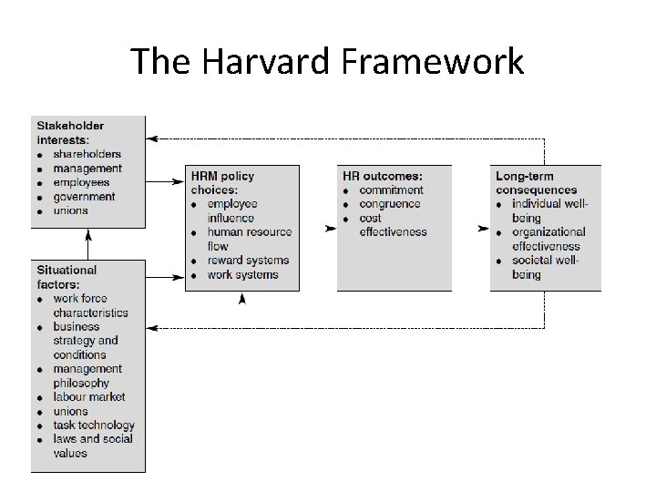
Source: Slide to Doc

The Harvard model is based on two features: line managers are more responsible alignment of competitive strategy and HR policies and HRM must set policies which regulate how the HR activities are developed in order to be more mutually reinforcing. ( Armstrong, 2020).

Many of the professionals think that the most appropriate model for large-scaled companies like British gas is Ulrich’s model. Survey for CIPD proves that the companies implemented this model increased the effectiveness of the HRM. This model was developed by David Ulrich who suggested that in giant companies Human resource functions should be divided into four segments. “The main contribution of the David Ulrich’s HR Model was the start of the movement from the functional HR orientation to the more partnership organization in HRM Function.” (HR handbook).
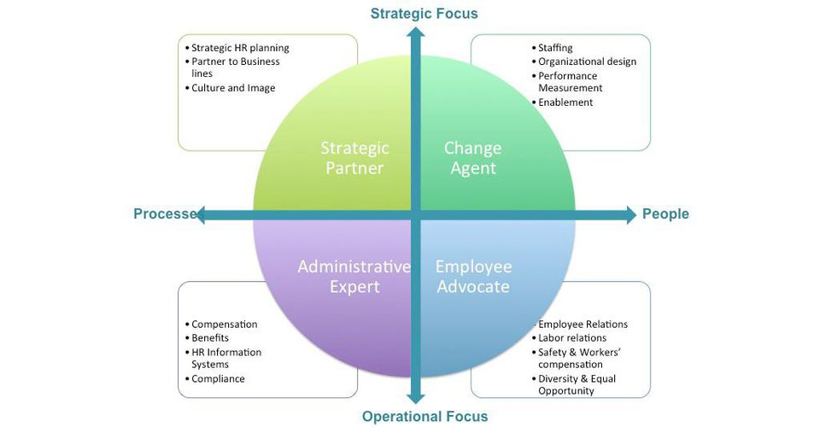 Source: Fobs (2013)

Strategic Partner refers to alignment of HR activities with the overall business strategy and sees the employees as internal clients. HR strategic partner creates strategic partnership with management and good relationship with the internal clients and connects them. Activities of this role are identifying talents and working for their development; giving feedback to internal clients; opens vacant positions and selecting of best applicants; supporting of diversity.
Change agent is about acting as an agent working with change management teams and responsible for communication and gaining trust and transition of the business in the workforce within the organisation. Human Resources is the supports change activities and ensuring the capacity for the changes. Activities of this role are sharing the objects of changes with the employees; preparing them to the level where these changes are well understood and easy acceptable; updating of existing job descriptions; arranging trainings and developing new skills and competences when it is required for changed job position; gaining feedback from employees and supports them in adopting changes.
Administrative Expert is about creating and maintaining employee records. Activities typical for the role are database updating, keeping information accurately; Preparing full set of documents, related to employment; Reviewing and renewing company policies and legal compliance. Good knowledge about the employment law is essential for this role.
Employee Champion is a core HR segment in this model. HR must represent people and ensure protecting their interests. Activities of this role are ensuring employee’s “voice” will be heard and considered while making management decisions; identifying company culture omissions and management; ensuring employees are treated fairly and ethically.
Ulrich’s model enables very good relationships between employer and employees which will have positive impact of the employee’s engagement – the key factor for improving the customer service which is the focus of the new strategy of Centrica.
As mentioned above, the Employee Champion resigned resigned in February 2021. While joining the Board she had some initiatives to increase the employment engagement which she defines as critical to company success.
All of roles in this model of HRM could be very beneficial for big organisations like Centrica because transitions will not cause so serious troubles and negative outcomes for organisation and changes will be accepted without commotion. In nowadays business environment is extremely dynamic and this creates needs of business to make intensive changes. Ulrich’s model is highly recommended because is most appropriate for the company especially now, when new strategic requires implementation of changes in relation with recovery and future growth of the business.

Conclusion
This article includes critical analysis of the dispute between Centrica and its employees and Also, it is considered why and how it happened. Such giant companies have heavy presents in the economic and social life and influence other organisations behaviour and employment relationships at national level. If Centrica can do it, for sure, many other companies will adopt similar tactics. This explains why such disputes are always in the centre of the public attention.
“Nearly 70% of companies accused of launching fire – and – rehire assaults on workers’ wages and conditions are making a profit and half have claimed government support during the pandemic “, (The Guardian, 2021). Also, there are other large-scales companies doing the same – British airways combines proposes redundancy and new contractual terms as well.

Has the dispute finished? No, it will continue…. In fact, the roots of the problem are very deep, the conflict started much earlier than it has been officially announced and has not finished yet. For long time the symptoms of the increasing needs of changes were ignored and allowed the problem to escalate to the levels where it cannot be resolved without concussion. Irreparably broken employment relationships are the reason for high prices paid by both sides. It is unjustified because most of factors caused business crisis were expected and it could be avoided.
Is the fire-and-rehire practice legal? – Yes! Is it ethical? – No! Is it moral – again No! But is it easy to be told simply who is right and who is wrong with one word? No! That kind of disputes have always negative outcomes at national level and avoiding of similar situation and conflicts will be very beneficial for the social peace.

For giants like Centrica it is not enough only to operate obeying the law but also, ensuring corporate social performance which includes ethical and discretionary responsibilities. Ethical behaving is very beneficial for the organisations in long term plan and definitely will be very favorable for increasing the profit – directly and indirectly.
To conclude, I would say that the border between moral and unmoral behaviour is very thin and the society, business and government should combine their forces to minimise the speculations with the legal opportunities. To ensure ethical and moral management both, employers and employees have to set and maintain high culture level in the organisations.

References

Armstrong, M. (2014), Armstrong’s Handbook of Human Resource Management Practice, 13th Edition, Cogan Page

Armstrong, M. (2020), Armstrong’s Handbook of Human Resource Management Practice, 15th Edition, Cogan Page

Torrington, D., Hall, L., and Taylor, S. (2008), 7th Edition, Pearson Education

Torrington, D. (2014), Human resource management, Pearson Education

www.centrica.com

Centrica Annual Report 2019

Centrica Annual report 2020

Cipd.co.uk

BBC, (2021), “British Gas owner Centrica to cut 5,000 jobs”, Available at: https://www.bbc.co.uk/news/business-53006073, Accessed: 19/04/2021

Business Human Rights, (2021), “UK: Hundreds of British Gas engineers face threat of dismissal following nine-month fight against alleged ‘fire and rehire’ threats to impose new contract with worse terms and conditions”, Available at: https://www.business-humanrights.org/fr/derni%C3%A8res-actualit%C3%A9s/uk-hundreds-of-british-gas-engineers-face-threat-of-dismissal-following-nine-month-fight-against-alleged-fire-and-rehire-threats-to-impose-new-contract-with-worse-terms-and-conditions/, Accessed: 21/04/2021

HRHandbook,https://hrmhandbook.com/hrm/hr-model/four-hr-roles-dave-ulrich/, Accessed:25/04/2021

GMB (2021), GMB British Gas engineers face mass April 1 sackings as strike continues, Available at: https://www.gmb.org.uk/printpdf/2653, Accessed: 18/04/2021

GMB, (2021), “GMB slams British Gas as further redundancies planned across UK”, Available at: https://www.gmb.org.uk/news/gmb-slams-british-gas-further-redundancies-planned-across-uk, Accessed: 21/04/2021

Mirror, (2021), “British Gas engineers start 5-day strike in war against 'fire and rehire' policy”, Available at: https://www.mirror.co.uk/money/british-gas-engineers-walk-out-23275499, Accessed : 20/04/2021

Mirror, (2021),British Gas worker “forced to choose between being mum and having job” in rehire row”, Available at: https://www.mirror.co.uk/money/british-gas-staff-devastated-dismissal-23828640, Accessed on 21/04/2021

Forbs, (2013), “Taking HR Analytics Beyond Technologists”,
Available at: https://www.forbes.com/sites/rawnshah/2015/04/13/taking-hr-analytics-beyond-technologists/?sh=3906b8276af2, Accessed: 25/04/2021

The Guardian, (2021), ‘A kick in the teeth’: British Gas engineers face losing their jobs or longer working hours, Available at: https://www.theguardian.com/business/2021/mar/28/a-kick-in-the-teeth-british-gas-engineers-face-losing-their-jobs-or-longer-working-hours, Accessed on 18April, 2021

The Guardian, (2021), GMB calls to renew British Gas strike over 'fire and rehire' plan, Available at: https://www.theguardian.com/business/2021/feb/01/gmb-calls-to-renew-british-gas-strike-over-fire-and-rehire-plan, Accessed 20/04/2021

The Guardian(2021), British Gas workers strike on Clapham Common, Available at: https://www.wandsworthguardian.co.uk/news/19109635.british-gas-workers-strike-clapham-common/, Accessed: 21/04/2021

The Guardian, (2021), “Fire and rehire’ tactics rife at firms that are in profit and claiming Covid cash”, Available at: https://www.theguardian.com/law/2021/apr/18/fire-and-rehire-tactics-rife-at-firms-that-are-in-profit-and-claiming-covid-cash, Accessed: 21/04/2021

Dorset Echo, (2021), “British Gas workers strike again - how it will affect you”, Available at: https://www.dorsetecho.co.uk/news/national/uk-today/19027452.british-gas-workers-strike---will-affect/, Accessed 21/04/2021

Slide to doc, “Human Resorce Management and Strategi Human Resource Management”, Available at: https://slidetodoc.com/human-resource-management-and-strategic-human-resource-management/, Accessed: 21/04/2021

The Sun, (2019), “British Gas boss gets 44% pay rise to £2.4MILLION despite hiking bills for millions and axing 4,000 jobs”, Available at: https://www.thesun.co.uk/money/business/8819490/british-gas-boss-pay-rise-hiking-bills-axing-jobs/#:~:text=THE%20boss%20of%20the%20firm,to%20the%20company's%20annual%20report.&text=It%20means%20he%20is%20paid,employee%2C%20who%20earns%20%C2%A333%2C718, Accessed: 18/04/2021

Glass door, (2021), Available at: https://www.glassdoor.co.uk/Salary/British-Gas-Gas-Engineer-Salaries-E296599_D_KO12,24.htm#:~:text=The%20typical%20British%20Gas%20Gas,estimated%20based%20upon%20statistical%20methods, Accessed 18/April/2021

Human resource management and Strategic Human resource Management, Online article, Available at: https://slidetodoc.com/human-resource-management-and-strategic-human-resource-management/ assessed on 21/04/2021

