Student name: Andrada-Madalina Muntean
Student number: 2118572
Personel Resourcing and Development (BMIH5005)
Lecturer: Kathryn Roberts

What are the current challenges that the industry is facing that is affecting employee recruitment and retention

An international business known as the Intercontinental Hotels Group (IHG) was founded in the beginning of the 2000s. Its headquarters seem to be in the UK. The enterprise, which hosts visitors who are primarily tourists from throughout the world, ranks as the biggest in the hospitality industry. IHG has more than 600,000 luxury hotels spread over around 4,600 outlets in more than 100 different countries. And over 150 million users use the company each year (Ihg.com. 2023). The number shows the company's high brand value. Because of its devoted customer base, the company has pushed well ahead of its rivals, as seen by its huge annual profits. The company's aggressive growth strategies, used to keep a competitive edge over rivals, are attributed with driving this development. The business' strong brand equity appears to be another reason for the speedy expansion. The approach will pay particular attention to the difficulties IHG has keeping staff on board as a result of internal and external business considerations. Brexit, Covid-19, and inflation are some of the outside issues that have an impact on IHG employees' ability to find and keep work. In light of this, the following aspects will be considered into account in our proposal in order to shed light on the difficulties IHG faces.
- The effect of Covid-19 on IHG's hiring, retention,
- Brexit's effects on IHG's personnel, recruiting, and retention
- The effects of inflation on hiring, retaining, and recruiting employees in IHG
- Probably effective way to deal with the difficulties
Economic output from this sector was reduced by a maximum of 42%. It has also become a challenge for the organization to comprehend the UK's present inflation rate that has increased to 9.3% (Bodenstein et al. 2019). The increasing living expenses have drastically lowered the user's expendable cash, resulting in a negative impact on the recreational activities that customers engage in. Such occurrences have important implications for the organization's existing hiring as well as retention strategy. Brexit was a phenomenon in which the United Kingdom left the European Community throughout 2022. This resulted in a set of regulations and guidelines that fundamentally changed the UK industry as well as the hospitality industry. The Covid-19 outbreak, on the opposite side, was a significant phenomenon of the twenty-first century, when the casualty numbers globally led to limitations on worldwide and national boundaries (Cesa-Bianchi et al. 2020). Several independent businesses in the hospitality industry were forced to close as a result of a total shutdown.
SWOT Analysis
Strength
- Through effective learning and training initiatives, a highly competent team (Bordo and Levy, 2021). A workforce who are not only particularly proficient but also driven to accomplish more as a consequence of substantial spending on education and training by InterContinental Hotels Limited PLC's employees.
- InterContinental Hotels Corporation PLC goods now consistently meet high quality standards because of technology, which also allows the business to scale up or down in accordance with market trends
Weakness
- The promotional strategy could have used a lot of work. The item is a top seller, but because its positioning and unique sales concept has not been clearly defined, it is vulnerable to attacks from competitors in this market.
- A bigger percentage of chances are forfeited as a consequence of poor forecasting of product demand than competitors. Because of its inability to foresee demand, InterContinental Hotels Company PLC keeps more inventories both inside and outside the company, which is one of the causes why its everyday stock is often higher than that of its competitors (Le Billon and Kristoffersen, 2020).
Opportunity
- Growth in the industry will lessen rivals' strengths and give InterContinental Hotels Group PLC additional chances to compete with its opponent (Gerwe, 2021).
- InterContinental Hotels Group PLC may be able to increase profitability and gain market share by passing the benefits on to customers by lowering the pricing for its goods as a consequence of cheaper transportation but also shipping expenses.
Threat
- The profit of InterContinental Hotels Group PLC may be severely impacted by rising salaries, notably moves like fifteen dollars an hour and price hikes in Asia. With changing client buying habits from digital portals, the conventional supply chain architecture—which is dominated by physical facilities—may be in danger.
- A challenge to the business of InterContinental Hotels Corporation Limited seems to be the restriction of low-quality, pirated products, particularly in emerging economies and low-income countries.

PESTLE Analysis

Political | It may be said that the corporation is critically affected by the state of the UK economy. The UK is currently suffering a level of inflation of 9.3% that has significantly reduced the residents' expendable cash and raised their costs of living, resulting in a negative impact on buying power. At this exact time, IHG is experiencing a significant staffing shortage as a result of Brexit (Yuan et al. 2020). As a result, the organization still has trouble finding qualified candidates outside of the UK.
Economic | The UK is simultaneously facing serious problems, one of which is the rising inflation rate, which has made consumer goods more expensive and reduced their purchasing power. Customers seem to be there but are unwilling to use their money for leisure. Economically speaking, the UK has seen a 42% decrease in the hotel sector's productivity (Recession, 2022). The COVID-19 outbreak not just limited access to the country for visitors from abroad but additionally the Economy that was generated by the sector.
Social | In the procedure that the UK business, societal consideration puts meaningful awareness on the social environments. The company has been struggling to fill positions as a result of Brexit, as norms and procedures have changed significantly since the UK's departure from the European Union (Matos et al. 2022). The proper operation of the business has been put at risk by a staffing shortage and immigration concerns when employing fresh people. As a consequence of the continuing economic collapse and the present rate of inflation, however, consumers' desire to spend cash on recreational activities has significantly decreased.

Technology | IHG is regarded as one of the biggest hotel chains around the globe. In addition to focusing on giving customers the greatest possible experiences, IHG also makes sure that it is leading as the top competitor in the service industry. Technology is an important factor since it not only stresses the ability to draw customers' focus to a greater level of customer service, but also increases the entity's total revenue. Because of the various conveniences, it can be said that the technology impact is at an all-time high. It offers amenities to its customers.
Environment | It should be noted that the United Kingdom has made the existence of a circular market a crucial condition for businesses. One such business seems to be IHG International, which places a strong emphasis on sustainable business practices in order to improve the globe through its adherence to environmental protections.
Legal | It should be noted that IHG has been currently dealing with a staffing shortfall as a result of the ongoing effects of Brexit. Once the UK left the European Union, Brexit had an influence on UK laws and regulations, but it also caused problems for businesses looking to hire new employees because of immigration restrictions. Brexit's alteration of the regulations and laws has had major negative effects on the nation's labour market, putting the operations of companies like IHG in jeopardy. It offers its clients.

Effects of inflation
Higher interest rates can aid in slowing the overall growth associated with aggregate demand in the nation's economy, and the slower growth will result in lower levels of inflation. The Bank of England raised the country's basic interest rate by about 3.5% in 2022 in reaction to the sharp rise in inflation (French et al. 2018). Monetary policy has been acknowledged as being the most important weapon in the UK for ensuring that unemployment and inflation remain low there. The practice of lowering interest rates is a part of macroeconomic policy when it comes to the unemployment rate. Reducing interest rates may lower the cost of borrowing overall and encourage consumers to invest as well as spend more.
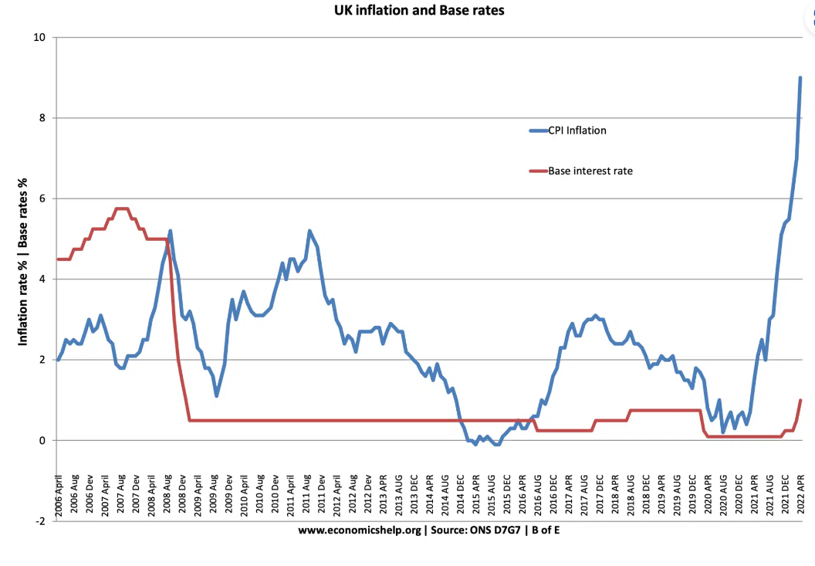
Figure: Base interest rate
(Source: Inflation rate, 2022).

Effects of Covid-19
The security of their citizens is the first priority for governments as well as companies as COVID-19's impacts expand over the entire planet. The consequences for company earnings and economic expansion must lead to an abrupt sell-off in equities markets around the world even though this focus will persist. We are pleased that the clients in the recreational and tourism sectors, who were the first to have to deal with the extraordinarily unfavourable weather, are moving quickly and remaining focused to understand and assess the economic and operational ramifications for their businesses (Buhalis,2020). The impact appears to be enormous and not yet foreseen on both revenue and distribution networks. Decisions to close motels, cafes, recreational places, and cinemas, in addition to the disturbance of the overall travel ecosystem, have a substantial impact on global tourism. In order to solve the challenges with capital investments and cash flow, IHG management as well as finance have been collaborating. They also keep in touch with their constituencies on a regular basis.
Effects of Brexit
Absence of staff resulted in irregularities in corporate procedures and ineffectiveness in achieving the organization's goal. It is obvious that manpower scarcity led to the establishment of a power firm of IHG Company with changes to the rules and laws resulting from Brexit. As well, it was difficult for the company to retain its workforce. According to the research (Gerwe, 2021), the business found it difficult to begin hiring talent and to entice existing employees to apply for jobs again. As a result, the overall amount of possibilities increased by about 40%.
Solution of issues
Digital inspections simplify procedures, enable quick on-boarding of new team members, and lessen cognitive load on existing team members. As a result, teams might put more of their attention into delivering outstanding client service as well as less on management. Coaching and promoting a positive work environment might additionally be the IHG Company’s main priorities (Dewi et al. 2019). By offering distinctive encounters to almost every visitor, IHG sets its brands apart from the competitors.
There's not enough opportunity for idleness with fewer employees. To ensure that the actions are as effective as has been reasonably possible, an open line of communication framework is required. Everybody must understand what is required, where it has to be completed, and how it is being performed. Leadership must also be made aware of all this.
Evaluation and conclusion
The absence of these policies may have a variety of negative effects, including long-term system composition, high unemployment, a swift depreciation of the currency, a collapse of the consumer and financial sectors, improper economic growth in the nation, and many more. Absence of these policies can result in a decline in GDP, higher inflation rates, and other factors that can eventually limit consumer spending and investment capacity, lowering aggregate demand and proving there is no longer a need for labour, workers, and businesses (Keogh-Brown et al. 2020). Trail frees up leaders' time so they may concentrate on the crucial tasks, such as developing distinctive client experiences and workforce development. Brexit has a profound effect on corporate laws in the UK. Like every other firm, Hotel operates in accordance with all applicable official EU regulations governing international trading and financial possibilities.
Conclusion
Macroeconomic policies, including monetary policy, supply-side policies, fiscal policy, and many others, are crucial because they work to create an environment that is suitable and stable for fostering robust and sustainable economic growth in the UK. The policies are essential because they address the various operations connected to the economy as a whole. The nation's macroeconomic policies are crucial because they enable the reduction and control of deflation, inflation, mild recessions, and violent blooms. This eventually resulted in higher living standards, wealth creation, and robust support. These policies are crucial for a long-term, steady economic expansion, lower unemployment and inflation rates, and equal distribution of income. IHG should concentrate on its primary goal of building Great Hotels Guests Love, which has always served as the company's motto. This goal includes a growing need to produce, among many other important performance metrics (KPIs), consistently top-quartile stockholder returns when compared to a large global hotel social circle

REFERENCES LIST:
Bodenstein, M., Guerrieri, L. and LaBriola, J., 2019. Macroeconomic policy games. Journal of Monetary Economics, 101, pp.64-81.
Bordo, M.D. and Levy, M.D., 2021. Do enlarged fiscal deficits cause inflation? The historical record. Economic Affairs, 41(1), pp.59-83.
Buhalis, D. 2020. ‘Technology in tourism – from information communication technologies to Tourism and smart tourism towards ambient intelligence tourism: a perspective article’, Tourism Review, 75(1), pp. 267–272
Cesa-Bianchi, A., Thwaites, G. and Vicondoa, A., 2020. Monetary policy transmission in the United Kingdom: A high frequency identification approach. European Economic Review, 123, p.103375.
Chang, C.L., McAleer, M. and Ramos, V., 2020. A charter for sustainable tourism after COVID-19. Sustainability, 12(9), p.3671.
Dewi, N., Azam, S. and Yusoff, S., 2019. Factors influencing the information quality of local government financial statement and financial accountability. Management Science Letters, 9(9), pp.1373-1384.
Fatima, T. and Elbanna, S., 2020. Balanced scorecard in the hospitality and tourism industry: Past, present and future. International Journal of hospitality management, 91, p.102656.
French, S., 2018. Between globalisation and Brexit: Migration, pay and the road to modern slavery in the UK hospitality industry. Research in Hospitality Management, 8(1), pp.23-31.
Gerwe, O., 2021. The Covid-19 pandemic and the accommodation sharing sector: Effects and prospects for recovery. Technological Forecasting and Social Change, 167, p.120733.
Ihg.com. 2023. IHG. Available at: https://www.ihg.com/hotels/us/en/reservation
Inflation rate, 2022. Available at: https://www.economicshelp.org/blog/42/inflation/economic-policies-to-reduce-inflation/
Keogh-Brown, M.R., Jensen, H.T., Edmunds, W.J. and Smith, R.D., 2020. The impact of Covid-19, associated behaviours and policies on the UK economy: A computable general equilibrium model. SSM-population health, 12, p.100651.
Le Billon, P. and Kristoffersen, B., 2020. Just cuts for fossil fuels? Supply-side carbon constraints and energy transition. Environment and Planning A: Economy and Space, 52(6), pp.1072-1092.
Matos, F. et al. 2022 ‘Organizational Resilience Factors of Startups: An Exploratory Case Study’, Proceedings of the European Conference on Management, Leadership & Governance, pp. 291–299.
Recession, 2022. Available at: https://www.economicshelp.org/blog/3881/economics/policies-for-reducing-unemployment/
Yasa, N., Giantari, I.G.A.K., Setini, M. and Rahmayanti, P.J.M.S.L., 2020. The role of competitive advantage in mediating the effect of promotional strategy on marketing performance. Management Science Letters, 10(12), pp.2845-2848.
Yuan, Y., Lu, L.Y., Tian, G. and Yu, Y., 2020. Business strategy and corporate social responsibility. Journal of Business Ethics, 162, pp.359-377.

