UNIVERSITY OF WALES TRINITY SAINT DAVID, LONDON



Programme: MSc Cybersecurity and Digital Forensics

Module Title: Data Security, Governance and Compliance

Module Code: ACCA7028

Assignment Title:
Development of an Integrated Cybersecurity Management Framework for
Data Security, Governance, and Compliance:
A Case Study of NatureGreen (NG)
Student Name: Shah Neelkumar Jigarkumar
Student ID: 2506171
Lecturer: Dr. Dipo Dunsin

Table of Contents
I. Introduction 2
II. Overview of the Case Scenario 2
III. Review of Existing Cybersecurity Framework Approaches 2
A. Hierarchical Cybersecurity Process Models 2
B. Supply Chain and Third-Party Risk Management 2
C. Sector-Specific Risk Management Models 3
D. Information Security Governance in Public Sector Contexts 3
E. Comparative Analysis of Security Frameworks 3
F. Zero Trust Architectures 3
G. Emerging Cybersecurity Trends 4
IV. Proposed Integrated Cybersecurity Management Framework (ICMF) 4
A. Framework Foundations 4
B. Structural Components 5
V. Framework Application to NatureGreen (NG) 6
A. Addressing the Breach 6
B. Compliance Alignment 6
C. Long-Term Resilience 6
VI. Critical Evaluation 6
VII. Conclusion 6
VIII. Reference List 7

Abstract-This report provides an Integrated Cybersecurity Management Framework (ICMF) which is specific to NatureGreen (NG), a multinational healthcare organization that has recently suffered a major data breach. The ICMF builds on existing studies and designs, such as ISO/IEC 27001, NIST CSF, GDPR, and Zero Trust Architecture to approach the most pressing issues in the area of governance, security in operation, and third-party risk, as well as resilience. It has five layers that are organized as strategic governance, operational controls, supply chain assurance, contextual risk management, and transformation-oriented resilience. The layers are backed by academic and industry literature and guarantee accords to the industry-specific risks and compliance standards. The framework has been applied to the breach scenario in NG showing how it has assisted in the incident response, compliance to regulations and long-term security maturity. The model is a proactive and flexible way of addressing the cyber threats in well-regulated industries.

Keywords- Cybersecurity Governance, Risk Management, Zero Trust Architecture, Supply Chain Security, Resilience and Automation, Healthcare Data Protection, Regulatory Compliance

I. Introduction
The intensive growth of digitalisation and global connectivity has added a lot of organisational reliance on information systems and, at the same time, enhanced vulnerability to online assaults. Modern organisations are bound by sophisticated digital ecosystems that comprise a remote workforce, cloud-based services, tightly integrated supply chains, and third-party sources of services. Consequently, cyber risks have no longer been only technical problems but have become enterprise-wide governance and compliance problems. Even though there are established standards and cybersecurity frameworks, including those developed by ISO/IEC 27001, NIST CSF and COBIT, most organisations are still faced with intermittent implementation, underdeveloped governance frameworks, the lack of visibility down the supply chains, and prioritisation of cyber risks put into action. The gaps are especially acute in the sphere of the most strictly regulated organization, such as healthcare and insurance where the confidentiality, integrity, and availability of valuable personal information represent the primary concern.

The current scholarly studies have revealed that alternative and isolated cybersecurity models tend to be insufficient in addressing the dynamic and situational aspect of cyber threats. There is a growing trend among the scholarly community to consider integrated, flexible and performance-based frameworks integrating the capabilities of governance, risk management, operational security and resilience. More importantly, these frameworks must also be satisfactory with regulatory compliance requirements and business goals with a view to maintaining sustainable security maturity. The application of these principles to a case of NatureGreen (NG) is a multinational health insurance organisation that has suffered a major data breach in this report. As a security manager, this report reviews the current models of cybersecurity, points out the main areas of weakness, and offers an Integrated Cybersecurity Management Framework (ICMF) that would fit the regulatory and operational environment of NG. The framework is subsequently tested on the scenario of the breach of NG to show that it is strategic, aligned in its governance, and resilient over a long-term perspective.

II. Overview of the Case Scenario
NatureGreen (NG) is a multinational healthcare organisation operating digital, cloud-based consumer services and handling sensitive personal and health-related data that provides insurance service in various jurisdictions, and it has a lot of personal, financial and medical data which is confidential and sensitive. To provide timely healthcare services, the organisation extensively relies on a digitally integrated core of cloud-hosted applications, third-party IT providers, and electronic medical record (EMR) systems to support timely healthcare services. Being efficient, such systems create a high level of cybersecurity risk as they are interconnected and dependent on outside service providers [1]. Like most modern businesses, NG has not yet gone through a security governance maturity cycle and therefore exposes its critical assets to threats due to its digital transformation. Recently, the organisation had a major cyber-attack of which attackers took advantage of the NG third-party supply chain vulnerability to penetrate its internal systems. This led to the illegal leakage of personally identifiable information (PII) such as the medical history and insurance history. After the attack, the perpetrators put forward a ransom demand linking it to data leakage unless payment was done.

The situation is indicative of the emerging trend where ransomware syndicates specifically attack healthcare organisations because of the premium nature of their information and their prospect of receiving money back [2]. Subsequent breach analysis revealed a number of system weaknesses: disjointed cybersecurity policy, undefined accountability functions, a lack of visibility into vendor risks, old access controls, and insufficient incident response capacity. These shortcomings resonate with the wider industry research that highlights the necessity of integrated and resilient cybersecurity models and architectures that are aligned with the governance of high-risk organizations such as healthcare [3]. This report addresses such needs by suggesting that a multi-layered framework can be used to improve the security posture of NG.

Assumptions
The design and application of the Integrated Cybersecurity Management Framework (ICMF) are based on the following assumptions, which reflect the operational, regulatory, and organisational context of NatureGreen (NG)
- NatureGreen operates across multiple jurisdictions and is therefore subject to stringent data protection and privacy regulations, including the General Data Protection Regulation (GDPR) and comparable healthcare data protection laws.
- The organisation relies on a complex digital ecosystem composed of cloud-hosted platforms, legacy systems, electronic medical record (EMR) systems, and multiple third-party service providers.
- Cybersecurity governance exists within the organisation but is immature, with limited board-level oversight, fragmented accountability, and insufficient integration with enterprise risk management (ERM).
- Third-party vendors have privileged access to critical systems and sensitive data, making supply chain cybersecurity a material risk domain.
- Executive leadership recognises cybersecurity as a strategic risk following the breach and is willing to sponsor governance reform, policy enforcement, and phased investment.
- Financial, technical, and human resources are constrained, requiring a risk-prioritised and incremental implementation of controls rather than a wholesale transformation.
- Regulatory compliance, business continuity, and service availability are critical organisational objectives that must be balanced against security controls.

III. Review of Existing Cybersecurity Framework Approaches
The current cybersecurity policy requires more than mere technical regulation, it is necessary to have a combination of governance, risk management, operational preparedness, and organisational flexibility. In this section, the author critically evaluates six established approaches to cybersecurity that help to shape an integrated framework that is relevant to the healthcare insurance setting of NatureGreen (NG).

A. Hierarchical Cybersecurity Process Models
Liu et al. [4] propose a hierarchical model of cybersecurity management that splits the functions and control among three levels, namely, the strategic, managerial, and operational. The strategic layer will deal with determining the level of risk taken by the organisation and how cybersecurity goals can be oriented towards business outcome. These goals are converted into action plans in the managerial layer and technical and procedural controls are implemented in the operational layer. Such a stratified approach will make roles/responsibilities clear and help measure performance indicators against set benchmarks. In a business such as NG, which has to exist in multiple jurisdictions and regulatory environments, such clarity is essential to avoiding duplications and redundancy of security responsibilities. The hierarchical system presupposes a rather fixed governance context and has only a minor flexibility in the domain-specific threats, including the ones that are prevalent in the healthcare or the financial sector.

More importantly, it does not have special measures to combat the third-party dependencies and supply-chain vulnerabilities. With the breach by NG in the last days being rooted in the supply chain, these omissions show that more flexible and externally conscious elements should be included in the framework.

B. Supply Chain and Third-Party Risk Management
Seid et al. [7], [11] explore how third-party and supply chain cybersecurity is handled by leading standards, including ISO/IEC 27001, NIST and the EU NIS2 Directive. Their study determines that there is significant lack of transparency in vendor risk, especially on dependency tracking, resiliency scoring and constant monitoring of the performance. Practically, organisations such as NG outsource some of the most essential functions such as claims processing and cloud hosting among others, thus exposing them to third-party failures by default. Seid et al. believe that, although there is growing appreciation of the importance of supply-chain threats, the majority of organisations use them on a one-time checklist exercise and not as a dynamic and continuous measure. The consequences of this gap are revealed in the NG case. A vulnerable third-party interface was used to access the systems of NG by attackers, posing burning questions of how this would be tolerated to vendors or the systems would withstand third-party digital ecosystems. This supports the necessity of a specific Supply Chain Assurance Layer integrated in any unified cybersecurity.

C. Sector-Specific Risk Management Models
Cybersecurity risk management model by Azura et al. [1] is dedicated to the online banking systems, with a context-sensitive control adaptation. They have a framework with in-depth threat classification, risk score on sectors based on risk, and policy enforcement based on threat landscapes. These characteristics are especially applicable to such sectors as healthcare, where data sensitivity and regulatory measures are on the higher level. Even though the original model is tailored to a banking sector, its principles, particularly concerning contextual control tuning, and prioritised risk response are applicable to the operating environment of NG. These two industries need to be highly available, confidential, and meet rigorous information protection requirements, including GDPR and HIPAA. However, this model by Azura et al.[1] does not cover the aspects of governance integration or the factors of enterprise-level scalability, which large, distributed organisations need. The fact that NG has difficulties in these aspects suggests that risk modelling should be integrated into a larger governance and operation picture.

D. Information Security Governance in Public Sector Contexts
Absence of governance is a prevailing theme in cyber-attacks and lessons of the public-sphere have valuable lessons to take. Magnusson et al. [5], [12] review the failures of the cybersecurity governance in the public organisations and identify several common failures that include poor strategic alignment, lack of accountability and the lack of capability building. These gaps of governance also apply directly to NG where internal audit by the time of breach showed that the organization lacked leadership with respect to cybersecurity and lack of reporting at the board level and little policy conformity to operational implementation [12]. The paper highlights the importance of leading and effective leadership, governance KPIs as well as professional growth in the field of cybersecurity teams. Magnusson et al. [5] also admit that governance, though fundamental, is not adequate on its own. It should be combined with tactical preparedness and operational lightness as a precondition of strategies efficient implementation and maintenance in the pressure [17].

E. Comparative Analysis of Security Frameworks
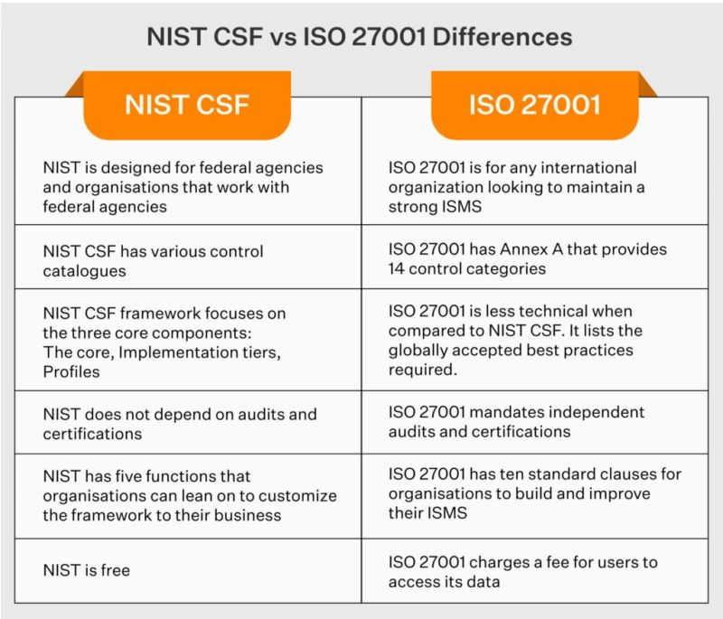
Figure 1: Comparison of NIST Cybersecurity Framework (CSF) and ISO/IEC 27001
(Source: Liu et al., 2025)
Figure 1 shows the major points of incompatibility between the NIST Cybersecurity Framework (CSF) and ISO/IEC 27001. The NIST CSF is a voluntary and flexible framework mostly tailored to the U.S federal agencies and organisations in the interaction with them, whereas the ISO 27001 is an international standard of Information Security Management Systems (ISMS). In comparison with NIST CSF, which is operationally adaptable in its fundamental elements of Identify, Protect, Detect, Respond, Recover, the ISO 27001 is governance and compliance based on structured controls, audits and certification. The present comparison reveals the complementary relationship between the two frameworks indicating that both technical defence and regulatory congruency might be enhanced by incorporating the use of the two.

F. Zero Trust Architectures
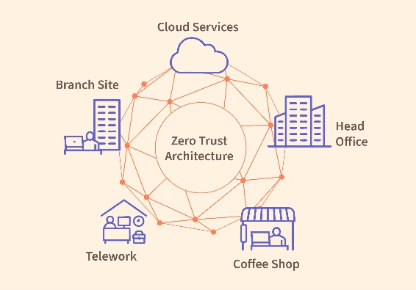
Figure 2: Zero Trust Architecture (ZTA)
(Source: Denzel, 2025)
Figure 2 graphically shows the logical components of the architecture, which are divided into segmented areas of the network, identity providers, policy engines, and automated monitoring tools. It is a sign of context-sensitive, dynamic trust assessment as a replacement of the security perimeters. Zero Trust Architecture (ZTA) is the paradigm of cybersecurity in a new understanding of the matter. ZTA does not use network location or credentials as a basis to trust but continuously verifies a person, and the concept of the least privilege is enforced. Denzel [2] recommends the fundamental elements of ZTA that consist of micro-segmentation, identity-based access control, and threat detection systems. Expanding on this, Pigola and Meirelles [6] consider issues in real-world realisation especially those in organisations whose systems are legacy and mediation siloed. They underscore barriers like resistance to change, insufficient IAM (identity and access management) maturity and lack of alignment between the business processes. Syed et al. [10] also supports the suitability of ZTA to remote-first and cloud-native deployment, but observe that it is suitable in operations (decentralised) such as the deployment at NG.

In the case of NG, ZTA would help to considerably minimize the attack surfaces and restrict the horizontal movement of attackers. ZTA adoption however needs strategic alignment, modernisation of infrastructure and cultural change issues which need to be incorporated into the overall governance model.

G. Emerging Cybersecurity Trends
Haque et al. [3] trace the change in the cybersecurity strategy that is concerned with the active threat management approach to be resilience-oriented and supportable by automation defence. The convergence of cybersecurity with the objectives of the digital transformation and the development of corporate-scale frameworks that will allow preventing the issue and quick recovery is a focus of their review. In related studies, Sontan and Samuel [12] note the growing influence of Artificial Intelligence (AI) to risk identification, behavioural analytics and predictive modelling. Artificial intelligence can assist in identifying anomalies in large streams of data and ranking alerts and recommending mitigation measures, reducing the workload on the human analysts. Nandi [13] expands on this and introduces a new generation of SOAR (Security Orchestration, Automation, and Response) systems, which automate operating processes, include threat intelligence feeds, and organize response teams.

A combination of these trends supports the idea that automation, analytics, and orchestration should be integrated into the strategy of any contemporary cybersecurity framework, especially when it comes to healthcare organisations that need to reconcile the three areas of speed, compliance, and reliability.

IV. Proposed Integrated Cybersecurity Management Framework (ICMF)

A. Framework Foundations
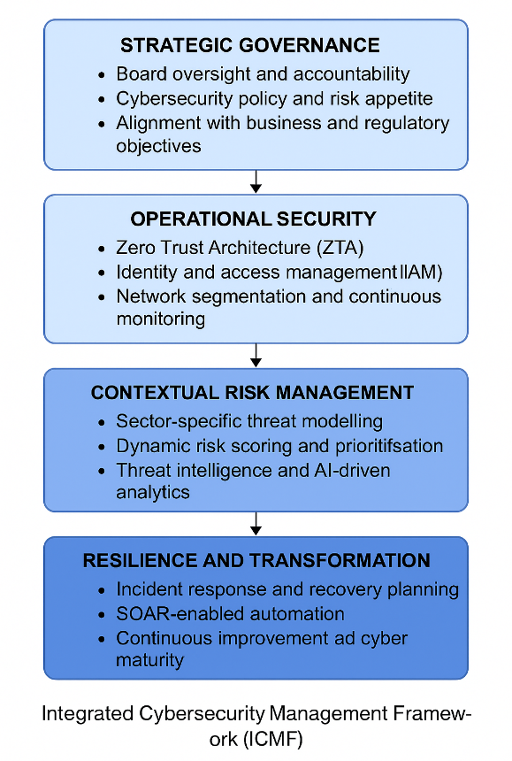
Figure 3: Integrated Cybersecurity Management Framework (ICMF)
(Developed in Creately)
Figure 3 shows the suggested Integrated Cybersecurity Management Framework (ICMF), which is divided into five layers, starting with strategic governance and ending with resilience. It focuses on regulatory congruence and threat flexibility, in favor of ongoing enhancement. Considering the gaps in the current models and frameworks of cybersecurity, this report suggests a multi-layered Integrated Cybersecurity Management Framework (ICMF) that would be suited to NatureGreen (NG) [5]. The ICMF is to be developed and operational to solve the strategic, operational, and resiliency problems of the organisation, concerning the context of very sensitive healthcare data and a more complicated threat environment. Based on the academic literature examined and the existing guidelines, the framework brings together five essential dimensions, namely, strategic governance, operational security, supply chain assurance, contextual risk management, and transformation-driven resilience [13].

The architecture is motivated by the emerging consensus in the cybersecurity literature that fragmented and reactive is too little in response to present-day threats [3], [7], [11]. Alternatively, the ICMF advocates a nimble, evidence-driven, and organisation-wide framework that gears cyber risk with greater corporate goals, regulatory adherence, and perpetual enhancement.
ICMF Layer | Governance Focus | Risk Management Focus | Compliance Alignment
Strategic Governance | Board oversight, accountability, cybersecurity KPIs, risk appetite definition | Enterprise-level cyber risk prioritisation | ISO/IEC 27001, GDPR
Operational Security | Policy enforcement, security architecture oversight | Access control, threat detection, lateral movement prevention | NIST CSF, ISO/IEC 27001
Supply Chain Assurance | Vendor accountability, contractual security obligations | Third-party risk identification and resilience scoring | NIS2 Directive, ISO/IEC 27036
Contextual Risk Management | Adaptive decision-making based on sector risk | AI-driven threat modelling and dynamic risk scoring | GDPR (data protection by design)
Resilience and Transformation | Crisis governance, incident oversight, recovery planning | Business continuity, incident response, recovery capability | GDPR, HIPAA, NIST CSF

B. Structural Components
Strategic Governance Layer
The strategic governance layer is the backbone of the ICMF and is also the place where cybersecurity is incorporated as a leadership priority as opposed to being an isolated technical issue. The responsibility of this layer is to establish the security policy and the risk appetite of the organisation, governance structures that would permit ongoing oversight and responsibility. Based on Liu et al. [4], this layer is developed based on the hierarchical model where different roles are assigned at the executive, managerial, and operational levels to ensure that there is an alignment between the strategy and execution. Magnusson et al. [5] also emphasize the importance of board engagement and capability building, especially in an organisation such as NG where one of the causes of the breach was the lack of governance competence. Melaku [8] also adds to it an adaptive governance model that will respond to a changing set of threats and regulatory specifications, enabling a flexible redistribution of resources and priorities. In the case of NG, it includes the adoption of executive dashboards, setting of key performance indicators (KPIs) of cybersecurity, making sure that cybersecurity risks are a topic of enterprise risk management (ERM).

Operational Security Layer
The operational security layer utilizes both technical and procedural controls to protect information systems and data assets of NG. The adoption of Zero Trust Architecture (ZTA) is central to this layer and alters the model of security on the basis of perimeter to ongoing verification of identity, context, and device posture. Zero Trust operates on the principles of the least-privilege access, a network segmentation, and detailed tracking (as described by Denzel [2]) to minimize the effectiveness of insider threats and inappropriate source usage. This is further supported by Pigola and Meirelles [6] who analyse the challenges of ZTA implementation and make the point that mature identity and access management (IAM) infrastructure and gradual deployment plan is necessary. Syed et al. [10] highlight the relevance of ZTA to remote workforces and cloud accounts which is included in the activity of NG. At NG, this layer would include the introduction of multi-factor authentication (MFA), internal network segmentation, the implementation of continuous behaviour monitoring tools and the conditional access of location, role and health of devices.

Supply Chain Assurance Layer
Since the breach that NG experienced occurred due to a third-party vulnerability, the supply chain assurance layer is a vital aspect of the ICMF. Seid et al. [7], [11] state that in traditional models, vendor risk is considered a compliance check or even a risk zone, but rather than an active risk domain. This tier fills that gap by deploying ongoing evaluation of supplier security positions, contractual mandates of security criteria and automated compliance targets to standards of ISO 27036, NIST SP 800-161, and the NIS2 Directive [15]. It also brings in resilience scoring that investigates the capability of a vendor to avert, recognize, as well as recuperate after cyber incidents. In the case of NG, the adoption of this layer would mean updating the contracts with third parties to encompass mandatory cybersecurity conditions, reviewing the vendors on a regular basis, and implementing threat intelligence solutions that also monitor the supplier ecosystems in real-time.
Contextual Risk Management Layer
Best practices in cybersecurity have to show industry-specific risks. In the case of NG, controls should be flexible to address such healthcare risks as ransomware and data leakage. According to Azura et al. [1], a contextual model is suggested in which the sensitive nature of the data, and the behaviour of users can be adapted dynamically. Zeriouh and Amara [9] also add this with the AI tools predictive modelling and risk scoring. NG can implement them by launching automated risk dashboards and alert systems which change dynamically depending on the new threats.

Resilience and Transformation Layer
The concept of resilience should be implemented in every security avenue. SOAR platforms that automate the detection and intervention are encouraged by Haque et al. [3] and proactive design, but Nandi [13] demonstrates. Okusi et al. [17] include the significance of recovery procedures as well as regulatory reporting. In the case of NG, there should be frequent simulations of incidents, proven backups, and standardized response actions in accordance with GDPR and HIPAA requirements.

Summary
Together, the five layers of the ICMF are a complete and flexible architecture that balances the unique drawbacks of NG and is consistent with best practices all over the world. The framework allows continuous improvement and systematic results with regard to strategic alignment and governance, as well as the threat response and supply chain security that are enhanced by AI. Above all, it will help in changing the reactive style of managing cybersecurity to proactive, risk-conscious, and resilient organisational culture.

V. Framework Application to NatureGreen (NG)

A. Addressing the Breach
The Integrated Cybersecurity Management Framework (ICMF) is a system that provides a systematic way of curbing the effects of data breach by NG. NG ought to implement board-level accountability and monitor KPIs of cybersecurity at the governance level. The operational layer is concerned with the implementation of Zero Trust Architecture (ZTA) with the help of access segmentation and identity validation. In the supply chain, NG should have a compulsory periodic evaluation of the vendors and adherence to NIS2, as well as continuous monitoring of risks. The resilience level is the implementation of SOAR playbooks, incident detection autopilot, and making a rapid recovery process.

B. Compliance Alignment
In ensuring the regulatory compliances of NG, the ICMF aligns with the GDPR by being aligned with data minimisation and preparedness to breach notification. It upholds ISO/IEC 27001 through relentless enhancement, audits and policy of governance [16]. The NIST CSF compliance is realised with the emphasis on the five major functions, such as Identify, Protect, Detect, Respond, and Recover.

C. Long-Term Resilience
The structure makes NG more adaptable to the new threats. By incorporating cybersecurity within the scope of the digital transformation and business continuity plans, NG will be able to provide a long-lasting protection, agility in operations, and trustworthiness in the long-term perspective of a controlled healthcare setting.

VI. Critical Evaluation
The proposed Integrated Cybersecurity Management Framework (ICMF) provides a unified and strategic method of handling new cyber threats. The layered design allows the framework to adapt to sector-specific requirements, and consistency across governance, operation, and resilience layers [4], [3]. Cross-functional integration, alignment with regulatory requirements and compliance with GDPR and NIST [1], [7], and automation emphasized on resiliency, with SOAR systems [15], are among the key strengths. Nonetheless, there are still implementation problems. They are the complexity of interdepartmental, resistance to change by the culture, and the lack of a technical and financial base, especially in implementing AI-based tools [9], [14]. Well-developed leadership, involvement of stakeholders, and staged introduction, as stressed by Magnusson et al. [5], are the keys to its successful adoption. To achieve the long-term benefits and prolong the effects of the framework, continuous employee training, performance checking, and executive supervision are necessary [8].

VII. Conclusion
This report proposed a customised Integrated Cybersecurity Management Framework to a problem that was being experienced by NatureGreen, a healthcare insurance organisation that had fallen victim to a cyber breach. Based on the body of academic literature and proven models, ICMF integrates governance, Zero Trust, risk modelling, as well as resilience planning into one unified strategy. The framework is based on the NIST, GDPR, and ISO requirements and aligns with them to ensure the organisation meets its regulatory requirements and matures. It is applicable to the NG scenario based on its practical applicability and strategic fit, which offers an avenue towards long-term cybersecurity resilience in sophisticated and controlled settings. It is important that organisations such as NG implement integrated, proactive, and sophisticated cybersecurity structures in order to stay safe and compliant with the future threat. The ICMF is a step to the attainment of these.

VIII. Reference List
- Azura, Y.T.Y., Azad, M.A. and Ahmed, Y., 2025. An integrated cybersecurity risk management framework for online banking systems. Journal of Banking and Financial Technology, pp.1-20.
- Denzel, K., 2025. A survey of security in zero trust network architectures.
- Haque, G.M.M., Akula, D.K., Mohammed, Y.S., Syed, A. and Arafat, Y., 2025. Cybersecurity risk management in the age of digital transformation: A systematic literature review. Emerging Frontiers Library for The American Journal of Engineering and Technology, 7(8), pp.126-150.
- Liu, M., Shore, M., Yeoh, W., Jiang, F. and Zeadally, S., 2025. Toward effective cybersecurity management: a hierarchical process model with performance assessment. Journal of Cybersecurity, 11(1), p.tyaf020.
- Magnusson, L., Iqbal, S., Elm, P. and Dalipi, F., 2025. Information security governance in the public sector: investigations, approaches, measures, and trends. International Journal of Information Security, 24(4), p.177.
- Pigola, A. and Meirelles, F.D.S., 2025. Zero trust in cybersecurity: managing critical challenges for effective implementation. Journal of Systems and Information Technology.
- Seid, E., Ilter, D., Blix, F. and Popov, O., 2025. Cyber Supply Chain Resilience: Analyzing ISO, NIST, and NIS2 Frameworks for Mitigating Third-Party Risks. Procedia Computer Science, 263, pp.591-599.
- Melaku, H.M., 2023. A dynamic and adaptive cybersecurity governance framework. Journal of Cybersecurity and Privacy, 3(3), pp.327-350.
- Zeriouh, K. and Amara, M., 2025. AI–driven frameworks for strategic risk management: A systematic review and model for organizational resilience and decision support. Journal of Intelligent Management and Decision, 4(3), pp.44-61.
- Syed, N.F., Shah, S.W., Shaghaghi, A., Anwar, A., Baig, Z. and Doss, R., 2022. Zero trust architecture (zta): A comprehensive survey. IEEE access, 10, pp.57143-57179.
- Pemmasani, P.K. and Abd Nasaruddin, M.A., 2022. Strengthening Public Sector Data Governance: Risk Management Strategies for Government Organizations. International Journal of Modern Computing, 5(1), pp.108-118.
- Sontan, A.D. and Samuel, S.V., 2024. The intersection of Artificial Intelligence and cybersecurity: Challenges and opportunities. World Journal of Advanced Research and Reviews, 21(2), pp.1720-1736.
- Nandi, S.R., 2025. Next-Generation SOAR Systems for AI-Enhanced Security Automation. Journal of Computer Science and Technology Studies, 7(8), pp.540-546.
- Möller, D.P., 2023. Cybersecurity in digital transformation. In Guide to cybersecurity in digital transformation: Trends, methods, technologies, applications and best practices (pp. 1-70). Cham: Springer Nature Switzerland.
- Saeed, S., Altamimi, S.A., Alkayyal, N.A., Alshehri, E. and Alabbad, D.A., 2023. Digital transformation and cybersecurity challenges for businesses resilience: Issues and recommendations. Sensors, 23(15), p.6666.
- Ahmadi-Assalemi, G., Al-Khateeb, H., Epiphaniou, G. and Maple, C., 2020. Cyber resilience and incident response in smart cities: A systematic literature review. Smart Cities, 3(3), pp.894-927.
- Okusi, O., Obiakor, I.J. and Adeloye, F.C., 2025. Designing resilient data risk management protocols for regulatory compliance and cyber incident response. International Journal of Advance Research Publication and Reviews, 2(7), pp.45-70.

