ANALYSIS INTO THE EFFECT OF EMPLOYEE ENGAGEMENT AND ITS IMPACT ON THE HOTEL BUSINESS

Executive Summary
In this proposal the use of employee engagement has been discussed in workplaces mainly under the hospitality sector. Hotel Travelodge has been selected as the hotel where the development of employee engagement and their need will be investigated. Required methods for the research and the secondary research for the proper application employee engagement have been discussed here.
Table of Contents
1.0 Introduction and Background 4
2.0 Aim 5
3.0 Objectives 5
4.0 Discussion 5
5.0 Work plan 9
6.0 Evaluation and Conclusion 9
Reference List 11

1.0 Introduction and Background
The hotel industry normally falls under the hospitality sector wherein several services are included such as the hotels, tourism, accommodation, food, and beverages among others that largely involve providing the needed hospitality to the people. Hospitality service within the hospitality industry is guided by many factors such as the level of staff, behavior of staff, and other such factors. One such factor, namely employee engagement plays a key role in the hotel organizations as they dictate the interest of staff in working under such organization which is very important for the hotels. Organizations such as hotels hire human resource personnel in order to assess their organizational policies and provide recommendations (Groupon, 2019). The role of HR in an organization is to properly inspect the causes of poor performance and look for a better outcome in the company such that the given organization gets better in terms of revenue and performance for which factors such as employee engagement needs to be considered.
For this research on the need for employee engagement, a hotel will be selected in the UK namely the Travelodge London Kings Cross Royal Scot hotel. This particular hotel will be used for carrying out the relative analysis on the impact of staff engagement but prior to the analysis, it is important that the background of this hotel is discussed in detail. The Travelodge London kings cross hotel is a very old building that was built in the year 1972 which is why it has that hint of heritage within it with old architectural designs and finishings. The building was last renovated in the year 2016 when the exterior design of the building was reshaped into a modernized structure although its interior has that feeling of colonial-era Britain. People drawn to nostalgia can easily come here to enjoy the flavors and memories of the past. It is important to state that the Travelodge Kings Cross hotel is not the only hotel under the Travelodge inn, in fact, the Travelodge boasts of a very large hotel chain that is located all across the UK. In the UK, it easily comes under the top 10 ranking of successful hotels (Travelodge, 2022). The Travelodge group of hotel business was first launched in the year 1985 and became a "value hotel brand" overnight after opening the "barton hotel" in central England which was a pretty impressive feat in those days. The Travelodge hotel chain of business boasts a total workforce of 11000 workers. Although, Travelodge king's cross hotel is equipped with 6 stories and a 3-star hotel providing services such as a bar, restaurant, and gym its rating is pretty poor on the websites. This hotel is situated at central London with a 5 minute drive from the British museum and St. Paul’s Cathedral. It is located at a quarter mile from the Kings cross metro station for convenient travelling.
There are total 50 rooms present in this hotel with a total of 41 employees present.
Their unique selling point is their location which is at City center area where all the tourist locations could be easily accessed. They have their own on-site bar cum restaurant where the visitors can enjoy meals.
These hotel are marketed at those travellers seeking to familiarize with the central london and its beautiful places that are enjoyed by common tourist in England.

Figure 1: Travelodge hotel chain
(Source: Groupon, 2019)
The engagement problem that is present in this hotel is mainly concerning the management which needs to be addressed.

2.0 Aim
Conduct research on the issues in hotel Travelodge and probable impact of employee engagement development as a solution.

3.0 Objectives
The objectives of the research proposal are discussed as follows:
- To determine the various measurement criteria of employee engagement used in hotel organizations
- To analyze the use of a survey in order to gather details on the employee engagement applied in the selected hotel
- To investigate various measures to address the issues raised in employee engagement

4.0 Discussion
The methodology which will be followed for this research work will include a combination of both primary and secondary research on the criteria of employee engagement. The criteria for finding out more details on the selected hotel business which is Travelodge will be done using the websites of the company as well as the sites detailing the characteristics of the building structure of Travelodge King's cross hotel. It would be important to find the measurement factors and influencing factors for the employee engagement concept in order to perform the subsequent primary analysis on the same.
Data collection
The primary analysis which will be performed for this research will be done using survey questionnaires which will be formed based on the influencing factors identified for the employee engagement. The factors and parameters for the survey questionnaires will be identified from the secondary research study using which further analysis will be done. The questionnaire that would be used for this research work would be based on the ratings so that it will allow for proper statistical analysis on the same. A probable statistical tool would be used to determine the relationship between the variables used in the survey such as the correlational analysis (Ogura et al., 2018). GDPR would be considered during the formation of these questionnaires where the personal details of the employee such as the name, address, and other fields would not be asked from the people but rather only the important details related to the staff engagement. The employee engagement questionnaire would be formed only for the employees of the Travelodge Kings cross hotel and only the survey be done on that particular hotel only for reference. The requisite anonymity will be maintained in the questionnaire form and results will be obtained.
A survey research strategy would be used for this research as the use of a survey form will be done in order to get the results on the topic. A quantitative research method will be used here in order to use the ratings from the employees of Travelodge kings cross hotel in relation to employee engagement for the appropriate result formation. The engagement of the employee within the kings cross royal scot hotel will be measured using a staff based questionnaire made with proper questions.
A secondary method that can be adopted in the case of measuring the engagement would be by using direct interview sessions with the employees of the hotel. The pros and cons of this secondary method have been stated below:
Pros:
- More detailed insight into the matter
- Realistic communication
Cons:
- Appointments would be needed
- More time will be required
- Hard to remember each of the verdicts
Definition of employee engagement
According to the author Sun and Bunchapattanasakda, (2019), employee management plays a critical role within the organization allowing for better management. The author states that there are a number of theories and concepts that relate to the level of staff engagement although there exist many differences and fallacies in these concepts. Regarding the identification of influencing factors in staff engagement, there is still confusion as there is no "authoritative standard" present in this domain. Employee engagement can be defined in 2 scenarios with one of them being the "multifaceted construct" that consists of the emotional, cognitive and behavioral parameters and the other one is the "unitary construct" which constitutes the traits such as dedication, optimism, and affection for one's work or job (Sun and Bunchapattanasakda, 2019). There are various frameworks present that can be used in order to define the staff engagement and they are the "needs satisfaction framework", "job demands resource model", and "social exchange theory". By utilizing this framework in the research work, the author finds out that employee engagement plays a key role in the "organizational performance" and "individual performance" of the staff.
Importance in hotel organizations
As per the author Singh, (2019), there is a relation present in the corporate social responsibility and the employee engagement in the hotel industry. While these two concepts are different from each other, their overall impact on the hotel institutions is more or less similar. The author shares that there are no shortcuts available in achieving a committed task force and their likeability in meeting the aim of the company. Employee engagement helps create a sense of well-being within the employee that allows the workforce to have a sense of satisfaction, hope, and workability which allows them to perform better at work (Singh, 2019). The well-being of the employees can be generated by using employee engagement and this can create an overall effective culture for doing work by these employees and increase growth within the hotel business.
Measurement criteria
According to the author Ayub and Islam, (2018), it is possible to assess the effect of employee engagement on the performance of the staff in the hotel organization using proper criteria of research. The author carried out research on a similar topic for the country of Kelantan where the primary mode of research analysis was selected by the author. Different factors of influence on the employee engagement were selected at random and a questionnaire was formed by the author in order to carry out the survey on the different hotel employees present. A basic sampling was followed by the author where the survey results were received by the author on which the correlation analysis was performed to detect the adequacy of the variables selected (Ayub and Islam, 2018). It was found by the author that only certain variables such as openness, trust, training, and collaboration had a good impact on their overall performance and the relative hotel in which they were working. Overall a good understanding of the matter was achieved by the proper utilization of the statistical techniques as well as the survey forms used on the subjects.
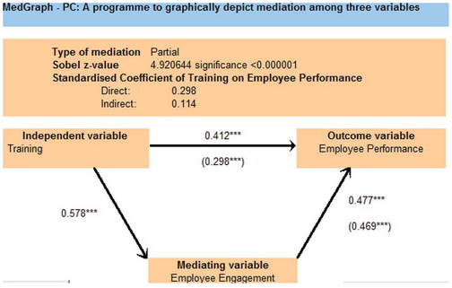
Figure 2: Variable analysis
(Source: Ayub and Islam, 2018)
Cause of recommendation
The measurement criteria involving the quantitative analysis based on the ratings attained on the survey form would be the ideal strategy to be adopted in this particular research on the need for employee engagement in the Kings cross Travelodge hotel. The quantitative analysis should be applied with a help of statistical techniques such as the correlation either bivariate or univariate as it would help highlight the relationships between the variables associated with the employee engagement concept. The author Suryani et al., (2020) state that the use of correlation analysis is appropriate in finding out the relationships between the structured variables as it is a budget-friendly method. Only the cost of survey forms would be needed to be bear along with the requirement of a suitable license of a statistical software after which the overall analysis can be easily done using the correlation analysis that can help underline the relationships without making the whole process exceedingly complex.

5.0 Work plan
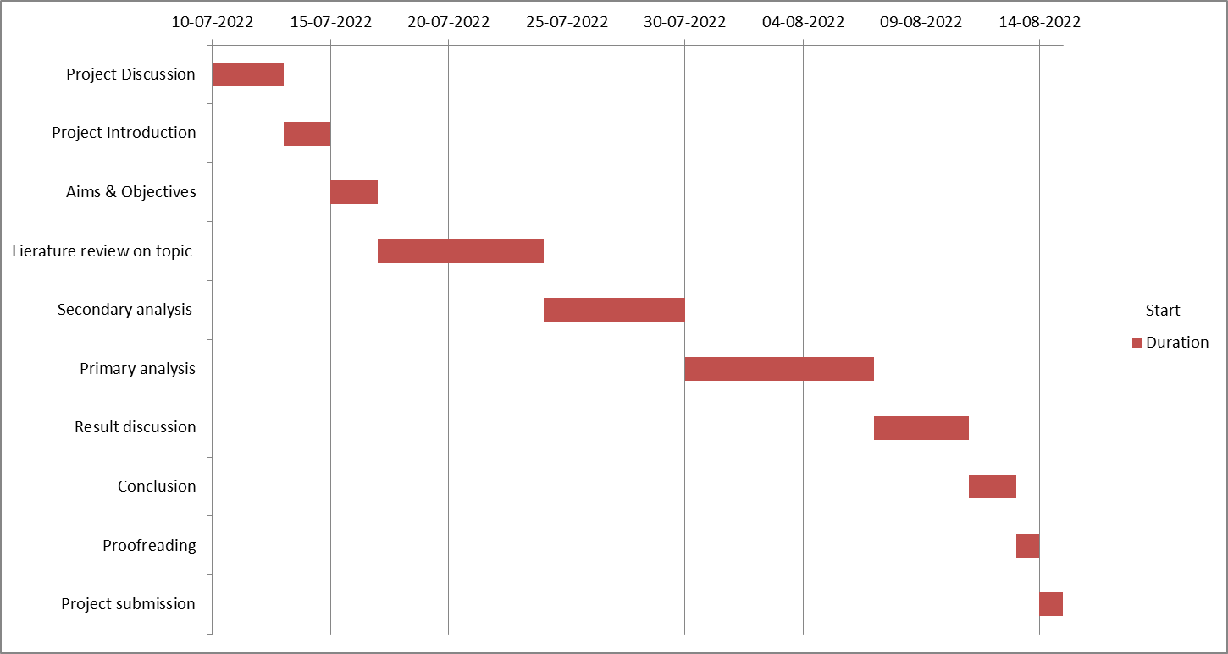
Figure 3: Gantt chart
(Source: Created in excel)

6.0 Evaluation and Conclusion
The necessary plan for conducting the research was discussed in a very detailed manner for this proposal and is indeed the correct way the hotel Travelodge kings cross could be assessed. Kings cross Travelodge hotel is a very established 3-star hotel and has been in operation since its renovation in the year 2016 it will be very hard to acquire any detailed information on the operations taking place within the hotel as they are always kept secret by the management. The use of a brief questionnaire would be a good option to consider as it would be allowed by the officials and would provide a summary regarding the impact on the employee engagement on the hotel as a whole or whether this is the reason that the hotel has been underperforming in the past couple of years. The use of quantitative analysis is relevant and feasible to produce proper findings for the survey at the time of their use as they provide appropriate results in terms of their usage (Lee et al., 2020). As for the result, it would provide an understanding regarding driving employee engagement and retaining the employee successfully within the Travelodge kings cross hotel.
The importance of employee engagement in the organization was discussed in detail for the provided context of research. The hospitality sector was focused on getting an even better understanding which showed how employee engagement positively affects the performance of the employees. A suitable strategy for performing the research on the impact of employee engagement on the Travelodge kings cross hotel was discussed as well in line with the selected method of primary and secondary research. By following these methods it will be possible to analyze the role of employee engagement in the hotel industry currently present in Travelodge hotels. It is important that the discussed methodology is followed in order to complete the research effectively and form results for the research topic selected.

Reference List
Ayub, N.B. and Islam, M.K., 2018. The Effects of Employee Engagement on Employee Performance in the Hotel Industry in Kelantan. Global Business & Management Research, 10(3).
Groupon, 2019, Travelodge, Availableat: https://www.groupon.co.UK/hotels/travelodge [Accessed on 22.06.2022]
Kwon, K. and Kim, T., 2020. An integrative literature review of employee engagement and innovative behavior: Revisiting the JD-R model. Human Resource Management Review, 30(2), p.100704.
Lee, J.Y., Rocco, T.S. and Shuck, B., 2020. What is a resource: Toward a taxonomy of resources for employee engagement. Human Resource Development Review, 19(1), pp.5-38.
Ogura, Y., Tanaka, Y., Hase, E., Yamashita, T. and Yasui, T., 2018, February. Two-dimensional auto-correlation analysis and Fourier-transform analysis of second-harmonic-generation image for quantitative analysis of collagen fiber in human facial skin. In Multiphoton Microscopy in the Biomedical Sciences XVIII (Vol. 10498, pp. 254-260). SPIE.
Sendawula, K., Nakyejwe Kimuli, S., BananUKa, J. and Najjemba Muganga, G., 2018. Training, employee engagement and employee performance: Evidence from Uganda’s health sector. Cogent Business & Management, 5(1), p.1470891.
Singh, J., 2019. Study of relation between CSR and employee engagement in hotel industry. In Corporate social responsibility: Concepts, methodologies, tools, and applications (pp. 1243-1249). IGI Global.
Sun, L. and Bunchapattanasakda, C., 2019. Employee engagement: A literature review. International Journal of Human Resource Studies, 9(1), pp.63-80.
Suryani, S., Heryanto, H., Rusdaeni, R., Fahri, A.N. and Tahir, D., 2020. Quantitative analysis of diffraction and infra-red spectra of composite cement/BaSO4/Fe3O4 for determining correlation between attenuation coefficient, structural and optical properties. Ceramics International, 46(11), pp.18601-18607.
travelodge, 2022, Kings cross hotel, Availableat: https://www.travelodge.co.UK/hotels/269/London-Central-Kings-Cross-Royal-Scot-hotel [Accessed on 22.06.2022]

