Module Name: Computer Architecture and Operating Systems
Module Code: ACCA4022_LON
Student Name: John Tandazo
Student ID: 2442071
Group: 2
Lecturer’s Name: Redhwan Al Amri

University of Wales Trinity Saint David

Table of Contents
Introduction 3
Main Body 3
Task 1: Key functions of general Operating Systems 3
4
2. Use of Windows OS CLI commands 14
3. Use of Linux OS CLI commands 22
4. Use of Windows OS scripts 28
5. Use of Linux OS scripts 30
CONCLUSION 33
Lecture Activities 33
34
Appendices 34
References 37

Introduction
This report analyses the importance of operating systems and how they manage computer tools. It explains the main functions of Windows and Linux, the use of command-line tools, and how terminal commands work. It also shows how to automate everyday tasks using scripts. These concepts are fundamental to the computing environment.

Main Body

Task 1: Key functions of general Operating Systems
When we use a computer, the first thing we interact with is its operating system, which is the first software we see. The operating system manages all the computer's programs, and these programs function by making requests to the operating system. Users interact with these programs through commands or windows with icons [1].
There are different operating systems like Windows and Ubuntu, designed for various computers, that control connected devices and tell them how to operate and interact. Each hardware component uses a different language because it is built differently, such as the keyboard, mouse, printer, and hard drive. To solve this, the operating system uses device drivers, which act as translators. This shows how important the operating system is, as it also allows the computer to boot properly [2].
Key functions of operating systems, using Windows and Ubuntu as examples
1-Process Management
Process management is essential in an operating system because it ensures multiple tasks run smoothly. It monitors system resources like CPU time and memory for each program, similar to assigning each one a fair share. The system tracks processes through states such as New, Ready, Running, Waiting, and Terminated. Without process management, tasks would not be organised properly, leading to poor performance, resource conflicts, and system instability. [3].
Windows
The most common way to see all the processes running on your computer is through the Task Manager. There you can decide whether to end, pause, prioritize, or start a program. Here's how to use it in Windows:
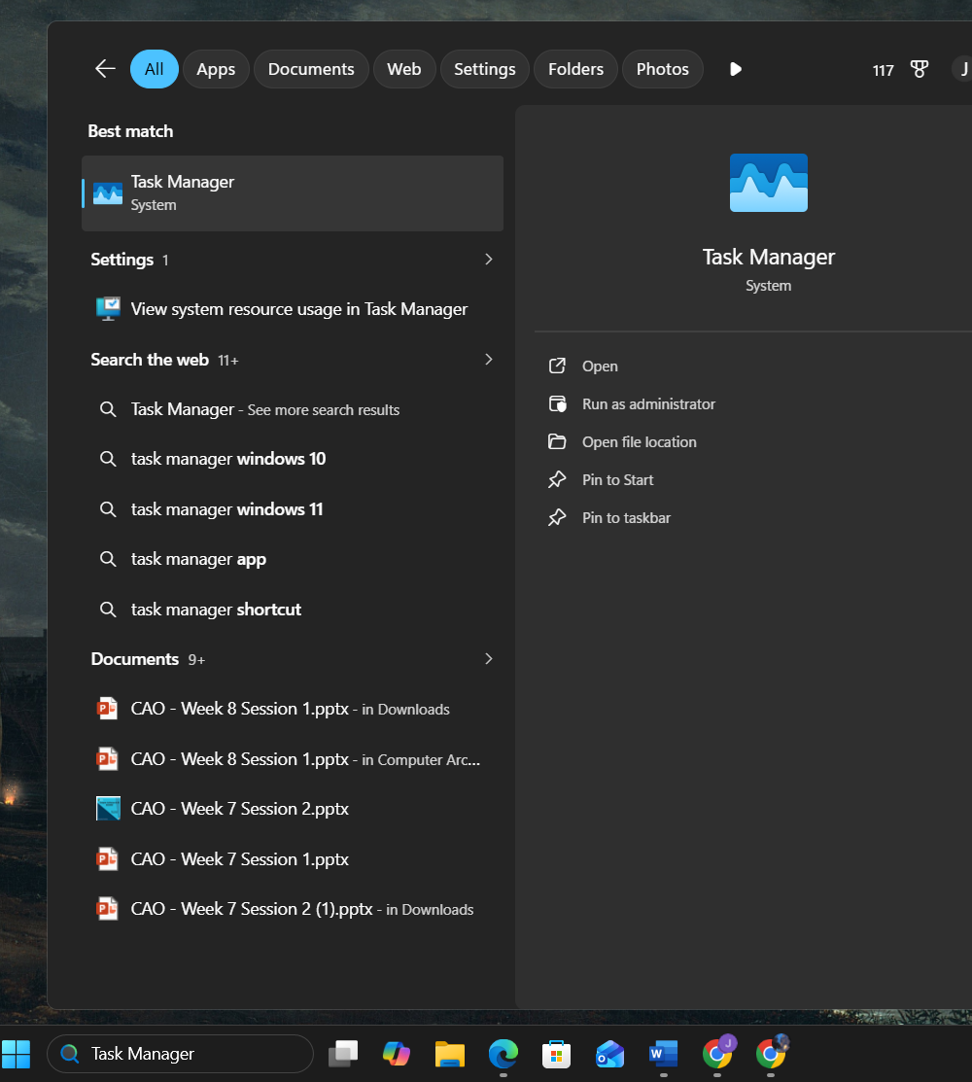

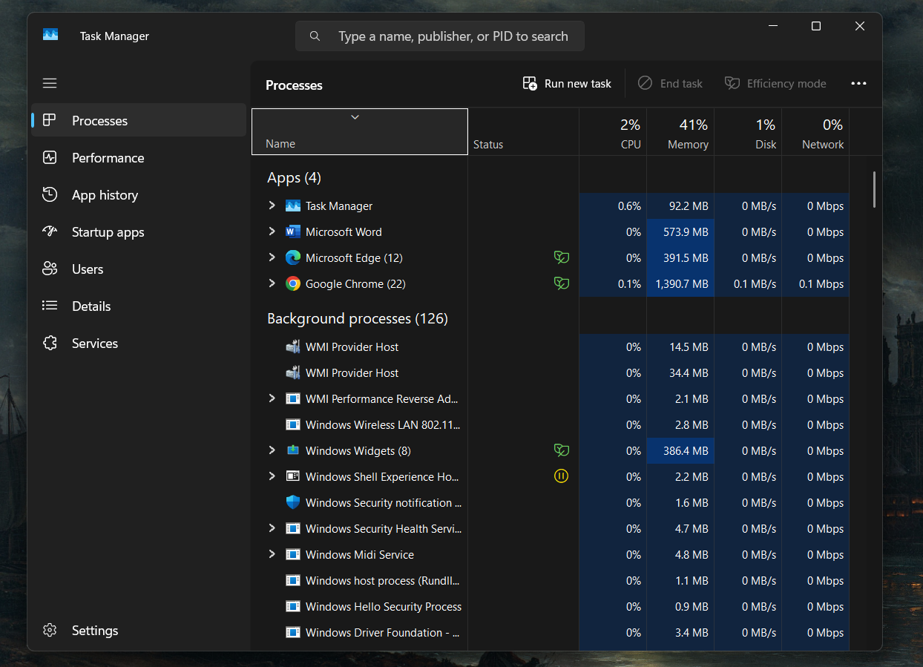

2-File System Management
The computer has a program that helps us manage the files we create, where we save work or study documents for later use. A file is a document, image, audio file, etc., and saved files can be organized into folders. In Windows, it's found like this:
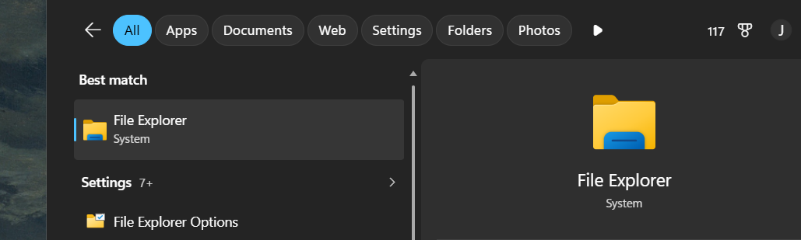

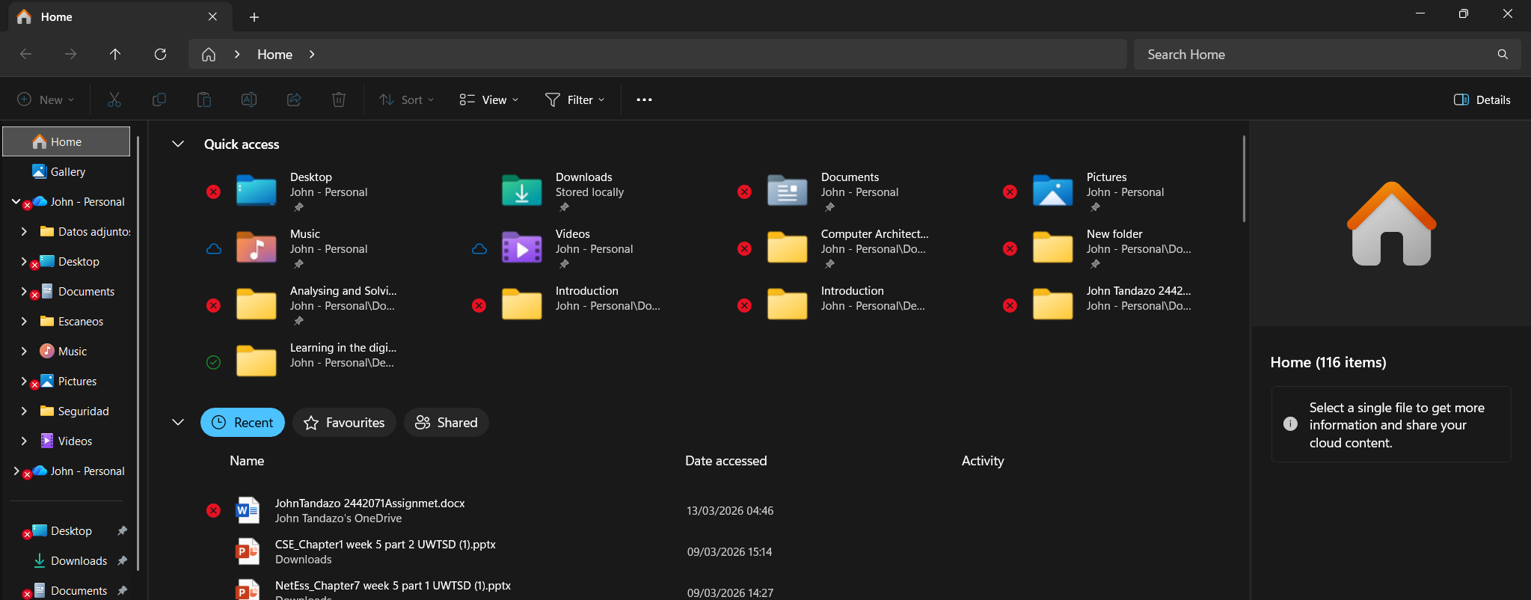

For example, in Microsoft Word, to create and save a document, these are the steps:
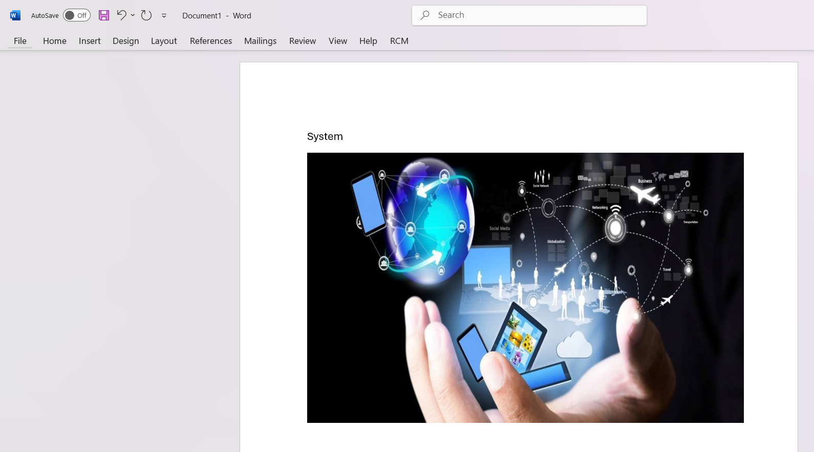
First, click on file

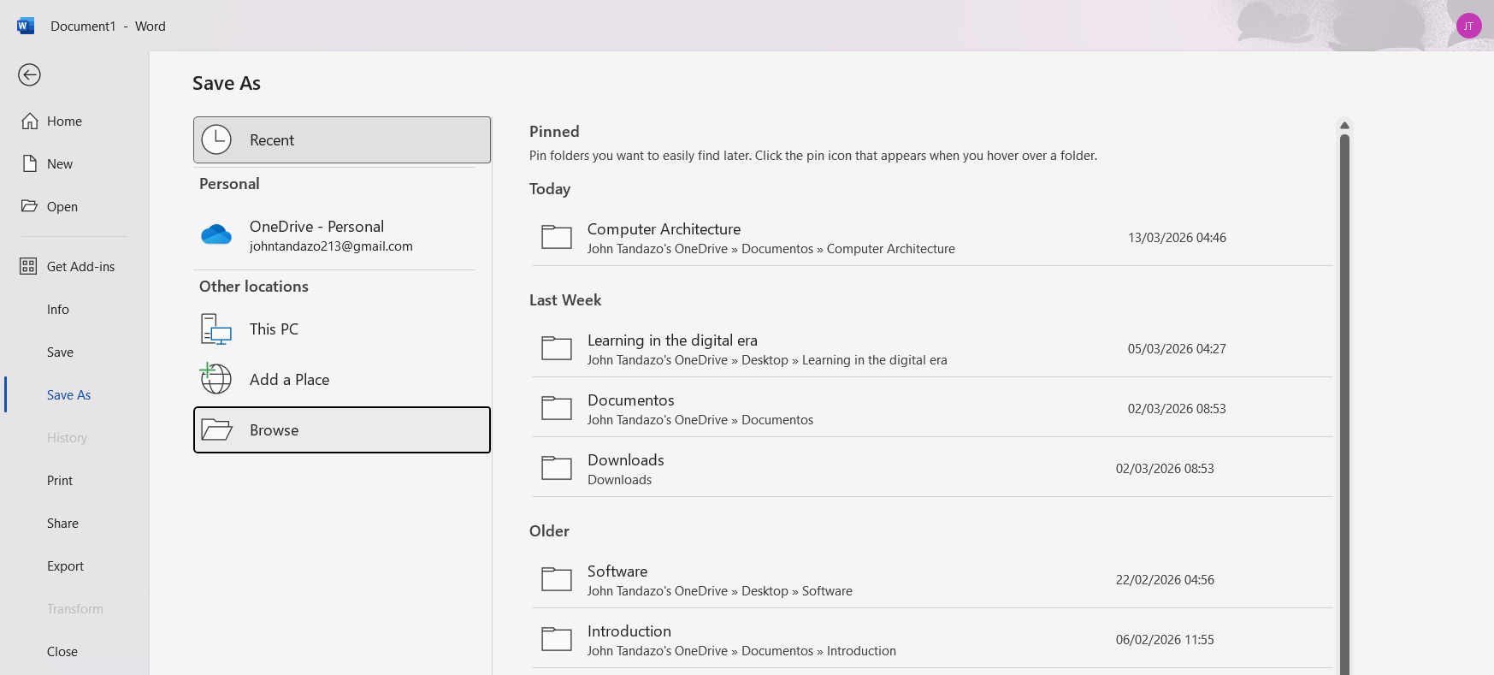
Second, click on Browser

Third, it automatically takes you to the Documents section in the file manager, and you'll also see the filename field where you need to type the name of the file you created. There's also the option to create a new folder. Click on New Folder.

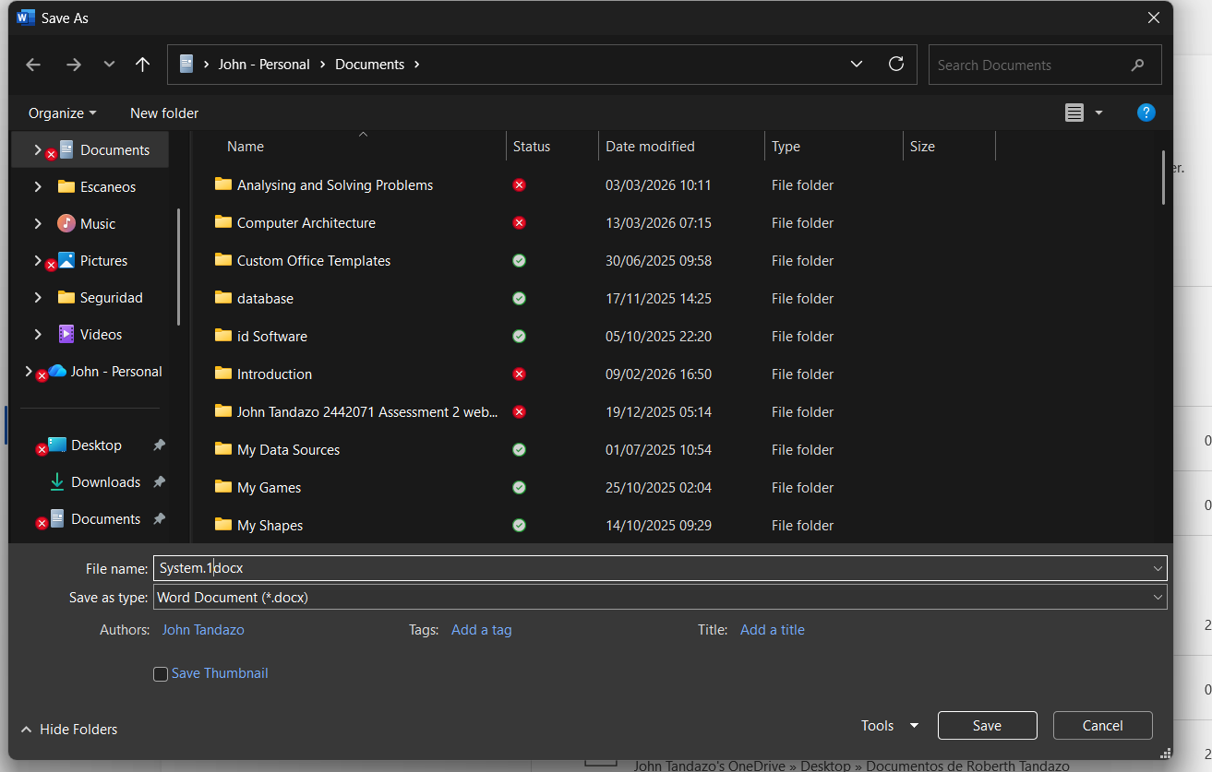

After creating the folder, save the file. Click on the folder and save the file inside it.
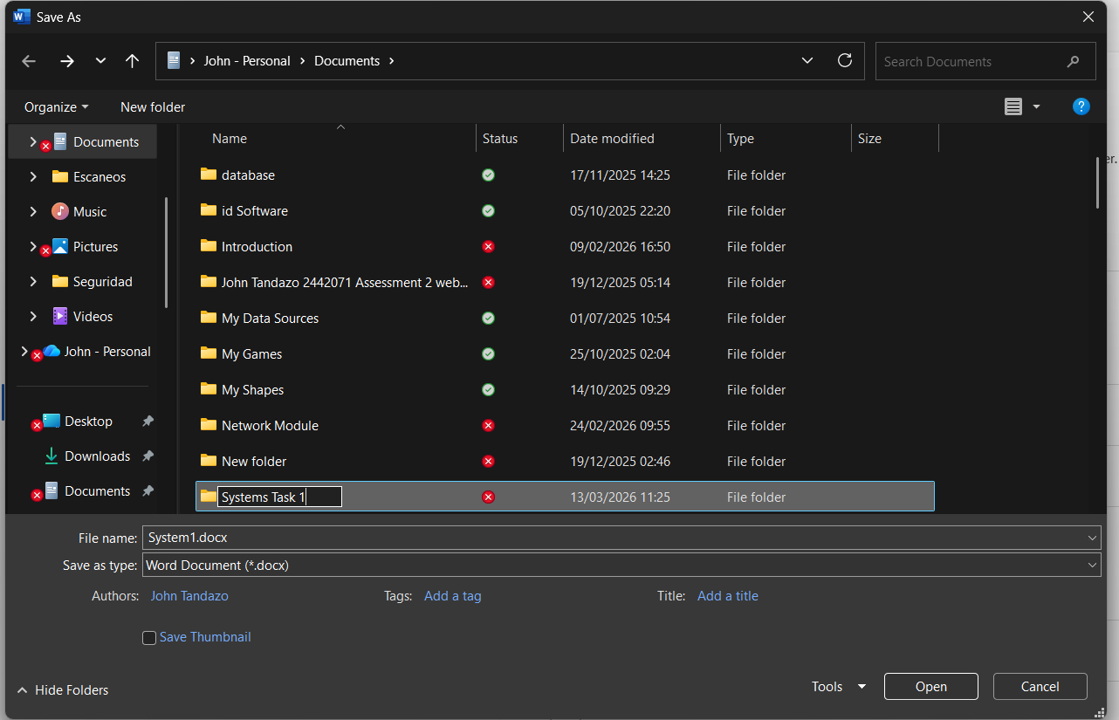

Finally, we have the file saved in the folder. This way, our documents are organized and easy to find later. [4].
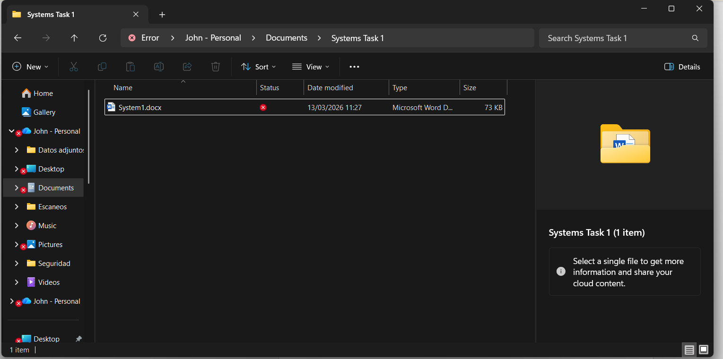

3-Device Management
Device management is a program that allows administrators to manage devices from a central server. It enables them to control devices by locking them, configuring settings, remotely updating software, wiping data, troubleshooting issues, and ensuring that each device is used for its intended purpose.
There are three ways to open the Device Manager program in Windows.
1st: Pressing the keys Windows + X
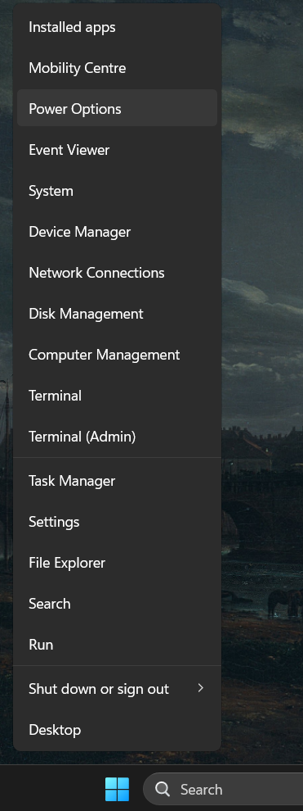

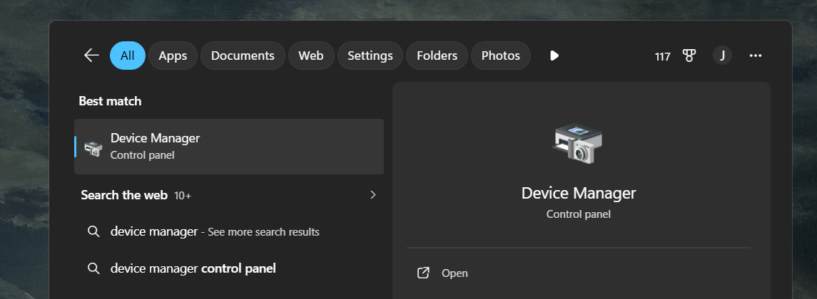
2nd: Searching in the Windows browser

3rd: Pressing the Windows key + R and typing devmgmt.msc
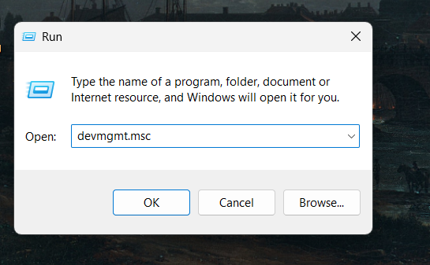

After completing these steps, the Device Manager window opens
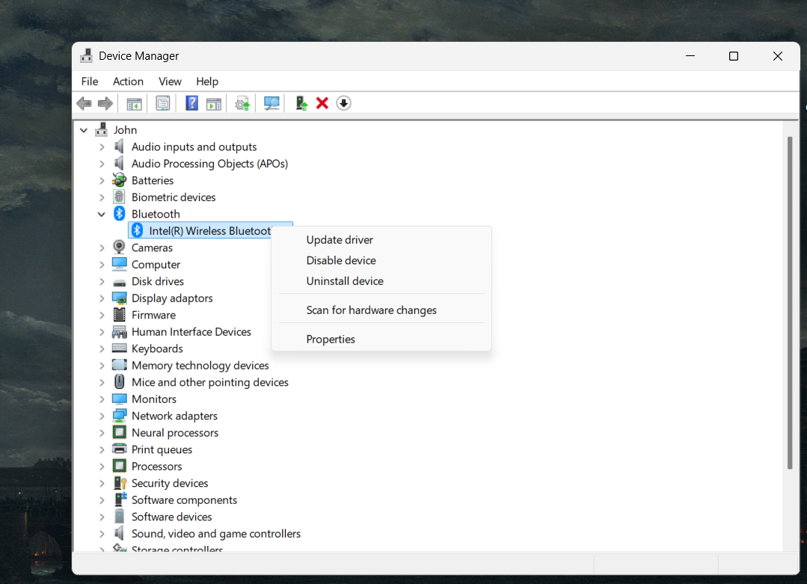

There, users can manage and control hardware devices [5].
4-Memory Management
Memory management is an operating system function that allocates RAM to programs so they run properly without affecting others. If a program uses too much memory, the system can slow down and may use virtual memory, which is slower. You can check memory usage in Task Manager by pressing Ctrl + Shift + Esc and going to the Performance tab, where RAM usage is displayed and managed by the system.
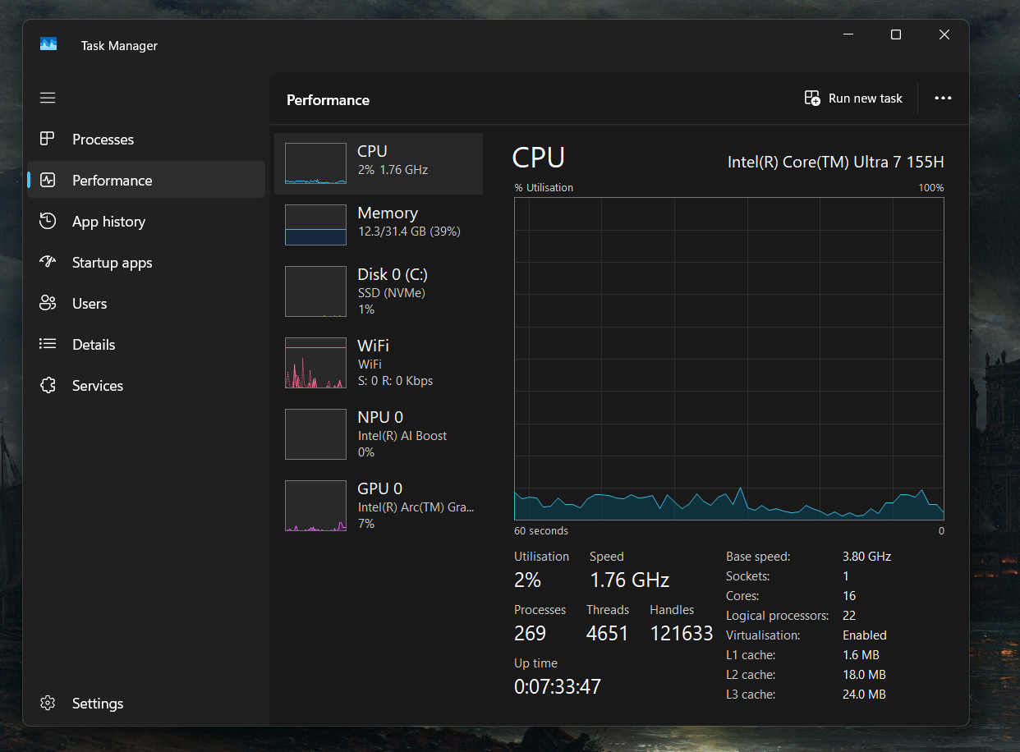

Memory management includes several key functionalities such as memory allocation, memory deallocation, and memory swapping.
1-Memory Allocation
Memory allocation is when the operating system allocates RAM to applications when they are opened.
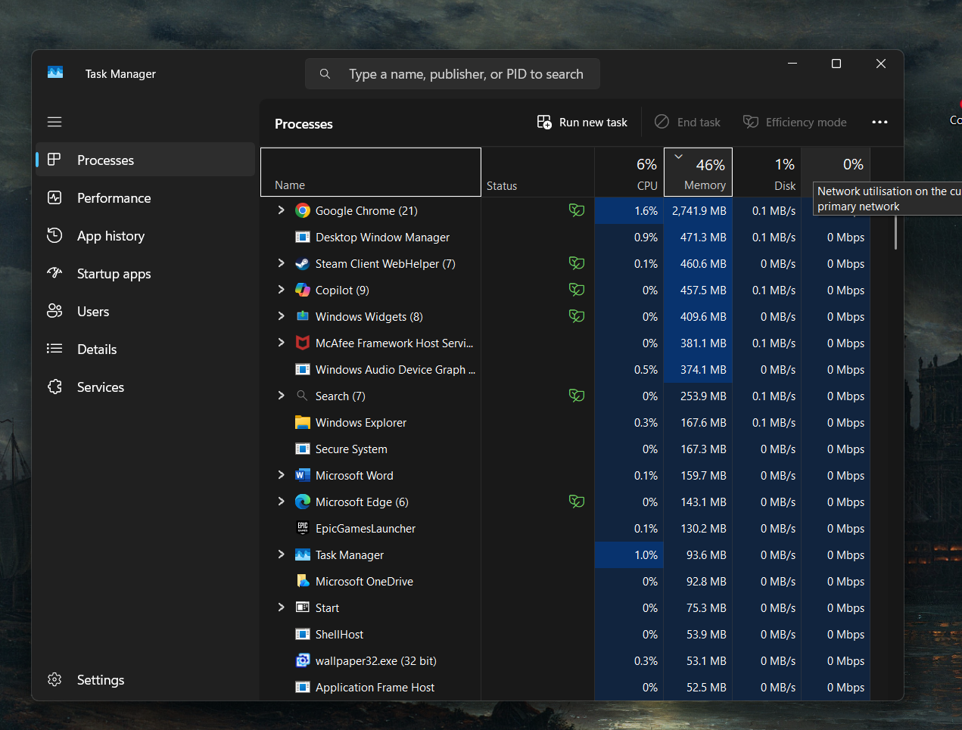

2- Memory Deallocation
Memory deallocation occurs when the operating system frees up memory after an application is closed.
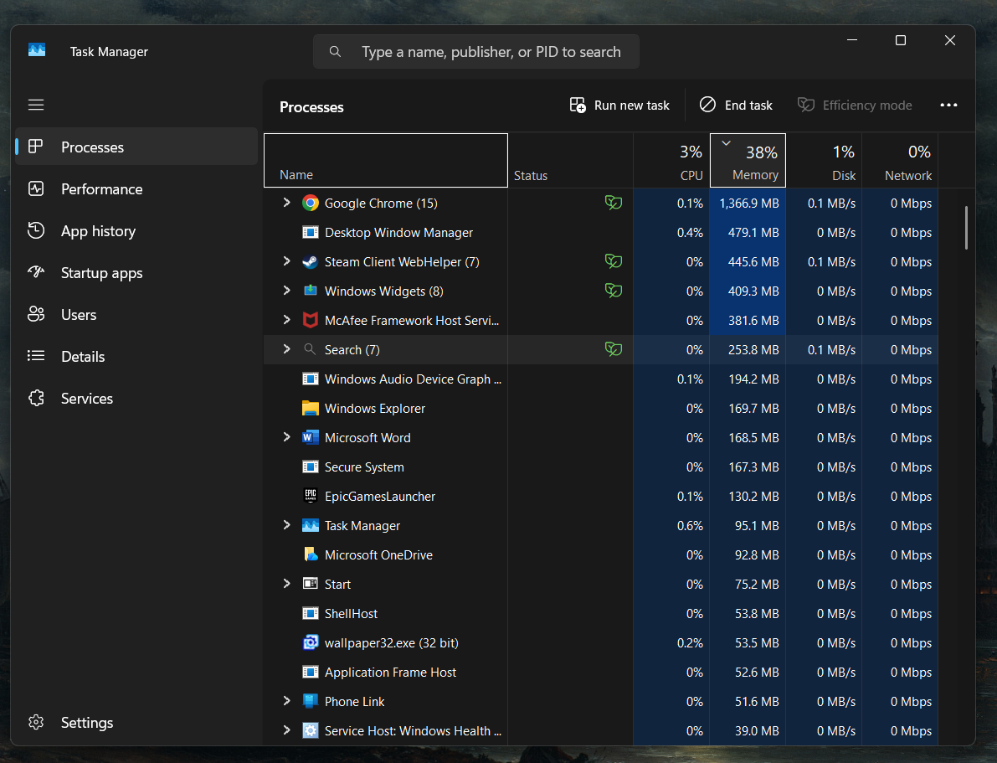

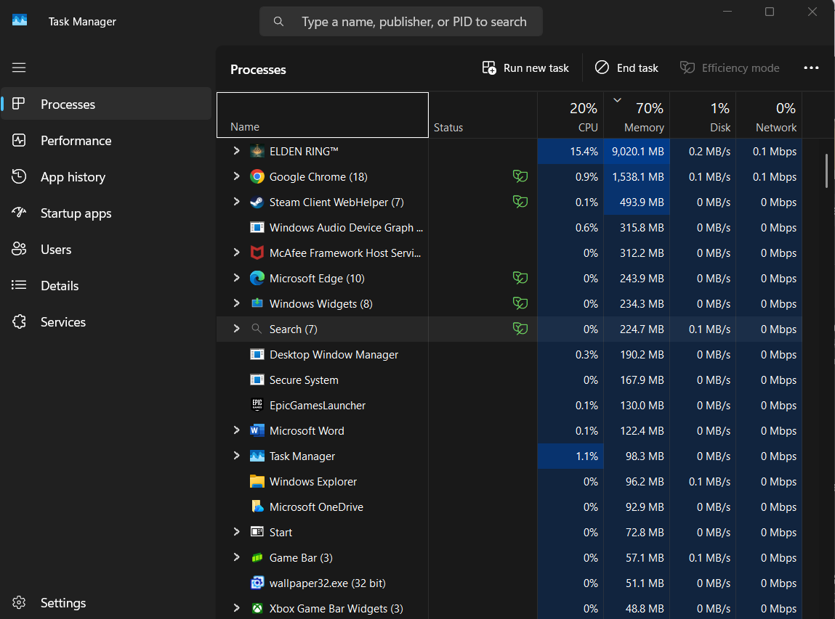
3- Memory Swapping

Memory swapping happens when the computer runs out of RAM and starts using the disk as extra memory. This allows programs to keep running, but the system may become slower [6].
UBUNTU
Process Management
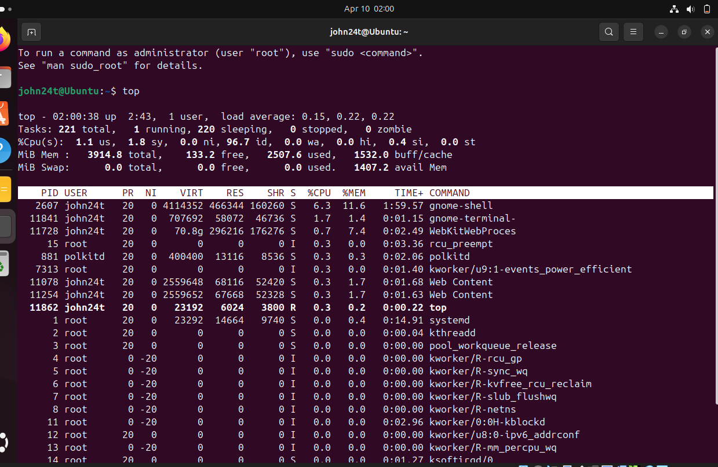
In Ubuntu, most tasks are performed using commands. For process management, the `top` command is used to see what's happening in real time, displaying information directly from the operating system itself.

2-File System Management
In Ubuntu, everything is located in a single directory that starts at /. You can use the cd command to move between folders, ls to view the contents of a folder, mkdir to create folders, and rm to remove files and directories
l (alias, used to list files and folders)
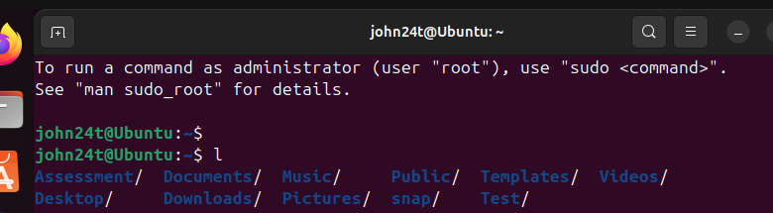

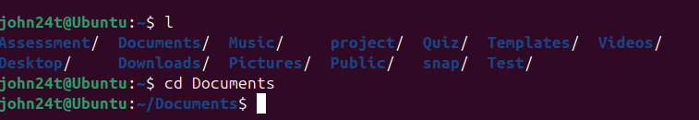
cd command

ls command
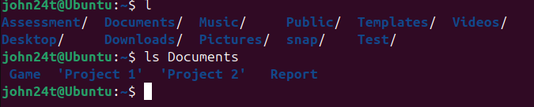

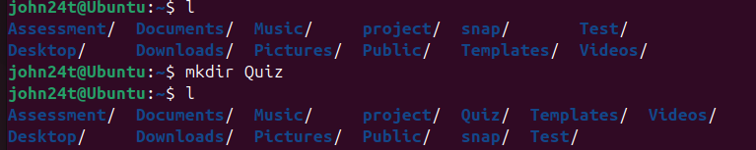
mkdir command

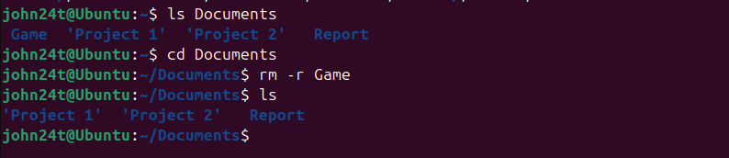
rm command

[7]

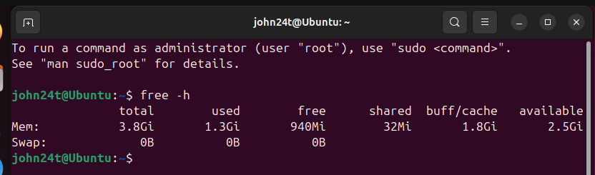
3-Memory Management

In Ubuntu, RAM is used intelligently to ensure everything runs smoothly. The `free -h` command lets you see how much memory you have, how much is in use, and how much is free [8].

4-Device Management
In Ubuntu, any device you connect, such as a USB drive or keyboard, is automatically recognized without needing to install anything manually. `lsusb` shows all connected USB devices, and `lsblk` shows all your disks and partitions.
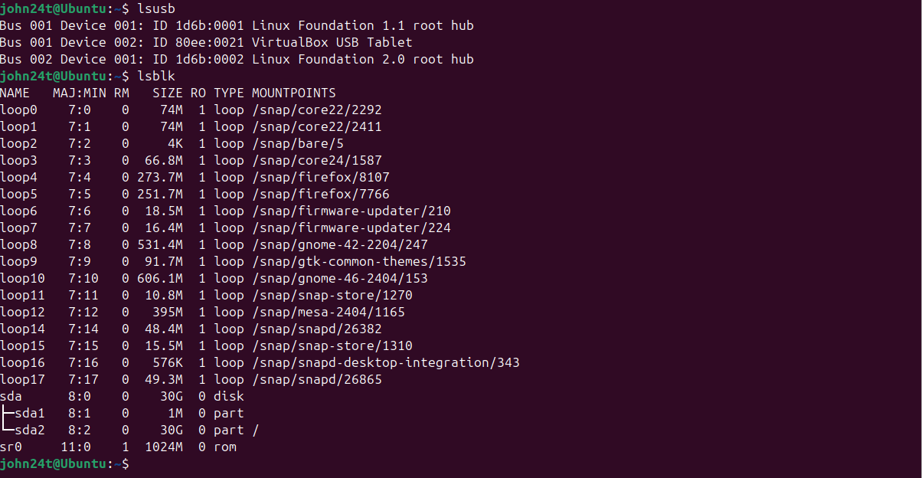

[9]

2. Use of Windows OS CLI commands
Windows includes two command-line tools: Command Prompt and PowerShell. Most of the commands work in both, but PowerShell is designed for advanced tasks. The following section presents 11 commands using the classic Command Prompt, grouped into five categories.
PROCESS MANAGEMENT
The `tasklist` command shows which programs are open, their ID numbers, and how much memory they are using. The `/fo csv` command separates the data with commas, making it super easy to export to Excel or use for programming, and `/nh` provides the data directly.
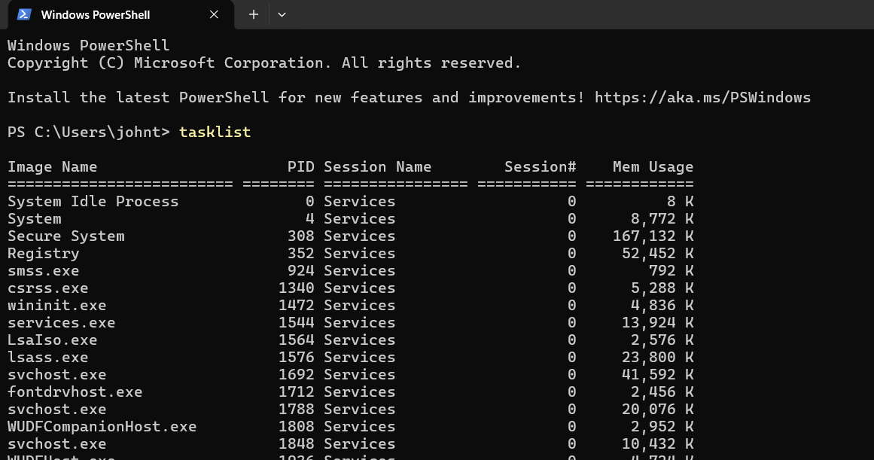
tasklist command

fo csv command
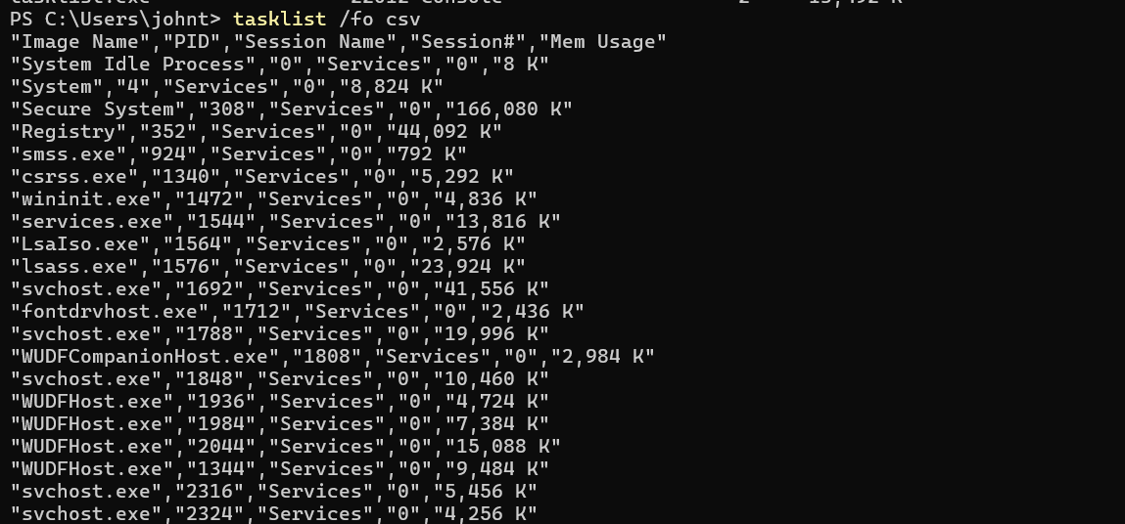

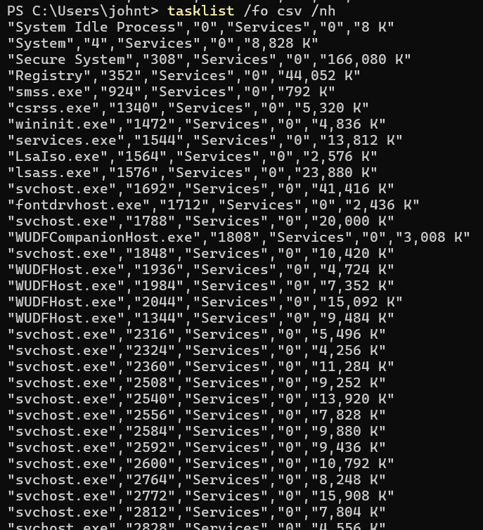
nh command

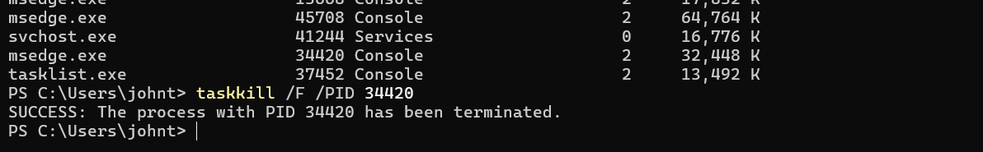
The taskkill command terminates a process by its PID. The /F switch forces termination even when the process is unresponsive

FILE & DIRECTORY MANAGEMENT
dir /a /s
The dir command is used to display the contents of a directory. The /a switch includes hidden and system files, while /s allows the command to list contents recursively across all subdirectories.
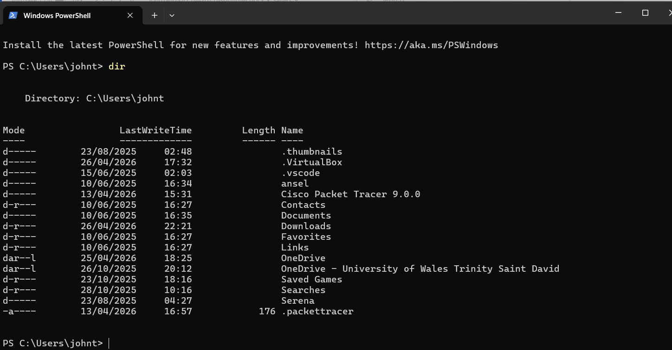

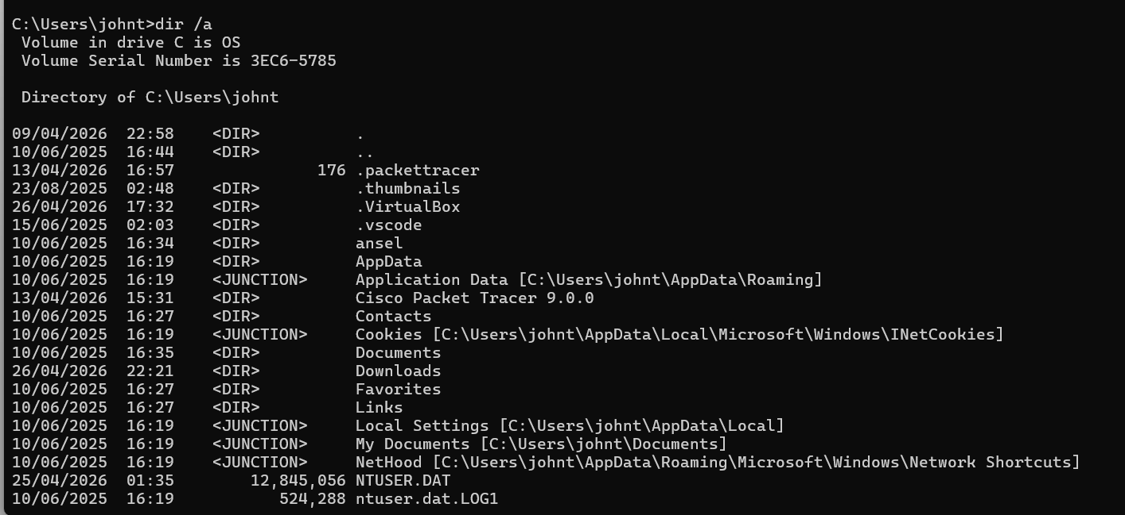

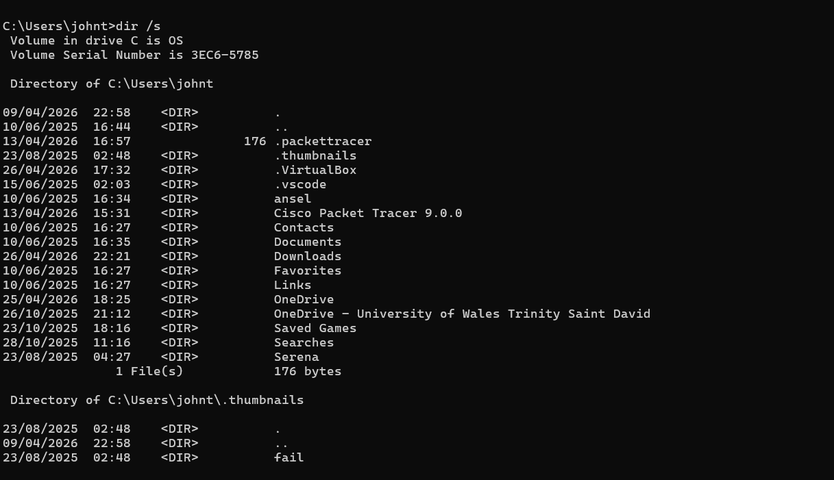

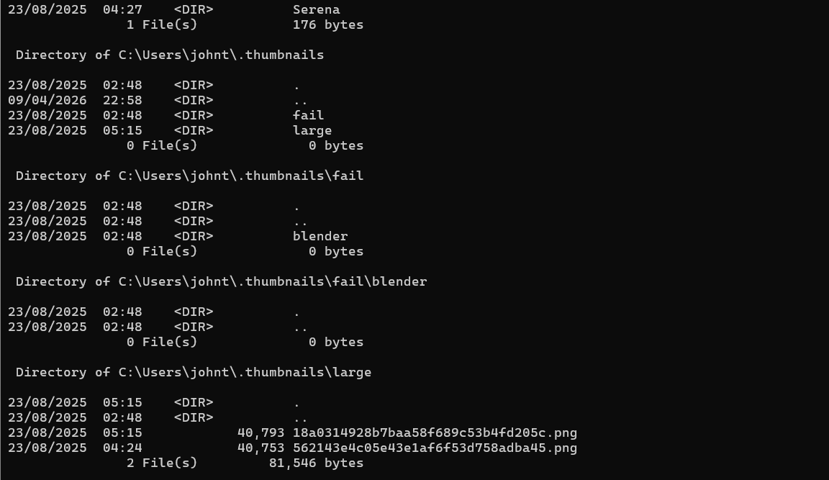

mkdir and rmdir /s /q
mkdir is for creating a new folder, and rmdir /s /q is for deleting a folder and everything inside it instantly without any confirmation prompts.
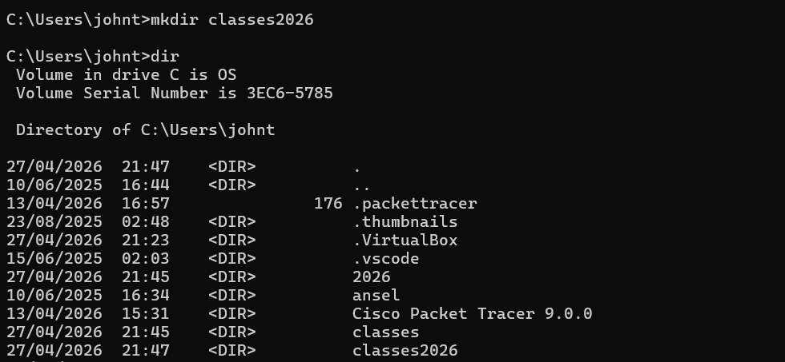

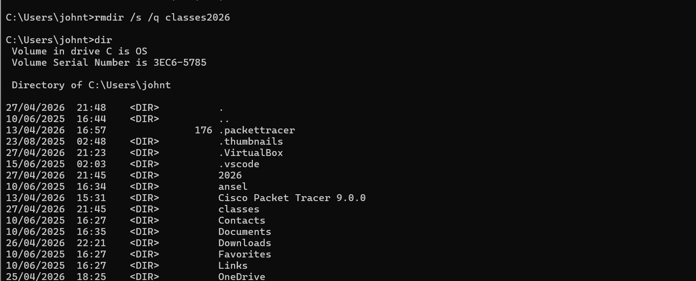

xcopy [source] [dest] /e /i /y
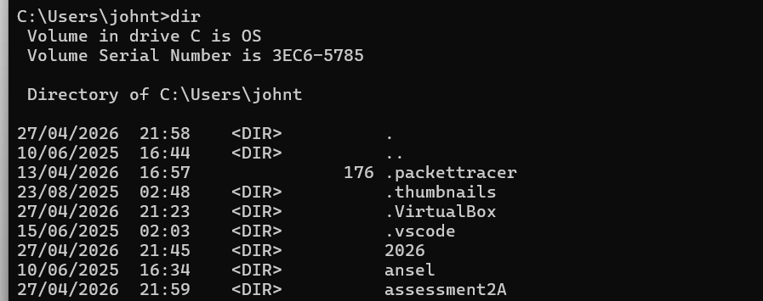
The command xcopy /e /i /y duplicates entire folders and all their content, automatically creates the destination if it doesn't exist, and overwrites files without asking for confirmation.

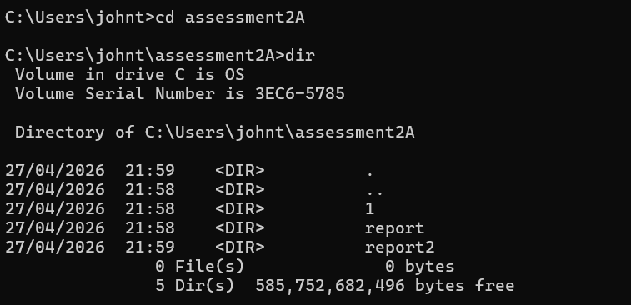

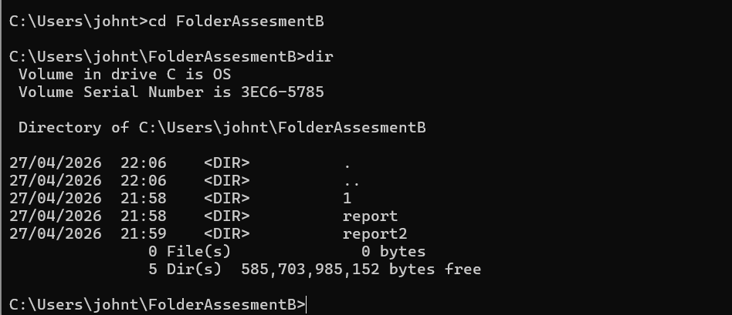
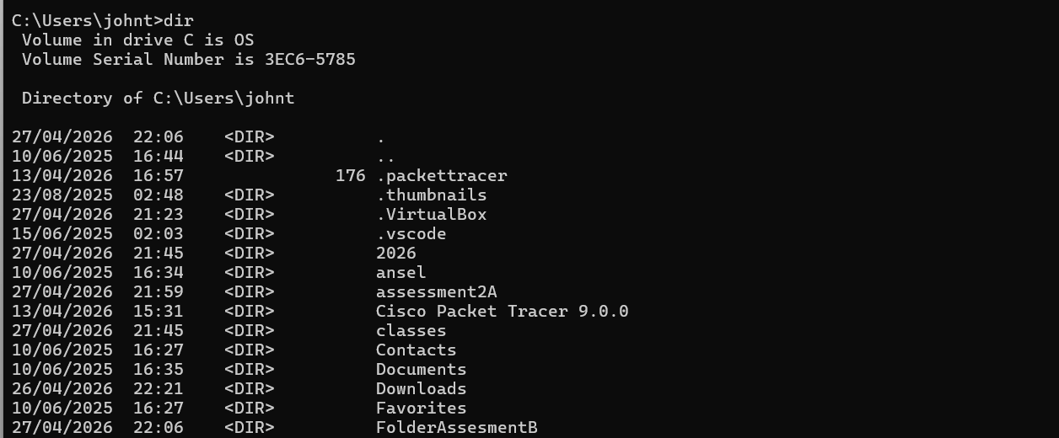
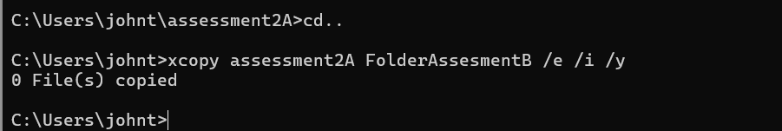
NETWORK TESTING & MONITORING
ping -n 4 google.com command
The ping command is used to check network connectivity. The -n 4 option specifies that four test packets are sent. The destination (google.com) is the address being tested to verify if it is active; such a name is required so that the packets know where to go.
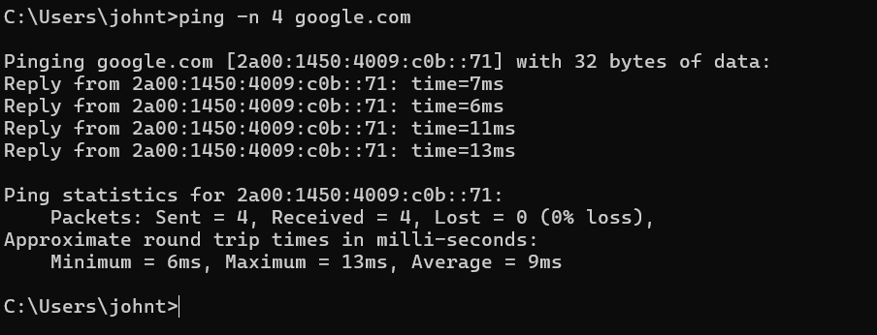

The ipconfig /all command shows detailed network information, such as the IPv4 address, subnet mask, default gateway, and DNS servers.
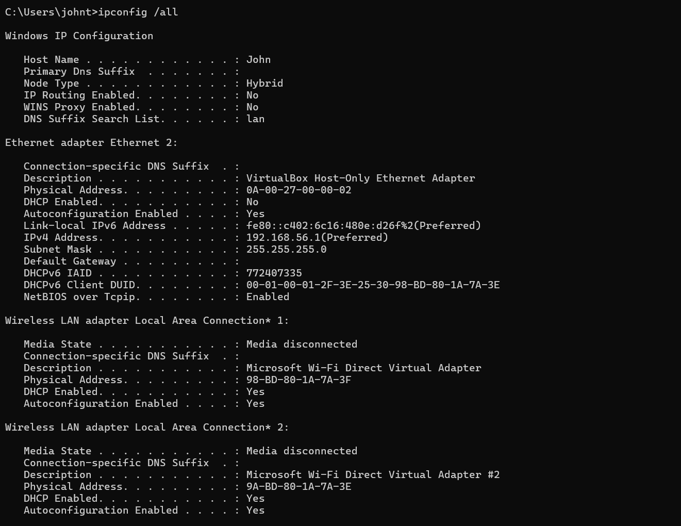

netstat -an command
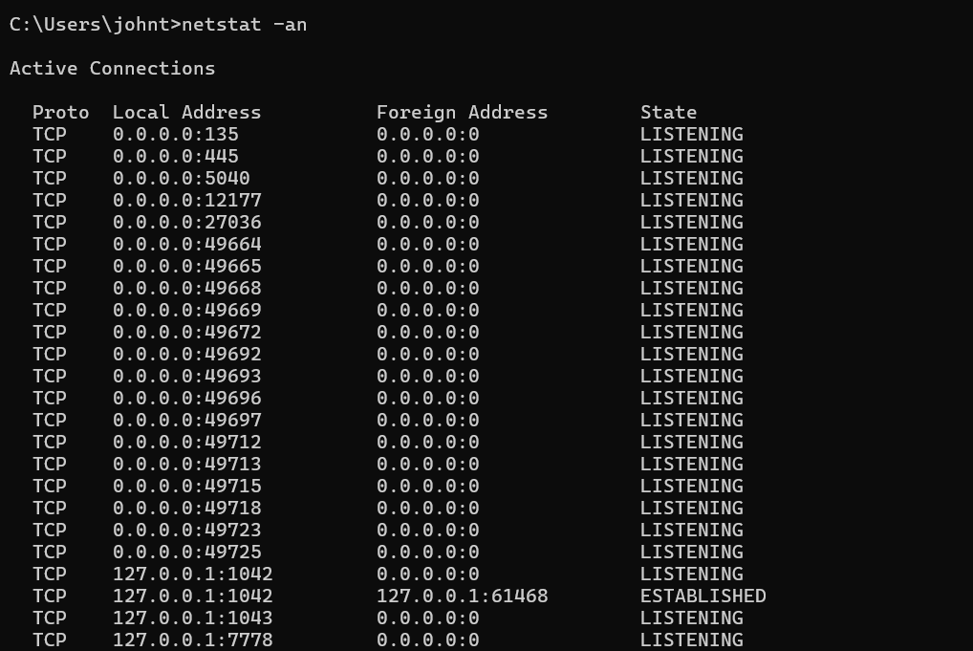
The netstat command shows active TCP and UDP connections. The -an options display all connections in numerical form, which is useful for security checks and troubleshooting.

USER MANAGEMENT
net user [username] [password] /add command

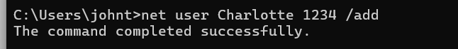
The net user command is used to set up a new person on the computer. By including a name and a password along with /add, the system creates a unique profile with a security key so someone else can log in and use the device.

net localgroup Administrators [user] /add
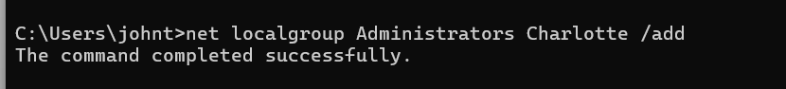
This command adds a user to the Administrators group, giving them admin permissions.
Net user [username]
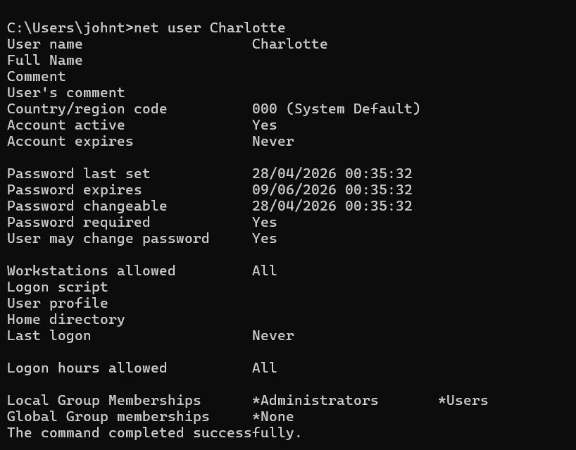
This command displays information about a specific user account. It is used to check that the user exists and to view details such as account status and settings.

net user /delete
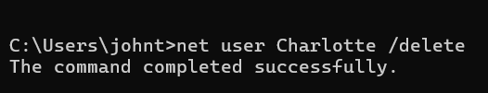
This command is used to delete an existing user account from the system.

[10]

TASK SCHEDULING
Windows allows scheduling tasks to run automatically at specific times, which saves having to do repetitive things manually. The schtasks command handles this from the Command Prompt and replaced the older AT command in modern versions of Windows.
schtasks /Create
This is where the task gets created. The example below sets up a disk cleanup that runs every day at 11:00 PM automatically:
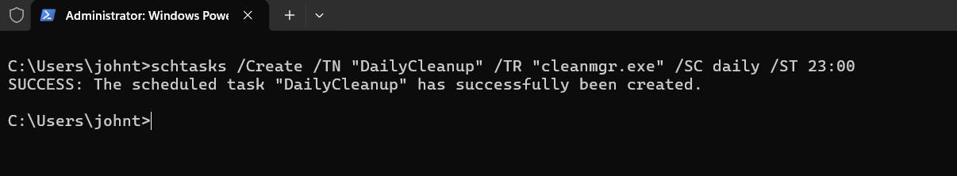
schtasks /Query
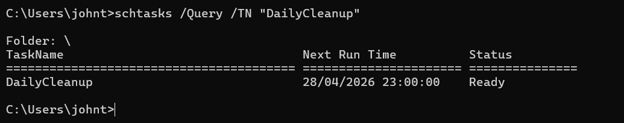
After creating it, this switch checks that the task actually exists and shows its current settings:

schtasks /Delete
Once the task is no longer needed, this removes it completely. The /F switch skips the confirmation prompt:
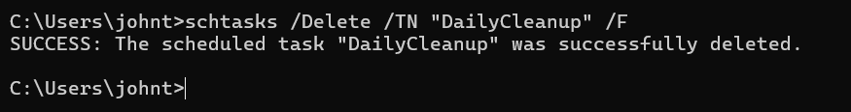
[11]

3. Use of Linux OS CLI commands
Ubuntu, which is also a Linux distribution, uses Bash as its default command-line interface, giving users direct control over the system through the terminal. The following section presents 12 commands grouped into five categories.

Process Management
ps aux
Running ps aux shows all the processes currently active on the system. It includes who started each one, how much CPU and memory it uses, and its process ID (PID). It is a quick way to see what the system is doing at any moment.
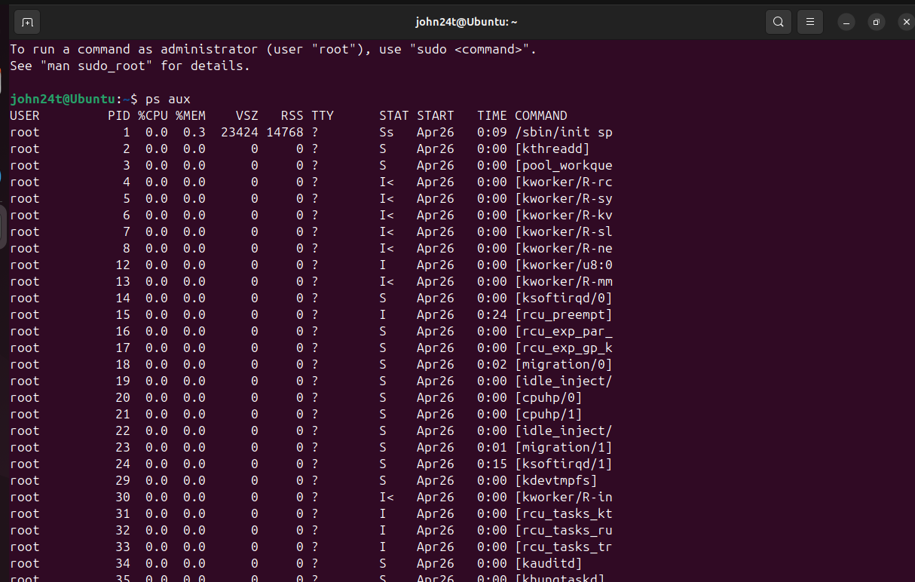

kill -9
When a process needs to be stopped immediately, kill -9 forces it to close using its PID. The -9 flag sends the SIGKILL signal, which the process cannot ignore or delay
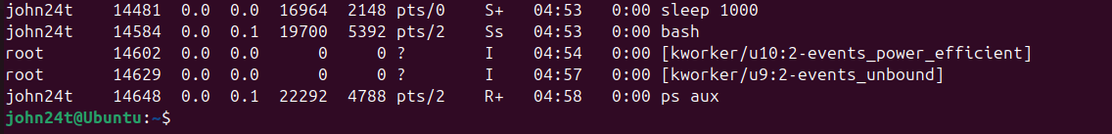
The "sleep 1000" process is selected to be terminated.
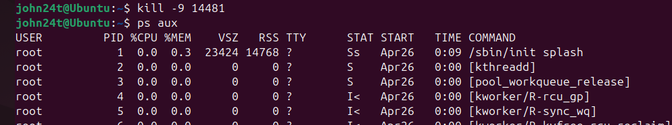

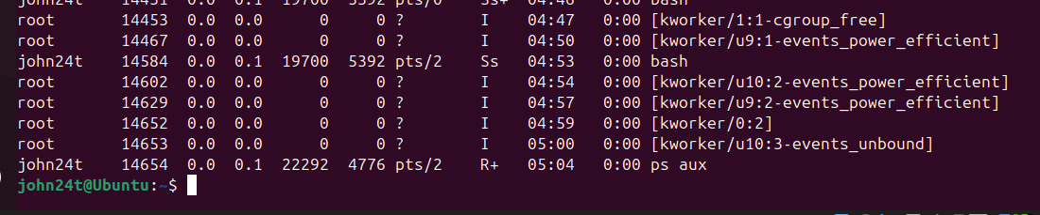

The "sleep 1000" process is terminated using the command kill -9 14481, where 14481 is the process ID (PID).
File and Directory Management
ls -la command
The ls -la command lists all files in a directory, including hidden ones. The -l option shows details such as permissions, owner, size, and modification date, while -a includes hidden files.
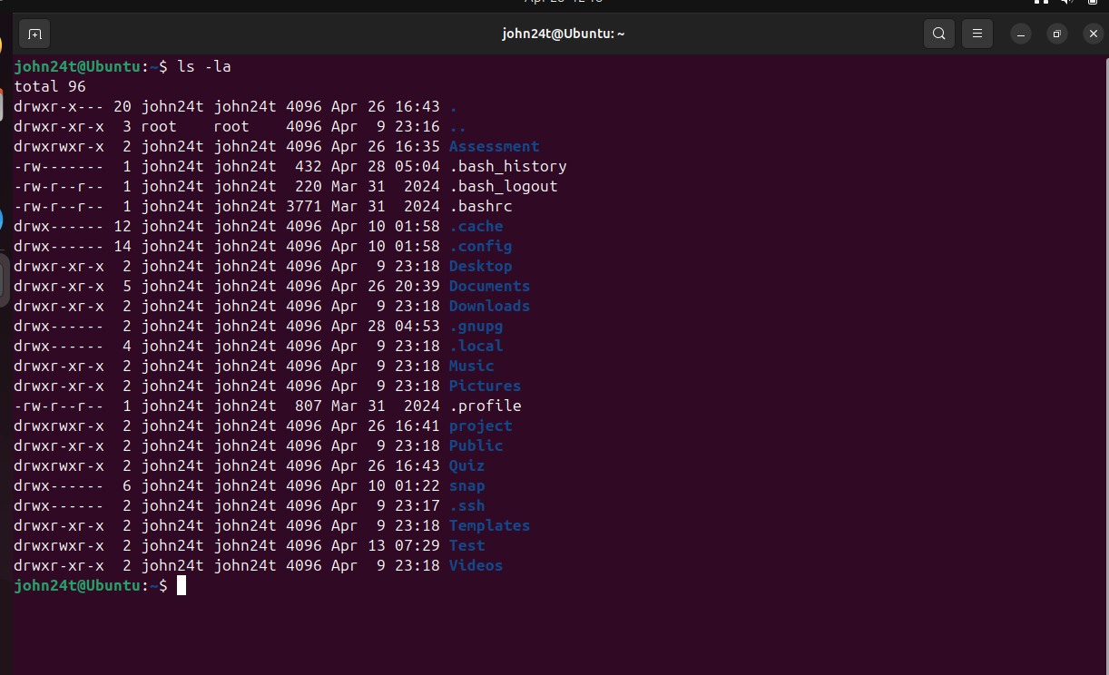

mkdir and rm -r
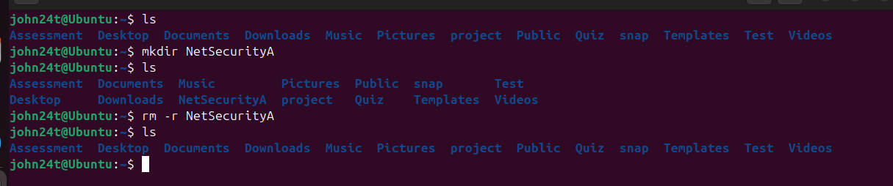
mkdir creates a new folder instantly. When a folder is no longer needed, rm -r removes it along with all its contents in one go

chmod 755
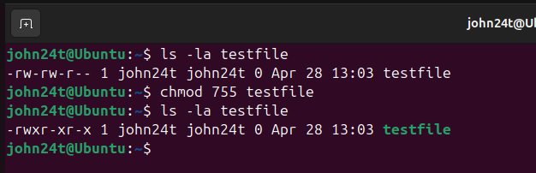
The chmod 755 command changes file permissions. In this practice, ls -la was used to check the permissions of testfile, then chmod 755 testfile was applied to update them, and ls -la was used again to confirm the changes.

Network Testing and Monitoring
ping -c 4
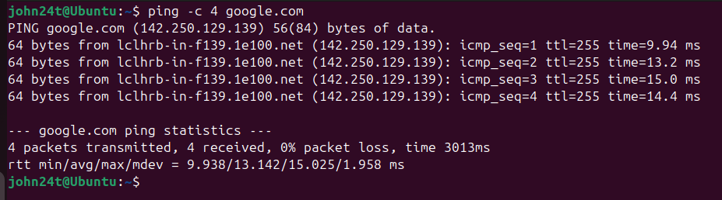
The ping command is used to check if a host is reachable over the network. The -c 4 option sends only four packets, so it doesn’t keep running continuously. In this case, google.com is used to confirm internet access and that DNS is working properly.

ip addr
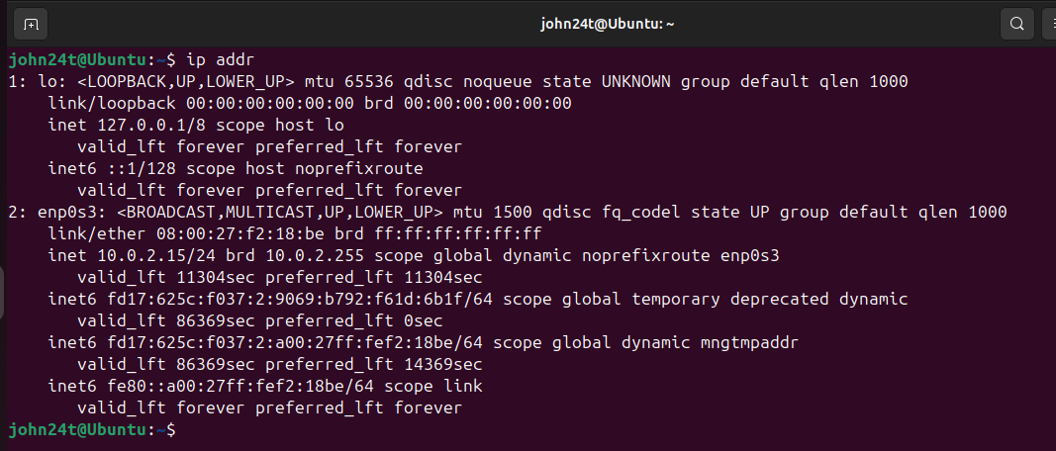
The ip addr command shows all network interfaces and their assigned IP addresses. It is a newer command that replaces ifconfig, which is no longer commonly used on most Ubuntu systems.

netstat -an
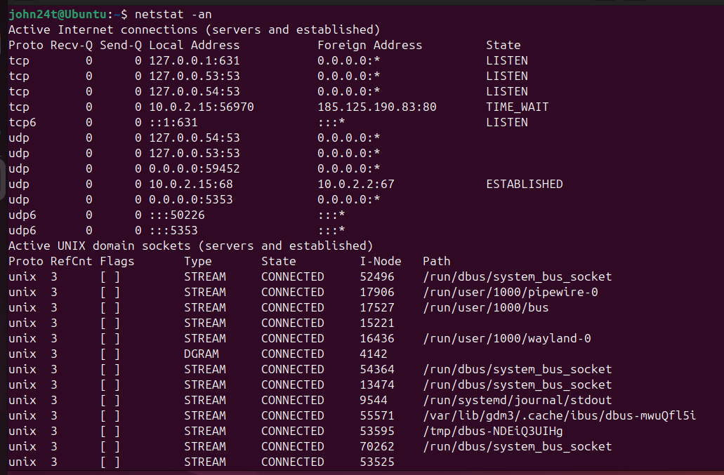
netstat -an lists all active connections and listening ports in numeric format. It is useful for checking what services are running and what the system is communicating with externally.
[12]

User Management
useradd -m
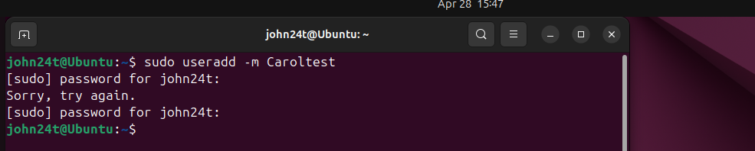
The useradd -m command creates a new user account and automatically sets up their home directory at the same time. It is the standard way to add accounts in Ubuntu.

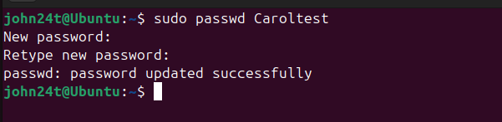
After creating a user, passwd assigns or updates their password. Without a password the account remains locked and cannot be used to log in

Task Scheduling
Ubuntu Linux uses cron to schedule tasks. It runs commands automatically at set times in the background, so there is no need to run them manually.
crontab -e
This opens the crontab file for editing. Each line follows the format: minute hour day month weekday command, telling cron exactly when and what to run
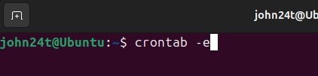

As this tool is used to schedule tasks, I want to schedule a command for the backup.sh file so that it performs a backup every night at 11:00 PM.
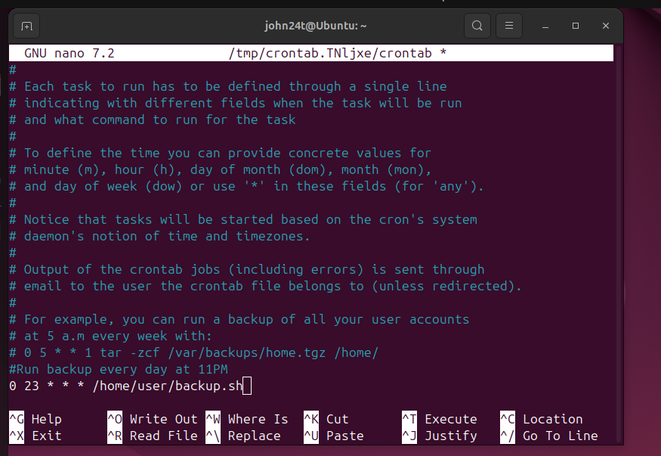

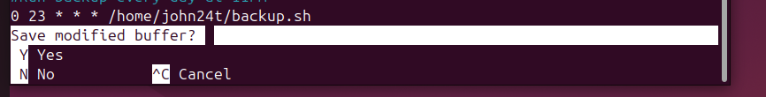

Once inside the crontab editor, type the command 0 23 * * * /home/john24t/backup.sh to schedule an automatic task every night at 11:00 PM. It is important to use your system username (such as john24t) so that Linux can find the correct file path. Finally, press Ctrl+O, then Enter to save, and Ctrl+X to close the editor.

crontab -l
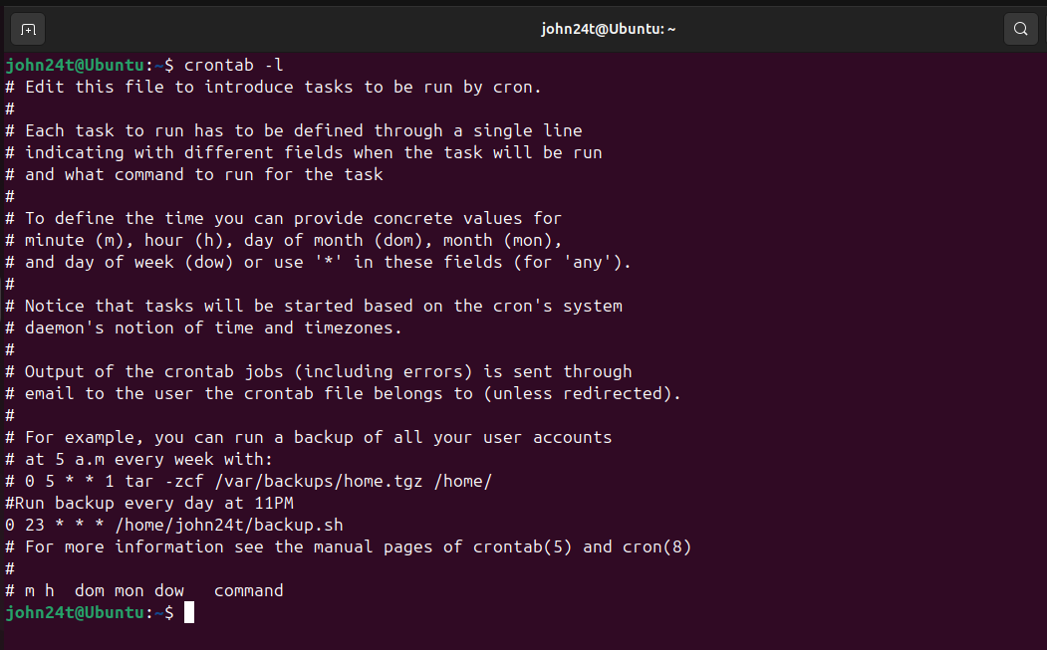
Lists all scheduled tasks currently saved for the user, confirming everything was saved correctly after editing.
[13]

4. Use of Windows OS scripts
Script 1 — Disk Space Checker
A tool for checking the available free space on any selected drive.
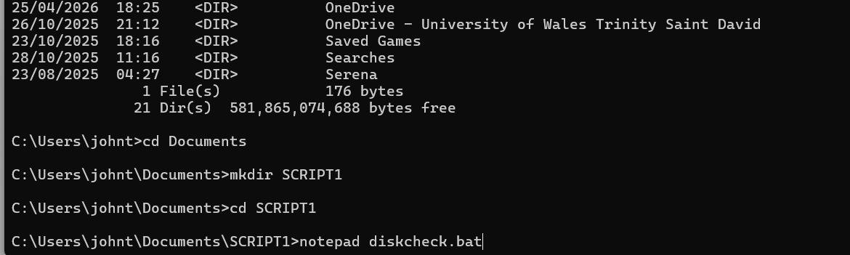

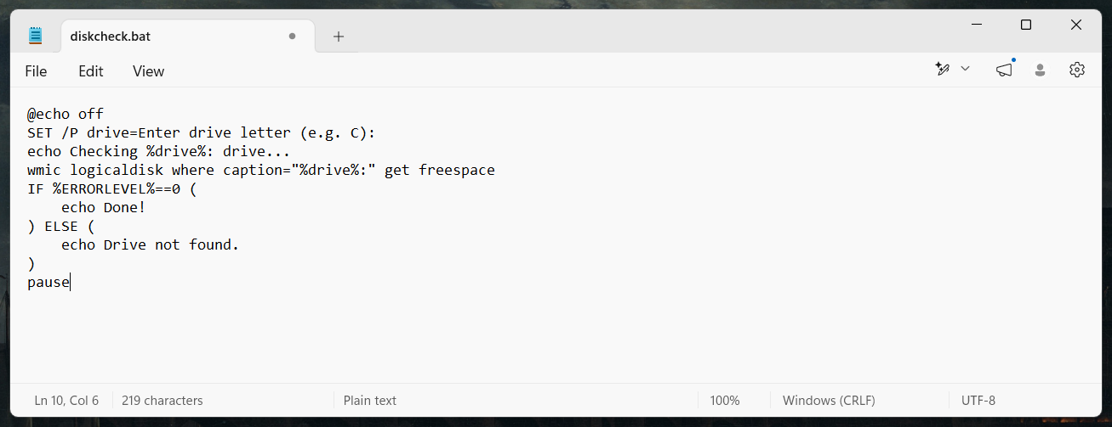
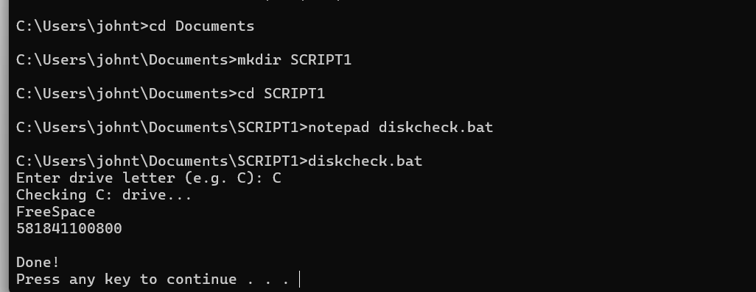
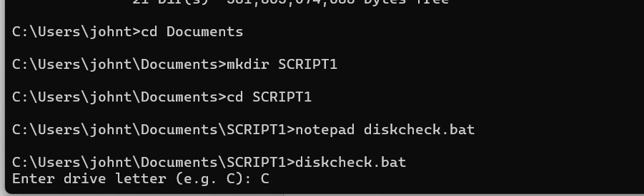

This script was written in Notepad and saved as a .bat file so CMD can run it directly. It starts by asking the user to type a drive letter, which gets stored in a variable. That variable is then used automatically to check how much free space that drive has left. At the end, a simple IF statement checks if everything went well and prints either a success message or an error. The entire script was built using Batch commands, making it a practical way to check storage without having to open File Explorer every time
Script 2 — Simple Addition Calculator
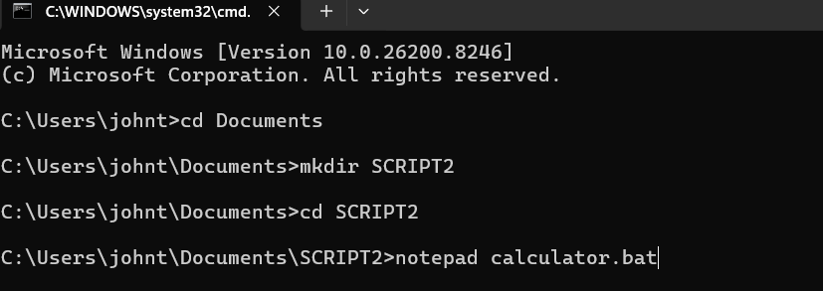

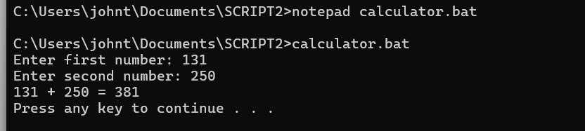
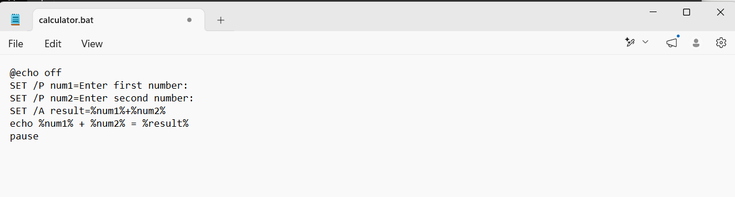
This script asks the user for two numbers and stores each one in a variable using SET /P. It then uses SET /A to add them together and shows the result on the screen. It’s a simple script that uses just a few basic Batch commands in CMD to get the job done.

5. Use of Linux OS scripts
Script 1 Ubuntu/Linux — System Info Checker
A script that displays key system details such as user, date, memory and disk space all at once.
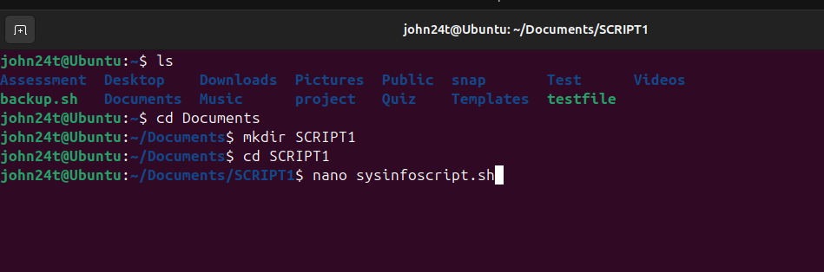
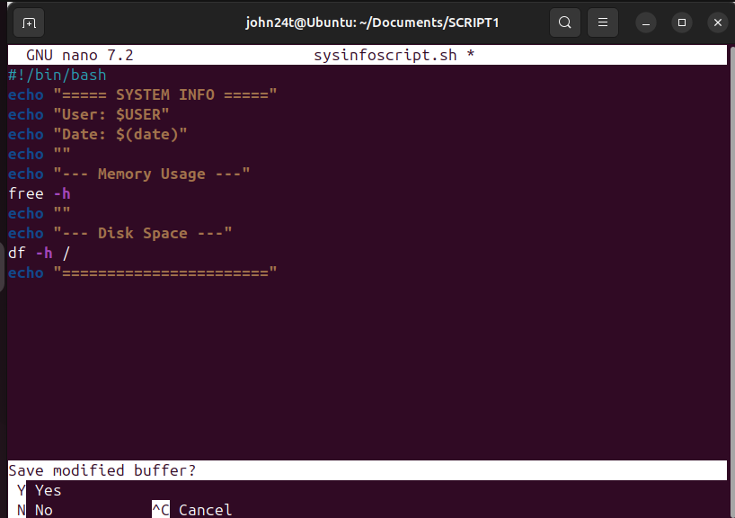

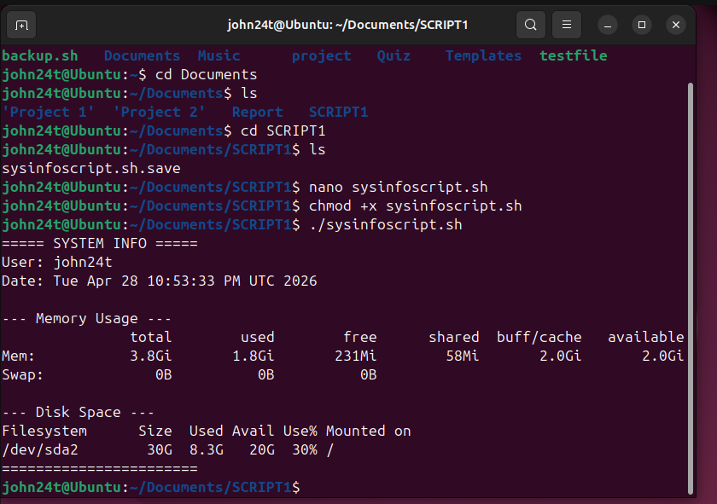

This script automatically displays key system information in one go. The current user is taken from the $USER variable, the date from $(date), memory usage from free -h, and available disk space from df -h. Instead of running each command separately, this script does it all at once, making it a practical and efficient way to check the system status quickly from the terminal.

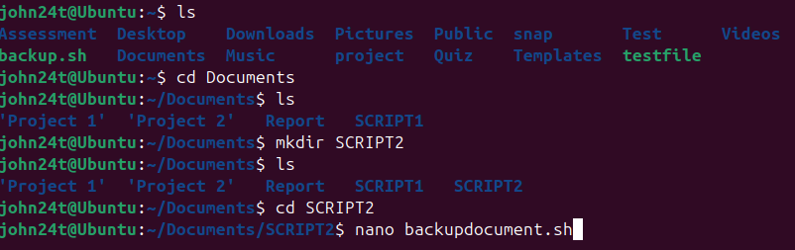
Script 2 — File Backup Document
A tool for backing up folders, saving each copy with the current date in the name.
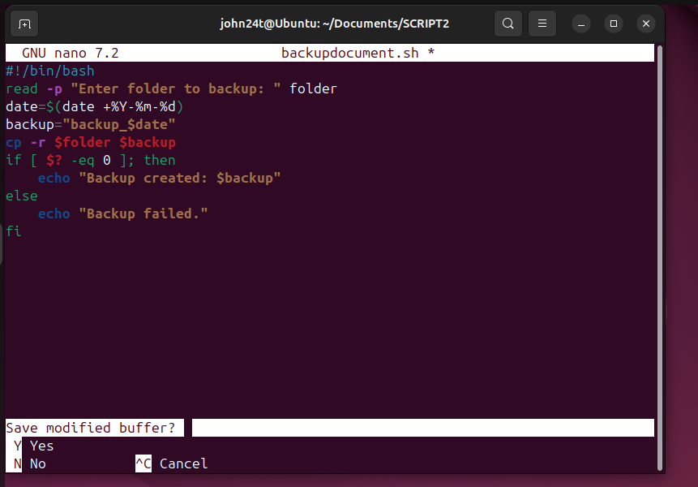

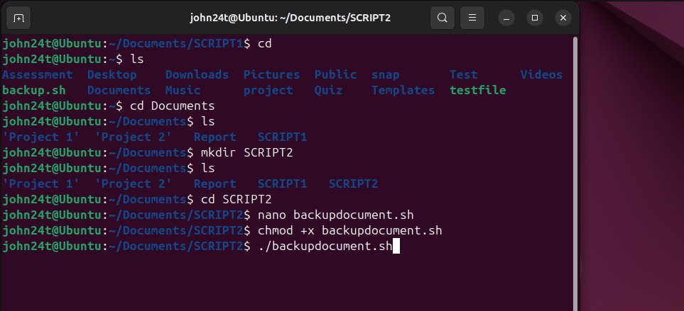

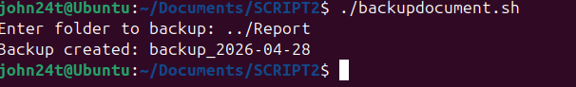

This script creates a backup copy of any folder chosen by the user directly from the terminal. As shown in practice, it is easy to run and its code is not that difficult. It asks for the folder path, stores it in a variable, and uses cp -r to copy everything inside it. The date is automatically added to the backup name using $(date), so each backup is unique and easy to identify. An if conditional then checks whether the copy was successful and prints the result

CONCLUSION
This report shows how important operating systems are and how they influence the way computers work. The operating system is the brain of every machine, without it, no hardware can function. Each operating system has key tools that help manage it more easily, such as process management to see which programs are running, or device management to monitor connected hardware. Finally, the terminal is one of the most powerful parts of any operating system, as it allows deeper control of the OS, faster task execution, access to advanced functions, and the ability to automate processes through scripts, all with just a few commands.

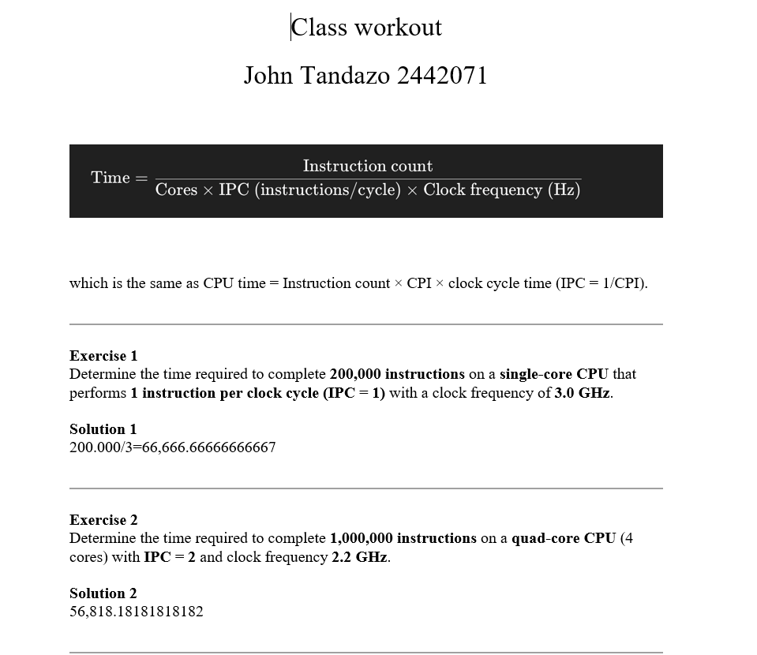
Lecture Activities

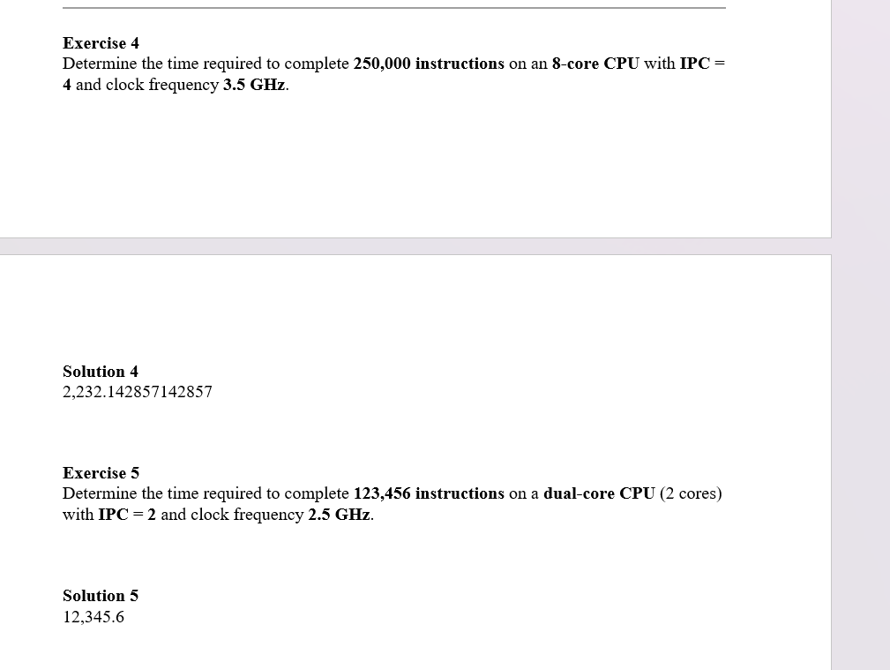

Appendices
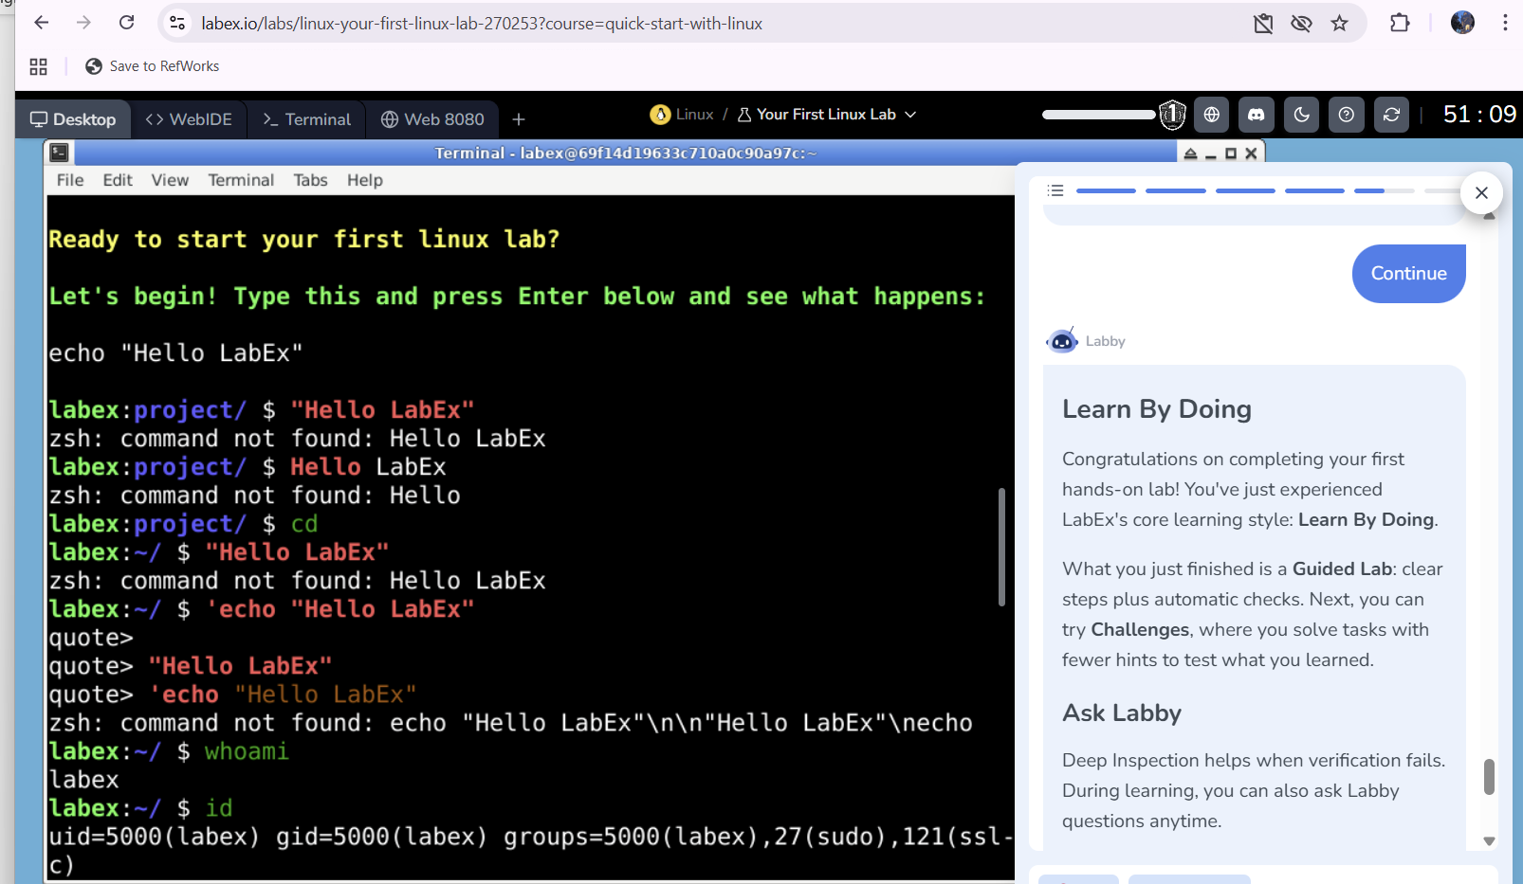
Course Labex.io
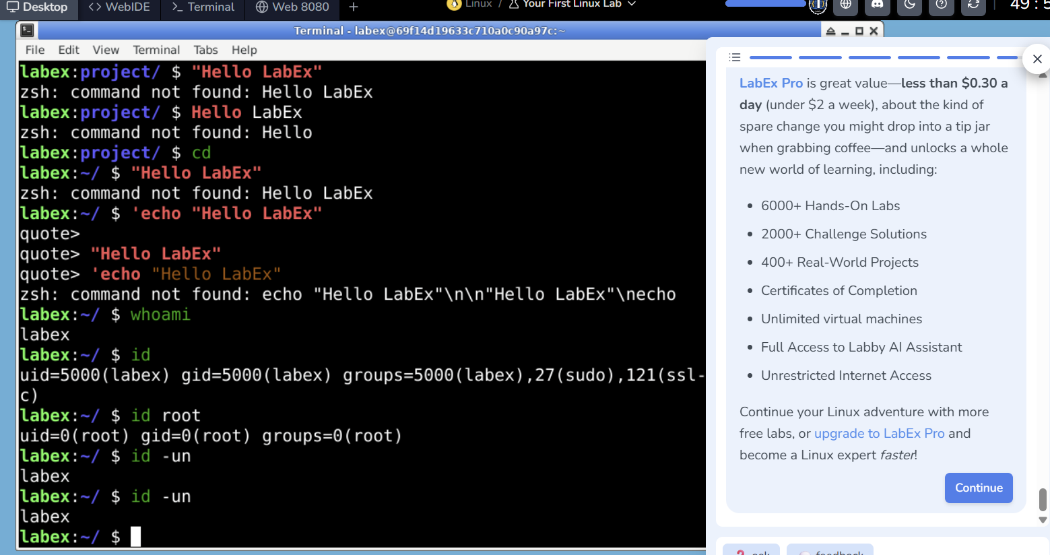
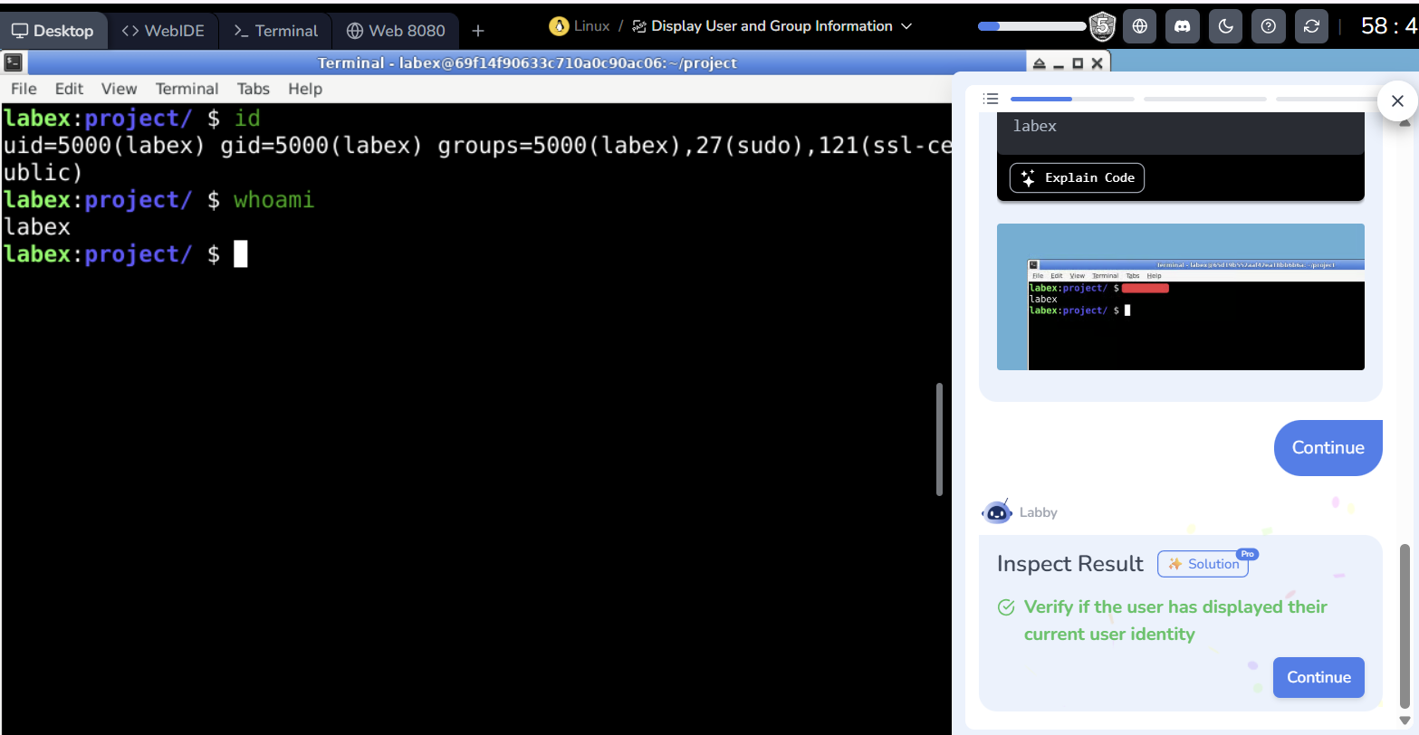
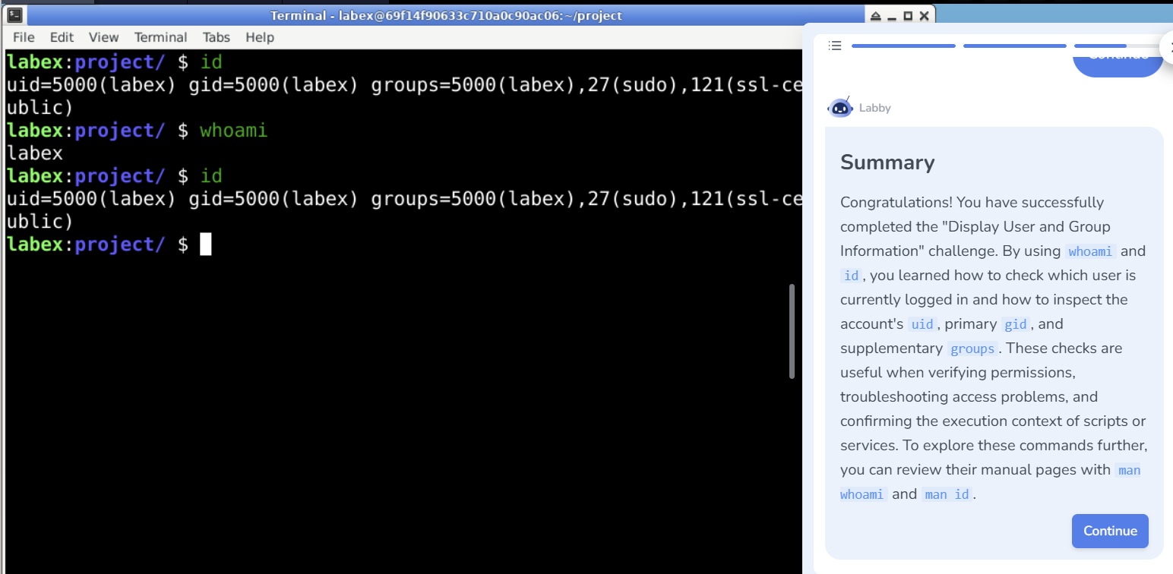
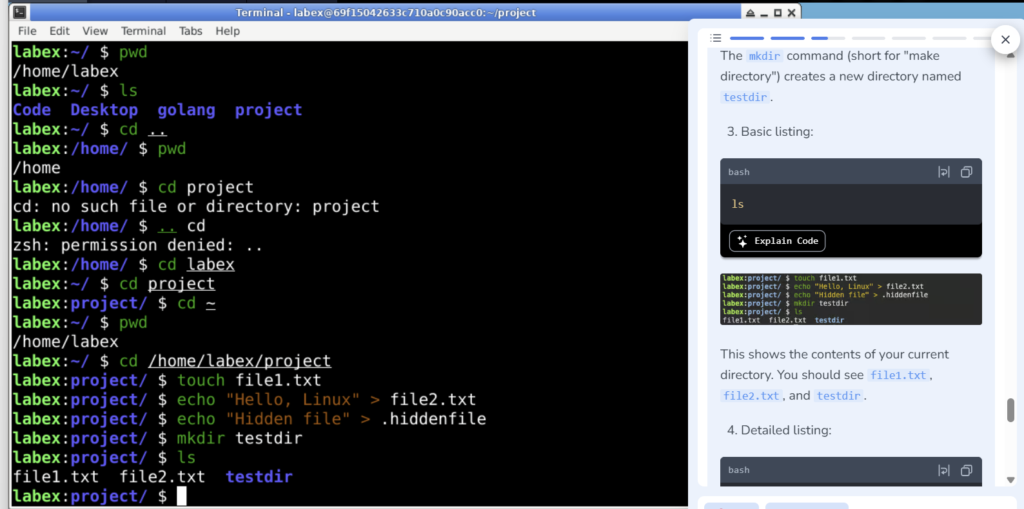
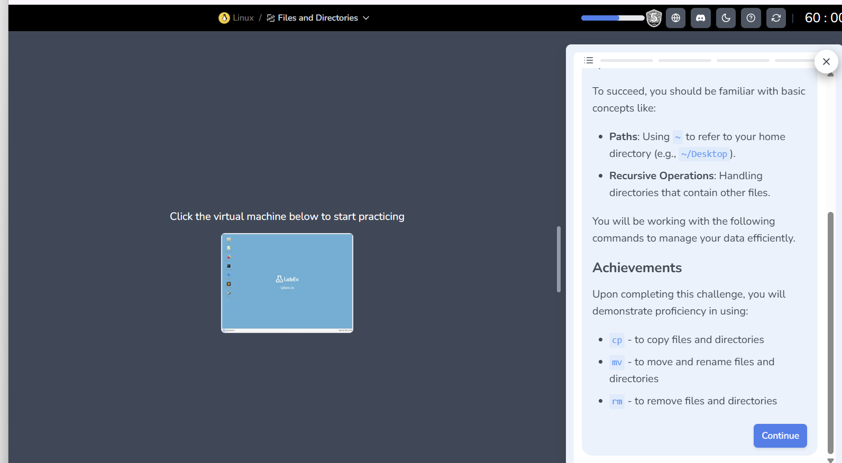

References

[1] | W. Ekta, Operating System Concepts, New Delhi: KHANNA BOOK PUBLISHING Co. (P) Ltd, 2011.
[2] | T. E. Unwana and E. I. a. U. V. O. Udoh, “A Study of the Importance of Operating System (OS) in a Computer System,” Journal of Computer Science Review and Engineering, p. 12, 2021.
[3] | Y. J. Petrizia1, “Overview of Process Management in Operating Systems,” International Journal of Advanced Research in Science, Communication and Technology (IJARSCT), p. 8, February 2025.
[4] | H. C. P. Library, “Computer Basics: Windows and File Management,” Henrico County Public Library.
[5] | A. K, “IoT Manager – Device Management,” Thangal Kunju Musaliar College of Engineering, Kerala, 2023.
[6] | D. S. E. S. A. S. Roberto Doriguzzi-Corin, “Empowering Network Operating Systems,” 2016.
[7] | S. William, The Linux Command Line, 3rd Edition: A Complete Introduction, San Francisco: No Starch Press, 2026, pp. 25, 103.
[8] | A. D. M. A. R. A. A. D. N. O. V. E. R. R. A. K. A. B. M. V. S. P. D. A. S. Armie Pakzad, “Text-Based Task Manager Using Shell Script in Ubuntu Linux,” in 2024 IEEE 16th International Conference HNICEM, Manila, Philippines, 2024.
[9] | S. W. Ross Brunson, “Chapter 1: Installing Linux,” in CompTIA Linux+ / LPIC-1 Cert Guide, Indianapolis, Pearson Education, 2015, p. 9.
[10] | J. P. Mueller, “Managing Data, Managing the Network, Managing Users, Performing Maintenance,” in Windows Command Line Administration Instant Reference, Indianapolis, Wiley, 2010, pp. 63, 85, 107, 131, 177.
[11] | P. K. Bhardwaj, “Managing Scheduled Tasks,” in How to Cheat at Windows System Administration Using Command Line Scripts, Syngress, 2006, p. 75.
[12] | M. Garrels, “About files and the file system, Processes, Networking,” in Introduction to Linux (Third Edition), Fultus Corporation, 2010, pp. 45, 73, 175.
[13] | C. N. David Clinton, “Managing User Accounts, Learning System Administration,” in Ubuntu Linux Bible, John Wiley & Sons, Incorporated, 2020, pp. 153, 215.

