2015801 (Lukas Molnar Riis)
2015801@student.uwtsd.ac.uk

ACBA 5010 – Client Letter and Draft BEP

Abstract
In this assignment I will go over the way that construction projects can be managed, and how building information modelling or BIM can be utilized to do this.
Index

- Introduction
- My letter to the client and BIM Execution Plan
- Conclusion
- Reference list
- Bibliography

- Introduction

Firstly, in this assignment I am going to write a letter to a client where I will talk about BIM level 2 and how BIM level 2 will work for them for their project in particular. I will talk about specifically how the information needed for the construction project will be passed on from one to another, for every person on the project who will need to use it, as well as this I will talk about how this information can be stored and managed and what needs to be done for this to happen successfully. Next, I will attach a BIM execution plan to my letter to the client which will include five things, project information, management, planning, standards and IT solutions.

- My letter to the client and BIM Execution Plan

Dear Swansea Council,

I am writing to inform you about how we will be using BIM level 2 as a means of sharing, managing and controlling information needed in order to carry out the works required for the infant school project in Swansea known as Ysgol Bae Abertawe. In order to meet the standards of BIM level 2 for this project our BIM processes must result in good collaborative working, where information is to be shared and traded between multiple people involved in the construction project. All information must be shared in a way that is accessible for all people to use. These particulars are the minimum requirements set by the UK Government, and this is for all construction work in the public sector. Due to this reason our contractors must also demonstrate that they will be working in this way, as well as our BIM processes must show that they comply, or funding should not be released from the Council’s treasury. At BIM level 2, there is still not a single source of data but there is enough data being shared and communicated for a BIM model to be successfully as BIM procedures can be followed.

McPartland, R, (2014).

Stroma, (2019).

The information we have in our BIM models and processed will be shared using a CDE, a CDE is a Common Data Environment. This is a place online where information from all professionalisms like architecture, landscape, electrical, plumbing as some examples can store their information to their specific file locations and access these files after they have been changed and modified by anyone concerned in this area of work, or just if they need to access copies of any drawings or BIM models that they need to carry out their works. A CDE is sometimes split into four key phases, and in the BS 1192 it is said that these are work in progress or WPI, shared information, published documentation and lastly an archive. Some examples of a CDE are Procore, Aconex, 4Projects known better as 4P as well as many more on the market.

McPartland, R, (2016).

Mordue, S, (2015).

By using BIM processes we can keep all information in the right places and updated without having to do much work at all. Before BIM was introduced to the construction industry the industry was falling behind in terms of modernisation by using IT services whilst industries like banking, marketing and information services have all used computer technology to their advantage for some time. BIM is able to change data instantly without having to be re-entered, this means that the work is coordinated much better and there is less time taken on making changes, as well as less chance of mistakes being made by having to do more work when making changes and discussing with the project team which data is most up to date and the right information is being used.

BIM allows multiple different forms of data to be used and crossed, when material quantities are known and accurately put into a data sheet or schedule then the monetary value can also be worked out by applying rates to the quantities. As well as adding monetary values to things the labour, specification and more can be worked out with this information.

Martin, T, (2020).

An important thing to remember is that BIM is a process whereas many who have not looked into BIM think that BIM is a just a software that is used in construction. By using this process correctly and working with multiple disciplines and ensuring everyone works well together, everyone working with the information in BIM especially the design team can ensure that they keep on top of all of the information and all the correct data is being passed around. By this method the information in BIM can be managed quite simply.

Overall by using BIM on this infant school project we can make sure to optimise not only our time spent working with the project information but also, we can ensure that we are using the correct information at all time. The key to our implementation of the BIM process into our project is that we work actively and collaboratively and all information on the CDE is correct and up to date, we do not want anyone working with old or incorrect information and by using BIM we are reducing the chance of this happening.

Sharman, J, (2016).

I hope you have had a chance to review all that I have said on BIM and how it can benefit the project. To aid in this I have also appended a BEP for this project below, a BEP is a BIM Execution Plan, for reference. My contact information is below.

Sincerely,

Lukas Mark Molnar Riis

Lead Consultant
lukas.molnar@designteam.co.uk
07951597813

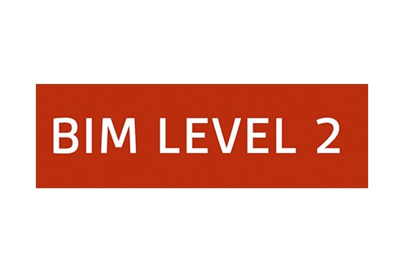
Pre-contract BIM Execution Plan (BEP)
Ysgol Bae Abertawe

Author: Lukas Molnar Riis, Lead Consultant

Amendment Record
Revision | Status | Date | Notes | By
PO1 | For comments | 24.04.2021 | First issue | Lukas Molnar Riis

Table of Contents

- Project information
  - Project overview
- Management
  - Roles and responsibilities
  - Project milestones
  - PIM Deliverable strategy
  - Survey strategy
  - Approval of BIM information
- Planning and documentation
  - Project Implementation plan
  - Collaboration processes
  - Task information delivery plan
  - Master information delivery plan
- Standards, methods and procedures
  - Volume strategy
  - PIM orientation and origin
  - File naming
  - Object naming
  - Layer naming
  - Agreed construction tolerance
  - Drawing sheet template
  - Annotations, dimensions, abbreviations and symbols
  - Attribute data
- IT Solutions
  - Software versions
  - Exchange formats
  - Process and Data management

- Project information
  - Project overview

Project name | Ysgol Bae Abertawe
Project number | 5010
Project description | Infant school design and construction in Swansea area
Site name | Swansea Infant School, Ysgol Bae Abertawe
Site description | Site is located in Swansea near the Tower of Eclipse across from the multistorey car park in this area

- Management
  - Roles and responsibilities

Below shows individuals involved in the project, their represented companies and their roles:

Name | Company | Role/Title | Resources | Contact Information
Lukas Molnar Riis | Design team | Lead consultant | Design1 | 07951597813  lukas.molnar@designteam.co.uk
Lukas Molnar Riis | Mechanial Team | Mechanical engineer | Mechanical1 | lukas.molnar@mechanicalteam.com
Lukas Molnar Riis | Electrical Team | Electrical engineer | Electrical1 | lukas.molnar@electricalteam.co.uk
Lukas Molnar Riis | Swansea City Council | Representative | Client1 | lukas.molnar@swansea.gov.uk

The below shows where responsibilities of the using of BIM information lie across all involved in managing the BIM:

Responsibilities | Resources
Key decisions in sharing and storage of information | Design1
Checking of any decisions and overall overview | Cient1
Ensure all standards, regulations and procedures are followed | Client1
Ensure the appointment of a project information manager | Design1
Accept and reject changes to information | Design1
Organise the distribution of design information | Design1
Flag up any issues if present to the right persons in work packages | Mechanical1/Electrical1/Client1
Confirm to design team that information is suitable | Mechanical1/Electrical1/Client1
Confirm design goals and deadlines needed | Design1
Ensure project’s CDE is running and able to be accessed | Design1/Client1
Ensure project’s CDE is able to be used by all who need access | Design1
Distribute updated information in a timely manner | Design1

  - Project Milestones

Project milestones should be set out in client or main contractor’s programme for works once supplied. This should show all key dates for each work activity across multiple trades. Allowing an idea of cost management and logistics around site when areas come available and trades are able to carry out their works.

  - PIM Deliverable strategies

At each project milestone, where a large event within the project’s programme is occurring then information should be exchanged for example in the planning phases of the project site plans, phasing plans, elevations, levels, services drawings and general arrangement drawings for all trades should have been produced and distributed at planning phase (P01).

  - Survey strategy

Within this project’s information the orientation and origin points will be used throughout, these will be mentioned in section 4.2 of this BEP. All information will be accessible through software mentioned in section 5.2 of this BEP.

  - Approval of BIM information

To approve of information, new or updated, before being uploaded to the chosen CDE the information must first go through an approval process.

Approval process

Any updated from clients or site teams is checked to see if anything has been flagged up or suggested to the design team for changes. Information is checked that the correct mesaurements and scales are being used before uploading. Information is checked generally to see if the data is showing what it needs to in order to satisfy the deisgn team, client, and site operatives and management. Once checked for any errors and satisfied, update informtions codes for revion numbers, upload information to chosen CDE.

3. Planning and documentation
3.1 Project implementation plan

No project implementation plan has yet been produced for this project. Once produced this should be inserted into this section and followed in accordance.

3.2 Collaboration processes

Information will be shared and exchaged through the use of CDE’s as previously mentioned. New and updated information will pass through the approval phases mentioned in section 2.5 of this BEP for information to be accurate and secure before being uploaded to the chosen CDE. Client, deisgn team and lastly construction team will work together utiliding these sharing and approval platforms in order to accurately exchange information. This will minimise chances of mistakes being made as multiple disciplines will be checking work done and updated information.

3.3 Task information delivery plan

A task information delivery plan has not yet been approved and finalised with the client so please see below a sample TIDP that can be populated for this project and is likely going to be used.
File identifier |  |  |  |  |  |  | Model/drawing title | Key dates
Project | Originator | Volume | Level | File type | Discipline | Number | Model/drawing title | Milestone 1 | Milestone 2 | Milestone 3 | Milestone 4 | Milestone 5

Jackson, R, (2015).

3.4 Master information delivery plan

A master information delivery plan has not yet been produced. A master information delivery plan can be produced once approved by both the client and site team.

4. Standards, methods and procedures

4.1 Volume strategy

This project does not require any geometric subdivision. Volume codes ‘ZZ’ will be used for this project.

4.2 PIM Orientation and origin

This project will use the survey and building points of 192364.7 N and 265976.9 E coordinates, the elevation point for this project is 0.

4.3 File naming

Files should be named in accordance with BS 1192, Section 13 using the project number followed by the originator code, followed by volume code, followed by the levels, followed by the file type code, followed by the role, followed by the classification code, and lastly followed by the drawing or file number and then the revision. Drawing packages will be split up by using a series code for example series 1 drawings can be plan drawings, series 2 can be detail drawings, deries 3 can be schedules, series 4 specifications and so on.

4.4 Object naming

Objects will be named in accordance with BS 8541-1. And named as the Author name or Manufaturer, the type of object and then the subtype of object.

4.5 Layer naming

All layers within the BIM information for this project will be named in accordance with BS 1192. And named using the role of the layer, followed by the classification of the layer, followed by the presentation of the layer, followed by the description .
4.6 Agreed construction tolerance

Information used within BIM for this project shall be in accordance with ISO 5601.

4.7 Drawing sheet template

All drawings for this project shall be produced in accordance with ISO 5457. And title blocks shall be in accordance with ISO 7200.

Example of title block drawing template is as below:
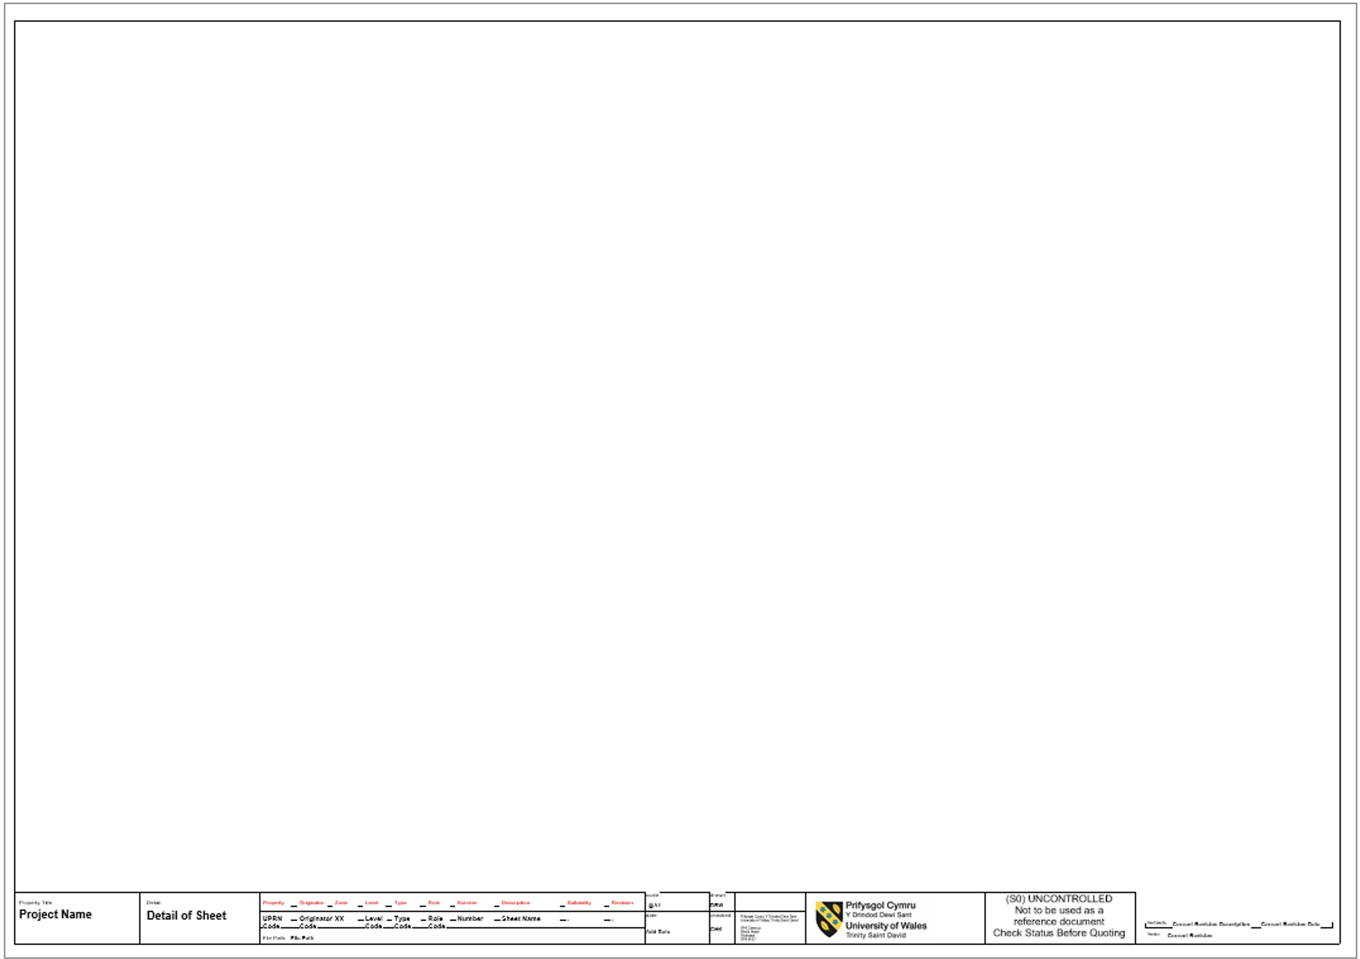

4.8 Annotations, dimensions, abbreviations and symbols

All of the above used in this project will be compliant with BS 8541-2. All used will be standard from BIM terminology.

4.9 Attribute data

Data will be exchanged thorugh the the online CDE or by common communications such as email and all documents will have coding to show te correct type of information it has within it.

5. IT Solutions

5.1 Software versions

Autodesk 3D and 2D modelling in Revit 2021 will be used as software for this project’s BIM needs.

5.2 Exchange formats

Exchange formats for this project using Revit 2021 will be .rvt on the 2021 version.

5.3 Process and Data management

Data will be transferred into surveys which is transferred into drawings, schedules and models which is then transferred into the chosen CDE.

Rossiter, D, (2016).

3. Conclusion

After studying the BIM process I can see that it is a great tool to use on constriction projects. It takes some managing but once the knowledge is known it can be straight forward and save a lot of time and energy, by storing, sharing and creating information needed for construction projects. BIM is a process that is bringing construction work forward in times, it can be a digital tool which can help many different people on a constriction project from the design team employed by the client or customer, all the way to the people who are using this information on the construction site itself. A BIM execution plan is a sort of guideline used to show the people involved in the project how BIM is going to be used, who is responsible for what in the use of BIM, and how information will be shared and managed, as well as giving a kind of textbook for people to use for them to better understand a lot of the things we see in everyday construction information, for example the codes used to name drawings. Overall if used correctly BIM is a great tool.

4. Reference list

- McPartland, R. (2014). BIM Levels explained. Available at: https://www.thenbs.com/ (Accessed 24th April 2021).
- Stroma. (2019). BIM Levels Explained. Available at: https://www.stroma.com/ (Accessed 24th April 2021).
- McPartland, R. (2016). What is the Common Data Environment (CDE)?. Available at: https://www.thenbs.com/ (Accessed 24th April 2021).
- Mordue, S. (2015). The Common Data Environment: the digital space where BIM data flows. Available at: https://www.bimplus.co.uk/ (Accessed 24th April 2021).
- Martin, T. (2020). How BIM helps facilitate contactless coordination on complex construction projects. Available at: https://www.smartbrief.com/ (Accessed 25th April 2021).
- Sharman, J. (2016). The information in BIM. Available at: https://www.thenbs.com/ (Accessed 25th April 2021).
- Jackson, R. (2015). PRODUCING A TASK INFORMATION DELIVERY PLAN (TIDP) FROM ARCHICAD 19. Available at: https://bimblog.bondryan.co.uk. (Accessed 25th April 2021).
- Rossiter, D. (2016). PLQ 2.5 – BEP Revisited. Available at: https://bimblog.house/ (Accessed 28th April 2021).

5. Bibiliography

- Design Buildings. (2021). Building information modelling BIM. Available at: https://www.designbuildings.co.uk/
- Autodesk BIM 360. (2016). BIM LEVEL 2 EXPLAINED. Available at: https://bim360autodesk.com/
- Design Buildings. (2021). Common data environment CDE. Available at: https://www.designbuildings.co.uk/
- Rodriguez, J. (2019). How to define a BIM Execution Plan (BEP). Available at: https://retaintechnologies.com/

