Marketing Essentials
BMIH4005 REWORK
Presentation & Supporting Marketing Plan

Table of Contents
1 Introduction 3
2 Marketing Plan 3
3 Conclusion 6
4 References 7
5 Appendices 9
5.1 Appendix I: 9
5.2 Appendix II: 9
5.3 Appendix III: 10
5.4 Appendix IV: 10
5.5 Appendix V: 11
5.6 Appendix VI: 11
6 Component 2: Presentation 13

Introduction
The aim of this marketing plan is to determine the potential target market for the selected hotel business. The marketing plan will discuss the use of the SOSTAC model. A comprehensive plan related to the strategies of Moxy and its services will be discussed in the marketing plan.

Marketing Plan
Here the SOSTAC model is used as an effective marketing and business planning (Smith et al., 2022). The first element of the model is Situational analysis which comprises 5C’s.
Company: The strength of Moxy is its high brand value, international expansion, strong financial position, competitive pricing and customer loyalty (referred to Appendix I). On the other hand, the weakness of Moxy is its limited service offerings. Moreover, fluctuating economic conditions and high dependency on Marriott are also considerable weaknesses for the hotel (Moxy, 2023). When talking about opportunities, it is clear that diversification and the invention of new technologies create great options for the hotel brands like Moxy (Marriott International, 2023 a). Undoubtedly, market competition and economic recession are threats to Moxy. Similarly, changing customer demands and preferences are threats to the hotel.
Customers: With reference to Similar Web (2023), it is identified that the total visitor on the website of Moxy is 189.3K. The market segment used by the Moxy brand is mainly business travellers and youngsters. The hotel targets young students of colleges and universities. Moreover, the hotel offers high-quality services to customers of age between 18 to 35. Both middle and high-class society is the target audience of Moxy Hotel.
Competitors: With the evidence of perceptual positioning mapping (referred to Appendix II), it is viewed that the key competitors of Moxy are Hilton, Premier Inn, Rosewood, Gosplitty, Moxy Chelsa and many more. When evaluating Bowman's clock strategy, it is observed that Moxy perform well in the hotel industry (Marriott International, 2023). The hotel offers excellent and high-quality services to the customers and is popular because of its unique and elite-class services within an affordable price range (Referred to Appendix III).
Collaborators: The hotel brand Moxy is owned by the largest hotel chain of Marriott International Inc. Moxy created a strong partnership with Marriott, like the development of Moxy Universe Playground, which provides an augmented experience to the visitors was done with the collaboration of Marriott (Marriott International, 2023).
Climate: The political factors affecting the performance of the hotel industry are current tax restrictions and the political stability of the UK. In terms of economic factors, the fluctuating inflation rate in the country has a considerable impact on the hotel business ((Office for National Statistics, 2023). The GDP rate in the UK is continuously shrinking after the pandemic (Islam and Muyeed, 2020), which impact hotel brands like Moxy. When talking about social factors, the demands and preferences of customers are changing, which makes it challenging for hotel brands to operate efficiently. Cultural trends are also a major social factor. Lastly, technological advancement is quite essential in the hotel industry. Hotels brand uses modern technology to attract customers and the international market.
Marketing Mix: Product: The brand is famous for providing unique services to guests along with modern accommodations. Price: competitive pricing strategy is used by Moxy. Place: The hotel brand operated via online and physical locations (Moxy Hotels, 2023 a). Promotion: Moxy uses different social media channels and social media marketing. The detailed marketing mix of Moxy is discussed in Appendix V.
The second element of the SOSTAC model is the Objective which mainly creates with the use of the SMART tool. Specific: The hotel aims to increase its growth rate to about 20% and website traffic by 5000 by the end of 2024. Measurable: To monitor the success of this goal, Moxy will keep an eye on the website traffic with the use of key performance indicators and measure the growth rate as well. The goal is attainable if the brand efficiently attracts customers to the website. Realistic: The hotel is already positioned as the first priority of young people, which will help in the attainment of this goal. Time-bound: The desired goal will take approximately one year to achieve.
The third element of the SOSTAC model is Strategy, which is performed with the use of the Ansoff matrix. According to Clarissia (2020), an Ansoff matrix is used to offer an easy tool for marketers to weigh up the risks and options that are associated with the new strategic decisions (referred to Appendix VI). The Moxy Hotel is considering market development by developing hotels in popular tourist destinations and underserved regions. With the help of a market development approach, the hotel will accommodate more visitors and profit from changing travel trends. Consequently, Moxy Hotel is attempting to increase the awareness of its brand by branching out into new areas and using its present product range.
The fourth element of the SOSTAC model is Tactic, which discusses the communication strategies Moxy used for addressing the issues highlighted in the situational analysis. In this step, the RACE model is used in the marketing mix. In the view of Blut et al. (2021), the RACE model mainly emphasises determining the behaviour of customers and offering them a positive experience. With the use of social media tactics, it become possible for hotel brands to communicate effectively with customers. In particular, Moxy Hotel is facing limited serving issues for which it will focus on investing in its website, like enhancing the browsing of the website, various social media platforms, and online reservation systems (Kandampully et al., 2022). The hotel will promote its greatest qualities, such as its modern design, vibrant public spaces, and ideal locations, in order to attract guests who put a premium on comfort, convenience, and elegance. In addition, Moxy will also employ visually appealing and interesting content to promote the upscale features and ambience of the hotel. Despite this, high-quality images, videos, virtual tours, and user-generated content will all be used to showcase the decor, ambience, and social experiences of the hotel. To enhance the entire guest experience, Moxy Hotel will communicate with guests before, during, and after their stay through tailored communication tactics (Yetimoğlu and Uğurlu, 2020). This category covers things like pre-arrival letters outlining the features, satisfaction surveys after a stay, and interaction aimed at fostering loyalty. Moxy hotels will compensate for the lack of extras and facilities by giving visitors distinctive and interesting experiences.
The fifth element in the SOSTAC model is Action, which defines key activities used in the marketing mix plan of Moxy.
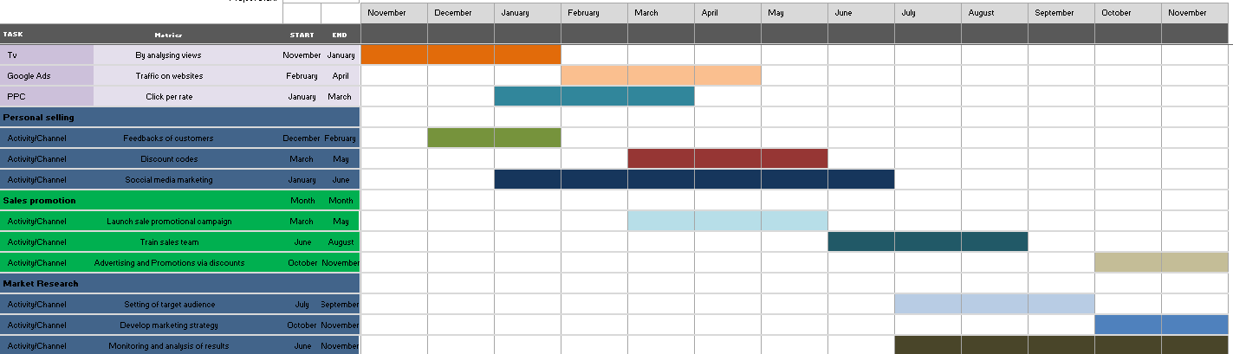
The last element of the SOSTAC model is Control; it mainly discusses the ways in which success will measure. Control measures will help the hotel in increasing its profit and create a positive attitude towards the brand (Chung, 2020). There are several methods to measure the success of a hotel, each of which may be shown by a unique set of metrics and key performance indicators (KPIs). Metrics like the conversion rate, the total number of distinct website visits, and the cost per client acquisition are commonly used to monitor new customers. Online reviews and ratings, brand sentiment studies, and customer satisfaction surveys are just a few of the factors that might indicate how customers feel about a certain business (Lucini et al., 2020). These indicators will be selected by Moxy due to their consistency with the SMART goals and direct association with the aforementioned results. They are effective because they will provide quantifiable data that can be monitored over time to evaluate the performance of Moxt Hotel.

Conclusion
The above report has presented a marketing plan for Moxy, which operate under the hotel chain Marriott. Moxy is the first choice of college and university students because of its unique and excellent services within an affordable price range. The report has concluded the marketing plan with the use of the SOSTAC model.

References
Blut, M., Wang, C., Wünderlich, N.V. and Brock, C., 2021. Understanding anthropomorphism in service provision: a meta-analysis of physical robots, chatbots, and other AI. Journal of the Academy of Marketing Science, 49, pp.632-658.
Chung, K.C., 2020. Green marketing orientation: Achieving sustainable development in green hotel management. Journal of Hospitality Marketing & Management, 29(6), pp.722-738.
Clarissia, S.M.S., 2020. A study on Ansoff Matrix Technique: As a growth strategy and an adaptive learning technique adopted in the leading brand of products. BIMS Journal of Management, p.18.
Islam, M.R. and Muyeed, A., 2020. Impacts of COVID-19 pandemic on the global economy: A meta-analysis approach. International Journal of Technical Research & Science, 5(05), pp.8-19.
Kandampully, J., Bilgihan, A. and Li, D.K., 2022. Unifying technology and people: Revisiting service in a digitally transformed world. The Service Industries Journal, 42(1-2), pp.21-41.
Lucini, F.R., Tonetto, L.M., Fogliatto, F.S. and Anzanello, M.J., 2020. Text mining approach to explore dimensions of airline customer satisfaction using online customer reviews. Journal of Air Transport Management, 83, p.101760.
Marriott International, 2023 a. Annual Report. [Online] Available at < https://marriott.gcs-web.com/static-files/b82978a6-9d28-4e38-9855-fc4ae2cebe11> [Accessed on 18th May 2023].
Marriott International, 2023. Moxy Expands Into The Middle East And Africa. [Online] Available at https://www.hotel-development.marriott.com/global-expansion-of-moxy-hotels [Accessed on 18th May 2023].
Moxy Hotels, 2023 a. Play On At Moxy Hotels Around The World. [Online] Available at < https://moxy-hotels.marriott.com/our-locations/> [Accessed on 18th May 2023].
Moxy Hotels, 2023 b. This Is The Place To Catch Special Offers From Moxy Hotels. [Online] Available at < https://moxy-hotels.marriott.com/offers/> [Accessed on 18th May 2023].
Moxy Hotels, 2023. Play On. [Online] Available at < https://moxy-hotels.marriott.com/> [Accessed on 18th May 2023].
Office for National Statistics, 2023. Customer Price Inflation. [Online] Available at https://www.ons.gov.uk/economy/inflationandpriceindices/bulletins/consumerpriceinflation/march2023#:~:text=The%20CPIH%20inflation%20rate%20is,down%20from%2013.4%25%20in%20February. [Accessed on 18th May 2023].
Similar Web, 2023. Moxy-hotels. Marriott. [Online] Available at < https://www.similarweb.com/website/moxy-hotels.marriott.com/#overview> [Accessed on 18th May 2023].
Smith, P.R., Smith, P., Berry, C. and Pulford, A., 2022. Strategic marketing communications: new ways to build and integrate communications. Kogan Page Publishers.
Yetimoğlu, S. and Uğurlu, K., 2020. Influencer marketing for tourism and hospitality. In The Emerald Handbook of ICT in Tourism and Hospitality (pp. 131-148).

Appendices

Appendix I:
SWOT Analysis
Strengths | Weaknesses
- High brand value  - Strong financial position  - International expansion  - Competitive Pricing  - High customer loyalty | - Limited service offerings  - Fluctuating economic condition  - High dependency on Marriott
Opportunities | Threats
- Diversification  - Market expansion  - Adoption of new technologies | - Rising market competition  - Economic recession  - Changing demands and preferences of customers

Appendix II:
Perceptual Positioning Mapping
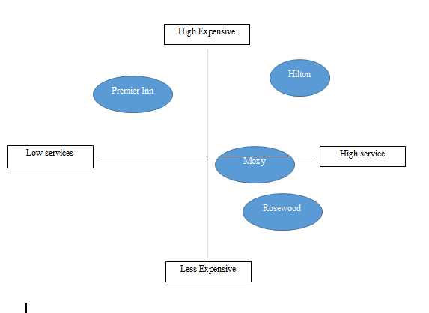

Appendix III:
Bowman’s Strategic Clock
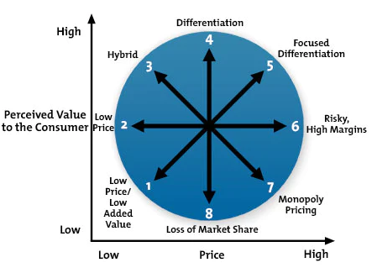

Appendix IV:
PESTLE Analysis
Political | - Tax restrictions in the UK.  - Political stability
Economic | - Changing inflation rate (Office for National Statistics, 2023)  - Low GDP rate in the country because of pandemic
Social | - Changing demands and preferences of customers  - Cultural trends
Technological | - Use of modern technologies

Appendix V:
Marketing Mix:
Product | - Moxy offers a different range of services to customers, including; a gym, furnished rooms, lobbies, bars, exciting themes and so on.
Price | - Moxy is a budget-friendly hotel.  - The hotel offers services with competitive pricing.  - It offers affordable options to customers along with luxurious services.
Place | - Moxy operates via both online and physical platforms.  - The brand maintains its excellent presence all across the world (Moxy Hotels, 2023 a).  - It is mostly located in trendy areas.
Promotion | - The main tool for promotion is digital marketing for Moxy (Moxy Hotels, 2023 b).  - Social media marketing, content marketing, and influencer marketing are also used for promoting hotel services.

Appendix VI:
Ansoff Matrix
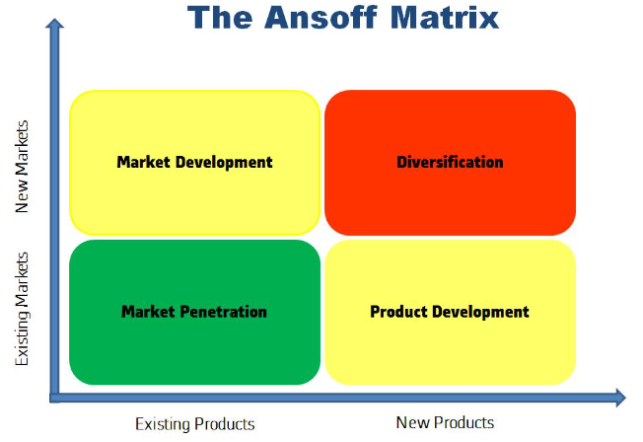

Component 2: Presentation



