Eco Bike Hub Case Study
Yizhen Wang
Abstract
In order to effectively solve the problems encountered by Eco Bike Hubs, this paper develops a solution based on database-related knowledge. The article consists of four parts: the comparison between SQL and NoSQL, Performance Tuning, Transactions, and Distributed Databases Solution.

Catalogue
1. SQL and NoSQL 3
1.1 SQL description 3
1.2 NoSQL description 4
1.3 SQL vs NoSQL 7
2. Performance Tuning 8
2.1 Index description 8
2.2 Addition of secondary index 9
2.3 Advantages of building indexed columns 10
3. Transaction 10
3.1 Transaction description 11
3.2 Solution for problem a 12
3.3 Solution for problem b 12
4. Distributed Database Solution 13
4.1 Distributed Database description 13
4.2 Solution 13

- SQL and NoSQL
  - SQL description
SQL database refers to relational database. Relational database is a database management system based on relational model, which mainly uses the idea of set algebra in mathematical concepts to organize and manage data. The relational model includes three parts: data structure, operation set and integrity constraints. Among them, the relational data structure is mainly represented by the entity relationship model, and the operations on the data are mainly divided into add, delete, modify and update operations; the relational set operations mainly include data query, selection, projection, connection, union, intersection, difference and other operations ; The integrity constraints of the relational model include entity integrity, referential integrity, and user-defined integrity.
Transaction is one of the most important features of relational database, which is a complete logical process composed of a series of database operations. ACID is the four necessary conditions for the correct execution of database transactions, which refer to atomicity, consistency, isolation, and durability. The specific meanings are as follows:
Atomicity: The execution of the transaction is atomic, during the process of the transaction, if an error is reported, the transaction will return to its initial state;;
Consistency: Before and after the transaction is executed, it is necessary to ensure that the integrity constraints of the database are not destroyed;
Isolation: Different transactions are isolated and invisible to each other when they are executed concurrently, and transactions will not view the data in the intermediate state;
Persistence: After the transaction is completed, the results of its operations on the database will be permanently persisted in the database.
Among them, the relational database maintains the atomicity, consistency and durability of the transaction through the log, and the isolation of the transaction is realized through the lock mechanism.
At present, the most widely used relational databases include commercial databases such as Oracle and IBM DB2, and open source databases such as SQLite and My SQL.
  - NoSQL description
The concept of NoSQL (Not Only SQL) has a long history, dating back to 1998
However, it was not mentioned again until it entered the era of big data in recent years. The main reason is that traditional relational databases encountered performance bottlenecks when faced with massive data, while NoSQL data can be better solved - massive data and high concurrency Read, efficient access and database high scalability, high availability - these "four high" problems.
CAP theory is the cornerstone of NoSQL database, which mainly includes the following three aspects:
Consistency, the data on all nodes is kept synchronized at all times;
Availability, each request can receive a response, whether the response succeeds or fails;
Partition Tolerance, the system should continue to provide services even if there are message loss partitions within the system.
NoSQL database is constrained by the CAP theory, and it is impossible to achieve a perfect design of high consistency, high availability, and high partition fault tolerance at the same time, and can only satisfy two of them at most. The CAP theory is shown in Figure 1.
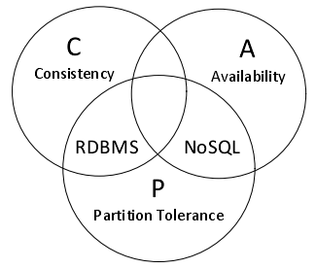
Figure 1 CAP Theory
Traditional relational databases choose high availability and consistency, which will inevitably lead to poor partition performance, so the scalability of relational databases is relatively poor. The NoSQL database sacrifices strong consistency, and usually only needs to meet the eventual weak consistency in exchange for high partition fault tolerance and high availability of the system. At present, there are many types of NoSQL databases, each of which provides solutions for different application scenarios and has its own characteristics.
NoSQL databases have no pre-set schema and are ideal for storing semi-structured as well as unstructured information. At the same time, it has the characteristics of high throughput, high availability and scalability. It is currently widely used in the Internet industry. For example, Google uses the self-developed NoSQL database Big Table to provide massive data storage services for Google's map, finance, search and other businesses. Facebook uses the NoSQL database Cassandra to store terabits of data per day for their users. Next, this article will briefly introduce four types of NoSQL databases:
(1) Key-value database: The principle of this type of database is to use a hash table, so that the Key value and the Value value are in one-to-one correspondence, and the corresponding Value value can be quickly queried according to the Key value information. This type of database has the advantages of fast query speed and easy deployment, but the data is unstructured and is usually used to store string and binary data. Mainly used in content caching, logging system, etc. The more representative ones are Tokyo Cabinet, Redis, Memcache DB, etc.
(2) Column storage database: This type of database stores data in columns, and the same key value corresponds to multiple different values. It is suitable for storing structured and unstructured data, data compression is easy, and the query speed for a certain column or several columns is very fast, but the functions are relatively limited. The most representative ones are HBase, Hypertable, etc.
(3) Document database: It is mainly suitable for storing semi-structured documents such as json, and supports indexing of certain fields. The main advantage is that the table structure is variable, and there is no need to pre-define the table structure and its data structure is not strict. Currently, Couch DB, Mongo DB, Sequoia DB, etc. are widely used.
(4) Graph database: The main principle of this type of database is to use the data structure of graph and algorithms such as N-degree relationship search. Such databases can handle massive amounts of responsible and interrelated data, and are mainly used in social networks, relational graphs, recommender systems, etc. The current mainstream graph databases include Neo4J, Info Grid, Infinite Graph, etc.
  - SQL vs NoSQL
SQL | NoSQL
Use tables to store related data | Store key-value pairs using JSON-like documents
The target schema needs to be defined before using the table | No specific schema is needed during storage operations on data
Promote the use of normalization to reduce the likelihood of redundant duplicate data | Store information using denormalized standards to guarantee that a computer file includes all the information of an item
Supports the use of JOIN operations to retrieve related data from multiple tables using one SQL statement | No need for JOIN operation
Data integrity constraints need to be met | Allows data to be stored anywhere without authentication
Achieve data consistency through the use of transactions | Implemented that during the update process, the object document is always single instead of multiple
Use the powerful SQL language for query operations | Provides excellent performance and scalability
Provides extensive support, Professional skills and Auxiliary tool | Query using JSON data object

- Performance Tuning
  - Index description
One of the best ways to reduce disk I/O and logical reads is to use indexes. Indexes allow SQL Server to find data in a table without scanning the entire table. The index uses a B-tree as the storage structure, so the operations required to query a specific row are minimized. Using indexes can greatly facilitate the people who use the database, saving them operation time to deal with other more important things. SQL Server provides a tool to simplify and automate database maintenance. The tool, called the Database Maintenance Plan Wizard (DMPW), also includes optimizations for indexes. If you run this wizard, you'll see statistics about indexes in the database, which work as logs and are updated regularly, thus reducing the workload of manually rebuilding indexes.. Features of the index include:
1. The index can speed up the retrieval speed of the database;
2. The index reduces the speed of maintenance tasks such as database insertion, modification, and deletion;
3. Indexes are created on tables, not views;
4. Indexes can be created directly or indirectly.
  - Addition of secondary index
By understanding the business scope and database requirements of Eco Bike Hubs. I feel that in the process of using the database, a lot of customer-related information needs to be added. Of course, the most important one is the customer's name, so that the customer's name can be matched with his needs. Then the problem arises, the customer's name is very likely to be repeated, so it is definitely not enough to query the customer's name alone, so when looking up the customer's name, the system should ask to enter all including the first and last name. To achieve what I said, I created a customer name index to improve query efficiency.
It is understood that each store has: [1] member responsible for customer bookings, whether it is sales, service or repair. [2] A mechanic who is responsible for and records service or repair work. The customer's bike must be tracked from the front of the store until repaired and returned to the customer. [3] Customers wishing to transact are handled by one employee at each store, but no more than 20 transacting customers per employee at any given time. Therefore, in order to be able to correspond customers to service employees, an employee name index is also necessary. Similarly, full names including first and last names are required.
CREATE INDEX StaffName ON Staff(FirstName,SurName)
I learned that Eco Bike Hubs also has a bike rental service. Customers can rent bikes as needed and available, but the date and time must be recorded. Therefore, when a customer wants to rent a bicycle, the staff needs to quickly check the information about the bicycles that are currently available for rent. Under normal circumstances, customers will first describe their ideal rental time period, and then the staff will select the bicycles that can be rented in the corresponding time period in the system to see how many types are available for customers to choose. So I created an index of bike info with start and end times for bike rentals.
CREATE INDEX BikeInfo ON BikeBooking(StartTime,EndTime)
  - Advantages of building indexed columns
In my opinion, the biggest advantage of building a column index is that it can greatly improve the speed of retrieving data from the database and improve the overall efficiency:

First of all, as mentioned earlier, the biggest contribution of the index is to speed up the search and improve the efficiency of database processing. Then, corresponding to the column, for any database, there must be some columns that need to be used frequently, so it becomes equally important to improve their efficiency. Moreover, for columns that often need sorting or range retrieval or are simply used, creating corresponding indexes has the same advantages as columns, that is, shortening query time, speeding up condition judgment, and improving overall efficiency. In general, in the process of informatization processing, efficiency is one of the most important indicators, so it is imperative to improve efficiency, and any measures that can help increase efficiency should be taken into consideration.
- Transaction
  - Transaction description
In my opinion, a transaction is actually a guarantee mechanism. It exists to ensure that when the business is not fully executed and successful, it can be rolled back to the original state. A guarantee mechanism. In fact, after the transaction is opened, all operations will be temporarily saved in the transaction log. The transaction log will only be synchronized to the data table when the commit command is obtained. In any other case, the transaction log will be cleared (rollback, disconnection).
These SQL statements are submitted to the system as a whole, either all or none of them are executed
Grammar steps:
Start a transaction: BEGIN TRANSACTION -- start a transaction
Transaction commit: COMMIT TRANSACTION -- commit operation
Transaction rollback: ROLLBACK TRANSACTION -- cancel the operation
  - Solution for problem a
This section is to address an issue that Eco Bike hubs has noticed in their system: Sometimes bicycle repair bookings are recorded but the details of the specific return date(s) as requested by customers are not registered in the system.
I created a transaction to add new subscriptions that might be needed. The first thing that needs to be done is to add the reservation information to the system, and then check whether the detailed information of the specific return date requested by the customer is already recorded in the system, that is, it has been registered in the system. If not, go through the error reporting process and abort the transaction. If the date already exists, it can be submitted. The details are shown in Figure 2:
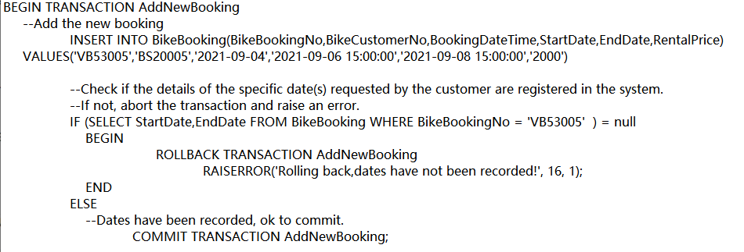
Figure 2 Implementation code

  - Solution for problem b
This section is to address an issue that Eco Bike hubs noticed in their system b: Customers are able to book bicycle hire times that are not registered as possible schedules available.
I created a transaction to add new booking information. First, add booking information, then check if the customer can book a bike rental time that is not registered as an available timetable. If not, go through the error reporting process and abort the transaction. If you have not registered, you can submit it. The details are shown in Figure3:
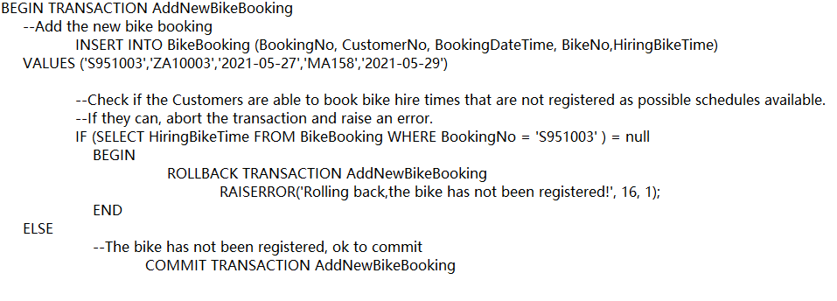
Figure 3 Implementation code

- Distributed Database Solution
  - Distributed Database description

Distributed database systems usually distribute multiple small and independent computer systems on multiple sites on a computer network. Each computer system is a relatively independent complete body, which can be regarded as a centralized database. It has its own independent database, database management system, basic hardware and software, etc., and can complete local work independently. The computer systems of each site are connected through a computer network to form a logical whole similar to centralized database operations. Based on the distribution and redundancy of data, users can store data in different sites according to actual needs. Therefore, the data stored in each site of the distributed database is different, and the data on each site can be based on the user's query. mutual transmission. Generally speaking, a distributed database management system is a software for corresponding management of distributed databases, and is mainly responsible for managing logically integrated data access, data consistency and data integrity in a distributed environment.
  - Solution
BikeBooking table(BookingNo, CustomerNo, BookingDateTime, BikeNo, HiringBikeTime)
Since the rental bike time booked by the customer is different, the horizontal segment can be used according to the rental time booked.
P₁: σ _{HiringBikeTime = ‘2021-09-08’} (BikeBooking)
P₂: σ _{HiringBikeTime = ‘2021-09-11’} (BikeBooking)
Reconstruction: P₁ ∪ P₂
BikeBooking(BikeBookingNo,BikeCustomerNo,BookingDateTime,StartDate,EndDate,RentalPrice)
I take into account that each bike will definitely vary in price due to differences in build or materials. Then, I think it is possible to divide the booking message according to the different price ranges of bicycles and use horizontal fragmentation.
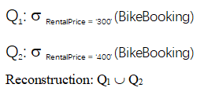
BikePrice(BikePriceID,BikePropertyRef, RegularBikePrice, ProfessionalBikePrice)
Different customers have different requirements for the bikes they rent, and regular bikes will definitely cost less than professional bikes, so I use mixed fragments to classify the information of the same bike and the same bike price.

Horizontal fragments:
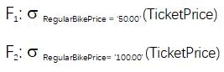
Vertical fragments:
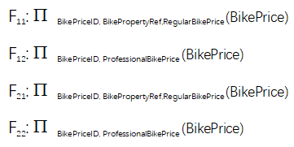
Staff (StaffNo, FirstName, Surname, Gender,DOB, Position, Salary, Bonus, ContactNo, EmailAddress, StartDate, LeavingDate)

I consider that different employees correspond to different positions, and the information must be different, so they can be separated from the employee information table. At the same time, I think the information in the salary column is more important, so I separate the salary information from other information separately. I decided to use a hybrid fragment approach.

Horizontal fragments:
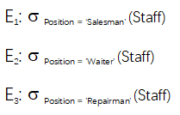
Vertical fragments:
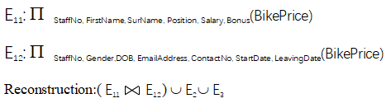
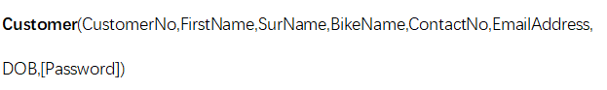
Using derived fragments for the customer table, each customer has its own predetermined repertory title.
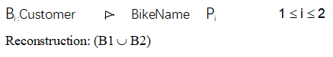

Reference


