ACCA5012
Assignment 2
nathan morgan 1801338
2020

Abstract
In this report the main criteria of the application will be discussed and then the implemented application is broken down into its key areas, reviewed, tested and discussed and then the solution is evaluated, and the future improvements are specified.

Table of Contents
Abstract 1
Table of Contents 1
Requirements 2
Design and Implementation 3
Screen shots 5
Evaluation 9
Reflection 12
References 12

Requirements
The designed web application was designed to fill the gap that currently exists amongst the top games being held on different platforms, the idea of the application is to bring all of the top shooter titles under one roof and allow the customer to purchase them as necessary.
The database design adheres to the standards of data normalisation to reduce the amount of repeated data [1] and this is a key to designing a robust system. The data held in the tables that is repeated should be evaluated and from this have further tables created and linked to reduce the amount of redundant data. Ultimately a perfect database will cover all aspects to reduce the amount of redundant data but changes in the business model can’t be accounted for and if the client wished to implement further genres and wanted to implement further tables this is achievable in a small amount of time by applying the changes and migrating them to the application.
The main features of the application are the ability to purchase activation keys for the top games, create and use personal accounts, make a purchase using their accounts and browse the games with filters for narrowing the search.
The application adheres to the criteria of displaying data stored on an SQL back end to a web application view. The application has been designed to display the stored games, their prices, and their descriptions.

The next criteria adhered to, is to interact with the displayed and stored data, allowing the user to search, filter and sort the data that is being displayed with interactive elements on the web application.

The third criteria are to implement form validation. Form validation was implemented on the customer register screen, login screen and on the purchase screen. These are all in place to reduce the chance of human error occurring, this is essential on any web form as it can reduce the chance of problems occurring with incorrect data.

The final criteria were to implement CRUD [2]. CRUD is an acronym for create, read, update, and delete. This is common infrastructure implemented in relational database applications. For the designed application, a standard user does not need full access to a CRUD system so an organisation hierarchy is to be implemented so authorised users have access to CRUD operations. And standard customers do not get to interact with the database at a level that allows for those types of changes.

Design and Implementation
  - Main sections in no specific order

Shared: Enums
This section contains two files specifying sets of named constraints called enums[3]
The first file titles “GameFilterColumns” is for the filter for data interactivity.
The second file titled “GameSortOptions” is for the types of sorts provided in the data interactivity.

Shared: SQL
Here the developer creates and populates the database using SQL [4] or Structured Query Language. This is the language used to interact and store data directly with the database [5].

Shared: queryables
This folder contains one class file called GameFilterQueries.
It has three main methods.
The first method is ApplyQueryFilter. This method checks if the string is empty then applies the search filter to the string and then returns the chosen field base on the user specified filter box.

The Second method is the ApplyQuerySort. This method sorts the filtered data by the user specified order. Such as by the name of the game in an ascending order or descending.

The final method is the ApplyQueryFetchRange and this is used for the paging class that ultimately limits and fetches the data we view at any one time.

Shared: view models
These are the models for the views, the model typically handles the data logic and rules of the application.
The first file is the BaseFilterViewModel. This item is the parent of the GamesFilterViewModel, and it has the logic for finding the page count, the record count and skip count. These are typically used in combination with the view and controllers. These models receive the data from the controller and display it on the view.

The child of the BaseFilterViewModel inherits the methods of the parent and has its own parameters for filtering the data in the

Shared: DataSeeder
This is the class for defining the types of user and communicating user information with the server.

Web: areas for identity
This is where the HTML for the user controller was created, this is simple input boxes with validation for the creation and login for the users are held. This area is the front end for the views. Where the backend is the seed users in the shared section.

Web: Controllers
Three controllers were created for the application, The GamesPurchasesController, The GamesController and finally the HomeController. These are the classes for handling the data to be handed to the models and the views.

Web: Views
The views are typically what the user see’s so in the designed application there are 4 main pages for the user to see, the home screen where they’re informed about the business, the games page where they’re able to interact with the database to view the available stock and the privacy and attributions pages, showing where the content was obtained from.

Web: appsettings.json
This is essentially a configuration file where the server connection information is held, and the applications user types are defined.
Web: start-up
The start up file is the main configuration file for the entire application. This key file is where all the services methods are called, and the configuration is imported.

These main sections can be summed up into 3 key systems
the login system
a typical system that communicates with the database with a hashed password using asp.nets authentication system [6]. And a user hierarchy so admins have access to the CRUD operations.

the purchase system
Collect the user’s payment method, the media choice, and the customers identity.
the content
Display the content stored in the games table to the user with access to paging and searching features. Some of the content was generated using mockaroo [7].

Screen shots
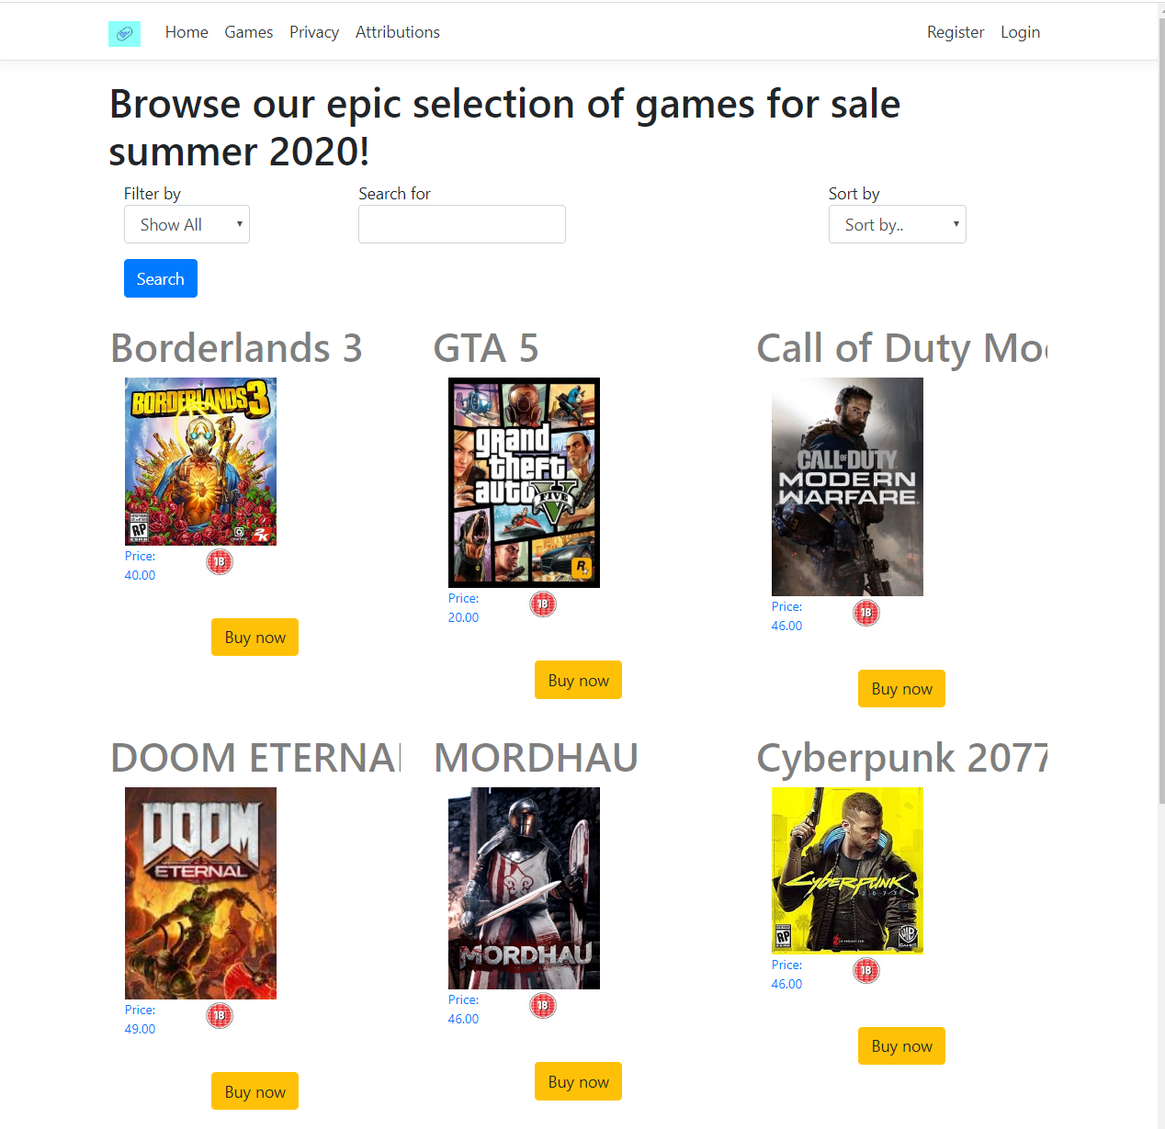
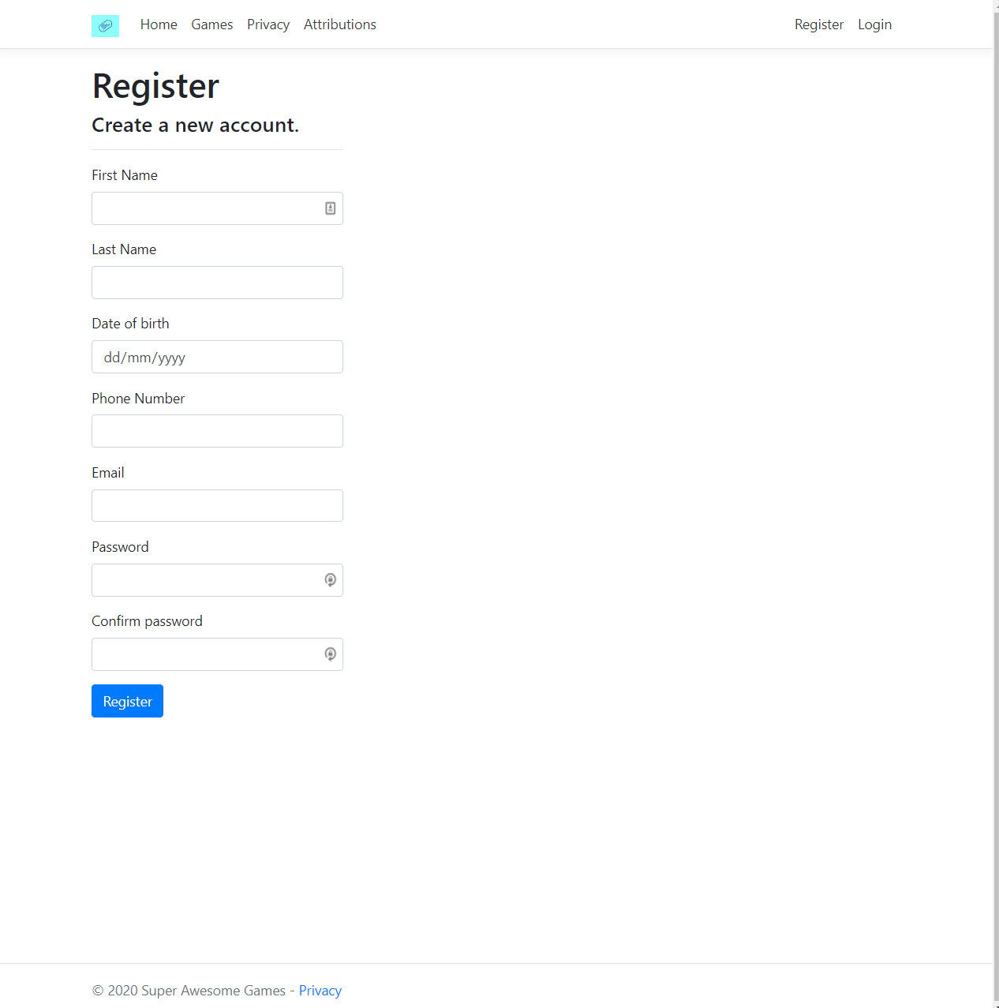
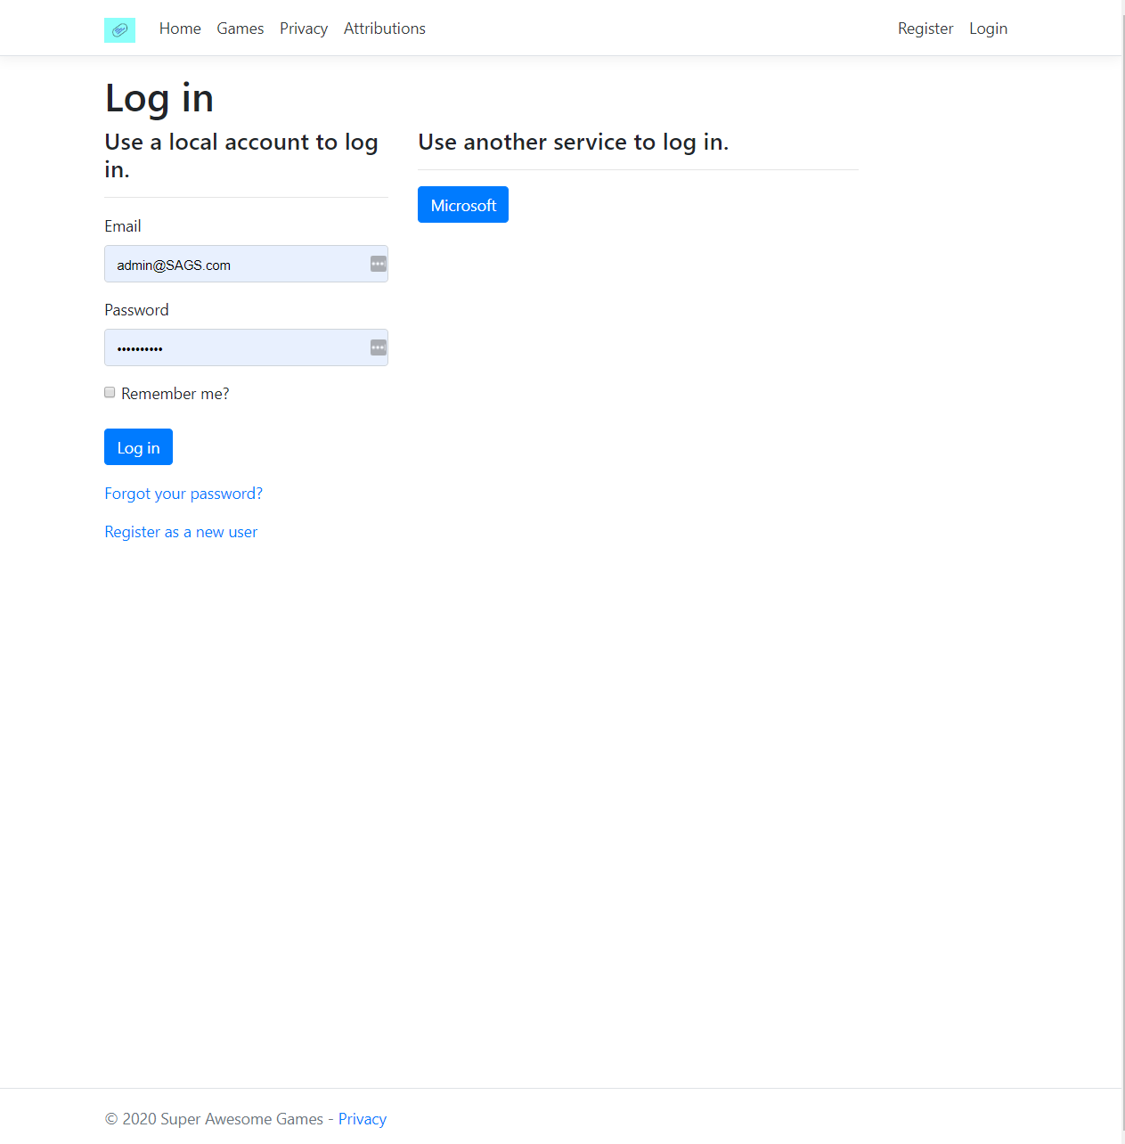
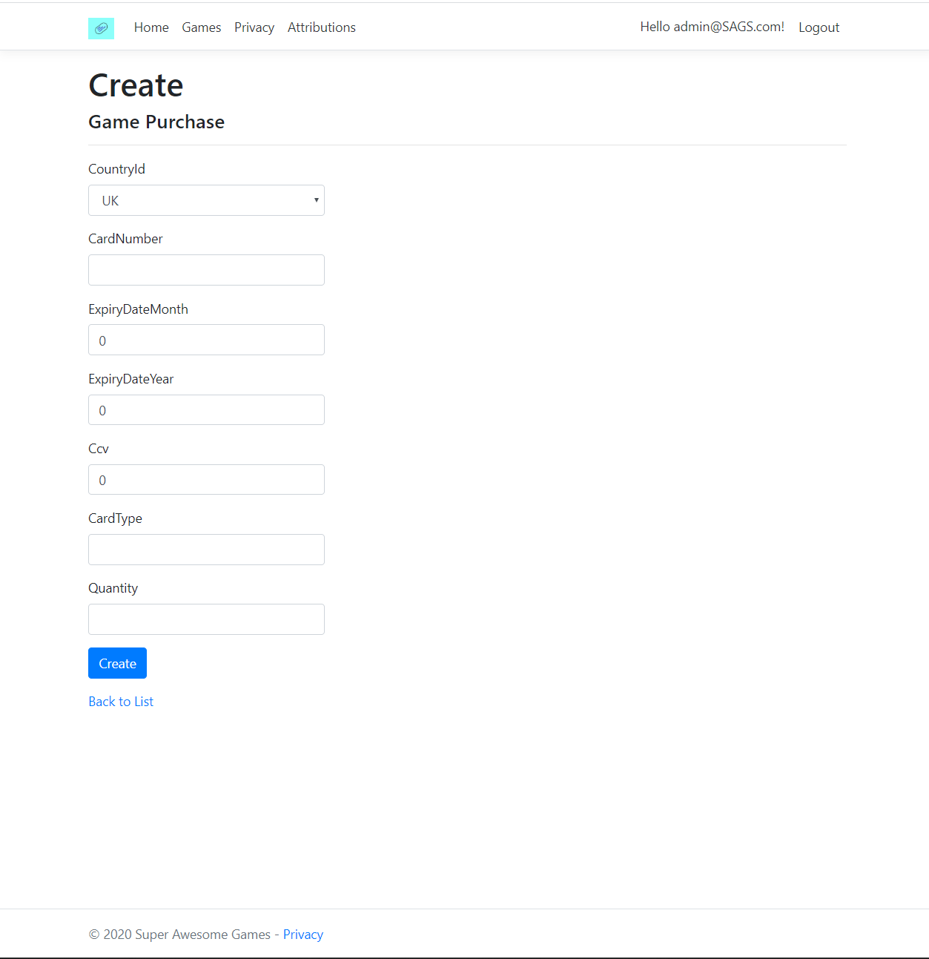

Evaluation & Testing
The games page Testing
Test Description | Preconditions or prerequisites | Test Steps | Test Data | Expected Result | Actual Result | Status
Go to details |  | Click on an item |  | Go to details | Go to details | pass
Detail user view | As user/guest | Check if crud operations are accessible while user |  | Not accessible | Not accessible | pass
Detail Admin view | Logged in as admin | Check if crud operations are accessible while admin |  | accessible | accessible | pass
Detail pages buy button |  | Takes to game purchase |  | Arrive at games purchase | Arrive at games purchase | pass
CRUD | As Admin | Test CRUD | Create sample case to test, edit it then delete it. | CRUD creates a new record, checks it exists, updates the record then delete it. | CRUD creates a new record, checks it exists, updates the record then delete it. | pass
Edit ;- upload image validation | As Admin; image exists | Upload a duplicate |  | Catches duplicates | Catches duplicates | pass
Create page upload image |  | Upload an image |  | Image is received on db | Image is received on db | pass
Back to list button from details |  | Click the Back to list button |  | Return to list of games | Return to list of games | pass

The games page purchases
Test Description | Preconditions or prerequisites | Test Steps | Test Data | Expected Result | Actual Result | Status
Prompt user to login | Nobody is logged in | Check if prompted to login on going to purchase screen |  | Go to login | Goes to purchase | FAIL
Validation |  | Check if implemented validation works | Out of bounds data | Throw a warning up | Throw a warning up | pass
Autofill |  | When a user starts entering details does the option to autofill work? |  | Autofill data | Data was autofilled | pass
Other peoples purchase |  |  |  | Not able to see other peoples purchases | Not able to see other peoples purchases | pass
Back to list |  | Takes to game purchase |  | Arrive at games purchase | Arrive at games purchase | pass

The customer sign up page
Test Description | Preconditions or prerequisites | Test Steps | Test Data | Expected Result | Actual Result | Status
On register | Form filled correctly | Creates account |  | Account added to database and logs user into created account | Account added to database and logs user into created account | pass
Validation |  | Check if implemented validation works | Out of bounds data | Throw a warning up | Throw a warning up | pass
Autofill |  | When a user starts entering details does the option to autofill work? |  | Autofill data | Data was autofilled | pass
Login to created account | Test if exists for standard user and admin | Try to log in to the created account |  | Logs in with the registered account | Logs in with the registered account | pass

Searching and paging functional testing
Test Description | Preconditions or prerequisites | Test Steps | Test Data | Expected Result | Actual Result | Status
Filter | Set the filter to by name and search string | Set filter/search string click search | gta | Goes to the search criteria by filter. | Goes to the search criteria by filter. Filter by price didn’t work due to datatypes. | Pass(3/4)
Search text | Clear fitlers and sorts | Type any asset name | gta | Shows the closest matching asset first | Shows the closest matching asset first | pass
Sort by | Repeat the previous test steps | Sort by other than default and check the change works |  | Orders it by the closest matching sort filter asset |  | pass
Next page |  | Click next button |  | Goes forward a page when clicked | Expands page instead of populating correctly | PASS
Previous page |  | Click previous page |  | Hides if pagenumber is 1, goes back a page when clicked | Expands page instead of populating correctly | PASS
Active page highlight |  | Active page will display with blue highlight |  | Displays active page | Expands page instead of populating correctly when clicked | pass
Number of items per page |  |  |  | Starts at 10, can be adjusted. | Adjusts as defined | pass

Reflection
The designed web application fills the client’s specifications and meets all the criteria for viewing and interacting with the data. The Web application adheres to the standard web design principle of header body footer and lays the content out in an easy to digest format.
For the personal aspect of the reflection, a severe lesson was learned about google chromes cache and how it can impact style changes.

The web application is scalable and easily upgradable if further implementations are required.
A suggested implementation is for the client to distribute more than one type of genre and with this the filter and database can be updated to reflect this in a short amount of time.

A further suggested implementation would be to incorporate Facebook and googles API [7] for authentication with the web application. This would be a quality of life upgrade for users and ultimately reduce the amount of time logging in and enhance the security of the accounts.

Another upgrade would be to implement a more interactive background, perhaps gifs of the gameplay for the relevant titles. This upgrade would be for vanity, and more so perhaps limit it only to the larger screen sizes as it will more likely be a computer rather than a mobile device.

Further improvements for styling would be more universal picture sizing achieved through more aggressive use of CSS.

While viewing other pages perhaps have a mini advert playing in the different empty spaces on the screen, with adverts leading to a game title in the store.

References

[1] | C. date. [Online]. Available: https://web.archive.org/web/20050404010227/http://www.aw-bc.com/catalog/academic/product/0,1144,0321197844,00.html.
[2] | J. Martin, “Managing the database environment,” [Online]. Available: https://books.google.co.uk/books?id=ymy4AAAAIAAJ&pg=PA381&dq=%22CRUD%22&redir_esc=y.
[3] | “enums,” [Online]. Available: https://en.wikipedia.org/wiki/Enumerated_type.
[4] | WIKI, “SQL,” [Online]. Available: https://en.wikipedia.org/wiki/SQL.
[5] | M. Chapple, “SQL fundamentals,” [Online]. Available: https://www.lifewire.com/sql-fundamentals-1019780.
[6] | asp.net. [Online]. Available: https://docs.microsoft.com/en-us/aspnet/mvc/overview/security/create-an-aspnet-mvc-5-web-app-with-email-confirmation-and-password-reset.
[7] | Wiki, “API,” [Online]. Available: https://en.wikipedia.org/wiki/Application_programming_interface.
[8] | mockaroo. [Online]. Available: mockaroo.com.

