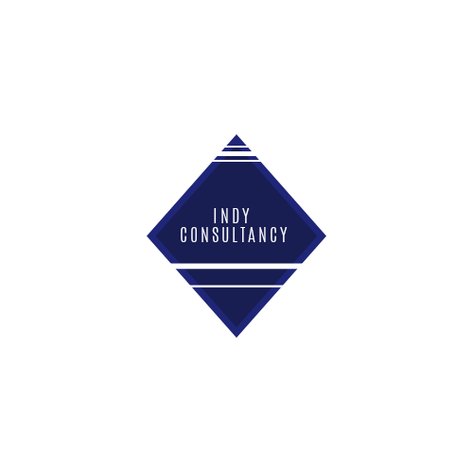

M6X01930
Student: Dayna Mehandzhiyska
1815045
Lecturer: Efua Adams

Contents

I. Project definition 3
1. Purpose 3
2.Objectives 4
3.Project Scope 4
4. Deliverables 5
5. Constrains 5
II - Confidence in the Audit Team 5
Project team and audit plan 6
1. Our team 6
2. Project and quality control 7
3. Dates 7
Consultancy report 8

Project definition

Purpose

Indy consultancy is a company oriented entirely toward the needs of its customers, placing itself entirely at the service of their business goals and needs, providing them with competitive advantages over others in the industry. Our mission and goals are to offer each of our clients an individual approach.
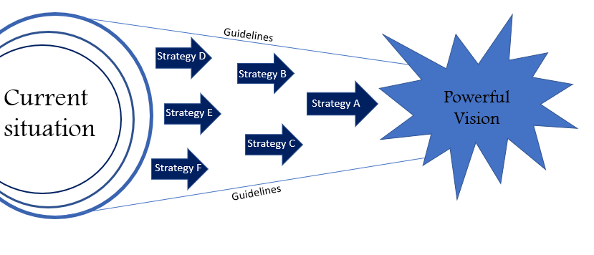

Our purpose is to assist, guide and benefit Marriott Heathrow London with the auditing process, indicating and outlining all possible flaws and respectively find their best resolution.
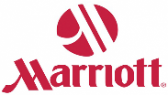
Marriott Heathrow London is hotel, conveniently located near London Heathrow airport. It is newly renovated sophisticated 4-star hotel, offering relaxing stay pre-, or post-, flight. The number of rooms available at the property are 393 which include standard rooms, business rooms, family rooms, president and junior suit. The guests are also able to enjoy the hotel’s swimming pool, gym and Leisure Club facilities including sauna, spa-pool, and steam room.
The Marriott brand sets standards globally to ensure that every guest enjoys the same service at each and every hotel in any part of the globe, by conducting an annual brand standard audit, the particular hotel may determine the areas they adhere to the brand standard as well as which areas require work to achieve or sustain the standards.
We are established company, known for its accuracy and dedication to its clients, with many years of experience behind our back. This experience allows us to use all the methods, techniques and knowledge we have, to make the best possible analysis that will give you a complete and realistic assessment of the state of your business. This would help you significantly to take your business to the next level.
Different sources should be used in obtaining audit evidence so that the evidence can be corroborated, thus making the relevant audit findings more reliable, and so it can be ensured that different points of view are considered.
- through interviews, questionnaires, focus groups, direct inspections and observations
- provided by the Hotel- information from databases, documentation, activity reports e.g. (reports of the internal audit structures, assessments of impact and ex-post evaluations).

2.Objectives

The process will take twelve weeks and we will dive in as deep as possible into detailed examination. This way, sufficient, relevant, and reliable evidence will be obtained in order to reach a conclusion on the audit issues and substantiate the audit findings and conclusions, ensuring that the content of the audit report will withstand critical scrutiny.
As using point system, we will decide whether the standards of the brands are met on the basis of what the cleanliness; condition; operations; service; financial Performance; employee engagement; facilities Management; leadership have scored.

3.Project Scope
- Heathrow Airport plays a crucial role in retaining the world's largest and most important position on the London aviation market. It offers over 70 per cent of UK long distance flights and handles more value-added freight than all the other UK airports combined. The area of the airport is densely populated.
There is a large choice of local buses that can take the guests to local towns.
Marriott Heathrow is one of the closest hotels to Terminals 2 and 3 and it is one of the finest in this area, it also has a sister hotel called Marriott Windsor / Heathrow 4 miles away, which also are used as an airport hotel. Marriott Heathrow is in a good location and unlike many hotels at Heathrow, it is easy for the guests to access the local pubs and restaurants nearby.

There are several attractions in the area with accessible transportation from Marriott Heathrow including Windsor Castle, Hounslow Urban Farm, Legoland Windsor UK, Hampton Court Palace etc.
Considerable number of 4-star hotels are situated in the area, in addition to that their price per night is similar, some of them have small difference in their guest rating, in their favour, which leaves Marriott Heathrow room for improvement. Some of the brands are Novotel London Heathrow, Hilton Garden Inn, Renaissance and Radisson Blu Edwardian, have similar price per night. Worth to mention are also the nearest budget options of hotels e.g. Premier Inn and Ibis styles.

4. Deliverables

At the end of the 12-week assessment, complete report will be provided to the hotel general manager and it will include analysis hotel departments efficiency. The subjects of examinations are as follows: Front office; Executive club; Kitchen; Food and beverage; Housekeeping; Leisure (fitness centre and pool); marketing;
We will address the areas which are branded features or services and award them with relevant points, where afterwards the total number of points on the report with action proposals.
Food safety items will hold fail or Pass. Failed objects will require a strategic action plan, which will be finished within 30 days of completion of the examination.

5. Constrains

- According to government plans, the system will end dependence on the labour from Europe. Concerns about high emigration from European Union countries are one of the main reasons for concern as this may affect labour force. According to the British Migration Advisory Council, around 70% of European Economic Area citizens arriving in the UK after 2004 would not meet the new visa criteria
- Coronavirus - As more individuals fall ill, coronavirus is likely to lead to a temporary lack of workers. Whether this is due to quarantines or workers making the decision to stay home, the end result is the same: companies and governments will be pressed to find laborers. This is likely to result in reduced Economic output.

II - Confidence in the Audit Team

We in Indy consultancy are a team of professionals working with love and enthusiasm. Over 30 years the company established itself as a leading audit company, with high quality of the services we provide. Our goal is not only to support the business of our customers through practical and specific advice, but also to provide them with useful and valuable information and alternative solutions. This is guaranteed by our highly qualified associates who have significant experience in the sphere, as well as in the environmental area, finance and renovated properties team members. We have worked with leading hotel brands on the market. Driven by the desire to build and maintain long-term relationships with our customers, we apply a creative and individual approach, high professionalism, ethics, respect and care to all our partners. Guarantee for honest and unbiased professional opinion. To carry out our audit procedures, we use the best and proven global practices and standards in the field of auditing.
The audit report issued by us is a guarantee for honest professional opinion obtained on the basis of detailed and in-depth analysis through the use of approved audit methodologies. As there is more than one competitor in the area of Marriott Heathrow Hotel, we are confident that our company can help and guide you towards success and differentiation from any other hotel.
Like most of our other services, we perform entirely at fixed rates. We believe that this expense should really be negligible given the long-term benefits that the hotel will receive itself from the improved operation. Our required fees are 2300£ for the brand standard audit, thorough consultancy report plus other expenses such as accommodation, meals on shift for every team member and transportation fees.
We are committed to our clients and understand that there are risks with the undertaking of this project, as well concerns from your side. Our company, however, is unshakable in terms of the precision of our experienced team. For your own comfort and peace of mind we offer one of your team associates to monitor the way we behave, and how we are going through. We are aware that the behaviour of most of your associates at the beginning will be at its best, due to our presence, which may affect the accuracy of the report, but we are confident that after the 12 weeks of working along with them, our assessment will be accurate.

Project team and audit plan

Our team

The project manager will be me – Dayna Mehandzhiyska, and we will keep close touch to make sure that all your questions are answered in clear and precise manner. I have more than 20 years’ work experience within the Marriott hotels, as starting from their educational bachelor course program, to the position of regional manager after a long way.
Our team will consist of two registered auditors, one assistant auditor and consultant. Over the years, our team has developed and grown, constantly expanding its knowledge and skills through various forms of training and qualification.

- Anne Lane - Our managing partner, registered auditor, and certified public accountant, Master of Economics, specialty "Accounting and Control"
Leading Specialist in the field of audit, with more than 20 years of experience, and background of working with numerous renovated properties from leading hotel brands.
- Martin Davies - auditor, expert Integrated solutions (business law, taxes, corporate finance, accounting, control) Master of Economics, specialty "Accounting and Control"

holds a certificate of mediator and is a leading specialist in the transformation and restructuring of companies and businesses. He specializes in the field of tourism, tax optimization, and corporate finance.
- Joanne Ivanova – Assistant auditor, Master’s degree in accounting and finance, passionate about customer service with background of working with hotels around the globe for over 15 years. Another way for your staff to adopt environmental practices is to start with composting. An unpleasant pile of garbage can reduce your waste and even lead to fertile soil, which you can then use for landscaping projects directly in your hotel. this fertile compost soil can even help you create your own herb garden from which your cooks can pick dill, parsley, rosemary and more.

Project and quality control

- As part of our audit engagement, efficient communication plays a big part of the process. We will make sure that there is direct flow of information between us and we will inform you weekly about the progress, via email and schedule meetings every two weeks.
- We will make sure that all departments are covered and will schedule our shifts throughout different times of the day, as this will give us more information.

Dates

• Start Date for Audit commencement 20th of July
• Completion Date for Audit 21st August

Consultancy report

Contents

Lobby arrival/ Front office………………………………………………………..………………………….….3
Arrival experience/Exterior 3
Guest Check-in 3
Bar area 3
Room service 4
Restaurant 4
General bedroom 4
Bathroom 5
Lobby 5
Public restrooms 5
Elevator 5
Corridors 5
Fitness centre and pool 5
Meeting/function rooms 6
Back of house 6
Food safety 6
Sales and Marketing 6
Guest service delivery 7
Financial Management 7
Employee Engagement; Training & Creative Development 7
Leadership 8
Green Hotel 8
Property maintenance 9
Conclusion……………………………………………………………………………………………………..…9
Appendix………………………………………………………………………………………………..……….10

Department | Points available | Achieved points
Lobby Arrival / front office | 45 | 45
Arrival experience | 15 | 15
Guest Check-in | 135 | 130
Bar | 205 | 85
Room service | 150 | 150
Restaurant | 265 | 195
General bedroom | 320 | 320
Bathroom | 220 | 220
lobby | 50 | 50
Public restrooms | 80 | 80
Elevator | 20 | 10
Corridors | 50 | 50
Fitness centre and pool | 100 | 100
Meeting/function rooms | 80 | 50
Back of house | 110 | 100

Department | Pass | Fail
Food safety | 10 | 0

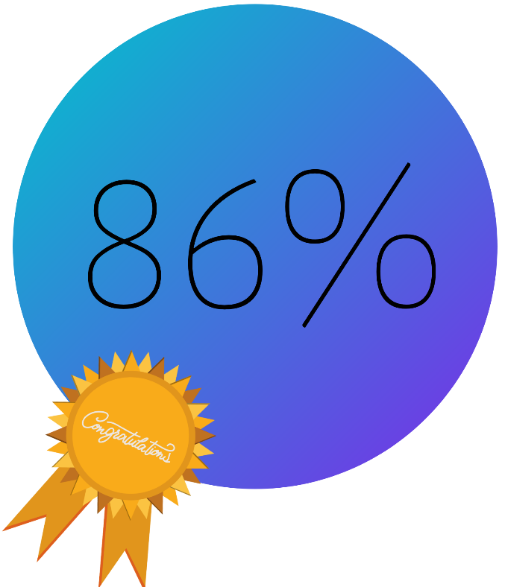

We would like to take this opportunity to thank Marriott Heathrow London for choosing and trusting Indy consultancy, and giving us the opportunity to work alongside their extremely professional team. After thorough investigation and analysis during the weeks spent in the property, we conclude that the hotel will pass the brand standard audit with overall score of 86% for which we would like to congratulate you and your associates. The pages shown in this document divide the rating into departments and strategic areas with specific suggestions for further improvement of the score at forthcoming audits.

- Lobby arrival/ Front office
Score 45/45

Marriott Heathrow London associates are very friendly, positive and responsive. They connect with the guests from the first moment they enter the property. The main reception is never left without a team member on duty. The front office manager is monitoring the procedures during peak times and assuring that the VIP guests are being greeted personally by him. Front office’s associates are Overall, the first impression and experience on arrival are excellent.

- Arrival experience/Exterior
Score 15/15

The condition of the hotel exterior is good and overall Marriott standards are met. The British and Marriott flags are well maintained.

- Guest Check-in
Score 130/135
A warm welcome is offered to guests on arrival at the hotel, the team is in good shape, the standards for uniforms and name tags are met. There is s problem with the discretion in providing the room number, as the associates were saying it out loud in the presence of other guests. This could be easily solved by brief team meeting where the managers and the staff can discuss the problem and find appropriate ways for the performance of the task. The customers are greeted with appropriate language. Once the associate has reviewed the payment method and the checking procedures are done, a key card packed is handed over and clear directions to the elevator are given.

- Bar area
Score 85/205
There is warm and polite greeting on arrival at M club. Good interaction exists between the associates and the guest. The uniforms and appearance of the team are excellent and customer assistance is offered at any time. The selected music is appropriate, and the food and drinks are well presented, in good quality, and meet the standards. The overall cleanliness is poor, especially during busy times, due to the weight of work carried by the remaining associates. I recommend at least one more person to be hired, as there are only two associates currently working there, and the manager cannot always be available to help. This way the team will not be so pressured and will be able to provide better service, and in the same time improve cleanliness of the workspace.
- Room service
Score 150/150
I have no complaints regarding the room service as everything was in order. I received a warm greeting over the phone and the associate was attentive and polite. I got advised in my choice, clearly the team member was knowledgeable about the menu offerings. The food was delivered on time and the associate was polite and caring. All standards were met.

- Restaurant
Score 195/265
At breakfast I was greeted by a team member seemingly whose uniform was in good condition. The associates were polite and always ready to give further assistance to the guests. Table setting, food selection on the buffy, and hot drinks, all met the criteria. There was a whole range of different breakfast dishes. Alternatives for the guests with different dietary requirements were provided as well. M club’s manager welcomed me with my entrance with friendly approach, he made my experience more personal, as he advised me which dishes are appropriate for vegans and offered his help during my stay in the lounge. I was offered a teacup ‘’to go’’ by an observant associate. A children’s menu was available and met the standards. With regard to the cleanliness of the workplace, as I mentioned before, I found the same problem concerning the shortage of staff.

- General bedroom
Score 320/320
The first impression of the hotel’s bedrooms was good. Guest room recycling meets the brand standard. There is a full range of coffee equipment in the rooms and all items were in place. The rooms have good television, that also meet the brand criteria. There are closet and ironing amenities, as well as safe. It was obvious that the housekeeping department associates maintain very good level of cleanliness. No shortcomings were found in terms of the condition of the rooms, which is good and expected, considering the recent renovation of the hotel.

- Bathroom
Score 220/220
Overall, the bathroom is in exceptional condition and, undoubtedly, the housekeeping team is taking good care of it. The products and towels available met the brand standard. The bathroom amenities such as hairdryer and wastebasket were in good shape. The condition of the toilet, fixtures, vents, shower and bathtub was very good. Regarding cleanliness all standards were met.

- Lobby
Score 50/50
Marriott Heathrow’s lobby outlook is excellent, the team members are taking care the good hotel image to be maintained. Guests can enjoy computer and printer services. The furniture is kept clean and in good condition. The team is friendly, behaves extremely professionally, offer further assistance to the guests, and makes every conversation very personal, so that the customers feel comfortable. When guests arrive in the hotel after long flights, probably nervous, and need such a warm and understanding welcome.

- Public restrooms
Score 80/80
The public restrooms were kept clean and the supplies met the standards, the responsible for the public area associates are constantly corresponding with the manager on duty and in case of occurred issue they can respond on timely manner.

- Elevator
Score 10/20
The elevator cleanliness is generally good, however some of the service elevators were out of service which troubled the free access and flow between the floors and caused confusion between the team members in peak times. This problem should be fixed as this is causing frustration between the associates. We recommend more frequent inspections in order to avoid breakdowns and long-term complications. Problems can become significant if left untreated, putting guests and technicians at danger. That being said, the simplest way to deal with these problems is to catch them before they get any worse. To have an elevator company perform regular service on your unit will guarantee that your lift continues to remain ready for use.

- Corridors
Score 50/50
The guest hallway/ stairwell signage looks very professional, well maintained and in good condition, all the standards were met. The stairways, doors, ceiling and vents were in good condition. The furniture. Equipment and decoration were in good shape. When I was crossing the corridors, I noticed how well the housekeeping associates were taking care with regard to the cleanliness.
- Fitness centre and pool
Score 100/100
The renewed fitness centre, even though quite small sized, was well equipped and in good condition, the pool and sauna were kept tidy and met the brand standard criteria for cleanliness and condition. Reception’s associates were friendly and welcoming, they provided me with towels which were in good condition. The Fitness Centre follows the required operating hours.

- Meeting/function rooms
Score 50/80
The meeting and function rooms cleanliness was not up to par and stains could be seen on the carpet, dark marks left on the white furniture, old food was left from previous meetings in the fridges and dusting on the vents. Such problems can be easily worked out with some regular cleaning by members of the team. Some cables were placed all around the room which could lead to trip hazards. The rooms are well equipped for all kinds of meeting activities and have beautiful decoration in every one of them. Our recommendation is to hold a team meeting and announce that changes need to be made. With their help you can divide them into pairs where they can clean different rooms and swop their tasks in-between every week. It is important to communicate and discuss the different options for resolving of the problem with your team.

- Back of house
Score 100/110
GuestVoice alert responses were met timely, in good manner, friendly, and in personalised way, showing care and responsiveness. The hotel’s associates showed excellent knowledge regarding Marriott Bonvoy loyalty membership benefits. When Art of hosting is held the associates thoroughly discuss different engaging topics, as well as how to optimise the stay of VIP’s in the hotel, if any.

- Food safety
Score 8 pass/ 0 fail
The personal hygiene was at a very high level and apparently the team was well trained. The food was stored in an appropriate way, and the facility was clean and well maintained. We did not find any evidence of pests. The dishwasher machines were kept in good condition, cutting board policy was followed and cross-contamination prevention procedures were followed. The friendly head chef showed us the needed documented Quarterly Global Safety Audit.

Sales and Marketing
Marriott Heathrow has 4/5 TripAdvisor score, and several reviews from unsatisfied guests, left without appropriate comment from the hotel’s authorities. We recommend reviewing and respond to the criticism as soon as possible, to apologize and thank, to clear up the misunderstandings and avoid excuses. At best the hotel should accept responsibility for the occurred problems and errors and show how you will optimize and fix the issue. There are also some outdated poor reviews, left before the renovation, regarding problems that are already fixed, and this easily could be solved as contacting the site’s admins. In addition, we noticed that the hotel’s social media presence is poor, and our recommendation is additional digital marketing training of the team, as this will result in sharing and creating more engaging content, which will potentially unlock opportunities for more bookings. Today, social media marketing is becoming one of the most important tools of a successful marketing strategy. Hotels around the world have already discovered ways in which social media can help grow every aspect of their company. 92% of all marketing experts indicate that their social media efforts have generated more attention to business.

Guest service delivery
We understand that currently there is no other working policy for guest recovery system, where unsatisfied guests are given complimentary access to the M club, however, we recommend reconsidering the present strategy and redirecting to one that will not create problems with unseated guests due to the limited space in peak times and will help preserving the uniqueness of the lounge.
Continuous quality improvement is not a cost, but a long-term contribution based on ensuring customer loyalty by meeting its needs. The quality of hotel services largely depends on the qualification and interest of human capital, on its creative abilities, the ability to master new technologies, as well as on the use of new organizational processes and forms of material base.
During this process, consumers go through many stages in their interaction with the company's employees. For example, functional quality can improve the impression of a room that does not fully meet customer expectations. However, if the functional quality is poor, nothing else will correct the customer's dissatisfaction. That is why we recommend regular training and refreshment of the team's knowledge.

Financial Management
To be ahead of the sustainability curve will lead to a competitive advantage. Numerous companies have reviewed their travel policies and process of selecting hotels, for that reason low carbon output score can contribute to more booking from eco-conscious travellers. We recommend implementation of more ways different to the already established practices, many hotels, for example, have invested in reusable shampoo, conditioner and soap dispensers as a way to reduce the use of plastic. In addition, you can also achieve resilience by replacing your toxic chemical cleaners with more natural products.
A good potential revenue opportunity for the hotel could be to open a small bar area in the lounge with new hired bartender. It could work in the happy hours between 7-9 pm, and it would have whole range of different kinds of cocktails and alcoholic beverages, unlike the current limited choices.

Employee Engagement; Training & Creative Development
There are many already established practices regarding employee engagement such as departments appreciation weeks, however, we recommend including more training programs, hosting clubs or unique committees. Associates within departments could share some common values and interests and encouraging them to pursue those interests together it would lead to improved relations. To achieve the desired commitment and motivation, it would be a great idea to combine external rewards with internal motivation. This will encourage self-motivation and responsibility.
In addition to specialized training, various courses can be organized, such as language courses. Courses can be offered in the hotel itself, and on certain days the trainings to be led by the respective teachers. Training activities must be perceived and considered in terms of specific learning objectives, which clearly contribute to the improvement of business, regardless of the form of knowledge acquisition and the change of attitudes. This approach focuses on impact and real development rather than participation in training initiatives. The development of the staff focuses on the improvement of the conceptual and analytical skills of the employees, on their intellectual and emotional growth. In this way, people are prepared for the successful implementation of more complex and more responsible work tasks, which are characterized by a growing share of operational management functions (planning, organizing, controlling) in each position.
Organizations are increasingly digitizing their work processes through various software solutions, a good platform is the so-called. Real-time feedback that quickly and easily systematizes information from employees and managers. Employees spend about 15 minutes a week answering questions about both their personal productivity and the company atmosphere and teamwork. The end result is presented understandably - with a graphical visualization of the processes of the organization. With this software you can easily notice the dynamics in the internal culture and react in a timely manner in case of problems.
We have outlined some of the innovative ideas for employee engagement, however, we cannot avoid the harsh reality we all face due to the Covid-19 pandemic and the challenges that every team or company faces. Associates might feel anxious, scared, and stressed, for this reason, we advise Marriott Heathrow managers to act quickly and keep their teams together and make sure they communicate regularly with the rest of the employees.

Leadership
Overall, the managers in the hotel are performing extremely professional and there is very good communication between the different departments, they treat their teams with care and attention, and yet there are still opportunities for further leadership improvements.
Nowadays, almost everyone suffers from excessive stress and some form of anxiety. As we are aware how busy the airport hotels are most of the time are, and for leaders, the workload and responsibility are even greater, the goal is not only to reduce negative influences, but to achieve internal balance, self-control and a clear mind, even in extremely tense and unforeseen situations. Our recommendation for solution to these problems are to be conducted various forms of relaxation, yoga, meditation or more active forms such as martial arts, outdoor activities, art therapies and others.
Integrating the benefits of a variety of physical activities, spiritual practices and educational games is a new approach to more holistic impact and personal development that has become popular recently. Retiring from everyday life for a few days and joining a retreat is a challenge that can help overcome limitations and insecurities, as well as rediscover personal qualities and raise awareness.

Green Hotel
Marriott Heathrow’s team has already established yearly organised activities which contribute for the environment, such as cleaning the river, good practice in the hotel as well is the program where guests who decline housekeeping service are being rewarded with extra loyalty points, meals and drinks vouchers etc.
Society is increasingly concerned about its health and well-being, as well as the environment in which it finds itself. Topics related to sustainable development are becoming increasingly popular. This is definitely among the top trends in the hotel and business strategy of hotels. Many hotels also rely on the eco trend by using eco products and recycling materials and resources. This saves energy costs, which overall improves business results.
Hospitality is related to the relationship between staff and guests. So why not engage the people you care about as well?
An easy way to encourage your guests while allowing them to make their choices is to leave small notes (made from recycled paper, of course) in the room to give playful reminders of water and electricity consumption. In addition to the potential for savings, active participation in your processes will encourage your guests and make them feel part of your family. This is a great way to strengthen the connection between them, leaving them with the need to return again, as well as a pleasant feeling to associate your hotel. In addition, word of mouth advertising always has the highest weight among them.
Another way for your staff to adopt environmental practices is to start with composting. An unpleasant pile of garbage can reduce your waste and even lead to fertile soil, which you can then use for landscaping projects directly in your hotel. this fertile compost soil can even help you create your own herb garden from which the hotel’s chefs can pick dill, parsley, rosemary and more.

Property maintenance
Our opinion is that, Marriot Heathrow maintenance team is performing overall well, however, very often you can find big gaps throughout the day in their schedule.
Our recommendation for the hotel maintenance team is to improve scheduling. Through the use of scheduling tools, you can assign tasks to yourself and others on a regular or daily basis and make the associates more organised and proactive. Creating a high-quality system includes a carefully formulated strategy and the ability to adjust to conditions, so that emergency repairs can be easily recorded. In addition to other maintenance types, preventive maintenance is definitely an important technique for managers. Preventive maintenance is meant to predict the occurrence of incidents and thus directly leads to enhancing the experience of the guests.

Conclusion

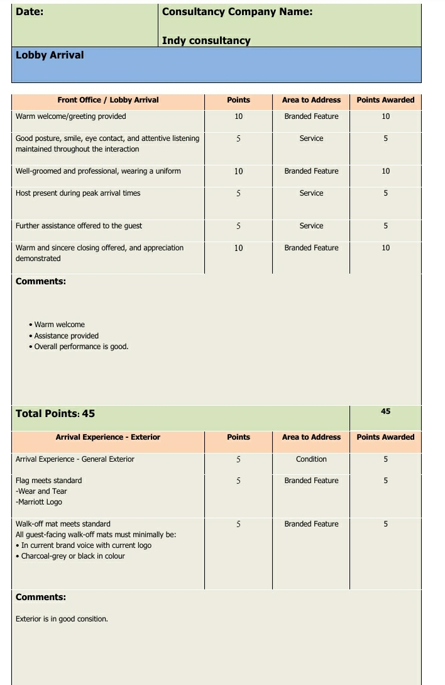
Indy consultancy completed the audit process within the set frame of twelve weeks on 21st August 2020. We hope you find our mutual work useful for your company and our suggestions have inspired new ideas for improvement of your workspace. We will be glad to work again together in the future.

Appendix


