

Design and Implementation of a Test Question Recognition and Classification System Based on Chemistry Test Paper Images
by
WENXUAN ZENG

Supervisor: Divya Chidambaram

Project submitted as part of the requirements for the award of MSc Software Engineering

September 2023

DECLARATION

I, Wenxuan Zeng declare that I am the sole author of this Project; that all references cited have been consulted; that I have conducted all work of which this is a record, and that the finished work lies within the prescribed word limits.

This work has not previously been accepted as part of any other degree submission.



Signed : .............................................

Date : ...........9/11/2023....................

FORM OF CONSENT

I Wenxuan Zeng hereby consent that my Project, submitted in candidature for the M.Sc. Software Engineering degree, if successful, may be made available for inter-library loan or photocopying (subject to the law of copyright), and that the title and abstract may be made available to outside organisations.

Signed : .............................................

Date : ...........9/11/2023....................

Abstract
In the context of the new crown epidemic, all kinds of online education information are all-around people. People are also increasingly inclined to use online teaching methods for learning and testing. While bringing convenience to users, the online examination system, compared with paper examination papers, contains a single question and fewer questions, and cannot automatically form examination papers according to the required knowledge points, which restricts the performance of the online examination system. develop. The text extracts the content of each test paper through the image detection and recognition algorithm of the test paper, and then uses the text classification algorithm to label each test question with knowledge point labels, and forms a specific test paper according to the knowledge point labels for online testing of personnel. Based on the research results of the test paper identification algorithm and text classification algorithm, an automatic test paper grouping system is constructed. The main work is as follows:
(1) Research on text detection and recognition methods for test papers. The test paper text detection algorithm is designed to detect the exact location of each item from the test paper image. For the traditional layout structure of complex test papers, there are often problems such as blurred pictures, slanted text, and unclear picture boundaries, and because traditional image detection uses bottom-up methods for document pictures and text, it is sensitive to noise and requires high text shape. It is not suitable for the multi-object and multi-shape test questions in the test paper text. This paper proposes a method with a Gaussian heatmap to detect the position information of the test questions. Then, through the text recognition method of the interview test paper, the picture information of the test question is converted into text information. Aiming at the problems of the irregular distribution of test questions and complex feature description in the text recognition task of the test paper, this paper uses a method based on time series classification to convert the feature map in the test question into a feature sequence. The method based on time series classification is optimized for text recognition of test questions so that it can recognize multi-line text and improve the text recognition rate.
(2) Research on the classification method of test questions oriented to test question information. Based on the test item information obtained by the test paper image text detection and recognition algorithm, the test item classification algorithm based on TF-IDF and the test item classification algorithm based on the cyclic neural network are studied to classify the knowledge points to which the test questions belong. The test question classification algorithm based on TF-IDF first uses the word segmentation tool to segment words, removes high-frequency words and stop words, then calculates the normalized TF-IDF value, obtains the weighted word vector according to the normalized TF-IDF value, calculates the knowledge point and The cosine similarity of weighted word vectors between test items is used to measure the textual similarity between test items and knowledge points. The test item classification algorithm based on a cyclic neural network uses BiLSTM to encode the test item information forward and backward, then perform feature fusion on the forward and backward coding information, and finally input the SoftMax layer classification to obtain the knowledge point category to which the test item belongs. The performance of the two classification algorithms studied is compared through experiments, and the algorithm with better performance is selected to construct the system.
(3) The design and realization of the test question automatic extraction system. By analyzing the actual needs of the system and the functional requirements put forward by cooperative enterprises, and integrating the test paper detection and recognition algorithm and text classification algorithm proposed in this paper, an automatic test question extraction system is designed and implemented. The teacher side mainly includes the test paper identification module, and test question management module, There are four modules including the automatic volume grouping module and marking module. The student side includes two modules, the personal information management module and the answering module. The test paper identification module can detect and identify the test paper images to obtain the specific content of the test questions, and the test question management module can classify the recognized test questions and label the test questions.

Keywords: text detection, text recognition; text classification; test question automatic extraction and classification system extraction system.

Table of content
Abstract I
Table of content III
Chapter 1：Introduction 1
1.1 Main research content of the paper 2
1.2 Structure of the paper 4
Chapter 2：Literature review 6
2.1 Research status of text detection algorithm 6
2.2 Current Research Status of Text Recognition Algorithms 9
2.3 Current state of research on classification algorithms 14
Chapter 3：Research on Image Text Recognition Detection Methods for Chemistry Test Questions 17
3.1 PCR-based text detection algorithm for chemistry test images 17
3.1.1 PCR horizontal text box generation 18
3.1.2 Generation of PCR Corner Point Text Boxes 19
3.1.3 PCR Arbitrarily Shaped Text Box Generation 23
3.1.4 Overall PCR methodology flow 24
3.2 Text recognition algorithm for chemistry test paper images 26
3.2.1 Feature extraction of text images based on convolutional neural networks 26
3.2.2 Context modeling based on bidirectional LSTM 27
3.2.3 Many-to-one mapping of CTC decoding 29
3.3 Experiment and analysis 30
3.3.1 Dataset description 31
3.3.2 Experimental results and analysis 31
3.4 Conclusion 35
Chapter 4: Research on test question classification methods oriented to test question information 36
4.1 Research on chemistry test classification algorithm by fusing RNN and CNN 36
4.1.1 Discussion and Analysis of CNN and RNN in Classification Algorithms 36
4.1.1 Algorithmic Fusion of CNN and RNN 37
4.2 Experimental results and analyses 39
4.2.1 Pre-processing of chemical test information 39
4.2.3 Experimental results and analysis of CNN-based classification algorithm 42
4.2.4 Experimental results and analysis of RNN-based classification algorithm 43
4.2.5 Experimental Results and Analysis of Classification Algorithm Based on Fusion RNN and CNN 45
4.3 Conclusion 46
Chapter 5: Chemistry Test Recognition and Classification System Implementation and Presentation 47
5.1 System requirements analysis 47
5.2 Overall system design programme 50
5.2.1 System framework design 50
5.2.2 Functional module design 52
5.3 Database design 57
5.3.1 Database information tables 57
5.3.2 System hardware operating environment 61
5.4 Implementation of specific functional modules 61
5.4.1 Question paper recognition module 61
5.4.2 Test question management module 63
5.4.3 Automatic Paper Formation Module 65
5.4.4 Student Answer Module 68
5.5 System Testing 70
5.5.1 Test paper recognition function test 70
5.5.2 Test question management function test 71
5.5.3 Tests of the automatic paper-grouping function 72
5.5.4 Student Answer Function Testing 72
5.6 Conclusion 73
Chapter 6: Conclusions and recommendation 74
6.1 Summary 74
6.2 Suggestions for further study 75
Reference 77

Chapter 1：Introduction
Since 2020, China has started to continuously promote paperless teaching in higher education in response to the traditional examination mode, which is difficult to adapt to China's current higher education evaluation reform to strengthen the whole process of course assessment and evaluation due to the complex and time-consuming operation and implementation process. Through online paperless teaching, teachers can release learning materials and learning tasks on the corresponding learning platforms so that students can learn course-related knowledge at home. Especially since the epidemic, online teaching has developed rapidly. Traditional teaching methods have great limitations in time and space, and it needs to complete teaching at a specific place and time. Online teaching avoids these problems, which reduces the consumption of human and material resources. Combining internet technology with education has become a trend of the times.
Online testing, as an important part of online learning, has also received extensive attention from teachers and students. The traditional paper-based test process includes manual selection of questions and questions, the layout and printing of test paper questions, the transport of examination papers, manual marking and manual score registration, etc., and the whole process is too cumbersome. Paperless examination also came into being, paperless examination eliminates the printing, examination paper transport and other steps, and at the same time improves the efficiency of the examination and ensures the results of teaching ^{[1]}.
At the same time, due to geographical reasons, the quality of examination questions varies from place to place, so this paper implements a subject testing platform that combines paperless examination and Internet technology. The platform can form a question bank of the corresponding subject through the automatic extraction and classification system of test questions in the test paper image by uploading the information of the questions from students and teachers, and generate an on-the-fly test paper according to the number of standard questions and the selected difficulty for all students to practice.
However, the development of education at the present stage has led to the continuous expansion of the scope of various types of question papers, which has also led to the drastic increase in the number of question papers of various subjects and the complexity of the question paper structure and other problems. Especially in chemistry test papers, there are letters, Chinese, chemical symbols and other languages, which is easy to upload the test question picture identification errors, this paper studies the theory and method of test paper detection and identification. In this paper, the theory and method of test paper detection and identification are studied, and the same knowledge points examined in the test questions are classified into the same category, which is convenient for students and teachers to find.
In summary, for the online test paper online test questions are few, can not be targeted according to the knowledge points of the test and other issues. Through the image detection and recognition algorithm, the paper test paper image is detected and recognised, the unstructured test paper information is structured and displayed, and the test question bank is formed, and then the test paper is automatically assembled through the classification algorithm of the text, and it is released to the online platform. Thus, it provides a rich test question bank and targeted knowledge point tests, which makes the learning process more comprehensive and efficient and improves user satisfaction. For enterprises, the automatic extraction and classification platform of test questions reduces the consumption of manpower and material resources, saves the manpower cost of enterprises, and brings economic benefits to enterprises, which is of certain research significance.

1.1 Main research content of the paper
The detection and recognition algorithm of the test paper was designed for the comprehensive consideration of the large number of questions in the layout of the chemistry test paper, the irregularity of the boundaries of the questions and the uncertainty of the lines of text. According to the extracted information of the test questions in the test paper, they are classified and can be automatically grouped by selecting knowledge points. The construction of automatic test question extraction and classification system is realised.
The main research contents are as follows:
(1) Research on image text recognition detection method for chemistry test questions. According to the system requirements analysis and functional design of this paper, in order to achieve the detection and identification of test papers, the PCR-based image text detection algorithm for chemistry test questions and the CRNN-based text recognition algorithm are studied and applied to the identification of pictures in chemistry test papers.
(2) Research on the classification method for test question information. According to the system requirements analysis of this paper, in order to classify the large amount of test question information obtained from the test question image text detection and recognition algorithm according to the knowledge points, CNN-based test question classification algorithm and RNN-based test question classification algorithm are researched, and through experiments, chemistry test question classification algorithm integrating RNN and CNN is proposed as the basis of algorithms for the construction of this paper's system.
(3) Design and implementation of automatic test question extraction and classification system. By combining the actual needs of users and the production requirements of enterprises, the automatic extraction and classification system of test questions is designed and implemented. The system forms a test question database according to the test paper image detection and recognition algorithm, then classifies the test questions through the text classification algorithm, and automatically composes targeted test papers for release according to the results of the test question classification.

1.2 Structure of the paper
This article focuses on the research of detection and recognition methods for test paper layout, and is divided into five chapters. The specific arrangement is as follows:
Chapter 1 introduces the research background, purpose, and significance of the research topic, and finally introduces the main research content and organizational structure of the paper.
Chapter 2 summarizes and analyzes the research status of methods such as text detection, text recognition, and text classification
Chapter 3 focuses on the problems of different shapes and complex layouts of test questions in the image of the test paper. This article uses a PCR model to detect the image of the test paper, obtain the position information of the test questions, and then recognize the test questions through CRNN and CTC to obtain the text information of the test questions.
In Chapter 4, based on the test question information obtained from the text detection and recognition algorithm of the test paper, a fusion chemistry test question classification algorithm based on TextCNN and TextRNN was studied. The performance of these algorithms was compared through design experiments, and it was found that the fusion algorithm of TextCNN and TextRNN designed in this paper is more superior.
Chapter 5: Overall Design and Implementation of a Chemical Test Question Recognition and Classification System. Conduct a requirement analysis of the automatic extraction system for test questions, and design the overall functionality and technical architecture of the system. Then, design the specific functions of the system and test each function.
Chapter 6 summarizes the work content of the entire article and analyzes its shortcomings, providing prospects for future research work.

Chapter 2：Literature review

2.1 Research status of text detection algorithm
The two mainstream schemes of the current text detection technology are regression-based text detection methods and segmentation-based text detection methods.
(1) Regression-based text detection methods
Regression-based text detection technology, according to whether to manually pre-set the a priori box can be divided into anchor detection methods and anchor detection methods.
There are anchor detection methods such as Single-Shot Multi-box Detector (SSD) ^{[2]}, Two-Stage Target Detection and Rotation Region Candidate Network (R2CNN) ^{[3]} based on Faster R-CNN architecture. They are all used for target detection of text, which can detect text in any direction, and at the same time can also offset and rotate the angle of the text to a certain extent, so that they can be applied to the dataset of irregular text. However, in order to determine the actual position of the text of multi-angle, multi-direction, the need to achieve good detection accuracy, resulting in the detection process consumes too much time, the target detection process is too complex, which ultimately achieve the actual benefits of the general effect. In the SSD architecture has TextBoxes + + + ^{[4]}, SegLinking (SegLink) ^{[5]}, TextBoxe + + ^{[6]}, SegLink + +^{[7]} and other methods, they are the first to design an a priori text box or to add a direction of the text box, and then for each character level text on the a priori text box or direction of the text box to carry out operation, regression operation on the a priori text box or direction text box or return it directly to the local text area, so that the text detection box adapted to the change of text line direction and aspect ratio can be obtained to achieve the detection of text in multiple directions. They not only inherit the high-speed characteristics of SSD in terms of detection speed, but also consume less time in the text detection process and are close to the two-stage target detection method in terms of experimental accuracy.
Anchor detection methods can detect text at multiple angles in a picture, but several bounding boxes must be designed in advance, and accompanied by a large number of parameters to be set manually, the algorithm is less flexible, most of the methods are not conducive to dealing with the actual situation of the text, and have received less attention in recent years.
Anchorless target detection methods often use full convolution to achieve target detection, among anchorless target detection methods there are Feature Pyramid Networks (FPN) ^{[8]}. Feature pyramid networks use a top-down approach to improve the sensitivity of the pixels in the image by detecting the multi-scale features of the target and then fusing these multi-scale features step by step. It significantly improves the accuracy of image detection, but there are still problems such as poor overall representation of the detected target and low enhancement efficiency. Therefore some text detection methods for the above mentioned problems, proposed relational network (R-Net) ^{[9]} method, which is a series of improvements based on the feature pyramid method. It makes a change in the mapping of the multi-scale feature vectors obtained after the convolutional layer, mapping these vectors to a scale-invariant space, allowing the model to carry out a significant improvement in its anti-interference ability. Pixel Aggregation Network (PAN) ^{[10]} proposes Feature Pyramid Enhancement Module (FPEM) to add bottom-up paths to the FPNs and multiple additions of FPN modules make it increase the detection accuracy. However, because of the superposition of multiple FPNs, it causes the complexity of the network structure and the problem of high depth of the network structure, which is not conducive to the training of the text and the effective learning of the text representation. Although the multiple superposition of FPN modules significantly improves the detection performance, it also leads to a significant increase in the amount of computation and parameter settings, resulting in low utilisation of computer resources and other problems.
Anchorless target detection methods have received a lot of attention in the field of text detection, mainly because the method does not have to set some of the parameters, and can be well adapted to text images in various complex environments and achieve a high level of detection for irregular scene text. However, with the development in recent years, most of the methods only focus on solving the problem of text shape irregularity and use feature extraction network architectures with complex structures to complicate the overall model, such as VGG16 ^{[11]} and ResNet50 ^{[12]}, etc., the redundancy of the feature extraction network structure and the overly large number of parameters lead to an overly cumbersome computation process and response slow.
(2) Segmentation-based text detection methods
The general situation of the scene text detection can be achieved using the method of segmentation of the image to achieve arbitrary shape of the text detection, generally using a full convolutional network, to achieve pixel level classification, so as to achieve the prediction of the text position on the text image and image segmentation. Finally, after processing of the algorithm, the text position, pixel classification and image background are combined to obtain a specific text segmentation frame.
Both CRAFT ^{[13]} and PixelLink ^{[14]} use segmentation to achieve text detection, and both of them simultaneously segment text and non-text regions to predict the relationship between neighbouring text pixels. However, in comparison, the CRAFT model is more demanding on the training set, which needs to be labelled at the character level, leading to a higher cost of training. Compared to PixelLink and CRAFT, Progressive Scaling Network (PSENet) ^{[15]} has a simpler method of describing the dataset, PSENet determines the number of lines of text in the image from the beginning, and then only needs to segment the text in the region to be detected step by step. Secondly using a kind of pixel expansion as a post-processing step, so as to complete the grouping of foreground and background pixels, and generating the text boundary region based on the idea of width-crossing priority, it is possible to achieve the detection of the image text. PSENet can effectively differentiate between neighbouring lines of text, but the over-complex structure of PSENet results in an increase in the computation time, and in the processing of the subsequent steps, the The complexity of computation causes the overall algorithm to be slow. Compared with CRAFT, the different labelling scales of the training set cause the detection accuracy of PSENet to be low. The Differentiable Binarisation Network (DBNet) ^{[16]} uses ResNet18 ^{[12}] as a backbone network to reduce the computational cost and optimise the efficiency of the algorithm from the point of view of the post-processing step. Firstly, the binarisation operation is normalised using a Sigmoid function, while the predicted regions and scaling are directly scaled, thus optimising the overall structure. At the same time, DBNet also uses deformable convolution (DCN) ^{[17]}, which can improve the detection accuracy of multi-scale text feature vectors after training on arbitrarily shaped text. Although the final computational results are delivered in real-time, the computational efficiency of the feature pyramid network FPN is too low and lacks optimisation, which results in an inefficient text representation that fails to form the correct text detection region.

2.2 Current Research Status of Text Recognition Algorithms
Text recognition is the starting point for recognising images, which mainly focuses on the textual information in the pictures, which is extracted from text images and converted into a format that people can understand. The input object of the text recognition model is a cropped text image, which can be obtained using the text detection step. In the text recognition process, the main challenges originate from the influence of complex scenes on the one hand, such as poor image quality and background noise; while on the other hand, the main problem lies in the diverse appearance of the text in the image, with varying text shapes and arbitrary orientations. This subsection will introduce the development process of text recognition algorithms and analyse the main problems of each text recognition algorithm.
In recent years, good results have been achieved in text recognition using deep learning techniques. Connectionist Temporal Classification (CTC) ^{[18]} and Attention Mechanism ^{[19]} can transform the input sequence into different rows, making the rows of arbitrary width aligned, and thus solving the problem of text recognition in images and natural language processing Problems. They have been widely used as text sequence recognition tasks. Most of the recent text recognition methods are done using CTC or attention mechanisms.
(1) CTC-based approach
CTC algorithm was firstly applied in the field of handwriting recognition and combined with Long Short Time Memory (LSTM) neural network to generate feature sequence prediction relative to the image. However, at that time, due to the limitations of computer hardware, for some deep learning methods, they could not be effectively supported by hardware conditions, thus failing to produce practical effects of the application, and could not bring the expected economic benefits.
With the development of the times, through the deep learning technology and a variety of concepts and technologies are integrated with each other, for the first time, the convolutional neural network, recurrent neural network and CTC algorithm are combined to form a convolutional recurrent neural network (CRNN) ^{[20]}.CRNN is to encode the input text image with a sequence of in-depth features, and then secondly, through the CTC algorithm, the text image is predicted to the corresponding labels, which can be realised model for character-free label training, and the accuracy of the final text recognition out will be significantly higher than the traditional methods. On this basis, Gated Recurrent Convolutional Neural Network (GRCNN) ^{[21]}, EnEsCTC ^{[22]}, Character Classification and Localisation (CCL) ^{[23]} and Fully Convolutional Sequence Modelling (FCSM) use CTC as a decoding algorithm, and the accuracy of text recognition and the flexibility of the algorithms are also more than that of traditional methods.
The basic condition for the CTC algorithm to be established is the mutual independence of the various estimation results, but the semantic information embedded inside the feature sequences is less analysed and cannot be modelled directly from the text images. In addition, in character-level text recognition tasks such as English recognition, the text recognition accuracy of the CTC algorithm is easily interfered by the environment and noise, and the interfered characters cannot be recognised by reasoning using contextual semantics. Although the CTC algorithm effectively reduces the cost of training, there is still a possibility of improvement for text recognition in complex scenarios and text recognition in irregular situations.
(2) Methods based on Attention Mechanism
The attention mechanism mainly improves the alignment performance of the text recognition process and achieves sequence-to-sequence alignment. Compared with the traditional CTC algorithm, the attention mechanism-based approach is more suitable for long text images, which is able to model the semantic information relationship of the context. This indicates that the attention mechanism based approach performs better in complex scenarios. Attention mechanism based methods are generally applied in the decoding part of the end-to-end approach, where the decoder makes predictions based on the input sequence of features containing semantic information one by one.
Attention mechanism-based methods have achieved some results in dealing with text recognition in recent years because they take advantage of more powerful semantic modelling capabilities. Some of the typical methods are Attention Scene Text Recogniser (ASTER) ^{[24]}, Text Recognition Network with Auto-correction (RARE) ^{[25]}.The ASTER method is based on extracting the feature values in the image by using a residual convolutional neural network, and then, by means of a decoder, performs the alignment of the text. The accuracy of recognising text images exceeds the traditional CTC based text recognition methods, but the computational speed is slower than the CTC based text recognition algorithms because of containing repetitive neural networks and having serial computational steps.
The traditional attention mechanism is prone to lose the semantic information in the image text, which is usually caused by the fact that the attention mechanism can only handle one-dimensional features. In turn, it needs to be combined with the correction network on the text image to form a semantic complement to complete the complete recognition model. In order to retain more spatial information and algorithmic flexibility without adding extra modules, Character-aware Neural Network (Char-Net) ^{[26]} and 2D Attention Text Recognition (Show Attend Read, SAR) ^{[27]} methods are proposed, which are both a text recognition method based on text prediction of 2D images. Among them, SAR maintains a high feature extraction efficiency in the backbone network, followed by an attention mechanism to achieve text feature alignment, which directly allows the prediction of the position of each character. Therefore, the network structure is more concise and the recognition accuracy is similar to the one-dimensional attention method, which provides a way to solve the text recognition problem in complex scenes. However, the feature map obtained by SAR recognition contains semantic information in two dimensions, which increases the model complexity, and at the same time requires a higher resolution of the image, which results in a huge consumption of computer resources and high hardware requirements.
In order to be able to use microscopic data and for irregular text scenarios, Spatial Transformer Network (STN) is proposed to achieve this.There are three main parts in STN network localisation network, generator and sampling network. On the basis of the STN network text recognition methods, various methods have been developed by improving the structure of the correction network, such as Attention Scene Text Recognition (ASTER) ^{[24]}, Multi-Object Rectified Attention Network (MORAN) ^{[28]}, Symmetry-constrained Rectified Network ( ScRN) ^{[29]}, ESIR ^{[30]} and Scale-Adaptive Orientation Attention Network (SLOAN) ^{[31]}.
Although the text recognition method based on the attention mechanism is better than the CTC-based method due to the incorporation of certain semantic information in complex scenes, which makes it more effective than the CTC-based method, it will suffer from the problem of attention bias ^{[32]} to a large extent. This is manifested in the fact that the prediction space weights of the decoder will be somewhat biased, and the character features cannot be accurately aligned, which affects the subsequent decoding steps and leads to persistent misrecognition. For this reason, the focusing network (FAN) based on the attention mechanism will monitor the position of the characters in the text image to get the specific position information of the characters, so as to assign the attention weights more accurately within the character region, thus alleviating the inaccuracy problem of the attention mechanism and improving the recognition accuracy. Decoupled Attention Mechanism Network (DAN) ^{[33]} replaces the RNN attention mechanism network based on the traditional approach by a fully convolutional network for probabilistic prediction of the spatial distribution of textual information.The DAN's localisation of textual feature positions is based on the spatial information of the text rather than semantic information. The advantage of this is that it can reduce the attention bias, and has a higher text recognition rate and faster decoding speed than most of the traditional methods based on the attention mechanism, but its disadvantage is also obvious is that it is limited by the number of convolutional channels, resulting in the length of the text that can be predicted is limited.
Compared with the traditional algorithm based on CTC, the decoding of the attention mechanism will have a certain attentional bias, which causes the decoding process based on the attention mechanism to consume too much time, thus forming a garbled result. The method using temporal classifiers does not have these problems, and it not only achieves automatic localisation at the character level, but also has a certain degree of immunity to problems such as image environmental noise and image ambiguity. However, due to the nature of the existing database itself, some unique characteristics of the training samples can cause a huge impact on the model, resulting in unsatisfactory results. For example, the training process cannot get all the features of the text in the image from the dataset.

2.3 Current state of research on classification algorithms
There are two commonly used text categorisation methods. The first is a statistical approach. The second one is neural network based methods. Statistical based text classification methods generally have methods such as regression model, maximum entropy model, plain Bayes, SVM and KNN. Neural network based text classification methods generally have methods such as convolutional neural network based and recurrent neural network based.
(1) Text classification based on statistical methods
The core idea of statistically based text classification is to use a large number of texts to train the machine (i.e., machine learning), so that the machine can grasp the laws of such documents and apply them to judgement. On the basis of machine learning, literature ^{[34]} proposes an improvement to the text feature representation and KNN classification algorithm algorithm by adding weights to the feature representation as well as reducing the effect of noise so as to enhance the accuracy of the model. Literature ^{[35]} proposes an improved method for multi-class text classification, where the authors use SVM to classify keywords and reclassify the classified text through OAD and DDAG, thus improving the accuracy of text classification. Literature ^{[34]} proposed a simplification method for the classifier, the authors first replaced the objective function in the entropy model with Shannon entropy, and then used C-mean clustering to classify the text, so as to achieve the simplification of the classifier.
(2) Text Classification Based on Neural Network Methods
Text classification based on neural networks is better compared to traditional statistical methods, and there have been a large number of related applications. Literature ^{[36]} proposed a Word2vec+CNN classification system for sentiment analysis, the authors used the vectors computed by Word2vec as the inputs of the network, combined them with the CNN structure for the sentiment text, and verified the feasibility of the system through a public dataset. Literature ^{[37]} validated the ability of deep learning networks to solve word spelling errors even without semantic information by applying character-level convolutional networks to text classification. Literature ^{[38]} proposed a method to represent text using GloVe word vectors, and experimentally verified the effectiveness of this method for text classification performance improvement. Literature ^{[39]} is similar to literature ^{[37]}, which also uses character-level convolutional networks for text classification, and verifies the excellent performance of the method with a large amount of data. Literature ^{[40]} proposes a deep learning method based on Ld-CNNSD, where the authors apply a priori knowledge to text classification, and use the Hidden Dirichlet model to assign topics to the words in the text, and after obtaining the semantics of the words, combine with the linear SVM kernel function to achieve the final classification.
The introduction of deep learning methods makes it possible to automatically extract the relationship between words from text data, saving a lot of money spent on feature extraction manually. At the same time, deep networks can also be used to portray word combinations more perfectly by combining the properties of word matching ^{[41]}. As part of the model, feature extraction can be flexibly applied to various text phrase matching tasks depending on the application scenarios and training data. In addition, combining the deep text matching model with the word vector technique can effectively solve the diversity problem in word matching. Finally, the hierarchical design feature of deep networks is exploited so that the deep text matching model can satisfy both the structural features of phrase matching and the hierarchical features of text matching ^{[42]}.

Chapter 3：Research on Image Text Recognition Detection Methods for Chemistry Test Questions
Usually, there are two ways to obtain images of chemistry test questions, either by taking photos and scanning paper test papers, or by downloading them directly from the Internet. The diversity of sources of chemistry test questions makes the acquired images often have problems such as uneven layout, different pixels, different fonts, and different text sizes. In addition, the characteristics of the chemistry test question images themselves, which combine Chinese characters and chemical equations, add to the difficulty of text detection and recognition.
In view of the above research objectives and research challenges, the PCR-based image text detection algorithm will be introduced in Section 3.1 of this chapter, and the CRNN+CTC-based image text recognition algorithm will be described in Section 3.2. And the experimental results and analyses of recognition detection using the above methods are given in section 3.3.

3.1 PCR-based text detection algorithm for chemistry test images
Considering the fact that chemistry test questions are distributed differently and do not overlap with each other, although the length of the text varies greatly, we can detect the target of the test questions according to the idea of "detecting the centre of the target". In this paper, we select the representative model of this idea - PCR (Progressive Contour Regression) method for research, the core essence of the PCR method is to effectively locate the text of the scene of any shape through the method of progressive contour regression. The method flow is mainly divided into three parts: generation of horizontal text box, generation of corner text box, and generation of arbitrary shape text box.3.1.1, 3.1.2, and 3.1.3 will discuss the above three parts, and the overall flow of the PCR method will be given in 3.1.4.

3.1.1 PCR horizontal text box generation
The PCR feature extraction and enhancement workflow is as follows:
Firstly, let be the input image with width W and height H. Entering into the feature extraction and enhancement module, the centroid heat map, denoted as , is generated by several full convolutional coding and decoding networks, where R denotes the scaling ratio of the size, and C denotes the number of centroid types which is the number of topics, and the coding and decoding networks are obtained by training the keypoint prediction network. In this process, the original position of the centroid C corresponds from to after the downsampling R multiplier is computed.Subsequently, the keypoints are mapped to the heat map by Gaussian kernel formula to output Gaussian heat map. If there exists a situation where the Gaussian distributions of two or more centre points coincide, the maximum value is taken as the mapping point. Where the Gaussian kernel formula is
(3-1)
The Loss function of the centroid prediction network can be expressed as
(3-2)
where (3-1) in Eq. (3-1) is the standard deviation associated with the height and width of the critical point, and xyc denotes the position index on the heat map. N in Eq. (3-2) denotes the number of centre points, and α and β are hyperparameters of the equilibrium loss function. Since downsampling is prone to cause quantification errors in the centroids, which interferes with the results of target detection, the position offset feature prediction is introduced for correction. The position offset feature map is denoted as , and the neutralisation represents the centre offset of the x,y channels after downsampling. The Loss function for position offset feature map training can be expressed as equation (3-3):
(3-3)
Consider the target text box needs to be predicted with the help of width-height feature map. Then let is the kth centre point of the bounding boxes (bounding boxes), its centre position is , the width and height dimensions of the bounding boxes can be expressed as . the width and height feature map is obtained through training, denoted as . the loss function of the training of the width and height feature map, L1 loss, is denoted as Equation (3-4).
(3-4)
The loss function of the final network can be expressed as
(3-5)
Where is the centroid loss function, is the width and height loss function, is the positional offset loss function, and is the balance parameter.

3.1.2 Generation of PCR Corner Point Text Boxes
The corner text box is formed by sampling uniformly on the contour of each horizontal text box and re-estimating the position of these sampled points using the Contour Localisation Mechanism to finally get the new text box contour identification points. In this case, the contour localisation mechanism (CLM) is shown in Figure 3-1.
Figure 3-1 Contour Positioning Mechanism
Specifically, in the CLM, the image that passes through the horizontal text detection frame is first input to the contour feature extractor (CFE). The contour point on the horizontal text detection frame is projected onto the input feature XXXXXXXX to generate the semantic feature . at the same time, the position information of the contour point on the horizontal text detection frame is . where is denoted as , i is the ith point on the contour of the horizontal text detection frame, and is the leftmost upper coordinate point on the horizontal text detection contour frame. is the coordinate point on the top left side of the horizontal text detection outline box. Through the above operation, the difference between the ith coordinate and the smallest coordinate position can be obtained, so as to get the position information of the outline of the text detection box. The semantic feature is concatenated with the position information of the horizontal text detection frame to generate the original detection frame in the region to be detected in this picture.
Secondly, the original detected contour frame feature is obtained and input to the Contour Information Aggregation (CIA) unit to get a more representative contour feature .The Contour Information Aggregation (CIA) technique can make full use of the cyclic nature of the textual contours in the geometric topology to aggregate feature information on the image. The contour information is semantically assembled into intersection nodes to avoid the influence of redundant or noisy points on the text contour. The CIA units used are shown in Fig. 3-2.
Figure 3-2 CIA Unit
The fused feature layer is passed through the filter and maximum pooling layer for feature information aggregation, and the whole process is shown in Figure 3-3.
Figure 3-3 Feature Information Aggregation Flow
Finally, the output from the CIA unit is fed into the Offset Prediction Hub (OPH) to generate the contour point as the reference offset .The Offset Prediction Hub (OPH) consists of three 1×1 convolutional layers with the number of filters of the three convolutional layers being 256, 64, and 2, respectively.After the OPH module, the contour point can be obtained as the new position by X+O .
The new text detection contour box generated by the CLM module is input into the corner point generator to generate new corner point position coordinate information.The newly generated corner point of the text prediction in the image is called , and its loss function is expressed as Equation (3-6).
(3-6)

3.1.3 PCR Arbitrarily Shaped Text Box Generation
The PCR arbitrarily shaped text box is a contour box obtained by taking the initialised corner point text detection box and regressing it step by step through K CLM cells.
Firstly, the corner point text detection box is initialised with points. Second, the progressive contour regression is performed using multiple CLM units. It is worth considering that the corner text box may have incorrect information about the corner points, which affects the detection of arbitrary text boxes. Therefore finally the Real Contour Location Mechanism (RCLM) needs to be utilised . This mechanism combines the contour scoring mechanism with contour localisation to increase the accuracy of the detected text box contours. The real contour localisation mechanism is shown in Figure 3-4.
Figure 3-4 Actual Contour Positioning Mechanism
Specifically, RCLM first feeds the contour points after asymptotic regression into the contour feature extractor (CFE) to obtain the contour features generated by the contour information aggregation module.denoted as , and then input into the contour offset module to generate the final contour position . meanwhile, input the contour feature into the contour scoring mechanism to generate the contour scores, and the s calculation formula is as follows.
(3-7)
where denotes the contour scoring network and is the corresponding network parameter. Specifically, in , the input is first fed into a convolutional layer with 256 filters and a size of 1×1 to obtain the feature representation . then the global feature representation is generated using the average pooling operation and the maximum pooling operation , denoted as:
(3-8)
Three fully connected layers (with hidden sizes of 512, 256 and 2) and one layer were stacked to generate the final contour scores of the detected text.The RCLM outputs the new contour point locations as and the contour accuracy as .The contour regression loss function is denoted as:
(3-9)
where denotes the jth contour point obtained by uniform sampling in the ith text detection frame.

3.1.4 Overall PCR methodology flow
In the specific scenario described herein, its PCR method detection workflow diagram, as shown in Figures 3-5.
Figure 3-5 Flowchart of the PCR method
First, the images of chemical questions are input into the convolutional neural network for feature extraction and enhancement, and the Gaussian heatmap is output. The thermal peak point is the geometric center point of the horizontal text detection box. The width and height of the target text can be predicted by the position of the peak point, and the horizontal text detection box can be obtained. Secondly, through the contour positioning mechanism, Corner Point Generation is realized, and the horizontal text box is returned to the Corner Point of each text box. Thirdly, arbitrary shape text boxes are produced by forcing approximations through multiple CLM iterations. Finally, text detection results with high confidence are generated by the actual reliable contour location mechanism. Using the actual contour positioning mechanism and the contour confidence score, the final text detection result is obtained.

3.2 Text recognition algorithm for chemistry test paper images

3.2.1 Feature extraction of text images based on convolutional neural networks
There will be a lot of mixed Chinese text and chemical equation in the chemistry exam paper. The structure of Chinese and chemical equation is different and the combined text length is also different. When identifying such mixed text, additional frames are needed to give a more comprehensive description of the monitored text area. Therefore, the following changes are made to the text image feature extraction module.
The training speed of the neural network and the calculation amount of the network parameters are adjusted according to the character recognition of the text image. First, the size of the convolution kernel of the first two convolution layers of the CRNN model is reduced. Then, the convolutional layer and the number of kernels in the convolutional layer are added to help identify text, so as to learn more macroscopic features of text lines. Then, a Dropout layer is added after each Convolutional layer to prevent overfitting. Finally, the text is adapted by modifying the aspect ratio of the maximum pooling layer.
In order to prevent the following small target feature information loss due to the depth and resolution reduction of the convolutional neural network, this paper introduces a multi-feature fusion module in feature extraction, as shown in Figure 3-6. In this module, the convolution layer of multi-feature extraction unit is added to improve the image feature description ability. The multi-feature fusion module can extract text features by fusing the small convolution layer with the large convolution layer in two branches. The feature extraction method of multi-feature fusion module is shown in formula (3-10), (3-11) and (3-12).
Figure 3-6 Multi-feature fusion module
(3-10)
(3-11)
(2-12)

3.2.2 Context modeling based on bidirectional LSTM
The RNN layer in the CRNN text line recognition model still uses the structure of CRNN and simultaneously uses Bi-LSTM (bi-LSTM) to obtain the timing features of the text. Since LSTM is directional in data transmission, that is, it can only infer the semantic information of historical context, which leads to the phenomenon of gradient disappearance when LSTM uses nonlinear functions to update the state of neurons, which limits the extraction of the semantic meaning of text before and after text. Therefore, this paper introduces Bi-LSTM to extract the semantic features of the text. A forward passing LSTM and a backward passing LSTM are combined to form a bi-directional LSTM (Bi-LSTM) and stacked several times to form a deep Bi-LSTM.
For any input feature sequence $x=x_{1},x_{2},……,x_{t}$, when it passes through the forward LSTM, the input signal is transformed into a set of neuron states u, as shown in formula (3-13); For backward transmission, when the same feature sequence is passed to it, another set of neuron states z is obtained, as shown in formula (3-14).
(3-13)
(3-14)
(3-15)
Bidirectional LSTM combines two sets of neurons into one set of neurons $\{u_{1},z_{1}\}$, such that there is a double length sequence output for any feature sequence input. The LSTM of each item can retain and store the semantic feature information of the previous neuron for a long time through the memory unit and the input gate, and discard the semantic feature that is not useful in the memory unit by forgetting the gate. Finally, the column vector $y=y_{1},y_{2},……,y_{t}$output by the sequence prediction unit can be obtained through the SoftMax function, which represents the prediction probability of the text, and the results are shown in equation (3-15). The structure of RNN sequence prediction network based on Bi-LSTM is shown in Figure 3-7.
Figure 3-7 Bidirectional LSTM-based RNN sequence prediction network model

3.2.3 Many-to-one mapping of CTC decoding
The CTC loss function is used in training to reduce the negative log-likelihood value of the label order probability so that the overall pattern can be achieved end-to-end. The CTC model is used to transform the prediction structure of the output sequence of the bidirectional LSTM in the feature sequence prediction layer, and finally output the label sequence, while ensuring that the output label sequence corresponds to the input sequence. CTC achieves end-to-end recognition by introducing blank label to avoid image segmentation during prediction. When data input to the CTC layer, assuming the dimensions of L, each sequence point data to predict the possible values of T, $L^{T}$possibility, so a data sequence of each probability is defined as a Path, due to the mapping Path between mutually exclusive, so the conditional probability formula is as follows:
(3-16)
With which set Y said input space, the space is $y=y_{1},y_{2},……,y_{i}$said the text in sequence, sequence length L, PI said Path Path, L said sequence prediction results, B sequence to represent text tags sequence mapping operations, the operation will repeat the label of the delete operation in the first place, then the empty Path to delete a given label.
The final output is the sequence label with the highest accuracy of the input text sequence.
(3-17)
Table 3-1 convolution neural network character recognition algorithm pseudo-code cycles
Algorithm 2.1 Convolutional recurrent neural network word recognition algorithm
Input: single question image;
Output: question text information;
Preprocessing: the image was passed through CNN to obtain the feature map (H×W×C), where C represents the number of channels, and then the image was scaled with the size of 32×W×1.
1: After CNN, it is transformed into 1× (W/4) ×512, that is, 512 feature maps are obtained through CNN, and the height of the feature maps is 1, and the width is W/4.
2: set the LSTM network parameters: the long T set to W / 4, unit number is set to 512 D;
3: Feed the feature map into LSTM;
4: Get the feature sequence vector (T× number of classes).
5: Take the character with the highest probability at each time step.
6: Merge the preceding and following characters;
7: Remove the "Blank" label;
8: Get the text

3.3 Experiment and analysis
Firstly, the convolutional neural network is used to extract the feature values of the image, and then the bidirectional LSTM is used to predict the feature sequence of the image. Finally, through the CTC decoder, the feature sequence is turned into the final output character sequence to verify the authenticity and effectiveness of the algorithm.

3.3.1 Dataset description
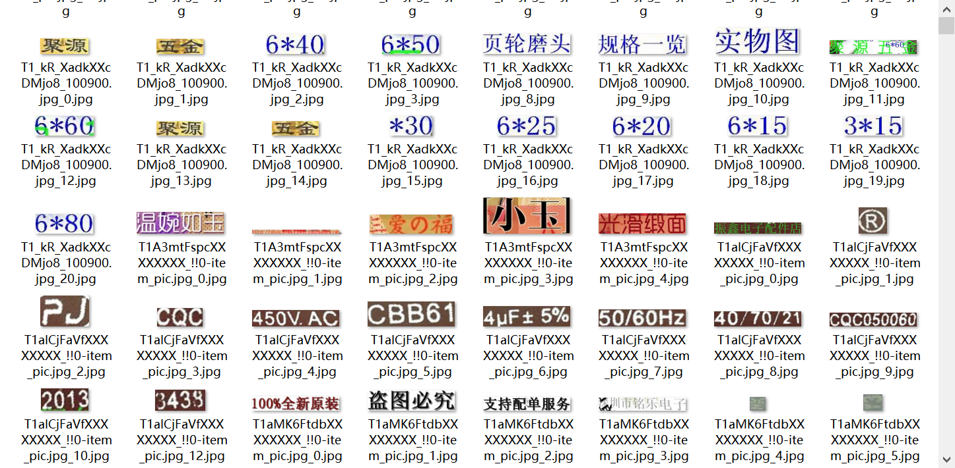
After a lot of research, it is found that the page-level dataset ICPR-MTWI-REC contains a large number of Chinese and English, numbers and symbols, as shown in Figure 3-8, which meets the conditions very well. Therefore, the ICPR-MTWI-REC dataset is used to train and test the model. And 1000 images in the dataset are used as the training set and 500 images are used as the test set, as shown in Figure 3-8.
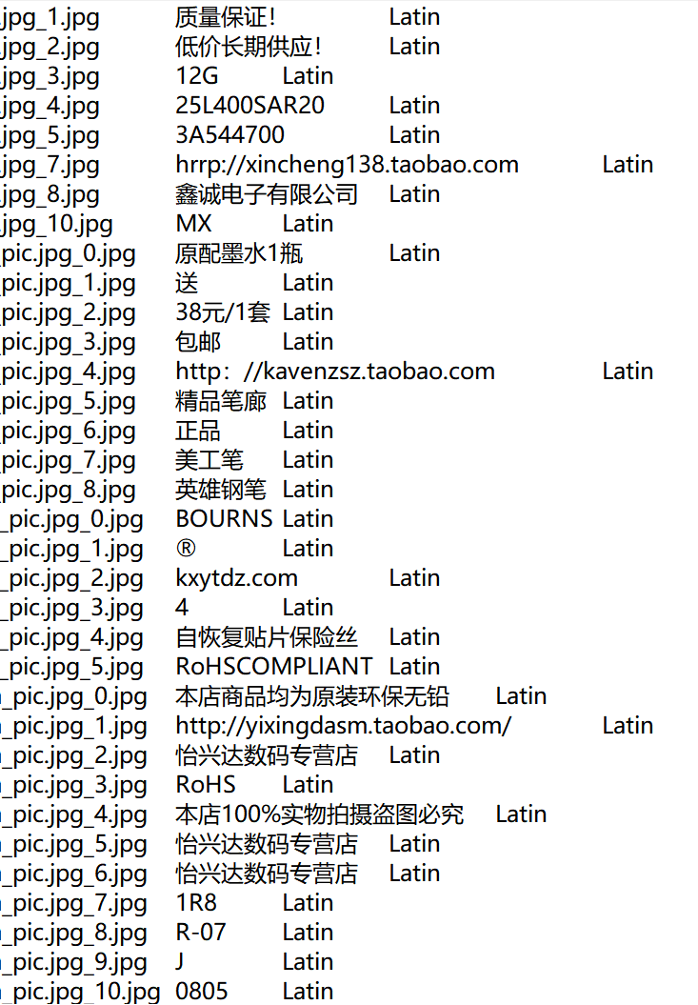
Figure 3-8 Image Dataset

3.3.2 Experimental results and analysis
(1) Training on the dataset
Data set ICPR MTWI - REC in CRNN model for training. A plot of the loss and acc functions over the number of training generations can be obtained, as shown in Figure 3-9.

Figure 3-9.Plot of loss versus acc over training generations
The function of the Loss function is mainly to evaluate the difference between the predicted value and the actual value of the model, and the calculation of the loss function is used to change the model parameters, so as to reduce the optimization error, until the loss function value drops to the target value, at which time the model tends to be stable. acc function is a common evaluation index to judge whether the recognition is accurate. Generally, the higher the value of acc function, the better the training effect of the model. It can be seen from Figures 3-10 that the loss value trained under the CRNN model gradually decreases and tends to be smooth with the growth of training generations, and the acc function gradually increases with the growth of training generations, which indicates that this CRNN model tends to be stable.
- Application of algorithm model
Firstly, the chemical test paper as shown in Figure 3-10 is text located by PCR text detection algorithm, and the picture is divided according to the question number in the test paper, and the position information of the four corner points of each text box as shown in Figure 3-11 is obtained, and the text box of image detection is obtained.
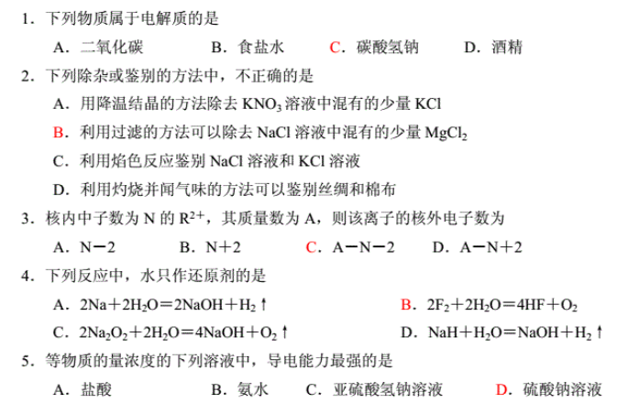
Figure 3-10 Original picture of chemistry paper
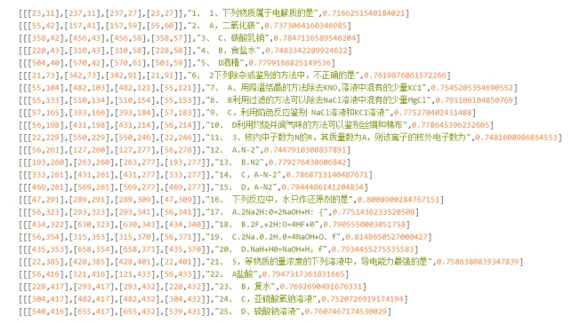
Figure 3-11 Obtained by PCR text detection algorithm of each text box figure angular point data results
Then, the text information in the text box is extracted by text recognition of each divided text box through CRNN algorithm, and the results are shown in Figure 3-12.
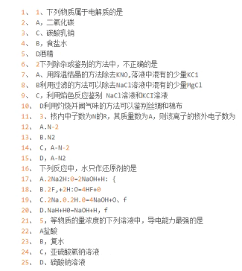
Figure 3-12 test figure identification test result
Through the above two steps, the algorithm of text detection and text recognition for chemical papers is realized, the chemical papers are extracted into corresponding text information according to different question numbers, the conversion from image papers to text papers is completed, and the text information in image papers is obtained. The examination paper of image information for operation is limited, but for a variety of operations to the question of text information, such as text display and text information in the database, the classification, etc.

3.4 Conclusion
In this chapter, the image test paper is defined as the image obtained by photographing the paper test paper and the existing test paper images on the Internet. The image test paper is transformed into the text data of the test questions by the text detection and recognition algorithm for the image test paper. In this chapter, PCR algorithm is used to complete the text detection of image papers, and each question is located to obtain a separate image of each question. Next, the text recognition work was completed through the improved sequence model, and the image of each test question was recognized as text data. Finally, the improved model was compared with the most advanced model on the public data set to verify the effectiveness of the algorithm.

Chapter 4: Research on test question classification methods oriented to test question information
This chapter studies the chemistry test classification algorithm, which classifies and associates the test information according to the knowledge points, and then can be used to achieve automatic grouping and questioning based on the classified test information. This chapter also studies the test question classification algorithm based on recurrent neural network and convolutional neural network, and proposes a fusion algorithm of RNN and CNN. Through experimental analysis, the superiority of the fusion algorithm is verified, and this algorithm is selected to construct an automatic test question extraction and classification system oriented to test paper images.

4.1 Research on chemistry test classification algorithm by fusing RNN and CNN

4.1.1 Discussion and Analysis of CNN and RNN in Classification Algorithms
It is not difficult to find out in the research of chemistry test-oriented classification algorithms:
On the one hand, the Text Convolutional Neural Network (TextCNN) model does a better job of extracting the information of the text in terms of how to capture the information of the context, and the structure is simpler and the training speed is faster. However, in order to avoid a heavy training process, CNNs are generally trained using a simpler convolutional kernel. When using such a simpler kernel, the size of the window is difficult to determine, and the size of the window will directly affect the efficiency of information extraction. Therefore, it is difficult to perform tuning and cannot be targeted according to training.
On the other hand, Text Recurrent Neural Network (TextRNN), which is good at extracting the temporal features of text, is conducive to capturing the semantics of long text, and the model is very flexible and easy to adjust the model structure. However, when it is used to extract the semantics of the whole text, inefficiency and slow training occur.
Therefore, this paper proposes a chemistry test classification algorithm with the fusion of CNN and RNN to take into account the advantages of the two algorithms, make up for the shortcomings of the two, and improve the superiority and practicality of the algorithm.

4.1.1 Algorithmic Fusion of CNN and RNN
The CNN and RNN algorithm fusion framework diagram is shown in Figure 4-1:Figure 4-1 Framework diagram of CNN and RNN algorithm fusion
The chemistry test text obtained after recognition is input into the RNN model and CNN model for classification, respectively, to obtain the probability distribution of the test text on the nine types of chemistry knowledge points, and output the maximum probability kinds of the two models as the classification results, and compare whether the two kinds are the same. If they are the same, the classification results of chemistry test questions are directly output; if they are not the same, the probabilities of the two on their respective models are compared, and the larger probability value is selected as the classification result.

4.2 Experimental results and analyses

4.2.1 Pre-processing of chemical test information
In order to extract the information of test questions according to the classification of knowledge points, this paper divides the new standard high school chemistry into 9 categories of major knowledge points and 36 categories of minor knowledge points in accordance with the high school chemistry syllabus. As shown in Figure 4-2.
Figure 4-2 Topology of chemistry knowledge points in high school
Based on the information of high school chemistry test questions extracted from the New Curriculum Standard in Chapter 4 of this paper, 10 people who are more familiar with high school chemistry are sought to mark the corresponding knowledge points of the test question information by manual labelling, and 5000 well-labelled test question-knowledge point correspondence data are obtained. Considering the general correlation and continuity of chemistry knowledge points, if the classification is carried out according to 36 subknowledge points, there will be a situation due to a large number of knowledge points overlapping with each other, which will lead to a significant reduction in the classification effect of the algorithm. Therefore, in this experiment, the test question classification data set is constructed according to 9 major categories, labelled as shown in Table 4-2.
Table 4-1 Classification of Chemistry Knowledge Points in the New Curriculum for Senior Secondary Schools
No. | Name of the knowledge point
1 | Understanding the chemical sciences
2 | Common inorganic substances and their applications
3 | Principles of chemical reactions
4 | Fundamentals of Organic Chemistry
5 | Structure and chemical properties of substances
6 | Fundamentals of chemical experimentation
7 | Chemistry and STSE
8 | Middle School Bridging Knowledge Points
9 | Chemistry and Social Hotspots
Table 4-2 Classification of Chemistry Knowledge Points in the New Curriculum for Senior Secondary Schools
Test Topic | Points of knowledge
The following statements about substances and changes are correct? | Understanding the chemical sciences
15.6 g of ${Na}_{2}X$ contains 0.4 mol of ${Na}^{+}$, what is the molar mass of ${Na}_{2}X$? | Understanding the chemical sciences
The method for removing $FeCl_{3}$ mixed in Fe(OH$)_{3}$ colloids is? | Principles of chemical reactions
How many unpaired electrons are outside the nucleus of an As ground state atom? | Structure and chemical properties of substances
Which of H, B and N has the largest atomic radius? | Structure and chemical properties of substances
For this equilibrium, the following statement is correct? | Principles of chemical reactions
The chemical equation for adding limestone to coal is? | Common inorganic substances and their applications
The theme of the Shanghai World Expo 2010 is "Better City, Better Life".Which of the following statements is incorrect? | Chemistry and STSE
Write the isomers of the chain compounds that match the following molecular formulas | Fundamentals of Organic Chemistry
The reagent used to identify acetic acid solution, glucose solution and sucrose solution is? | Fundamentals of chemical experimentation

4.2.3 Experimental results and analysis of CNN-based classification algorithm
In this section, experiments are designed for CNN-based test question classification algorithm.For the CNN-based test question classification algorithm, 2000 test questions of 9 categories of new standard high school chemistry knowledge points are selected for experiments in this paper. The experimental results are shown in Table 4-3.
Table 4-3 Experimental results of CNN-based test question classification algorithm
 | precision | recall | f1-score | support
Understanding the chemical sciences | 0.6908 | 0.7275 | 0.7087 | 433
Common inorganic substances and their applications | 0.7516 | 0.6962 | 0.7228 | 339
Principles of chemical reactions | 0.6657 | 0.7104 | 0.6873 | 328
Fundamentals of Organic Chemistry | 0.7447 | 0.6364 | 0.6863 | 55
Structure and chemical properties of substances | 0.8467 | 0.6755 | 0.7515 | 188
Fundamentals of chemical experimentation | 0.8190 | 0.9198 | 0.8665 | 187
Chemistry and STSE | 0.7767 | 0.7877 | 0.7822 | 212
Middle School Bridging Knowledge Points | 0.7400 | 0.7208 | 0.7303 | 154
Chemistry and Social Hotspots | 0.6759 | 0.7019 | 0.6887 | 104
macro avg | 0.7457 | 0.7307 | 0.7360 | 2000
weighted avg | 0.7372 | 0.7345 | 0.7341 | 2000
Overall accuracy | 0.7345 |  |  | 2000
According to the experimental results, it can be seen that the CNN-based test question classification algorithm is able to classify test questions based on knowledge points.Experiments on the dataset constructed in this chapter showed that the highest recognition rate of 0.8467 for the test questions of Chemistry Experimental Fundamentals and the overall accuracy rate of 0.7345 proved the usability of the algorithm in classifying the knowledge points of the test questions.

4.2.4 Experimental results and analysis of RNN-based classification algorithm
In this section, experiments are designed for RNN-based test question classification algorithm.For the CNN-based test question classification algorithm, 2000 test questions of 9 categories of new standard high school chemistry knowledge points are selected for experiments in this paper. The experimental results are shown in Table 4-4.
Table 4-4 Experimental results of RNN-based test question classification algorithm
 | precision | recall | f1-score | support
Understanding the chemical sciences | 0.6628 | 0.6582 | 0.6605 | 433
Common inorganic substances and their applications | 0.5932 | 0.7227 | 0.6516 | 339
Principles of chemical reactions | 0.6984 | 0.6707 | 0.6843 | 328
Fundamentals of Organic Chemistry | 0.5312 | 0.6182 | 0.5714 | 55
Structure and chemical properties of substances | 0.8496 | 0.5106 | 0.6379 | 188
Fundamentals of chemical experimentation | 0.8408 | 0.9037 | 0.8711 | 187
Chemistry and STSE | 0.6185 | 0.7877 | 0.6929 | 212
Middle School Bridging Knowledge Points | 0.7407 | 0.6494 | 0.6920 | 154
Chemistry and Social Hotspots | 0.6271 | 0.3558 | 0.4540 | 104
macro avg | 0.6847 | 0.6530 | 0.6573 | 2000
weighted avg | 0.6869 | 0.6765 | 0.6731 | 2000
Overall accuracy | 0.6765 |  |  | 2000
According to the experimental results, it can be seen that the test question classification algorithm based on RNN has only 0.6765 in total accuracy, which is not as good as the test question classification algorithm based on CNN, and in the experiments on the dataset constructed in this chapter, the recognition rate of the test questions on the structure and chemical properties of substances and the fundamentals of chemical experiments is the same as that of the test question classification algorithm based on CNN, which possesses a higher accuracy; and the recognition accuracy rate of common inorganic substances and their applications and the fundamentals of organic chemistry is relatively The recognition accuracy of common inorganic substances and their applications and the basis of organic chemistry is relatively lower than that of the CNN-based classification algorithm, and the recognition accuracy of the principles of chemical reactions is relatively higher than that of the CNN-based classification algorithm; indicating that the two recognition algorithms can be relatively complementary to each other to obtain a higher recognition accuracy.

4.2.5 Experimental Results and Analysis of Classification Algorithm Based on Fusion RNN and CNN
In this section, experiments are designed for RCNN-based test question classification algorithm. For the CNN-based test question classification algorithm, 2000 test questions of 9 categories of new standard high school chemistry knowledge points are selected for experiments in this paper. The experimental results are shown in Table 4-5.
Table 4-5 Experimental results of RNN and CNN based fusion test question classification algorithm
 | precision | recall | f1-score | support
Understanding the chemical sciences | 0.8194 | 0.7021 | 0.7562 | 433
Common inorganic substances and their applications | 0.7324 | 0.7670 | 0.7493 | 339
Principles of chemical reactions | 0.7281 | 0.7591 | 0.7433 | 328
Fundamentals of Organic Chemistry | 0.7885 | 0.7455 | 0.7664 | 55
Structure and chemical properties of substances | 0.7318 | 0.8564 | 0.7892 | 188
Fundamentals of chemical experimentation | 0.9000 | 0.9626 | 0.9302 | 187
Chemistry and STSE | 0.8333 | 0.7783 | 0.8049 | 212
Middle School Bridging Knowledge Points | 0.8543 | 0.8377 | 0.8459 | 154
Chemistry and Social Hotspots | 0.6667 | 0.7115 | 0.6884 | 104
macro avg | 0.7838 | 0.7911 | 0.7860 | 2000
weighted avg | 0.7844 | 0.7815 | 0.7811 | 2000
Overall accuracy | 0.7815 |  |  | 2000
According to the experimental results, it can be seen that the test question classification algorithm based on the fusion of RNN and CNN has a total accuracy of 0.7815, which is higher than the recognition accuracy of both CNN-based and RNN-based classification algorithms, except for the lower recognition of the structure of the substance and the chemical properties, and all the other subjects are more accurate than CNN-based and RNN-based classification algorithms.

4.3 Conclusion
In this chapter, an algorithm for fusion of CNN and RNN is proposed. And the architectural design and code implementation of this algorithm are carried out. After the experimental comparison of the above three algorithms, it is concluded that the fusion algorithm of CNN and RNN has high accuracy and practicality in the classification results of chemistry test questions.

Chapter 5: Chemistry Test Recognition and Classification System Implementation and Presentation
The core function of the Chemistry Test Question Recognition and Classification System for Test Paper Images is to convert test paper image information into structured test question text information, to achieve the functions of automatically extracting test question information by uploading test paper images, and to facilitate the improvement of the efficiency and quality of teachers' teaching by intelligently selecting and grouping test questions according to the knowledge points. In order to achieve the purpose of converting a large amount of unstructured test paper image data into structured test question information that is classified into categories according to knowledge points, this chapter will analyse the functional requirements and non-functional requirements of the constructed system, and put forward the overall design scheme of the Chemistry Test Question Recognition and Classification System oriented to test paper images.

5.1 System requirements analysis
Chemistry test recognition and classification system should have two main functions: test question recognition and test question classification. Test question recognition function is to detect and recognise the image of the test paper to get the specific test question location information, and store the test question information into the database. The test question classification function is to classify the unclassified test questions in the database according to the knowledge points through the test question classification algorithm, and store the classified information into the database. In the following, we will introduce the specific functional requirements of the system from the teacher's side and the student's side respectively.
The functional requirements of the teacher's side are as follows: firstly, uploading test questions in the system, converting test paper images into text information and saving them in the database; secondly, automatically classifying the obtained test questions according to the knowledge points; and thirdly, automatically assembling classified test questions into test papers according to the knowledge points selected by the teacher. The following is a detailed description of these three functions, the use case diagram of the teacher's end is shown in Figure 5-1.
Figure 5-1 Teacher Use Case Diagram
(1) Test question upload function.The test question upload function is the basis of this system, which is to detect the image of the test paper to get the specific location information of each test question on the test paper, and then identify the obtained test question information to get the specific information of the test question.
(2) Classification and management of test questions. The test questions in the database are classified by the test classification algorithm, and each test question is labelled with a knowledge point and then saved in the database. Teachers can artificially correct the wrong knowledge points of some test questions and classify them.
(3) Group paper function. Teachers can automatically generate test papers by selecting test classes, knowledge points, types of questions and number of questions. According to the knowledge points of the test questions, the test questions are automatically randomly selected from the database, and the test paper is composed. Teachers can select classes to publish online question papers for students to complete.
The functional requirements of the student side are as follows: Firstly, student users can register and log in, and maintain their personal information. Secondly, students can complete the test tasks issued by the teacher and view the history of the test. The example of the student side is shown in Figure 5-2.
(1) Registration and login and personal information maintenance. Students can register and login in the student terminal and save the registration information into the database. Students can also modify their personal information and save the modified information into the database.
(2) Viewing online exams and historical exam records. Students can take the online test paper tasks issued by the teacher, take the test for the knowledge point, and feedback the completed test paper information to the teacher. And students can independently look through the question records, review the wrong questions, and consolidate the knowledge.
Figure 5-2 Student Use Case Diagram

5.2 Overall system design programme
In the previous section, the functional and non-functional requirements of the chemistry test identification and classification system were analysed. In this section, the system will be designed mainly from three aspects, including the system framework, functional modules and technical architecture.

5.2.1 System framework design
Teachers first detect and identify the test questions according to the test paper image to get the information of the test questions, and then pass the obtained data into the classification model to get the test questions with the knowledge point labels, and then select the knowledge points and the test question types for the automatic combination of the test paper to get the whole test paper. The system platform can be roughly divided into three parts data storage layer, business layer and front-end display layer, the overall system framework is shown in Figure 5-3.
Figure 5-3 Overall System Framework
(1) Data storage layer.The data storage layer is mainly used to store the basic information of teachers and students, test question information, examination information and test paper information. The user's basic information can identify the user for the purpose of assigning different privileges. Test question information is used to detect and identify the test paper image through the system, and save the question information into the database for the classification of the next test questions. The test paper information is used to combine the classified test questions to form a whole test paper for the release of test tasks. Examination information is the automatic combination of the test paper in the form of examination released.
(2) Business layer. The business layer is mainly to complete various logical operations to complete the system's functional services. The core services of this system are the test paper detection and identification services and the automatic classification of test questions. Test paper detection and recognition is to convert unstructured test paper image data into structured test paper data and save it in the database. The automatic classification of test questions is based on the classification algorithm of test questions to get the knowledge point labels. In addition, the business layer also includes various services such as automatic paper formation, student examination and teacher marking.
(3) Front-end display layer. The front-end display layer is mainly used to provide a visual interactive interface for administrators and ordinary users. On the one hand, teachers can upload questions for test paper identification on the teacher-side platform, classify the uploaded questions to get the corresponding knowledge points, and then automatically combine the questions with labels to form test papers according to the demand, and finally publish the test papers. On the other hand, students can browse and complete the test papers on the student platform, and feedback the completion status to the teacher. Teachers can assess and evaluate the completed papers.

5.2.2 Functional module design
Requirement analysis of the test paper image oriented chemistry test recognition and classification system which is divided into teacher side and student side.The overall architecture of the system is shown in Figure 5-4.
Figure 5-4 System Functional Module Diagram
The core function of the Chemistry Test Identification and Classification System is the detection and identification of test papers and the automatic classification of test questions. The system is divided into the teacher's end and the student's end, and the teacher's end includes the following modules: test question uploading module, test question classification and management module, and grouping module.
(1) Test question upload module. The timing diagram of the test question upload module is shown in Figure 5-5.
Figure 5-5 Test Upload Module Timing Diagram
The teacher user needs to perform the test upload operation by first clicking on the Upload Test Papers button, which will select the test papers to be tested from within the local file. The selected question paper will be displayed to see if it is selected incorrectly. Then click on the recognition button, the image of the test paper to be detected through the detection and recognition algorithm to get the specific content information of each test question, and save it into the database, because it needs to use the detection and recognition of the image technology, which will be introduced in this paper.
(2) Test question classification and management module. As shown in Figure 5-6, the timing diagram of the test question classification and management module.
Figure 5-6 Timing diagram of test question classification and management module
When the teacher user enters the Test Question Classification and Management module, the system automatically loads the test question classification model, extracts the unclassified test questions from the database, inputs them into the test question classification model, classifies the test questions, labels them with the knowledge points, and saves them in the database. As the teacher user can view, edit and delete the test questions, if the identified questions have wrong information or the knowledge points are wrongly classified, the teacher can manually modify them in this module. Because this function involves the classification of knowledge points, it requires some research.
- Group paper module. Teacher users can enter into the group paper module to select classes, subjects and knowledge points, when the selection is complete, then enter the number of each type of questions and immediately click the release button. The system randomly extracts test questions of the corresponding subjects and types from the test bank, and composes the extracted questions into test papers. Teachers can choose to release the practice tasks online, save them into the database, and let students complete the practice tasks. As shown in Figure 5-7, the timing diagram of the paper formation module.
Figure 5-7 Timing diagram of the automatic question paper generation module
The student side includes the student registration, login and maintenance module and the examination module.
(1) Student Registration, Login and Maintenance Module
Students can enter their names, classes, passwords and other information in the student platform to complete the registration and save them in the student table, and then they can log in to the system with their user names and passwords, and the account names and passwords they enter are verified at the time of logging in, and they enter the system if they pass the verification, and if there is a mistake in the input of the account or the password, they return to the login interface and pop up a prompt of "Error in inputting account or password! If there is an error in the input of account or password, it will return to the login interface and pop up the prompt of "Account or password input error", as shown in Figure 5-8. The logged-in user can modify the personal information in the system and update the student data table when the personal information is changed.
Figure 5-8 Student Login Timing Diagram
(2) Exam Module
When the teacher releases the practice tasks, the released practice tasks will be saved into the test paper table, and the system on the student side will extract the relevant test paper information from the test paper table. Students can log in to the system to see the online test tasks released by the teacher and complete the test online, and the completed practice tasks will be saved into the test question completion table, which can be used for the teacher's modification and review. As shown in Figure 5-9, the sequence of student exams.
Figure 5-9 Student Examination Timing Chart

5.3 Database design
The teacher-user recognises the test paper image through the system's test paper detection and recognition function, and stores the obtained information about the test questions in the test question table.The unclassified test questions are passed through the test question classification model to get the knowledge point classification of each test question, and the test paper is composed according to the teacher's requirements of knowledge points and question types. The student user can complete the posted practice tasks and view the final score.

5.3.1 Database information tables
(1) Teacher Information Table
When a teacher user registers on the teacher's end, the basic information of the teacher is stored in the Teacher Information Table. It includes fields such as teacher id, teacher name, account password, subject, grade, gender, creation time and modification time. When the personal information of a teacher user is changed, it can be modified and the last modification time will be recorded in the teacher table. The specific design of the teacher information table is shown in Table 5-1.
Table 5-1 Teacher Information Sheet
Field Name | Field Type
teacher_id | int
real_name | varchar(255)
password | varchar(255)
subject | int
user_level | int
sex | int
create_time | datetime
edit _time | datetime
(2) Student Table
When a student user registers and logs in on the student side, the system adds to the student table and verifies the student information. The student table is updated when the student performs personal information maintenance and the update time is recorded. There are fields such as student id, student name, account password, class, gender, creation time and modification time. The specific design of the student table is shown in Table 5-2.
Table 5-2 Table of Students
Field Name | Field Type
student_id | int
real_name | varchar(255)
password | varchar(255)
class | int
sex | int
create_time | datetime
edit _time | datetime
(3) Test Question List
When the system performs the function of grouping papers, it needs to extract the test questions from the test question table according to the knowledge point category of the test questions, and the whole test question table saves the information of the test questions after the classification module. Among them are fields such as test id, test question stem, test answer, knowledge point id, question type, test score, creation time, modification time, etc. The specific design is shown in Table 5-3.
Table 5-3 Table of Test Questions
Field Name | Field Type
topic_id | int
stem | varchar(255)
reply | varchar(255)
Knowledge _point_id | int
type | int
score | int
create_time | datetime
edit _time | datetime
(4) Question paper table
The question paper table is used to store the information about the question papers that will be automatically grouped. It contains the test paper id, test question id, publisher, class, total score of the test paper, creation time and modification time. The specific design is shown in Table 5-4.
Table 5-4 Table of test papers
Field Name | Field Type
paper_id | int
topic_id | int
publisher | int
class_id | int
total_score | int
create_time | datetime
edit _time | datetime
(5) Grade Sheet
The grade table records the basic information about each student completing each exercise. When a student completes an exercise task, the results of this exercise are recorded and the basic information about the student's completion of this exercise is stored in the results table. There are achievement id, student id, test paper id, score, teacher id, creation time and modification time. The specific design is shown in Table 5-5.
Table 5-5 Table of Achievements
Field Name | Field Type
paper_id | int
student_id | int
topic_id | int
score | int
teacher_id | int
create_time | datetime
edit _time | datetime
(6) Knowledge point table
When the system executes the classification algorithm for unclassified test questions are classified according to the name of the knowledge point saved in the table. It contains the knowledge point id, knowledge point name and the subject to which it belongs. The specific design is shown in Table 5-6.
Table 5-6 Table of knowledge points
Field Name | Field Type
Knowledge _point_id | int
Knowledge _name | int
subject | int
(7) Class List
When a teacher releases an online practice task, a class selection is made and based on the class table all students within that class can be allowed to practice the task. The class table contains class ids and student ids, and the specific implementation is shown in Table 5-7.
Table 5-7 Class List
Field Name | Field Type
class_id | int
student_id | int

5.3.2 System hardware operating environment
This system uses Spring Boot backend framework and Vue and other front-end components, low requirements for the server, as shown in Table 5-8 platform development environment.
Table 5-8 Platform Development Environment
Experimental Environment | Version Information
Computer System | Window11
Programming Language | JDK1.8、Python3.6、JavaScript
Compiler Software | Webstorm、IDEA
Development Framework | Vue3.0、SpringBoot2.1
Database | MySQL5.6

5.4 Implementation of specific functional modules

5.4.1 Question paper recognition module
When the user enters into the home menu of the system, click on the title upload in the menu bar to enter into the test paper recognition module. Then click on the test paper upload button, select the local test paper image file, check whether the test paper is uploaded incorrectly in the interface, confirm that there is no error and click on the recognition, the test paper in the question to detect and identify, and get the final question information. Finally, save the questions in the test paper into the test question data table, and the result of the interface after realisation is shown in Figure 5-10.
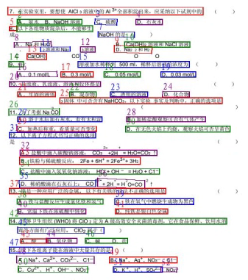
Figure 5-10 Question paper recognition module
The overall process for teachers to operate the test paper recognition module is: the teacher logs into the system through account and password authentication, then the teacher uploads the local test paper image in the system, and then calls the test paper detection and recognition service to get the text information of the test paper respectively, and this text information is obtained by dividing the test paper automatically according to the number of the question, so that the text information of the test questions obtained is divided into the text of each question, and finally, the teacher will review and correct the errors of Finally, the teacher will review each question and correct the error, and after confirming that there is no error, it will be stored in the database. Figure 5-11 Flowchart of test paper recognition module.
Figure 5-11 Question paper recognition module flowchart

5.4.2 Test question management module
When the teacher user enters the test classification module, the system will automatically load the test classification module and classify the test questions according to the knowledge points. Teachers can enter keywords in the search box according to the types and knowledge points of the test questions, click the query button to search, and click the browse button to view all the test questions, and then modify the questions if they are found to have errors in the types of knowledge points or questions. The specific flow of the test question management module is shown in Figure 5-12.
Figure 5-12 Flowchart of Test Question Management Module
In this module, all the test questions are classified and all the unclassified test questions are displayed. After the teacher clicks to classify them, the system predicts the knowledge points to which they belong and labels them, and the teacher confirms each one of them one by one, clicks to confirm them, and stores them in the database. At the same time, the system can also view the corresponding test questions under all knowledge points, and teachers can browse and correct them. In this module, the main purpose is to categorise and manage the test questions, so that teachers can manage the test questions in a unified way, and the result of the interface after implementation is shown in Figure 5-13.

Figure 5-13 Screenshot of the Test Question Management Module Page

5.4.3 Automatic Paper Formation Module
Teachers can determine the scope of practice by selecting the class, determine the test content by selecting the subjects and knowledge points, and finally enter the number of questions required for each knowledge point and click the confirmation button. The system will automatically extract the relevant test questions under the knowledge point in the subject to complete the assembly, and display the assembly results on the assembly page. Finally, the teacher can publish the assembled papers in the form of practice tasks for students to practice online or offline. The specific flow of the automatic paper-forming module is shown in Figure 5-14.
Figure 5-14 Flowchart of the automatic paper-grouping module
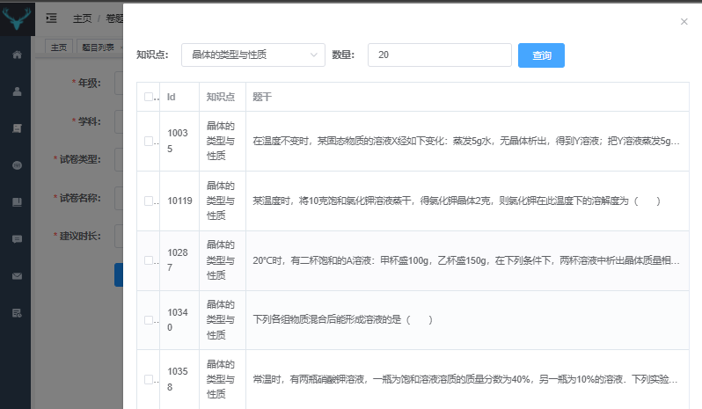
Figure 5-15 Selected Crystal Classes and Properties Knowledge Points
As shown in Figure 5-15, the first knowledge point selected is the types and properties of crystals, fill in the number of questions, and click on the query button, all the questions will be displayed below, and you can independently select the questions you want to practice or automatically extract the corresponding number of questions from the questions under the knowledge point. When you want to practice another knowledge point, just select the knowledge point of the test questions, and the number of questions can be obtained to the knowledge point of the corresponding test questions. Figure 5-16 Quantity of Matter Knowledge Point Selection.
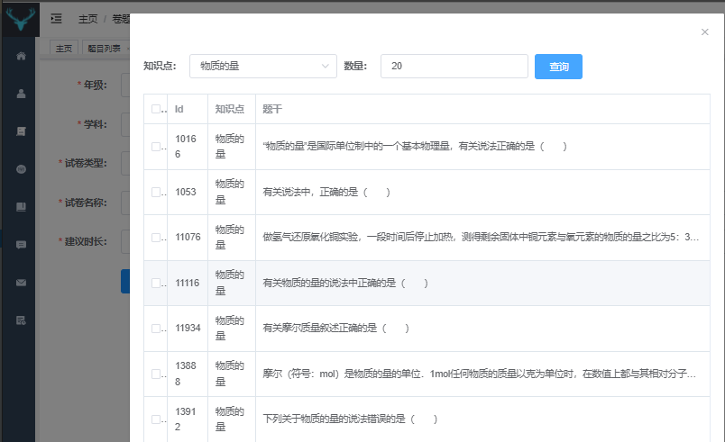
Figure 5-16 Selected Knowledge Points for Amounts of Matter
This module is the application of the classified test questions, mainly to complete the group paper function, the teacher in the system to select the knowledge points and the number of questions can be determined to include the question type and the corresponding number of test papers, click to confirm, you can generate the final test paper, the teacher in the overall test paper to check the correctness of the paper can be released, after the completion of the release of the corresponding students can receive the test paper, and then begin to carry out the test.

5.4.4 Student Answer Module
The student online test task information display screen is shown in Figure 5-17.
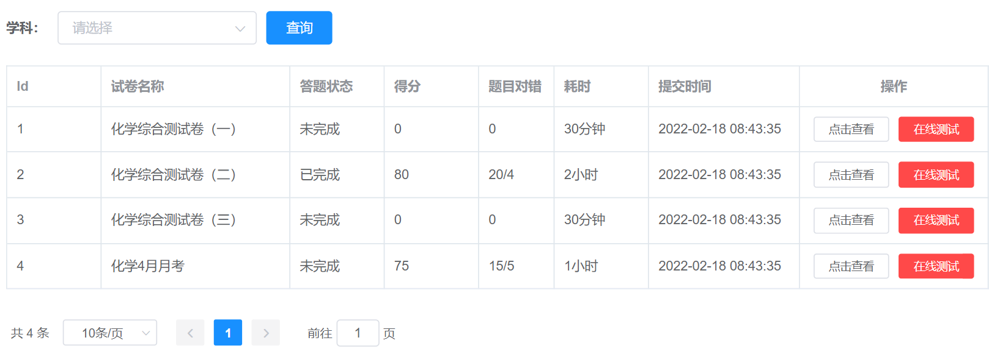
Figure 5-17 Student online test task information display screen
Provide students with the function of completing online exams issued by teachers. Students can enter the Student Answer module from the menu bar on the student side, which not only allows them to view the information of completed online exams through the history information function, but also allows them to complete the tasks of online tests issued by the teacher through the online test function. At the same time, students can also quickly retrieve all completed and uncompleted papers for a particular subject through the subject search bar, and select an online test task that is still in an uncompleted state to take the test. All submitted test papers cannot be tested and submitted repeatedly, as shown in Figure 5-18 for the flow chart of the student answer module.
Figure 5-18 Student Answer Module Flowchart
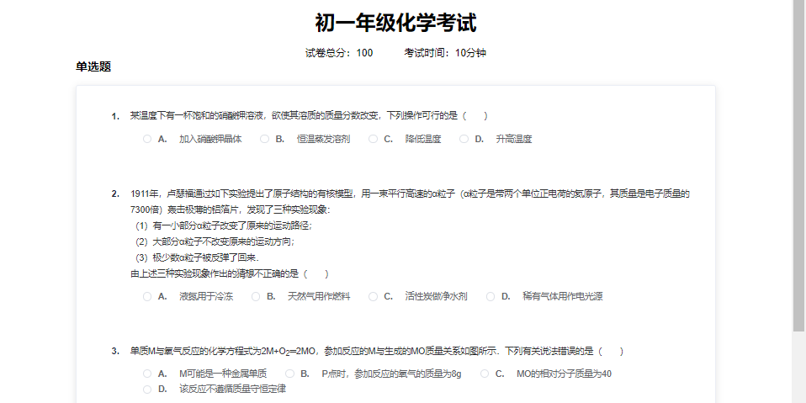
Figure 5-19 Student Answer Screen
The student's answer screen is shown in Figure 5-19 Students need to select the answer for each multiple choice question and complete the exercise.

5.5 System Testing
The system test is mainly to verify the stability of each function and structure of the system, and whether the system can run stably under certain server pressure. The system is mainly tested in five modules: test paper recognition module, test question classification module, automatic paper grouping module, student registration, login and maintenance module, and student question answering module.

5.5.1 Test paper recognition function test
In the test paper recognition function, mainly for the question upload module of the system, different kinds of images are used to test the recognition of test paper images in the chemistry test question recognition and classification system in the following four cases. In the first case, when the uploaded image format is incorrect, whether the system will have the prompt of uploading image format error. The second case, whether the system displays the uploaded image when the uploaded image format is correct. The third case, when uploading a non-examination paper type image, whether the system will have a prompt that the uploaded image is of the wrong type and cannot be recognised as an image. In the fourth case, when the format and type of the uploaded image are correct, whether the system can recognise the question paper and save the recognised questions into the database. The use case tests of the question paper recognition module are shown in Table 5-9.
Table 5-9 Test cases for question paper recognition function
Test item | Description/Input/Operation | Expected results | Real results
Incorrect image upload format | Click on the upload image button and enter an incorrectly formatted image | The system returns to indicate an image format error | meet expectations
Image uploaded in the correct format | Click on the Upload Image button and enter the correctly formatted image | The system displays the uploaded image | meet expectations
Upload a non-examination paper type image | Upload a non-examination paper type image and click on the Recognise button. | The system indicates that the uploaded image is incorrect and cannot be recognised | meet expectations
Upload a paper type image | Upload a paper type image and click the Recognise button | The system indicates that the paper has been recognised successfully. | meet expectations

5.5.2 Test question management function test
Test question management function is mainly for the test question management module, teachers can preview, delete, edit and search test questions and other functions. Specific test question management module use case test shown in Table 5-10.
Table 5-10 Functional Use Cases Test for Test Question Management
Test item | Description/Input/Operation | Expected results | Real results
Preview Button | Click on the preview button | You can preview all the information of the whole test. | meet expectations
Delete button | Click the Delete button | You can delete the question. | meet expectations
Edit button | Click on the Edit button | You can edit the question. | meet expectations
Search Button | Input the search content in the search box and click the search button. | You can search correctly and support fuzzy query. | meet expectations

5.5.3 Tests of the automatic paper-grouping function
The auto-grouping feature automatically builds test papers by selecting the conditions, and the teacher-user determines the test questions and presents them to the grouping box by clicking the Confirm button. When the teacher clicks on the PDF download for offline testing, or click on the immediate release, the test paper will be saved into the database. Specific test paper identification use case tests are shown in Table 5-11.
Table 5-11 Use Case Tests for the Automatic Volume Grouping Function
Test item | Description/Input/Operation | Expected results | Real results
Test Confirmation Button | Select the class, subject, knowledge point and number of questions, and then click on the Confirm button. | In the group paper box, the test questions are displayed | meet expectations
Question Confirmation Button | One or more of class, subject, knowledge point and number of questions are missing, then click the Confirm button. | The system suggests that the lack of conditions can not be extracted questions. | meet expectations
PDF Download Button | Formation is complete, click the PDF download button | The system will save the question paper into PDF format and download it to the local area. | meet expectations
Publish Now Button | Formation of the paper is complete, click the Publish Now button | The system saves the composed papers into the database | meet expectations

5.5.4 Student Answer Function Testing
The student answer function is mainly to test whether students can view the completed test papers and test the unfinished test papers online in the practice module of the student terminal. Specific test cases are shown in Table 5-12.
Table 5-12 Student Answer Function Use Case Testing
Test item | Description/Input/Operation | Expected results | Real results
View Button | Click on the View Unfinished Tests button | The system indicates that the incomplete test cannot be viewed | meet expectations
View Button | Click on the Finished Papers View button | The system displays the details of the paper correctly | meet expectations
Online Test Button | Click on the Online Test button for incomplete papers | The system enters the online test page | meet expectations
Online Test Button | Click on the Finished Paper Online Test button | The system prompts that the completed test cannot be taken again | meet expectations
Search Button | Enter the subject in the search box and click the search button. | The system displays all the papers of the subject | meet expectations

5.6 Conclusion
Based on the research content of Chapter 3 and Chapter 4, this chapter constructs a front-end and back-end software framework of SpringBoot+Vue, and designs and implements a chemistry test question recognition and classification system. This chapter firstly carries out the overall design of the database of the chemistry test question recognition and classification system, determines the basic functional modules of the system, including the test paper recognition module, the test question management module, the automatic paper grouping module, the student registration and login module, the student answering module, and demonstrates and tests the specific functional modules.

Chapter 6: Conclusions and recommendation

6.1 Summary
This paper proposes a chemistry test question recognition and classification system, which investigates test paper image detection and recognition techniques and text classification methods, using a contour regression based test paper detection algorithm, a convolutional recurrent neural network test question recognition method and a recurrent neural network based text classification algorithm. Finally the implementation and demonstration of the system is carried out. This paper mainly completes the following work content:
(1) Aiming at the problems of complex layout of test papers and different shapes of test questions, a PCR-based text detection algorithm for chemistry test images is used to divide the test question images according to the question numbers in the test papers and obtain the position information of each text box divided. The obtained text boxes are inputted into the CRNN model consisting of convolutional neural network (CNN) + recurrent neural network (RNN) + CTC, and the final results of the recognised test question text are obtained.
(2) Aiming at the problem that a large amount of test question information obtained by the test question image detection and recognition algorithm is not labelled and classified, which is not conducive to utilisation in engineering projects, the categories of knowledge points are defined according to the syllabus, the test question information classification dataset is constructed manually, and two test question classification algorithms are studied. Firstly, CNN-based test question classification algorithm is used to extract text information through convolutional kernel, and then RNN-based test question classification algorithm is used to extract text information through Bi-LSTM, and the probability distributions of the text to be tested on nine categories of chemistry knowledge points are obtained from the text information extracted by the two algorithms, and the corresponding knowledge point with the largest probability is output, which is the category of the text to be tested. By designing experiments to compare the performance of the two algorithms, it is found that the RNN-based test classification algorithm has higher accuracy in identifying the module of substance structure and chemical properties, but the total accuracy is only 0.6765, which is not as good as that of the test classification algorithm of CNN, so the classification algorithm based on the fusion of RNN and CNN is proposed, and the classification algorithm has 0.7815 total accuracy, which is better than that of the classification algorithms of CNN and RNN-based. RNN-based classification algorithms both have higher recognition accuracy.
(3) Design and implement a chemistry test recognition and classification system, implement and test for each functional module of the system. The system is built using SpingBoot as the back-end microservice framework, MySQL relational database for data storage, and front-end components such as Vue and Element UI. The system uses the development method of front-end and back-end separation, and completes the functions of the test paper recognition module, test question management module, automatic paper grouping module, paper marking module, student registration and login and personal maintenance module, and question answering module.

6.2 Suggestions for further study
This paper focuses on the detection and recognition of test paper text, using, in test paper text detection, the contour recursive method, so that the text of the test paper layout can be accurately detected in the complex scene, and tested in several important network structures, all to achieve good results. For the text recognition of the question paper layout an improvement is proposed about the decoder, which improves the accuracy of the two decoder models and successfully extracts the text in the test questions. Future work can be centred on the following points:
(1) For the current test paper recognition algorithm, it is difficult to deal with large paragraphs of text due to the limited length of the text sequence that the model can handle. The problem of limited text sequence length can be solved in the future by fusing text semantic information into the model.
(2) As the existing question paper layout will have complex mathematical formulas, images and text for integration, making it difficult for the recogniser of the question paper layout to accurately identify the text images and formulas. Later on, we can solve this problem for special cases and design some new text recognition encoders.
(3) The test question classification algorithm based on recurrent neural network is not accurate enough to calculate the similarity when dealing with long text test questions, and some multi-level models can be designed to solve the problem.

Reference
- Han Bing, Li Guixiang. Design and implementation of Java-based online testing system[J]. Communication and Information Technology, 2021, 2: 55-61.
- Liu W, Anguelov D, Erhan D, et al. Ssd: Single shot multibox detector[C]. European Conference on Computer Vision. Springer, Cham, 2016: 21-37.
- Ma J, Shao W, Ye H, et al. Arbitrary-oriented scene text detection via rotation proposals[J]. IEEE Transactions on Multimedia, 2018, 20(11): 3111-3122.
- Liao M, Shi B, Bai X, et al. Textboxes: A fast text detector with a single deep neural network[C]. Thirty-first AAAI Conference on Artificial Intelligence. 2017.
- Shi B, Bai X, Belongie S. Detecting oriented text in natural images by linking segments[C]. Proceedings of the IEEE Conference on Computer Vision and Pattern Recognition. 2017: 2550-2558.
- Liao M, Shi B, Bai X. Textboxes++: A single-shot oriented scene text detector[J]. IEEE Transactions on Image Processing, 2018, 27(8): 3676-3690.
- Tang J, Yang Z, Wang Y, et al. Seglink++: Detecting dense and arbitrary-shaped scene text by instance-aware component grouping[J]. Pattern Recognition, 2019, 96: 106954.
- Lin T Y, Dollár P, Girshick R, et al. Feature pyramid networks for object detection[C]. Proceedings of the IEEE Conference on Computer Vision and Pattern Recognition. 2017: 2117-2125.
- Wang Y, Xie H, Zha Z, et al. R-Net: A relationship network for efficient and accurate scene text detection[J]. IEEE Transactions on Multimedia, 2020, 23: 1316-1329.
- Wang W, Xie E, Song X, et al. Efficient and accurate arbitrary-shaped text detection with pixel aggregation network[C]. Proceedings of the IEEE. CVF International Conference on Computer Vision. 2019: 8440-8449.
- Qassim H, Verma A, Feinzimer D. Compressed residual-VGG16 CNN model for big data places image recognition[C].2018 IEEE 8th Annual Computing and Communication Workshop and Conference (CCWC). IEEE, 2018: 169-175.
- He K, Zhang X, Ren S, et al. Deep residual learning for image recognition[C]. Proceedings of the IEEE Conference on Computer Vision and Pattern Recognition. 2016: 770-778.
- Baek Y, Lee B, Han D, et al. Character region awareness for text detection[C]. Proceedings of the IEEE. CVF Conference on Computer Vision and Pattern Recognition. 2019: 9365-9374.
- Deng D, Liu H, Li X, et al. Pixellink: Detecting scene text via instance segmentation[C]. Proceedings of the AAAI Conference on Artificial Intelligence. 2018, 32(1).
- Wang W, Xie E, Li X, et al. Shape robust text detection with progressive scale expansion network[C]. Proceedings of the IEEE. CVF Conference on Computer Vision and Pattern Recognition. 2019: 9336-9345.
- Liao M, Wan Z, Yao C, et al. Real-time scene text detection with differentiable binarization[C]. Proceedings of the AAAI Conference on Artificial Intelligence. 2020, 34(07): 11474-11481
- Dai J, Qi H, Xiong Y, et al. Deformable convolutional networks[C]. Proceedings of the IEEE International Conference on Computer Vision. 2017: 764-773.
- Graves A, Fernández S, Gomez F, et al. Connectionist temporal classification: labelling unsegmented sequence data with recurrent neural networks[C]. Proceedings of the 23rd International Conference on Machine Learning. 2006: 369-376.
- Jaderberg M, Simonyan K, Vedaldi A, et al. Reading text in the wild with convolutional neural networks[J]. International Journal of Computer Vision, 2016, 116(1): 1-20.
- Shi B, Bai X, Yao C. An end-to-end trainable neural network for image-based sequence recognition and its application to scene text recognition[J]. IEEE Transactions on Pattern Analysis and Machine Intelligence, 2016, 39(11): 2298-2304.
- Wang J, Hu X. Gated recurrent convolution neural network for ocr[J]. Advances in Neural Information Processing Systems, 2017, 30.
- Liu H, Jin S, Zhang C. Connectionist temporal classification with maximum entropy regularization[J]. Advances in Neural Information Processing Systems, 2018, 31.
- Qi X, Chen Y, Xiao R, et al. A novel joint character categorization and localization approach for character-level scene text recognition[C]. 2019 International Conference on Document Analysis and Recognition Workshops (ICDARW). IEEE, 2019, 5: 83-90.
- Shi B, Yang M, Wang X, et al. Aster: An attentional scene text recognizer with flexible rectification[J]. IEEE Transactions on Pattern Analysis and Machine Intelligence, 2018, 41(9): 2035-2048.
- Shi B, Wang X, Lyu P, et al. Robust scene text recognition with automatic rectification[C]. Proceedings of the IEEE Conference on Computer Vision and Pattern Recognition. 2016: 4168-4176.
- Liu W, Chen C, Wong K Y. Char-net: A character-aware neural network for distorted scene text recognition[C]. Proceedings of the AAAI Conference on Artificial Intelligence. 2018, 32(1)
- Li H, Wang P, Shen C, et al. Show, attend and read: A simple and strong baseline for irregular text recognition[C]. Proceedings of the AAAI Conference on Artificial Intelligence. 2019, 33(01): 8610-8617.
- Luo C, Jin L, Sun Z. Moran: A multi-object rectified attention network for scene text recognition[J]. Pattern Recognition, 2019, 90: 109-118.
- Yang M, Guan Y, Liao M, et al. Symmetry-constrained rectification network for scene text recognition[C]. Proceedings of the IEEE. CVF International Conference on Computer Vision. 2019: 9147-9156.
- Zhan F, Lu S. Esir: End-to-end scene text recognition via iterative image rectification[C]. Proceedings of the IEEE. CVF Conference on Computer Vision and Pattern Recognition. 2019: 2059-2068.
- Dai P, Zhang H, Cao X. SLOAN: Scale-adaptive orientation attention network for scene text recognition[J]. IEEE Transactions on Image Processing, 2020, 30: 1687-1701..
- Liang Y, Li H, Guo B, et al. Fusion of heterogeneous attention mechanisms in multi-view convolutional neural network for text classification[J]. Information Sciences, 2021, 548: 295-312.
- Wang T, Zhu Y, Jin L, et al. Decoupled attention network for text recognition[C]. Proceedings of the AAAI Conference on Artificial Intelligence. 2020, 34(07): 12216-12224.
- Huang Wenming, Mo Yang. Chinese spam filtering based on text-weighted KNN algorithm[J]. Computer Engineering, 2017, 34(3): 193-199.
- Nguyen V T, Huy H N K, Tai P T, et al. Improving multi-class text classification method combined the SVM classifier with OAO and DDAG strategies[J]. Journal of Convergence Information Technology, 2015, 10(2): 62.
- Ouyang X, Zhou P, Li C H, et al. Sentiment analysis using convolutional neural network[C]. 2015 IEEE international conference on computer and information technology; ubiquitous computing and communications; dependable, autonomic and secure computing; pervasive intelligence and computing. IEEE, 2015: 2359-2364.
- Zhang X, Zhao J, LeCun Y. Character-level convolutional networks for text classification[J]. Advances in neural information processing systems, 2015, 28.
- CHENG Yan, SUN Huan, CHEN Haomai, et al. A capsule model for text sentiment analysis by fusing convolutional neural network and bidirectional GRU[J]. Journal of Chinese Information, 2021, 35(5): 118-129.
- Zhang X, Zhao J, LeCun Y. Character-level convolutional networks for text classification[J]. Advances in neural information processing systems, 2015, 28.
- Liu J, Xu Y, Deng J, et al. Ld-CNNs: A Deep Learning System for Structured Text Categorisation Based on LDA in Content Security[C]. International Conference on Network and System Security. Springer, Cham, 2016: 113-125.
- Pang Liang, Lan Yanyan, Xu Jun, et al. A review of deep text matching[J]. Journal of Computing, 2017, 40(4): 985-1003.
- Zhai Jianfeng. Deep learning in natural language processing[J]. Computer Programming Skills and Maintenance, 2013 (18): 74-76.
- Yi-Ou Lin, Lei Hang, Xiao-Yu Li, et al. Deep learning in natural language processing: methods and applications[J]. Journal of University of Electronic Science and Technology, 2017, 46(6): 913-919.
- Yue Chengqing. Research on an adaptive guided learning strategy based on knowledge points[D]. Master's thesis of Southeast University, 2005.
- Wigington C, Tensmeyer C, Davis B, et al. Start, follow, read: end-to-end full-page handwriting recognition[C]. Proceedings of the European Conference on Computer Vision (ECCV). 2018: 367-383.
- Lyu P, Liao M, Yao C, et al. Mask textspotter: an end-to-end trainable neural network for spotting text with arbitrary shapes[C]. Proceedings of the European Conference on Computer Vision (ECCV). 2018: 67-83.
- Liu X, Liang D, Yan S, et al. Fots: fast oriented text spotting with a unified network[C]. Proceedings of the IEEE Conference on Computer Vision and Pattern Recognition. 2018: 5676-5685.
- Li S, Li W, Cook C, et al. Independently recurrent neural network (indrnn): building a longer and deeper rnn[C]. Proceedings of the IEEE conference on computer vision and pattern recognition. 2018: 5457-5466.
- Donkers T, Loepp B, Ziegler J. Sequential user-based recurrent neural network recommendations[C]. Proceedings of the eleventh ACM conference on recommender systems. 2017: 152-160.

