ACBA 5017 ASSIGNMENT 1
Dow Chemical Company | [Company address]
sT sannans field m&e package
Goodrum, Joseph (J)
2025
Contents
Introduction 2
Ventilation 2
Heating and Domestic hot water 5
Lighting, small power & telecoms 7
Wastewater and drainage 8
Sprinkler 8
Appendix 9
References 12

Introduction
This document will look to Justify the proposed mechanical and electrical strategy recommendations for the Nash property being developed by Llanmoor homes in the St Sannans field residential development that are provided in the supplied M&E layout drawings of the property.
The technical drawings include ventilation, Heating, Domestic hot water, DHW, sprinklers, telecoms, lighting, waste water, drainage and small electrical and are designed to conform to current Welsh building regulations, with guidance from good practice guides.

Ventilation
As shown in the supplemented ventilation layout we have proposed that the building is fitted with a centralised mechanical ventilation and heat recovery system, MVHR, and a recirculating kitchen extraction system.
Building regulations Part F volume 1 2022, states that there is a requirement under the regulations to provide ventilation to a habited residential building, the ventilation must remove vapours and pollutants from the building whilst also providing the users of the building with a supply of fresh air from outside in order to promote a healthy environment for the users of a building (Welsh Government, 2022, p. 11).
We have specified a centralised MVHR unit rather than a decentralised unit as this is a new build development rather than retrofit, the installation can be designed into the building rather than trying to adapt the building to suit the MVHR System. The installation of the unit and ducting can be coordinated at the design phase of the project around the other construction elements, the building having improved airtightness and better performing elements such as insulation and glazing rather than older buildings constructed to older building regulations is also more suited to an MVHR system in terms of performance gains (Welsh Government, 2024, pp. 59, 70, 19).
The building is being built to current building regulations and as such a MVHR unit will be more suitable than a traditional constant or intermittent mechanical extraction only system, although these will comply with building control, as this will give improved performance by both extracting contaminants and providing a controlled, heated supply of fresh air to the building as opposed to relying on uncontrolled and unheated supply air to replenish the extracted air from a MEV system. By meeting these demands this system better meets the requirements of the building regulations in terms of Part F and the performance requirements in part L more than an MEV system (Welsh Government, 2022b, p. 11).
We have also specified the use of an intermittent recirculating cooker extraction hood above the cooking area this is to remove the volatile organic compounds, VOC’s, associated with cooking and not to provide the ventilation for the kitchen area as we recommended the installation of the MVHR system. The MVHR system will control all the extraction ventilation to the property and will be sufficient to extract the VOC’s from the kitchen area (Welsh Government, 2022c, p. 16).
The calculations below are based on the requirements of Part F for ventilation.
3 x bedrooms as per table 1.3-part F = 31l/s ventilation for minimum whole dwelling extraction rate based on the number of bedrooms.
0.3l/s x Total Floor area m2 = 108.5m2 x 0.3l/s = 32.55l/s Minimum whole dwelling ventilation extraction rate by floor area.
Minimum high extraction rate requirement as per table 1.2-part F = 35l/s continuous extraction high-rate minimum.
35l/s x 3.6 = 126m3/h total continuous extraction ventilation high rate for the building.
According to the above calculation we have designed the MVHR ventilation system to extract126m3/h as the continuous minimum extraction rate to comply with building control.
For the recirculating extractor hood Part F requires 60l/s minimum or 216m3/h.
For the recirculating extractor we recommend the installation of a Luxair Nuvola recirculating ceiling cooker hood Appendix 1 shows this meets the ventilation rates required (Nuvola - 90cm x 60cm Recirculating Ceiling Cooker Hood - White, no date).
For the MVHR system we recommend the installation of Blauberg Reneo-Fit D100 S14 MVHR unit or equivalent, appendix 2 shows this meets the ventilation rates, and the number of room connections required (vipdesign.com.ua, no date).
For the installation of the MVHR unit we have specified that this is located upstairs in the airing cupboard, this will allow easy access for maintenance purposes, will make the unit less intrusive, and reduce noise from the unit in inhabited areas (Swainson et al., 2018, p. 6). The ducting comprises of 4” and 5” diameter ducting and has been used to reduce noise caused from air movement to an acceptable level. Figure 1 shows good practice limits for velocities of air through an MVHR system, 1.5m/s at final branches, 2m/s for pipe runs, and 3m/s for MVHR connections.
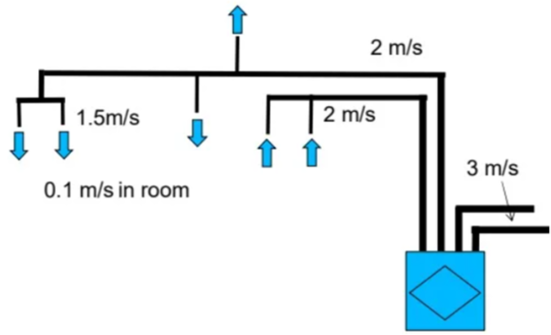
Figure 1.
Figure 2. shows the velocity for different diameter ductwork and has been used to calculate the required ducting diameter.
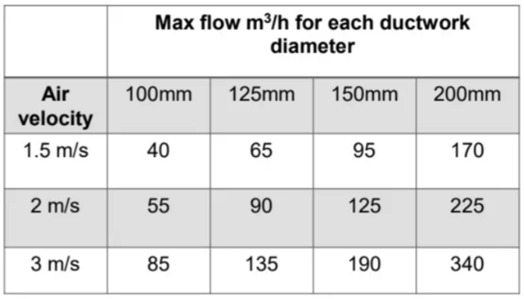
Figure 2.
The ducting has been designed to reduce crossovers to as little as possible and to try to follow the route of transfer rooms where practicable.
As recommended by the Passivhaus good practice guide MVHR for single dwellings we have recommended the installation of attenuators on each branch run to eliminate noise from the MVHR unit, the air moving through the ducting, and noise from separate rooms being transferred throughout the building and being brought down to acceptable levels (Swainson et al., 2018b, p. 10).
The supply air has been balanced to meet the extracted volume of air with each floor of the building also being balanced to try and eliminate draughts and pressure differentials throughout the building.

Heating and Domestic hot water
In the DHW and drainage drawing we have specified the installation of a gas-powered combi boiler; the combi boiler will provide the property with a supply of hot water for heating and for use within the building. We have chosen the installation of a combi boiler as these appliances are efficient and when compared to other systems, such as air source heat pumps, are more cost effective for installation. Combi boilers also have the potential to be run on hydrogen gas and as such may be compatible with United Kingdom government plans to introduce this gas into the national network (Ludlow, 2024) (Hydrogen boilers: everything you need to know - British Gas, no date).
We recommend the installation of a Worcester Greenstar style 35kw combi boiler or equivalent, as shown in figure 3 (Find a new boiler | Worcester Bosch, no date). It is noted that a 30kw boiler will be sufficient but when reviewing approved document L conservation of fuel and power it is specified that the boiler should be of sufficient size to be able to be regulated down to the requirements of the building (Welsh Government, 2024b, p. 39).
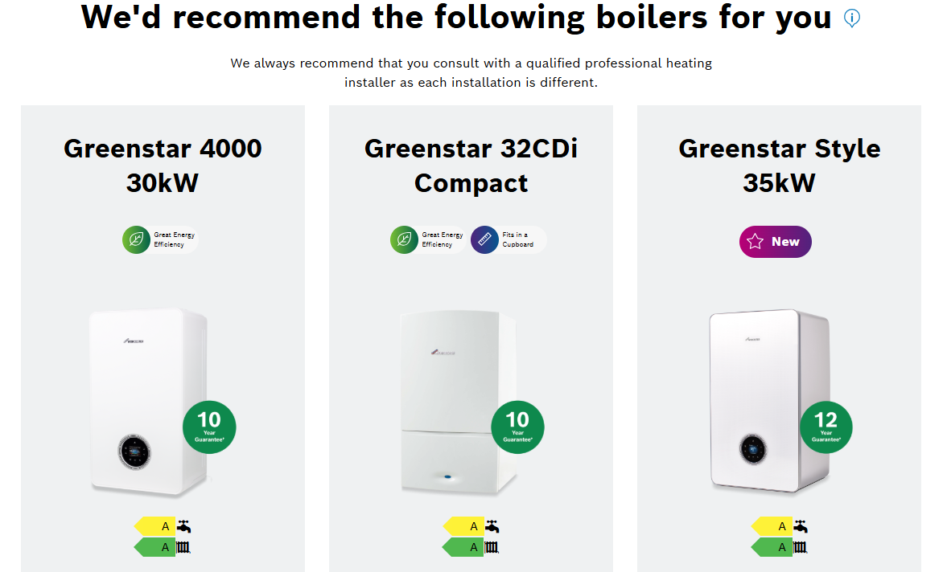
Figure 3.
Approved document J covers combustion appliances and fuel storage systems this document governs the installation of the heating system, we have specified the boiler to be located in the kitchen as this is a well ventilated space with easy access to the boiler for maintenance and the flue for the boiler can routed directly to the outside as the boiler is located on an exterior wall in accordance to the requirements in approved document J (Welsh Government, 2010).
We have tried to ensure that flow and return pipework runs through the transfer rooms where possible to minimize disruption of future maintenance works.
Figure 4. shows the BTU requirements for each of the building’s rooms, using this information we were able to develop a radiator schedule shown in Figure 5. to match the requirements of the building (Heat loss Calculator | City Plumbing, no date) (Central heating Radiators | Convector Radiators | Victorian Plumbing, no date). The dimensions of the radiators have been reviewed against the dimensions of the rooms to ensure they match the spaces available; we have tried to locate emitters near the coldest parts of the room, near the glazing units, where possible.

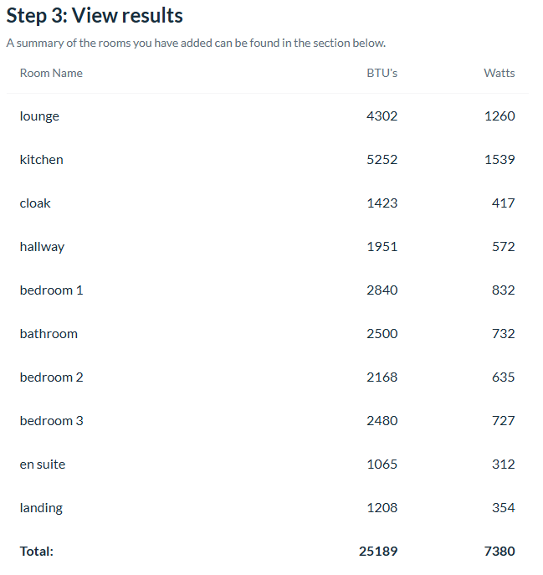
Figure 4.

Radiator schedule | Emitter size | Emitter BTU
Lounge | 600 x 1000 type 21 slim double panel radiator | 4346
Kitchen / diner | 600 x 1200 type21 slim double panel radiator | 5795
Cloak | 600 x 600 type 11 compact single radiator | 1944
Hallway | 600 x 800 type 11 single panel radiator | 2592
Bedroom 1 | 600 x 900 type 11 single panel radiator | 2917
Bedroom 2 | 600 x 800 type 11 single panel radiator | 2592
Bedroom 3 | 600 x 800 type 11 single panel radiator | 2592
Bathroom | 600 x 800 type 11 single panel radiator | 2592
En suite | 500 x 500 type 11 compact single convector radiator | 1392
Landing | 500 x 500 type 11 compact single convector radiator | 1392
Figure 5.
Approved document G covers sanitation, hot water and efficiency in this document there is a requirement for all washing facilities to be supplied with wholesome heated water, in the domestic hot water plan, DHW, we have supplied all washing facilities with hot water and cold water supply and kept pipe runs either to the exterior walls of the building or tried to keep pipe runs to the transfer and unoccupied areas should any maintenance be required in the future on the system (Welsh Government, 2010b, p. 16). We have also accommodated supplies of cold water for the installation of white goods such as dishwasher and washing machine.

Lighting, small power & telecoms
We have included a mixture of downlights and pendant lights across both floors of the building along with a downlights used in the more frequently used areas and wet rooms of the building where higher levels of lighting are required with 300 Lux at surface height being provided to the Kitchen area, 200 Lux at floor level for wet rooms, and 150 Lux at floor level in the lounge area (Franklin, 2024). We have also made provision for the installation of high-speed communications in the lounge where this is most likely to be required to conform with the requirements set out in approved document R electronic communications (Crown copyright, 2017).
We have included the provision of multiple double sockets in the lounge and kitchen areas as the most frequently inhabited areas and to ensure that the building remains suitable for future technology use, the sockets in the building will be split across two ring mains one per floor.
We have included the installation of smoke detectors/alarms and a heat detector to comply with approved document B Fire safety one smoke alarm has been located on the first-floor landing, one in the kitchen area, and one in the lounge area. The heat alarm has is located the kitchen area, which is the room at most risk of fire, the alarms require a main power supply and are radio linked to each other (The Building Regulations 2010. 2006 edition incorporating 2010, 2016 and 2020 amendments, 2006, p. 20).
We have made provision throughout the building for the installation of fused spurs for the fire suppression pump, boiler, extractor hood, cooker, and MVHR unit.

Wastewater and drainage
We have included the wastewater and drainage layouts, in these layouts we have, where possible, kept waste and drainage routing with minimal bends and as direct as possible in line with guidance from Approved document H Drainage and wastewater. We have included the use of bottle traps for wastes to eliminate any odours from the sewage system and to capture large solids and prevent discharge into the sewer system (Welsh Government, 2002, p. 24).
We have also included ventilation of the drainage system by including standpipes on the soil system that are open ended, there is also the provision of a manway at the intersection of the sub surface drainage pipes for maintenance and in line with approved document requirements.

Sprinkler
The M&E package also includes a sprinkler system layout as the building is being built in Wales and under the Welsh regulation 37a it is a requirement for all new residential buildings to be fitted with a fire suppression system (Samuel et al., 2018).
The fire suppression system has been designed to comply with BS9251:2021 under this document the building is categorised as requiring a category 1 fire suppression system and is connected to the mains water with booster pump to allow sufficient flow of water for the required duration for the category of suppression system (BSI Standards Publication, 2021, p. 13).

Appendix
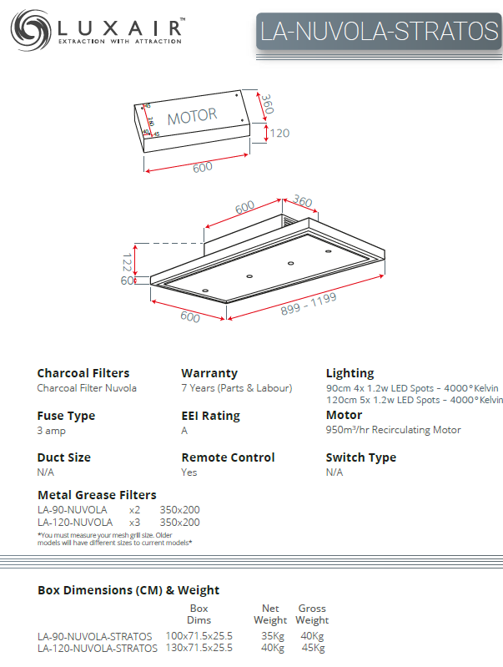
Appendix 1.
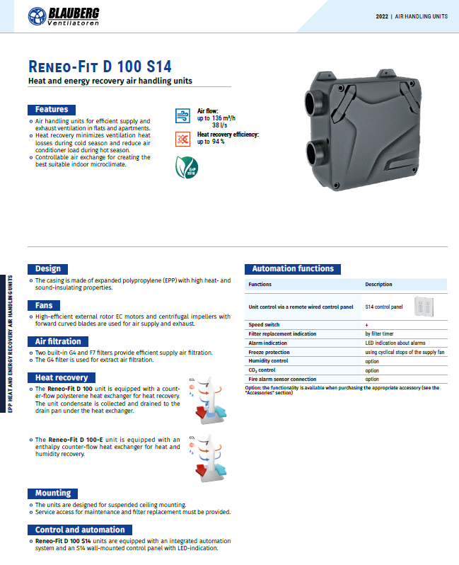
Appendix 2.
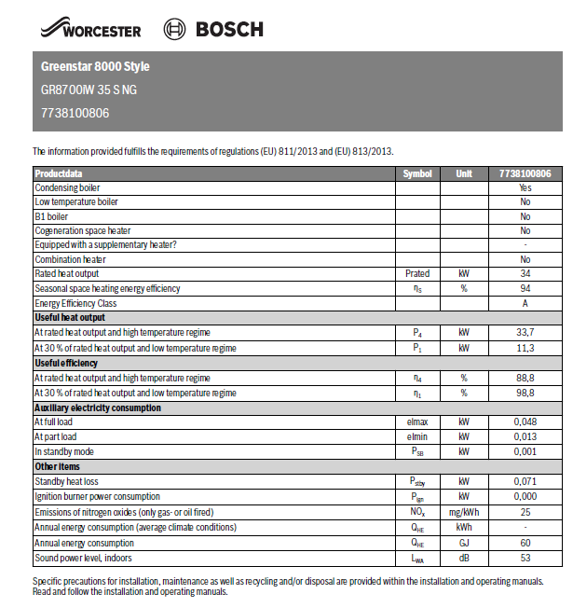
Appendix 3.

References
BSI Standards Publication (2021) BS 9251:2021 Fire sprinkler systems for domestic and residential occupancies — Code of practice. BSI Standards Limited.
Central heating Radiators | Convector Radiators | Victorian Plumbing (no date). https://www.victorianplumbing.co.uk/radiators/central-heating-radiators.
Crown copyright (2017) The Building Regulations 2010. 2016 edition, Physical Infrastructure for High-speed Electronic Communications Networks. 2016 edition. https://www.gov.wales/sites/default/files/publications/2019-05/building-regulations-guidance-part-r-physical-infrastructure-for-high-speed-electronic-communications-networks.pdf.
Find a new boiler | Worcester Bosch (no date). https://www.worcester-bosch.co.uk/products/boilers/find-a-new-boiler/tool/boiler-selector/?user_type=homeowner. (Date accessed 15.01.2025)
Franklin, C. (2024) 'How Many LED Downlights Do You Need?,' Lux guide, 4 November. https://www.electricalcounter.co.uk/articles/led-downlights-guide. (Date accessed 15.01.2025)
Heat loss Calculator | City Plumbing (no date). https://www.cityplumbing.co.uk/heat-loss-calculator?srsltid=AfmBOooYJppJieycgLTcg1UMCh1Br3HwodmU1UjmBLWSGeOpQxCrwkip. (Date accessed 15.01.2025)
Hydrogen boilers: everything you need to know - British Gas (no date). https://www.britishgas.co.uk/the-source/greener-living/hydrogen-heating.html. (Date accessed 15.01.2025)
Ludlow, D. (2024) How much does a heat pump cost to run? Heat pump vs gas boiler explained - Grand Designs Magazine. https://www.granddesignsmagazine.com/heating/how-much-does-a-heat-pump-cost-to-run/. (Date accessed 16.01.2025)
Nuvola - 90cm x 60cm Recirculating Ceiling Cooker Hood - White (no date). https://luxairhoods.com/90cm-Recirculating-Ceiling-Kitchen-Hood-White?srsltid=AfmBOorRMykvcvjaEwpONpX5RM5dqXEegDeJ45MhLwGmjmFZuCgqouKl. (Date accessed 16.01.2025)
Samuel, F. et al. (2018) Building Regulations Wales, Circular. Circular. Welsh Government. https://www.gov.wales/sites/default/files/publications/2019-06/amendments-to-building-regulation-37a-and-schedule-3-wg-0182017.pdf.
Swainson, M. et al. (2018a) Good Practice Guide: MVHR for single dwellings, Good Practice Guide: MVHR for single dwellings. Edited by K. Mead et al.
Swainson, M. et al. (2018b) Good Practice Guide: MVHR for single dwellings, Good Practice Guide: MVHR for single dwellings. Edited by K. Mead et al.
The Building Regulations 2010. 2006 edition incorporating 2010, 2016 and 2020 amendments (2006) For Use in Wales. report.
vipdesign.com.ua (no date) Suspended heat recovery air handling unit Reneo-Fit D 100 S14 | BLAUBERG. https://blaubergventilatoren.de/en/product/reneo-fit-d-100-s14. (Date accessed 15.01.2025)
WELSH GOVERNMENT (2002) Approved Document H: Drainage & Waste Disposal.
Welsh Government (2010a) The Building Regulations 2010. 2010 edition incorporating 2010 and 2024 amendments, Building Regulations. 2010 edition incorporating 2010 and 2024 amendments. report.
Welsh Government (2010b) The Building Regulations 2010. 2010 edition incorporating 2010 and 2018 amendments, Approved Document G: Sanitation, Hot Water Safety and Water Efficiency. 2010 edition incorporating 2010 and 2018 amendments. report. https://www.gov.wales/sites/default/files/publications/2023-05/building-regulations-guidance-part-g-sanitation-hot-water-safety-and-water-efficiency.pdf.
WELSH GOVERNMENT (2022a) Approved Document F Volume 1. 2022 edition, Building Regulations 2010. 2022 edition.
WELSH GOVERNMENT (2022b) Approved Document F Volume 1. 2022 edition, Building Regulations 2010. 2022 edition.
WELSH GOVERNMENT (2022c) Approved Document F Volume 1. 2022 edition, Building Regulations 2010. 2022 edition.
Welsh Government (2024a) Approved Document L Volume 1. 2022 edition incorporating 2024 amendments, Approved Documents. 2022 edition incorporating 2024 amendments. report. Welsh Government. https://www.gov.wales/sites/default/files/publications/2024-05/building-regulations-approved-document-l-vol-1.pdf.
Welsh Government (2024b) Approved Document L Volume 1. 2022 edition incorporating 2024 amendments, Approved Documents. 2022 edition incorporating 2024 amendments. report. Welsh Government. https://www.gov.wales/sites/default/files/publications/2024-05/building-regulations-approved-document-l-vol-1.pdf.

