melat mekbeb
ACADAMIC SKILLS | (LCLM4001_LON)
Report
Name STUDENT MELAT Genene MEKBEB Number/student number 2123174 module NUMBER: (lclm4001_LON) module title: acadamic skill report date 22/8/2024 lecturer name timoth hopkins

Contents

1 INTRODUCTION 2

2 Reflection topic
2.1 Note taking skills 3
2.2Finding information/Research skill 4
2.3 Referencing 5
5 Conclusion 6
6 References 7
7Appendices 8

1 INTRODUCTION

This report is about myself and my experience in the classroom learning about Academic Skills. My experience was challenging and useful learning from my experience. This report uses Gibb’s Reflective Cycle (1988) to explore how this module has helped me develop three key academic skills: note taking skills, research skills, and referencing skills. Through reflection on specific activities and assignments, I will demonstrate the progress I have made in these areas and outline my plans for further development. I will outline the six stages of the Gibbs Reflective cycle by following this stage Description Feeling Evaluation Analysis conclusion action plan and demonstration how to this work framework can be applied to academic skills promote self-improvement and contribute to ongoing learning. Deeper understanding of experience in the future, improve and personal growth.

2.1 Note taking skills

Description
We learned about note taking in Week 2. We looked at different styles, for example, Cornell notes, diagrammatic, tabular, linear. We tried to make notes of the lecture highlighting important detail, and we listened to a BBC programme about motivation capture key points and ideas. We made notes from what we heard. (See Appendix Feelings
I struggled to catch the words spoken on the audio because it was fast if I miss Something important or straggle to organize my note. This felt confusing and sometimes difficult. And its was use full I might feel confidence and prepare for future or exam.

Evaluation
I thought this was useful and has impacted the way I use notes. This may that I need to improve my listening or summarizing skills.

Analysis
The struggle for me is that English is not my first language. Because this means many words I have not heard before, or do not use. It was useful because it helps me remember what I was told, but also how I thought about this.
Conclusion
I realise that note taking is useful and can help me understand and follow what is going on in class. I also think it helps me use English. But to get better at note taking I will also practice using it summarizing information and focuses on lectures and reading.

Action Plan.
I have used different note taking ways in Academic Skills classes and Digital Skills classes. I have become better at taking notes. I focus on summarizing information try be writing down my note with unnecessary detail. I will use my note taking next term in my next courses.
2.2 Finding information/Research skill
Description in week 3 we learned about finding information I was assigned a research project for my course that required me to gather information on topic. The task involved identifying credible sources, information from various materials, and presenting my findings in information. For example, CRAAP TEST. (see Appendix 2)
Feelings
I felt excited and motivated as on the research journey. The prospect of new skills and knowledge was energizing and promising. volume of information overwhelmed me at times. I felt struggled to find the information.
Evaluation
I thought this information had its strengths, because that I success in finding information was using searching terms or google scholar. I felt confidence when found useful source, but I struggle to access certain information. Volume of information overwhelmed me at time.
Analysis
I found the researching method hard to understanding because more general searching resulted in less relevant information. I had to accessed and filter information from news articles to avoid potential bases or inaccuracies. May not the same standard.
Conclusion
Many challenges I have many come from my use IT skills, use English and managing dealing with large volume of information. This sometimes makes it hard to follow the class. On the other hand, I have used researching in the classes and this help me.
Action plan I will practice using researching in my future. Maybe I can find way of practicing my use of IT skills outside UWTSD.

2.3 Referencing
Description
At the start of week 3 we learn about referencing I was unable to properly cite and referencing sources. for example, Harvard referencing In-text Citation referencing list. I collect referencing from academic journal, book, and online source (Appendix picture 3.)

Feelings
I felt extremely anxious, which can be understood through it was difficult harder to with online source. I have felt frustrated when checking each reference for accuracy.
I found the Harvard referencing hard to understand. Although the lesson was useful,
reliable and relevant sources.

Evaluation
This was a very useful class because to get the online source of information, without referencing, would be incomplete. And I used the method in the other classes since.

Conclusion
I need a better understanding of how reference online source. I use academic data based (like google scholar) library article book journals to find the information. This all-necessary source taking in class, and this help me.

Action plan
I need to practice with different type of source training such as style guidance or referencing tools. Helps me systematically address and improve to my citation and referencing skills. I would be able to further necessary assistance or advice for Harvard reference.

3 Conclusion
From this understanding, reflection on your academic skills such as note taking, researching referencing using Gibbs reflective cycle strength high light the strength and weakness. Better to guidance and use of tools can creditable.my approach to the situation could have been more effective.in the future. This experience has highlighted the important and I will lesson my effectiveness in moving forward. exploring my feelings, evaluating the situation, and analysing the underlying issues, I gained a comprehensive understanding of the challenges we faced. The cycle's structured approach facilitated a detailed exploration of both positive and negative aspects of the experience. invaluable tool for structuring my reflections and gaining a deeper understanding of my experiences. By incorporating this reflective process into my practice, I can better manage similar situations and a more effective and improving.

4 References

Spiro, J. Williams, K. Woolliams, M. (2020). Reflection writing. 2nd rev. Bloomsbury
Academic, London, 2020.

Gibbs G, (1988). Learning by Doing: A guide to teaching and learning methods.

Hickson, H., 2011. Critical reflection: Reflecting on learning to be reflective. Reflective practice, 12(6), pp.829-839.

5 (Appendix picture 1)

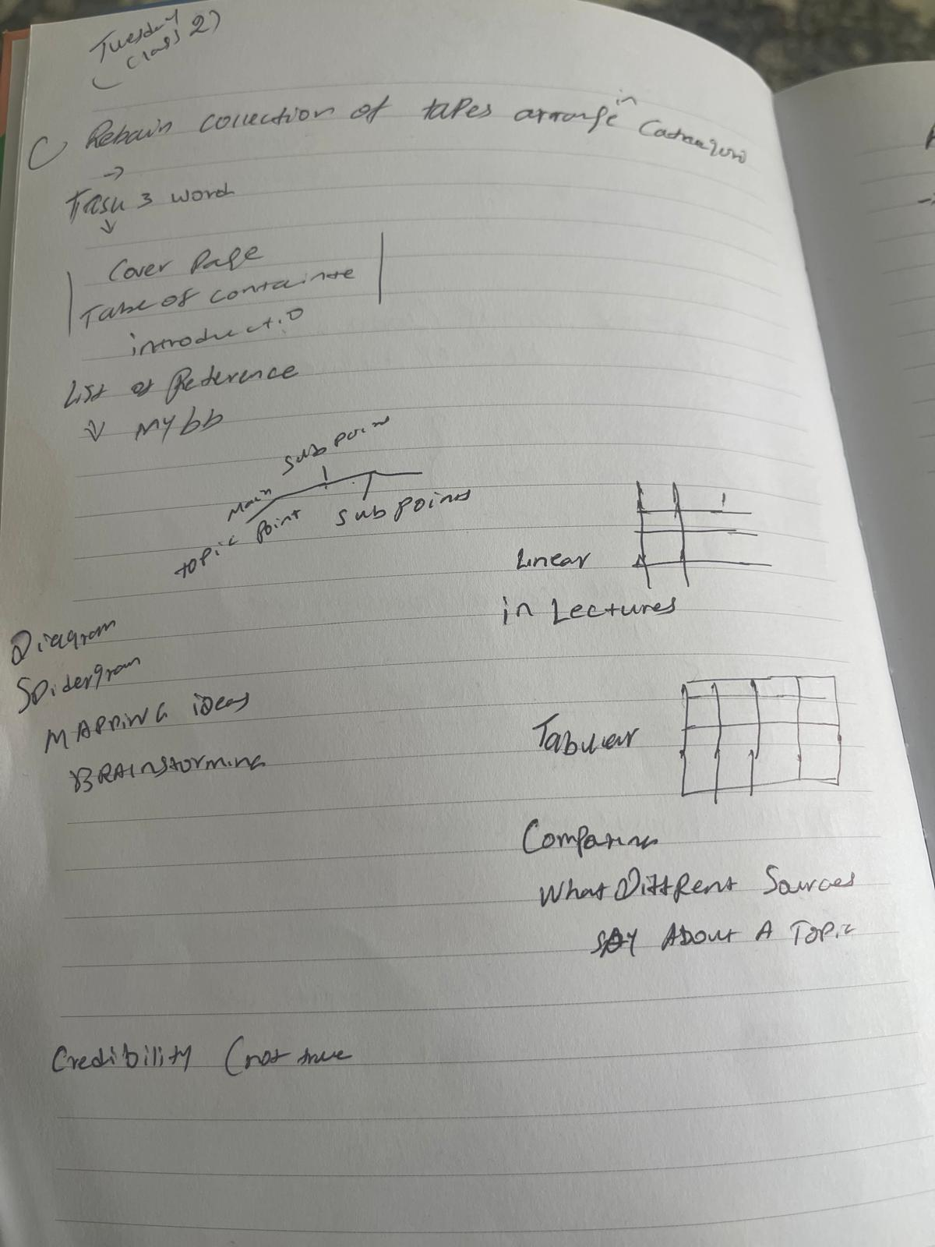

(Appendices picture 2)

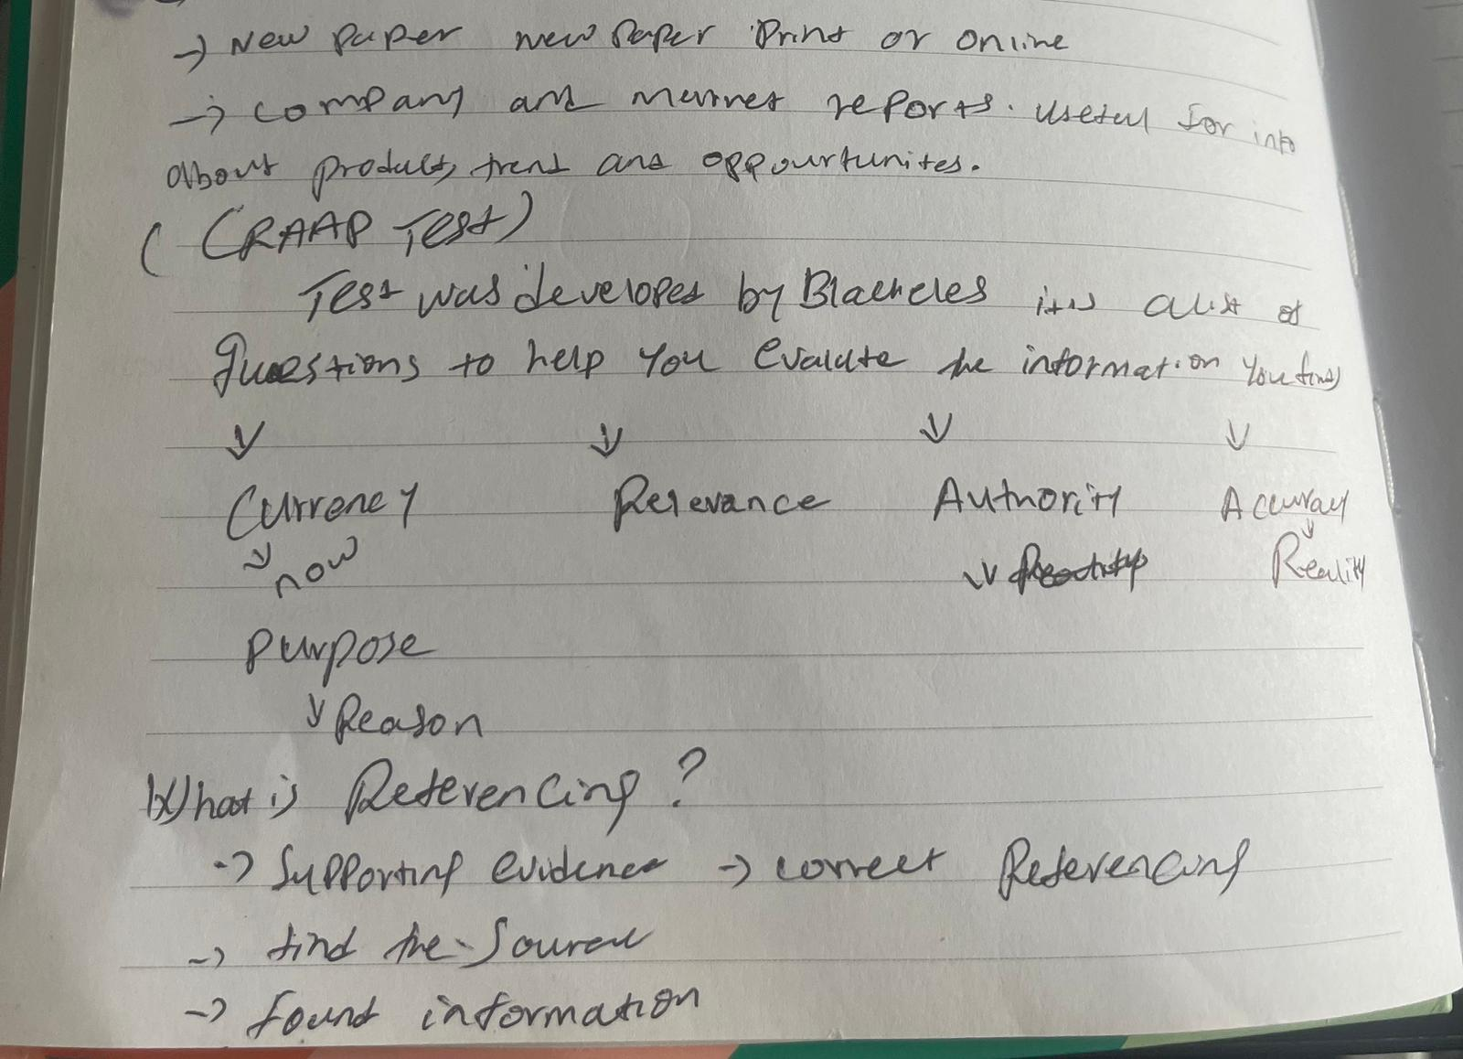

(Appendices picture 3)



