COMMUNICATION MODELS
By Elena-Angelica Dobriu (2011624)

Table of Contents
Introduction 3
Types of communication 3
Basic framework of communication models 4
Barriers to effective communication 4
Types of communication models 5
Conclusion 12
References 13

Introduction
Communication can explain that the process of "transmitting information from one person to another"(Abdullah et al., 2020). The term communication has been derived from the Latin word 'communist, which means common(Abdullah et al., 2020). Therefore, the explanation indicates that in proper communication, a common understanding of the message is required. The three standard segments in every communication process are the sender, the message, and the receiver. The ingredients in the communication process help in determining the excellence of the communication. Difficulty in any of the communication elements can result in poor outcomes in communication and reduce its effectiveness. In this report, a vivid description of communication models and processes shall be done concerningBarry's case study discussed in class.

Types of communication
In the communication channel, there are two types of communication: verbal and nonverbal communication. Verbal communication can be defined as communication using words to deliver a particular message to the receiver. Verbal communication can be of two types oral and written communication. Nonverbal communication refers to communicating using gestures and body movements. Written forms of verbal communication include memos, letters, newspapers, reports, and so on. Written communications can be both formal and informal. Oral forms of verbal communication include interpersonal communication and intrapersonal communication. Oral communication can be either face-to-face or over a telephone. Some verbal communications are formal or informal. Traditional verbal communications in an organization are usually used in meetings, and everyday oral communications take place

The basic framework of communication models
Any communication process begins with two essential components: the sender and the receiver. The communication process is initiated when a person desires to convey the mental images or thoughts in the mind of a person is put across to another person. The person who wants to communicate the message is called the sender, and the person to receives and understands the message is known as the receiver. The process of rendering images into the symbols is called encoding. After encoding the message, the communication process moves forward, and the message is transmitted to the receiver. The message is sent through verbal, written, or face-to-face interactions. These mediums are known as channels. When the message is received through a channel, the decoding process begins. Effective communication is considered when the message is converted back from symbols or signals to the sender's form.

Figure: Basic communication model

Barriers to effective communication
Some of the barriers to effective communication are as follows:
Physical barriers: Physical barriers to contact in the workplace include:
- Restricted areas for the staff or visitors in an organization.
- Separate sitting arrangement behind closed doors for people working in different ranks.
- Separated working unites in a large workplace.
- Perceptual barriers: It type of fence is formed when there is a difference in opinion with people working in the workplace. Keeping an open mind is very necessary while facing this barrier.
- Emotional barriers: Emotional barriers are mainly caused when the speaker or the receiver faces any overwhelming emotion, such as fear or mistrust.
- Cultural barriers: In a diverse workplace, when people do not freely interact with people belonging to a different cultural background, it is a cultural barrier.
- Language barriers: This barrier is common when a person familiar with a different language joins the workplace, much like Barry. This issue is one of the main problems in the workplace. As companies are nowadays working in a global workplace, they hire employees from different cultural and ethnic backgrounds. There are plenty of cases in which the employees from diverse backgrounds might not be familiar with the common language and hesitate to communicate with the other company members(Nwabueze and Mileski, 2018).
- Gender barriers: There are differences in the speaking patterns of men and women. Besides, the attitude of the organization is treating both men and women also contributes to this barrier.

Types of communication models

Shannon and Weaver model
Shannon and Weaver's model focuses on the transmission of the signal from the origin to the target via a transmitter and a receiver on both ends of the channel with minimum intrusion or noise. In the initial stages of the "information theory”, it was created to segregate “noise" from the "signals" transmitting the "information". However, afterward, Weaver extended the theory and applied "Shannon's information theory of communication". Therefore, the idea was finally developed when Shannon focused on the engineering aspects of the theory, and Weaver developed the philosophical aspects of the theory related to human communication methods. The model consists of 7 elements: information source or sender, encoder or transmitter, message, channel, Decoder or receiver, destination or noise source(Gillespie and Schiffman, 2018).
Sender: the sender is the originator of the data or message which is to be transmitted.
Encoder: encoder is the transmitter that is responsible for converting the messages into signals. The sender's message is converted into signal waves like binary data compatible with transmitting through cables or satellites.
Decoder: a Decoder is a reception of the signal, where the signal is converted back to the message. The binary data or signal waves are converted into a message in the form that the receiver.
Receiver: The receiver is the destination of the message which the sender sends. On the basis of the message received on the receiver's feedback, feedback shall be sent to the sender. In case there is noise in the channel, the communications flow between the sender and the receiver will be disrupted.
Noise: while transferring the messages from the encoder to the Decoder through the channel, the process might be affected by physical noise, which might cause disruptions within the channel and affect the communication flow. Therefore noise is responsible for sending or receiving an incorrect message through the channel.
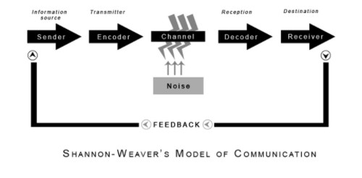
Figure: Shannon-Weaver's model of communication

Westley & MacLean Model of communication
The "Westley & MacLean Model of communication" focuses on analyzing the communication between the source and the receiver. This model was a variation of"Newcomb's model of communication" and contains some conceptions from "Lewin's model".According to the Westley and Maclean communication model, communication begins when a person starts responding selectively to his/her physical surroundings rather than when a person starts talking. This model focuses on the solid relationship between responding to "surroundings and the process of communication". "Communication begins when a person receives a message from their surroundings". Each receiver counters differently to the messages they receive from their surroundings based on their orientation. The "Westley and Maclean model of communication" consists of various components which might even be a source of uncertainty.

Advantages of the Westlet & Maclean Model of communication:
- The immense importance of feedback in the communication process has been considered in this model.
- The message is formed and sent to the environment; therefore, there is not necessarily an involvement of a person. Consequently, it can be ensured the news can attempt to appeal to diverse ways(Bucur and Ban, 2019).
- The sender's social and cultural background forming the objects of orientation is an essential aspect of decoding the message, often susceptible to misunderstanding. Barry faces a similar problem of misunderstanding as being from a different social inclination.
- This model applies to both interpersonal communication and mass communication.

Disadvantages of the Westley & Maclean model of communication:
- The different concepts and variables in the model make it a fairly complex model.
- The model fails to address multiple messages at the same time.
- There is a fair chance that the information sent might be changed during transmission due to the channel's noise because the model does not address it.
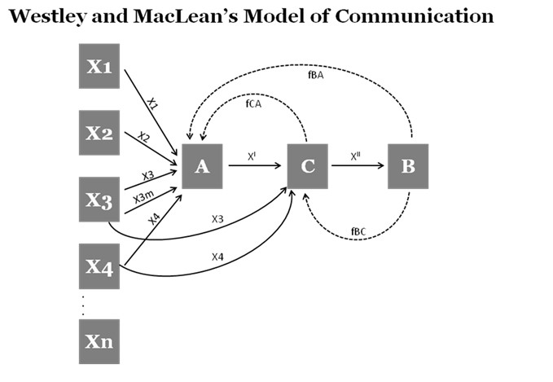
Figure: Westley and Maclean's model of communication

7 C's of effective communication
The model of 7C's of effective communication consists of 7 factors that are to be maintained to have an effective communication system. This framework is applicable for both written and oral forms of communication. The seven factors in the framework are as follows:
Completeness: The communication process must be complete, which means that the entire process from transmitting the information from the sender to decoding the receiver's message should be done for effective communication. Some of the features of complete contact are as follows:
- Complete communication helps in enhancing the reputation of a company.
- Complete communication can provide adequate information to the receiver.
- A better decision-making process is undertaken with the help of complete communication.
- It is a cost-saving method of sending important information as no information goes missing during the process.
- It retains the interests of the audience.
- Conciseness: Conciseness implies communicating the message in the least number of words possible without underestimating the other C's of communication. Brevity is very important for maintaining effective communication. Concise communication consists of the following features:
- It is cost-saving
- It is time-saving
- It helps in highlighting the primary objectives of the message without using too many words.
- It appears to be more appealing to the audience.
- It helps in preventing repetitiveness.
- Consideration: Consideration implies showing empathy. Effective communication is only possible by considering the listeners, i.e., the listener’s perspective should be considered. While communicating with an audience, the speaker should consider the audience's issues to impress them. Some of the features of considerate communication are as follows:
- Empathize with the interests of the audience because it will help in getting a response from the audience.
- Optimism should be maintained towards the audience.
- Clarity: The clarity aspect emphasizes a particular message rather than trying too hard to impress the audience. The clarity in communication can be achieved by maintaining the following features:
- It clarifies the meaning of the message.
- The clarity in expressing the thoughts will help in enhancing the meaning of the message.
- Use of articulate words to clarify the message.
- Concreteness: Concrete communication implies that the message should particular and relevant to the topic rather than general. The following features should be maintained for maintaining the concreteness of the news:
- The message is fraught with facts and figures.
- Concrete messages are less susceptible to be misread.
- Courtesy: Courtesy in a message entails that the receiver should receive enough respect from the sender. A courteous message should have the following features:
- It is not biased, although it might be directly positively towards the audience.
- Appropriate use of terms to show respect to the receiver.
- Correctness: Correctness in a message signifies that the message should be void of any grammatical errors. The following features should be maintained in proper communication are as follows:
- The message is exact and correct.
- Correct communication helps in boosting the confidence of the speaker.
- Correct use of language is present.

Conclusion
In this report, the different barriers to communication in the workplace have been recognized. Although there are diverse issues to conduct effective communication, the main problem lies in understanding the basic concept of a communication model, which has been evaluated here. Some popular communication models have also been used in this report to illustrate further the models of communication.

References
Abdullah, Z., Ling, T.Y., Sulaiman, N.S., Radzi, R.A.M. and Putri, K.Y., 2020. The effects of verbal communication behaviors on communication competence in the pharmaceutical industry. Journal of Critical Reviews, 7(12), pp.697-703.
Bucur, M. and Ban, A., 2019. Study on the Westley Maclean Model and the Co-Orientation Model and their Exemplification in an Industrial Enterprise. Acta Marisiensis. Seria Technologica, 16(2), pp.25-28.
Gillespie, D.J. and Schiffman, R., 2018. A critique of the Shannon-Weaver theory of communication and its implications for nursing. Research and theory for nursing practice, 32(2), pp.216-225.
Nwabueze, U. and Mileski, J., 2018. Achieving competitive advantage through effective communication in a global environment. Journal of International Studies, 11(1).

