
Dayana Emiliana Balandra Heredia (2442006)
University Of Wales Trinity Saint David
Operating Systems Assignment
DR. Redhwan Al-Amri (Lecturer)

Table Of Contents
1. Introduction 1
2. Key Functions of Operating Systems 1
3. Windows OS CLI Commands 5
4. Linux OS CLI Commands 7
5. Windows Batch Scripts 11
6. Linux Bash Scripts 12
7. Conclusion 12
References 12
Appendices 13

1. Introduction
Operating systems are an important part of modern computers because they allow users to interact with hardware and software efficiently. Popular operating systems such as Microsoft Windows and Linux provide tools that help manage system resources, files, processes and network connections.
This report explores the main functions of operating systems and explains how command line interfaces (CLI) can be used to manage system tasks. It also demonstrates the use of different Windows and Linux commands, as well as simple scripts that automate common tasks. The aim of this report is to show how operating systems support users and improve the management of computer systems.

2. Key Functions of Operating Systems
Operating systems are essential software that manage the hardware and software resources of a computer. They provide an interface between the user and the computer system and make it possible to run applications efficiently. Modern operating systems such as Windows, Linux and macOS include many built-in tools that help users manage processes, memory, files and devices.
One of the most important functions of an operating system is process management. This function allows the system to run multiple programs at the same time. The operating system decides how the CPU is shared between different tasks and ensures that each process gets the necessary resources to run correctly. In Windows, process management can be monitored using the Task Manager, which displays information about running applications, CPU usage and memory usage.
Operating systems also play an important role in system stability and performance. They manage how different applications use system resources and ensure that programs do not interfere with each other. For example, if too many applications try to use the CPU or memory at the same time, the operating system decides how resources are distributed. This helps prevent the system from slowing down or crashing.

Another important responsibility of operating systems is providing a user interface. Most modern operating systems include graphical user interfaces (GUI) that allow users to interact with the computer using icons, windows and menus. However, command line interfaces are still very important because they allow advanced users to perform tasks more efficiently. System administrators often use command line tools because they provide greater control over the system.

Operating systems also handle system updates and maintenance. Updates help improve security, fix bugs and add new features to the system. Without proper system management, computers may become vulnerable to malware, viruses or unauthorized access. For this reason, operating systems include security features such as user accounts, passwords and permissions.
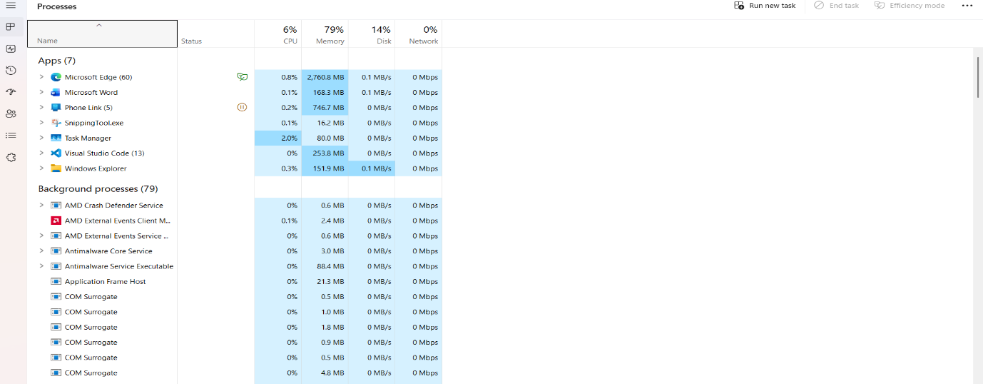
Figure 1: Task Manager Showing running process
Another important function is memory management. The operating system controls how the computer's memory (RAM) is used by different programs. It allocates memory space to applications and ensures that programs do not interfere with each other. Efficient memory management helps improve system performance and prevents system crashes when multiple applications are running.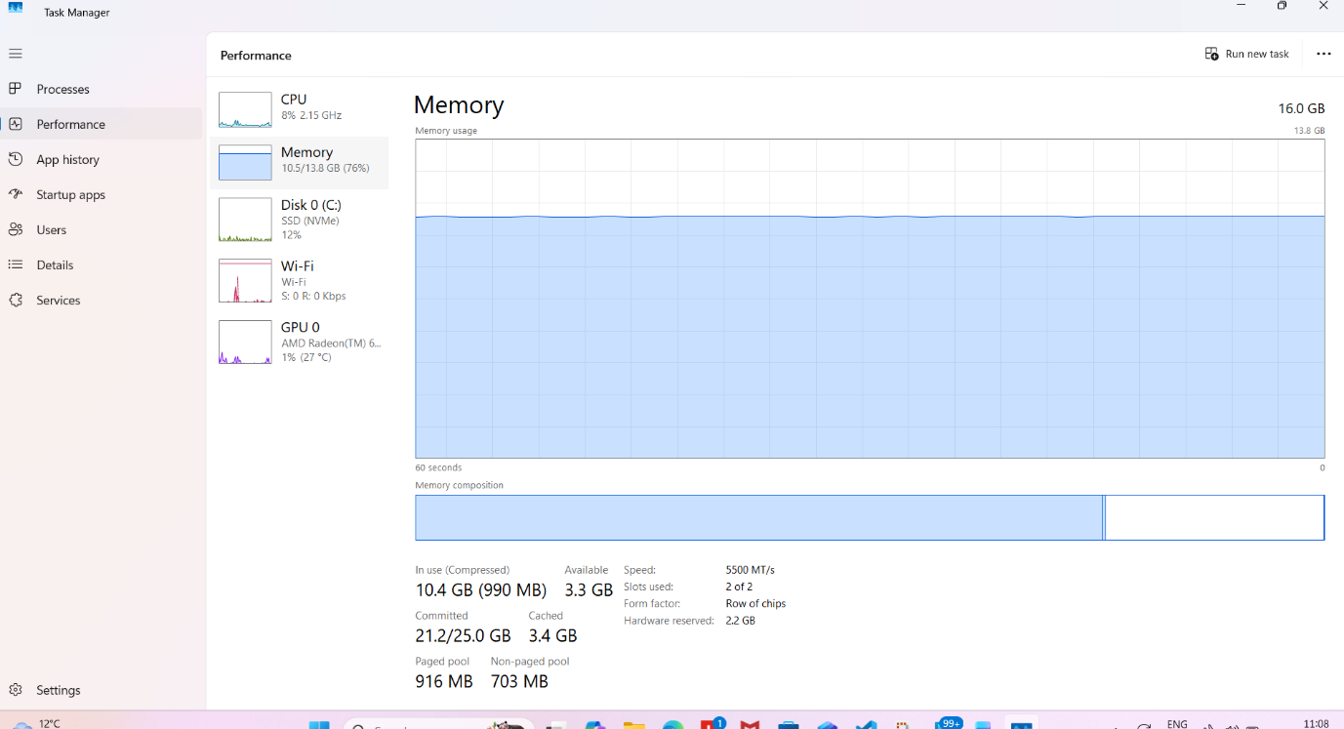
Figure 2: Memory usage monitored using Windows Task Manager.
File system management is also a key function of operating systems. The operating system organizes data on storage devices such as hard drives and solid-state drives. It allows users to create, delete, copy and move files and folders easily. In Windows, this can be done through File Explorer, while in Linux it can be managed through both graphical tools and command line commands.
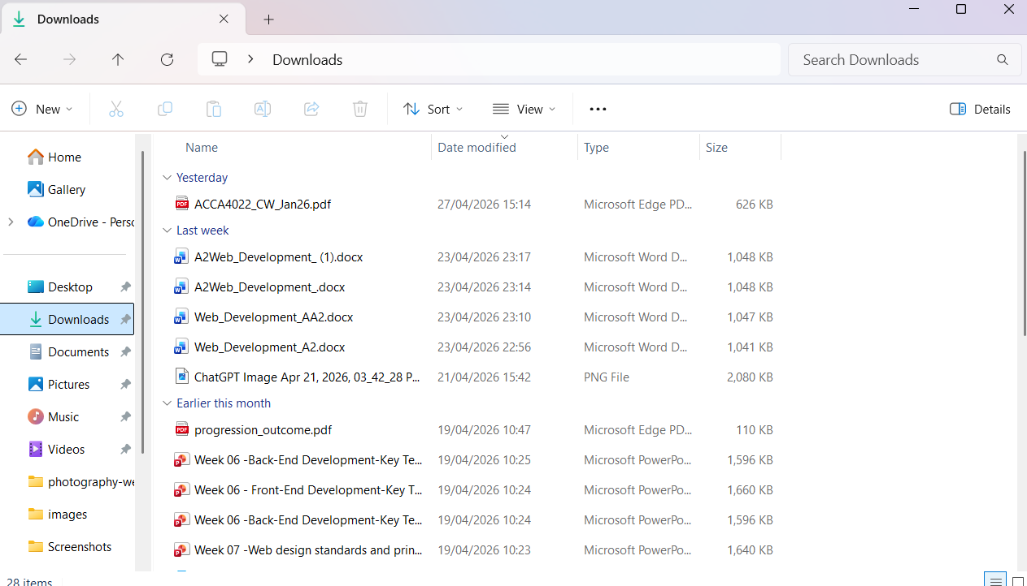
Figure 3: File Management Using Windows File Explorer.
Operating systems also provide device management. This means that the operating system controls and communicates with hardware devices such as printers, keyboards, monitors and storage devices. Device drivers are used to allow the operating system to interact with different hardware components. For example, Windows Device Manager allows users to view and manage installed hardware devices.
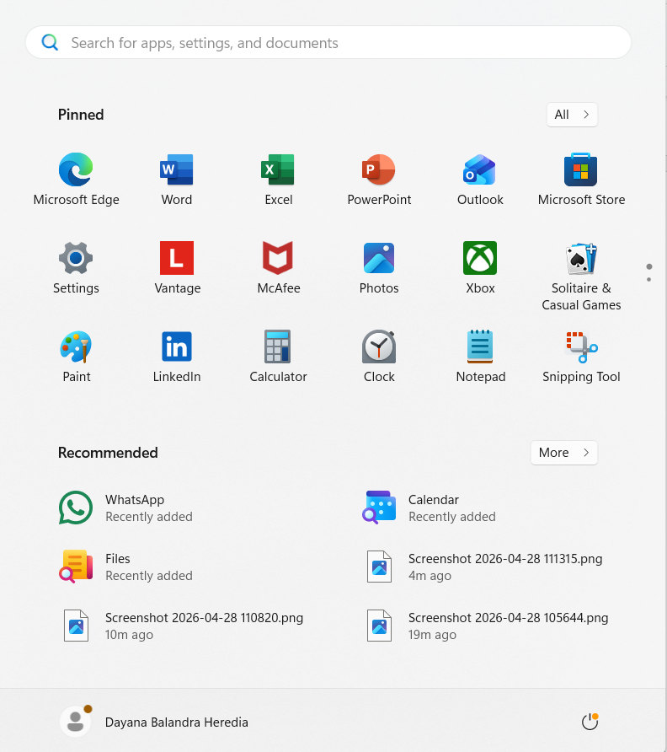
Figure 4: Windows Device Manager Showing Hardware Devices.
Another key function is user management and security. Operating systems allow multiple users to access the system with different permissions. Administrators can control access to files, applications and system settings. Security features such as user authentication, passwords and permissions help protect the system from unauthorized access.
Finally, operating systems support network management. They provide tools that allow computers to communicate with other devices over a network or the internet. Commands such as ping, ipconfig or network monitoring tools allow users to check network connections and diagnose network problems.
Overall, operating systems perform many important functions that ensure computers run efficiently. By managing processes, memory, files, devices and network connections, the operating system provides a stable environment for users and applications. [1]

3. Windows OS CLI Commands
Windows operating systems include a command line interface called Command Prompt. It allows users to perform different tasks by typing commands instead of using the graphical interface. [2]

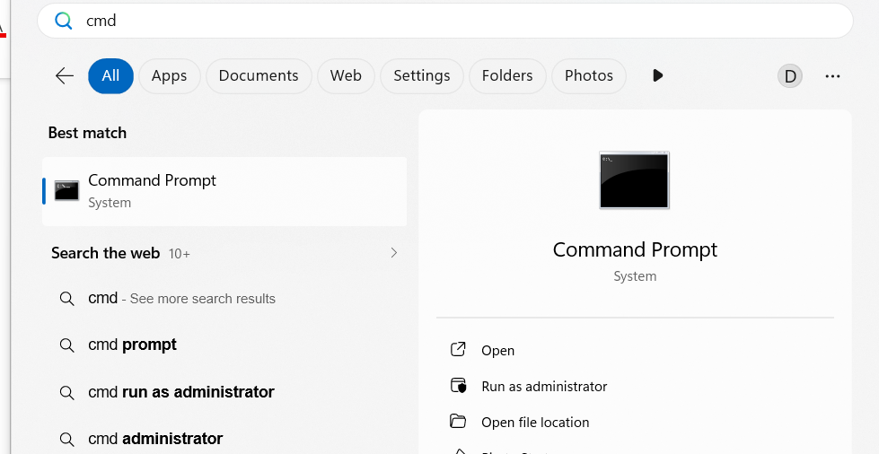
Figure 5: Searching for Command Prompt in Windows.
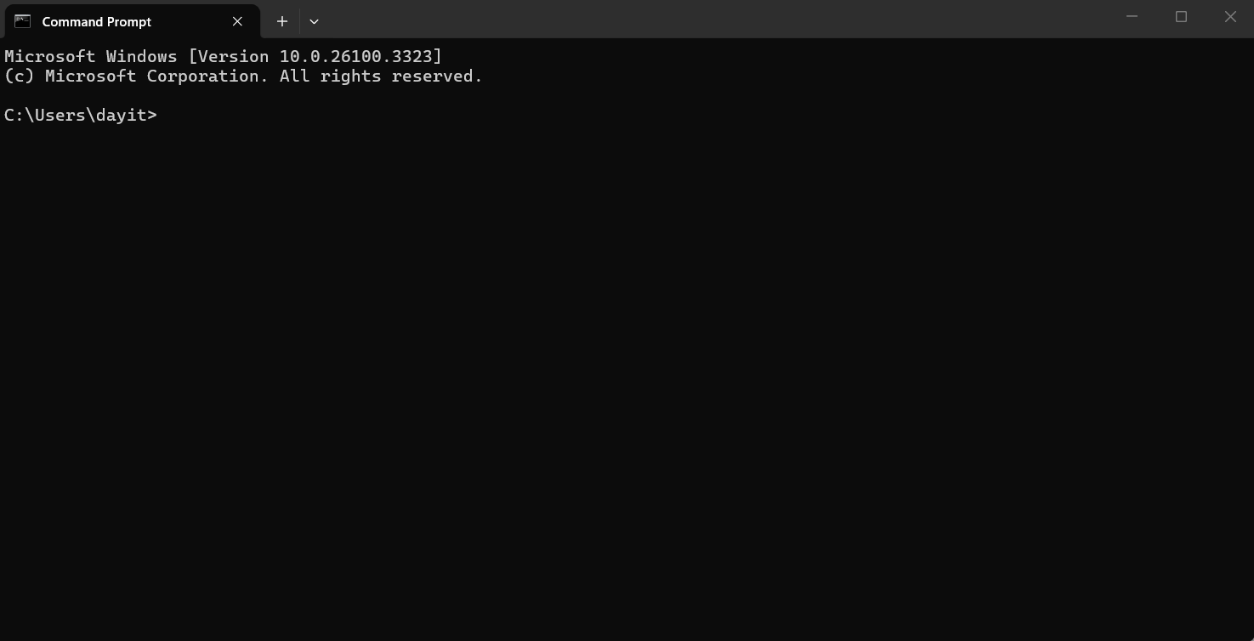
Figure 6: Command Prompt interface in Windows.
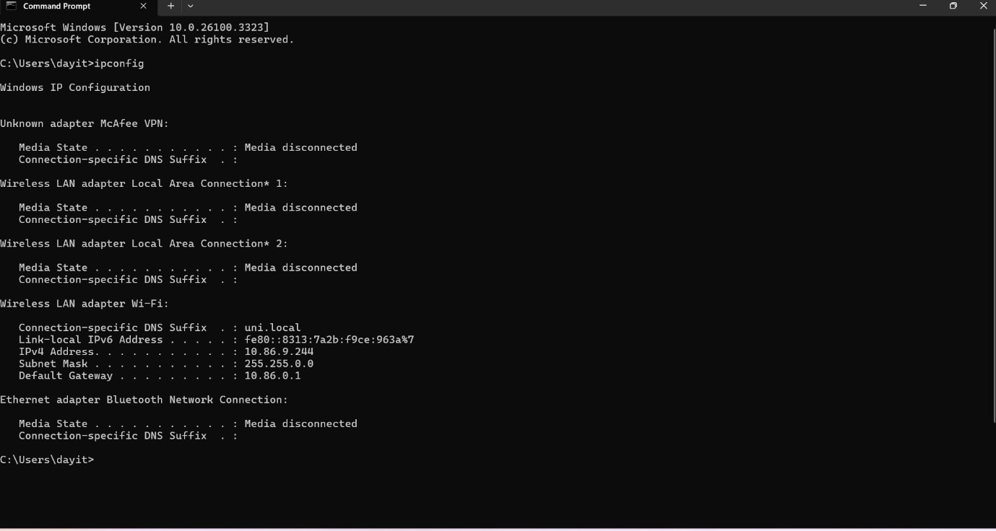
Figure 7: Output of the ipconfig command showing network configuration.
Another useful command in Windows Command Prompt is dir. This command is used to display a list of files and folders in the current directory. It helps users quickly see the contents of a folder using the command line.
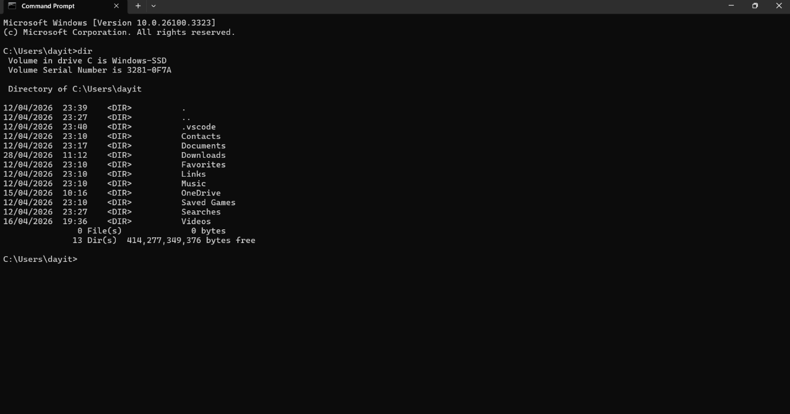
Figure 8: Using the dir command to list files and directories.
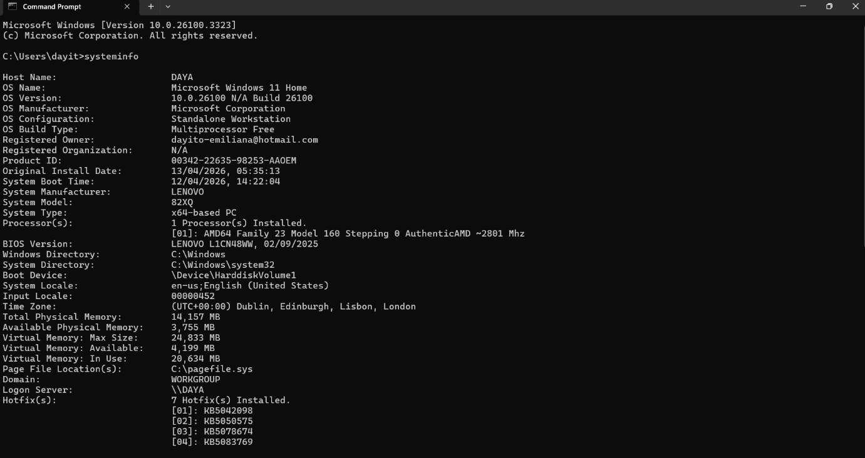
Figure 9: System information displayed using the systeminfo command.
The ipconfig command was useful because it displayed important network information such as IP address, subnet mask and default gateway. This is important when checking whether a computer is connected to a network correctly. The dir command was also useful because it showed the files and folders available in the current directory. This helps users manage files without using File Explorer. The systeminfo command provided detailed information about the operating system, hardware and system configuration. These commands show how Windows CLI tools can be used for monitoring, troubleshooting and basic system administration.
Using command line tools in Windows can be very helpful for troubleshooting and system administration. Many network problems can be diagnosed using commands such as ipconfig, ping or tracert. These commands allow users to check network connectivity, identify configuration issues and test communication between devices.
The command line interface also allows users to perform tasks more quickly than using graphical tools. For example, system administrators may need to check system information on many computers. Instead of navigating through different menus, they can use commands such as systeminfo to quickly retrieve system details.
Although many users prefer graphical interfaces, the command line remains an important tool in Windows operating systems. It provides more flexibility and allows users to automate tasks through scripts. For this reason, understanding command line tools is an important skill for IT professionals.

4. Linux OS CLI Commands
Linux operating systems also include a command line interface called the terminal. The Linux terminal allows users to manage files, processes, users and network information by typing commands. [3]
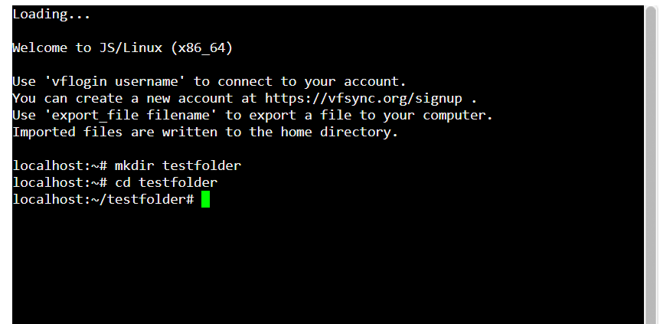
Figure 10: Creating and navigating to a directory using the mkdir and cd commands in Linux.
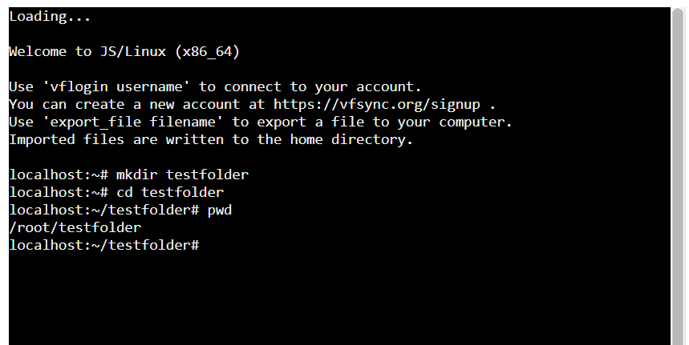
Figure 11: Using the pwd command to display the current working directory.
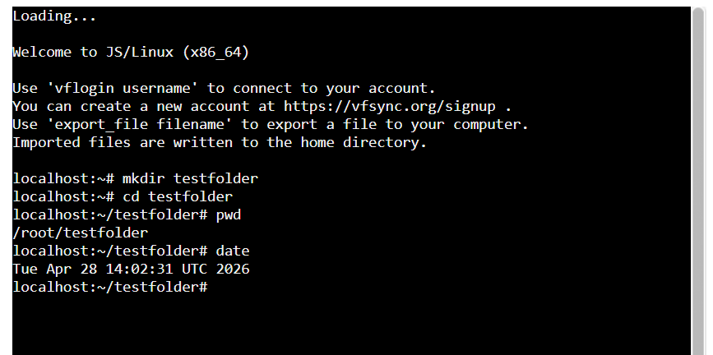
Figure 12: Using the date command to display the system date and time in Linux.
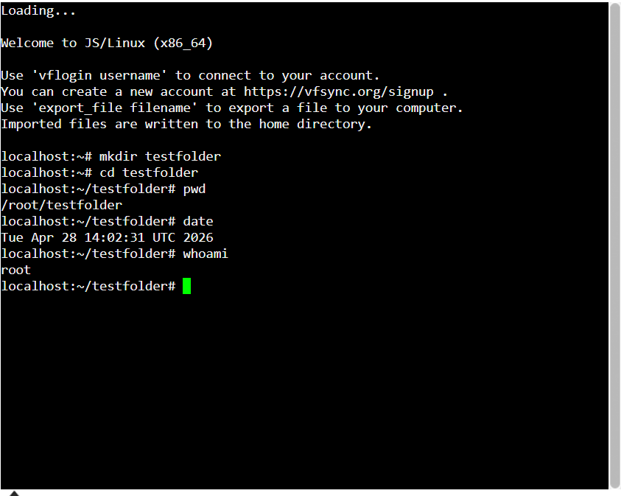
Figure 13: Using the whoami command to display the current user.
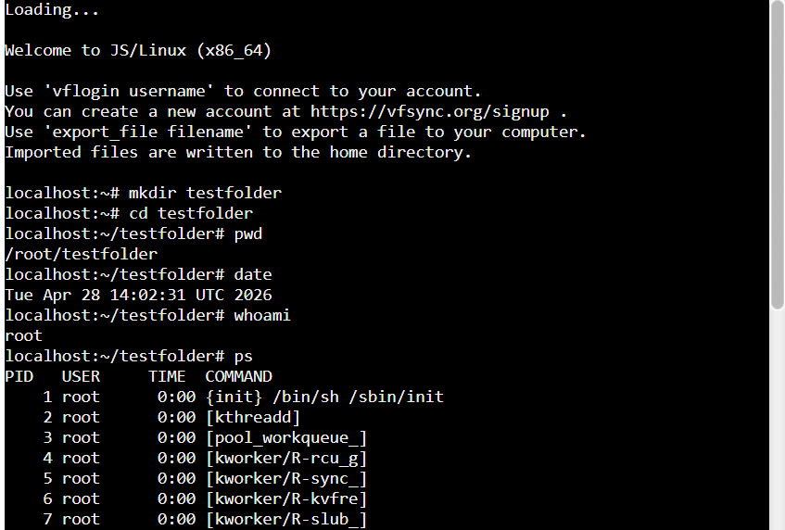
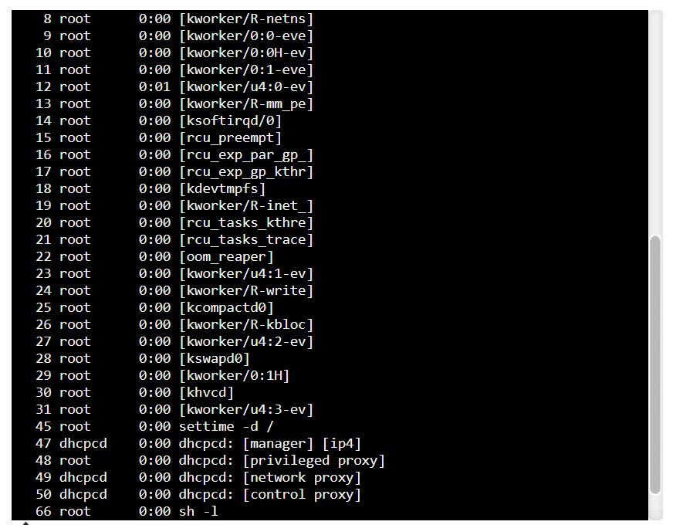
Figure 14: Using the ps command to display running processes in Linux.
The Linux commands demonstrated different areas of system management. The mkdir command was used to create a new directory, while the cd command was used to move into that directory. The pwd command showed the current working directory, which helps users understand where they are in the file system. The date command displayed the current system date and time. The whoami command showed the current logged-in user, which is useful for user management. The ps command displayed running processes, supporting process monitoring in Linux. These examples show that Linux commands are useful for file management, user information and process management.
The Linux command line interface is widely used by developers, system administrators and IT professionals because it provides powerful tools for managing systems. Many Linux servers are managed entirely through the command line without using a graphical interface. This allows administrators to manage systems remotely and efficiently.
Linux commands are often combined together to perform complex tasks. For example, administrators may use commands to create directories, monitor processes, check system logs and manage user accounts. Because Linux systems are widely used in servers, cloud computing and web hosting, learning Linux commands is an important skill in the technology industry.
Another advantage of Linux command line tools is that they can be automated using scripts. Bash scripts allow users to execute multiple commands automatically, saving time and reducing manual work. This is especially useful in system maintenance and server management tasks.

5. Windows Batch Scripts
Windows batch scripts are simple text files that contain a series of commands executed by the Windows command interpreter. These scripts help automate repetitive tasks such as displaying system information, creating folders, or running programs. Batch files use the ".bat" extension and are executed through the Command Prompt.

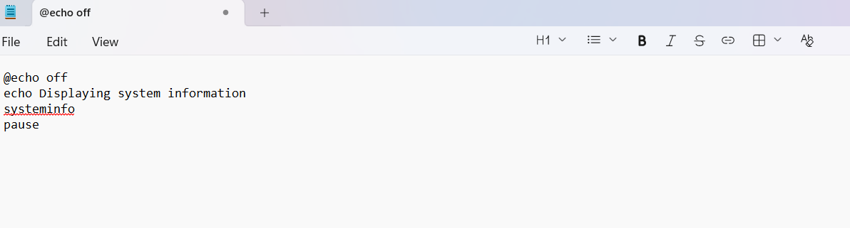
Figure 15: Example of a simple Windows batch script displaying system information.
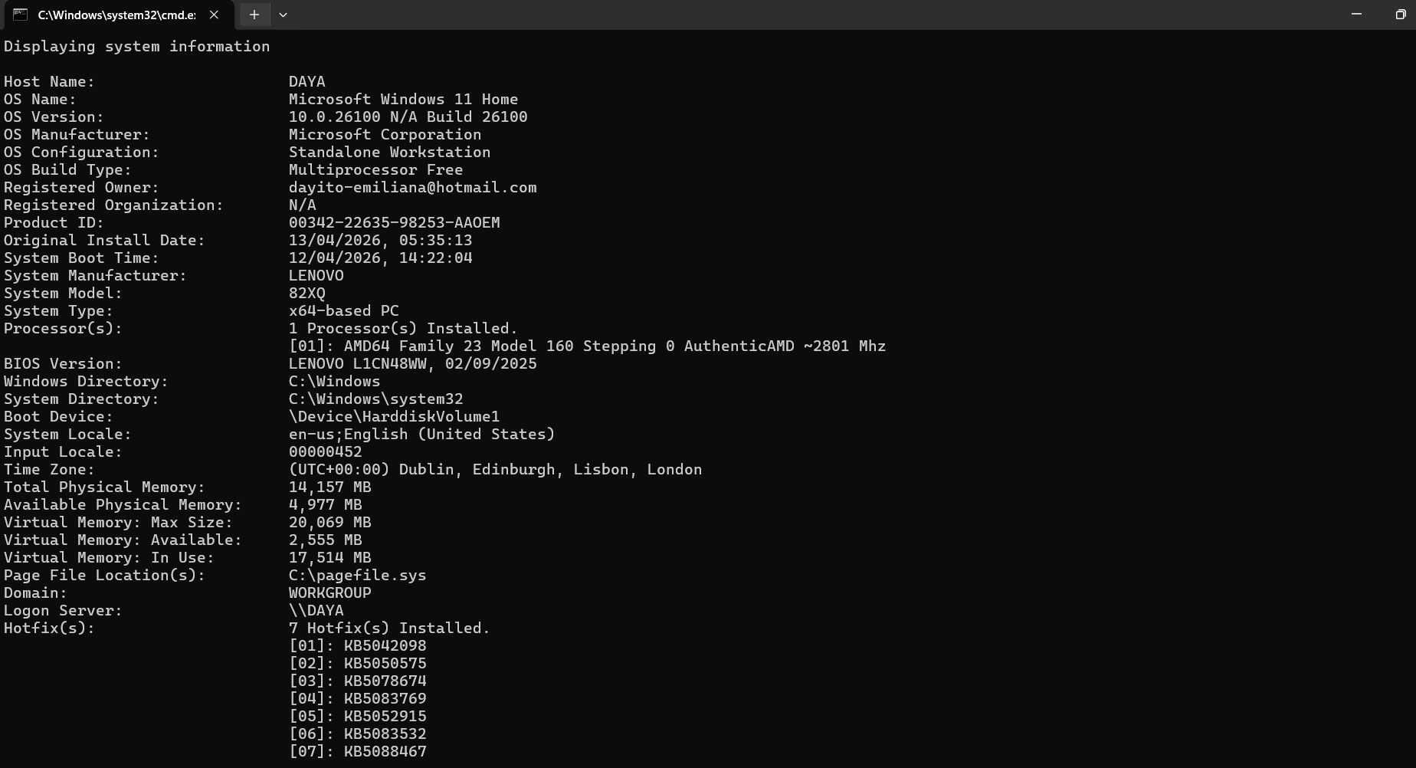
Figure 16: Execution of a Windows batch script displaying system information.

6. Linux Bash Scripts
Linux bash scripts are used to automate tasks in the Linux operating system using the Bash shell. A bash script is a file that contains a sequence of commands that the system executes automatically. These scripts are commonly used for system administration, file management, and process automation.
A simple Bash script can combine several Linux commands into one file. For example, a script can display the current directory, the current user and the system date. This helps automate routine checks in Linux. Bash scripts are useful because they reduce the need to type the same commands repeatedly. They are often used by system administrators to manage files, check processes, create backups and monitor systems. In this assignment, Bash scripting demonstrates how command line knowledge can be used to automate simple operating system tasks.
Another advantage of Bash scripting is that it helps administrators automate repetitive system tasks. For example, a simple script can check system information, monitor running processes or display system status. Instead of typing several commands individually, the script can execute them automatically in sequence. This helps save time and improves efficiency when managing Linux systems.
Bash scripts are also commonly used for system maintenance tasks such as creating backups, checking disk usage or monitoring server performance. In professional environments, administrators often create scripts to automate daily tasks and reduce the risk of human error. For this reason, learning Bash scripting is an important skill for students studying computing or information technology. [4]

7. Conclusion
In conclusion, operating systems provide essential tools that allow users to manage files, processes, and system resources efficiently. Both Windows and Linux offer command line interfaces that enable users to interact with the system using commands. Learning these commands and scripting techniques helps improve productivity and allows users to automate tasks effectively.
Understanding the basic functions of operating systems and learning how to use command line tools is an important skill for anyone studying computing. Command line interfaces provide more control over the system and allow users to perform tasks quickly and efficiently. While graphical interfaces are easier for beginners, CLI tools are often preferred by system administrators because they allow greater flexibility and automation.
The examples in this report demonstrated how Windows and Linux commands can be used to manage files, processes and system information. Additionally, the use of simple scripts shows how repetitive tasks can be automated. This knowledge is useful not only for academic purposes but also for real-world IT environments where efficient system management is essential. [5]

References

[1] | W. Stallings, Operating Systems: Internals and Design Principles, Boston: Pearson, 2018.
[2] | Microsoft, “Windows Commands Documentation,” 2024. [Online]. Available: https://learn.microsoft.com/en-us/windows-server/administration/windows-commands/.
[3] | The Linux Documentation Project, 2024. [Online]. Available: https://tldp.org/LDP/Bash-Beginners-Guide/html/.
[4] | Hat, Red, “Linux Commands,” 2023. [Online]. Available: https://www.redhat.com/en/topics/linux/what-is-linux.
[5] | A. Silberschatz, P. B. Galvin and G. Gagne, Operating System Concepts, Hoboken: Wiley, 2018.

Appendices
Appendix A: Screenshots of Windows CLI commands
Appendix B: Screenshots of Linux CLI commands

