
APPENDIX GA36a

LEVEL 4 ASSESSMENT SPECIFICATION
Student name: | ALEN STEFANOV DIMITROV | Student ID number: | 2439941
Programme: | Certificate of Higher Education in Business Skills for the Workplace
Module: | Academic Skills
Module code: | LCLM 4001 | Contribution to Overall Module  Assessment (%): | 100%
Lecturer: | Dr. Lilian Dooshima Dugguh Sylvia Hoffmann | Internal Verifier: | Yohan Mendis  Dr. Lizeta Demetriou Naomi Doerge
Assignment Title: | Academic Skills  Task 3 - REFLECTIVE ANALYSIS OF ACADEMIC SKILLS DEVELOPMENT: STRENGTHS, CHALLENGES, AND PERSONAL GROWTH | Word count (or equivalent): | Task 3 – 1000 words (+/-10%)
Submission deadline: | Task 1 - In-Class Quiz Taking place in the week beginning:  7th July 2025 (Week 5)  Task 2 – In-Class Exercise Taking place in the week beginning:  21st July 2025 (Week 7)  Task 3 – Reflective Report:  21st of August 2025, 10:00AM | Return date of provisional marks & written feedback: | 12th September 2025
Submission method: | All written assessments, where practical and possible, must be submitted via Turnitin unless otherwise instructed by the Lecturer. (Please DO NOT put this assessment specification into Turnitin or it will match many similarities with other students’ submissions.)  Alternative submission method (if applicable):  Late submission of the assessment will result in a late penalty mark:  Work which is submitted up to 1 week late will be capped at 40% for the first attempt and will be awarded a mark of 0% for re-assessment. Late submission
penalties may be lifted only if there is an approved extenuating circumstances claim.
Work submitted more than 1 week late will be considered as a non-submission and will not be marked. The work may be considered as a submission for reassessment if offered by an Examining Board or if there is an approved extenuating circumstances claim.
Academic honesty / referencing: | Academic honesty is required. In the main body of your submission, you must give credit to authors on whose research and ideas your work is based. Append to your submission a reference list that indicates the books, articles, etc. that you have used, cited or quoted in order to complete this assessment.
Module Learning Outcomes (from module syllabus)
Upon the successful completion of this module, the student will be able to:

- Show awareness and ability to apply the key academic skills needed to succeed in higher education;
- Reflect on their learning.

Table of Contents
Introduction 5
Description of Experiences 5
Specific experiences and activities 5
Key classroom events and impact 5
Analysis and Personal Reflection 6
Evaluate Experiences 6
Analyse the Experiences and Learning 7
Contribution to Understanding of the Module Content 8
Strengths and Areas for Improvement 8
Personal Growth and Development 8
Conclusion 9
References 10

Introduction
This reflective report aims at examining my learning process during the Academic Skills module. This module has become the core of my development because it has equipped me with tools that are necessary to be successful in higher education since it has taught me time management, note-taking, paraphrasing, academic writing, referencing, and critical thinking. My portfolios will focus on important activities including the academic skills quiz, application workout, and classroom participatory activities that transformed my learning style. Along with enhancing my technical skills, such experiences helped me become more self-aware, defining my academic identity and contributing to my academic growth, as I prepare to take on future academic experiences.

Description of Experiences

Specific experiences and activities
Academic skills quiz was one of the initial learning experiences that I had. This in-room activity identified my levels of knowledge of time management, referencing, and academic writing rules. At the beginning, I was nervous, but clear structure allowed becoming aware of the strengths and weaknesses. It revealed that I possessed a good knowledge of referencing, but my knowledge of policies on academic misconduct was still insufficient (Bermudez et al., 2021). The exercise of academic skills was another important experience that entailed note-taking, paraphrasing, and creating a coherent academic paragraph in timed conditions. It was not an easy job because it demanded accuracy and expediency. Note taking was doing well but paraphrasing was more challenging, because I often had trouble keeping the meaning and at the same time preventing plagiarism.

Key classroom events and impact
One-on-one classroom discussions and interactive activities also contributed to my progress. Team activities, discussions and peer reviews made me learn to hear different perspectives and improve academic communication. These group events did not only enrich my knowledge on crucial topics but also provided me with confidence (Hendriarto et al., 2021). Collectively, they offered a source of reflection, building upon strengths and pointing out what needed strong attention to improve.

Analysis and Personal Reflection

Evaluate Experiences
Looking back at my academic skills quiz, I realised it was one tool that provided a great test of what was in store for me in my college life. I used time effectively and answered questions on taking notes and academic writing confidently, which solidified my conviction that I should be organised. But I had problems with the reference area, especially using the Harvard system properly. This discrepancy demonstrated the necessity to be more specific and regular when referring. The exercise of the use of academic skills was difficult yet valuable (Jardinez and Natividad, 2024). I developed into a note-taking strength, and I could easily take important information and convey it to an audience. It was not easy to paraphrase, though, since I tended to oversimplify or repeat original structures. The time constraint was also a challenge in writing a coherent paragraph, as I also placed my emphasis on fluency over structure. Such difficulties highlighted the importance of paraphrasing perfection, and better brevity in order to be closer to academic norms.
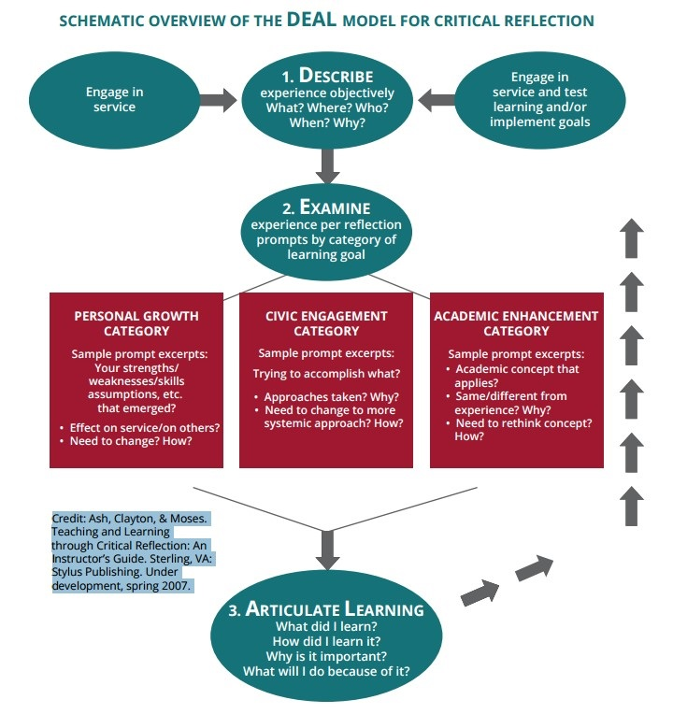
Figure 1: DEAL Model - Describe, Examine, Articulate Learning
(Source: pugetsound.edu, 2025)

Analyse the Experiences and Learning
These experiences showed that the quality of academic work needs precision and flexibility. The quiz showed that the theoretical knowledge should be followed by the details-orientedness, especially in referencing. The paraphrasing activity confirmed to me that rephrasing should be preceded by real understanding because it is a thinking process that requires the mental process of content and not language. The paragraph-writing activity supported the value of fluency and clarity and structure in academics. Lastly, classroom discussions stressed active listening, which taught me that cooperation is not only reinforced by speaking your own ideas with assurance but also by being able to listen to a variety of ideas.

Contribution to Understanding of the Module Content
Furthermore, all these experiences enhanced my understanding of the module. The quiz made me familiar with the academic integrity, primarily, with the referencing and misconduct, and the application practice helped me recall the main skills of taking notes, paraphrasing, and arguing and structuring. This was further expanded in the classroom through a focus on communication, critical thinking, and assessing alternative perspectives. These experiences together proved the interktion of academic skills: time management benefited quizzes and tasks, referencing, and paraphrasing benefited written work, and communication benefited the group activities (Malik et al., 2023). All of them gave an informative, realistic idea about the skills I would need to succeed in higher education.

Strengths and Areas for Improvement
Based on reflection, I have found some strengths. I am inherently organised and can manage time and so I was able to accomplish well in tasks under pressure. My note-taking skills are also a strength, as I can filter key information and present it clearly. In addition, I have confidence in communication, which helped me contribute actively to discussions. Nonetheless, areas for improvement remain. I must develop consistency in applying referencing styles and devote more practice to paraphrasing to avoid structural or linguistic overlap with original texts (Edwards-Fapohunda, 2024). Additionally, I need to refine my writing by balancing fluency with conciseness and by focusing more closely on structure. Another area for improvement is group participation. While I engage actively, I sometimes dominate conversations rather than fostering balanced dialogue.

Personal Growth and Development
This module has been central to my personal growth as a student, enabling me to recognise both strengths and areas needing improvement. I have become more self-aware, understanding that skills such as paraphrasing and referencing require ongoing practice rather than surface-level knowledge. The experience also fostered resilience, as I adapted to the demands of timed assessments and unfamiliar tasks. Additionally, I refined my time management by breaking work into smaller steps and applying discipline more effectively. Cooperative tasks have opened my mind to the importance of discussion and positive criticism in education (Zamiri and Esmaeili, 2024). Most importantly, I have acquired an academic identity consisting of reflection, adaptability, and continuous improvement that can both facilitate future work and serve as the foundation of a career.

Conclusion
To sum it up, the module Academic Skills has proven to be a positive and changeable learning experience. The strength and areas to work on were revealed through the academic skills quiz, the application exercise, and activities in the classroom. I gained confidence in time usage, note-taking, and communicating and was also aware of the necessity to improve my paraphrasing and referencing. Above all, the module helped me to be self-reflective in my learning and this has enhanced my self-awareness and academic identity. In the future, I am more prepared to take on new academic obstacles by being resilient, flexible, and determined to grow every day.

References
Journals
Bermudez, T.C., Alcaide, A.M., Barcelona, A.M., Peralta, E. and Malaco, A., 2021. Online class: Its implication towards academic skills development. Indonesian Journal of Educational Research and Technology, 1(2), pp.61-66.
Edwards-Fapohunda, D.M.O., 2024. The role of adult learning and education in community development: A case study of New York. Iconic Research And Engineering Journals, 8(1), pp.437-454.
Hendriarto, P., Mursidi, A., Kalbuana, N., Aini, N. and Aslan, A., 2021. Understanding the Implications of Research Skills Development Framework for Indonesian Academic Outcomes Improvement. Jurnal Iqra': Kajian Ilmu Pendidikan, 6(2), pp.51-60.
Jardinez, M.J. and Natividad, L.R., 2024. The Advantages and Challenges of Inclusive Education: Striving for Equity in the Classroom. Shanlax International Journal of Education, 12(2), pp.57-65.
Malik, A.R., Pratiwi, Y., Andajani, K., Numertayasa, I.W., Suharti, S. and Darwis, A., 2023. Exploring artificial intelligence in academic essay: higher education student's perspective. International Journal of Educational Research Open, 5, p.100296.
Zamiri, M. and Esmaeili, A., 2024. Methods and technologies for supporting knowledge sharing within learning communities: A systematic literature review. Administrative Sciences, 14(1), p.17.
Websites
pugetsound.edu, 2025. DEAL Model - Describe, Examine, Articulate Learning [online]. Available at: https://www.pugetsound.edu/deal-describe-examine-and-articulate-learning. [Accessed on: 16.08.2025]

