UWTSD Module Title: Work-based Learning Project (Extended)
UWTSD Module Code: BMPF7010D
Word count:

How the exploration of attention with voice students brings awareness to different aspects of singing.

Contents Page

Proposal
- The context 2
- The justification 2
- The intended impact 3
- The outlined intentions 4
- An expected timeline 4
- The ethics and insider research 5
- Personal learning outcomes 6

The Project Report
- Introduction 6
- Literature Review 7
- Methodology 21
- Methods 23
- Findings 24
- Discussion 30
- Conclusion 32

References 34

Appendices 38

Proposal
The context
The research will take place at The Bristol Conservatoire, which is a further and higher educational setting specialising in performing arts, including musical theatre, dance and acting courses. As part of their course, students receive weekly one to one singing lessons. It is in these one to one lessons the research is intended to take place.
I have noticed that at this level, once basic understanding of their voice has been established and their knowledge is deepening and their skills are developing more focus is encouraged on the internal workings of the vocal apparatus used to produce sound healthily, efficiently and artistly. This, I have noticed in some students, can lead to overthinking or over fixating on the internal muscles rather than the voice overall. It was this realisation that led me to the research question; How does the exploration of attention with voice students bring awareness to different aspects of singing?

The Estill method which is widely followed within this educational setting, and whose aim is to ‘isolate and control vocal structures” (Estill Voice Academy Online, 2025) states that there are three main disciplines to mastering anything; ‘Craft’ (the physiology of the voice), ‘Artistry’ (the singer’s interpretation and expression) and ‘Metaphysics’ (Flow - craft + artistry), the Estill method focuses on ‘Craft’ (Steinhauer, K, Mcdonald Klimek, M and Estill, J. 2017) (p. 27). The intention of this research is not to question or go against this method, instead to explore whether adding external focus at the ‘Craft’ stage might make it easier for students to access the physiology easier. Alternatively, if working on external focus is the next stage after Craft and could be explored within the ‘Artistry’ phase of a singer’s journey. Ultimately, at what point the teacher encourages the student to explore a focus which is external to the muscles within the vocal tract, is not the purpose of this study but rather to determine if its use is beneficial to the student, the efficiency of their voice and ability to access technical vocal skills.

The justification
Throughout my 15 years of years of teaching singing to students of all ages, styles and abilities I have noticed differences in the way students learn and will always endeavour to tailor my teaching to suit their needs. One struggle in particular is the tendency to get ‘stuck in their heads’ with so many different aspects to think about; for example, breathing, pitching, breath support etc, they tend to focus internally on these aspects in order to access them. The purpose of this research is to explore the effects of using “external focus”, directing attention either towards the external environment or the outcome, while singing to improve efficiency for the singer and achieve better expression, including dynamics and phrasing. During previous literature review research regarding movement during singing I discovered research showing the affective use of external focus on such activities as padel boarding, where the participants were encouraged to focus on the board on the water rather than their feet. Other studies involved darts, where they were encouraged to focus on the intended destination of the dart as opposed to the dart itself, and playing a musical instrument (Wulf, 2013). Wulf (2013) found that musicians had better performance success when they focused on the sound quality rather than what their hands were doing. It also speeds up the learning process (Ibid). The overall outcome success of external focus on the intended movement are present in all ages, levels and abilities (Chua et al., 2021). Applying the word attention is contextual and complex and could have a different meaning for singers, than it does sportspeople and even musicians, which will be explored later on in the literature review. My theory with regards to singing, is that the internal focus would be on the muscles within the vocal tract, so shifting focus to hands or arms, or the feeling of movement elsewhere could effectively be external focus. I recognise that this line is blurred and for the purposes of this study I will refer to the ‘internal focus’ as being muscles within the vocal tract, and external being anything outside of this, including arms and other body parts. However I intend to explore an external focus further from the body as well, and will use my literature review to further inform my decisions. The Dalcroze method, which advocates music education through movement, found that “mapping phrases out in movement in the physical space” (Juntunen, 2016) (p.18) helps to connect with the intention of the piece and facilitate creativity.
There appears to be a gap in the literature around how singers feel when they explore different foci of attention. The intention of most of the literature appears to be around physical goals and outcomes rather than participant experience, whether that is sports or creative subjects. The intended physical outcome for a singer can be a difficult one to determine and therefore I hope to explore sensations and how a singer can learn from their exploration.
The intended impact
I aim to discover whether switching focus externally rather than internally has a positive effect on the efficiency of singing, as perceived by the student and whether there is an improvement in their expression as perceived be myself, the researcher, and the student. I also aim to determine which form of external focus is the most effective, ie. hand movements, a point in the distance, or their sound.
This research could lead to teachers exploring a wider approach to teaching vocal technique and adding an extra element to their teaching which may have a positive effect on some students who have different learning styles and may find it harder to access a more conventional method. One size does not fit all when it comes to learning a skill and therefore it is the responsibly of the teacher to have knowledge and understanding of different teaching methods and techniques to ensure the student can access the learning.
The outlined intention
I intend to invite around 50 participants, in the hope I’ll get 6-10, from the current student cohort at The Bristol Conservatoire (at which I teach on a freelance basis) each to participate voluntarily in a one-to-one voice lesson with the researcher, within which we will choose a section of a song they know well and explore different external focus points and compare them to an internal focus ie lifting soft palate, retraction of false vocal folds, tongue position (not explicitly focusing on the Estill method). Before each external focus point (listed below) they will sing with an internal focus in order to directly compare and feel the difference, if any.
External focus points;
1. Expressive hand movements (freely performed by the student). Partially external.
2. A fixed point in the distance or my hand movements (possibly including an object). Fully external.
3. The sound they are producing. Fully external – intended outcome (Wulf, 2013).

After each external focus point I will ask the student to fill in a questionnaire indicating whether it felt; easier, harder, no different, not sure.
I intend to work through this set of external focus points (1- 3 above) twice, in order for the student to fully understand what is being asked of them, and therefore be able to answer questions with more clarity and confidence. Directly after the experiment I will conduct a structured interview with the participant, during which I will ask open ended questions to understand their experiences and perceptions in more detail.
In order for myself, the researcher to be fully present during the experiment and interviews, I intend on video recording the lessons to allow for researcher observations afterwards, to look at expression, dynamics and phrasing and whether there are any other noticeable changes within the students voice and/or body. This will also allow for the smooth running of the interview and accurate documenting of answers given.
I have chosen to use a mixed method approach for this research as it suits my objectives as part of my work-based practice. My assumption as a researcher is that knowledge is “experiential, personal and subjective” (Jackson, 2013) (p. 52) and that it is unrealistic to eliminate any bias and “remain emotionally detached and uninvolved with the object of study” (Burke Johnson and Onwuegbuzie, 2004) (p. 14) as quantitative purists would expect from educational researchers. Nor do I side with qualitative purists which believe in multiple realities. Instead I believe the best chance of answering my question relies on combining the methods to compliment each other. As I endeavour to gain understanding on how students experience something subjectively, I must rely on their experiences. Therefore I will include a qualitative and quantitative phase within the overall research study to be inline with the mixed method approach as defined by Sadan, 2014, and will use a “partially mixed concurrent equal status design” as laid out by (Leech and Onwuegbuzie, 2009) (p. 268).
Based on the reasons stated my chosen methods will be; Observations, experiments, participant questionnaires using closed-ended questions, and interviews with open-ended questions to encourage participants to observe their own experiences and express these in an attempt to gather subjective views on their experiences. Others’ perceptions are impossible to experience, observe or quantify, and therefore rely on explanation, leading me to choose qualitative data collection in order to capture this in a realistic way. I will then use an thematic approach to analyse this data in an attempt to understand perceptions and possibly find some themes and links within these explanations. I intend to mixed this with the use of quantitative data by using questionnaires with closed ended answers.
An expected timeline
What | When from | Until
Ethics form completion | 01/11/24 | 07/01/25
Proposal draft | 06/01/25 | 27/01/25
Literature review research and writing | 06/01/25 | 06/08/25
On site research to be conducted at The Bristol Conservatoire | - | By 31/03/25
Review footage and make observations and dictation of interviews | 31/03/25 | 21/04/25
Write draft report | 31/03/25 | 06/08/25
Edit draft into final submission | 06/08/25 | 22/08/25

The ethics and insider research
I anticipate that the ethical implications of this research will be very few. I will be mindful of asking a participant to work outside of their comfort zone, which could potentially lead them to feel uncomfortable, and in severe cases could cause stress. However, they are encouraged out of their comfort zone regularly and so I do not anticipate this being an issue. I will make them fully aware that they can stop at any point during the experiment and interviews for any reason, which they do not need to disclose to me, or anyone else.
I will ensure student anonymity by numbering the participants in the order within which they participate in the research, and any video data will be held securely at the researcher’s residence and will not be shared with anyone outside of the University. I will also make the students aware before they agree to participate that this experiment is completely separate to their studies and will in no way affect any grades or performance outcomes of their course. Before undertaking any first hand research I will gain ethical approval from University South Wales Trinity St David (See Appendix A).
I recognise that as a singing teacher undertaking research based on my previous observations and therefore previous beliefs and biases, I am an insider researcher and as such have an advantage of knowing the subject well and having previous experience and knowledge of this, however I must remain unbiased when collecting data to not influence participants’ answers in order to gain accurate and useful data.

Personal learning outcomes
PLO1: Learn to review research with a broad and open mind and observe negatives as well as positives to my research topic.
PLO2: To challenge my own world view and broaden my beliefs in an effort to be a well-rounded and open-mined teacher.
PLO3: To conduct research which is relevant and useful to the wider teaching community, as well as for my own teaching after completion of this Masters degree.
The Project Report
Introduction
As a technical singing teacher at a post-16 performing arts conservatoire I work with students, most of whom have some experience of singing technique, and have noticed a strong focus on the inner workings of the intrinsic muscles of the vocal tract. This is not all together surprising as the lessons they receive are for vocal technique. However, in my other work with younger and less experienced singers I employ strategies to externalise what can not be seen in an attempt to help them understand a certain sound, or sensation that they are aiming for, as well as to add a level of fun and playfulness to the lessons. I wondered if this could be useful for college level of students to help them get out of their head, free up their voice and improve, while asking the question ‘how does the exploration of attention with voice students bring awareness to different aspects of singing?’
During previous research into the use of gestures and movement within the teaching studio I explored the concept of focus of attention. This lead to my curiosity around whether this could be an effective way to explore the voice inside and out, just by switching where their attention lies. The research for the success of focusing externally is overwhelmingly positive however most of these studies were done within sports (Fillingim and Fine, 1986; Singer et al., 1993; Wulf et al., 1998; Wulf et al., 1999; wulf et al., 2002; McNevin et al., 2003) some with musicians (Duke et al., 2011; Mornell and Wulf, 2019; Williams et al., 2023), and even fewer using exclusively singers (Atkins, 2017; Atkins, 2018).
This research project aims to explore the use of different foci of attention and how these could be utilised with different students to help them gain the most out of their voice, by experimenting with volunteer participants, encouraging them to shift their focus and gaining their insight as to how it felt for them. It also aims to broaden their awareness, not to disregard what the internal muscles are doing, but to compliment them by allowing a different view point by asking participants open-ended interview questions which encourage reflection on their experience. The final aim is to put forward examples of external focus to aid best practices moving forward by choosing a few different points of focus, based on the literature, and exploring which ones are beneficial. I hypothesise that an external focus will bring about the most positive outcomes, making it easier to sing, giving the student more confidence in their ability and broadening their understanding of where they can lay their focus. I believe it will release them from overthinking about muscles they can not see and largely can not feel, and giving them a new perspective.

My expected personal learning outcomes are as follows;
PLO1: Learn to review research with a broad and open mind and observe negatives as well as positives to my research topic.
PLO2: To challenge my own world view and broaden my beliefs in an effort to be a well-rounded and open-mined teacher.
PLO3: To conduct research which is relevant and useful to the wider teaching community, as well as for my own teaching after completion of this Masters degree.

Literature Review

I have undertaken a narrative literature review starting with the articles I uncovered during a previous project and broadening my search from there. These articles were mainly sports based and largely by the same researcher. From there I explored the reference lists and began to broaden this further creating a list of search terms to explore (see Appendix B). Due to the fairly sparse amount of literature on this subject I decided not to use an exclusion criteria and opted to keep the search broad so as not to miss something interesting or relevant. I used a mixture of the UWTSD online library resource, Google scholar and my own collection of reference books on voice pedagogy and psychology. It became clear that I needed a more in-depth understanding of the word “attention” and this became a main focus point of the research.
When discussing the matter of ‘attention’, it is important to consider the meaning of the word and what other words arise when considering this an area of study and research. Chun et al. (2011) believe that “attention is a core property of all perceptual and cognitive operations” (p.73) and that it is so ever-present that it makes it very difficult to study. This literature review will begin by exploring different ways in which leading researchers in this field and psychologists attempt to define it in order that a usable definition can be found to test out the theory within this project.
The initial interest in this topic emerged from researching gesture and movement within the teaching studio and how this could have an effect on the student’s ability to learn and access their voice with ease. This research lead to Wulf’s OPTIMAL theory, which is a three part learning strategy focusing on self belief, autonomy and external focus of attention (Wulf and Lewthwaite, 2016). They believe that “Optimizing Performance Through Intrinsic Motivation and Attention for Learning,” (p. 1383) strengthens learning by coupling goals and actions, using external focus of attention as part of this learning process (Wulf and Lewthwaite, 2016). It may be that the choice of attentional focus creates different goals for the motor system, which leads to different ways in which our brain tackles the learning task. External focus aims to minimise distraction in order to achieve the task goal, where as internal focus is on the movement itself (Lohse et al., 2014).
Wulf (2013) defines ‘external’ focus as “focus on the intended movement effect” and ‘Internal’ focus as “focus on the body movements” (p.77). The results of these studies are overwhelmingly in favour of an external focus. The majority of her research is within the field of sports however, where the focus on an intended outcome is far simpler and easier to measure than that of singing. Williams et al (2023) noted that other researchers had in fact defined ‘external’ focus of attention slightly differently for musicians, as focusing on sound production. Even though this is an intended outcome, it is an abstract idea and experienced internally – through the ears. I would argue that singers are in a different category to musicians, as well as sports people, because the sound being produced is coming from the body, internally, and experienced from within the body, therefore can anything be truly external for a singer? (See Appendix C). In a study conducted with golfers, when instructed to focus internally they were expected to concentrate on their body movements and coordination, for example their arm movements. When they shifted their attention to the movement of the golf club, this constituted an ‘external’ focus (McNevin et al., 2003). When applying this to singing, concentrating on body movements and coordination would include movements such as lifting the soft palate, or raising the larynx (Williams et al., 2023). However when it comes to focusing externally it is harder to find something disconnected to the body to focus the attention on in the same way as golfers can focus on their golf club, or, in relation to musicians, a pianist can focus on the keys (Atkins, 2017). Singers cannot observe what cannot be seen within the vocal tract, for example the vocal folds or movement of the larynx in the way a pianist can seen their fingers (Brand, 2021), further differentiating singers from other forms of musicians. This absence of visual cues and lack of a target to focus on, may mean that focusing internally is more optimal for singers than external focus (Gottwald et al., 2020).
Fillingim and Fine, (1986) discuss “internal sources of information” as sensations which come from within the body and “external sources are perceived by the senses (sight and sound)” (p.115). If we take this interpretation and apply it to singing then the ‘internal’ focus would be the feeling, or sensation, of the soft palate lifting within the vocal tract, and the ‘external’ focus would be the sound. Can we say that the singer’s perception of their own sound they are producing from within their body is experienced externally? Could their personality type and level of self esteem affect their ability to process this information objectively, as suggested by Fillingham and Fine (1986)? They say that “research suggests that individuals process external and internal sensations to varying degrees” and that their “degree of self consciousness may be related to differential processing of internal and external stimuli” (p. 116). Some people have a tendency to scrutinize themselves and their behaviour, to the point of obsession whereas others have a complete lack of self awareness (Fenigstein et al., 1975). The effects of directing attention toward the self negatively affects self-esteem as well as contributing to aggressive behaviour (Ibid). Type A characteristics include; competitiveness, striving for achievement and aggressiveness, where as type B is someone without these tendencies (Carver et al., 1976). These personality types are likely to act differently in a high pressure situation, for example a performance. Type B’s self conscious feelings may be heightened leading to a disruption in their automatic responses (Mornell and Wulf, 2019), where as type A’s competitive nature may see this as a challenge and react differently (Carver et al., 1976).
Chun et al (2011) have a similar view point in terms of external attention being “the selection and modulation of sensory information” (p.73). When focusing one’s attention externally they are considering space and time, and objects within these. “Internal attention refers to the selection and modulation of internally generated information” (p.77), referring more to the mind, cognition and the processing of information including, rules, responses and memory. This is rather different to focusing on physical aspects experienced within the body, ie swinging a golf club or lifting the soft palate (Ibid).
Within the world of psychology ‘attention’ is an ambiguous word which is difficult to define (Chun et al., 2011). On one hand William James states that “everyone knows what attention is. It is the taking possession of mind in clear and vivid form… it implies withdrawal from some things in order to deal effectively with others” (p. 74) Where as Styles (2006) simply states that “no one knows what attention is” (p.255) and that psychologists can not agree. She believes it is not a single concept but a broader, umbrella term for various psychological phenomena. Shiffrin (Styles, 2006) believes “attention has been used to refer to all those aspects of cognition” (p.1), which Styles, theorises that the use of the word ‘all’ is a way to validate that the term covers multiple other aspects. Chun et al (2011) encourages us to step away from the word ‘attention’ as a single concept and “consider attention as a characteristic and property of multiple perceptual and cognitive control mechanisms” (p.74). Attention is used as a way to select and process information when there is far too much information for us to process at any one time, and to select the correct response or outcome to the information received (Chun et al., 2011). They believe that there is a distinct difference between the attention used in selection and that which already exists within the mind. If one were to try to categorise these into ‘external’ and ‘internal’ then it could be said that information in through the senses would be ‘external’ and that which is represented in the mind would be classed as ‘internal’. My interpretation of this would be that external focus on senses would be more objective, where as internal processing would be far more subjective having to rely on memories and experiences to make sense of it.
Maxfield and Treinkman, (2021) highlight the subtle distinction between ‘external’ and ‘internal’ focus and that a small change in the wording can shift the focus. They use the example “feel your feet supporting you” compared with “feel the floor supporting you” (p.408) may yield a different outcome for a singer working on grounding. The floor is external to the singer, where as the feet are internal. They agree with Wulf (2023) that internal refers to the body movement and external to the outcome. They discuss the importance of teachers finding ways to word instructions to keep them separate from the body. They use the example of raising the back of the tongue in order to create the [i] vowel sound, versus asking the student to speak the word ‘Key’ before singing it, which creates the shape within the mouth without drawing specific attention to what is moving internally. This feels like a much more natural and instinctual way to create sound without tension. A study by Wulf et al. (2002) into external focus feedback also highlights the power of wording. They suggest that most feedback is giving in relation to the body movement, which would make it internal and explored the idea of rewording the feedback to focus more externally, examples include “Toss the ball high enough in front of the hitting arm” (internal focus feedback) versus “Toss the ball straight up” (external-focus feedback) (p. 174). The participants who received the external feedback were more accurate (Ibid), indicating that a subtle shift in wording could have an impact on focus and achievement.
Imagery is also a useful way to gain an instinctual understanding, Maxfield and Treinkman, (2021) uses the examples “thread the needle” and “sing like you are beginning to yawn”. In my professional experience I have found this to be a useful instructional tool for beginners and a way to explore a sensation or a shape within the vocal tract. However, there are a few pit falls, for example if you sing like you are beginning to yawn this will lift the soft palate while also lowering the larynx which could be helpful for a round, sob-like sound, however when working on isolating these muscle areas it gets confusing. Another downside to these imagery instructions is that students with aphantasia, which is a condition where the person can not picture something in their mind, struggle to access these in the same way someone without aphantasia can. In this case more internally focused instruction would be more beneficial. This would be another area to explore, however it is beyond the scope of this project to delve into alternative learning styles.
Styles (2006), instructed her participants to set their visual focus straight ahead of them, while shifting their attention to different areas of cognitive focus. The ‘corner of the eye theory’ (Styles, 2006) where one can be looking in a direction but focusing their attention elsewhere is to be considered when conducting my research. Cognitive attention is the focus of this experiment therefore I will aim to keep their eye focused on where I want their attention focused, in order to help lessen the cognitive load.

Outcomes of focusing externally; a more in depth look at relevant studies

Atkins, 2018 conducted a study using 11 trained singers, singing a simple three note melody on one vowel, with six focuses; soft palate position (internal), a steady vibrato (internal), sending the sound to an object 18 inches away (external), sending to sound to an object further away (distance unspecified) (external), and sending the sound toward a shape 19 feet away (external). They also had a controlled condition with no instructions (focus unknown). The results showed that expert listeners had more positive feedback about the singers’ tone quality when they focused externally as opposed to on internal targets (Atkins, 2018). Following on from this study, Mornell and Wulf (2019) conducted their own study with experienced musicians playing a complex piece of music for a longer period of time, for which they had rehearsed previously. Rather than a specific place to lay their focus as per Atkins (2018) study above and in line with the definition by Chun et al., 2011, the researchers decided to be consistent with their own interpretation of focus and their previous studies within sports (Wulf et al., 1998; Wulf et al., 2001; Wulf and Lewthwaite, 2021). Therefore they chose an internal focus on the movement of fingers and precision of notes, and an external focus on the intended outcome, “expressive sound of the movement” (p.375) for an audience. The results of this study had a similar outcome to Atkin’s 2018, with musical expression and technical precision being rated highest when they focused externally (on sound production) than when they focused internally (on finger movements and precision) (ibid).
Williams et al, (2023) embarked on quite a different approach to the study of focus of attention. Having discovered the sparse nature of the research for musicians they set out to study the effects of external focus on a number of different elements, not only of music performance, but of learning. They developed a practice tool which encourages external focus and is based on audiation, being able to hear and imagine an intended sound in your head without playing it, not dissimilar to Maxfield and Treinkman (2021), in their use of imagery in instructions. This tool is called “The Audiation Practice Tool” (APT) (Williams et al, 2023, p.1) and encourages the student to imagine the musical phrase about to be played, (including pitch, tone, dynamics etc), then to sing the phrase while using gestures, followed by playing the phrase, and finally to play the phrase again with an entirely different emotional intention or character. During these four stages the focus are entirely on the intended sound, which is inline with Mornell et al’s. (2019) interpretation of external focus. This may have had a different outcome if singers were included in this study. Firstly the singing aspect would possibly be less effective, although the use of gesture could prove a useful addition. Gestures have many benefits to externalising the sound, as “attentional capacity is automatically diverted toward the execution of a gesture and its visual perception” (Brand, 2021, p.7). However, as mentioned earlier, producing the sound from their body (their instrument) brings a whole set of other considerations. This study focused on accuracy, and self efficacy on an objective level, while also exploring the musicians’ experience with more subjective aspects, such as confidence and enjoyment. Overall the results showed a positive outcome when it came to accuracy, however the results for self efficacy and confidence did not show anything significant, neither did the scores for motivation and engagement (Williams et al., 2023). They learnt that most participants found the practice tool engaging and enjoyable. I would like to explore the student experience element of external focus for my research project, and focus mainly on how the participants experience different levels of internal and external focus, how they interpret this and how this could become a tool for them in their lessons, practice and performance.

Other studies include; Runners level of tolerance to pain and fatigue, which found that the group who were asked to focus on a word cue which they were instructed to count (external focus) reported significantly less symptoms of pain and fatigue than that of the group focusing on their breathing (internal focus) (Williams et al., 2023). Duke et al., (2011) chose four modes of focus to study on novice pianists; ‘internal’ (fingers moving), ‘near’ (ends of the piano keys) ‘Mid’ (the hammers) and ‘distal’ (the sound) and found that the pianists achieved more even timing the further their focus went from internal.
Inducing an internal focus of attention resulted in no learning benefits relative to giving no instructions (McNevin et al., 2003) even though participants tend to naturally focus internally if given no instructions (Brand, 2021). Regardless of skill level, type of skill, ability to move, and age, an external focus is more effective than internal (Maxfield and Treinkman, 2021). This contradicts the notion that novice learners need more instructions on the internal workings of the movement, but rather on the intended outcome.
Lohse et al (2014) believes that focus on the external strategy will produce a better performance as it allows the body to coordinate more naturally, otherwise it can lead to “episodes of microchoking” (Brand, 2021, p. 5) which can influence the thoughts, fears and anxieties of the performer under pressure, leading to “conscious movement control” (p. 5) and stage fright (Mornell and Wulf, 2019; Brand, 2021). Performers tend to constrain their motor systems when adopting an internal focus by attempting to consciously control the processes and going against “automatic control mechanisms” (Mornell A, Wulf G 2019, p. 377). The muscles needed to produce a beautiful tone are not under conscious control according to Atkins, R. (2017) and experienced singers are not always aware of what is physically happening within the vocal tract to produce the tone and that the way to develop control is by repetition and aural skills where “singers begin to connect auditory and kinaesthetic feedback in ways that gradually modify the neuromuscular control required to produce a beautiful tone” (Atkins, 2017 p. 421). When interviewed regarding vocal technique, singer Cornell Macneil reportedly said “If you’re talking about a column of air which is free to vibrate, your vocal cords and your larynx have absolutely nothing to do with it, and you should never think of them at all. They do anything except vibrate for you. You leave them alone. It’s automatic and I don’t like to think about it” (Brand 2021, p. 7). This leans heavily towards not micromanaging muscles which intrinsically know how to coordinate and backs up the idea that conscious control can have a negative impact. Estill, however, would disagree with this notion and believes the best way to sing is to be able to isolate each muscle to control its movement (Steinhauer, K, Mcdonald Klimek, M and Estill, J. 2017, p. 41). Brand (2021) accepts and highlights the need to address internal mechanisms of the voice when it comes to focusing on technical aspects but suggests that the teacher be mindful of a balanced used of internal and external focuses of attention. They also argue that singers have various areas to concentrate on, from the respiratory system, to the movement of the articulators and other areas such as the jaw. Attempting to focus on all of these will lead to an internal focus which is not conducive to a positive learning or performance outcome, and therefore it does not seem wise to bring focus to internal mechanisms which can not be seen, in the way a pianist can see their fingers (Brand, 2021). Therefore shifting the attention of focus on to the outcome of the movement could lead to unconscious or automatic processing (McNevin et al., 2003).

After careful consideration of various view points on the definition, or lack there of, for attention, as well as reviewing the studies, ‘breathing’ will be the internal focus of this study. This sensation is felt internally, and more accessible than some smaller muscles in the vocal tract. For the external aspect I have chosen three sperate focus points getting further from the body (near, mid and distal, as per the study by Duke et al, 2011). These are; an object within the participants hands (physically external but controlled by the body), an object in the researchers hands (a few metres away) and the sound (intended outcome). This third choice, I believe also encompasses an internal aspect however I would like to explore this as an external sensation.

Unconscious / automatic processing
When students are asked to focus on their body’s movements this could lead to consciously intervening in the automatic control processes, which could in turn disrupt the coordination of the system (McNevin et al., 2003). An external focus leads to a faster and reflexive response in order to control the mechanisms without interfering with the automatic control processes (Brand, 2021). This may be the case with instinctual movements, like walking, and talking but when it comes to high level use of intrinsic muscles for singing, relying on instincts may not be enough, as I have often seen in the teaching studio that pure intention does not necessarily lead to the intended outcome. This theory could work in the later stage of learning when the student is more familiar with the inner workings of their muscles and can rely on their instincts more. Masters, R. (1992) discusses the term “Deautomization” put forward by Deikman (1969), who suggested that even the simplest of movements, like walking, could fail if too much attention is given to it rather than trusting the body to know the movement. Freud theorized that mistakes are most likely to occur on the times when the person performing them has put the most pressure on them to be most accurate (Masters, 1992). Singing, and playing an instrument is not a simple task, but is multi layered and requires complex motor control, which is not possible to control when focusing internally as this requires processes that increase explicit monitoring of implicit movements, which slows down cognitive processing (Lohse et al., 2014; Williams et al., 2023). Lohse, K. (2014) discusses the importance of variability, “because it allows for movement patterns to be effectively adapted to the environment” (p. 930), which is vital for a performing singer who not only tackles the difficulties of working with a living instrument, open to fatigue, strain, infection and tension, but of performers in general who perform in high-pressured environments. This variability human’s have means that there could be many different ways to achieve the same task. Allowing students to explore different areas of attention and how these work for them in any given time and environment could be beneficial to their development as a singer. Focusing externally increases movement variability (Lohse et al., 2010). Attention determines which aspects of movement is relevant to the task and which to dismiss, when focusing externally it allows for more freedom for the body to engage the coordination needed for completing the task most effectively (Lohse et al., 2014). According to the “constrained action hypothesis” (p 411) (Maxfield and Treinkman, 2021) focusing internally interferes with the ability to self organize body movements naturally leading to a less than optimal performance, where as focusing externally could help the performer handle the pressure by relying on automaticity (Maxfield and Treinkman, 2021).

Limited Capacity
Humans have a limited capacity to process visual information and only a small amount of information can be processed in any moment (Desimone and Duncan, 1995). This is also true for auditory attention, however the way we control our ears is different to how we control our eyes in that we can select what we listen to but would be easily distracted if a louder, or seemingly more important sound were to catch our attention (Styles. E, 2006). Our attention can be both focused and divided at the same time, as per the ‘cocktail party theory’ where one is alert to the sound of their name across the room while taking part in a separate conversation (Johnston and Dark, 1986). Because at all times our environment gives us far more information than one can process effectively, attention is needed to filter this information and decide an appropriate outcome. “One’s memory contains more competing traces than can be recalled, and the available choices, tasks, or motor responses are far greater than on can handle” (Chun et a., 2011, p. 75). This would lead me to believe that we can only partially control what we set our attention on and therefore wholly trying to focus our attention externally or internally without any crossover seems impossible. However we can split our attention across different senses, for example, looking in one direction while listening to a sound in another direction, combining an “auditory and a visual task” (Styles, E. 2006, p. 6), which is what this experiment will do, by vocalising (and therefore using auditory senses) at the same time as looking in a direction and drawing attention there. It may be that selecting the amount of attention given to a task is more important than attempting to focus attention on one aspect, as “giving attention to any one target leaves less available for others” Desimone and Duncan, 1995, p.194) The resources for human processing (effort, capacity, attention) are distributed by the performer to perform the task successfully (Navon et al., 1979), and humans need this cognitive flexibility in order to efficiently adapt to changing requirements of our environment or given task (Ghazanfar and Schroeder, 2006). All of this evidence leads to using attention in a way to prioritises what is important to the task at hand and balancing the amount of attention, or effort given. I believe this would change depending on the task, the person performing the task, the environment and the intended outcome. I theorise that one’s distribution of attention would be different when learning a new skill, versus honing that skill and then performing that skill under pressure. This experiment is dealing with college students who are honing their skills, and further research would need to be undertaken to explore the other two aspects.

Current practices
One of the best known models in voice pedagogy is the Estill Method. Jo Estill, a trained, but self-described ‘natural singer’ asked herself the question “how am I doing this?” (Steinhauer, K, Mcdonald Klimek, M and Estill, J. 2017, p. 2 and p. 7), which lead to the creation of her model which focuses internally on the mechanicians of the voice to develop the ‘Craft’ (physiological) (Steinhauer, K, Mcdonald Klimek, M and Estill, J. 2017). In her words “singing is a mystery… because the voice was inside and not visible” (Steinhauer, K, Mcdonald Klimek, M and Estill, J. 2017, p. 3). Even though modern technology can now see inside the vocal tract and analyse what is happening physically, this does not necessarily make it easier for the singer to understand and feel this as they sing. She created vocal qualities based on perception of sound, one of which being ‘Sob’ which came about from someone noticing that when she sang in a certain way it sounded like she was crying (Steinhauer, K, Mcdonald Klimek, M and Estill, J. 2017, p. 7). This external reference led to mimicking the sound to create the shape inside her vocal tract. So in fact one is relying on the auditory understanding of what crying sounds like and linking this to the physical feeling within. This led to her main theory to create each vocal quality, "Power- source- filter" (or breath, tone and resonance) theory which translates as the respiratory system producing the breath (power) to the Vocal folds buzzing together (source) and then onto the space within the vocal tract enabling the buzz to turn into voice qualities (filters) (Steinhauer, K, Mcdonald Klimek, M and Estill, J. 2017, p. 14 and p. 15), all of which are internal. She believed that one can control the independent movement of the physiological structures within the vocal tract to reliably create different voice qualities (Steinhauer, K, Mcdonald Klimek, M and Estill, J. 2017, p. 22), and from that belief, created 13 “figures” in an attempt to achieve these. These figures are a series of exercises to train the intended muscle group for reliable use. (See Appendix D for list of figures).
Each of the figures chapters within the book, The Estill Voice Model, Theory and Translation, although in-depth in their explanation of the science behind what is happening, begin with an ‘exploratory exercise’. This guides the singer in an exercise which relates to external experiences. For example when exploring onsets and offsets the singer is encouraged to imagine a scenario and draw on their own instincts as to how to create the intended sound, (For full exercise see Appendix D), before relating this sensation to what is physically happening within the vocal tract. This use of external focus makes the sensation relatable before internalising it. Having this base physiological knowledge and then using this to drill exercises (of which the book does not provide, nor does further research online) could build awareness of the these internal sensations and ultimately make the exploratory exercise redundant at a higher level. As the Estill Model does not take you further than the craft/physiological stage it is then left to other methods to build upon the skills learnt and externalise it so as not to get stuck on the internal sensations. In my professional experience with singers who have trained mostly using the Estill method, would greatly benefit from exploring external focus as some are stuck in either a state of accurate but expressionless singing, or caught up in tension.

In addition to these exploratory exercises, hands signs have been introduced into the Estill Model, (Estill Voice International, 2020) which externalise the internal sensations by creating a visual and kinaesthetic way to access and understand what can not be seen and is difficult to feel (Steinhauer, McDonald Klimek and Estill, 2017, pg 38. (Mete and Dündar, 2020) This use of gesture has a positive effect on learning to sing and are used in such methods as Kodaly and Dalcroze. They benefit the singer by contributing to more accurate intonation, breath support, vowel formation, timbre, musical intention and creativity (Author and Frey Stegman, 2003; Bowyer, 2015; Brunkan, 2016; Juntunen, 2016).

The Dalcroze method is known for experiencing music through movement (Spector et al., 1992; Caldwell and Jaques-Dalcroze, 1993; Mead, 1996; Juntunen, 2002; Anderson, 2012; Jones, 2018; Daly, 2022) so on the surface it would appear to favour an external focus of attention, however Jacques-Dalcroze started out by creating “musical exercises to develop more acute inner hearing as well as an inner neuromuscular feeling for music” (Mead, 1996) p. 38) after noticing that students did not understand aurally what they were notating. This improved the students musicianship, and he noticed subtle movements that students would naturally make (ibid) and harnessed this to explore the music through movement, externalising the sound and taking it from the mind (internal) to the body (external) encouraging awareness, creativity and autonomy (Daly, 2022). It aims to bring attention to attention first by “doing and experiencing, then analysing and intellectualising, followed by experiencing again with greater understanding” (p. 106). Which is similar in some respects to the Estill model, starting with an exploratory exercise, followed by theory and then bringing them together. Dalcroze however, leans heavily into the student sensing and feeling their actions and analysing these (ibid) rather than a more teacher-led approach. Daly, D (2022) recognises that students need guidance with technical aspects of the voice but are encouraged to always return to the body and through self awareness aim to solve issues themselves. Students involved in Dalcroze Eurythmics activities are encouraged to turn to introversion and to internalize such musical aspects as rhythm, before exploring this externally with others (Anderson, 2012). This focus on the internal is an interesting approach to focus of attention. To return to the body would be to encourage inward, internal focus, however this is a different approach to thinking about mechanism and is more of a holistic view of the instrument. Not trying to control small internal muscles of the vocal tract which are difficult to feel but listening to the body and learning from it in order to harness “musical creativity, expressivity, interpretation and communication” (Daly, 2022, p. 106) in an effort to build all round musicians who value these skills over a soul focus on technique. Jaques-Dalcroze (1930) encouraged students to give themselves up “body and mind to the expression of feelings, to act without exaggerated analysis or explanations” (Anderson, 2012, p. 27). This highlights once again how complex the meaning of ‘attention’ is and how subjective it can be. Here we have two very different model’s of teaching voice which both focus on the internal focus for a large amount of their teaching but in very different ways. One way which influenced the Dalcroze method was the idea of combining three sensory inputs; visual, auditory and kinaesthetic in an attempt to bring about the musical function and desired behaviour (Anderson, 2012), however due to our limited capacity it may be beyond the human scope to incorporate all three with a full focus of attention (Styles. E, 2006. Desimone and Duncan, 1995). The Dalcroze method touches on how to engage students’ attention firstly, as well as how to guide them to know where to focus their attention. Dalcroze theorised that students will gain more from a teacher who speaks less and moves more, while also encouraging them to move with them (Caldwell and Jaques-Dalcroze, 1993) possibly minimising the level of distraction, or difficulty focusing or multitasking. Caldwell and Jaques-Dalcroze (1993) highlighted that students often need help in deciding what to focus on when given a mass of information, and talks of voice students who when asked what they were concentrating on said they were “concentrating on concentrating” (Caldwell and Jaques-Dalcroze, 1993, p. 27). They suggest giving clearer instruction on where to focus attention and “by narrowing the focus of their attention, you will find that their learning will improve” (p. 28), in line with limited capacity and selective attention theories (Johnston and Dark, 1986; Desimone and Duncan, 1995; Bater and Jordan, 2019).
Where Estill is focused on the “craft” and technique of the inner workings of the voice specifically, Dalcroze is concerned more with musical understanding and an inner sensing and knowing of the music. These differing internal focus of attention could compliment each other in the teaching studio. The Somatic Voice Works method by LoVetri follows a similar ethos to Dalcroze in that it is mostly concerned with the whole singer and encourages a holistic approach to voice teaching (White, 2017). It also focuses on the inner feelings of singers and their psyche (Ibid), which, similar to Dalcroze, is technically focusing internally on the mind, but related to the body as a whole. I am interested in this approach and the power it gives to the student to explore and find their voice within. This voice method highlights the importance of the exploration of body awareness and posture which is developed subjectively over time through exploration. It is guided by such other methods as yoga, Pilates, Feldenkrais and the Alexander technique, all known for combining strength and awareness of body and mind (White, A. 2017, Feldenkrais, M. 1990). The Alexander Technique is heavily based on body awareness and exploration, and although not a vocal method is often used within teaching to harness an awareness, and especially a “means whereby” (Alexander, 2018, p.66-67). This focuses on the process, and the exploration rather than the outcome. It encourages non-critical observation and feeling without changing. Another valuable resource for singers for which I believe shifting one’s attention and remaining curious about the outcome could have a positive effect.

Table of examples of studies, their chosen focus of attention and outcomes

Source | Type of activity | External | Internal | Outcome
Increasing the distance of an external focus of attention enhances learning  (McNevin et al., 2003) | Stabilimeter platform | Focus on distance markers on the board – ‘far outside’ and ‘far inside’ | Focus on markers close to their feet – ‘Near’ | Increasing the distance externally enhanced learning
Instructions for Motor Learning- Differential Effects of Internal Versus External Focus of Attention  (Wulf et al., 1998) | Ski Simulator | Force exerted on the wheels of the platform on which they were standing | Focus on the force exerted by their feet | External test group were significantly more effective than the internal group
Learning advantages of an external focus of attention in golf  (Wulf et al., 1999) | Golf ‘pitch shots’ | Motion of the club | Motion of their arms | External focus group achieved higher accuracy scores than the internal group
Enhancing the Learning of Sport Skills Through External-Focus Feedback  (wulf et al., 2002) | Volley ball  Soccer | Movement effects  – received feedback on the movement effects | Body movement  – received internal feedback on body movements | More accurate if they received external focus feedback
Focus of Attention Affects Performance of Motor Skills in Music  (Duke et al., 2011) | Piano | •Hammers  •Sound | •Fingers  • Piano keys | Temporal evenness was positive in non-pianists.  No change in expert pianists
The Effects of Internal Versus External Information Processing on Symptom Perception in an Exercise Setting  (Fillingim and Fine, 1986) | Running | Any outside sense – sight and sound | Breathing | Less pain/fatigue reported in the group focusing externally
Effects of Focus of Attention on Tone Production in Trained Singers  (Atkins, 2017) | Singing | •Focusing attention to 3 different points in the room  •Imagine filling the room with sound | •Vibrato  •Soft Palate | Testing tone production -  Ring and overall tone quality improved with external focus
Focus of Attention in singing- expert listeners' description of change in trained singers' tone quality  (Atkins, 2018) | Singing | •mic 18 inches away  •Directing their sound to the music stand half way across the room (ambiguous)  •Directing sound towards a circle (19 ft across the room) | •soft palate position  •keeping vibrato steady | Three note pattern sung  Focused on tone quality
Practicing Musical Intention: The Effects of External Focus of Attention on Musicians’ Skill Acquisition  (Williams et al., 2023) | Natural trumpeters | ﻿•Imagery  •Singing  •Gesturing,  •Playing  different variations  • Avoiding verbal instructions as  much as possible | N/A | Positive affect on pitch accuracy
Adopting an External Focus of Attention Enhances Musical Performance  (Mornell and Wulf, 2019) | Musicians, incl. singers | •Playing expressively to an audience | •Precisions of fingers or lips  • Playing correct notes | Better technical scores for expression (external)
To Be Aware or Not Aware? What to Think About While Learning and Performing a Motor Skill  (Singer et al., 1993) | Throwing | •Focus on Centre of the target, ignore movement cues (non awareness)  •Focus on readying, imagining and target (Five step approach group) | •Feeling of the movement and the noise of the ball (awareness group)  NB noise of the ball = external | Slightly different study in that it tested awareness rather than focus, however focus did play a part in it.  ‘Non awareness’ and ‘5 step approach’ (both external) did better than ‘awareness’
An internal focus of attention is optimal when congruent with afferent proprioceptive task information  (Gottwald et al., 2020) | Computer game | Focus on motion of the pen they were moving | Fluid motion of their hand | Internal focus more beneficial for tasks with less visual input and more body awareness

Methodology

The decision on which methodology to follow, and therefore methods to use was informed by my intention to find out how singer’s feel about an external focus of attention and whether they believe this leads to more efficient singing. My world view that a person’s perception and experience guides their experience, led me initially to a constructivist paradigm, however this can be restrictive and therefore I have leant towards a more practitioner-based paradigm which aims to solve problems in the real work and therefore have chosen the pragmatic paradigm (Winter, 2021). Through this paradigm I can explore student’s experiences in order to guide my holistic approach to teaching for the future. The focus on practical skills and problem solving within the teaching studio means a pragmatic approach where theories can be applied to real life is a clear choice for this project (Baron and McNeal, 2020).

Even though I was testing a theory, I did not influence the participants either way to allow them to draw their own conclusions and experiences and report back the subjective conclusions, without feeling influenced. I ensured that my questions were well thought out and did not inadvertently influence the participant. I did this by looking at similar studies and their choice of questions as well as using my own common sense and knowledge in what a leading question is.
When choosing questionnaire and interview questions I considered my positionality as the researcher, as “assumptions shape the outcome of the research” and can “profoundly affect what I find” (Jackson, 2013).
My positionality coming into this research is that many students can get caught up in focusing internally when crafting their singing skills, and from my literature review research and my own professional and personal experiences I believe that external focus can have a positive effect on this. I tried hard not to share these views with the participants and ensured this bias was not evident in my questions, or reactions to their answers.
I reject the notion that researchers should approach research completely unbiased and did not believe it is achievable in this case to enter into this project emotionally unattached as this is something I am passionate about and have a keen interest to understand (Burke Johnson and Onwuegbuzie, 2004). I believe the constructivists and interpretivists view that people experience things subjectively and therefore generalisations are not possible. However, for this research, the qualitative purist view alone would have made it harder to code and analyse the data, due to the emphasis on in-depth and rich description by participants and is beyond the scope of this fairly small research experiment (Burke Johnson and Onwuegbuzie, 2004). My teaching heavily relies on a holistic approach and I believe this to be the best practice when approaching the voice, always taking into account different perspectives and I believe this project to be no different (Pretnar Žagar and Podjed, 2024). Therefore I chose to use a mixed method approach, having a qualitative phase, as well as a quantitative phase (Sadan, 2014), because my aim was to find best practices to aid teaching in the future and this combination of qualitative and quantitative data acquisition best reflects techniques used in real practice, and the best way to attempt to answer the research question (Burke Johnson and Onwuegbuzie, 2004; Sadan, 2014). It is also a popular method used within education research (Leech and Onwuegbuzie, 2009).
The qualitative data collection allowed for participants to express their thoughts without the need for quantifying their highly subjective experience of their own body. However the quantitative element allowed for a different representation of how the participants felt. This non-purist combination of methods (Burke Johnson and Onwuegbuzie, 2004) gave me the best overall view on whether the participants find external focus useful to them, and therefore possibly to others.

I have chosen to use a thematic approach to analysis to ensure a thorough and rigorous analysis (Braun and Clarke, 2006; Clarke and Braun, 2017). This data analysis method allows for flexibility for many types of research project, allowing for any sample size, method of data collection and types of questions. It “can be used to identify patterns within and across data in relation to participants’ lived experience, views and perspectives and behaviours and practice; ‘experiential’ research which seeks to understand what participants ‘think, feel, and do’” (Clarke and Braun, 2017) (p. 297). This method lends itself perfectly to the style of this research and allowed for codes and themes to be created to ensure I got the most accurate understanding of the qualitative data.
As a singing teacher, who teaches within the setting the research took place, I recognise that I am an insider researcher and therefore undertook the research with some bias, however I was also uniquely placed with specialist knowledge and understanding of the subject which can put me in a good position to undertake the research and analyse the data. “The conduct of fully objective and value-free research is a myth, even though the regulatory ideal of objectivity can be a useful one” (Burke Johnson and Onwuegbuzie, 2004), therefore I ignored my biases and ensured I gained answers from my participants without influencing their thoughts or experiences.

Methods
The methods I have chosen for this project were a mixture of quantitative and qualitative as per my chosen mixed method approach. I used questionaries with closed-ended questions, interviews with open-ended questions and observations undertaken by the researcher, myself.

For the quantitative side of my mixed method approach I used multiple choice questions which I asked them throughout the experiment so as to get an accurate answer in the moment. These questions and multiple choice answers related to the practical section of the experiment and aimed to get the participants to analyse how the sensations felt for them, comparing an internal and external focus of attention. They answered each question by choosing one of the same four options (see appendix E), this simplified their experience in an attempt to get a snap shot of their perspective. Following each question, I asked them if they wished to elaborate on the answer given leading into the qualitative aspect of the research and giving a broader understanding of their choice. At the end of the practical experiment I entered the qualitative phase of interviews by asking them six open-ended questions in an attempt to encourage them to think about what they just experienced and put into words what they learnt from it. After the experiment was over I analysed the video recording to gain a broader understanding of their answers and how they approached the experiment in an attempt to add another perspective to their experiences.

I used four participants aged 18+ who have at least 2 years experience with technical singing lessons and attend the college within which I teach. Two of these students were known to me however I do not teach them on a regular basis, two of which I had not met previously. They had consented to the research project and were given all the information, and a consent form, prior to agreeing to take part (see Appendix F). They were also asked to bring an excerpt of a song that they knew well but had some challenges in. As per ethical considerations, I began by reiterating the information given out, reminding them of the video camera and checking that they were still happy with this, as well as reminding them they can pull out of the experiment at any time. I then went into more detail about the how the next 30 minutes would run. They sang through their song choice, checked they could sing this without lyrics and began the experiment. They were instructed to sing the excerpt firstly while focusing on their breathing (internal) only, followed immediately by singing it again with their focus on a beanbag which they were instructed to move around in their hands (external - near). After this they answered the first closed-ended question, with an option to elaborate. We continued by returning to the internal focus and singing the excerpt again, followed straight after by repeating the excerpt focusing on the beanbag moving in my hands (roughly 3 metres in front of them – mid external). They returned to the questionnaire to answer the question. Lastly, they sang again with the internal focus followed by singing with the last external focus, the sound (external – far). I instructed them to close their eyes while they sang and focus solely on the sound they were producing. They returned to the questionnaire for the final question. After this section of the experiment was over I conducted the semi-structured interview, asking them six open-ended questions. I allowed this interview to be more of a discussion to encourage authenticity in their answers and bring a sense of ease.

Findings
Quantitative data
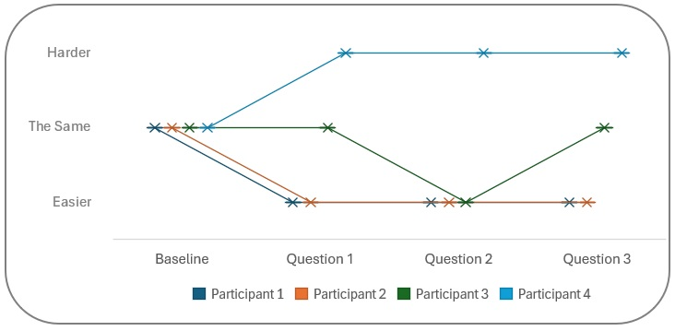

The four options for the participants to choose from were; Easier, Harder, The Same and Not Sure. None of the participants chose ‘Not sure’ therefore this has been left out of the graph and further analysis.

Overall, the majority found each external focus easier on their voice than the proceeding internal focus. The ‘Mid’ focus, on the beanbag being moved by me (question 2), was the easiest, with 3 out of 4 participants choosing this options. Interestingly the one participant who did not choose ‘easier’, in fact found it ‘harder’ which was not expected from my research and my initial hypothesis. P1 and P2 found each external focus easier, while P3 found the ‘near’ focus, and focus on intended outcome the same as when focusing internally. This would suggest that externally focusing generally does not cause a negative effect. Apart from with P4 who chose ‘harder’ for all three questions. I theorise that P4 either has a clearer understanding of their vocal mechanisms and therefore draws their attention there, or that they are more familiar with focusing internally and therefore in their comfort zone.
These results are not conclusive enough to make a strong argument either way and further proves that each singer is different, with unique lived experiences, sensations within their voice and ways of processing information. Therefore there is the need for a holistic approach to their vocal development.

Analysis of qualitative data

The method for qualitative data analysis chosen was Braun and Clarke’s (Braun and Clarke, 2006; Clarke and Braun, 2017) method of thematic analysis. Phase 1 was undertaken by transcribing the video footage taken from the day of the experiment (See Appendix G), while noting down any initial obvious themes that emerged to revisit at a later stage. After this, phrase 2 involved going through the transcription and summarising key points that the participants made and categorising these into codes. At this stage there were 11 themes in total, including a misc theme for codes that did not fit, these were colour coded for clarity on the next read through of the transcription. A re-read of the transcript was undertaken with special care to find new codes. These new codes from ‘Round 2’ of phase 2 were cross referenced against ‘Round 1’ and new themes were redefined. These themes were narrowed down to four main themes and 12 subthemes which were explored in a mind map (See appendix H) Phase 4 had two levels to ensure the themes were coherent, related to the research question and were true to the data. In level 1 the codes were scrutinised within their themes and subthemes to ensure they fit within the theme and made sense as a whole. Some changes were made to improve the clarity of the narrative. Level 2 encouraged scrutiny of the entire mind map as a whole and whether this reflects the evidence. Following this stage the final set of themes emerged with one main theme at the top, ‘Focus’ and three themes following on from that. The final phase involved double checking that the each theme captured a different, but relevant part of the data. Once writing up the analysis began the themes were readjusted back into smaller themes so as not to get too general, with the aim to link this all back to the overarching theme of ‘Focus’ as this was the primary aim of the experiment.

The final main themes are:
- Level of focus and limited capacity
- Overthinking
- External vs Internal
- Technique – Improvement and awareness
- Sensations / Proprioception – Physical impact and posture
- Confidence – Trust, ease and freedom

Level of focus and limited capacity

"Limited Capacity of attention is necessary because at any given moment the environment presents far more perceptual information than can be effectively processed” (Chun et al., 2011, p. 75).
Through carefully chosen questions regarding focus (See appendix I), the data collected showed that there were mixed views on the ease of committing to one focus, and the element of distraction became a recurring theme with one participant welcoming the distraction and finding multi-tasking (focusing externally while singing) helpful, while one said that distraction is not helpful at the early stages of learning a skill, and another stating that while focusing on the beanbag in hand it was too distracting. This reinforces the idea of limited capacity explored within the literature review, that there is often too much information for us to process and therefore we need to select the information we feel most relevant to the situation and keep our focus on it (Chun et al., 2011).
Participants said that their mind tended to wander, and that it was challenging to focus on one thing, and hard to have the brain space to focus on technique while also adding expression. These sensations (internal sources of information) come from the body, whereas external ones are perceived from outside, however these compete with each other for attention and therefore it would be important to find a balance (Fillingim and Fine, 1986). While one found it helpful to explore different focuses it seemed clear that deciding and assigning the level of focus to the each area was challenging. An understanding of where to lay their focus would be beneficial as one can look in one direction but focus their attention elsewhere (Styles. E, 2006). One participant stated that generally they do not manage to focus in the moment while singing but rather that they are thinking ahead to the difficult bit on the song they are singing. While another said that if they are not thinking about something it tends not to happen, but that when focusing on the beanbag in the distance it allowed for other focuses to come in, suggesting that this could be an affective way to split focus and multitask, by being able to filter out some sensory inputs. One must choose which stimuli to focus on at the expense of another stimuli in order to make a selection for attentional processing (Styles. E, 2006). There were a couple of mentions that focusing externally (beanbag in hand and sound) meant that they were not focused so much on what they were doing vocally, and that distraction helped them think less, resulting in better vocal fold closure on their last note, which would suggest again that having a focus as a distraction may open up the mind for less overthinking.

Overthinking
It became clear that overthinking was a factor within this experiment. It tended to be when focusing internally (on the breath) this overthinking happened, however one participant stated that when they watch their reflection (in practice) this leads to overthinking around posture. They found it hard to detach from critical thinking, and the singular focus lead to overthinking which built up over each internal focus test. Another participant found that when focusing on the bean bag in their hand, that their overthinking about sound production lessened. Participants found that focusing in the distance, on the beanbag in hand and on the sound lessened overthinking, made them more relaxed which lead to less overthinking and a better outcome. This allowed for trust in themselves to not overthink their sound production. This points to an external focus being more beneficial to avoid overthinking and reinforces that singers may be more likely to intervene with natural processes and interfere with relatively automatic coordination if overthinking the internal movements (Masters, 1992; McNevin et al., 2003).

External vs Internal
For the purposes of this data analysis the uses of these terms will stay true to what they were in the experiment. External = The surroundings and anything outside of the body including, bean bag in hand, bean bag at a distance and sound. Internal = anything within the body, including the larynx, soft palate, the tongue and the breath.
It seems that as a general rule participants tend to focus internally when they are singing, especially in lessons and in practice. This may be partly due to the Estill method being the main model used with these students therefore they are used to this focus point, and one to one lessons at this college are technique based, rather than artistry. Also, research by Brand (2021), suggested that an internal focus tends to be the chosen focus if not instructed otherwise. One participant stated that they purposefully bring their focus back to the internal functions when their focus drifts to the external, and find it harder to stay focused on the breath solely without their mind wandering. This is the same participant (P4) who found all three external focus of attention harder than internal, which may explain why is was harder for them if they were struggling to maintain focus. When focused externally some participants noticed it was more fun, they thought less about their vocals and on their reflection. One participant found it harder to focus in the distance and yet found it less all-consuming, leaving room to think about the song but not the physiological side. Once again, this was P4, who found external focus harder, however I would argue that by “thinking about the song” and not the physiological side that they are in fact focusing externally on the outcome. This indicates that solely focusing on one thing can be helpful in some aspects but hinder others and relates back to an earlier point of finding balance in our level of focus and allowing for limited capacity, and possibly their familiarity with the piece or skill level, as was discovered by Styles (2006), who studied jugglers, the more skilled the juggler is, the less attention is needed on that skill and therefore the more the attention can be split. Focusing externally during a performance seems to be the choice by most, including P4, once muscle memory has been established and the internal aspect has been practiced, however one participant noted that it would be helpful to focus externally not just in a performance setting. It seemed for one participant that in a particularly challenging part of the song section (the last note) focusing externally did not help this as they were unable to mentally go through the checklist of things they would do to achieve a technically secure note.

Technique – Improvement and awareness
Participants found that by focusing externally it helped them to not look for sounds, there was noticeably less pushing, and they were more relaxed which lead to improvement in intonation, linking to similar findings in studies explored in the literature review (Fillingim and Fine, 1986; McNevin et al., 2003; Maxfield and Treinkman, 2021). When talking about focusing on ‘sound’ in particular it made it easier to identify what they were doing better, or worse and what was working for them. Overall they felt they made a better sound when focused on it, however one participant (P4) found this more challenging as they are told in lessons to stop focusing on the sound so it went against their instincts, and they felt that when they listened to the sound they got caught up in it and forgot about technique and therefore it did not work so well for them. It seems then that it may feel better, with less pushing and a more relaxed feeling, also bringing more awareness to the sound but that it did not necessarily mean the sound improves in all cases.

Technique – Articulation, execution and the breath
The breath in particular appears to be a self proclaimed problem area for some participants and this lead to some differing experiences. On one hand they were happy to be able to focus purely on the breath (internal focus) and they felt that this helped their execution, but also that this brings negative, self critical, thoughts before even beginning to sing due to bad habits surrounding breath, or a belief that this is an area they need to work on. This focus on what is already represented in the mind, sitting in their working memory, or recalled from long-term memory (or habits) rather than on real time sensory input seems to play a part here. Its possible that exploring this distinction could help open up and break out of negative thinking around so called bad habits (Chun et al., 2011). One participant noted that the most contrasting in feel were the sound (external) and the breath (internal). For one participant external focus improved their technique with regard to articulation, and breathing as well as reaching a top note of an ascending scale easier. This data suggests that far more research would need to be conducted to explore these themes further and that vocal technique is a vast topic which would need more detailed questions and analysis of the vocals, which is beyond the scope of this project, however is it still important to note the experiences of these participants.

Sensations / Proprioception – Physical impact and posture
Singing is a physical act and therefore this theme was inevitable. The experience of external focus and its impact on the body seemed fairly consistent across all participants. When focused on the beanbag in the distance there was less for them to do and therefore less to interfere with them physically, in line with research by Styles, E (2006), suggesting that although difficult to focus on two visual or auditory task simultaneously, mixing the two senses is not that difficult. The participant noted that it felt more free, and more comfortable with less tension in the body and less pushing, adding to vast amount of research highlighting the positive effects of externally focusing (Fillingim and Fine, 1986; Singer et al., 1993; Wulf et al., 1998; Wulf et al., 1999; wulf et al., 2002; McNevin et al., 2003).

One participant found that when focusing on the bean bag in their hand, they were less grounded and supported in their body, which in turn affected their sound. When listening to the sound (external) they were much more critical of themselves and therefore thought less about what they were physically doing, which has its positives and negatives. Most found that when focusing on the beanbag in hand that this had a negative impact on their posture and that it was compromised because their focus was down. It seems that the type of focus is important when analysing the physical impact and it appears that focusing on something in the distance, which is far more distal than something in the hands, has the most positive affect on the body, and possibly focusing on the sound is too far removed from the body to allow for split focus and that an element of trust comes in that the body knows what to do (Maxfield and Treinkman, 2021).

Confidence – Trust, ease and freedom
Trust was an unexpected theme to arise through analysing the data. It was noted that when performing they had to trust the work had been done internally so that they were free to focus externally in order to give a performance with expression and conviction. When focusing externally they trusted themselves not to overthink what they were doing and the sound they were making, and when focusing on the beanbag in the distance one participant in particular felt they could trust themselves more because they knew their singing would not be compromised by watching something move, rather than moving it themselves. "Cognitive flexibility is a crucial human ability allowing efficient adaptation to changing task challenges" (Ghazanfar and Schroeder, 2006). Participants also felt that where they had less trust in their ability, that focusing externally helped. I would argue that this is due to automatic processes having the freedom to work how they know best to (Maxfield and Treinkman, 2021). Most participants felt more relaxed, with it feeling more free and easy when focused externally (beanbag in hand, beanbag in the distance or sound) with one stating that they did not have to think about the lyrics when focusing on the bean bag, the words were just coming out. One participant however found it easier when focused internally on the breath. This would suggest that there are different uses for different focus points at different times in the learning process and that all students will experience these differently, and subjective experiences play a big roll (Chun et al., 2011). More research would be useful to determine at what stage one might explore external focus, or how to decide which students would benefit from focusing on the sound, versus on the breath or in the distance as this is clearly quite different for different students. Factors to consider may be; skill level, song choice, attractor states and problem areas, as well as how familiar they are with the song.

Discussion

Participant experiences and answers varied considerably, with no real pattern emerging, other than focusing on something in the distance generally yielded more positive results (with the highest number of participants finding this focus easier than focusing internal). This is in line with research conducted by Fillingim and Fine (1986) which suggests individuals process external and internal sensations differently depending on many factors, including; past experiences and beliefs, personality type and level of self consciousness. Exploring different focuses of attention highlighted a more interesting outcome, that exploration in itself encouraged participants’ own analysis of their experience with many experiencing surprising results that they were not expecting or had not considered, which could lead them to a better, more in-depth understanding of their own voice. Staying true to a semi structured interview format as laid out in my methods, allowed these organic analyses by participants, and a broader scope of answers, for example;
“I feel like I skip so far ahead in the song I don’t actually stay in the moment” (P1)
“I felt more relaxed in what I was doing and what I was singing and what sound I was making… I think I trusted myself to not focus on it.” (P2).
“I wasn’t holding too much tension because I was focusing on the beanbag instead of too much on what I was doing.” (P3)
“Listening to the external sound is quite helpful as well.. it gives you a different perspective on it.” (P3)
“Every so often I’d have to go ..’oh no wait.. beanbag’ cause I was looking at it but maybe my focus wasn’t 100% on it” (P4).
As learnt from the literature review, ‘attention’ is an ambiguous word and although we as humans may have an understanding of this and how we can ‘focus our attention’ or ‘pay attention’, what this actually means to each individual seems quite different according to these findings. The terms ‘external’ and ‘internal’ almost became redundant in this experiment when it became clear that they were not clearly defined enough, and that even when explaining the definition to be used in the experiment, participants still had their own views and preconceived ideas of what this means for them; “Externally is like a lot of posture things, making sure that this space is closed and that my knees aren’t locked… and then internally is like soft palate and tongue, larynx and that sort of area.” (P4). ‘Sound’ was another point of difference between students. I stand by the choice for ‘sound’ as an external focus because I wanted to explore how this differs from other musicians. There were mixed views on this and inconclusive results. Some participants found that focusing on the sound meant that they could hear and correct what was needed, which is quite different to purely focusing on the outcome without correctly anything. Their awareness of the sound may lead to problems if the sole focus remains there. Two participants noted that when focusing on the beanbag moving this helped to distract from the sound production, implying that they believe they need distraction from the sound, rather than focus on it. When focusing on the sound, self criticism came up, which I believe is a difference between singers and other musicians. A singing voice is a very personal, and sometimes vulnerable thing, so self criticism and self-consciousness are bound to play a part, as touched upon by Fillingim R, Fine, M. (1986). However according to the quantitative data, 50% found it easier to focus on the sound than on the breath, so it may be that it is not necessarily the best form of external focus for singers but could be better for some than focusing internally. Within my practice moving forward I would explore this further with my students and use multiple different types of focus; internal, external, near, mid, distal etc to encourage my students to explore how this feels for them. If something does not work for them I would find this just as interesting and helpful than if it did. I will continue with my holistic approach and encourage back and forth communication around focus of attention, discussing attention as a scale rather than choosing one.

A clear limitation of this study was the sample size, which was very low, at 4 participants. While this could not give an accurate picture for the quantitative data, it did allow for a more in-depth analysis of the qualitative data, which would have been much harder to do with more participants. Another limitation was the choice to allow for the participants to choose their own song segments. Guided by the literature I made this decision because I wanted a more accurate representation of a lesson rather than choosing a 3 note phrase (Atkins, 2018) or teaching them the same song (Atkins, 2017). However this comes with the risk that a participant has chosen a song which is beyond their skill level therefore they are likely to be distracted by this. Another limitation, which I do not believe can be avoided, is that the more a participant sings the same section of a song, the more familiar and comfortable they become with it, meaning the last time they sing it is likely to yield a more positive response in terms of how easy it felt because the muscles are warmed up to the specific section and its demands on the voice. On the other hand if the song section is straining their voice they may be too tired by the end to answer accurately on the sensations for the last test.

Conclusion

This report studied different focus of attention, by comparing the internal focus of breath, to three different external focus in an attempt to test my hypothesis that external focus makes singing easy, and explore how shifting these foci of attention can help students discover aspects about their voice they had not considered before.
The quantitative data generally showed each external focus to be easier for the participant than the internal focus. The qualitative data elaborated on this and made it clearer that there were various factors which affected the experiences, for example; distraction, an inability or difficulty to focus fully on one thing, preconceived ideas of their own voice, and self criticism. There was no clear best way to focus which suited all participants and everyone’s experiences were slightly different. While some found the distraction of shifting their focus welcome, others found it detrimental, pointing to the fact that all singers are different and need tailored lessons with a holistic approach. Following one method would not suit everyone and I believe fusing the technical aspects of the Estill method with the freedom Dalcroze offers could make for a well rounded, self-aware and technically accomplished singer.
By the nature of focusing, as per the literature, it is almost impossible to focus on one thing entirely and therefore it is no surprise this was difficult for them. Exploring the spectrum of attention as a broad term and finding levels within this could encourage more balance in the way they focus their attention creating a best of both scenario rather than blocking out one focus entirely in favour of another. Their pre-conceived ideas of their own voices, either technically or their self criticism around their sound, may have hindered their freedom to explore without judgement. This is quite a large subject that I am not convinced ‘focus of attention’ could solve entirely. However alongside other confidence building, and mindful approaches could work as part of. I believe Dalcroze could be beneficial in exploring the whole self as a musician and possibly work on acceptance.
If I were to do build upon this research I would look at how to compare not only internal to external focuses, but different levels of external to each other, as this became clear that playing with the bean bag was quite different to watching the beanbag being played with.
I would also consider gathering more participant information pre experiment, for example skill level, previous vocal technical difficulties, any alternative learning styles like ADHD or aphantasia, and possibly personality type. This would give an extra level of depth and understanding to their observations. The scope for further research is vast. One could look further into tonality, expression and pitch accuracy. This could be within a lesson environment or a performance environment. The use of a stroboscope or MRI to view a voice in action would be an exciting way to see if shifting attention of focus has a physical effect on the intrinsic muscles.
On reflection, I found it hard as the researcher to stay impartial and not ask leading questions during the practical research. The nature of a semi-structured interview meant that I had guide questions but allowed myself freedom to respond to the participants’ answers in an effort to gain authentic responses. This however, as a fairly inexperienced researcher, was far more difficult than anticipated. In the future I would consider more carefully worded questions to elicit an authentic response without much need for follow up questions.
When exploring the literature it became clear that the topic of ‘attention’ is vast and without clear definition, which I found overwhelming when deciding on my own definition and on hindsight could have been clearer on this before conducting the experiment. However I do feel that the ambiguity around what was meant by ‘internal’ and ‘external’ focus led my participants to explore and discover some interesting ideas which may have been missed if the task was more prescriptive.

References

Alexander, F. (2018) The Use of The Self. 2n Ed. London: Orion Publishing Group

Anderson, W.T. (2012) ‘The Dalcroze Approach to Music Education’. General Music Today 26(1), pp. 27–33. Available at: doi:10.1177/1048371311428979.

Atkins, R.L. (2017) ‘Effects of Focus of Attention on Tone Production in Trained Singers’. Journal of Research in Music Education 64(4), pp. 421–434. Available at: doi:10.1177/0022429416673842.

Atkins, R.L. (2018) ‘Focus of Attention in singing- expert listeners’ description of change in trained singers’ tone quality ’. International Journal of Research in Choral Singing 6(1)
Author, L. and Frey Stegman, S. (2003) Choral Warm-ups: Preparation to Sing, Listen, and Learn.

Baron, Annette. and McNeal, Kelly. (2020) Case study methodology in higher education. IGI Global.

Bater, L.R. and Jordan, S.S. (2019) ‘Selective Attention’. in Encyclopedia of Personality and Individual Differences. Cham: Springer International Publishing, pp. 1–4. Available at: doi:10.1007/978-3-319-28099-8_1904-1.

Bowyer, J. (2015) ‘More than Solfège and Hand Signs’. Music Educators Journal 102(2), pp. 69–76. Available at: doi:10.1177/0027432115611232.

Brand, S. (2021) ‘Attentional Focus Effects and Singing Enhancing Vocal Performance through Body Movements and Gestures as External Foci of Attention’. The International Journal of Arts Education 16(1). Available at: doi:10.18848/2326-9944/CGP.

Braun, V. and Clarke, V. (2006) ‘Using thematic analysis in psychology’. Qualitative Research in Psychology 3(2), pp. 77–101. Available at: doi:10.1191/1478088706qp063oa.

Brunkan, M.C. (2016) ‘Relationships of a Circular Singer Arm Gesture to Acoustical and Perceptual Measures of Singing’. Update: Applications of Research in Music Education 34(3), pp. 56–62. Available at: doi:10.1177/8755123314567782.

Burke Johnson, R. and Onwuegbuzie, A.J. (2004) Mixed Methods Research: A Research Paradigm Whose Time Has Come.

Caldwell, T. and Jaques-Dalcroze, E. (1993) ‘A Dalcroze Perspective on Skills for Learning’. Music Educators Journal 79(7), pp. 27–28.

Carver, C.S., Coleman, A.E. and Glass, D.C. (1976) The Coronary-Prone Behavior Pattern and the Suppression of Fatigue on a Treadmill Test.

Chua, L.-K., Jimenez-Diaz Judith, Lewthwaite, R., Kim, T. and Wulf, G. (2021) ‘Superiority of External Attentional Focus for Motor Performance and Learning: Systematic Reviews and Meta-Analyses’. Psychological Bulletin 147(6), pp. 618–645. Available at: doi:10.1037/bul0000335.supp.

Chun, M.M., Golomb, J.D. and Turk-Browne, N.B. (2011) ‘A Taxonomy of external and internal attention’. Annual Review of Psychology 62, pp. 73–101. Available at: doi:10.1146/annurev.psych.093008.100427.

Clarke, V. and Braun, V. (2017) ‘Thematic analysis’. Journal of Positive Psychology 12(3), pp. 297–298. Available at: doi:10.1080/17439760.2016.1262613.

Daly, D.K. (2022) ‘Creativity, autonomy and Dalcroze Eurhythmics: An arts practice exploration’. International Journal of Music Education 40(1), pp. 105–117. Available at: doi:10.1177/02557614211028600.

Denes, P.B. and Pinson, E., (1993). The speech chain. Available at: https://www.researchgate.net/figure/The-speech-chain-speech-production-and-speech-perception-web-ref2_fig3_262730106. (Accessed 20/05/25)

Desimone, R. and Duncan, J. (1995) NEURAL MECHANISMS OF SELECTIVE VISUAL ATTENTION. Available at: www.annualreviews.org/aronline.

Duke, R.A., Cash, C.D. and Allen, S.E. (2011) Focus of Attention Affects Performance of Motor Skills in Music.

Estill Voice Academy Online, Foundations of Estill voice training, https://estillvoice.docebosaas.com/learn/courses/24/foundations-of-estill-voice-trainingr. (Accessed April 2024.)
Estill Voice International, (2020) Estill Exercises App. Version 1.0.56. (Accessed 10/11/24)

Feldenkrais, M. (1990) Awareness Through Movement. New York: HarperCollins

Fenigstein, A., Scheier, M.F., Buss, A.H. and Buss, H. (1975) Public and Private Self-Consciousness: Assessment and Theory.

Fillingim, R.B. and Fine, M.A. (1986) The Effects of Internal Versus External Information Processing on Symptom Perception in an Exercise Setting.

Ghazanfar, A.A. and Schroeder, C.E. (2006) ‘Is neocortex essentially multisensory?’. Trends in Cognitive Sciences 10(6), pp. 278–285. Available at: doi:10.1016/j.tics.2006.04.008.

Gottwald, Owen, Lawrence and McNevin (2020) ‘An internal focus of attention is optimal when congruent with afferent proprioceptive task information’. Psychology of Sport and Exercise 47. Available at: doi:10.1016/j.psychsport.2019.101634.

Jackson, E. (2013) Choosing a Methodology: Philosophical Underpinning.

Johnston, W.A. and Dark, V.J. (1986) ‘Selective Attention ’. Annual Review of Psychology (37 43-75)

Jones, J.D. (2018) ‘Scaffolding the Dalcroze Approach’. General Music Today 32(1), pp. 5–12. Available at: doi:10.1177/1048371318770821.

Juntunen, M.-L. (2002) The practical applications of Dalcroze Eurhythmics.

Juntunen, M.-L. (2016) The Dalcroze Approach Experiencing and Knowing Music Through Embodied Exploration. Oxford University Press. Available at: doi:10.1093/acprof:oso/9780199328093.001.0001.

Leech, N.L. and Onwuegbuzie, A.J. (2009) ‘A typology of mixed methods research designs’. Quality and Quantity 43(2), pp. 265–275. Available at: doi:10.1007/s11135-007-9105-3.

Lohse, K.R., Jones, M., Healy, A.F. and Sherwood, D.E. (2014) ‘The role of attention in motor control’. Journal of Experimental Psychology: General 143(2), pp. 930–948. Available at: doi:10.1037/a0032817.

Lohse, K.R., Sherwood, D.E. and Healy, A.F. (2010) ‘How changing the focus of attention affects performance, kinematics, and electromyography in dart throwing’. Human Movement Science 29(4), pp. 542–555. Available at: doi:10.1016/j.humov.2010.05.001.

Masters, R.S.W. (1992) ‘Knowledge, knerves and know-how- The role of explicit versus implicit knowledge in the breakdown of a complex motor skill under pressure’. British Journal of Psychology 343–358(83)

Maxfield, L. and Treinkman, M. (2021) ‘MINDFUL VOICE Focus of Attention Research: A Review and Update for Teachers of Singing’. Journal of Singing 77(3), pp. 407–418.

McNevin, N.H., Shea, C.H. and Wulf, G. (2003) ‘Increasing the distance of an external focus of attention enhances learning’. Psychological Research 67(1), pp. 22–29. Available at: doi:10.1007/s00426-002-0093-6.

Mead, V.H. (1996) More than Mere Movement Dalcroze Eurhythmics.

Mete, M. and Dündar, M. (2020) ‘The effect of kodaly method on the musical knowledge and skills of preservice teachers’. Elementary Education Online 19(4), pp. 2053–2073. Available at: doi:10.17051/ilkonline.2020.763316.

Mornell, A. and Wulf, G. (2019) ‘Adopting an External Focus of Attention Enhances Musical Performance’. Source: Journal of Research in Music Education 66(4), pp. 375–391. Available at: doi:10.2307/48588750.

Navon, D., Gopher, D., Kahneman, D., Leshovitz, B. and Levin, J. (1979) On the Economy of the Human-Processing System.

Pretnar Žagar, A. and Podjed, D. (2024) ‘Ethnography beyond thick data’. Annals of Anthropological Practice 48(2), pp. 272–288. Available at: doi:10.1111/napa.12226.

Sadan, V. (2014) ‘Mixed Methods Research: A New Approach’. International Journal of Nursing Education 6(1), p. 254. Available at: doi:10.5958/j.0974-9357.6.1.052.

Singer, R.N., Lidor, R. and Cauraugh, J.H. (1993) ‘To Be Aware or Not Aware? What to Think About While Learning and Performing a Motor Skill’. The Sport Psychologist 7, pp. 19–30.

Spector, I., Jaques-Dalcroze, E. and Odom, S.L. (1992) What Is Dalcrozian?

Steinhauer, K, Mcdonald Klimek, M and Estill, J. (2017) The Estill Voice Model Theory and Translation, Pittsburgh: Estill Voice International.

Styles, E, (2006) The Psychology of Attention. Hove: Psychology Press
White, A.R. (2017) ‘Vocal traditions: Somatic VoiceworkTM The LoVetri Method’. Voice and Speech Review 11(2), pp. 240–248. Available at: doi:10.1080/23268263.2017.1383559.

Williams, S.G., van Ketel, J.E. and Schaefer, R.S. (2023) ‘Practicing Musical Intention: The Effects of External Focus of Attention on Musicians’ Skill Acquisition’. Music and Science 6. Available at: doi:10.1177/20592043231151416.

Winter, D. (2021) UNDERSTANDING RESEARCH METHODS: FROM COACH TO PRACTITIONER RESEARCHER. Available at: www.voiceworkshop.co.uk.

Wulf, G. (2013) ‘Attentional focus and motor learning: a review of 15 years’. International Review of Sport and Exercises Psychology 6(1), pp. 77–104. Available at: doi:10.1080/1750984X.2012.723728.

Wulf, G., Höß, M. and Prinz, W. (1998) ‘Instructions for Motor Learning- Differential Effects of Internal Versus External Focus of Attention’. Journal of Motor Behaviour 30(2), pp. 169–179.

Wulf, G., Lauterbach, B. and Toole, T. (1999) ‘Learning advantages of an external focus of attention in golf’. Research quarterly for exercise and sport 70, pp. 120–26.

Wulf, G. and Lewthwaite, R. (2016) ‘Optimizing performance through intrinsic motivation and attention for learning: The OPTIMAL theory of motor learning’. Psychonomic Bulletin and Review 23(5), pp. 1382–1414. Available at: doi:10.3758/s13423-015-0999-9.

Wulf, G. and Lewthwaite, R. (2021) ‘Translating Thoughts Into Action: Optimizing Motor Performance and Learning Through Brief Motivational and Attentional Influences’. Current Directions in Psychological Science 30(6), pp. 535–541. Available at: doi:10.1177/09637214211046199.

wulf, G., McConnel, N., Gärtner, M. and Schwarz, A. (2002) ‘Enhancing the Learning of Sport Skills Through External-Focus Feedback’. Journal of Motor Behavior 34, pp. 171–182.

Wulf, G., Shea, C. and Park, J.-H. (2001) ‘Attention and motor performance- Preferences for and advantages of an external focus’. Motor Control and Learning 72(4), pp. 335–344.

Appendices

Appendix A – Approved Ethics Form

APPLICATION FOR ETHICAL APPROVAL

RESEARCH STUDENTS
This form is to be completed by the student within SIX months for full-time students and TWELVE months for part time students, after the commencement of the research degree or following progression to Part Two of your course.

Once complete, submit this form via the MyTSD Doctoral College Portal at (https://mytsd.uwtsd.ac.uk).

This document is also available in Welsh.

RESEARCH STAFF ONLY
All communications relating to this application during its processing must be in writing and emailed to pgresearch@uwtsd.ac.uk , with the title ‘Ethical Approval’ followed by your name.

STUDENTS ON UNDERGRADUATE OR TAUGHT MASTERS PROGRAMMES should submit this form (and receive the outcome) via systems explained to you by the supervisor/module leader.

In order for research to result in benefit and minimise risk of harm, it must be conducted ethically. A researcher may not be covered by the University’s insurance if ethical approval has not been obtained prior to commencement.

The University follows the OECD Frascati manual definition of research activity: “creative work undertaken on a systematic basis in order to increase the stock of knowledge, including knowledge of man, culture and society, and the use of this stock of knowledge to devise new applications”. As such this covers activities undertaken by members of staff, postgraduate research students, and both taught postgraduate and undergraduate students working on dissertations/projects.

The individual undertaking the research activity is known as the “principal researcher”.

Ethical approval is not required for routine audits, performance reviews, quality assurance studies, testing within normal educational requirements, and literary or artistic criticism.

Please read the notes for guidance before completing ALL sections of the form.

This form must be completed and approved prior to undertaking any research activity. Please see Checklist for details of process for different categories of application.

SECTION A: About You (Principal Researcher)
1 | Full Name: |  | Elizabeth (Libby) Williamson
2 | Tick all boxes that apply: |  | Member of staff: | ☐ | Honorary research fellow: | ☐
 | Undergraduate Student | ☐ | Taught Postgraduate Student | ☒ | Postgraduate Research Student | ☐

3 | Institute/Academic Discipline/Centre: | UWTSD / Voice Study Centre
4 | Campus:
5 | E-mail address: | libbywilliamson@live.co.uk
6 | Contact Telephone Number: | 07900218929
 | For students:
7 | Student Number: | 2224780
8 | Programme of Study: | MA Professional Practice (Voice Pedagogy)
9 | Director of Studies/Supervisor: | Louise Emanuel / Julie Crossman/ Debbie Winter

SECTION B: Approval for Research Activity
1 | Has the research activity received approval in principle?  (please check the Guidance Notes as to the appropriate approval process for different levels of research by different categories of individual) |  | YES | ☒ | NO | ☐
 |  |  |  |  | Date
2 | If Yes, please indicate source of approval (and date where known): Approval in principle must be obtained from the relevant source prior to seeking ethical approval | Research Degrees Committee |  | ☐
2 |  | Institute Research Committee |  | ☐
2 |  | Other (write in)  WAPPAR Ethics Board Representative |  | ☒

SECTION C: Internal and External Ethical Guidance Materials
 | Please list the core ethical guidance documents that have been referred to during the completion of this form (including any discipline-specific codes of research ethics, location-specific codes of research ethics, and also any specific ethical guidance relating to the proposed methodology). Please tick to confirm that your research proposal adheres to these codes and guidelines. You may add rows to this table if needed.
1 | UWTSD Research Ethics & Integrity Code of Practice | ☒
2 | UWTSD Research Data Management Policy | ☒
3 | [List any other relevant documents here] | ☐

SECTION D: External Collaborative Research Activity
If there are external collaborators then you should gain consent from the contact persons to share their personal data with the university. If there are no external collaborators then leave this section blank and continue to section E.
1 | Institution
2 | Contact person name
3 | Contact person e-mail address
4 | Is your research externally funded? |  | YES | ☐ | NO |  | ☐
5 | Are you in receipt of a KESS scholarship? |  | YES | ☐ | NO |  | ☐
6 | Are you specifically employed to undertake this research in either a paid or voluntary capacity? | Voluntary | YES | ☐ | NO | ☐
7 |  | Employed | YES | ☐ | NO | ☐
8 | Is the research being undertaken within an existing UWTSD Athrofa Professional Learning Partnership (APLP)? | If YES then the permission question below does not need to be answered. | YES | ☐ | NO |  | ☐
9 | Has permission to undertake the research has been provided by the partner organisation? | (If YES attach copy)  If NO the application cannot continue | YES | ☐ | NO |  | ☐

Where research activity is carried out in collaboration with an external organisation
10 | Does this organisation have its own ethics approval system? | YES | ☐ | NO | ☐
 | If Yes, please attach a copy of any final approval (or interim approval) from the organisation (this may be a copy of an email if appropriate).

SECTION E: Details of Research Activity
1 | Indicative title: | The Effects of External Focus on Efficiency and Expression in College Level Students.
2 | Proposed start date: | 06/01/25 | Proposed end date: | 22/08/25
Introduction to the Research (maximum 300 words per section)
Ensure that you write for a Non-Specialist Audience when outlining your response to the points below:
- Purpose of Research Activity
- Proposed Research Question
- Aims of Research Activity
- Objectives of Research Activity
Demonstrate, briefly, how Existing Research has informed the proposed activity and explain
- What the research activity will add to the body of knowledge
- How it addresses an area of importance.
3 | Purpose of Research Activity  The purpose of this research is to explore the effects of using “external focus”, directing attention either towards the external environment or the outcome, while singing to improve efficiency for the singer and achieve better expression, including dynamics, phrasing and authenticity. During previous research regarding movement during singing I discovered research showing the positive effects of external focus on such activities as padel boarding, darts and playing a musical instrument. I intend to test this theory with singers, and explore how best this could be utilised within the vocal teaching studio.  (this box should expand as you type)
4 | Research Question  How best to use external focus within the teaching studio to encourage efficiency and expression?  (this box should expand as you type)
5 | Aims of Research Activity  I aim to discover whether switching focus externally rather than internally has a positive effect on how the singer feels when they sing and if there is an improvement in their expression as perceived be myself, the researcher. I also aim to determine which form of external focus is the most effective, ie. hand movements, a point in the distance, or their sound.  I aim to gather information regarding where singers currently tend to set their focus during a lesson, practice and performance, and whether they feel this helps or hinders their efficiency and expression.  I aim to discover whether the concept of external focus is currently widely utilised by singing teachers.  (this box should expand as you type)
6 | Objectives of Research Activity  I will use college and university level students at The Bristol Conservatoire.  To examine any positive or negative effects when a student focuses externally versus internally when singing, by observing such musical factors as; natural dynamic changes, phrasing, articulation, emotion, mood and characterisation. I will measure these by using a baseline exercise and deciding, using my professional experience, whether I believe these expressive elements have improved or diminished with the use of internal/external focus, and recording these observations using a number scale.  To explore which focus point is most effective for; ‘expression’, by using a number scale to record my observations, and ‘ease of singing’ by using a number scale for the student to record their observations.  To assess any difference in expression between each area of focus, by observing and recording anecdotally the changes I observe.  To analyse student feedback on whether their focus changed the ease with which they sing, using their number scales as well as interviews and possibly diaries.  To analyse teachers’ current use of internal or eternal focus within lessons, by looking at their feedback in questionaries, of how they use this as a tool within lessons and whether they notice any positive or negative affects.  (this box should expand as you type)
Proposed methods (maximum 600 words)
Provide a brief summary of all the methods that may be used in the research activity, making it clear what specific techniques may be used. If methods other than those listed in this section are deemed appropriate later, additional ethical approval for those methods will be needed. You do not need to justify the methods here, but should instead describe how you intend to collect the data necessary for you to complete your project.
7 | - Continue a narrative literature review into this topic by exploring previous research projects of a similar nature and analysing their data. I will aim to make this as closely related to singing, and music, as possible.  - Consult students on their experiences through semi structured interviews, relating to how they felt the switch of focus affected their efficiency and expression. With the use of a mixture of closed and open ended questions.  - Invite volunteer participants from the current student cohort at The Bristol Conservatoire (at which I teach on a freelance basis) to participate in a voice lesson with me, the researcher, within which I will teach a short song, and explore different focus points; 1. Internally, 2. On expressive hand movements, 3. On a fixed point in the distance, 4. On the sound they are producing.  - Video record the lessons so I am able to review the footage and audio later to analyse whether the expression changed, and observe any other changes which may have occurred. I will use the same exercises for each student, and use a base line score before exploring the external focus.  - Circulate a questionnaire to all students to answer closed-ended questions about where they set their focus when singing, whether this is different in practice as it is in performance, if they notice a difference when they do shift focus or whether they are even away of shifting focus, which I will record in a graph to analyse the percentages.  - Circulate a questionnaire to teachers to ask closed-ended questions about where they generally encourage students to focus, if this changes depending on what they are working on or the level of the student.  - I will hold a focus group for participants to discuss how changing their focus from internal to external effected their experience, and which focus (hands, distance, sound) worked best for them.  - I intend to gather qualitative and quantitative data during my research.  - I may ask student participants to keep a diary to record progress made when using external focus within their practice.  (this box should expand as you type)
Location of research activity
Identify all locations where research activity will take place.
8 | This research is likely to take place at The Bristol Conservatoire, Bristol, where I currently teach on a freelance basis.  (this box should expand as you type)
Research activity outside of the UK
If research activity will take place overseas, you are responsible for ensuring that local ethical considerations are complied with and that the relevant permissions are sought. Specify any local guidelines (e.g. from local professional associations/learned societies/universities) that exist and whether these involve any ethical stipulations beyond those usual in the UK (provide details of any licenses or permissions required). Also specify whether there are any specific ethical issues raised by the local context in which the research activity is taking place, for example, particular cultural and/or legal sensitivities or vulnerabilities of participants. If you live in the country where you will do the research then please state this.
9 | N/A  (this box should expand as you type)

10 | Use of documentation not in the public domain: Are any documents NOT publicly available? | NO | ☒
10 |  | YES | ☐
11 | If Yes, please provide details here of how you will gain access to specific documentation that is not in the public domain and that this is in accordance with the current data protection law of the country in question and that of England and Wales.  (this box should expand as you type)

 | Does your research relate to one or more of the seven aims of the Well-being of Future Generations (Wales) Act 2015? | YES | NO
12 | A prosperous Wales | ☐ | ☒
13 | A resilient Wales | ☐ | ☒
14 | A healthier Wales | ☐ | ☒
15 | A more equal Wales | ☐ | ☒
16 | A Wales of cohesive communities | ☐ | ☒
17 | A Wales of vibrant culture and thriving Welsh language | ☐ | ☒
18 | A globally responsible Wales | ☐ | ☒
19 | If YES to any of the above, please give details:
 | (this box should expand as you type)

SECTION F: Scope of Research Activity
 | Will the research activity include: | YES | NO
1 | Use of a questionnaire or similar research instrument? | ☒ | ☐
2 | Use of interviews? | ☒ | ☐
3 | Use of focus groups? | ☒ | ☐
4 | Use of participant diaries? | ☒ | ☐
5 | Use of video or audio recording? | ☒ | ☐
6 | Use of computer-generated log files? | ☐ | ☒
7 | Participant observation with their knowledge? | ☒ | ☐
8 | Participant observation without their knowledge? | ☐ | ☒
9 | Access to personal or confidential information without the participants’ specific consent? | ☐ | ☒
10 | Administration of any questions, test stimuli, presentation that may be experienced as physically, mentally or emotionally harmful / offensive? | ☐ | ☒
11 | Performance of any acts which may cause embarrassment or affect self-esteem? | ☐ | ☒
12 | Investigation of participants involved in illegal activities? | ☐ | ☒
13 | Use of procedures that involve deception? | ☐ | ☒
14 | Administration of any substance, agent or placebo? | ☐ | ☒
15 | Working with live vertebrate animals? | ☐ | ☒
16 | Procedures that may have a negative impact on the environment? | ☐ | ☒
17 | Other primary data collection methods. Please indicate the type of data collection method(s) below. | ☐ | ☒
 | Details of any other primary data collection method:  (this box should expand as you type) | ☐ | ☒
If NO to every question, then the research activity is (ethically) low risk and may be exempt from some of the following sections (please refer to Guidance Notes).

If YES to any question, then no research activity should be undertaken until full ethical approval has been obtained.

SECTION G: Intended Participants
If there are no participants then do not complete this section, but go directly to section H.

 | Who are the intended participants: | YES | NO
1 | Students or staff at the University? | ☒ | ☐
2 | Adults (over the age of 18 and competent to give consent)? | ☒ | ☐
3 | Vulnerable adults? | ☐ | ☒
4 | Children and Young People under the age of 18? (Consent from Parent, Carer or Guardian will be required) | ☒ | ☐
5 | Prisoners? | ☐ | ☒
6 | Young offenders? | ☐ | ☒
7 | Those who could be considered to have a particularly dependent relationship with the investigator or a gatekeeper? | ☐ | ☒
8 | People engaged in illegal activities? | ☐ | ☒
9 | Others. Please indicate the participants below, and specifically any group who may be unable to give consent. | ☐ | ☒
 | Details of any other participant groups:  (this box should expand as you type) | ☐ | ☒

Participant numbers and source
Provide an estimate of the expected number of participants. How will you identify participants and how will they be recruited?
10 | How many participants are expected? | I intend to have between 6 and 10 participants to take part in individual lessons where they will be filmed and observed, however this is dependant on who chooses to take part.  These will be existing students at The Bristol Conservatoire, either students of mine or of other teachers at the institution. Their ages will range from 16 – 21 and I will get parent/guardian consent from those under 18.  I will also send out questionnaires to around 60 students and 10 staff, of which I am unsure how many will be filled in and returned.  (this box should expand as you type)
11 | Who will the participants be? | College/ university students ages 16 – 21 years contacted through the college.  Singing teachers at the college and online.  (this box should expand as you type)
12 | How will you identify the participants? | I will use convenience sampling and will include those who are available and willing to take part. I will include all students of any level to ensure I get a cross section of data for varying levels.  (this box should expand as you type)

 | Information for participants: | YES | NO | N/A
13 | Will you describe the main research procedures to participants in advance, so that they are informed about what to expect? | ☒ | ☐ | ☐
14 | Will you tell participants that their participation is voluntary? | ☒ | ☐ | ☐
15 | Will you obtain written consent for participation? | ☒ | ☐ | ☐
16 | Will you explain to participants that refusal to participate in the research will not affect their treatment or education (if relevant)? | ☒ | ☐ | ☐
17 | If the research is observational, will you ask participants for their consent to being observed? | ☒ | ☐ | ☐
18 | Will you tell participants that they may withdraw from the research at any time and for any reason? | ☒ | ☐ | ☐
19 | With questionnaires, will you give participants the option of omitting questions they do not want to answer? | ☒ | ☐ | ☐
20 | Will you tell participants that their data will be treated with full confidentiality and that, if published, it will not be identifiable as theirs? | ☒ | ☐ | ☐
21 | Will you debrief participants at the end of their participation, in a way appropriate to the type of research undertaken? | ☒ | ☐ | ☐
22 | If NO to any of above questions, please give an explanation
 | (this box should expand as you type)

 | Information for participants: | YES | NO | N/A
24 | Will participants be paid? | ☐ | ☒ | ☐
25 | Is specialist electrical or other equipment to be used with participants? | ☒ | ☐ | ☐
26 | Are there any financial or other interests to the investigator or University arising from this study? | ☐ | ☒ | ☐
27 | Will the research activity involve deliberately misleading participants in any way, or the partial or full concealment of the specific study aims? | ☐ | ☒ | ☐
28 | If YES to any question, please provide full details
I will be using a camcorder or an iPhone to video record the research participants.

(this box should expand as you type)

SECTION H: Anticipated Risks

Outline any anticipated risks that may adversely affect any of the participants, the researchers and/or the University, and the steps that will be taken to address them.

If you have completed a full risk assessment (for example as required by a laboratory, or external research collaborator) you may append that to this form.
1 | Full risk assessment completed and appended? |  | Yes | ☐
1 |  |  | No | ☐
2 | Risks to participants  For example: sector-specific health & safety, emotional distress, financial disclosure, physical harm, transfer of personal data, sensitive organisational information
 | Risk to participants:  Engagement in new exercises unknown to the participant, which could potentially cause stress.  (this box should expand as you type) | How you will mitigate the risk to participants:  Ensure they are aware that they can withdraw at any time for any reason and that they are able to discuss any concerns with either myself or the welfare team, and I will follow the college’s safeguarding guidelines at all times.  (this box should expand as you type)
3 | If research activity may include sensitive, embarrassing or upsetting topics (e.g. sexual activity, drug use) or issues likely to disclose information requiring further action (e.g. criminal activity), give details of the procedures to deal with these issues, including any support/advice (e.g. helpline numbers) to be offered to participants. Note that where applicable, consent procedures should make it clear that if something potentially or actually illegal is discovered in the course of a project, it may need to be disclosed to the proper authorities
 | (this box should expand as you type)
4 | Risks to the investigator  For example: personal health & safety, physical harm, emotional distress, risk of accusation of harm/impropriety, conflict of interest
 | Risk to the investigator:  Being exposed to participants divulging sensitive information or concerns.  (this box should expand as you type) | How you will mitigate the risk to the investigator:  I will engage in the mental health support through the university or Voice Study Centre if this feels needed.  (this box should expand as you type)
5 | University/institutional risks  For example: adverse publicity, financial loss, data protection
 | Risk to the University:  Bringing the institution into disrepute.  (this box should expand as you type) | How you will mitigate the risk to the University:  I will indicate that the project is my own individual research and I will ensure ethical guidelines are adhered to.  (this box should expand as you type)
6 | Environmental risks  For example: accidental spillage of pollutants, damage to local ecosystems
 | Risk to the environment:  N/A  (this box should expand as you type) | How you will mitigate the risk to environment:  (this box should expand as you type)

 | Disclosure and Barring Service
 | If the research activity involves children or vulnerable adults, a Disclosure and Barring Service (DBS) certificate must be obtained before any contact with such participants. | YES | NO | N/A
7 | Does your research require you to hold a current DBS Certificate? | ☒ | ☐ | ☐
8 | If YES, please give the certificate number. If the certificate number is not available please write “Pending”; in this case any ethical approval will be subject to providing the appropriate certificate number. | 001903206214

SECTION I: Feedback, Consent and Confidentiality

1 | Feedback  What de-briefing and feedback will be provided to participants, how will this be done and when?
I will allow students to review the finished research if they wish, in the form of a link to a google drive sent via email. As I am not allowed direct contact with them via email (due to safeguarding) this will have to be done via the college.

(this box should expand as you type)
2 | Informed consent  Describe the arrangements to inform potential participants, before providing consent, of what is involved in participating. Describe the arrangements for participants to provide full consent before data collection begins. If gaining consent in this way is inappropriate, explain how consent will be obtained and recorded in accordance with prevailing data protection legislation.
A consent form will be sent out with the invite email to participate. If they are patriating in a lesson they will need to sign the consent form and bring this to the lesson, if under 18 they will need a parent/guardian signature also.

These consent forms will be kept in a secure place for the duration of my course and then will be destroyed.

(this box should expand as you type)
3 | Confidentiality / Anonymity  Set out how anonymity of participants and confidentiality will be ensured in any outputs. If anonymity is not being offered, explain why this is the case.
I will ensure participants are aware that data will be made confidential with the use of pseudonyms.

(this box should expand as you type)

SECTION J: Data Protection and Storage

 | Does the research activity involve personal data (as defined by the General Data Protection Regulation 2016 “GDPR” and the Data Protection Act 2018 “DPA”)? | YES | NO
1 | “Personal data” means any information relating to an identified or identifiable natural person (‘data subject’). An identifiable natural person is one who can be identified, directly or indirectly, in particular by reference to an identifier such as a name, an identification number, location data, an online identifier or to one or more factors specific to the physical, physiological, genetic, mental, economic, cultural or social identity of that natural person. Any video or audio recordings of participants is considered to be personal data. | ☐x | ☐
 | If YES, provide a description of the data and explain why this data needs to be collected:
2 | Personal data, such as names and email addresses will need to be collected on consent forms for validity.  (this box should expand as you type)
 | Does it involve special category data (as defined by the GDPR)? | YES | NO
3 | “Special category data” means sensitive personal data consisting of information as to the data subjects’ –  (a) racial or ethnic origin,  (b) political opinions,  (c ) religious beliefs or other beliefs of a similar nature,  (d) membership of a trade union (within the meaning of the Trade Union and Labour Relations (Consolidation) Act 1992),  (e) physical or mental health or condition,  (f) sexual life,  (g) genetics,  (h) biometric data (as used for ID purposes), | ☐ | ☐x
 | If YES, provide a description of the special category data and explain why this data needs to be collected:
4 | (this box should expand as you type)

 | Will data from the research activity (collected data, drafts of the thesis, or materials for publication) be stored in any of the following ways? | YES | NO
5 | Manual files (i.e. in paper form)? | ☒ | ☐
6 | University computers? | ☐ | ☒
7 | Private company computers? | ☒ | ☐
8 | Home or other personal computers? | ☐ | ☒
9 | Laptop computers/ CDs/ Portable disk-drives/ memory sticks? | ☒ | ☐
10 | “Cloud” storage or websites? | ☒ | ☐
11 | Other – specify: | ☐ | ☐
12 | For all stored data, explain the measures in place to ensure the security of the data collected, data confidentiality, including details of backup procedures, password protection, encryption, anonymisation and pseudonymisation:
All data will be encrypted and kept in password protected cloud storage on the Company’s Office 365 system which will not be shared. Any USB sticks used to store or transfer data will be password protected. All data transfers will be encrypted, and password protected. All participants will be given a unique identifier to ensure confidentiality and this list will be kept securely in the password protected folder. The data will be stored until the completion of the project and then deleted. In accordance with the DPA2018, participants will have the right to ask to see what data is held relating to them, and this data will be deleted immediately if the participant requests this, in which case the data will not be used in the project.

(this box should expand as you type)

 | Data Protection
 | Will the research activity involve any of the following activities: | YES | NO
13 | Electronic transfer of data in any form? | ☒ | ☐
14 | Sharing of data with others at the University outside of the immediate research team? | ☐ | ☒
15 | Sharing of data with other organisations? | ☐ | ☒
16 | Export of data outside the UK or importing of data from outside the UK? | ☐ | ☒
17 | Use of personal addresses, postcodes, faxes, emails or telephone numbers? | ☐ | ☒
18 | Publication of data that might allow identification of individuals? | ☐ | ☒
19 | Use of data management system? | ☐ | ☒
20 | Data archiving? | ☐ | ☒
21 | If YES to any question, please provide full details, explaining how this will be conducted in accordance with the GDPR and Data Protection Act (2018) (and any international equivalents, where appropriate):
There will be email communication for which I will ensure the emails are password protected.

(this box should expand as you type)
22 | List all who will have access to the data generated by the research activity:
College staff and I, who will be contacting students on my behalf and therefore will have access to their names and email addresses (as per usual contact). They will not have access to video footage, interviews, diaries or other data collected during the research.

(this box should expand as you type)
23 | List who will have control of, and act as custodian(s) for, data generated by the research activity:
Myself only

(this box should expand as you type)
24 | Give details of data storage arrangements, including security measures in place to protect the data, where data will be stored, how long for, and in what form. Will data be archived – if so how and if not why not.
All data will be encrypted and kept in password protected cloud storage on the Company’s Office 365 system which will not be shared. Any USB sticks used to store or transfer data will be password protected and will be reformatted at the end of the project in order to destroy the data. The data will be stored until the completion of the project and then deleted.

(this box should expand as you type)
25 | Please indicate if your data will be stored in the UWTSD Research Data Repository (see https://researchdata.uwtsd.ac.uk/ ). If so please explain. (Most relevant to academic staff)
N/A

(this box should expand as you type)
26 | Confirm that you have read the UWTSD guidance on data management (see https://www.uwtsd.ac.uk/library/research-data-management/) | YES | ☒
27 | Confirm that you are aware that you need to keep all data until after your research has completed or the end of your funding | YES | ☒

SECTION K: Declaration
The information which I have provided is correct and complete to the best of my knowledge. I have attempted to identify any risks and issues related to the research activity and acknowledge my obligations and the rights of the participants.

In submitting this application I hereby confirm that I undertake to ensure that the above named research activity will meet the University’s Research Ethics and Integrity Code of Practice which is published on the website: https://www.uwtsd.ac.uk/research/research-ethics/
1 | Signature of applicant: | E. Williamson | Date:  25/11/24

For STUDENT Submissions:
2 | Director of Studies/Supervisor: | Laura James | Date:  3.2.25
3 | Signature: | Laura James | Date:  3.2.25

For STAFF Submissions:
4 | Academic Director/ Assistant Dean: |  | Date:
5 | Signature: |  | Date:

Checklist: Please complete the checklist below to ensure that you have completed the form according to the guidelines and attached any required documentation:
☒ | I have read the guidance notes supplied before completing the form.
☒ | I have completed ALL RELEVANT sections of the form in full.
☒ | I confirm that the research activity has received approval in principle
☐ | I have attached a copy of final/interim approval from external organisation (where appropriate)
☐ | I have attached a full risk assessment (where appropriate) ONLY TICK IF YOU HAVE ATTACHED A FULL RISK ASSESSMENT
☒ | I understand that it is my responsibility to ensure that the above named research activity will meet the University’s Research Ethics and Integrity Code of Practice.
☒ | I understand that before commencing data collection all documents aimed at respondents (including information sheets, consent forms, questionnaires, interview schedules etc.) must be confirmed by the DoS/Supervisor, module tutor or Academic Director.

RESEARCH STUDENTS ONLY
Once complete, submit this form via the MyTSD Doctoral College Portal at (https://mytsd.uwtsd.ac.uk).

RESEARCH STAFF ONLY
All communications relating to this application during its processing must be in writing and emailed to pgresearch@uwtsd.ac.uk , with the title ‘Ethical Approval’ followed by your name.

STUDENTS ON UNDERGRADUATE OR TAUGHT MASTERS PROGRAMMES should submit this form (and receive the outcome) via systems explained to you by the supervisor/module leader.

Appendix B - Search terms

- External focus
- Internal focus
- External focus and singers
- External focus and music teachers
- External focus and musicians
- External focus and learning
- Internal versus external
- Selective attention
- Focus of attention SAME psychology
- Focus of attention definition in psychology
- External and internal focus psychology
- Internal attention of focus psychological definition
- Focus of attention SAME music
- Focus of attention SAME singing
- Focus of attention SAME singers
- Focus of attention SAME sport
- Proprioception
- Proprioception and attention of focus
- Attention and learning
- Attentional focus effects

Appendix C – Speech chain

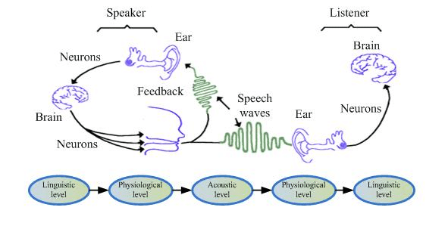
Denes, P.B. and Pinson, E., 1993. The speech chain. Macmillan.

Appendix D – List of Estill figures

- True vocal folds: onset/offset control (pages 43- 56)
- False vocal folds control (pages 59 – 68)
- True vocal folds: body-cover control (pages 71 – 87)
- Thyroid cartilage control (pages 89 – 101)
- Cricoid cartilage control (pages 103 – 113)
- Aryepiglottic sphincter control (pages 115 – 125)
- Larynx control (pages 127- 125)
- Tongue control (pages 139 – 154)
- Velum control (pages 155 – 167)
- Jaw control (pages 169 – 177)
- Lips control (pages 179 – 186)
- Head and neck control (pages 187 – 197)
- Torso control (pages 199 – 211)
(Steinhauer, K, Mcdonald Klimek, M and Estill, J. (2017)

Example of exploratory exercise

Onset/Offset exploratory exercise;
Pretend you are on a picnic and pull out a baguette and see that one end is mouldy:
- You hold your breath and exclaim “Oooo!”
- Then you ask, “Who brought this?”
- You accuse your brother “You?”
What do you feel as the voice ‘turns on’ for the “Ooo”, “Who” and “You”?
(Steinhauer, K, Mcdonald Klimek, M and Estill, J. (2017)

Appendix E – Questionnaires (blank)

Question 1 | Focus - Hands moving
Compared with the internal focus, did this feel….

Easier |  | Harder | The same |  | Not sure

Question 2 | Focus – Moving object
Compared with the internal focus, did this feel….

Easier |  | Harder | The same |  | Not sure

Question 3 | Focus – The sound
Compared with the internal focus, did this feel….

Easier |  | Harder | The same |  | Not sure

Filled in Questionnaires

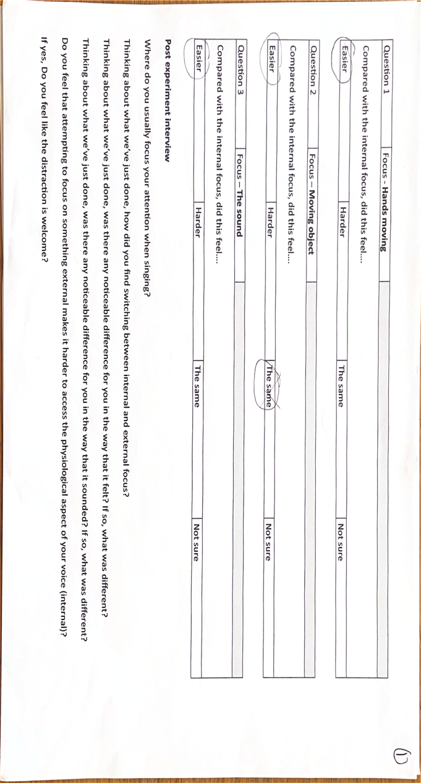
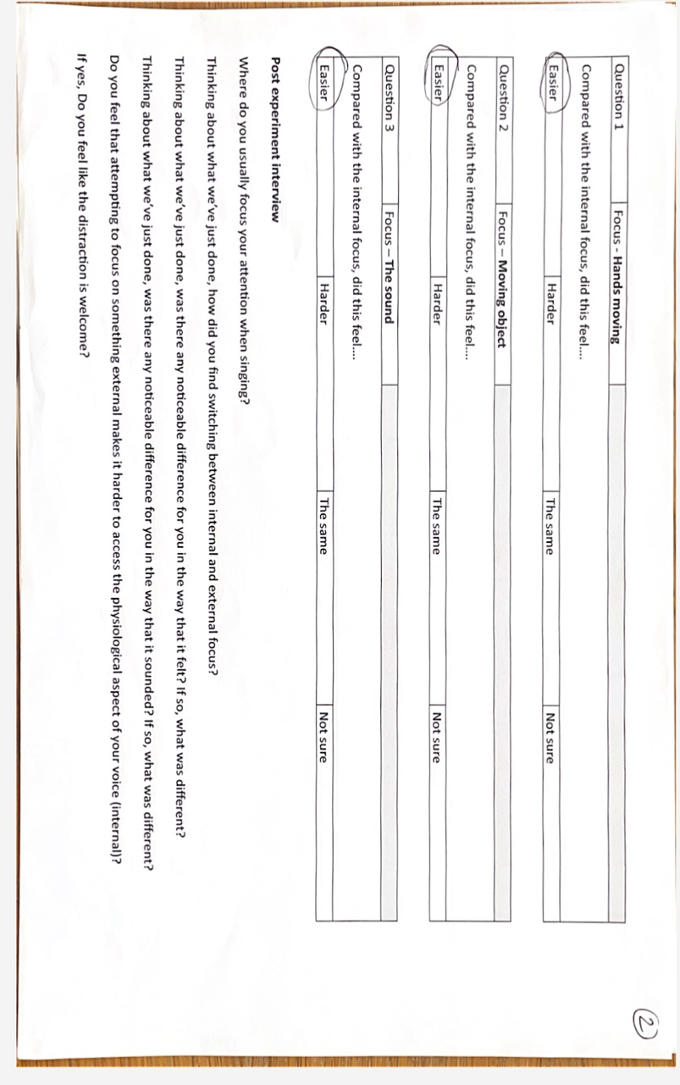

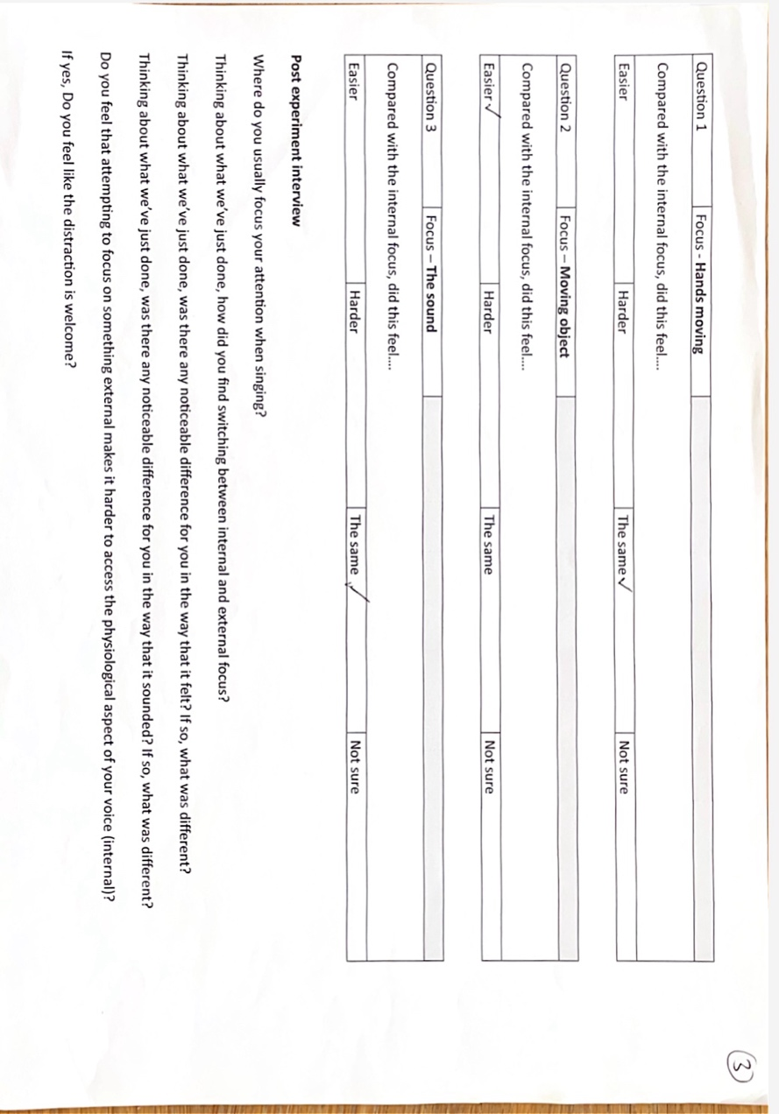
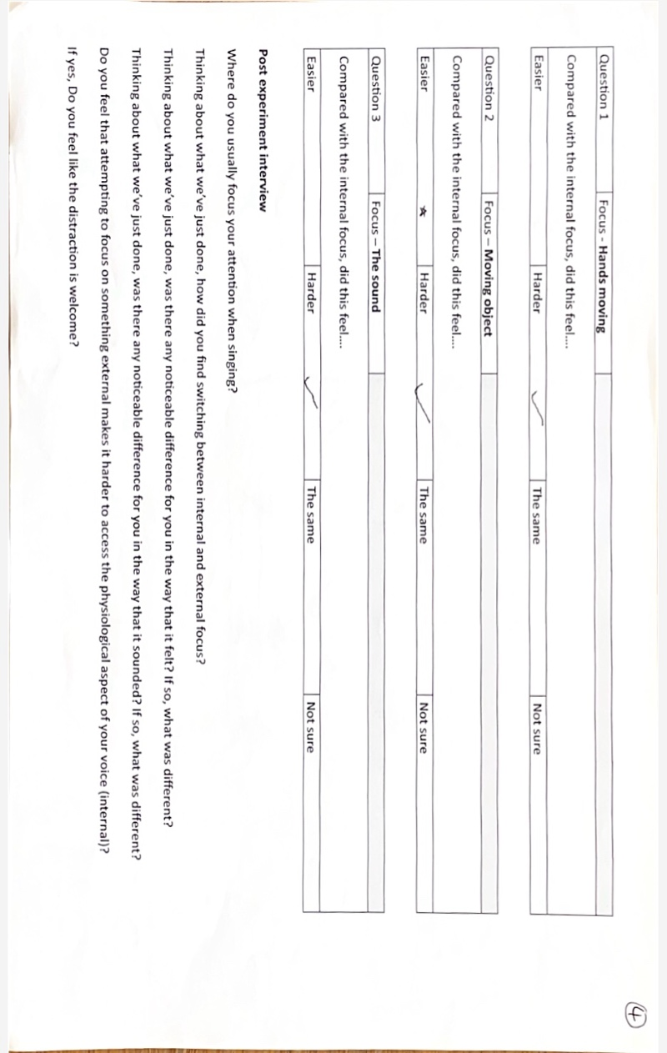

Appendix F - Information and consent form
Dear Student
I am undertaking a research project for the final module of my Masters degree in Voice pedagogy. My current area of interest is around external focus and its potential effect on the efficiency of singing - how easy or hard voice production feels compared with focusing internally.
I would like to invite you to participate in this research project.
As a participant, you would be required to attend a one-to-one lesson with me at The Bristol Conservatoire for a maximum of 30 minutes on a day in March 2025. (This will be in addition to your allotted amount of lessons)
You will be required to bring a short section of a song that you are familiar with but find technically difficult. The style of this song is not important. During the lesson, you will be guided through a number of different focus points to asses efficiency.
Please note - I will not be assessing your ability as a singer, nor will this in any way affect your course grades. It is entirely separate from your course requirements, and your participation is purely for my own research. Your role in this research is completely voluntary, and you can pull out at any time throughout the process.
More details regarding the purpose and nature of the research are below, along with a more detailed overview of what we will do.
Research project working title:
How best to use external focus within the teaching studio to encourage efficiency and expression?
Purpose and nature of the study:
The research aims to explore the effects of focusing on something external to the vocal tract. For example, your hands, a distant point or the sound itself, in an effort to build on existing research to establish if this could be a useful part of a lesson, a student’s practice and/or performance strategies.
Further details on how the project will run:
During the one-to-one lesson;
· You will arrive, and we will re-establish that you are happy to participate in the research.
· We will do a quick warm-up, likely using simple SOVT exercises, before singing through the short passage of the song you have brought.
· I will give you a copy of the score-style questions I would like you to answer and ensure that you are clear about what you need to do.
· The experiment will begin -
· You will be asked to sing your chosen song section while focusing on the vocal tract (internal focus) – this could include tongue position, soft palate, and larynx position.
· I will then instruct you to focus externally – more precise instructions will be given on the day.
· We will repeat this process for three different external focus points.
· After each external focus point I will ask you to fill in a questionnaire indicating whether it felt; ‘easier, harder, no different or not sure’, than the previous internal focus.
· We will finish the lesson with a short discussion, led by me, where I will ask some questions to gain more of an understanding of how you felt the different focus points affected your voice.
· Please note that, by exploring these external focus points, I may be asking you to step outside of your comfort zone, however I will endeavour as always to make you feel comfortable and safe to express yourself.
All answers will be anonymous, with the questionnaires being numbered rather than named, and any data will be securely kept at my residence and shared only with my university, University of Wales Trinity St David, as required for marking.
To ensure the ethical validity of this research, I will need to obtain your written consent before I can undertake this research.
If you are happy to participate please confirm your consent by filling in the consent form.
I have 10 places available, and these will be given on a first-come, first served basis. you will be informed if and when you will be required.
This research study has been approved by the UWTSD Research Ethics Committee and I would like to thank you for considering participating in it.
Consent Form
I give my consent to take part in the research
· I _____________________________________, voluntarily agree to participate in this research study.
· I understand that even if I agree to participate now, that I can withdraw at any time.
· I understand that I can refuse to answer any question involved during the research process without any consequences of any kind.
· I have had the purpose and nature of the study explained to me in writing and I have had the opportunity to ask questions about the study.
· I understand that participation involves attending a one to one lesson, in addition to my usual lessons, at a time set out by the researcher.
· I understand that I will not benefit directly from participating in this research, nor will there be any effect, positive or negative, on my grades at The Bristol Conservatoire.
· I agree to the lesson being video recorded (not to be shared publicly).
· I understand that all information I provide for this study will be treated confidentially.
· I understand that in any report on the results of this research, my identity will remain anonymous.
· This will be done by changing my name to a number and disguising any details given in the questionnaire which may reveal my identity.
· I understand that signed consent forms and original video recordings will be retained in the researcher’s house, securely kept with only the researcher to have access until the researcher’s university exam board confirms the results of their dissertation.
· I understand that under freedom of information legalisation, I am entitled to access the information I have provided at any time while it is in storage as specified above.
· I understand that I am free to contact any of the people involved in the research to seek further clarification and information.
Name and Signature of student (18+)

Name ___________________________________________

Signature ________________________________________

Date ____________________________________________
Researcher information:
Libby Williamson
MA student at University of Wales Trinity St David

Appendix G - Transcription of experiment
R = Researcher
P = Participant + number 1, 2, 3 or 4

Video 1 – P1
R – cool, so we’ll go again then, so exactly the same cut this time you’re focusing on your breath
P1 = Ok

P1 - Sings

R = Cool, great, how’s the volume on that, is it ok?
P1 = Yep
R = Great! Um so this time we’ll focus um, externally so let me give you my beanbag friend R throws beanbag to P1. You can fidget with it, move it between your hands

P1 = It’s cute, its got a little.. inaudible…
R = Laughs
P1 = sorry
R = That’s ok. Um ok, Crucially keep your attention on that as you go. Cool, let’s go again
P1 = starts to play around with beanbag, watching it, drops it, picks it up
R = oh yeah and don’t worry if you drop it just keep your focus on it
P1 = I probably will drop it
Both = laugh

P1 - Sings

R = Nice. Good save at the end (referring to P1 nearing dropping the beanbag
P1 = Thank you
R = great, so on your music stand question 1, um, just circle or tick or whatever you like, whether that felt easier, harder, the same or not sure, compared with the first time you sang it focusing on your breath.
P1 = writes something
R = Er, and then anything, anything to note, any comment, or not really? You don have to write it down, you can just say
P1 – Oh ok, I felt on the erm, I felt I was more strained on the.. when I was trying to get higher, I felt like it was the … which one was it? ‘air’ sings ‘Gerswin in the air’..
R = On the first time or second time?
P1 = First time. But it felt better so... I felt like I was focusing less on the words so I felt like I was less tripping over myself
R = on the first time, or the second time?
P1 = the second time.. when I was doing this, when I was doing this, (touching the beanbag) I felt like I was less tripping on the words
R = Ok, cool, great. Lets go again, you’re gonna know this section of the song so well, laughs
P1 = it’s gonna be great
R = Beanbag back to me please, thank you

Throws beanbag
R = Um, back to focusing externally on the breath .. internally, sorry
P1= laughs
Sings

R = Cool, nice. alright, so this next one er we’re going back to external but you’re going to focus this time on a moving object, which is going to be me throwing this around..
P1 = Ok
R = so focusing on the beanbag rather than me, again, If I drop it doesn’t matter just focus on that, yeah?
P1 = yep
R = Er great, er.. same section.. Goes to get phone to play music
P1 –
Sings
R = throws bean bag.
R = great. Back to our question 2 then, so same thing, whether um. So ignoring the first two times, we’re comparing that time with the last one of the internal.. so whether that felt easier, harder, the same or not sure, and again, anything, any comments, or thoughts?

P1 = Um, very fun, laughs, its very fun just to watch you throw it, um, it, it just, it felt more, it just felt more comfy, singing it. It just felt.. that time, when you were throwing it, it just felt yeah easier.

R = Ok
P1 = yeah

R = Cool, so this will be the last time round, if you like, so back to our internal focus on the breath err.. yeah and then I’ll tell you afterwards..

P1 = Sings

R = Great. So on our last one we’re going to focus on the sound, that you’re making, so you’re gonna close your eyes. Hold onto the.. well you don’t have to but.. you can hold onto the stand just cause sometimes when we close eyes we can go woah.. wobbles.. so, hold onto that, unm, yeah and really focus on, trying non critically focusing on the sound
P1 = Ok
R = .. um and just kind of hear that for what it is, Um yeah
P1 = Ok. Cool

P1 closes eyes – sings.

R = cool, great. And then back to our questions. So our last question, was that easier, harder, the same, or not sure, as the previous internal focus. And then any thoughts any comments on that
P1 = Um it felt really really um good, on this time to identify… where I was like stumbling over my words, like where I was breathing, I could identify what was better, and what was worse
R = when your eyes were closed?
P1 – yep
R – Ok
P1 – it was quite fun actually, going into like.. cause I was less focused on like I don’t know, movement with my hands, looking at myself in the window, I was more focused on the voice, like you said
R – yeah
P1 – yeah
R = Cool. Ok great. Let me just grab you a chair just to have a chat about…inaudible. Gives chair to P1
Yeah so any thoughts on these, don’t worry if er.. there’s no right or wrong, …thoughts
Um
Where would you usually focus your attention when singing? This might not be a sort of one size fits all but.. where do you kind of find yourself focusing, do you think?
P1 – Um I feel like I focus way too much on, like if there’s like a song with like a big belt I focus on the end goal, more than me in the moment
R = Mmhmm
P1 = I feel like, yeah I feel like I skip so far ahead in the song I don’t actually stay in the moment, in the song, when singing that
R = ok so do you feel like you kind in your thoughts?.. more than
P1= Yeah
R = Yeah. Um what about internally versus externally do you think, you were saying about sort of looking at yourself in the reflection, do you feel like that’s where your focus lies mostly, or do you think it is more in, thinking about the technique, thinking about what’s moving internally
P1 = I think it’s yeah looking in the mirror, not mirror, window, cause I’m like, Cause what can I see like shoulders back, cause I’m like really bad, slouch especially when I sing, my shoulders love to go up and slouch inwards so I’m like trying to be aware of that
R = yeah, yeah ok. Um so thinking about we’re just done, how did you find the switching between internal and external focus
P1 = it was odd. Laughs
R = Laughs Was it?
P1 = it was very, it was quite cool to be honest. Um but it was weird to have a focus on a different thing coz like I just focus on the song and like what I’m like singing and focusing on words and then only like through you throwing the thing, or I was throwing it, it was like, oh wait I can do both, multitasker. Yeah basically I can, I can put my focus on a different place, without… thinks… what am I trying to say? I can put my focus somewhere else and not just on the singing
R = yea yeah, ok, cool. Um.. der der der.. Er. And so do you feel like there was a noticeable difference in the way that it felt, either either in your throat, or in your breath, or any kind of different feeling or was it kind of overrun by just kind of focusing..
P1 = I think it was overrun by focusing.. I do, when closing my eyes and focusing on the words I knew that my breathing felt better in that one compared to the rest of the times, it was like I felt like I could actually like breathe, cause the song’s really fast and I know in that song that I go gasps .. mumbles words, gasps, which is so hard to get out of that bad habit..
R = it almost, that song kind needs it a bit doesn’t it, cause your like telling yourself to calm down.. a really tricky song to control your breath but still be the character.
P1 = Mmm
R= Any noticeable in the way that it sounded for you? In any of them, don’t worry about kind of comparing them in pairs just any of them
P1 = yeah. Um I think I, I don’t know I think they all quite sounded the same to me, except for like, I think at the beginning it was way more breathy, and towards the end it was a bit more stable, I thought, than when I started
R = yeah and maybe because you’ve just sung it 6 or7 times, but yeah
P1 – yeah yeah yeah
R = did you find it hard, and I guess I kind of the know the answer to this, from your answers from your previous questions, or one question question before, did you find it hard to, focus on, or kind of access that sort physiological aspect, ie breathing, whilst also focusing on using the beanbag
P1 = It was quite easy, cause it was I don’t know, it just felt like I had something else to focus on, so I didn’t really need to think about my vocals, I can like, the words a just coming out, like oh cool mimicks watching the beanbag move up and down Yeah I don’t know.
R = Cool, great . And generally do you find distraction, welcoming, so like its very much like…
P1 Nods
R – you do?
P1 yeah
R – do you use that much in your, in your kind of practice?
P1 = no, should do, that could be good
R = could do yeah yeah yeah
R – Nice. That’s pretty much it for my questions, any other thoughts, any other thoughts or anything, that you have, that I haven’t kind of covered with the questions, that want to share?
P1 = I felt after a couple of times singing it, I felt like, my, the ‘calm’ at the end felt more like powerful, I felt like at the beginning I was a bit like, sings lightly. And then I was like sings again with more VF closure it felt just more like, I don’t know that’s just singing it over time and singing it again and again but I felt like it was helping me with less thinking about I need to be quiet and demure and can just sing it whatever. Maybe the distraction helped me think about it less
R- Yeah
P1 – yeah
R – on that last one, or just generally
P1 yeah on the last one
R = cool, great, I’m just double checking that I’ve done everything.. let me just press pause on this

Video 2 – P2
R: Cool, so let go then, focusing on your breath, so that section that we’ve just gone through, focusing on the breath. Err are you ready?
P2: Yeah
R: Sings
R: Cool, great, so were gonna go back and do the exact same section, but this time here’s your beanbag. So completely focusing on that, do whatever you want with it, if you drop it, doesn’t matter you can just pick it up
P2: Yeah
R: Err Cool, ready to go again?

P2: Yeah. Sings

R: Cool, good job, Woah (in reaction to beanbag being thrown back)
P2: laughs Sorry
R: So go to to your questionnaire, um think about whether that was easier, harder, the same or not sure compared to the breath, er sorry, focusing on the breath. You can just circle or tick or whatever.
P2: I would say easier
R: And also if whether you have any extra kind of comment there, if you haven’t, then don’t worry or if you thought ‘oh yeah I felt this or I flet that’
P2: Um thinks I think, I just felt less focused on the singing, I think breathing I associate so much with singing especially cause my breath has been a big problem with my singing I think like I just I wasn’t really thinking about what noise I was making much
R: Yeah ok, with the beanbag?
P2: yeah
R: yeah ok. Cool. Alright so that was the first kind of like er little chunk. And then we’ll do that, we’ll do that again. So we’re going back to focusing on, er focusing on the breath, so focusing externally and then after that we’ll do another external, internally sorry laughs
Ok, so again, focusing on the breath.

P2: Sings

R: cool, this time, again, we’ll do exactly the same thing but this time we’re going to be focusing on erm an external kind of object over here, so I’m going to be playing with the beanbag, just focus on where the beanbag is going, again, if I drop it just focus on and see it be picked up again.
P2: Yeah (various times through explanation)
R: um yeah, same section

P2: Sings
R: Nice. I knew I would drop it every time
Both: Laugh
R: Er. Great so yeah on to question 2 then, basically the same but you’re comparing that time with just the time before
P2: yeah. I think that that one was easier again
R: And again any thoughts or comments, don’t worry if not
P2: Um I think I found it easier because .. I knew that me focusing on that wouldn’t compromise my singing as mush as when I was, as when I was throwing the ball, so I could trust myself a bit more to like focus on it
R: Yeah
P2: if that makes sense
R: yeah yeah yeah
P2: Like I felt like I was compromising my posture before, yeah
R: yeah yeah yeah. Ok cool. Er. Nice. So yep, We’ll go onto our last chunk, so we’ll go back to internally focusing on that breath. Same section.

P2: Sings

R: cool. And then our last external focus is going to be the sound. So you’re gonna close your eyes and hold onto the stand just to kind of,
P2: yeah yeah
R: cause when we close our eyes then we feel like we can’t stand up. Um and try to focus on the sound that you’re making
P2: yeah
R: Try to do it no critically, so its not necessarily that you need to hear what you’re.. and this is quite hard, hear and change what you’re doing just kind of observe that sound, and um yeah as it within the room kind of rather than it within you. If that makes sense. Erm..cool. lets go

P2: sings
R: Cool. And then onto question 3 same thing just comparing it to that internal focus, the breath one
P2: you know what I was expecting that to be harder but I think it was easier
R: Ok. I find it really hard to like stay inpartial like ‘ok’. Like normally in a lesson there’s quite a lot of back and fort….
Inaudible talking over each other
P2: yeah I’d hate that
R: Great. So that’s the experiment part, and then I forgot to say that theres some questions, some interview questions as well, ‘interview’, not like going for a job.. if you wanna grab a stool then please do um this is just kind an open discussion really prompted by these questions
P2: do I need to write?
R: no no no, just answer. So yeah generally when you’re singing, either in a lesson or in practice or in performance where do you, you may have different ones, where do you generally set your focus, so having a think about what we were just doing, so do you generally focus externally or internally, or on a particular thing, or it could change depending.

P2: I think my like habit, my like attracter state, is very much to focus externally on like just just the sound I’m making and how that is sounding but actually very recently I’ve been trying to focus a lot more, postural-ly and internally. Like a more.. wait is posture internal or external?
R: well this is a question.. yes I would that is more internal than external .
P2: then I would say more internally then, actually I’d say I focus a lot on breath as well as, and then also like posture and the mistakes I’m making but then I tend to think about that before I start singing than half away through singing, like completely start focusing externally again and then have to like catch myself back, like ‘hh no whats going on here cause this is important”
R: yeah yeah ok, cool. Um so thinking about what we’ve just done, how did you find switching find going between internal and external focus?\

P2: um I actually think I found that ok. I did have to keep kinda reminding myself, actually I had to remind myself more when I was focusing internally, that I was focusing on, I feel like like going through the check list I normally go through when I’m singing but no just focus on just the breath
R: Yeah yeah , I think we often do that, we have to multi task when we’re singing and focus on different things, so yeah its hard to stay with one. Um er was there a noticeable different for you in the way that it felt, between any of them really and if so what’s that?
P2: um I would say that in the last, moving object and sound especially, it was um, I just I felt more relaxed, in what I was doing and what I was singing and that sound I was making, I felt like I, I think I trusted myself to not focus on it… if does that makes sense?
R: To not focus on?... You trust yourself to focus on?...
P2: I think I, I think it actually, focusing on something else almost I feel like I benefit from that when I’m singing so I think I’m just like, so I can focus on that I could tell what I was doing was better
R: Ok
P2: if that makes any sense
R: yeah I think so yeah. Er was there a noticeable different in the way hat it sounded? And again what was that difference? And not just in the last one when you were focusing on the sound, was there any moments where you thought ‘that sounded a bit different’ either good or bad?
P2: um, yes I think specifically that last note I was struggling with more when I wasn’t going through that check list and having to focus on something else, and I think that’s the thing I need actively fight against not just going into what I’ve been like taught to do
R: ok so hold let me get that clear.. so that last note, or the last, yeah, no um was harder when you were focusing externally?
P2: Yes
R: ok
P2: yes, but I think a lot of it I think when I was focusing externally felt a bit more free cause I wasn’t pushing cause I wasn’t thinking about what I was.. my sound I was thinking about the sound I was making
R: yeah
P2: I think all the time I’m looking for sounds, it actually helped me not do that
R: yep ok. Er and der der der, I guess you’ve kind of just answered that but when you tend to focus on something externally does that make it harder to access physiological aspect of the voice?
P2: I’d say erm it makes it.. er harder on things that I trust my ability to do but easier on things that I don’t trust my ability to do.
R: interesting
P2: like cause I’m such a big overthinker and over worker with my body when I’m singing so actually when I was relaxing a bit more the bits that, sometimes like that intervals that go a bit dodgy, didn’t quite as much, like the last note got a bit worse coz I think I was not thinking about the things I would normally think about
R: yeah yeah yeah, ok. Erm, yeah and then. Oh so yeah do you feel like that distraction is welcome I guess you’ve kind of answered that as well, its sort of a yes and no isn’t it?
P2: yeah like I think there are certain things where I think that work really well, and then certain things, like no.
R: yeah yeah yeah. Ok great. That’s it. Is there anything just that you wanna add, any other thoughts that we haven’t really covered in any of these questions?
P2: Um I don’t think so actually.
R: No? Cool. Let mw know pause this then

Video 3 – P3
First instructions already given
R: ok great, Are you ready?
P3: Yes I’m ready

P3: Sings
R: Cool, nice. So we’ll go straight in again?
P3: yeah
R: and this time erm…er beanbag. So yeah really try and stay focused on the like beanbag what your hands are doing. Just that kind of area
P3: ok, this area, ok cool
R: Yep. Ok ready?
P3: Yes. Sings

R: Cool
P3: Cool
R: and then refer to question 1, you just circle or tick or indicate whether, that was harder, er, easier, harder, the same or not sure as the focus on the breath
P3: Wait, what was the question sorry?
R: so was that time, when you were um using the beanbag, did that feel easier, harder, the same or you’re not sure, as the one before when you were focused on the breath?
P3: hmm that was.. the same but for different reasons
R: Interesting, can you elaborate on the different reasons?
P3: yeah so, the breath I feel like it helped me just to concentrate on the breath as that is something I’m known for doing not good, um, but I kind of started over thinking it so it made it harder in that respect cause I was just thinking about the breath so I was overthinking all of the breaths that I took. And then with that pointing to the beanbag I found it really difficult to like, think about anything other than the beanbag in my hands. The distraction element of it was good because it was taking my focus away from trying to do everything technically correct but the actual beanbag like I couldn’t ground or anything cause I had a beanbag in my hand
R: ok
P3: so yeah, it was the same but different elements of easiness and hardness I think, yeah
R: ok, Cool. Great thanks. Its really hard to like stay impartial, I keep saying things like yeah hmm great
P3: yeah laughs
R: Nice ok, so we’ll basically now go and do the same thing so we’ll go, or similar thing, we’ll go back now to focusing on the breath
P3: Cool
R: um and then the external focus, I will throw this up and down, not to you
P3: Ok,
R: I saw the panic in your face, I will move this around and your focus is still on that beanbag but it’s controlled by me
P3: Ok, cool
R: um, yes but the first one is back to that external focus, internal focus, of the breath
P3: internal
R: Internal, breath

P3: Sings
R: Cool
P3: Ok
R: Alrighty I’m gonna bring myself over here. Errm. Cool yeah so just focusing on wherever this beanbag goes, I have dropped it every time, but that’s ok
P3: that’s ok
R: just focus on it being there
P3: on the floor
R: yeah exactly.

P3: Sings
R: Cool
P3: Cool
R: So yeah back to the questions, question 2, so this one you’re trying to just compare it to just the one before, the
P3 the breath
R: the breath before, yeah
P3: that was easier, yeah.
R: yeah?
P3: I liked that one
R: Any er thoughts or comments as to why?
P3: because when I was focusing on my breath I was really really internally, like I was overthinking I feel like, like yeah, I was just overthinking, but when you were throwing the beanbag it kind of distracted me from too much of this indicates towards her body as a whole so I wasn’t holding too much tension because I was focusing on the beanbag instead of too much on what I was doing
R: yeah, yeah yeah
P3: yeah
R: Ok, great. Alright, last little, last little 2, so then we’ll go back to er internal breath focus
P3: fabulous
R:.. again, and then the last one if focusing on the sound but I’ll explain when we go, after we’ve done this one
P3: cool
R: so, oh yeah, same bit, internal breath

P3: Sings

R: Cool. And then last one is going to be focusing on the sound, this is the sound of your voice
P3: Ok laughs
R: So try to do it non critically, so it’s not kind of hearing it and then being like “oh my gosh I don’t like that I need to change it”
P3: Yeah
R: It’s just, and I know that’s quite hard, but its just observing that sound and kind of, um, yeah non critically basically… as much as possible
P3: ok
R: um, close your eyes but hold onto the thing if you like just cause sometimes as soon as we close our eyes we’re like oh my god… inaudible but you don’t have to if you feel balanced, maybe that’s just me … um. Yeah so again same section focusing on the sound you’re creating.

P3: Sings
R: Nice. Well done from staying balanced,
P3: Thank you
R: it felt like that was more of a distraction holding onto that than not
P3 yeah, it was
R: Um cool, question 3, same thing, see if you can compare that to the previous internal breath focus.
P3: I feel like it was… thinking.. the same, yeah
R: Mmhmm
P3: Because when I was, obviously breath control, I’ve discussed before and I just feel like I overthink it but equally its quite useful because I do have to focus on it a lot cause its normally my problem area. But with the sound I was trying not to be critical but I was listening to it from someone else’s perspective like I was trying to listen to what they’re hearing and what I would want to hear if I were listening to me, yeah I don’t know I found it hard because I was just thinking ‘oh this would sound better if I did this, and this would sound better if I did this, but equally it was helpful because I could non critically think from someone else, just about the sound, not about what I’m doing,
R: Yeah
P3: Yeah
R: It’s really hard I think to not even, even when you’re trying to not be critical, yeah. Its really hard isn’t it.
P3: Yeah
R: It’s a good thing to practice though I think
P3: it is yeah
R: Cool, great. That’s that part of it done, um take a seat if you like and then we’ll just go through these questions, more as like a discussion kind of back and forth, you don’t have to write anything down, I’ll just re watch it. Um, er yeah so where do you usually focus your attention when you’re singing, either in a lesson or in practice, or in performance, I appreciate there might be some sort of differences…
P3: In a lesson, wherever they’ve told me to focus, but when I‘m performing I’m generally thinking about the overall sound that’s coming out and less about, I just kind of have to trust that I’ve done the work internally in lessons and focused on the individual parts and I just have to trust that its going to come out right at that point
R: Yeah
P3: Yeah
R: Yeah ok. Um thinking about what we’ve just done, how did, how did you find switching between internal and external?
P3: Helpful actually, I feel like, you don’t normally, or I don’t normally think about doing external work. A lot of the work I’ve done with you and with Kat has all been internal, how does this feel, how did that change it, so I think listening to the external sound is quite helpful as well, it gave me, gives you a different perspective on it
R: Mmm yeah. Ok. Um, was there any noticeable difference, and we’ve kind of covered this, was there any noticeable difference in the way that it felt, yeah felt, more than sounded, and what was that difference? I guess just overall
P3: Um yeah I feel like each time I did with the breath I was overthinking and it felt a lot more tense than it probably should have, maybe with, especially with the sound I think I was less tense and it felt less pushed cause I was listening to the sound instead of just focusing on breathing
R: yeah yeah
P3: yeah
R: did it get more, so with each kind of, with each internal one did it get more tense or was it
P3: Yeah. Yeah cause each time I did it I was thinking about something else and it just progressively got worse I think
R: What something, as in a different aspect of the breath or..
P3: as in a different, I don’t know my brain just built and built up like oop oop.. indicated getting more and more tense in the body
R: oh ok, right. And then some kind of question, was there a noticeable difference in the was that it sounded, and what was that difference, not just when you focusing on the sound
P3: Yeah yeah yeah
R:… again overall, was there any that stood out for you as sounding different?
P3: I think especially when I was doing the beanbag throwing I think it sounded worse, cause I was looking wrong and wasn’t supporting
R: yeah yeah
P3: I think I was just a bit too distracted with that one. I think it sounded better when I was focusing on the sound because was actually really listening to what I was singing
R: Yeah
P3: yeah
R: Cool um, do you feel that attempting to focus on something external makes it harder to access the physiological aspect of your voice? So like the body, the action of it
P3: Yeah um it depends on the one, the first one yeah because I was doing stuff with my hands and that really through me off. When I was focusing on you doing it and when I was focusing on the sound I don’t think It really affected the way I was technically thinking about standing and stuff
R: Yeah ok
P3: Yeah
R: So then would you say that that distraction was welcome?
P3: Yeah, yeah it felt like it was a help
R: So not the first one, but the second two
P3: Yeah yeah
R: Cool, great, any other kind of thoughts that have come up that have not been covered in any of the questions.
P3: no no I think that covers it.

Video 4 – P4
R: Great, so you’re going to focus on internal sensations of the breath as you sing. Are you ready?

P4: Sings
R: Great. And now we’ll go back and do the same section, but here is your beanbag
P4: Thank you. The cutest beanbag
R: laughs. I know ..inaudible Give it a little.. yeah do what you want with it.. you can either throw it you can just squidge it, if you drop it that’s fine, just pick it up again
P4: yep
R: but try and keep that focus the whole time on that

P4: Sings

R: Great. So question 1…
P4: would you like me to write on the sheet?
R: yeah so you can just circle, or tick or just indicate whether it was, er that one with the beanbag was easier, harder, the same or not sure compared to the internal one
P4: Um, do you want me to tell you as well?
R: You can tell me if you like, I will be looking at them so..
P4: I think, harder, because um my focus was down and I’ve done quite a lot about like posture and that kind of thing, so having my head in a different place was a bit like ‘ah’. Um and then like not having the brain space to do all the technique stuff that I might have done before with this bit, cause I was doing this. But then like some bits felt freer so it was a bit of that like, there wasn’t the like, overthinking but then there was too little thinking I think
R: Yeah, yeah yeah I hear you. Ok great.. I find it really hard to stay impartial I want like a full discussion, but yeah nice. Beanbag back please thank you. So we’ll go for like round 2 where we do the same section again we’re going to focus back in on the breath um, then when we do it again the moving object is going to be me, or this (indicating the beanbag) I will stand there, you’re going to carry on watching the beanbag but it’s me who’s controlling it
P4: Ok
R: Um but yeah so the first one is back to internal focus of the breath. You ready?
P4: Mmm hm

P4: Sings
R: Nice. Great. So same bit um, yeah focusing on the beanbag, I’ve dropped it almost every time, so if I do drop it just continue focusing on it
P4: Laughs
R: Right lets go

P4: Sings
R: Cool. Great so back to question 2 then, compared to the previous um internal breath rather the very first one, again whether watching this was easier, harder, the same, or not sure
P4: Um I think it’s.. this one is trickier to pinpoint. Because some things felt easier and some things felt harder
R: Ok
P4: Like it was, I felt like the first time it was, I was thinking a lot about the bean bag but that time because I didn’t have to control it, it was it was less like all consuming so I have some room to think about.. the song
R: Uhmm
P4: If that makes any sense, but I think overall.. probably like a little bit harder
R: Yeah?
P4: Yeah
R: Do you wanna do like kind of, well I’ve got that kind of that answer, but maybe do a ‘harder’ and then little indication on the ‘easier’
R: Cause yeah I hear that, it’s not necessarily black or white is it with whether it’s easier or harder
P4: yep like I think it it meant I was probably a bit more relaxed because of my focus wasn’t on like exactly everything that I was doing. But then yeah because of that some things felt harder
R: mm, yeah. Yeah yeah yeah. I hear that.
Er, cool ok great. Next chunk then, we’re going back to our internal focus, back to that breath, and then second one will be the, your sound, which I think I’ll explain after. Lets do the internal one again…. No let me explain now, sorry let me explain now, so what we’ll do with the sound is I’ll get you to close your eyes, you can hold onto the stand to balance yourself um and focusing on erm, the sound that you’re creating in a non critical way, which is quite tricky..
P4: right
R: but it’s not like, oo I’m gonna try and change that, more just kind of like engulfing yourself in it, almost like you’ve put yourself, you’re listening to a recording of yourself, a recording of something
P4: right, yep
R: Um Yep but that will be our second one. So back to internal breath.

P4: Sings

R: Cool, so then our last one the.. sound. You don’t have to hold on to that, I just forget how to stand up straight when I close my eyes.. Laughs.. um yep cool
Does that make sense by the way, that kind of sound?..
P4: Yeah I think so

P4: Sings

R: Cool…
P4: Interesting
R: so … what did you say? “interesting?”
P4: Yeah
R: Ooo looking forward to hearing your interesting thoughts… yeah was easier, harder, same..
P4: Um I think harder, I think I get told all the time to stop listening to myself..
R: Mm
P4: because when I do then I’m like, I try and change stuff but really, well I get told all the time to stop thinking about that and just think about what the muscles are doing instead, and that really showed me that when I do listen to myself it doesn’t work as well, sometimes
R: Ok
P4: Um but yeah I find it harder to focus on like unbias-ly what the muscles are doing if I’m listening to myself. It was a weird one to get my head around like ‘what do you mean don’t listen to myself when I’m singing?”
R: Mm
P4: But yeah so it was harder.
R: Ok. Interesting. Ok great. Nice.. that’s that part of this done, so if you want to plonk yourself down, I cant remember if I said bout the questions at the end um but yeah we’ll just have a quick kind of discussion really, lead by these kind of questions.
So yeah where do you usually, you don’t have to write anything down you can just answer, where do you usually focus your attention when you’re singing?… we’ve kind of covered some of this just in your comments but when your, and there are maybe different focuses for different situations but in lesson, and practice and performance, where do you feel like you focus your attention mostly in terms of kind of externally and internally
P4: Um externally is like a lot of posture things making sure that this space is closed and that my knees aren’t locked and that sort of thing, and then internally is like soft palate and tongue, larynx and that sort of area is where my focus is a lot of the time.. but then once it’s sort of in my muscle memory I’m always just focusing on the acting, and like intentions and that kind of thing.. yeah
R: Yeah ok, so more,
P4: but to start with…
R:… internally for practice and lessons then once you’ve found that, it’s external for performance
P4: Mm yeah
R: Cool um so thinking of what we’ve just done, how do you, how did you find switching between internal and external focus?
P4: Um I think it was interesting trying to just do one of them, like having just done an internal focus one and then trying to just focus purely on a beanbag, I found that quite challenging, cause every so often I’d have to go ..’oh no wait.. beanbag’ cause I was looking at it but maybe my focus wasn’t 100% on it
R: Mm
P4 Um I think yeah that was challenging
R: Mm where do you think the focus.. where did the mind wander to? Did it wander back to breath or did it just kind of wander to what I’m doing later kind of thing?
P4: Um, probably would wander like where my attention usually is so like, the like what’s going on here, that type of thing... indicates towards throat
R: Mm Yeah Cool. Um again this has kind of been covered again, but was there a noticeable difference for you in the way that it felt, so ignoring sound, in the way that is felt, and what was that difference? Just generally kind of across the whole bit, was there anything kind of stand out difference in sensation?
P4: hmm um I think focusing on the sound and focusing on the breath was the most different one for me
R; Compared to each other?
P4: Yeah
R: Mmhmm ok
P4: um I think I just get a but caught up in the sound bit and forget to do the technique-y bits
R: Yeah. And if that’s also something that you have almost worked on not doing, that must bring another kind of element to it in a way
P4: Mm yeah
R: Um ok so same kind of question then, was there a noticeable difference again kind of across all of them in the way that is sounded for you? um yeah and if there was what was that difference?
P4: It felt like, um I don’t want to use the word better, easier, hit the notes better..
R: yeah you can use the word ‘better’ that’s ok
P4: it sounded better .. when I was doing the internal focus I think, just to be able to like purely focus on the technique and breath, everything I felt that sounded better, or I found it easier to to do the hard bits
R: Mm hmm cool. Um again I think we’ve kind of covered this but do you feel that attempting to focus on something externally does that make it harder for to access that physiological side?
P4: Yes
R: laughs ‘Yes”
P4: Yes, it’s a lot of focus for me to do that like a lot of the time it might be like “um why didn’t you do that that we talked about last time or two minutes ago? and its like ‘oh I forgot to think about it so it didn’t happen” so..
R: yeah yeah
P4: so if I’m not thinking about something then it tends to not happen.
R: yeah
P4: Yeah, unless I’ve practiced it a lot
R: There are so many different elements aren’t there in singing, juggling all of it is um, it’s tricky
P4: Yeah
R: Um, I guess then do you, you’ve kind of answers this too in a way but do you feel like the distraction is welcome? Kind of in any aspect?
P4: I think it’s definitely good to not be thinking about technique all the time if you’re moving onto like acting through it and like properly performing it but um so like getting used to not be able or having the brain space or the time to think about everything that’s probably a good thing to get used to, um but like in the initial stages, no, when I’m like learning like initially learning something.
R: yeah yeah. Ok great. Thank you that’s really helpful. Is there any other kind of comments or things we haven’t really covered with any of these questions that you feel you’d like to share?
P4: No not particularly
R: Cool great, well then we’re done.

Appendix H – Mind map

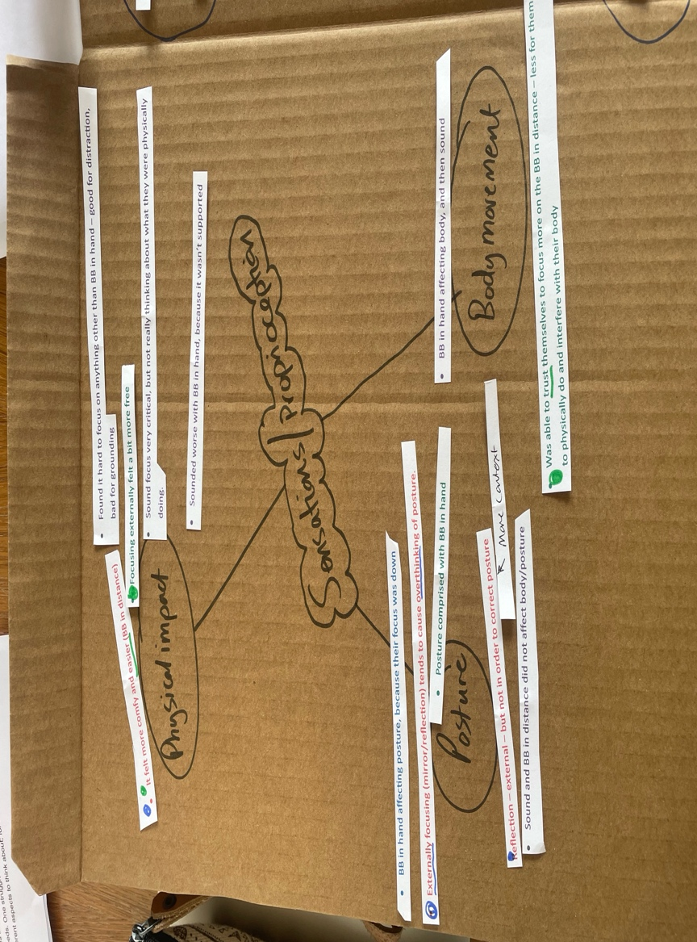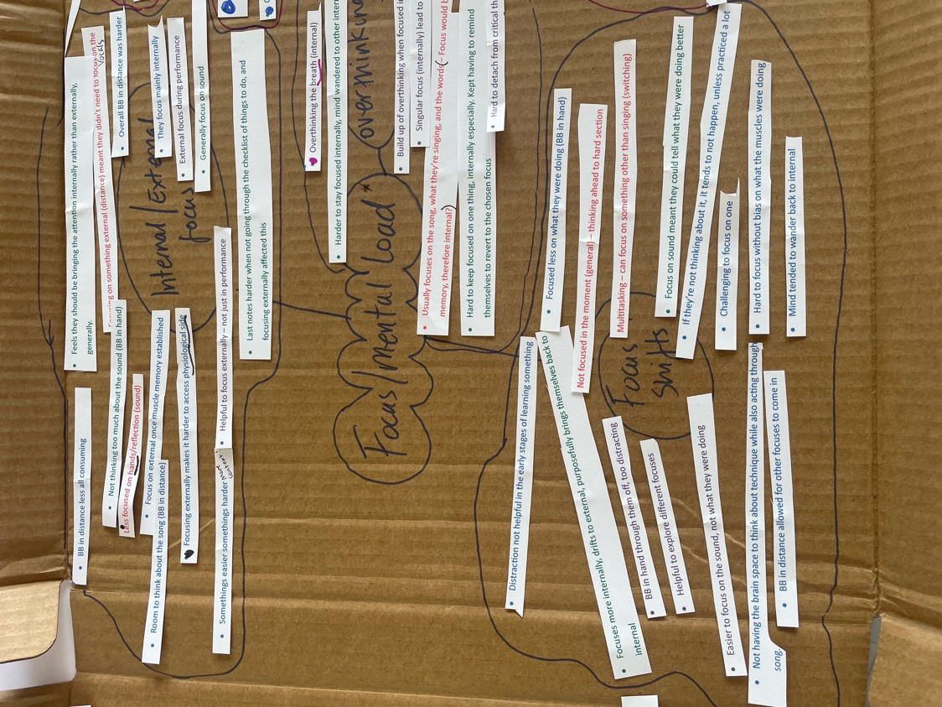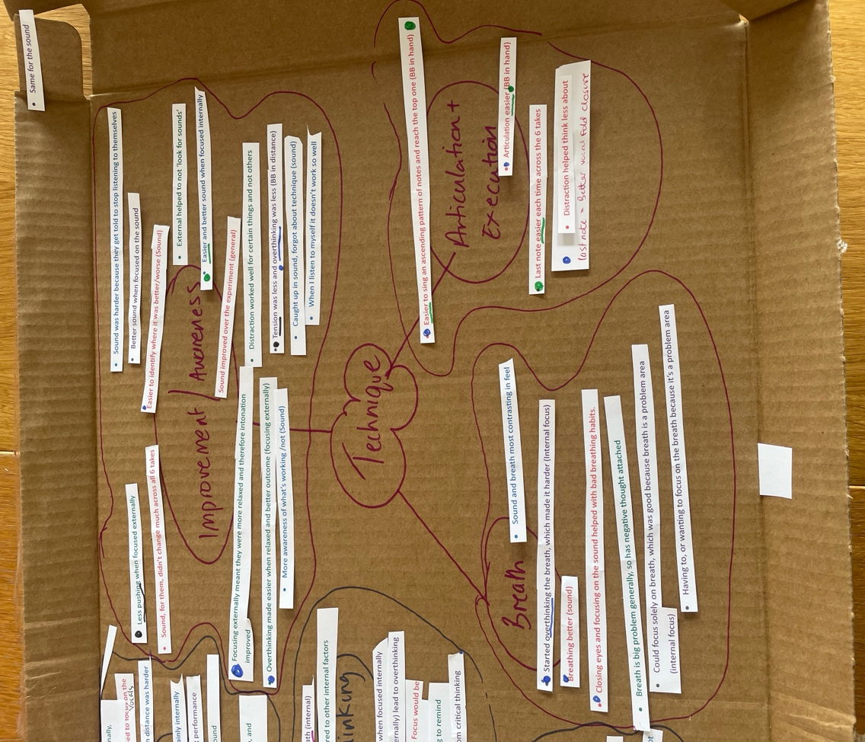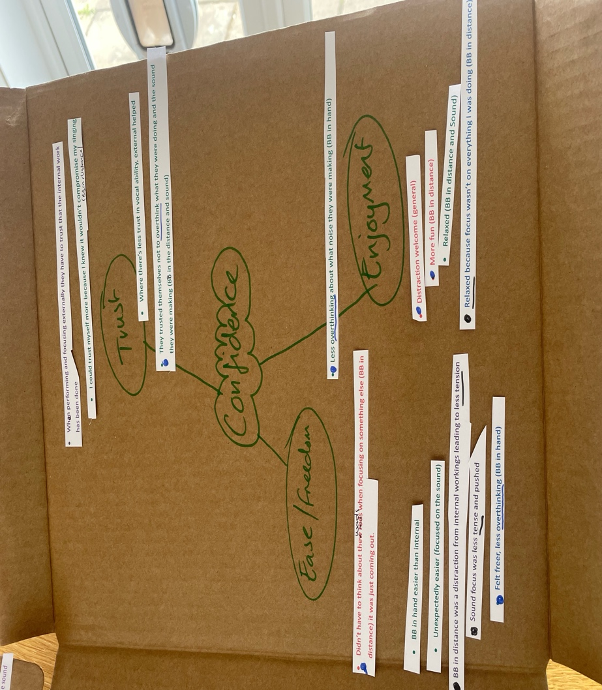

Appendix I - Post experiment interview

Where do you usually focus your attention when singing?

Thinking about what we’ve just done, how did you find switching between internal and external focus?

Thinking about what we’ve just done, was there any noticeable difference for you in the way that it felt? If so, what was different?

Thinking about what we’ve just done, was there any noticeable difference for you in the way that it sounded? If so, what was different?

Do you feel that attempting to focus on something external makes it harder to access the physiological aspect of your voice (internal)?

If yes, Do you feel like the distraction is welcome?

