

MARKETING FUNDAMENTAL

Name : Petrica Dana
Student ID -2215984
Module code -LCBB4004
Module name – Marketing Fundamental Task 2
Lecturer-Piyumika Gamage

Marketing Fundamentals External Analysis & Evaluation

Table of Contents
INTRODUCTION 1
MAIN BODY 1
Process and stages of marketing 1
Marketing environment 3
Pestle analysis 4
Porter's five forces model of Unilever 5
Recommendation 7
CONCLUSION 9
References: 10

INTRODUCTION
Change is a ongoing process it is never ending process. The firm has to make changes according to the changes made in the external and internal environment. The change has ability to impact the functioning of business so it is very important for firm to analyse change and make plan to cope up with the changes occurred. The strategies of the organisation should be flexible enough so that they can adapt change in the premises of business in order to ensure its long term growth. In the highly competitive market it helps organisation to remain competitive by competing over its competitor (Kalaignanam, and et.al., 2021). In this report Unilever company is taken into consideration. It is British multinational organisation which was established ninety four years ago in 1929. The headquarter of company is in London, England. The company deals with variety of product that are food, health care, beauty, well-being products etc. it is the known as the largest producer of soap around the global world. The report includes the concept of marketing and the process as well as stages of marketing. It provide information about the marketing environment along with this it analyse the external environment of company through different models. Later recommendation for the problems faced by company has been explained in order to sustain in the highly competitive market.

MAIN BODY

Process and stages of marketing
Marketing is a technique for promoting, distributing as well as selling the goods and services of the company to the desired consumer. It create awareness of company products and services which give insight about the existing product of company. This will create basic idea about the company products and services offered by company the marketplace. It create interaction between the company and the audience. Marketing process is a tool which helps to create value customer (Appel, and et.al., 2020). It helps organisation to interact large audience in order to consume their goods and services. It is considered as one of the concept of marketing which ensures long lasting relationship among the business and customers. It also helps to create value for the organisation as the firm understand the needs, wants and preferences of customers and develop products and services according to that. It enhance the sales of the company which increases the revenue as well as profit of the company. The process of marketing are given below: -
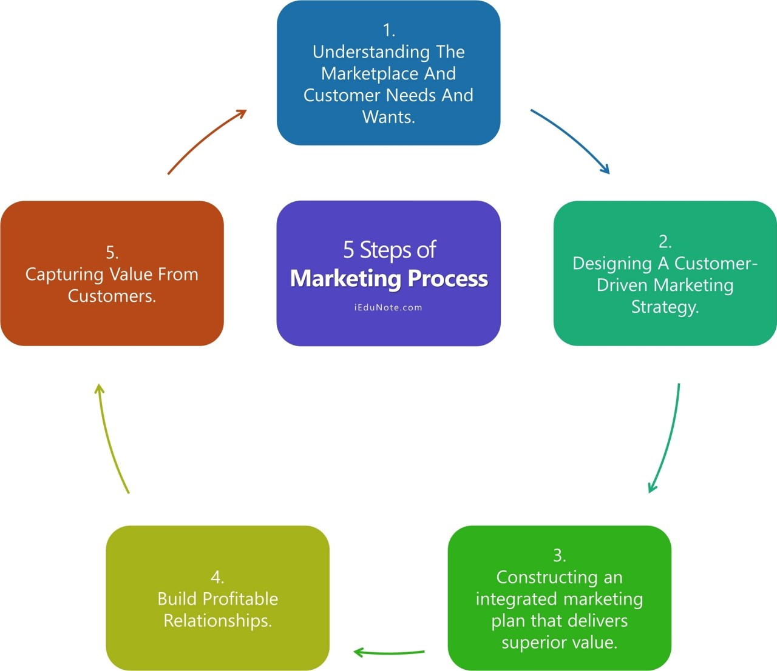
Figure 1:steps of marketing process
(Source: https://www.iedunote.com/marketing-process)

- Knowledge of customer and market: - It is important to understand the need wants and demand of the customer so that the company can gain appropriate knowledge about their customer preferences and can develop goods and services as per the trends of market (Rust, 2020) . It will help company to build appropriate strategy in order to satisfy the base of its customer and build trust among the buyers in the functioning of company.
  - Needs: - It refers to the basic needs of the consumer which are considered as necessity like food, clothing, safety, shelter and the individual needs of person. The marketer cannot created this needs as they are the basic needs which is to be fulfil or survival of human. In this the marketer focuses on developing such goods which are safe to use for the consumers. Producing safe and healthy products are the responsibility of firm.
  - Wants: - It refers to the desire of a person for consuming the goods and services of the firm. In order to attract large base of customer the firm should identify and ensure that goods and services are provided keeping in mind the preferences of consumer. The human wants can be shaped by society as well as by individual.
  - Demand: - The demand refers to the request or order given by audience in order to fulfil their desire. People demand products and services which they want to consumer and fulfilling the demand of the consumer is very important for firm in order to sustain and grow in the marketplace (Marketing Process: 5 Steps of Marketing Process 2023). It will satisfy the base of its customer and build Positive image of the company among the buyers.
- Customer oriented marketing strategy: - designing strategies in order to fulfil demand of the consumer is essential for the firm as it will help firm to perform their activities effectively and efficiently. The strategies developed by the management team will give insight to the employees for performing day to day activities. The strategies should be made by keeping focus on two main areas that are:-
  - selecting customer to serve: - In this step the firm analyse the customer of the firm and divide them in the groups as per their needs and wants. They decide the market into different segment and then serve as per the section of society (Erkin, and Muborak, 2022) . The plan their strategies as per the specific section of the target market.
  - selecting value proposition: – In this step the organization determine how to serve their customer. This include how the company differentiate themselves and position themselves in the market. The company design strong value prepositions in order to gain greatest advantage in the target market.
- Integrated marketing plan: - The marketing strategy of company outlines the information of which customer the firm will serve and how it will create value for both. After this the market will design the appropriate integrate marketing plan which will benefit the functioning of the firm and will intend value to buyers (Moorman, and et.al., 2019) . This include the set of marketing strategies which company will use in order to serve the large base of its customer. All the marketing techniques and tools will combined, it will create integrating marketing plan that provides the information and delivers the expected value of the consumers. This program builds customer good customer relationship by converting the plan and strategies made into the action.
- long term Customer relationship: - This step states the process of building and maintaining the relationship among the customer. It is very important to build appropriate customer relationship which benefits the working of the organisation. It deliver superior customer value and maintain the satisfaction level of the consumers. Building strong relationship enhances the trust of the customer on the company which enhances the share of buyers portion on purchasing of commodities and services of company. It enhances the sale of the company and assist firm to build positive image in the existing marketplace.
- Capturing value for customer: - Managing customer relationship helps to maintain and produce customer equity. The customer equity can be measured by the market share or the current sales of the firm. It is not possible for marketers to build the customer relationship by them (Arnett, Wittmann, and Hansen, 2021) . But they have to perform nearly with other department of firm and create partnership outside the organisation. The more profitability rate of customer the high the customer equity. In order to maintain relationship the company has to be good with both the the customer as well as partnership management relationship.

Marketing environment
It refers to all the internal as well as external forces of environment that create had ability to influence and drive the marketing operations of the firm (Summers, 2019) . In order to remain competitive in the market the marketer have to be aware of the marketing environment so that they can evaluate the treat and opportunities will can arise in the company. The environment of marketing is vast and diverse which consist of various controllable and uncontrollable factors that can impact the company at large extent. The management team of the company should regularly monitor the environment in order to tackle with the situation. In order to measure the competitive marketing environment of the Unilever Pestle and porters five forces of the particular company is given below: -

Pestle analysis
Pestle analysis is a tool which is used by the marketer to analyse various factors of environment which is powerful and can drive the functioning of company. The model consist of six elements that are studied by the organisation (Eierle, and et.al, 2022) . For gaining adequate knowledge about the market in which the company is operating it activities, this model is used by each and every company for the purpose of achieving the predetermined goal and objective of firm. This model is used by the marketer in different scenarios which aids them to build strategic plans which enhances the ability of firm to perform better in the market. The six elements of the model are describes below: -
- Political Factor: - This refers to the factors which is influenced due to alteration or change in the policies, rules and norms of the government. The trade laws imposed by the government and the restriction regarding import and export creates impact of the company which hinders the success of the company. The stability of the government is the factor which creates positive impact on the working of Unilever company. As change in the government leads to new an alteration in the policies and rules of the government which can create impact on the company so political stability of united kingdom is one of the positive factor which help company to grow in the market.
- Economical Factor: - This refers to those factors which influence the company growth due to decrease in the sale of the company. The increase in the wages rate in the country creates impact on the company as it increase the expenses of the company (Vardopoulos and et.al., 2021) . Increase in the expenses will impact the marketing strategies of company due to need of investment. on the other hand high growth rate of developing country creates positive impact on the Unilever as the nation grow in terms of consumer goods. This will assist company to gain height and grown in the existing marketplace.
- Sociological Factor: - It refers to the trends, norms and preferences of society which has ability to impact the company both positively as well as negatively. The company Unilever provides goods and services to consumer which ensures that the products are safe to use. This factor attract large number of consumer towards consuming the goods ns services of the particular company (Phan, 2021). It creates positive image of the company in the market which enhances the sale and revenue of company. This will positively impact the marketing department of company as they can attract large number of customer.
- Technological Factor: - It refers to availability well as unavailability of of technology which creates impact on the functioning of business both positive and negative. In context to Unilever, the company is using new techniques which helps them to remain competitive in the market. It enhances the ability of company to provide innovative goods to its customer which satisfies the base of customer and interact targeted audience towards company. Investment in technology enhances the production of the company and also provide assistance to the marketing department to interact large audience it will automatically increases the sale of company.
- Environmental Factor: - It refers to those factor which drives the atmosphere of the company. The use of sustainability and renewable resources by the Unilever creates positive impact on the brand image of company. The products of the particular company are designed in such a way that they are safe for the consumers (Grassi and Vallati, 2019). The material used are eco-friendly and doesn't harm the environment. The company is also following the environmental laws imposed by the government which creates positive impact on the company.
- Legal Factor: - It refers to those factor which creates impact on the company due to laws imposed by the community in the country. In context to Unilever, the company is operating in many countries so they need to take care of many laws and regulations. The company has to follow the laws related to the employees health and safety which creates impact on the company as they have to alter their plan and train workforce.

Porter's five forces model of Unilever
The Porter's model is a management tool used by organisations to understand the influence of external factors prevailing in their external environment (Gray, 2021). The organisations must consider the issues related to the five forces in order to ensure its long-term success. The organisational strengths and market position of Unilever are capable of addressing these forces. The Unilever competes in in a global market of consumer goods. The five forces analysis will be helpful in identifying the need to strategically prioritise the bargaining power of consumers and the competition in the industry environment. The external factors of these forces of the company have a direct impact on its financial performance. Here is the Porter's five forces analysis of Unilever:-
- Competitive rivalry: The competition is a major force in the industry Unilever is operating. This force of competitors is strong because of the factors such as high number of firms, low switching costs and high level of aggressiveness of the firms. There are a lot of well established firms operating in the industry of consumer goods. This imposes a strong force on the Unilever (Anastasiu, Gavriş and Maier, 2020) . These firms are aggressive which further increases the intensity of competition. Another factor making the force strong is that it is easy for consumers to switch from the firm to another.
- Bargaining power of customers: The industry environment of Unilever is based on the response customers provide to its products. The low switching cost, high quality of information and small size of the individual buyers are the factors that makes this force strong for Unilever. The consumers have an access to the information regarding consumer goods which makes it easy for them to decide when to switch from Unilever's products to other company's products. The small size of individual customers do not have that big impact on the profits of Unilever. The major contribution towards the strong force of consumers' bargaining power is by two factors that are high quality information and low cost of switching.
- Bargaining power of suppliers: The suppliers also have a major impact on the operations of every organisation (Helmold, Samara and Helmold, 2019). It also affects Unilever by affecting the supply level available to the company. It is a moderate force for Unilever. The overall supply, size of individual suppliers and the population of suppliers, all are moderate which makes this force moderate for Unilever. The company has large number of suppliers but the size of average supplier is moderate. The population of suppliers is also moderate which enables them to put a limited but significant impact on Unilever.
- Threat of substitutes: The substitutes has the power to reduce the revenue of Unilever. The low availability of substitutes and the low ratio of performance to price of substitutes are the weak forces which makes the overall power of this force of substitutes weak for Unilever. For instance, it is easy for customers to access close-up toothpaste of Unilever than its substitute home-made organic dentifrice (Yu and et.al., 2023). This makes the threat of substitutes low for Unilever. The substitutes of Unilever's products have low performance with minimal cost difference which makes the products of Unilever even more attractive to the buyers.
- Threat of new entrants: - The threat of new entrance is low as the company deals in various countries globally. It will be difficult for the other firm to compete with the company as it requires large percentage of capital. In order to compete with Unilever the new firm will require new and innovative technology this is risky for the other firms to invest huge amount on technology. Along with this the brand image of the Unilever is good which has build the trust of customer so the buyers will to purchase the product of the particular company rather than other companies.

Recommendation
- To avoid the fraud done by other company and safe the patents and copyrights the company needs to develop a separate department which will keep eye on the rules ans laws. It will ensure that the working of company doesn't impact due to any misconduct. It will provide desired information to the customer and will create awareness about the legalities and process of company.
- The company should develop the strategies in order to create awareness among the customer related to rising health consequences (de Ruyter, and et.al., 2022). It will create good impact on the consumer related to company which interact large number of audience towards the firm.
- The company Unilever should focus on improving the sustainability program which will provide various opportunity to the company for sustainability of business (Bolton, 2022) .
- The company should provide training to the employees on regular bases it will assist firm the production capacity of the company.
- The company should use raw material for which will assist company to produces goods on low cost it will increase the profit margin of the firm.
- Appropriate strategises should be planned by the manager in order to create knowledge among the employees for using the technology in the right way as it will eliminates the chances of accident in the company.
- The manager should provide discounts to the the users and give various offers which will impact large number of customers towards the company. They can use the discount of by one get one, 50 % discount on the some products, one two get on on the costly items of company.
- Te company should expand their areas of distribution by expanding their networking this will available the goods of company at the various areas which will enhance the sale of company.
- The company should focus on maintaining good relation with the countries by hiring the workers of their country (Mehralian, Mohammad Mehdi and Parinaz Khazaee, 2022) . The company should follow the rules and regulations of the other countries and pay taxes on time this will create good relationship of the company with the other countries government.
- The should hire talented workers in the company which will require less number of staff in the company as talented workforce work in such a way that it benefits the company and decrease their expenses which enhance the profit of organisation.
- The manager should use influencer marketing strategy it will build positive impact on the company sale as the fans of influencer trust on the company products. It will attract large number of audience to consume the products of the company.
- The company should remain active on social media by positing regular content on the sites. Along with this they should create attractive pages on the internet it will attract the customer. This reminds people about the joy and happiness they aim to provide to their company.

CONCLUSION
From the above report it can be concluded that it is very important for firm to make alteration in the premises of company as per the change occurred in the external environment of business. The firm should regularly monitor the environment of business In order to make changes in the strategies and technique for effectively performing various functions of business. It assist firm to identify opportunities and threat which might impact the working of company and can make changes in business activity to remain competitive highly competitive market and earn strong position in the particular industry. The analysis done by the manager of the company will assist company to alter and modify their strategies which will improve their ability to compete in the market. The above report covers introduction about marketing and its importance for effectively performing the activities of business. Along with this it explains various stages a of marketing. Further it describes the marketing environment and proper analysis of the company external environment is done through PESTLE analysis and porters five forces model. Later it gives recommendation to the company about the problem faced by them in performing the activities of business.

References:
Books and Journals
Anastasiu, L., Gavriş, O. and Maier, D., 2020. Is human capital ready for change? A strategic approach adapting Porter’s five forces to human resources. Sustainability, 12(6), p.2300.
Appel, and et.al., 2020. The future of social media in marketing. Journal of the Academy of Marketing science, 48(1), pp.79-95.
Arnett, D.B., Wittmann, C.M. and Hansen, J.D., 2021. A process model of tacit knowledge transfer between sales and marketing. Industrial Marketing Management, 93, pp.259-269.
Bolton, R.N., 2022. The convergence of sustainability and marketing: Transforming marketing to respond to a new world. Australasian Marketing Journal, 30(2), pp.107-112.
de Ruyter, and et.al., 2022. Reimagining marketing strategy: driving the debate on grand challenges. Journal of the Academy of Marketing Science, 50(1), pp.13-21.
Eierle, and et.al, 2022. External factors and the pricing of audit services: A systematic review of the archival literature using a PESTLE analysis. Auditing: A Journal of Practice & Theory, 41(3), pp.95-119.
Erkin, G. and Muborak, R., 2022. Modern marketing concept. Web of Scientist: International Scientific Research Journal, 3(8), pp.60-66.
Grassi, A. and Vallati, M., 2019, May. AI to Facilitate Legal Analysis in the PESTLE Context. In Proceedings of the 2019 Emerging Technology Conference. University of Huddersfield.
Gray, D., 2021. What makes successful frameworks rise above the rest. MIT Sloan Management Review, 62(4), pp.1-6.
Helmold, M., Samara, W. and Helmold, M., 2019. Tools in PM. Progress in Performance Management: Industry Insights and Case Studies on Principles, Application Tools, and Practice, pp.111-122.
Kalaignanam, and et.al., 2021. Marketing agility: The concept, antecedents, and a research agenda. Journal of Marketing, 85(1), pp.35-58.
Mehralian, Mohammad Mehdi, and Parinaz Khazaee., 2022 "Investigating the Interrelationships between Digital Marketing and Marketing Intelligence and Their Effect on Business Strategy." In 16th International Conference on Management and Marketing Intelligence, Economics and Finance (2022). 2022.
Moorman, and et.al., 2019. Challenging the boundaries of marketing. Journal of Marketing, 83(5), pp.1-4.
Phan, S., 2021. The effect of PESTLE factors on development of e-commerce. International Journal of Data and Network Science, 5(1), pp.37-42.
Rust, R.T., 2020. The future of marketing. International Journal of Research in Marketing, 37(1), pp.15-26.
Summers, J.O., 2019. Guidelines for conducting research and publishing in marketing: From conceptualization through the review process. In How to Get Published in the Best Marketing Journals. Edward Elgar Publishing.
Vardopoulos, and et.al., 2021. An integrated SWOT-PESTLE-AHP model assessing sustainability in adaptive reuse projects. Applied Sciences, 11(15), p.7134.
Yu, and et.al., 2023. Resilience of Symphony Orchestras to Challenges in the COVID-19 Era: Analyzing the Hong Kong Philharmonic Orchestra With Porter's Five Force Model. In Handbook of Research on Entrepreneurship and Organizational Resilience During Unprecedented Times (pp. 586-601). IGI Global.
ONLINE
Marketing Process: 5 Steps of Marketing Process 2023. [Online] Available through: <Marketing Process: 5 Steps of Marketing Process 2023. >./

