Michael Leather
Level 6 Undergraduate
BA International Development and Global Politics

What are the main differences between linear and cyclical approaches to economic activity? Can a changeover from mainly linear to mainly cyclical be achieved by economic incentives and, if so, which types of incentive would you propose?
Introduction to Linear and Circular Economics.
Examining the difference of the two geometric forms of economics would be better served by first understanding what the characteristics of each one are. In its simplest terms, linear economy is described by Furkan Sariati as ‘Take -make-dispose’, where using the resources you need, the market produces the products to be sold at a profit whilst disposing of everything superficial to that process including the product at the end of its lifecycle, which can occur naturally or be engineered into the product to maximise profit, (Sariati, 2017, p.32).
Sariati’s explanation of circular economy is not particularly as well defined as the former. He refers to it as conceptual and gives more historical facts on its emergence. A more direct explanation comes from a report by the Ellen Macarthur Foundation that describes it as an industrial based approach on three principles. Firstly, it designs out waste ensuring that the product is designed for disassembly and reuse. Secondly, Is the principle that distinguishes between the consumability of the product from the durability of the products parts, all encompassed in a system described as ‘Circularity’, which embeds the reduced waste of the first principle. Thirdly, is the use of renewable energy in the industrial process to fuel this cycle which should be renewable by nature and would reduce the use of material resource. This would increase the process’s ability to produce due more efficiently and not being dependant on the volatility of resource availability thereby replacing consumption with usage, (Macarthur, 2013, p.8).
What’s So Wrong with a Linear Economy?
Linear economics hasn’t become a pariah overnight; it has always been wrong. It is only since the realisation that it is at the expense of a future for the living planet that it has come to the fore and alternatives have been sought. An 18th century political economist Sir James Steuart summed up Economics with his much maligned, (at the time), descriptor of political economy which encompasses the principles of circular economy when he wrote:
The principle object of this science is to secure a certain fund of subsistence for all the inhabitants, to obviate every circumstance which may render it precarious; to provide everything necessary for supplying the wants of the society, and to employ the inhabitants (supposing them to be freemen) in such a manner as naturally to create reciprocal relations and dependencies between them, so as to make their several interests lead them to supply one another with their reciprocal wants, (Steuart, 1767, p.3).
However, since the Industrial Revolution, that definition, which encompasses the circular notion, has been ignored and a linear focus has taken its place. From Adam Smith’s theory of economics in his book Wealth of Nations which advocates among other things, a free market, to Keynesian economics, which called for more government intervention, the whole approach to Economics has been growth. The ability to trade and expand the economy through use of the resources by the manipulation of the factors affecting economy, i.e. Land, Labour and Capital, has only been possible for those with the means and enterprise to do so. The successful development of factories, mining and mass production of food and products for profit has largely been concentrated in developed western countries and by a handful of entrepreneurs. H William Batt (2016, p.346), states that the earth should be seen as a common resource for the benefit of all and that these common areas became exploited by a few which forced the labour to move into urban areas because that was where the majority of production was taking place and as well as the landowners starting to rent out parcels of land for profit. In more modern times, the demographics of various populations are now shifting from traditional high density populated industrial nations to emerging markets (Sariati, 2017, p.32). The control was not solely focused on land grabbing. Other natural resources that were seen as commons became subject to privatisation such as lumber, coal, oil and even water. Modern times have led to many more elements being subject to exploitation through privatisation and profit. As global markets expanded, it is the developing nations that have been exploited by western investment and resource extraction.
The Linear approach was endorsed as the way in the 1960’s when an American economist Walt Rostow advocated the 5 stages of growth in ‘The Stages of Economic Growth: A Non-Communist Manifesto’, to be followed if the developing nations during this period wanted to emulate the booming US economy at the time. This theory has an analogy of an aircraft flight with the points referring to preconditions for take-off, and the take-off itself. The problem with this linear model, which is most eloquently summed up by Kate Raworth in her circular economic theory ‘Doughnut Economics’, is that the plane does not land but continues into the sunset of consumerism (Raworth, 2022, p.249). Rostow’s final point for economic success is ‘The Age of Mass Consumption’, a theory that gives no consideration for distribution and welfare of labour or a ceiling at which growth is complete. Note in figure 1 it is the developed countries that are producing the most waste from mass consumption.
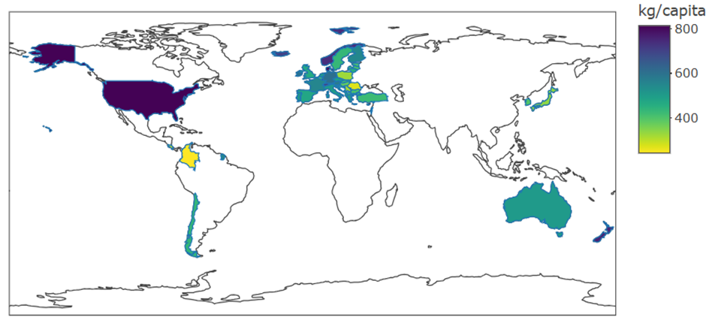
Figure 1. Municipal Waste Generated (2018) per capita. Source: (Materialflows.net,2018).
In an effort to keep pace with the western worlds’ mantra, developing countries that were becoming independent from their colonial masters looked to the World Bank and other western investors to advance their own growth in an effort to emulate and keep pace with the West. Research indicates that there are currently 2,781 billionaires on the planet, where all but 3 of the top 20 are American, worth collectively $14.2 trillion. Much of the gains have come from the top 20, who added a combined $700 billion in wealth since 2023, (Forbes Media, 2024). These few people account for 12-13% of the world’s Gross National Product, (GDP). It is this 12-13% that are constantly in pursuit of growth in an American-led Linear model.
The World Bank is a developed world’s institution that is controlled by its shareholders who are the member states and private venture capitalists. Its purpose is to loan money to its shareholders but then charges them interest! A lot of the money is invested from the private sector to fund developing nation’s initiatives, (World Bank, 2024). The process is being undermined as a development tool by the aforementioned dominant players in these partnerships as they are powerful western corporations and foundations whose “rhetoric and promises of partnerships fail to effectively democratise global governance or act as the silver bullet for the everyday plights of exploited children, women and workers” (Gregoratti, 2014, p.319), with only growth in mind. It leaves the developing nations in a position where they cannot repay the debt because their growth never comes in line with the developed nations. Evidence of this was seen in the city of Cochabamba in Bolivia in the 1990’s where the water system was privatised at the insistence of the World Bank to enable Cochabamba authorities to settle a debt, (Batt, 2016, p.350).
The following link allows access to the International Monetary Fund database which will show you the ratio or percentage of each countries national debt in relation to their GDP. Note that the countries that exceed 100% and are still rising under this linear approach are the developed nations thereby posing the question, “Are their economies working?”
https://www.imf.org/external/datamapper/GGXWDG_NGDP@WEO/OEMDC/ADVEC/WEOWORLD.
Looking at the linear approach, the World Wildlife Fund, (WWF), states in a report that “This approach has exhausted the planet’s resources to a point where it will no longer be able to deliver” (WWF,2012, p.100). The report focuses on an ecological calculator measuring population, land use, land productivity, energy use, diet and climate change and concludes, “If the economics continue as they currently are, humanity will need the resources of the equivalent of 2.9 planets to support the ‘business as usual’ assumptions”, (WWF,2012, p.100). A report from NASA by Johan Rostrom and many of his eminent cohort members support this overreach and identified nine planetary boundaries within which humanity should be expected to operate in if that is to be avoided (Rostrom, et al, 2009). Six years on these boundaries are assessed by Will Steffen, (one of Rostrom’s original cohorts), in 2015 and concluded that humanity had already exceeded 4 of those boundaries, see figure 2 (Steffen, 2015).
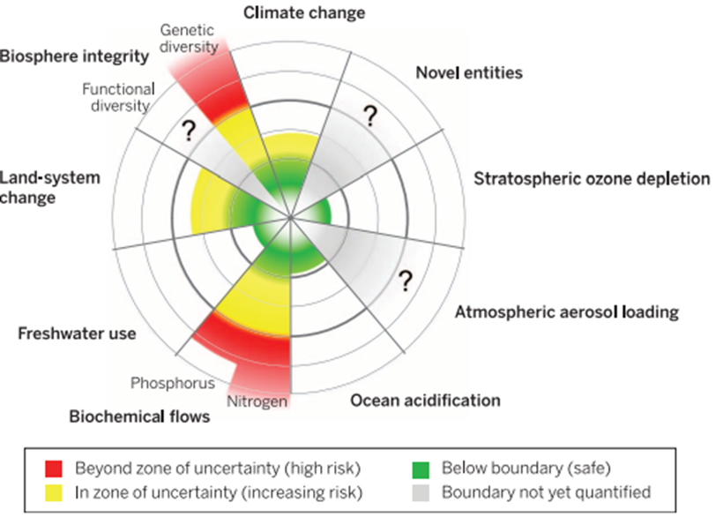
Figure 2. Current status of the control variables for seven of the planetary boundaries. (Source: Steffen et al, 2015)
The Ellen Macarthur Foundation (2013) estimates the waste generated by countries who subscribe to the Organisation for Economic Co-operation and Development (OECD), of which there are only 38 member countries, all of which can be classified as developed nations,
Consume over 21 billion tonnes of materials that aren’t physically incorporated into the products themselves (i.e., materials that never enter the economic system – such as overburden and parting materials from mining, by catch from fishing, wood and agricultural harvesting losses, as well as soil excavation and dredged materials from construction activities (Macarthur, 2013, p.15)
And goes on to say that
Some 65 billion tonnes of raw materials entered the global economic system in 2010 – a figure expected to grow to about 82 billion tonnes in 2020 (Macarthur, 2013, p.15)
And
In Europe, 2.7 billion tonnes of waste was generated in 2010, but only about 40% of that was reused, recycled or composted and digested (Macarthur, 2013, p.15).
Further evidence in the inability of the linear approach to function properly can be found in the number and frequency of financial disasters and recessions that have happened over an extensive period around the globe under the linear model. A website called World Finance, which is an online magazine which has an audience of finance professionals and corporate and private investors, (the very people who perpetuate growth), lists the worst ten financial disasters and states that the only certain thing is that it will happen again, (World Finance, 2024). A quote from Jamie Dimon, the CEO of JP Chase summed it up when he said, “My daughter asked me when she came home from school, “What’s the financial crisis?” and I said, it’s something that happens every five to seven years”, (Ozili, 2021). A Linear economy is too volatile with its scarcity of resource and fluctuating pricing levels to be sustainable.
Are There Benefits of A Circular Economy?
A circular approach has to be restorative through the three principles referred to in the Ellen Macarthur report (2013) by introducing systems that distinguish between consumption and use of materials in the areas of both biological and technical nutrients to the process. The biological elements are non-toxic and therefore compostable, and the technical elements of a production process be designed to reduce or eradicate waste and make them reusable whilst using the minimal amount of energy (Macarthur, 2013, p.22-24).
Two examples of industries that have or would benefit from a circular approach are the construction industry and telecommunications. An initiative in Riverdale, USA where a case study into the benefits of the deconstruction of old housing as apposed to demolition on behalf of the American Environment Protection Agency was undertaken. In the executive summary of that report it found that 76% of materials were diverted from landfill, saving considerable costs at only an increase of forty cents per square foot and an increase in labour market potential (Lifecycle Building, 1997, p.5 of 55). Japan, Kajima Construction Company has developed a deconstruction technique that has achieved the recycling of 99% of its steel and concrete, 92% of that from its buildings (Macarthur, 2013, p.37). In the telecommunications field there is still a huge potential for a move to circular. The Macarthur Foundation report estimates that there were 1.6 billion mobile phones entering the market in 2010 and in predominantly developed markets the lifecycle usage time of these was 2.5 years with projection of growth of this market in the developing nations (Macarthur, 2013, p.37). The report goes on to highlight that in Europe alone there were 160 million phones that were discarded but not recycled and whilst the waste tonnage is low, the average weight of a mobile phone is 150g, the phones are embedded with valuable metals like gold, silver and other rare earth metals that have to be mined invariably in developing nations and are lost. This has been estimated as a loss of $500 million annually, as only 6% of these phones find their way onto the secondary phone market (Macarthur, 2013, p.37) The benefits of a more circular approach are clear.
Can You incentivise towards a Circular Economy?
Achieving a circular economy would not be easy as attitudes towards growth, greed and fear would have to be overcome. I would argue that the problem is systemic and thereby the only incentive that can be offered is acceptance that failure to embrace the change is condemning the current linear approach to environmental and societal collapse. An option would be returning the control of what are known as commons. These are natural elements that are distinguished between those made naturally and those made by man. These are the birthright of all humanity such as water and land but when given market value, are taken up by private economic interests of the 12-13% of the most rapacious elements of society, (Batt, 2016, P.350-354).
One of these ‘commons’, land, has been a source of a huge increase in wealth by those that speculated and a thorn in the side of indigenous people who were forced into migration and relocation. Batt argues that a way to redress this s freehold title could not be revoked is to devise a taxation system that addresses land value increases which in turn sets out rent limits and reduces the taxation on Labour and Capital. He further argues that these rent limits which are affected by land values are a construct of the community’s vitality and not one site’s activity thereby should fund the local needs through tax, (Batt, 2016, p.354-358). These taxes cannot be seen as incentives on any level but that is not to say they should not be introduced.
Efforts are being made to create circular economies by keeping the circle tight thereby returning the materials and capital back to the source: the smaller the circle the quicker it happens. This has been applied to the commoning of capital as reviewed by Cato and North in their article about common ownership where they address the part of capital: Money, (Cato & North, 2014, p.39-41). They evaluate how money can be exchanged for other things without being affected by the power of the capitalist economy, because they argue that “it is precisely the location of the power to create finance that will enable or retard if not destroy any attempt to create an economy based on common ownership”, (Cato: North, 2016, p.39) and creating a currency that allows trade without the need to have anything to do with the sphere of state influence has a chance of creating a sustainable circular economy based on commons, (ibid, p.40). Examples of limited successes in this area can be found amongst other places, in Bristol, UK with the creation of the Bristol pound and in Brazil where they have set up a local bank called Banco Palmas. The difficulty with these and other schemes is that they have to compete with powerful national currencies. The Bristol pound ceased existence in 2023.
Where Next?
The Macarthur Foundation acknowledge that the transformation to a circular economy will be messy and holds significant barriers. The biggest of these is that economies are entrenched in the linear model with a plethora of contracts and regulations that need to be overcome to change the mindsets. However, these mindsets are getting weaker as pressure is applied through tighter environmental standards and a scarcity of the resources required to maintain the linear flow. Alongside this, our information technology is feeding a shift that is fuelled by consumer reaction (Macarthur, 2013, p.78).
The Ellen Macarthur Foundation report titled ‘Towards A Circular Economy’ was published in 2013 and set out a road map towards 2025 when they anticipated the mainstream phase to a circular economy would commence. Further research needs to be carried out to identify where, the world is on that road map.
Word Count with References, Student Title Block and Essay Question 2716 Words

References
Batt, H. William. “Saving the Commons in an Age of Plunder.” The American Journal of Economics and Sociology, vol. 75, no. 2, 2016, pp. 346–71. JSTOR, http://www.jstor.org/stable/43818693 . Accessed 16th Dec. 2024.
Cato, M. S. & North, P., (2016), Rethinking the Factors of Production for a World of Common Ownership and Sustainability: Europe and Latin America Compared, Review of Radical Political Economics Vol 48, Issue 1, p 36-52, Available at: https://doi-org.ezproxy.uwtsd.ac.uk/10.1177/0486613415586981 (Accessed 18th Dec 2024).
Ellen Macarthur Foundation, (2013), Towards The Circular Economy, Vol 1, Available at: https://emf.thirdlight.com/file/24/xTyQj3oxiYNMO1xTFs9xT5LF3C/Towards%20the%20circular%20economy%20Vol%201%3A%20an%20economic%20and%20business%20rationale%20for%20an%20accelerated%20transition.pdf (Accessed 12th Dec 2024).
Forbes Media LLC, (2024), The Richest In 2024, Available at: https://www.forbes.com/billionaires/ (Accessed 16th Dec 2024).
Gregoratti, C., (2014), UN Business Partnerships, Ch 22, Weiss, T.G. and Wilkinson, R., (ed), International Organisation And Global Governance, New York and London, Routledge Taylor Francis Group.
Lifecycle Building .org, (1997), Deconstruction - Building Disassembly and Material Salvage:
The Riverdale Case Study, Available at: https://lifecyclebuilding.org/docs/Riverdale%20Case%20Study.pdf (Accessed 18th Dec 2024).

Ozili, P. K., (2021), 100 Quotes from the Global Financial Crisis: Lessons for the future, Available at:
file:///C:/Users/mleat/OneDrive/Desktop/Ozili100QuotableQuotesfromthegreatestfinancialcrisisofalltime.pdf (Accessed 17th Dec 2024).

Raworth, K., (2022), Doughnut Economics: Seven Ways to Think Like A 21st Century Economist, 2nd Ed, UK, Penguin Random House.

Rostrom, J., et al, Planetary Boundaries: Exploring the Safe Operating Space for Humanity, Ecology and Society 14(2), Available at:
https://pubs.giss.nasa.gov/docs/2009/2009_Rockstrom_ro06010m.pdf (Accessed 16th Dec 2024).

Sariati, F., (2017), Linear Economy Versus Circular Economy: A Comparative and Analyzer Study for Optimization of Economy for Sustainability, Visegrad Journal on Bioeconomy and Sustainable Development, Volume 6 (2017): Issue 1, Available at: file:///C:/Users/mleat/OneDrive/Desktop/Linear-Economy-Versus-Circular-Economy-A-Comparative-and-Analyzer-Study-for-Optimization-of-Economy-for-Sustainability.pdf (Accessed 12th Dec 2024).

Steuart, J. B., Sir, (1767), An Inquiry into the Principles of Political Oeconomy (Vol. 1 of 2), Available at: https://www.gutenberg.org/cache/epub/60411/pg60411-images.html (Accessed 15th Dec 2024).

World Finance, (2024),
The top ten great financial crises, Available at: https://www.worldfinance.com/special-reports/the-top-ten-great-financial-crises (Accessed 17th Dec 2024).

World Wildlife Fund, (2012), Living Planet Report 2012: Biodiversity, Biocapacity and Better Choices, Available at: https://files.worldwildlife.org/wwfcmsprod/files/Publication/file/5bd0cghy29_Living_Planet_Report_2012_Biodiversity__biocapacity_and_better_choices.pdf (Accessed 16th Dec 2024).

Figures

Materialflows.net, (2018), Circular Economy: Data Indicators, Available at: https://www.materialflows.net/circularity/ (Accessed 16th Dec 2024).

Steffan, W., et al, (2015), Planetary boundaries: Guiding human development on a changing planet, Science, Vol 347, Issue 6223, Available at: https://www.science.org/doi/pdf/10.1126/science.1259855 (Accessed 16th Dec 2024).

