University of Wales Trinity Saint David

Accademic and Employability Skills BMSW 4001
Lecturer :Nadeem Mirza
Student: Galina Cavcaliuc
Student ID: 1916729

Reflection Essay

Introduction

After completing my second semester in Trinity Saint David CertHE T2GW1 at the University of Wales, I managed to benefit from the course of the second semester, and also to consolidate what I already knew, I just needed to focus.
With great difficulty, I gave a lecture on time management. I am a big waste of time and on this lecture I confirmed this. But I found a solution to my problem. I learned of the important details that is responsible for our upcoming actions. Just imagine, I wake up at 9 in the morning, prepare breakfast for the children, then the rest of the household chores, until 7 in the evening. Then comes my husband, he stays with children, at this time I go to bed, because at 9:30 pm I go to work. My shift is from 10-6 in the morning. Suddenly I fell asleep and wake up not at 8:30, but at 9:30 in the evening, I was 20 minutes late, now I will finish work at 6:20. At this time, my husband will go to work and I risk that my children will be left alone at home. The conclusion from this is that everyone should distribute their affairs with precision in time , so as not to create discomfort for others. Otherwise, you will become irresponsible and frivolous in their eyes. I realized that while at home, I can't think of anything else, because when I was in my house I usually spent time preparing food, cleaning which I don't think is realistic. I decided to stop postponing for later, now I can do it with the ability.
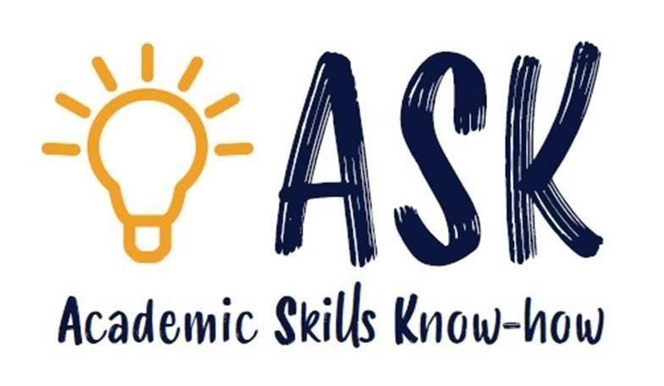
I like learning tactics and working in a group. When I pass on my ideas to the group, trying to balance the ideas of others so that the group can come to a common solution. It is very cognitive that it can be beneficial to me regardless of career . I choose, because the ability to control the situation while maintaining diplomacy with colleagues is a valuable asset. Apart from this, I cannot remember any other power that I discovered. I don't consider myself selfish, but honestly, I'm very happy with who I am and it's hard for me to think about strengths that I don't already have.
The highlight for me will be the creative part of the research work. I really enjoy expressing myself in creativity more than in any other medium, so it was fun to take my thoughts and feelings and turn them into a painting.

As for other points and ideas, I can't think of anything. To be honest, this tutorial gave me new opportunities and ideas for time management. Through meticulous classroom work and teacher support, I discovered a method of time management. Now I began to take notes in a notebook so as not to forget important things, I got my sight and understood: I need to learn to take care of society, because I like it or not. I myself am part of it. And I understand that if this "social flaw" of mine does not disappear by the time I make a career, I may have problems, especially if I work with people most of the time.

Another lecture, Power Point, was very important to me. PowerPoint is a presentation software developed by Microsoft. It is used to create business presentations and can also be used for educational or informal purposes. The work consists of slides that include text, images, and other media such as audio clips and movies. You can add sound effects to make your presentation more engaging. Do not forget about the important, use in moderation rather irritates the audience than grabs their attention. PowerPoint presentations are created as a template that includes background color or image font. Modifications to a template can be saved in a “master slide” where the main theme of the slides is. When you make a modification to a master slide, the rest of the slides are modified as well. This will make your slides look the same in your presentation. For me it was a great experience in managing the program. With gratitude to the university, I want to say that the lecture on Power Point Presentation helped me. It is very interesting and also requires creative thinking and many different ideas when creating a slide with a cover design. Overall, I am very pleased with this lecture. Just recently, I realized an important thing: in each lesson we discuss topics that are used on a daily basis.
We studied a lot in the second semester, during which we explored many things that apply in everyday life. For example, a resume (week 2, semester 2) is a short, written description of your education, qualifications, previous job, and sometimes your personal interests that you send to your employer when you try to apply for a job. Before researching this topic, it seemed to me that a resume was a simple format for presenting yourself in front of a donation robot, but alas, I was disappointed. I found that a cover letter was attached to the resume sent - a letter containing information on the topic. Without it, your resume loses its strength and effectiveness. For myself, I have identified several rules for writing a resume.*the 'profile' section: a short section presenting you, including date of birth, address, and whether or not you have a driving licence and a vehicle;

Academic writing requires a style that differs from other forms of written communication. Using this letter is not only about using the right words; it is important to present your ideas and arguments in an accessible and reasonable way. Mastering the style is one of the first steps on the road to quality writing at university. Practice is part of development like problem solving and analytical skills, effective communication, and creativity and innovation. This style consists of core skills such as academic writing, presentation skills and abstracting, which underlie more complex skills such as critical thinking and reflective practice.
As such, I am aware of the importance of academic skills, not only for the success of my program of study, but also after I leave Trinity St. David University of Wales as I am looking for a graduate job. Therefore, developing and practicing these skills while studying will better prepare me for work. I had some difficulty with Summarizing in Week 6, Semester 2, a very unusual method, but very important. From a professional point of view, accuracy must be present and even, when speaking, one must not forget what we are saying and how clearly we express our thoughts.In this lectures I hand mention for me that we are summarize to report a ideas or work of another writer in our own work. Summaries should be short and significantly shorter.
Than the work itself. If the resume is large, you can rephrase the work rather than summarize. If it is too short, then important points have been missed. Generally, the length of a resume should be between a quarter and one third of the total length.
Summary article. For example, if you are summarizing an essay consisting of three
pages, the resume should be approximately three-quarters to one full page). I remember a teacher telling us about some tips from a resume writer in a way that would help:
* keyideas
* notes
*logical order
* ideas

What you have to know about Summarizing ?
- Read and understanding
*without personal iddea
- Autor’s details and sources

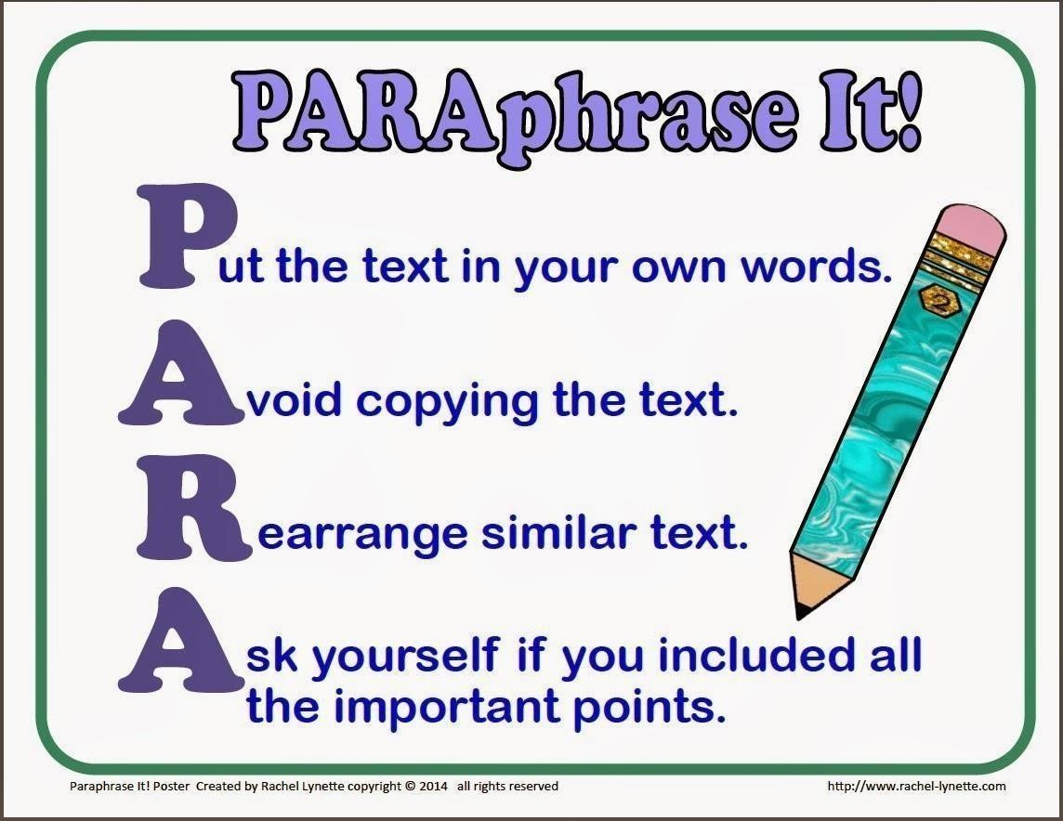
One of the rules is to use the present tense to discuss essays and facts from it, direct
quotes or examples to support your claims. The second rule is that paraphrasing should be more than quoting, as well as minimized. Third, it should be used only in a unique language, so as not to be paraphrased.
In this case, always capitalize the name and enclose it in quotation marks. Don't use italics. Italics should only be used when referring to longer works.
To final summarize is mean to go to the main idea or skim through so that you can then interpret your texts quickly and develop your syntheses.
Another lesson about Paraphrasing week 5 at term2, I could not leave me indifferent. Until today, I could not even think that being a student is really interesting and you get to know a completely different world. The only negative for me was that it is very difficult to combine family, work with study. For the bliss and pleasure that I get in every lecture, I agree to sacrifice. Each lesson is very useful for me. I really feel how I am developing. I learned how to do
Paraphrasing.
Paraphrasing is mean to read the text ,remove the text, explain the idea out loud, write/type the explanation ,return to original text to confirm accuracy in names ,numbers, spellings , sourcings
.
Lots time I wondered if I had chosen the right course .Sometimes it seems like a lecture is not for me, but when I get to practical work ,I change my mind .Practical work does not allow me to get bored and even , concentrating ,I forget about all the bad thoughts.
To sum up everything I said above ,a wonderful course and sincere teachers .If not for them ,with their talent and ability to explain clearly the essence of the lecture and with patience bring us to understanding .Thank you so much for the entire journey with us .Now it remains to wait for the third round ,for sure we will have something interesting .I noticed that with each lecture it becomes more exciting and there are many new sources with the information that we wanted to receive.
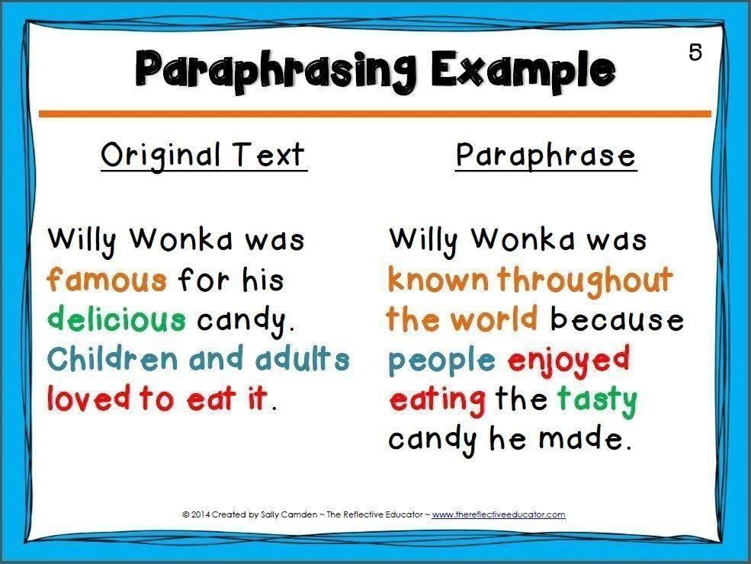
For my self ,I learned a lot of interesting things about how to make the company prosperous ,how to make advertisements for the company’s production and how to maintain documentation and financial reports .When I started the course ,I expected to gain knowledge in order to be a successful director and build my business to the highest level. Now I am strong and I am not ready to give up for anything.
Appendix:
Reference using https://techterms.com/definition/powerpoint#:~:text=PowerPoint%20is%20a%20presenta tion%20program%20developed%20by%20Microsoft.&text=PowerPoint%20is%20often %20used%20to,as%20audio%20clips%20and%20movies.
https://dictionary.cambridge.org/dictionary/english/dictionary

