

Program: MBA – Master of Business Administration
Module: Strategic Management
Module Code: LCMB7003
Assignment Title: Strategic Management
Report
Student ID: 2246016

Table of Contents
Task 1: Group Task………………………………………………………………………………3
Summary of Paper……………………………………………………………………………….4
Task 2: Individual Assignment…………………………………………………………………..5
References……………………………………………………………………………………….16
Task 1: Group Task
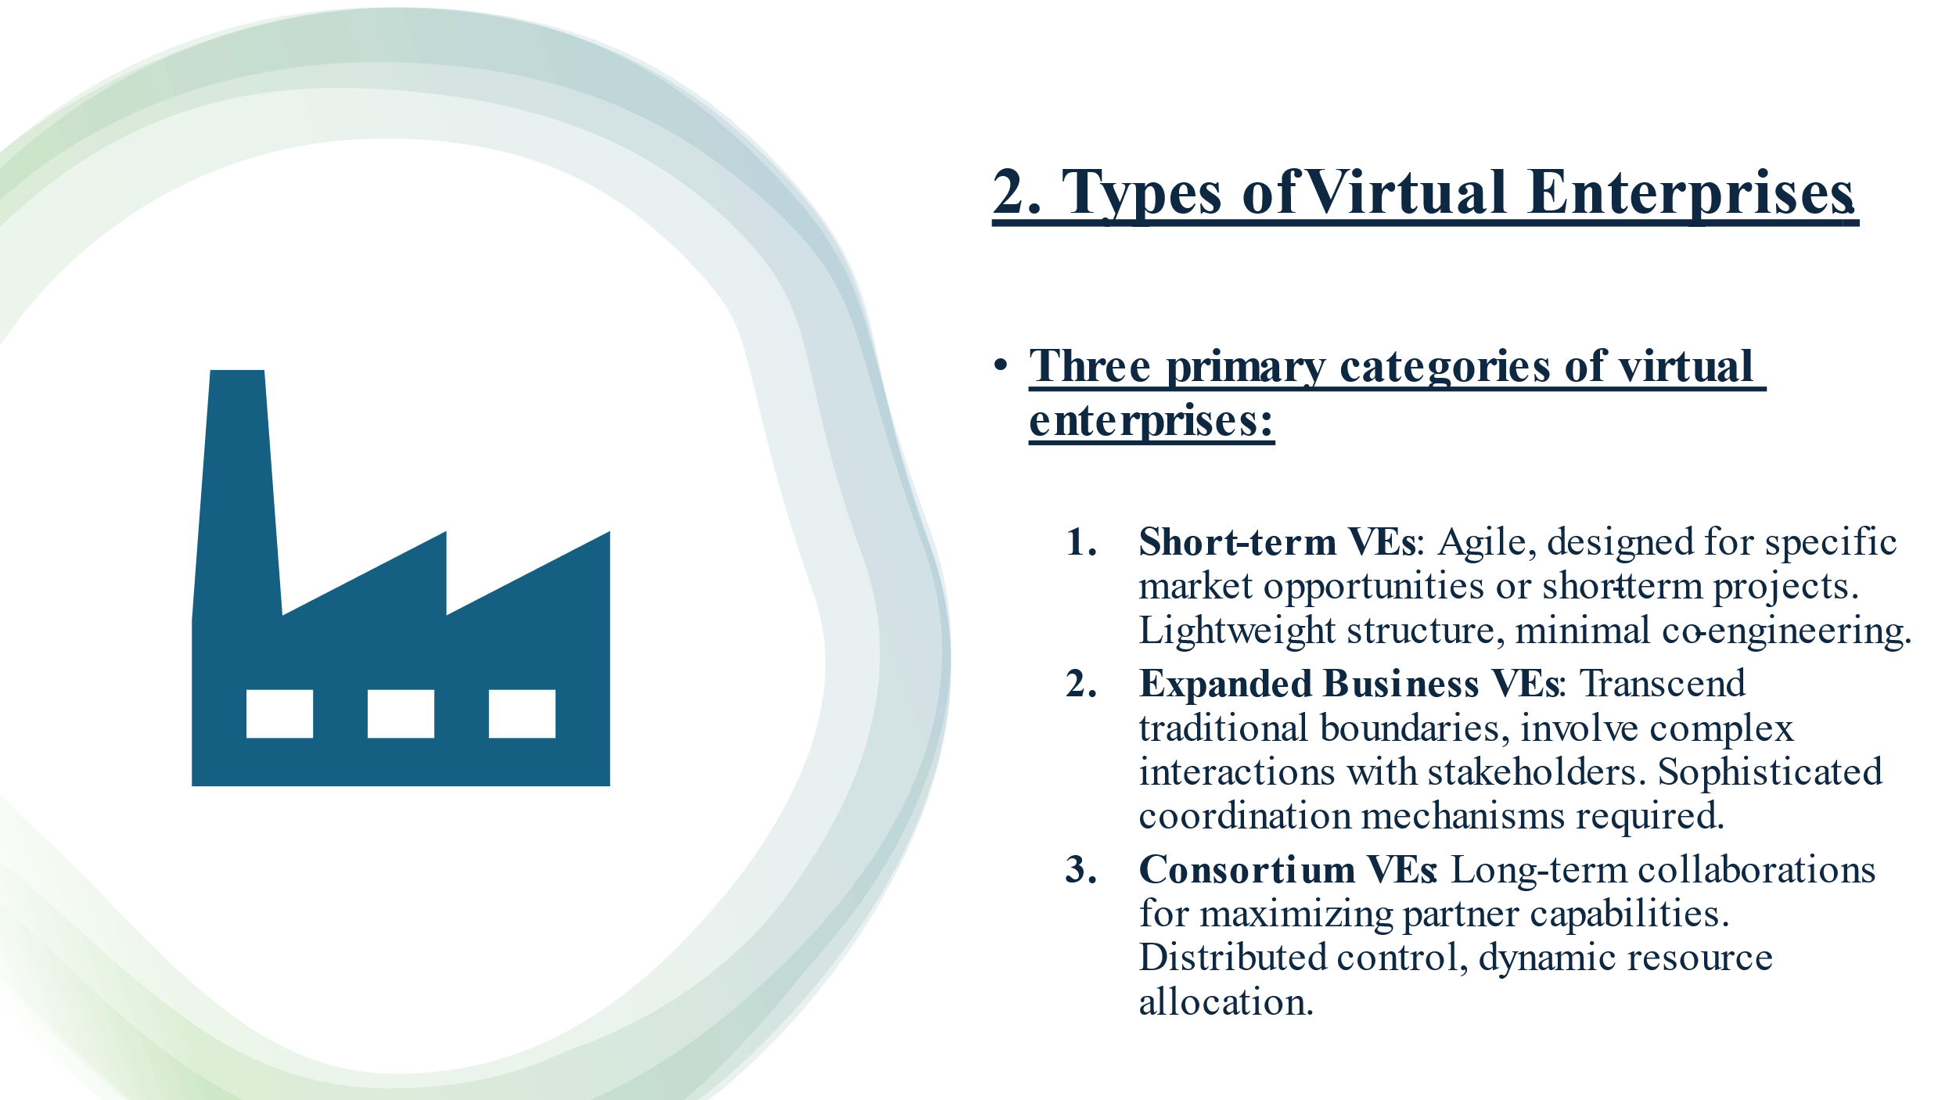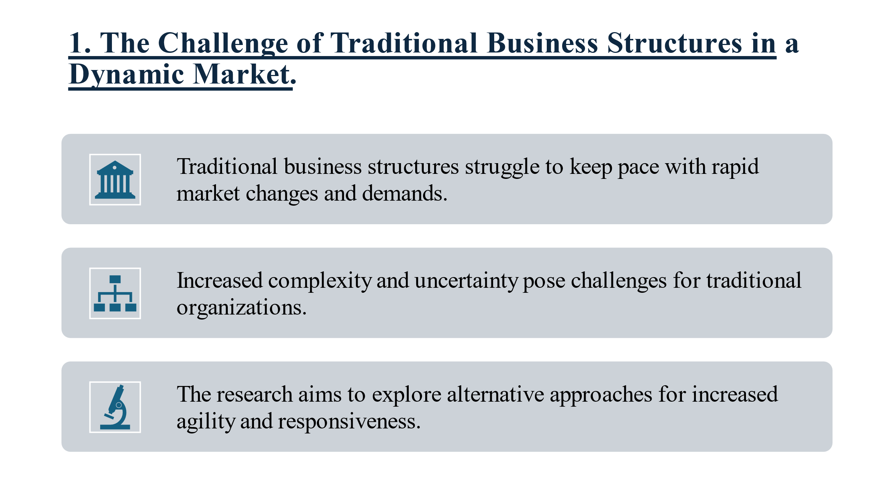
Summary:
The paper titled "Virtual Enterprise—organisation, evolution and Control" by M.T. Martinez, P. Fouletier, K.H. Park, and J. Favrel, published in the International Journal of Production Economics, explores the concept of the Virtual Enterprise (VE) as a pivotal structure in advanced manufacturing. The paper's objective is to analyse the characteristics, evolution, and control mechanisms of VEs, with a focus on a non-hierarchical, distributed control system tailored for a Consortium VE, implemented through a Multi-Agent System (MAS). The paper’s critical insights can be divided into analysing VE characteristics, VE types, control structures, and the application of MAS for dynamic decision-making in a VE environment.
Analysis of VE Characteristics
The paper begins by positioning VE within the broader landscape of advanced manufacturing paradigms alongside concepts like Concurrent Engineering, Agile Manufacturing, and Computer-Integrated Manufacturing (CIM). The authors argue that VE represents a more sophisticated organisational model that responds to the demands of a globalized and rapidly changing market environment. The VE framework allows multiple organizations to pool their resources and capabilities to respond quickly to market demands, emphasising flexibility, adaptability, and global supply chain optimisation.
The characteristics of VE are driven by three main factors: market characteristics, production processes, and strategic objectives. Market characteristics dictate the nature of demand—whether it is driven by direct customer requests or market studies—and influence the level of product customisation required. The production process is closely tied to these market demands, requiring synchronisation and high interoperability between organizations, particularly in collaborative activities. Strategic objectives, such as cost reduction, reactivity, and robustness, also shape the VE structure. However, the paper highlights the inherent limitations of VE, particularly the tension between the need for flexibility and the stability required for long-term operations.
VE Types and Their Evolution
The authors categorize VEs into three primary types: Short-Term VE, Consortium VE, and Extended Enterprise VE. Each type corresponds to different stages in the VE lifecycle and reflects varying levels of complexity and collaboration.
- Short-Term VE: Characterized by a lightweight and flexible structure, the Short-Term VE typically forms in response to a specific market opportunity. The tasks within this structure are often independent and require minimal synchronous collaboration. The focus is on achieving quick results with minimal overhead.
- Consortium VE: This type of VE involves a higher level of collaboration and synchronisation among partners. The Consortium VE is suited for projects that require both customised and semi-standardized products. It is distinguished by a non-hierarchical and cooperative structure, with the potential for leadership roles to emerge organically based on expertise and resources.
- Extended Enterprise VE: Representing the most complex and long-term form of VE, the Extended Enterprise spans company boundaries and integrates various systems and processes across a network of partners, customers, and suppliers. This structure requires robust communication and coordination mechanisms, as well as the ability to adapt to changes in the market or production processes.
The evolution of VE structures is driven by the need to balance the complexity of management systems with the flexibility required to respond to market demands. The paper proposes that as a VE matures, its structure may evolve from a Short-Term VE to an Extended Enterprise, with increasing integration and centralization of management functions.
Control Structures for VE
The paper's central contribution lies in its proposal for a control structure tailored for Consortium VEs. Unlike traditional hierarchical organizations, a Consortium VE relies on a distributed control system that facilitates concurrent engineering and collaborative product development. The control structure is designed to manage the allocation of roles and responsibilities among partners, ensuring that tasks are distributed efficiently and that the autonomy of each partner is maintained.
A significant challenge in VE management is coordinating tasks across heterogeneous organizations with different resources and expertise. The paper advocates for a task decomposition and allocation process that iteratively refines the division of labor based on each partner's specific capabilities. This process involves creating a task link graph that maps the relationships between tasks and optimises the overall project timeline.
Multi-Agent System for Dynamic Decision-Making
To address the complexities of managing a VE, the authors propose the use of a Multi-Agent System (MAS) for decision-making and control. MAS is a distributed artificial intelligence approach where autonomous agents interact within a network to achieve collective goals. In the context of VE, MAS offers a bottom-up approach to control, allowing for self-organization and adaptability in response to changes in the environment or market demands.
The MAS framework for VE is organized into multiple levels, with agents representing different functions, resources, and activities. Each agent operates autonomously but interacts with other agents to coordinate tasks and optimize the overall production process. This approach enhances the flexibility and robustness of the VE, enabling it to respond quickly to unexpected events, such as equipment failures or changes in customer demand.
The MAS model proposed in the paper is particularly well-suited for VEs because it can accommodate the dynamic and distributed nature of these enterprises. By decentralizing control and leveraging the capabilities of individual agents, the MAS approach mitigates the risks associated with hierarchical management structures and improves the overall efficiency of the VE.
Critical Insights and Conclusion
The paper’s critical analysis underscores the potential of VE as a transformative organizational model in manufacturing. However, the success of VE hinges on the development of sophisticated control systems that can manage the complexity of multi-organizational collaboration. The MAS-based approach proposed by the authors offers a promising solution, providing the flexibility and adaptability needed to thrive in a competitive and rapidly changing market.
Nevertheless, the paper also acknowledges the challenges associated with implementing such a system, particularly the need for advanced communication protocols, compatibility between different organizational systems, and the design of effective task decomposition methods. Future research should focus on refining these tools and methods to ensure that VEs can fully realize their potential.
In conclusion, this paper provides a comprehensive and insightful analysis of the VE concept, its evolution, and the control mechanisms necessary for its success. The authors’ proposal for a MAS-based control system represents a significant advancement in the management of VEs, offering a framework that is both flexible and robust enough to meet the demands of modern manufacturing.

Table of Contents
1. Introduction 1
1.1 Virtual Organization 2
1.2 Thesis Statement 2
2. The Emergence of Virtual Organizations 2
2.1 Historical Context and Technological Advances 2
2.2 Advantages of Virtual Organizations 3
2.3 Challenges Facing Virtual Organizations 3
3. Strategic Planning in Virtual Organizations 4
3.1 Setting Strategic Goals 4
3.2 Resource Allocation in a Virtual Setup 5
3.3 Risk Management Strategies 5
4. Designing Virtual Organizations 5
4.1 Structural Design for Virtual Environments 5
4.2 Technology Infrastructure and Support 6
4.3 Collaborative Tools and Practices 7
5. Leading Virtual Organizations 7
5.1 Leadership Styles Suitable for Virtual Organizations 7
5.2 Employee Engagement and Performance Management 7
5.3 Cultural Integration and Management 8
6. Conclusion 8
7. References 9

1. Introduction
The rapid advancement of technology and the forces of globalization have dramatically reshaped the traditional workplace, giving rise to what is now known as the “virtual organization.” This section explores the evolution of virtual organizations, focusing on the strategic management challenges and opportunities that these entities face in today's dynamic business environment. A virtual organization is a network of independent entities that collaborate within a digital environment, transcending the limitations imposed by traditional organizational boundaries and physical locations. These organizations leverage advanced technological platforms that enable the seamless coordination of people and resources across the globe (Shokri Gazafroudi, Prieto & Corchado, 2019). The defining characteristic of virtual organizations is their reliance on communication technologies, such as the internet, intranets, and other web-based tools, to facilitate collaborative work and streamline processes. This digital integration allows virtual organizations to respond swiftly to market fluctuations and evolving customer preferences, positioning them as agile competitors in the global marketplace. The emergence of virtual organizations introduces a novel paradigm in strategic management, particularly in the areas of planning, designing, and controlling operations (Noto et al., 2023). This study critically assesses the application of strategic management concepts within virtual organizations, with a specific focus on their unique requirements—namely, flexibility, decentralized decision-making, and continuous innovation. Through this assessment, the coursework aims to enhance understanding of various strategic approaches and leadership styles applicable to virtual settings, ultimately proposing practical strategies that can improve efficiency and foster cohesion among virtual teams (Martin, 2023).

2. The Emergence of Virtual Organizations
Virtual organizations used to remain as niche approaches to traditional offline approaches but they have now become mainstream business due to technologic advancements and shifts in economic and social scenarios. This part deals with the historical story, merits, and limitations of the post-modern which includes electronic media, cinema, and television.

2.1 Historical Context and Technological Advances
Although the term virtual organization has been around in the late 20th century business world to find new forms of increased flexibility and reduced operational costs while competing in the world market. The Internet and technologies that became common in the 1990s provided the means that allowed employees to work away from the office rather than in its close proximity and also to send and receive information in real time wherever they were, which characterizes virtual enterprises (Hernández et al., 2019). One key technological progression, like high-speed internet, cloud computing, collaborative software, and complex cybersecurity tools, has played vital role. Such technologies allowed the enterprise to function without having to rely on a single physical corner because of their ability of connecting different entities and sharing information with no delays.
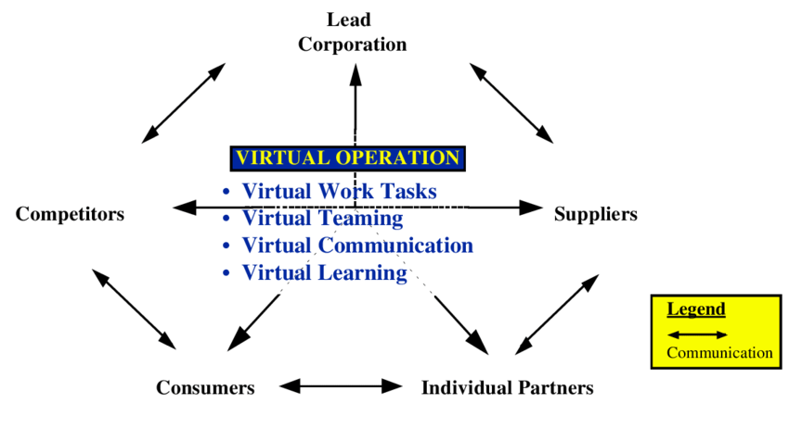
Figure 1: The Heart of a Virtual Organization Adapted from Grenier and Metes (1995)
2.2 Advantages of Virtual Organizations
Virtual organizations offer several distinct advantages that make them attractive in today’s dynamic business environment:
Cost Efficiency: Digitalization of business processes helps in downsizing on physical space of business offices and associated high overhead costs while increasing the business investment on growth and development by releasing these funds.
Flexibility and Scalability: The capability to rapidly and smoothly adapt to any changes in the business and either downscaling or upscaling its operations without the lofty barriers of space (Lee, 2021).
Access to Global Talent: Employment of talent across boundaries and geographical limitations portraying as a diversity inability giving birth to creative and best teams.
Enhanced Responsiveness: This decentralized nature coupled with the ability to quickly implement change thanks to digital communication tools and the use of digital operations will make the organization healthy in the face of market changes or customer needs.

2.3 Challenges Facing Virtual Organizations
Despite their advantages, virtual organizations are not without challenges. The following issues are particularly significant:
- Communication and Collaboration Difficulties: The absence of face-to-face interactions can lead to misunderstandings, making team development and collaboration more challenging.
- Technology Dependence: Over-reliance on technology can be a double-edged sword; system failures or technological breakdowns can severely disrupt operations.
- Security Risks: The distributed nature of virtual organizations increases their vulnerability to cybersecurity threats, as data is often stored across multiple networks and locations (Pizło & Parzonko, 2021).
- Cultural and Management Issues: Working with a team that is made up of different and cultures, time zones, calls for remarkable management strategies to build a team and maintain production.

3. Strategic Planning in Virtual Organizations
In virtual organizations strategic planning tends to be more dynamic than the counterparts in the traditional organizations as these organizations operate in a different manner. So the next part features the details on strategic planning and tactile knowledge management in the remote office.

3.1 Setting Strategic Goals
To follow out strategic goals in a virtual organization, you must specify clear and achievable goals that are in agreement with the mission of organization and the feature of its distributed workforce. The goals that have the best suitability for change and are technologically advanced enough to use the virtual nature effectively have to be created (Cortellazzo, Bruni & Zampieri, 2019).
- Clarity and Alignment: Goals must be clearly defined and communicated to ensure that all team members, regardless of their location, are aligned with the organization’s direction (Cortellazzo, Bruni & Zampieri, 2019).
- Flexible: Goals should be adaptable to changes in technology and market developments, enabling the organization to remain agile in a rapidly evolving environment (Bagga, Gera & Haque, 2023).
- Performance-Oriented: Goals should incorporate SMART (Specific, Measurable, Achievable, Relevant, Time-bound) metrics that can be digitally monitored, providing a clear framework for assessing progress and success.
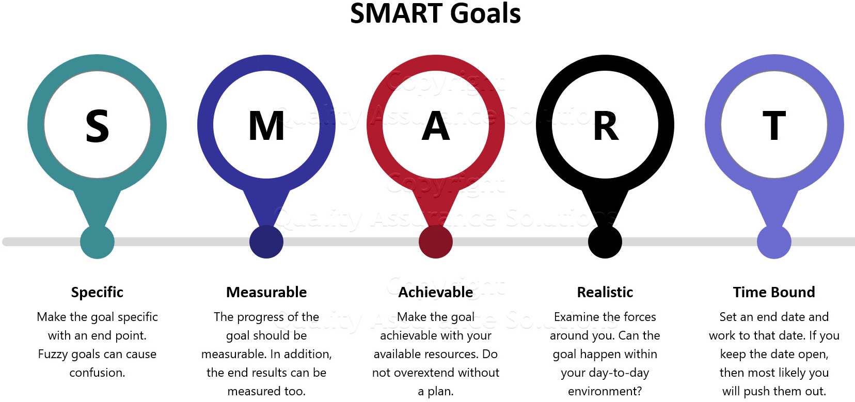
Figure 2: SMART Goals: The Most Powerful Step to Meet Objectives https://www.quality-assurance-solutions.com/

3.2 Resource Allocation in a Virtual Setup
Resource allocation in virtual organizations extends beyond traditional management practices by focusing on the distribution of digital tools, systems, and knowledge essential for virtual operations (Halabian, 2019). The adoption of a robust technology stack is critical, including advanced communication tools, project management software, and reliable cloud services, which support seamless operations across various locations. Equally important is investing in the training and development of team members to ensure they are proficient in using digital tools and can collaborate effectively, regardless of their physical location. Additionally, budgeting practices within virtual organizations must shift focus from traditional office-related expenses to those associated with remote work, such as cybersecurity measures and software licenses. Strategic resource allocation is thus pivotal in maintaining operational efficiency and safeguarding the organization’s digital assets.

3.3 Risk Management Strategies
Risk management in virtual environments needs to be proactive in the sense that any potential sources of risk need to be recognized and addressed before they can pose a problem in the organization. To mitigate the threats posed by technological failures, organizations need to promote the strong cybersecurity measures, as well as the secure backup options that are central to protecting the information and maintaining the organizational operations when the IT system is under risk (Fu & Zhu, 2019). Furthermore, the managerial operations remain vital for maintaining inter-functional coordination and guaranteeing the quality of outputs when working in a virtual environment. Legal compliance is another important factor which would also demand that the virtual organizations update themselves on the current legal demands and data protection laws in various states. Also, human resource management requires changes to correspond to new conditions of teleworking, including such issues as isolation, the lack of clear working time, and corporate culture.

4. Designing Virtual Organizations
Designing a virtual organization requires careful consideration of its structural design, technology infrastructure, and collaborative practices to ensure efficiency and effectiveness in a non-traditional work environment. This section delves into these three critical areas.

4.1 Structural Design for Virtual Environments

The structural organization of virtual organizations are efficiently structured in such a way that they can easily adapt to changes in a fickle business environment and as well take advantage of emerging opportunities. Different from the old-fashioned, rigidly-hierarchical organizations, which are usually slow to make decisions, most virtual organizations run on a relatively flat organizational structure. Thus, team decision-making capacity is notably strengthened when combined with this strategy which helps team members to be more independent (Rumsey & Le Dantec, 2022). This structure is defined by such constituents as centralization, where authority and decision-making are distributed across an organization in order to enhance its ability to respond and adapt quickly. Singularly, scalability takes on a vital role; the workforce is organized into units that are modular and flexible, and can be readily reshaped to reflect particular project tasks. In turn, this promotes adaptability and targeted expertise. Lastly, the network configuration has been set to establish interactions and collaborations with multiple parties outdoors, thereby using different interpreters as well as enhancing the function of the organization.
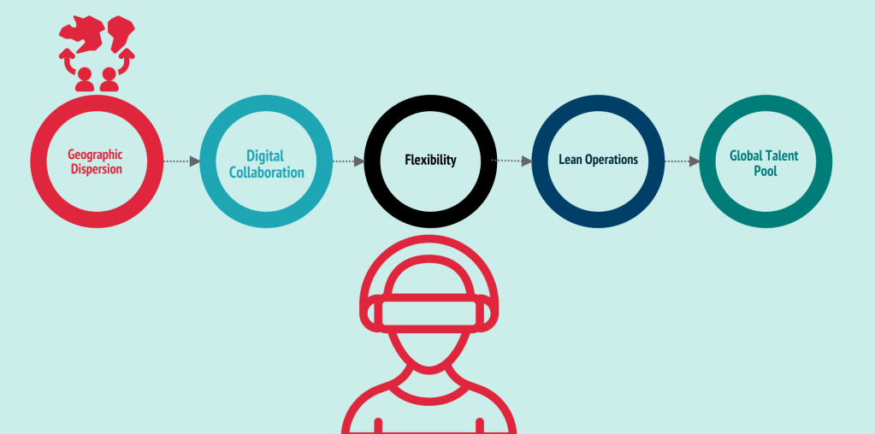
Figure 3: Structural Design for Virtual organizations (Rumsey & Le Dantec, 2022)

4.2 Technology Infrastructure and Support

Modern technology infrastructure is to allow the virtual organization to work properly, making communication, collaboration and business across the teams in the all world smooth. Among the most notable aspects of this framework is the secure connectivity where all our team members can have easy and secure access to organizational networks and data through the use of VPNs, encrypting communications, and employing strong authentication methods. This led us to another important aspect, scalability, where our IT infrastructure can rapidly adapt to the requirements of the organization, keeping performance and security at high levels (Dincelli & Yayla, 2022). Moreover, the IT support system needs to be user-responsive and capable of prompt resolution of technical obstacles so that they can prevent the unnecessary lag in people's productivity. They constitute the technical core, which ensures the agility and adaptability characteristic of such companies.

4.3 Collaborative Tools and Practices
Collaboration in a virtual environment can be made more efficient by employing techniques that are aimed at enhancing teamwork and communication, by means of software tools and identified best practices. That includes, for example, cutting-edge collaborative software that incorporates functions such as video conferencing, real-time convergent, project management, and document sharing to create the effect of a smooth work flow. Henceforth, building a trade mark for virtual collaboration becomes a must. These include, establishing of communication rules, guidelines, documentation best practices, and holding of structured digital meetings which may change from time to time with the aim of keeping everyone in the team aligned and well informed (Morrison-Smith & Ruiz, 2020). Additionally, it is vital to maintain cultural sensitivity when designing the collaborative practices of the global teams to improve their inclusiveness, and that, will make the teams cohesive among their members from diverse cultural backgrounds, thus, better the general effectiveness of the global teams in question.

5. Leading Virtual Organizations

5.1 Leadership Styles Suitable for Virtual Organizations

Direction of leadership in virtual firms must be tailored towards the independence, adaptability and trust paradigm. In such settings, leadership that is truly impactful is usually comprised of transformational and service leadership styles. Transformational leaders lead by example because they not only induce and encourage their team members, but also share the vision and allow creative ideas to prevail which are the fuel of the fire in the remote settings that are not overseen (Sandberg, Pennington & Lindquist, 2022). The Servant Leadership, which focuses on meeting the collective needs of the workers, promotes trust and individual participation, a vital requirement for remotely working teams whose physical management on a daily basis is not possible. Such leadership styles facilitate the environment of accountability and empowerment paramount for the virtual organization’s advancement.

5.2 Employee Engagement and Performance Management

The engagement of remote employees and the kind of performance management they need are presented in a rather unique way. Virtual leaders step up the usage of technologies to keep all networks open and evaluate performances based on facts. Frequent virtual encounters, evaluation sessions, and digital instruments for setting and tracking measures are vital for this purpose (Sanchez-Sepulveda et al., 2019). Aside from these basic elements, it would be advisable for leaders to also acknowledge and include digital platforms in their feedback mechanisms. Furthermore, stimulating a feeling of co-work and network among virtual workers can help increase the level of commitment and motivation, conditioning better performances eventually.

5.3 Cultural Integration and Management

Virtual organizations similarly portray a multi-cultural workforce spreading out other areas' cultural backgrounds, meaning that integration of culture and management becomes a key leadership function. Leadership must be nationally-sensitive and proactive in designing policies that recognize and valorize different cultures (Tadesse & Ayenew, 2023). This may be in the form of training opportunities for all team members where the cultural diversity is taught, developing communication practices that are suitable for all time zones and languages, and creating interactions between different cultures that help to foster mutual understanding and respect. As a result, harnessing this diversity is an asset to the organization by boosting creativity, solving problems, and realizing innovations.

6. Conclusion
Virtual organisations can be known as a revolution in the process of the modern business enterprise due to the changed technology and international business practices. These groups have many of benefits: high adaptability, greater cost savings, and access to a vast pool of international talent but also have some issue like remote teams management, communication consistency and security. The achievement of victory through these problems is pegged on strategic planning, consistent design, and effective leadership. The management styles that involve translating power and voice to self-organizing team members, adopting communication technologies that afford easy and inclusive communication and facilitating behaviours that foster team membership, are key principles that determine the effectiveness and viability of virtual teams. These changes in the work nature demonstrate virtual organizations as the result of the role of technology in influencing business to look for new avenues towards market improvement and functioning.

7. References

Shokri Gazafroudi, A., Prieto, J. and Corchado, J.M., 2019. Virtual organization structure for agent-based local electricity trading. Energies, 12(8), p.1521.
Hernández, E., González, A., Pérez, B., de Luis Reboredo, A. and Rodríguez, S., 2019. Virtual organization for fintech management. In Distributed Computing and Artificial Intelligence, Special Sessions, 15th International Conference 15 (pp. 201-210). Springer International Publishing.
Lee, M.R., 2021. Leading virtual project teams: Adapting leadership theories and communications techniques to 21st century organizations. Auerbach Publications.
Pizło, W. and Parzonko, A., 2021. Virtual organizations and trust. In Trust, Organizations and the Digital Economy (pp. 61-78). Routledge.
Bagga, S.K., Gera, S. and Haque, S.N., 2023. The mediating role of organizational culture: Transformational leadership and change management in virtual teams. Asia Pacific Management Review, 28(2), pp.120-131.
Halabian, H., 2019. Distributed resource allocation optimization in 5G virtualized networks. IEEE Journal on Selected Areas in Communications, 37(3), pp.627-642.
Fu, Y. and Zhu, J., 2019. Big production enterprise supply chain endogenous risk management based on blockchain. IEEE access, 7, pp.15310-15319.
Rumsey, A. and Le Dantec, C.A., 2022. Escaping the Holodeck: Designing virtual environments for real organizations. In Human-Technology Interaction: Shaping the Future of Industrial User Interfaces (pp. 223-249). Cham: Springer International Publishing.
Dincelli, E. and Yayla, A., 2022. Immersive virtual reality in the age of the Metaverse: A hybrid-narrative review based on the technology affordance perspective. The journal of strategic information systems, 31(2), p.101717.
Sanchez-Sepulveda, M., Fonseca, D., Franquesa, J. and Redondo, E., 2019. Virtual interactive innovations applied for digital urban transformations. Mixed approach. Future Generation Computer Systems, 91, pp.371-381.
Morrison-Smith, S. and Ruiz, J., 2020. Challenges and barriers in virtual teams: a literature review. SN Applied Sciences, 2(6), pp.1-33.
Sandberg, D.S., Pennington, C.M. and Lindquist, M.A., 2022. Virtual Leadership: CEOs and C‐Level Executives of Healthcare Organizations in the United States Reimagined New Roles as Virtual Leaders. Journal of Leadership Studies, 16(3), pp.61-69.
Tadesse, A. and Ayenew, Z., 2023. Managing virtual teams and system thinking: A systematic review. J. Intell Manag. Decis, 2(3), pp.151-159.
Cortellazzo, L., Bruni, E. and Zampieri, R., 2019. The role of leadership in a digitalized world: A review. Frontiers in psychology, 10, p.456340.
Martin, M. (2023, March 7). Virtual Workplace: Top Companies Making It Work and How. Smith.ai; Smith. https://smith.ai/blog/virtual-workplace
Noto, G., Marisca, C., & Barresi, G. (2023). Adapting management control to virtual teams: evidence from a natural experiment. Qualitative Research in Accounting & Management, 20(5), 621–646. https://doi.org/10.1108/QRAM0420220066

