

LOCATION: Swansea | LLEOLIAD: abertawe
LEVEL 5 | LEFEL 5
EXAMINATION PERIOD | CYFNOD ARHOLIADAU
2021 | 2021

MODULE CODE: ACMA5004
MATERIALS IN SERVICE

TIME: TWO HOURS

answer TWO quESTIONs out of THREE

Equipment or materials required – None
Adnoddau neu ddefnyddiau sydd eu hangen - Dim

ANSWER TWO QUESTIONS

Question 1
(a) Figure 1 below shows the result from a tensile test to determine the mechanical properties of an alloy.  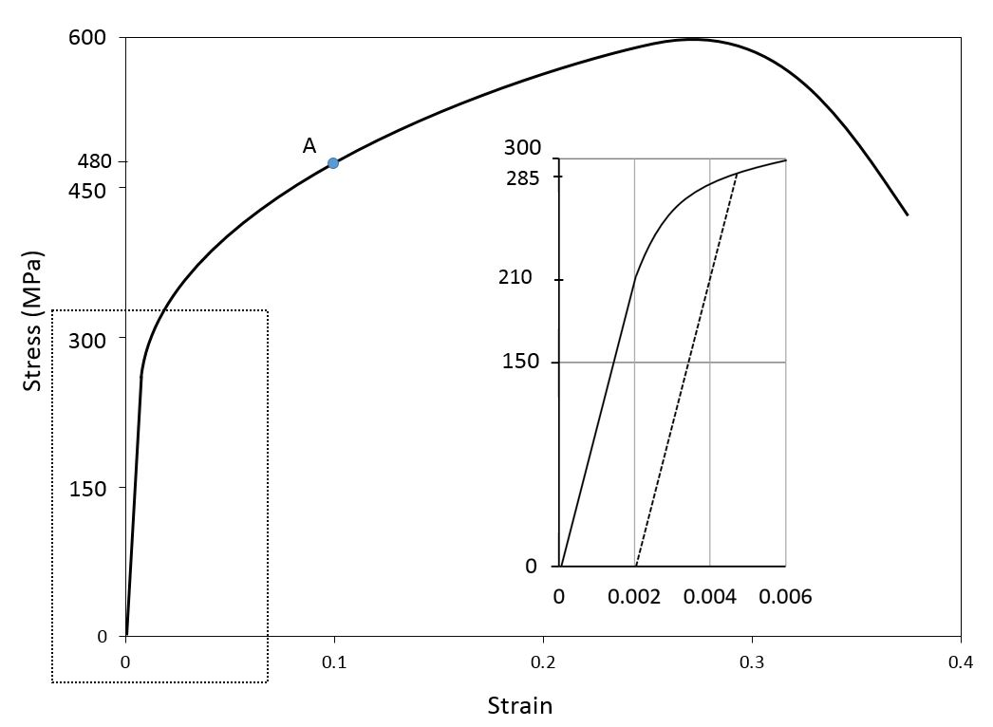  Figure 1  Explain why, for a test such as this, a sample is used which has thick end regions and a narrow centre region. | [10 marks]  [10 marks]  [ 4 ]
(b) During the test, the sample is stretched and the force is measured, along with the sample extension.  Using this information, and assuming that you were given the information about the dimensions of the sample, explain how the stress and strain in the sample would be calculated. | [10 marks]
(c) Using the graph, calculate the following:
(i) The tensile strength of the alloy. | [10 marks]
(ii) The Young’s modulus of the alloy. | [12 marks]
(iii) The 0.1% proof stress of the alloy. | [8 marks]
In each case, explain clearly how you obtained the result, with a sketch if appropriate, and show all your workings. Include the correct units in your answer.

Question 2

(a) A circular cross section bar measures 100mm in length and 7mm in diameter. This bar extends elastically by 0.01mm under a tensile load of 2kN. At the same time, the diameter contracts by 0.00033mm. Determine the Young’s modulus (E) and the Poisson’s ratio (υ) for this metal. [ 25 marks]

(b) The following table lists the data obtained during a series of Charpy Impact testing:

Temperature (ºC) | Absorbed Energy-Toughness (J)
75 | 88.6
50 | 87.6
25 | 85.4
0 | 82.9
-25 | 78.9
-50 | 73.1
-65 | 66.0
-75 | 59.3
-85 | 47.9
-100 | 34.3
-125 | 29.3
-150 | 27.1
(b1) Draw a diagram of Impact toughness versus temperature. [4 marks]

(b2) Calculate the Impact transition temperature from ductile to brittle fracture, as the temperature that corresponds to the mean value of maximum and minimum absorbed impact energy. [7 marks]

(b3) Calculate the Impact transition temperature as the temperature that the absorbed energy is equal to 65J. [7 marks]

(b4) Comment on the demonstrated different temperature values deduced in questions b2 and b3. [7 marks]

Question 3

- Assuming that the crystal structures of metals can be considered as packing of solid spheres in contact, calculate the atomic packing density for the BCC (Body Centred Cubic) crystal structure. [10 marks]

- Explain the principles of dissimilar metal wet corrosion.

[20 marks]

(c) A relatively large plate of a glass is subjected to a tensile stress of 40 MPa. If the specific surface energy and modulus of elasticity for this glass are 0.3 J/m² and 69 GPa, respectively, determine the maximum length of a surface flaw that is possible without fracture. [20 marks]

Diwedd/End

