

Developing Innovation and Creativity for Business

Advantage (BMSW6102)

Task 1 and Task 2

Student Name: Ana Cojan
Student Number: 2109647
Lecturer Name: Charles Nwaogwugwu

Table of Contents
Task 1 3
Introduction 3
Innovative Product or Unique Service Proposition 3
eCommerce Website Proposal 5
Content Creation Strategies: 5
Payment Methods and PCI-DSS Compliance: 6
Marketing Strategy 6
Reaching the Target Audience: 7
Addressing Customer Journeys: 7
Privacy and Data Protection 8
Conclusion 9
Task 2 11
Introduction 11
The Market Gap or Problem 12
Proposed Solution (Product/Service) 13
Market and Competitive Analysis Highlights 14
Summary Business Concept and Model 15
Competition and Differentiation Strategy 16
Marketing Strategy 17
Privacy and Data Protection 18
What I have Learned and Future Benefits 19
Conclusion 20
Reference 22
Task 1 22
Task 2 24

Task 1

Introduction
The goal of this project is to develop a creative business strategy that prioritises the most important aspects of innovation and creativity in the workplace via the use of design thinking and innovation models. This will be accomplished by developing an original method of doing business. This endeavour, while encouraging the application of knowledge and abilities gained during our educational journey, emphasises the significance of originality and innovative problem-solving for the success of modern businesses. Being ability to think creatively and provide original answers to challenges is an absolute need in today's corporate environment. In today's fast-paced, highly competitive business climate, it is commonly acknowledged that innovative thinking and creative problem solving are must. Businesses that encourage new ways of thinking about old challenges not only survive, but thrive in today's fast-paced economy. They are more capable of handling difficult circumstances, meeting the changing needs of their customers, and staying ahead of the competition. Therefore, this study offers a precious opportunity to bridge the gap in understanding between theoretical frameworks and cutting-edge procedures. Furthermore, the present economic challenges, such as inflation and oil prices, must be taken into account. Traditional "brick-and-mortar" merchants are finding it harder to succeed as a result of these changes. The growing cost of conducting business as a consequence of inflation and rising energy expenses has driven company owners to evaluate their strategy and seek more sustainable solutions. The reason for this is the ever-increasing price of conducting business. By using state-of-the-art technological tools and creative methods to problem solving, this project allows students to explore and build novel company concepts that may succeed despite the present economic climate.

Innovative Product or Unique Service Proposition
To meet the rising need for environmentally friendly urban mobility options, especially in densely populated urban areas, EcoLogiWheels offers a subscription-based electric bicycle-sharing service.
Innovative Product or Service:
EcoLogiWheels rents out ecologically efficient and very practical electric bicycles. Subscribers may access these electric bicycles from a system of docking stations located across the city. Our goal is to provide a sustainable mode of transportation that is both reliable and ecologically beneficial in order to reduce traffic, lower emissions, and promote healthier lifestyles among the general public by 2023 (Ucla, 2023).
Target Customers and Their Needs:
City residents and commuters who are looking for a cost-effective transport alternative are our target customers. These consumers care about the environment and want to reduce their carbon footprint. Our electric bicycle sharing programme will also provide them with the convenience and flexibility they need in their regular commute.
Sales Strategy:
For EcoLogiWheels to work, a smartphone app and a network of docking stations will be used. An electric bicycle may be found and borrowed using the app, then locked and returned to any docking station. The service is paid for on a regular basis, with several daily, weekly, and monthly plans available to fulfil the needs of various consumers.
Venture Name:
Our business is named "EcoLogiWheels," a combination of the terms "Eco" (for the service's concern for the environment), "Logi" (for the service's focus on logistics and convenience), and "Wheels" (for the mobility and transportation it offers).
Sustainability Strategy:
EcoLogiWheels is devoted to environmental responsibility in many ways. First, our electric bicycles have no emissions and help keep the air pure. Second, we only utilise eco-friendly components in our e-bikes. We want to add solar-powered docking stations to lessen the carbon footprint of the charging process. To further reduce our carbon impact and improve urban greenery, we want to work with neighbourhood environmental groups to plant trees.
Competitive Analysis and Differentiation:
The industry of electric bicycle-sharing platforms is very new, although it is experiencing rapid growth, as per Bieliński et al. (2020). The sector comprises numerous competitors; however, EcoLogiWheels distinguishes itself via its unwavering commitment to environmental responsibility. The e-bikes offered by our company are outfitted with cutting-edge technology to ensure rides that are both safe and efficient. Additionally, our subscription plans have been designed to offer reasonable and adaptable solutions. Furthermore, we place significant focus on establishing strong partnerships with municipal authorities to guarantee accessibility and convenience. Moreover, our unwavering dedication to ecological initiatives distinguishes us from our competitors. With its dedication to environmental sustainability and emphasis on user-friendliness, EcoLogiWheels is poised to become the preferred choice for urban residents seeking an eco-friendly and convenient mode of transportation.

eCommerce Website Proposal
Platform Selection:
Software-as-a-service (SaaS) systems like Shopify are popular for their user-friendly interface and capacity to handle growing demands (Eleken, 2021); whereas our specific service would be better suited by a customised website. The implementation of a tailored solution allows for the customization of the website to accommodate the specific needs of our e-bike-sharing service. The suggested additions involve the integration of many capabilities, such as real-time bike availability tracking, user-friendly route planning facilitation, and seamless connectivity with our mobile application. The implementation of this customization tool ensures a more seamless experience for our clientele and aligns with our overarching goal of delivering a service that places user requirements at the forefront.

Content Creation Strategies:
- Website Copy: The primary objective of the website will be to deliver information on EcoLogiWheels in a manner that is both lucid and compelling, while also being succinct (Yaqoob et al., 2021. The aforementioned information encompasses several aspects of our service, such as subscription options, station locations, environmental initiatives, and safety rules. The content shall possess an informed and accessible tone, effectively communicating our dedication to both sustainability and convenience.
- Photography: The inclusion of high-resolution photographs depicting our electric bicycles, docking stations, and users enjoying their rides will be imperative in effectively communicating the convenience and advantages offered by our service (Yang et al., 2019. The promotion of user-generated material will also be emphasised, highlighting the communal nature of our service.
- User Experience Design: The design of the website will have a high emphasis on optimising user-friendliness. Intuitive navigation, responsive design for various devices, and fast loading times will be key (EBR, 2023). The user interface will encompass several key components, namely a user account dashboard, a station locating map, subscription plan selection, and real-time updates on bike availability.

Payment Methods and PCI-DSS Compliance:
EcoLogiWheels will provide a range of payment options to accommodate the different interests of its customers. The available payment methods will encompass credit/debit card transactions, PayPal, and maybe other digital wallet services. The key concern lies in guaranteeing the security of various payment methods.
To address PCI-DSS compliance issues, we will:
- It is recommended to employ secure and encrypted connections, namely Hypertext Transfer Protocol Secure (HTTPS), in order to safeguard user data throughout transactional processes (CSA, 2023).
- Utilise a payment gateway provider of high repute, placing significant emphasis on data security and adherence to PCI compliance standards (Muhammad et al., 2022).
- It is imperative to consistently carry out security audits and vulnerability assessments in order to safeguard sensitive consumer data.
- The implementation of two-factor authentication (2FA) for user accounts is recommended in order to bolster security measures (Marky et al., 2022).
It is acknowledged that the establishment of PCI-DSS compliance is not solely a legislative obligation, but also a crucial factor in fostering customer trust. The preservation of privacy and the facilitation of a smooth, secure, and pleasant interaction with EcoLogiWheels are contingent upon the implementation of robust payment procedures.

Marketing Strategy
Effectively advertising EcoLogiWheels, a state-of-the-art electric bicycle-sharing service, will require a comprehensive marketing strategy that goes beyond just brand awareness enhancement. The foundation of our marketing strategy is predicated upon the identification and delineation of our target demographic, the careful selection of appropriate distribution channels, and the implementation of techniques aimed at facilitating a cohesive and uninterrupted customer experience (SS, 2023).
Target Customer Base:
Our core demographic consists of working professionals and eco-conscious residents of highly populated urban regions (ages 18 to 60). Commuters like these look for economical, environmentally responsible, and easily accessible transit options. We hope that green-minded sightseers will visit our fair city.

Reaching the Target Audience:
- Geotargeted Marketing: We will use geotargeting to direct our marketing efforts towards densely populated locations that see a lot of visitor traffic (BC, 2023). This helps us better communicate with our core demographic of consumers.
- Content Marketing: Writing interesting blog posts and articles about urban transportation, environmental responsibility, and travel around urban areas. These will be disseminated via our website and various social media outlets.
- Social Media (e.g., Facebook): We're going to make Facebook our primary social media channel. Regular updates on e-bike stock, docking station openings, and green policies will be provided (Li et al., 2021). User-generated content showcasing subscribers' experiences will also be welcomed.
- Paid Search Engines (e.g., Google): Implementing Google Ads, we will target terms relating to electric bike-sharing, sustainable transportation, and city commuting (Lewandowski and Schultheiß, 2023). This will guarantee exposure when potential clients conduct related service searches.
- Email Marketing: Through pre-launch marketing, we want to collect email addresses from interested customers and use them to distribute service announcements, discounts, and informative articles on topics like e-bikes and environmental responsibility (Rosmalasari et al., 2020). We plan to employ email marketing to maintain interest in and knowledge among our subscriber base.

Addressing Customer Journeys:
We'll make every step of the customer's journey easy and exciting:
- Awareness Stage: We'll spread the word using carefully crafted content, social media, and paid search engine marketing. EcoLogiWheels' value as a green transportation choice will become more widely known, bringing in more customers.
- Consideration Stage: Customers will begin their research on our website, learning about membership options, station locations, and eco-friendly initiatives. The content will be organised to provide a wealth of specifics.
- Decision Stage: Customers can join the service via the web. We'll make it easy to sign up, and there'll be a variety of subscription plans to choose from so that everyone's needs can be met.
- Retention Stage: We plan to use loyalty programmes and rewards for referring new clients as retention strategies (Kim et al., 2021). Regular email updates will keep users engaged and informed.
Pre-Launch Promotion:
Prior to the official introduction, we will undertake pre-launch promotional activities. The use of these promotional strategies is expected to result in an increase in our newsletter subscriber base, as they are specifically designed to stimulate enthusiasm among potential subscribers (Baker et al., 2020). Viable solutions for businesses to consider include social media contests, referral programmes, and collaboration initiatives with adjacent establishments. The marketing endeavours of EcoLogiWheels are strategically aimed at effectively communicating and engaging with our target customers throughout the whole duration of their relationship with our brand, encompassing the many stages of the customer life cycle, ranging from early awareness to fostering enduring loyalty. Our strategic objective is to position EcoLogiWheels as the preferred choice among urban residents and tourists who prioritise environmental sustainability. This will be achieved through targeted marketing efforts that align with their preferences and values.

Privacy and Data Protection
Ensuring the protection of privacy and data is of utmost importance for EcoLogiWheels in order to foster trust and uphold the security of client information. Our organisation is dedicated to adhering to regulatory requirements, specifically the General Data Protection Regulation (GDPR) and the Data Protection Act 2018, which dictate the appropriate management of personal data (GOV, 2019).
GDPR and Data Protection Act 2018: EcoLogiWheels will guarantee adherence to the General Data Protection Regulation (GDPR) and the Data Protection Act 2018 by implementing stringent data protection policies and practices. Measures shall be implemented to ensure the secure collection, processing, and storage of personal data, including user profiles and payment information. The privacy regulations implemented by our organisation will demonstrate openness by explicitly outlining the methods through which customer data is utilised, identifying the individuals or entities with allowed access to this data, and describing the intended purposes for which it is employed.
Privacy and Electronic Communication Regulations (PECR): EcoLogiWheels will adhere to the regulations set forth by the Privacy and Electronic Communications Regulations (PECR), which govern the practises of electronic marketing communications (ICO, 2019). Prior to sending marketing emails or messages, we shall actively get explicit agreement from customers, providing them with the option to either opt in or opt out of receiving such communications. The PECR additionally requires the implementation of a mechanism that allows customers to opt out of receiving marketing messages if they no longer choose to receive them.
Importance of Consent, Opt-Out Mechanisms, and Rights: EcoLogiWheels acknowledges the need to acquire explicit agreement from users regarding the handling of data. We shall implement measures to guarantee that customers are granted authority over their data (SL, 2023). This encompasses the entitlement to erasure, enabling them to formally request the removal of their personal information from our systems. The implementation of opt-out systems will facilitate user-friendly procedures, allowing customers to exercise their right to revoke consent for marketing communications at their discretion.
Security Measures: In order to ensure the protection of customer data, we shall establish stringent security protocols for our cloud service providers (Hostinger, 2023). This encompasses the practice of securing data with encryption throughout both its transmission and storage phases. The access control measures implemented will be rigorous, ensuring that only a select number of individuals possess the necessary authorization to retrieve sensitive client data. Systematic security audits and comprehensive vulnerability assessments will be regularly undertaken in order to detect and mitigate possible risks to the integrity and confidentiality of data.

Conclusion
In conclusion, EcoLogiWheels is a new electric bicycle-sharing service that has been developed to suit the requirements of urban mobility while also placing an emphasis on the preservation of the natural environment. Our all-encompassing marketing strategy is centred on reaching out to city commuters who are environmentally conscious, and our bespoke eCommerce platform assures a user-centric interface. We adhere to the General Data Protection Regulation (GDPR) and the Privacy and Electronic Communications Regulations (PECR), which place an emphasis on getting consent and offering opt-out methods, in strict accordance with our deep-seated dedication to the protection of personal information. Given the current state of the economy, which is characterised by inflation and rising energy prices, EcoLogiWheels promotes itself as a sustainable urban mobility solution that is in line with the desire for cost-effective and environmentally aware alternatives to traditional physical retail establishments. This demand is a direct result of the demand for alternatives to traditional retail establishments that are both cost-effective and environmentally conscious. The potential ramifications of our enterprise beyond mere convenience, with the aim of making a positive contribution to the ecological and sustainability aspects of urban environments, while also demonstrating adaptability in the face of economic obstacles.

Task 2

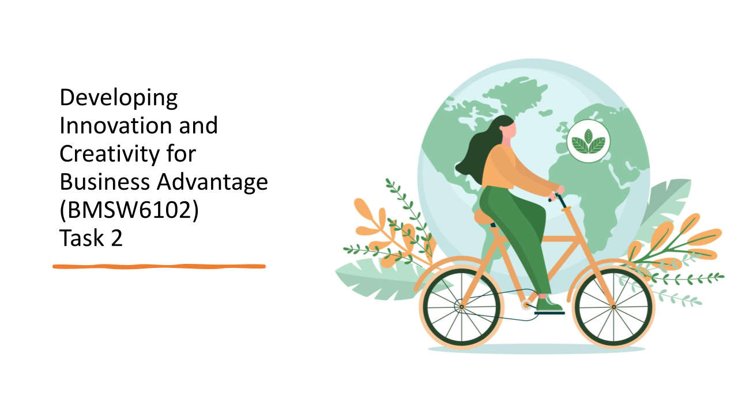

Introduction
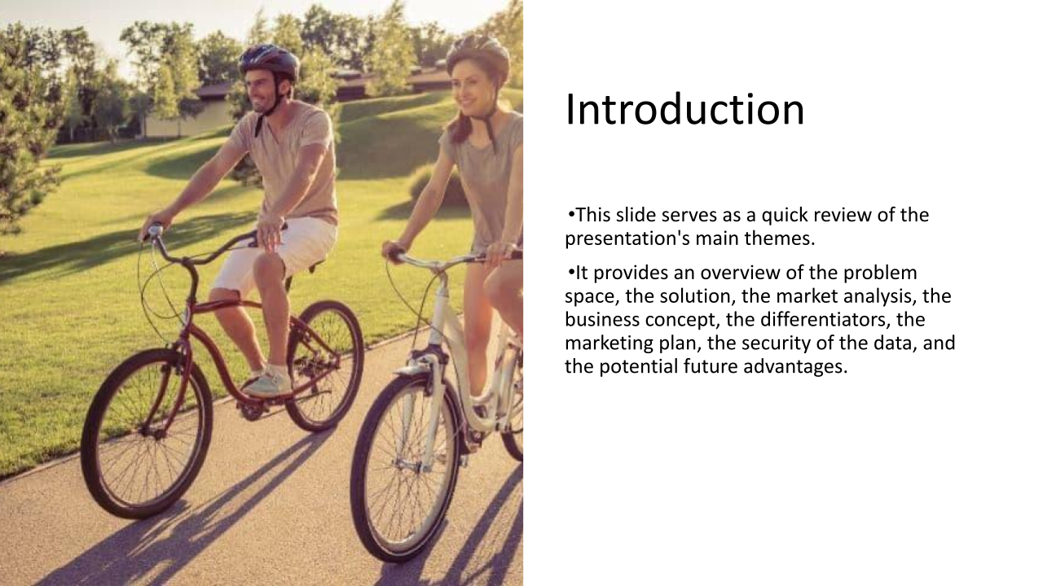
At this point in the presentation, it is crucial to review the path taken up to this point. We've investigated the void in the market, focusing on the difficulties of living in a city and how EcoLogiWheels intends to address those issues. We've gone over the problem, the business model, and the ways in which we'll set ourselves apart. We also laid out our marketing plan, which is geared towards attracting members of our ideal customer demographic. The importance we place on protecting user data and following the law has been emphasised. Finally, we discussed the takeaways and long-term benefits of this project. Let's put it all together as we continue our thrilling adventure into the world of EcoLogiWheels.

The Market Gap or Problem

Worsening traffic congestion and rising carbon emissions from conventional transport are just two of the many issues that urban centres throughout the world are struggling to overcome. As a result, there are problems with the environment and people's quality of life suffers. Despite the prevalence of these problems, there is a distinct absence of accessible and inexpensive sustainable mobility alternatives. Our goal is to close the existing sustainability gap by offering urban commuters a more practical and environmentally responsible alternative, thereby improving the quality of life in cities. To address this need, EcoLogiWheels is launching a membership-based electric bike-sharing service that will transform urban transportation in a way that is both environmentally responsible and considerate of its users.

Proposed Solution (Product/Service)
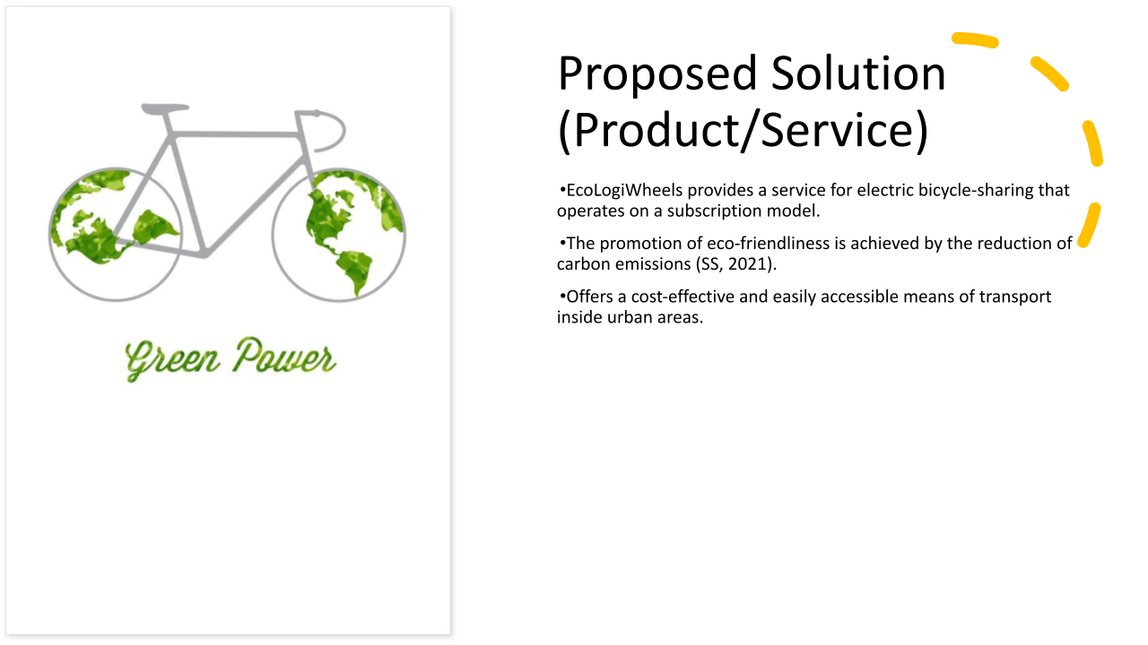
Introducing EcoLogiWheels, a potential solution to address the issues of urban mobility. This pioneering enterprise introduces a subscription-oriented electric bicycle-sharing service that effectively mitigates carbon emissions and alleviates traffic congestion. EcoLogiWheels places emphasis on the principles of cost-effectiveness and convenience, providing consumers with a sustainable means of mobility. This service prioritises environmental sustainability by offering urban commuters a dependable and affordable alternative that is in keeping with their ecological principles. By opting for EcoLogiWheels, consumers actively contribute to the promotion of a more environmentally friendly urban setting, all the while benefiting from a convenient and environmentally conscientious means of transportation.

Market and Competitive Analysis Highlights
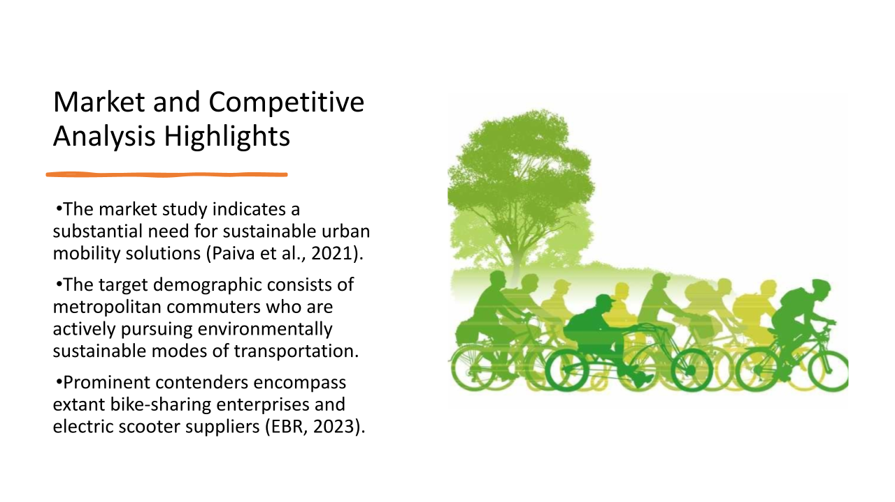
The market analysis conducted reveals a significant need for sustainable urban mobility solutions, hence confirming the importance of EcoLogiWheels. The target demographic mostly comprises metropolitan commuters who are actively seeking environmentally friendly transportation alternatives. Significantly, our analysis reveals the presence of established rivals in the industry, specifically in the form of bike-sharing programmes and electric scooter providers. This indicates that there is market acceptance and acknowledgement of sustainable mobility alternatives. Given this comprehension, EcoLogiWheels is strategically positioned to cater to the requirements of environmentally aware urban commuters and confront rivals through its user-centric strategy and dedication to ecological sustainability.

Summary Business Concept and Model
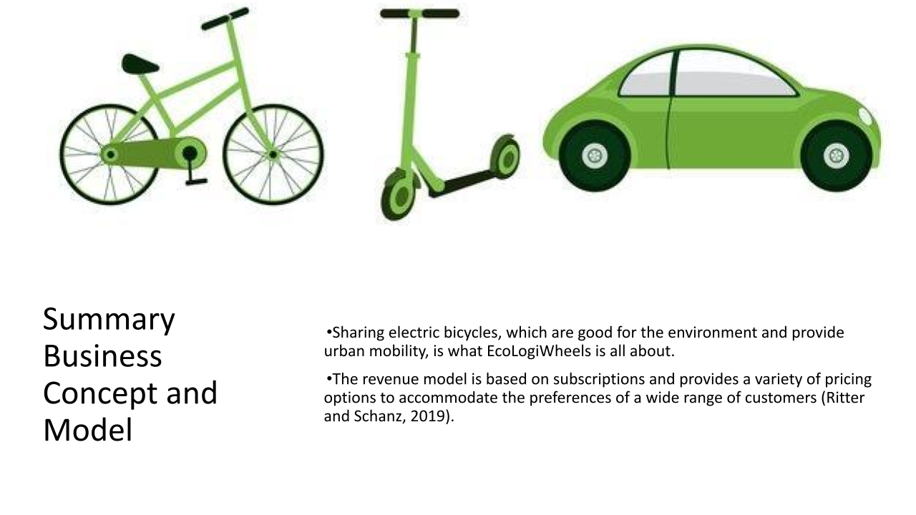
The fundamental business concept of EcoLogiWheels is around the provision of electric bicycle-sharing services, which aim to facilitate environmentally sustainable urban travel. The revenue model employed by our organisation is based on a subscription model, wherein consumers are provided with a variety of price options that are customised to meet their specific requirements. This strategy is in accordance with our organisational purpose to enhance the accessibility and affordability of sustainable transportation. Customers have the option to select between daily, weekly, or monthly subscription plans, so providing them with a range of choices that cater to their individual needs in terms of flexibility and cost-effectiveness. By adopting electric bicycle sharing, users have the opportunity to contribute positively to their environment while also benefiting from the ease offered by our subscription-based model. This makes it the favoured option for sustainable urban transportation.

Competition and Differentiation Strategy
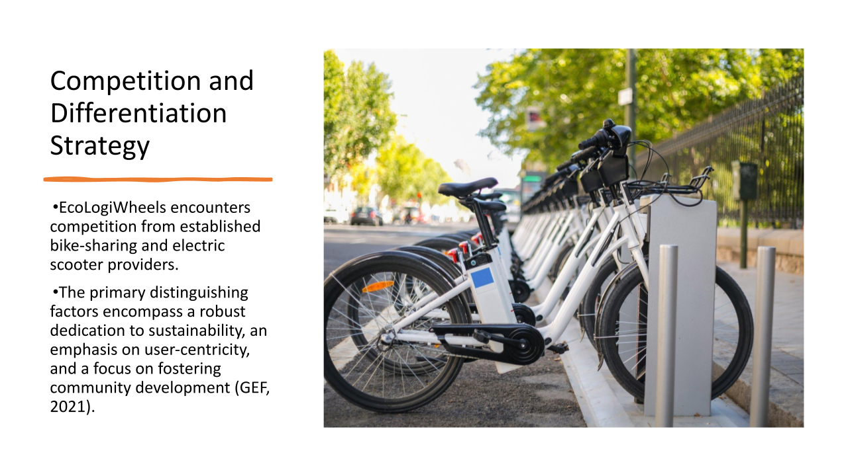
EcoLogiWheels works within a competitive setting, battling with existing bike-sharing and electric scooter businesses. But our unique selling points help us stand out. Our continuous dedication to sustainability guarantees a much smaller carbon footprint than conventional urban transport methods. We take a customer-first approach to our service, always putting the comfort and satisfaction of our paying customers first. In addition, our efforts to strengthen the bonds across our user base have resulted in an increase in brand evangelists. EcoLogiWheels is built on these distinguishing features, making us the go-to option for sustainable, user-friendly, and community-focused urban transportation.

Marketing Strategy
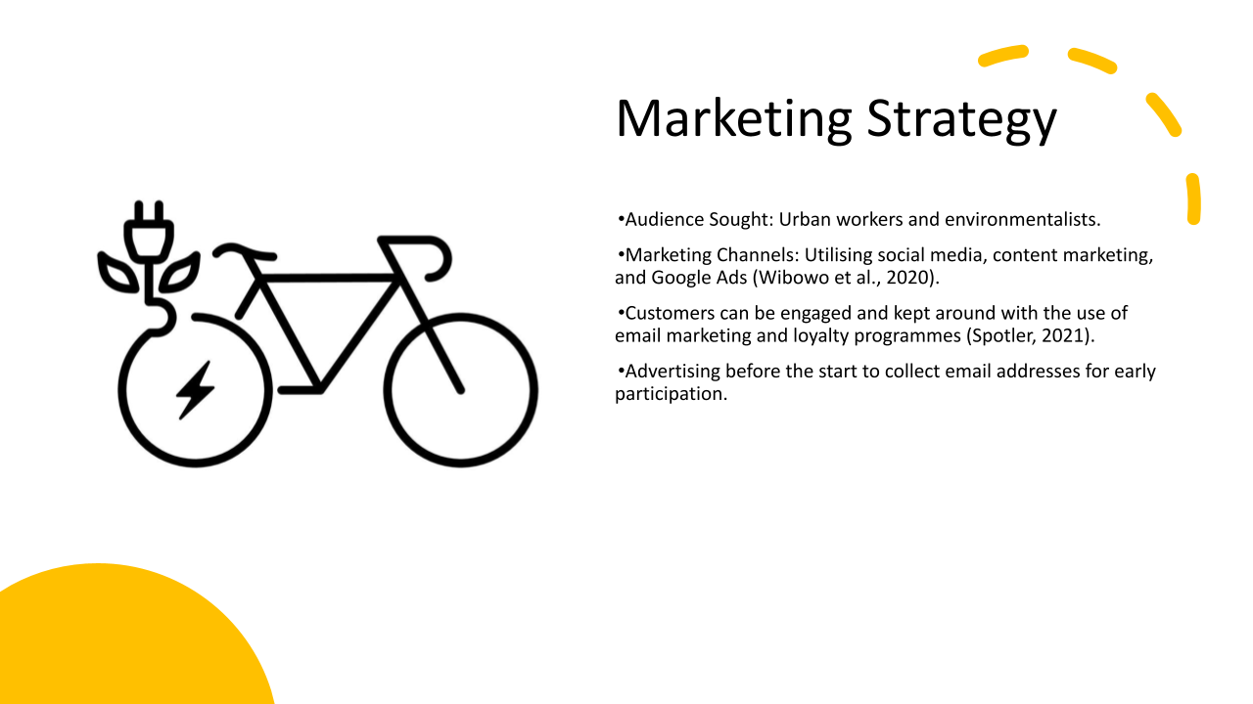

Urban commuters who value sustainable transit and environmentalists are our main marketing targets. We use a thorough and unified strategy to attract these target demographics. Facebook is used to interact with potential subscribers through compelling content and e-bike availability notifications. Our website uses content marketing to educate and entertain readers with urban mobility and sustainability blog entries and articles. Targeting electric bike-sharing and sustainable transportation keywords with Google Ads increases visibility. The topic is email marketing, specifically how to keep subscribers engaged. This is done through constant information dissemination and loyalty initiatives. Pre-launch Promotional Strategy: We collect email addresses before our product launch to encourage early engagement and interest in EcoLogiWheels. This complete marketing strategy ensures effective engagement and retention of our target group.

Privacy and Data Protection
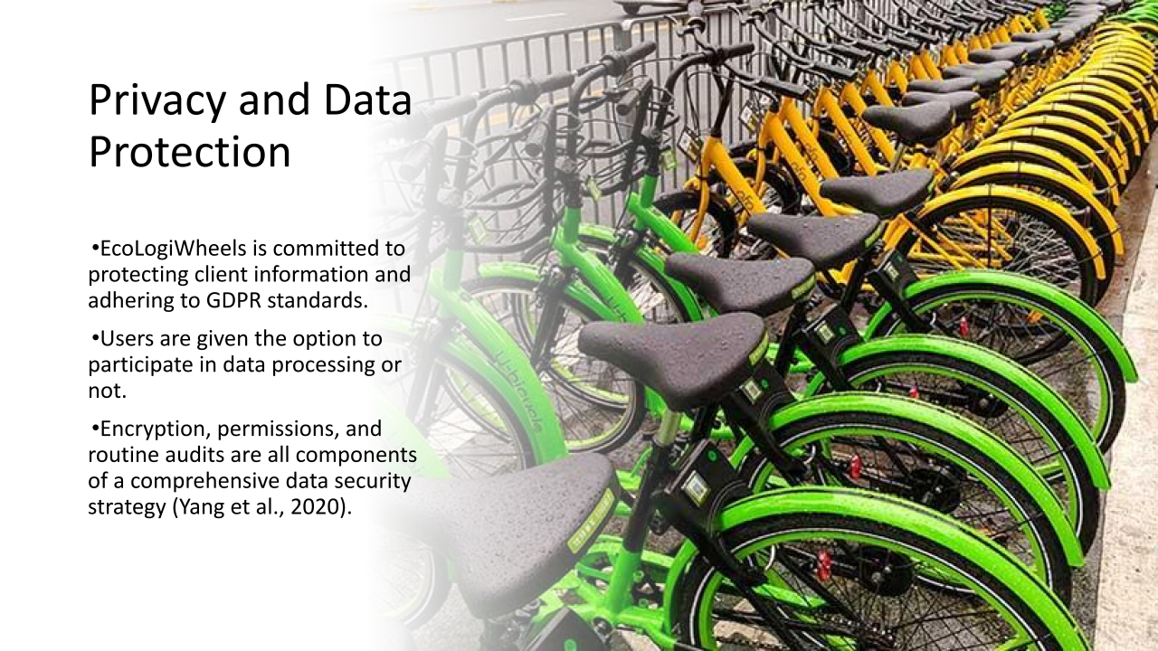
EcoLogiWheels is committed to protecting your privacy and complying with GDPR. When it comes to protecting consumer information, we will not waver in our dedication. We place a premium on user approval, so everyone has the option to participate in or decline data collection. This gives our clients more agency over their own data. We've taken extensive precautions to protect your data, such as encrypting it while in transit and at rest, limiting who can access it, and conducting regular security assessments to spot and eliminate vulnerabilities. By following these guidelines, we ensure that our users' personal information is protected and gain their trust.

What I have Learned and Future Benefits
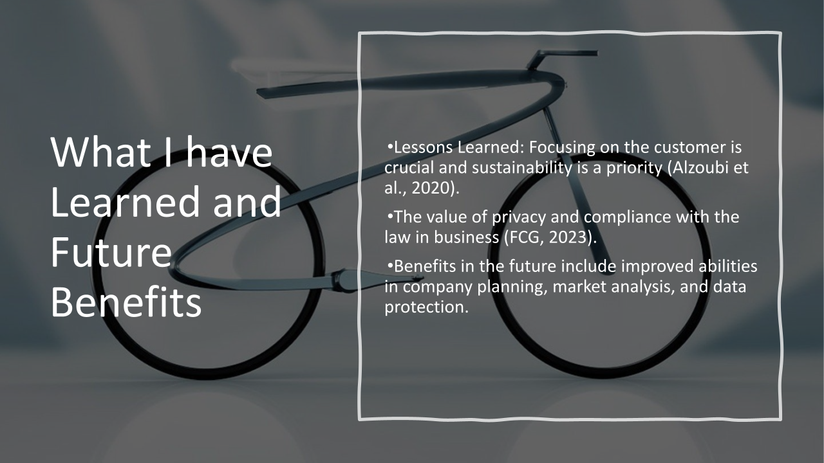
The job has helped shed light on some very important facts. In the first place, it stresses how crucial it is to prioritise long-term viability and customer satisfaction when dealing with contemporary issues. Second, in this day of increased data privacy concerns, it highlights the importance of data protection and regulatory compliance in all business operations. These insights will be helpful in the years to come. They've helped me become more proficient in market analysis, data security, and business strategy. These abilities and insights will be critical to the development and success of future entrepreneurial endeavours, guaranteeing that they are not only long-lasting and customer-centric, but also fully compliant with data protection legislation and legal criteria.

Conclusion
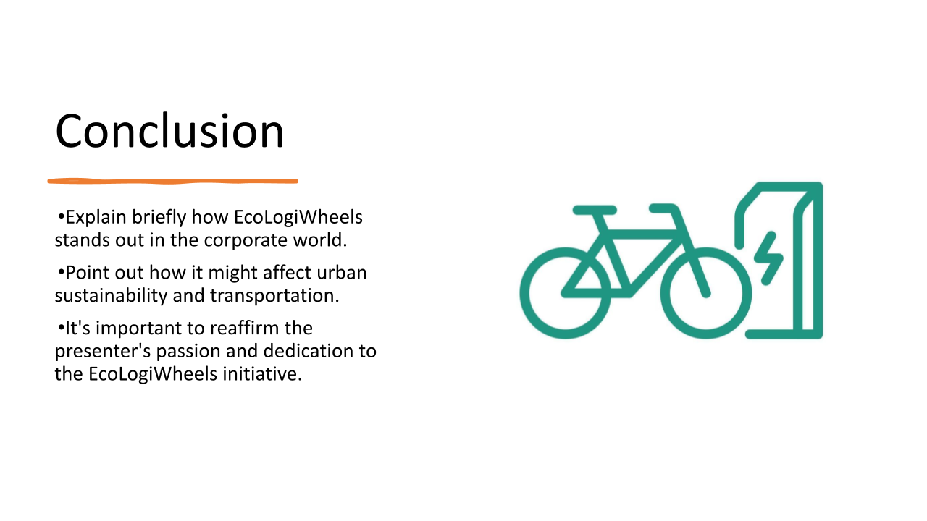
In conclusion, EcoLogiWheels is more than a commercial opportunity; it's a game-changing technology with the potential to alter the face of urban sustainability and transportation. Our goal is to significantly improve city life by reducing traffic and carbon emissions through the introduction of a low-cost, easy-to-use transport option. There is a lot to gain, and everyone involved is fully dedicated to seeing it through. EcoLogiWheels has the potential to improve the lives of city commuters and the environment, and we couldn't be more thrilled about it. Your consideration is greatly appreciated. Let's hit the road and head for a more environmentally friendly and sustainable tomorrow.

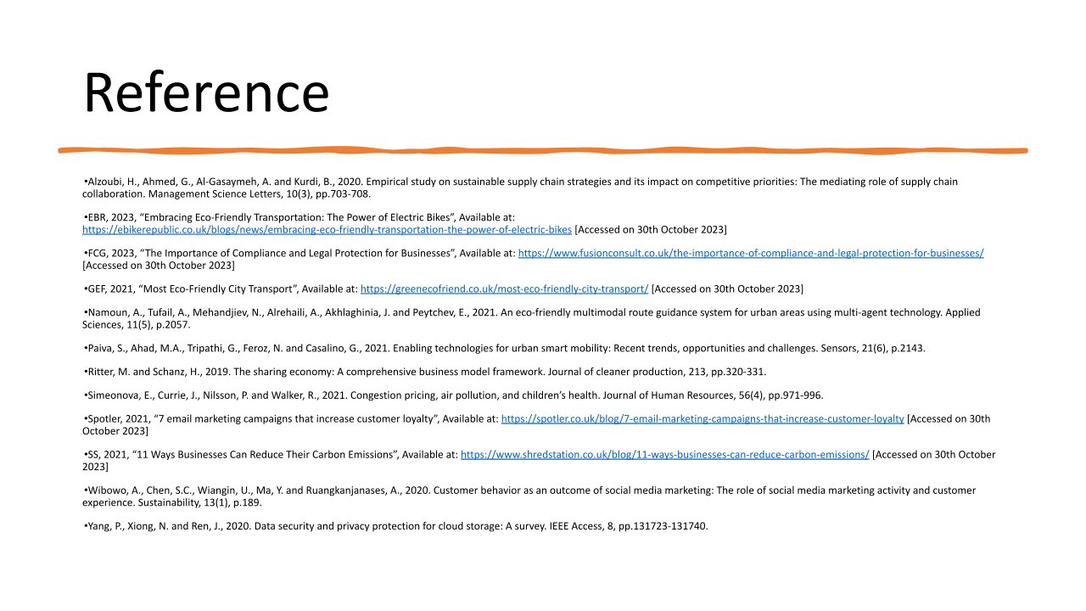

Reference

Task 1
Baker, W.E., Grinstein, A. and Perin, M.G., 2020. The impact of entrepreneurial orientation on foreign market entry: the roles of marketing program adaptation, cultural distance, and unanticipated events. Journal of International Entrepreneurship, 18, pp.63-91.
BC, 2023, “What is geo-targeting?”, Available at: https://www.bigcommerce.co.uk/ecommerce-answers/what-is-geo-targeting/ [Accessed on 30th October 2023]
Bieliński, T., Dopierała, Ł., Tarkowski, M. and Ważna, A., 2020. Lessons from implementing a metropolitan electric bike sharing system. Energies, 13(23), p.6240.
CSA, 2023, “Hypertext Transfer Protocol Secure (HTTPS)”, Available at: https://www.csa.gov.sg/Tips-Resource/internet-hygiene-portal/information-resources/https#:~:text=Hypertext%20transfer%20protocol%20secure%20(HTTPS)%20is%20the%20secure%20encrypted%20version,service%2C%20or%20health%20insurance%20provider. [Accessed on 30th October 2023]
EBR, 2023, “Embracing Eco-Friendly Transportation: The Power of Electric Bikes”, Available at: https://ebikerepublic.co.uk/blogs/news/embracing-eco-friendly-transportation-the-power-of-electric-bikes [Accessed on 30th October 2023]
Eleken, 2021, “What is SaaS? Explanation, Benefits, and Examples”, Available at: https://www.eleken.co/blog-posts/what-is-saas-explanation-benefits-and-examples [Accessed on 30th October 2023]
GOV, 2019, “Data protection”, Available at: https://www.gov.uk/data-protection#:~:text=The%20Data%20Protection%20Act%202018%20is%20the%20UK's%20implementation%20of,used%20fairly%2C%20lawfully%20and%20transparently [Accessed on 30th October 2023]
Hostinger, 2023, “9 Cloud Security Best Practices and How to Implement Them”, Available at: https://www.hostinger.co.uk/tutorials/cloud-security-best-practices [Accessed on 30th October 2023]
ICO, 2019, “What are PECR? ”, Available at: https://ico.org.uk/for-organisations/direct-marketing-and-privacy-and-electronic-communications/guide-to-pecr/what-are-pecr/#:~:text=PECR%20are%20the%20Privacy%20and,the%20e%2Dprivacy%20Directive'. [Accessed on 30th October 2023]
Kim, J.J., Steinhoff, L. and Palmatier, R.W., 2021. An emerging theory of loyalty program dynamics. Journal of the Academy of Marketing Science, 49, pp.71-95.
Lewandowski, D. and Schultheiß, S., 2023. Public awareness and attitudes towards search engine optimization. Behaviour & Information Technology, 42(8), pp.1025-1044.
Li, F., Larimo, J. and Leonidou, L.C., 2021. Social media marketing strategy: definition, conceptualization, taxonomy, validation, and future agenda. Journal of the Academy of Marketing Science, 49, pp.51-70.
Marky, K., Ragozin, K., Chernyshov, G., Matviienko, A., Schmitz, M., Mühlhäuser, M., Eghtebas, C. and Kunze, K., 2022. “Nah, it’s just annoying!” A Deep Dive into User Perceptions of Two-Factor Authentication. ACM Transactions on Computer-Human Interaction, 29(5), pp.1-32.
Muhammad, T., Munir, M.T., Munir, M.Z. and Zafar, M.W., 2022. Integrative Cybersecurity: Merging Zero Trust, Layered Defense, and Global Standards for a Resilient Digital Future. INTERNATIONAL JOURNAL OF COMPUTER SCIENCE AND TECHNOLOGY, 6(4), pp.99-135.
Rosmalasari, T.D., Lestari, M.A., Dewantoro, F. and Russel, E., 2020. Pengembangan E-Marketing Sebagai Sistem Informasi Layanan Pelanggan Pada Mega Florist Bandar Lampung. Journal of Social Sciences and Technology for Community Service (JSSTCS), 1(1), pp.27-32.
SL, 2023, “How Do I Protect Customer Data?”, Available at: https://sprintlaw.co.uk/articles/customer-data-protection/ [Accessed on 30th October 2023]
SS, 2023, “Introduction to Marketing”, Available at: https://www.studysmarter.co.uk/explanations/marketing/introduction-to-marketing/ [Accessed on 30th October 2023]
Ucla, 2023, “5 Environmental Benefits of Sustainable Transportation”, Available at: https://transportation.ucla.edu/blog/5-environmental-benefits-sustainable-transportation [Accessed on 30th October 2023]
Yang, Y., Wu, X., Zhou, P., Gou, Z. and Lu, Y., 2019. Towards a cycling-friendly city: An updated review of the associations between built environment and cycling behaviors (2007–2017). Journal of Transport & Health, 14, p.100613.
Yaqoob, H., Teoh, Y.H., Goraya, T.S., Sher, F., Jamil, M.A., Rashid, T. and Yar, K.A., 2021. Energy evaluation and environmental impact assessment of transportation fuels in Pakistan. Case Studies in Chemical and Environmental Engineering, 3, p.100081.

Task 2
Alzoubi, H., Ahmed, G., Al-Gasaymeh, A. and Kurdi, B., 2020. Empirical study on sustainable supply chain strategies and its impact on competitive priorities: The mediating role of supply chain collaboration. Management Science Letters, 10(3), pp.703-708.
EBR, 2023, “Embracing Eco-Friendly Transportation: The Power of Electric Bikes”, Available at: https://ebikerepublic.co.uk/blogs/news/embracing-eco-friendly-transportation-the-power-of-electric-bikes [Accessed on 30th October 2023]
FCG, 2023, “The Importance of Compliance and Legal Protection for Businesses”, Available at: https://www.fusionconsult.co.uk/the-importance-of-compliance-and-legal-protection-for-businesses/ [Accessed on 30th October 2023]
GEF, 2021, “Most Eco-Friendly City Transport”, Available at: https://greenecofriend.co.uk/most-eco-friendly-city-transport/ [Accessed on 30th October 2023]
Namoun, A., Tufail, A., Mehandjiev, N., Alrehaili, A., Akhlaghinia, J. and Peytchev, E., 2021. An eco-friendly multimodal route guidance system for urban areas using multi-agent technology. Applied Sciences, 11(5), p.2057.
Paiva, S., Ahad, M.A., Tripathi, G., Feroz, N. and Casalino, G., 2021. Enabling technologies for urban smart mobility: Recent trends, opportunities and challenges. Sensors, 21(6), p.2143.
Ritter, M. and Schanz, H., 2019. The sharing economy: A comprehensive business model framework. Journal of cleaner production, 213, pp.320-331.
Simeonova, E., Currie, J., Nilsson, P. and Walker, R., 2021. Congestion pricing, air pollution, and children’s health. Journal of Human Resources, 56(4), pp.971-996.
Spotler, 2021, “7 email marketing campaigns that increase customer loyalty”, Available at: https://spotler.co.uk/blog/7-email-marketing-campaigns-that-increase-customer-loyalty [Accessed on 30th October 2023]
SS, 2021, “11 Ways Businesses Can Reduce Their Carbon Emissions”, Available at: https://www.shredstation.co.uk/blog/11-ways-businesses-can-reduce-carbon-emissions/ [Accessed on 30th October 2023]
Wibowo, A., Chen, S.C., Wiangin, U., Ma, Y. and Ruangkanjanases, A., 2020. Customer behavior as an outcome of social media marketing: The role of social media marketing activity and customer experience. Sustainability, 13(1), p.189.
Yang, P., Xiong, N. and Ren, J., 2020. Data security and privacy protection for cloud storage: A survey. IEEE Access, 8, pp.131723-131740.

