3. Chapter Three: Methodology

3.1 Introduction
This chapter of the research details the methodology used to investigate the factors involved In incidents of assault on Police officers within South Wales Police. The objectives of this research are;
- Identify the forms of violence most experienced by police officers.
- Identify the factors most commonly contributing to violence against police officers.
- Examine the underlying causes of risk factors most associated with violence against police officers.
- To evaluate the effectiveness of existing force policies and procedures for officers attending incidents resulting in assaults against them.

3.2 Research Onion
Saunders, Lewis and Thornhill (2009) devised the Research Onion (Fig.1) which is one of the most used methods in academic writing in relation to the collection of primary data and the subsequent analysis of said data.
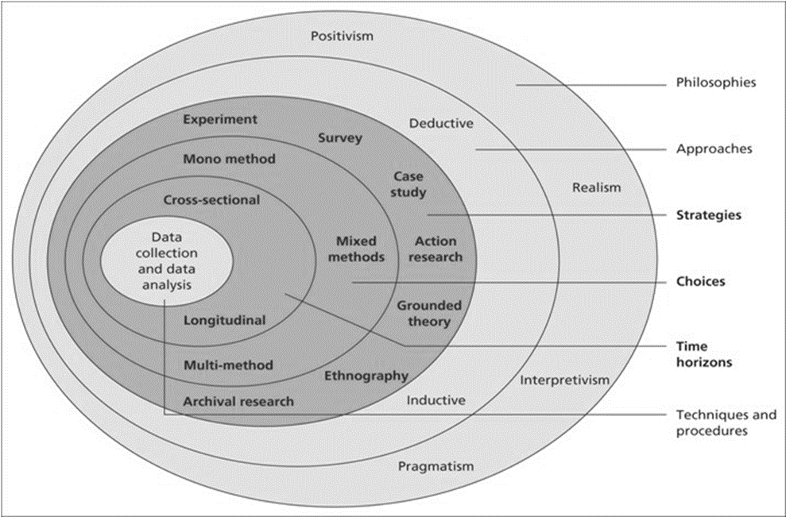
Figure 1. Annotated Diagram – The Research Onion showcasing the researcher’s chosen research process for this study (Source: Saunders, Lewis and Thornhill, 2009).

3.3 Research Philosophy
The first layer of the research onion consists of the research philosophy, which is considered to be the foundation of the study as it explains the set of beliefs the research is built upon (Jansen 2023). The philosophies within the first layer of the research onion consist of positivism, realism, interpretivism and pragmatism. Within this Positivism, Interpretivism and Pragmatism are considered the three main research philosophies (Phair and Warren, 2021). These three can be considered linked philosophies as they can fall within the larger Epistemology philosophy. Epistemology can be considered a theory relating to knowledge and is concerned with the mind’s relation to reality (Benton, 2017), that is how we obtain knowledge and then come to understand.
Bryman (2016) explains that Positivism poses that knowledge exists outside of what is being studied, and what is being studied can only be done so objectively and cannot include opinions or personal viewpoints. Interpretivism on the other hand places an emphasis on the impact both social and cultural factors can have on a person. Within interpretivism, the researcher actively draws a holistic view of the participant and their actions, thoughts, and meanings. Finally, Pragmatism approaches research from a practical perspective where the knowledge gained is constantly questioned and interpreted. This means that there is an element of researcher involvement and subjectivity when drawing conclusions from participants responses.
Within the pragmatic research approach, both quantitative and qualitative methods can be utilised, such as those used within a mixed-methods approach, as this research will utilise pre-existing figures collected by South Wales Police along with surveys involving both quantitative and qualitative questions the research philosophy utilised for this study will be Pragmatism.

3.4 Research Approach
There are two primary types of research approaches frequently used within academic writing, these being a deductive approach and an inductive approach, and are visible within Figure 1. According to Bryman (2016), these approaches differ significantly. Firstly, a deductive study starts with a theory, with the researcher’s objective being to either prove or disprove the initial theory or hypothesis. Conversely, Bryman (2016) describes an inductive study as effectively the reverse of a deductive one. Here the researchers may come by or identify findings and subsequently gather data with the aim of drawing a conclusion as to the underlying reasons behind the phenomena.
As such, this research project will utilise an inductive approach, with the specific goal of enhancing the comprehension of the underlying factors involved in assaults against police officers within the South Wales Police force.

3.5 Ethical Considerations
The research undertaken should not pose any ethical concerns since participation is entirely voluntary and will be restricted to individuals aged eighteen and above. Participants will have the ability to withdraw from the study at any point if they feel it is warranted. Participants will also be informed before commencing the survey of an estimated time-frame for completion in order to allow them to arrange a suitable time for completion.
Nonetheless, it is important to note that all gathered data will be treated with the utmost confidentiality and anonymity, primarily because the research employs formal online questionnaires where no personal data is retained. In order to safeguard the data collected from any potential misuse, stringent password protection and encryption methods will be used.

3.6 Research Strategy and Choice
The chosen approach by the researcher is to develop an online questionnaire that will be accessible through hyperlinks shared via South Wales Police force intranet and e-mail. This approach recognises the potential sensitivity of the subject matter, and that conducting face-to-face interviews may deter some participants. This online method aims to provide complete anonymity, thereby encouraging individuals who might otherwise hesitate to participate. A further advantage of completing the research using this method is that it is time efficient, the easier and quicker it is for participants to complete, the more likely it is that individuals will participate.
Additionally, this approach stands out as the most straightforward and cost-effective way to conduct the questionnaire. Given the need for a substantial volume of data, it offers the most efficient means of ensuring an adequate number of participants. The high number of participants will facilitate the collection of sufficient quantitative data to determine outcomes, alongside qualitative data, thereby enhancing the research’s reliability and validity.
An anticipated drawback of this method is that gathering and analysing the data obtained from the questionnaire responses may be time consuming and require substantial effort.

3.7 Time Horizon
Within the Research Onion two distinct time horizons exist, the longitudinal and cross-sectional approaches. A longitudinal approach to research permits the examination and comparison of behaviours over an extended duration. In contrast, a cross-sectional study design is an observational method that enables the analysis of data from participants at a particular moment, often through surveys or questionnaires (Sahay, 2016).
For this research project, the cross-sectional approach will be employed. This choice maintains the efficiency of the research as it is the most suitable model for population-based surveys (Kesmodel, 2018) and also suits the brief timeframe of this research.

3.8 Techniques: Data Collection and Analysis
The questionnaire will be distributed through an online form and exclusively to officers within South Wales Police. This approach aims to ensure that the responses originate from the individuals who are likely to have encountered violence against them within their roles.
To maintain anonymity, officers completing the questionnaire will provide minimal personal information, such as age, gender, and length of service. None of the questions will request any personal details that could potentially identify any individual.
In order to obtain a sufficient dataset, the research will aim to conduct 100 surveys. On completion, the quantitative data obtained will be analysed and displayed into various graphs and charts in order to show the findings and to potentially identify any patterns or recommendations to be made.

3.9 Sample
Jansen (2023b) defines identifying a sample as the process of defining a subgroup (sample) from the larger group of interest (population). Ghauri, Gronhaug and Strange (2020) posed that when conducting research, it becomes necessary to select a representative portion of the population, as studying the entire population would be impractical for comparison purposes. Nonetheless, it’s worth noting that sample sizes smaller than 25 will often yield results influenced by individual responses. In such instances, larger sample sizes lead to more dependable findings (Flick, 2011), particularly in quantitative research.
Quantitative research demands a larger number of participants to ensure the reliability of its findings. While sample characteristics remain significant in qualitative research, smaller samples are typically employed due to personal nature of this approach and its reduced reliance on extensive data from multiple sources.
In this research the aim is to target 100 respondents, all of which will be officers within South Wales Police force. This sample size will allow the researcher to capture individual perceptions of the issue of assaults against emergency workers effectively. This is also an optimal sample size as the research encompasses both quantitative and qualitative approaches.

3.11 Reliability and Validity
When assessing any data collection method within a study, two critical variables to consider are reliability and validity. Roberts and Priest (2006) emphasised the role of reliability and validity in demonstrating the rigour of the research processes and the credibility of the research findings.
Whilst the terms validity and reliability are often used interchangeably, they carry distinct meanings. Reliability signifies consistency, whereas validity assesses whether the tests effectively measure their intended variables (Drost, 2011).
In this study, adherence to a predetermined structure provided by the Research Onion will enhance the reliability and validity of results. Additionally, questionnaires are being utilised and are considered to be a trustworthy and valid means of data collection because they offer extensive insights into participants’ perspectives (Akinci and Saunders, 2015).
However, it is essential to acknowledge that Cohen, Manion and Morrison (2017) noted that complete elimination of threats to validity and reliability is unlikely, but their impact can be mitigated by maintaining a focus on validity and reliability throughout the research process.

3.12 Limitations
Whilst being beneficial for enhancing knowledge of the suspect of assaults on emergency workers within South Wales Police, having a target sample consisting solely of South Wales Police officers may also offer its own limitations. One of the reasons for this being that not only is it likely other students within the current university cohort completing research will use surveys or questionnaires sent to South Wales Police officers, but students within previous cohorts will have also used these methods. This in turn could lead to the targeted sample becoming overly saturated with requests for survey completion, which could result in surveys being avoided, overlooked, or not completed correctly. Consequently, the number of survey responses and the accuracy of results may be affected.
Furthermore, it is anticipated that despite efforts being made to ensure the participants understanding of the questions and completion of the survey, there is still the likelihood that some of the participants completing the survey may misinterpret or fail to understand what is being asked, again affecting the results.

3.13 Conclusion
Within this chapter the aspects of the research approach have been examined and clarified, the subsequent chapter aims to amalgamate, present and investigate the outcomes from the collected data.

References –

1. Akinci, C. and Saunders, M. (2015) Using questionnaire surveys for within-organisation HRD research: In Handbook of research methods on human resource development. London: Edward Elgar Publishing.

2. Benton, M.A. (2017) ‘EPISTEMOLOGY PERSONALIZED’, The Philosophical quarterly, 67(269), pp. 813–834. Available at: https://doi.org/10.1093/pq/pqx020.

3. Bryman, A. (2016) Social research methods. 5th ed. Oxford ;: Oxford University Press.

4. Cohen, L., Manion, L. and Morrison, K., 2017. Validity and reliability. In Research methods in education (pp. 245-284). Routledge.

5. Drost, E.A. (2011) ‘Validity and reliability in social science research’, Education, research and perspectives, 38(1), p. 1–.

6. Flick, U., (2011). ‘A beginner’s guide to doing a research project’. Introducing Research.

7. Ghauri, P., Gronhaug, K. and Strange, R. (2020) Research Methods in Business Studies. Cambridge University Press.

8. Jansen, D. (2023a) Research Philosophy & Paradigms Positivism, Interpretivism & Pragmatism, Explained Simply. Available at https://gradcoach.com/research-philosophy/ (Accessed September 2023)

9. Jansen, D. (2023b) Sampling Methods & Strategies 101. Available at https://gradcoach.com/sampling-methods/ (Accessed September 2023)

10. Kesmodel, U.S., 2018. Cross‐sectional studies–what are they good for?. Acta obstetricia et gynecologica Scandinavica, 97(4), pp.388-393.

11. Phair, D. and Warren, K. (2021) Saunders’ Research Onion: Explained Simply. Available at https://gradcoach.com/saunders-research-onion/ (Accessed September 2023)

12. Roberts, P. and Priest, H. (2006) ‘Reliability and validity in research’, Nursing standard, 20(44), pp. 41–45. Available at: https://doi.org/10.7748/ns2006.07.20.44.41.c6560.

13. Sahay, A., 2016. Peeling Saunder's research onion. Research Gate, Art, 3(2), pp.1-5.

14. Saunders, M., Lewis, P. and Thornhill, A. (2009) Research methods for business students. England: Pearson Education Limited.

