Business Plan
Sweet & Salty Romanian Traditional Pastry
Students and ID Number:
- Cristina Anton 2110293
- Andreea Rotariu 2107119
- Andreea Tamba 2112920
- Alice luliana loan 1911517
- Mirabela Mutcu 2108200
- Alys - Oksana Bosneac 2113970
Name Lecture: Olu Adegbite

Module: Managing Enterprise in the 21 st Century
BMSW 4006

Table of Contents
1. Overview 3
2. Product and Services 4
3. Market audit 4
4. Target Market 8
5. Marketing Plan 9
6. Management Team 10
7. Financial Plan 10
References 12

Summary
Sweet & Salty Romanian Traditional is a start-up bakery based in Birmingham, UK. This business is owned and managed by six partners. The company provides customers with a salty and sweet pastry product. The company plans to build a strong market position in the urban region thanks to the industry experience of its partners. The business aims to provide competitively priced products to meet the needs of local people. In addition, the company implement effective marketing mix strategies to build a large consistent customer base. The business has borrowed £50,000 from the Lottery UK.

1. Overview
Sweet & Salty Romanian Traditional Pastry is a Private Limited Company LTD located in Birmingham, the UK. This business is a traditional Romanian pastry store which specializes in sweets and pastry. We expect to entice the interest of a regular loyal consumer base with our variety of pastry products. It is equally owned by two or more partners to operate and manage business operations and share its profits. The business plans to build a strong market position in Birmingham thanks to the industry experience of its partners and the mild competitive environment in the region. By opening a traditional Romanian pastry shop, we are committed to providing our consumers with a wide range of salty and sweet traditional pastries. In addition, we intend to improve customer satisfaction with cold, hot, salty, and sweet pastries by presenting varied flavor to increase their pleasure (Yenny, Sulistyowati and Afriani 2022).

2. Product and Services
The business sells sweet and salty pastries along with exceptional customer service in a traditional Romanian pastry store. We aim to accommodate the highest qualities and standards. We will cater for the needs for healthy and delicious pastries with different flavors to attract many customers in Birmingham. In the area, numerous students, Romanian people, and many other nationalities can be attracted by traditional pastry. Sweet & Salty Romanian Traditional Pastry always offers fresh and hand-made pastry products. We aim to provide our products at competitive prices to meet the demand of middle to high-income people and travelers. In addition, our business always focuses on meeting the demands of local customers, as well as a substantial level of travelers from nearby highways (Sitorus et al. 2021).

3. Market audit
SWOT Analysis
Strengths
As our business is new in the bakery market, our qualified and well-experienced bakers play a vital role in the success of our business in Birmingham. This is because they will produce a delicious and quality pastry. The delicious and tasty pastry will attract people to our traditional Romanian pastry shop. The main strength of the business is its ability to provide large orders for events and parties in Birmingham quickly. In addition, artistic and unique designs of pastries add value to our products. The food and taste will remain the same, but artistic presentation and creative design often make a difference (Ratnadianti, Fahmi and Hannan 2020). This will give us an edge over our competitors in the bakery industry. Additionally, the things that matter at the end of the day are experienced workers and skilled bakers. They will help the business in many ways, such as producing better-quality products, better customer satisfaction, and less wastage.
Weaknesses
As production and indirect/direct costs increase, we may increase the price to cover expenses. But consumers do not like daily food price increases as they purchase them casually daily. Then again, it takes a lot of time for a new business to gain the trust of buyers and a reputation as an established brand in the marketplace as a new bakery in Birmingham. Opportunities
The product portfolio expansion is an excellent conventional strategy for winning market share. For this purpose, Sweet & Salty Romanian Traditional Pastry needs to do market research to find products that are missing in the market. Recently, we have introduced bakery products in a nearby environment. We always offer exceptional products to our customers at affordable prices. However, some foods contain high levels of sugar. This substance causes high blood pressure, high cholesterol levels, heart attacks, and obesity. Hence, Millennials and Gen Z are shifting their focus to healthy products. In this context, it provides an excellent opportunity for our business to offer pastries with less sugar. This will allow the business to entice the attention of the young diet-conscious consumer market. This move will also enable the company to target a market of diet-and health-conscious consumers (Ripsas, Schaper and Tröger 2018).
Threats
The bakery industry has become very competitive as many pastry businesses have created franchises. Their presence makes it difficult for new brands and small bakery businesses, like Sweet & Salty Romanian Traditional Pastry shop, to maintain their market share in Birmingham. The main competitors are LOAF, The Early Bird Bakery, and Medicine Bakery. These businesses spend tens of thousands of pounds on promoting and marketing their services and products. They have built a loyal customer database, and it will be difficult to change the minds of those buyers. Therefore, we need to conduct market research to understand the marketing strategies of our business competitors and provide affordable pastry products to grow our business successfully (Mariani, Bartoloni and Morelli 2019).
In addition, the business must follow the health and safety rules for the preparation of pastry products. As it is a food business, the production process and the quality of foods are essential to our customers. Thus, we must set high standards for our bakery irrespective of inspection by members of the food authority. As a result, we have certified our products according to food safety regulations in the UK. This will demonstrate our commitment to the business (McKenzie 2017).
PESTLE Analysis
Political Factor
The UK government is actively enacting on the regulatory framework for food products, focusing more on sustainability sourcing and elements. The government enforces public health schemes, banning certain food items and a basic minimum wage. Furthermore, the government has banned genetically modified foods. Therefore, it generates a robust potential opportunity for product line innovation while focusing on healthy products.
Economic factors
The performance of the Sweet & Salty Romanian Traditional Pastry shop depends a lot on the abilities and skills of its workers. Thus, the appropriate availability of skilled employees and bakers for Sweet & Salty Romanian Traditional Pastry is essential to stay ahead of the competition. In general, the cost of hiring employees is rising in all industries. It is caused not only due to increased demand for workers but also because of the high government expectations for minimum wages (Paschen 2017).
Socio-cultural factors
The British social structure is diverse, with diverse cultural sensibilities. With the growth in education and progression in health and food safety research, customers are now actively seeking better and healthier food options. Also, the lifestyle is changing towards a comfortable and easy-go living, which means customers prefer to consume simple products but want the assurance of positive health effects.
Technological factors
Today, business sustainability focuses on technological advancements. Companies are investing heavily in emerging technologies to stay ahead of the competition in the UK bakery market. Therefore, Sweet & Salty Romanian Traditional Pastry must explore and anticipate the existing and future technological trends to make sure the long-standing business survival.
By investing in the right technological innovation, Sweet & Salty Romanian Traditional Pastry can gain operational efficiency, optimize user experience, and position itself as an innovative business in the UK (Yenny, Sulistyowati, and Afriani 2022).
Legal
This implication tends to affect the business operations in a multifaceted sense because the British government has launched a less sugar plan in the country. The government has imposed a sugar tax on beverages and food to minimize consumption and its associated risks (Magnani 2022).
Environmental Factors
The Sweet & Salty Romanian Traditional Pastry business works with social responsibility while fulfilling the laid down obligations. It is governed by corporate governance and regulations stipulated by the UK laws on manufacturing products. Additionally, Sweet & Salty Romanian Traditional Pastry can invest in renewable energy sources to reach the goal of sustainable business development (Gunawan and Melinda 2021).

4. Target Market
The primary target market for Sweet & Salty Romanian Traditional Pastry is the steady stream of Romanian people and students. We specifically target people with an appreciation for delicious desserts and a need for relaxation and comfort. The business targets people of all ages who love to eat pastries. The organization will specifically target locals and students in urban areas as the ready-to-eat food category is popular among millennials. Therefore, there is a lot of room for growth in the pastry and confectionery business in this population (Sharma, Nasreen and Mishra 2017). The main reason for shifting the focus of the industry to urban areas is the growing demand for sweet and salty snacks that can be enjoyed between drinks or meals. Sweet & Salty Romanian Traditional Pastry will target affluent and educated customers who are eager to try new products and experiences. (Sharma and Nasreen 2018).

5. Marketing Plan
Product
Sweet & Salty Romanian Traditional Pastry produced fresh-made confectionery products by considering the millennial target market. The target customers belong to urban families and anyone with a sweet tooth. Hence, the business will provide those customers with Romanian pastry with a wide variety and flavors. Sweet & Salty targets health-conscious customers with plans to introduce healthier versions such as unhealthy ingredients-free pastry (Nijssen 2017).
Price
The organization will adopt a value-based pricing strategy to stay ahead of the competition in the UK bakery market. Hence, the business will offer customers healthy and fresh pastries at medium prices. (Ratnadianti, Fahmi and Hannan 2020).
Promotion
Sweet & Salty will promote its traditional Romanian pastry through a digital media platform. Public perception and word-of-mouth are highly essential in the business aspect. In the marketing mix, word-of-mouth focuses on giving the best customer experience to encourage individuals to spread the positive word about the business. The organization also advertises its products through local newspapers, Facebook, and Instagram. (Heroux 2020).

6. Management Team
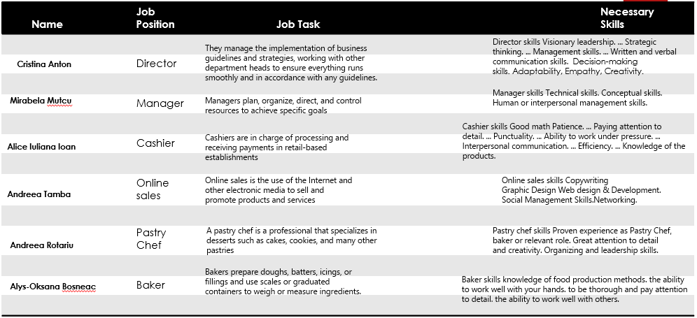

7. Financial Plan
Table 1: Cash Flow Statement

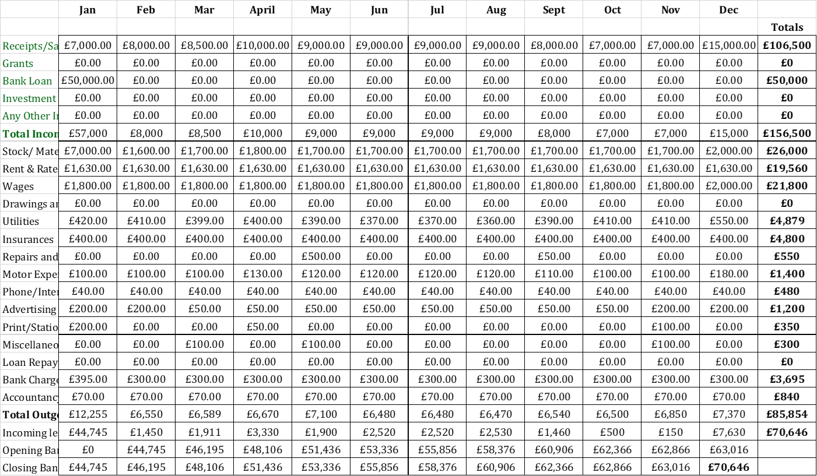

Table 2: Profit and Loss Statement
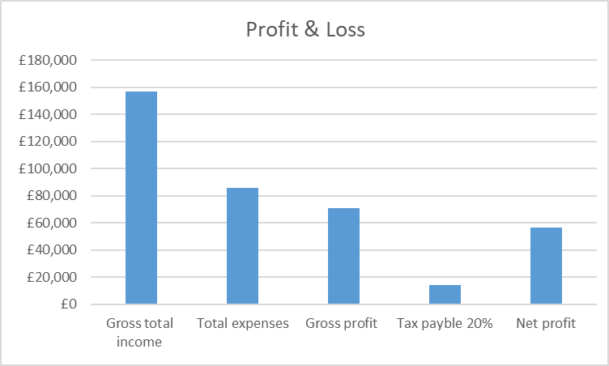
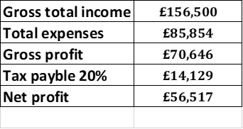
The company borrowed a £50,000 loan from The Lottery UK as a five-year loan. The company is expected to earn profits for this period to be approximately £56,517. The business does not anticipate any cash flow problems. The profits will be equally distributed among five partners of the company.

References
Gunawan, A. and Melinda, T., 2021. Analysis of Marketing Mix and Purchasing Decisions (a Study of Kene Kopi Products). KnE Social Sciences, pp.510-518.
Harris, T., 2018. Start-up: a practical guide to starting and running a new business. Springer.
Heroux, L., 2020. A Longitudinal Study of American and Canadian Convenience Store Marketing Strategies. International Business Research, 13(8), pp.1-66.
Magnani, G., 2022. Managing the "4Ps" in Culturally Distant Countries: From Theory to Business Practice. In Marketing in Culturally Distant Countries (pp. 131-184). Springer, Cham.
Mariani, G., Bartoloni, L. and Morelli, D., 2019. Managing uncertainty in the start-up environment: is a business plan an incentive or a limitation?. Managing uncertainty in the start-up environment: is a business plan an incentive or a limitation?, pp.73-96.
McKenzie, D., 2017. Identifying and spurring high-growth entrepreneurship: Experimental evidence from a business plan competition. American Economic Review, 107(8), pp.2278-2307.
Nijssen, E.J., 2017. Entrepreneurial marketing: an effectual approach. Routledge.
Paschen, J., 2017. Choose wisely: Crowdfunding through the stages of the start-up life cycle. Business horizons, 60(2), pp.179-188.
Ramli, NS, 2017. A review of marketing strategies from the European chocolate industry. Journal of Global Entrepreneurship Research, 7(1), pp.1-17.
Ratnadianti, A., Fahmi, I. and Hannan, S., 2020. Digital marketing strategy of small and medium enterprises for snack in Bogor city. Jurnal Manajemen & Agribisnis, 17(1), pp.74-74.
Ripsas, S., Schaper, B. and Tröger, S., 2018. A startup cockpit for the proof-of-concept. In Handbuch entrepreneurship (pp. 263-279). Springer Gabler, Wiesbaden.
Sharma, Y. and Nasreen, R., 2018. Perceived Consumer-centric Marketing-Mix at the Urban Bottom of the Pyramid-An Empirical Study of Non-core Food Items. Business and Management, 10(1).
Sharma, Y., Nasreen, R. and Mishra, V., 2017. Impact of consumer-centric marketing-mix on purchase behavior of non-core food items: An empirical study of urban subsistence marketplace. Asian J. Manag. Sci, 6, pp.28-41.v
Sitorus, N.B., Juliana, J., Maleachi, S., Djakasaputra, A. and Prabowo, G., 2021. Café Marketing Strategy Analysis in The Covid-19 Pandemic. International Journal of Social and Management Studies, 2(5), pp.44-53.
Velita, L. and Suson, J., 2020. Green marketing strategies for a sustainable business. Journal of Agriculture and Technology Management, 23(1), pp.26-34.
Yenny, M., Sulistyowati, R. and Afriani, M., 2022. Marketing Strategy of Sari Delicatessen Pastry Shop at Sari Pacific Jakarta. International Journal of Travel, Hospitality and Events, 1(2), pp.150-156.

