DATABASES AND APPLICATION DEVELOPMENT – (ACCA5026)
Assignment: Database creation and written report.

Adam Smith (2317631)
Digital Degree Apprenticeship

Table of Contents
Introduction 2
Entity Relationship Diagram & Schema 3
Database creation 4
Database creation 4
Table creation 4
Data entry 7
Testing constraints 15
Roll back and commit operations 15
Performance Tuning Enhancement 16
Appendix 17

Introduction
AdventureWorks Cycles (AWC) is an established cycle manufacturer who cover a large range of the market for cycles and cycling paraphernalia. In an effort to modernise and expand their business they intend to create an online business platform.
AWC have requested a consultation for a database solution for their proposed online marketplace. AWC have outlined their most important elements; Products, Manufactuerers, Categories, Customers and Orders, along with specific processes they would like the database to implement; Manufacturer Registration, Product Listing, Customer Registration, Product Purchase, Order processing and Feedback & Reviews

Entity Relationship Diagram & Schema
Through the design process for the intended database a database schema has been created to identify and document the required tables and fields to build the relational database. The Schema below shows the tables which will be created, along with their fields, primary and foreign keys and type of relationship. A full-scale copy has also been in the additional documents file.
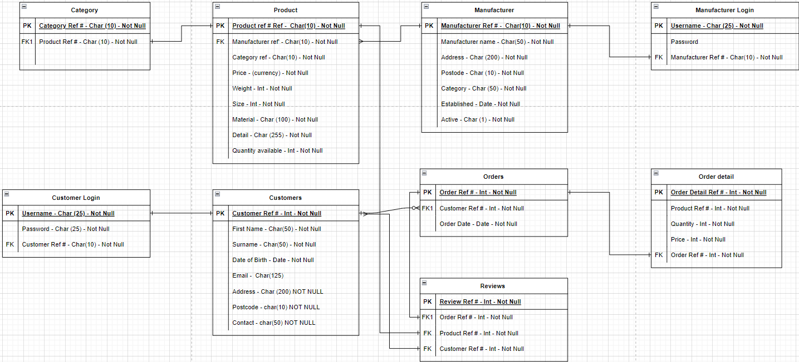
Figure 1 - Database Shema showing primary keys, foreign keys and all non-key attributes.

Below is a copy of the entity relationship diagram created during the design process to display the intended tables, fields and relationship between tables and processes. A full-scall copy of this is also included in the in the additional documents file.
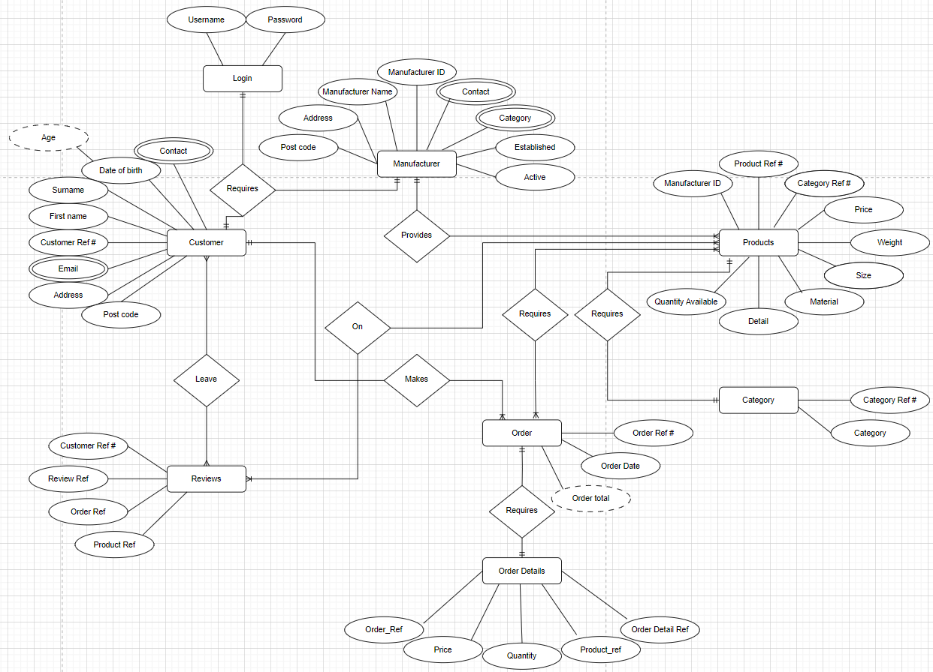
Figure 2 – ERD showing primary keys foreign keys and relationship types

Database creation
The database has been created in MYSQL. Below are screenshots of the commands used to create the database and the required tables. For each stage a screenshot is provided to document the MYSQL commands.

Database creation
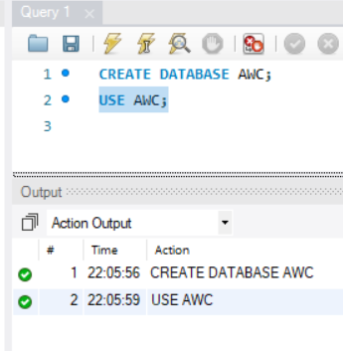
CREATE DATABASE AWC;
USE AWC;
Figure 3 – Database creation and command to use the created databse

Table creation
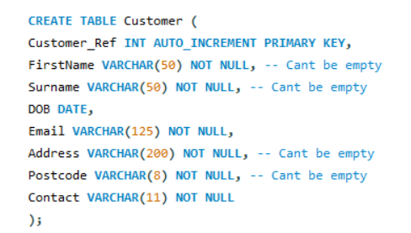
Figure 4 – Creation of customer table
Unfortunately, I was unable to get the table to commit without removing nearly all forms of validation. My primary issues were around the foreign key constraints. Were I to continue with the project this would be my first area of concern which will require rectification.

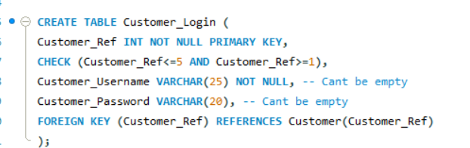
Figure 5 – Creation of Customer_Login table
The above tables displays constraints for Not Null (field cannot be empty), and ensuring a customer must have a reference of between 1-5 as this is the intended number of customers for testing. Were the database to go into production this would be removed as the database would require a large number of customers which should scale automatically with the auto increment for customer ref.

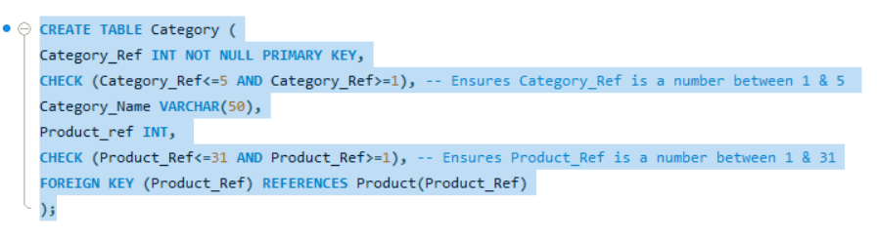
Figure 6 – Creation of category table
The above currently displays constraints to restrict the categories to 5 and products to 31. Were the database to go into production again these constraints would need to be adjusted in line with the current parameters for categories or products, i.e. to be adjusted if numbers increase or decrease.

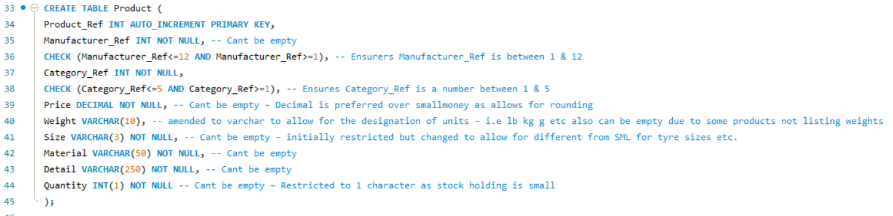
Figure 7 – Creation of Product table
An amendment has been made to this table and so it differs from the schema to allow for weight to be a varchar field to allow for the designation of units. Given categories can change items will be measured in different units and it is not practical to have a universal measurement across all categories.

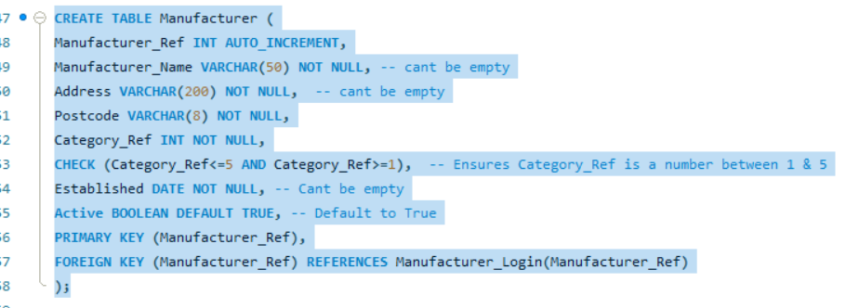
Figure 8 – Creation of Manufacturer table

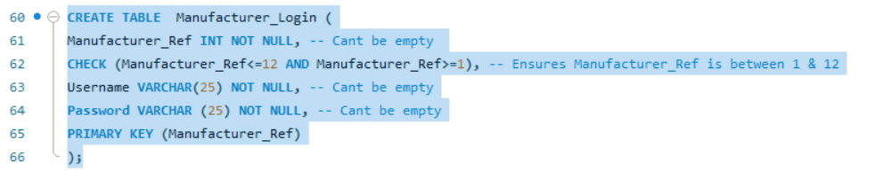
Figure 9 – Creation of Manufacturer_Login table

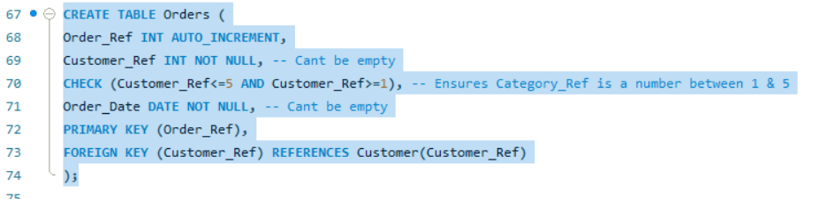
Figure 10 – Creation of Orders table

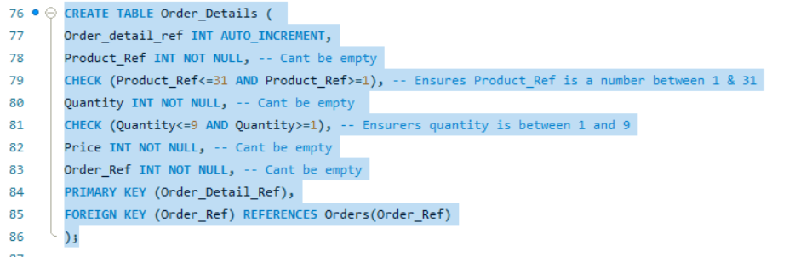
Figure 11 – Creation of order detail column
I have structured the database to have an order table and then an order detail table to allow for them both to be normalised to the 3rd form. The order table will have a single line per order, whilst the order detail column allows for multiple separate items (which will have an individual scaling Order_detail_ref) to be linked to the single order number or Order_Ref. It is expected for the Order_Detail table to be significantly larger than the Orders table.

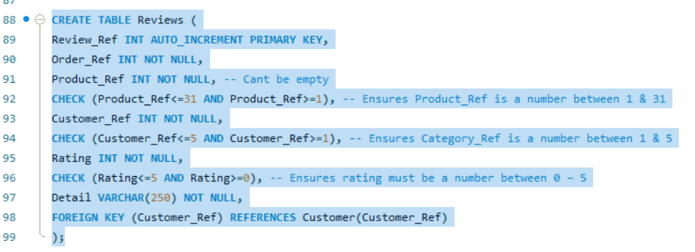
Figure 12- Creation of Reviews table
There is a change in the intended details for the Reviews table. I have been unable to commit the table with the intended foreign keys and so I have had to remove some of these relationships. It would be my intention for future improvement of the database to include these relationships as intended

Data entry
Below I document the process of populating the database with simulated data. For each stage I provide a screenshot of the MYSQL commands and the data as accepted.
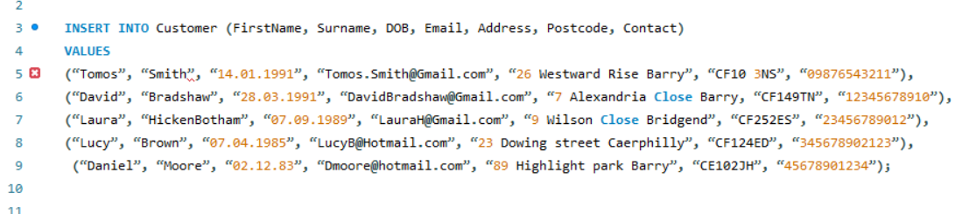
Figure 13 – Insert Customer Data command
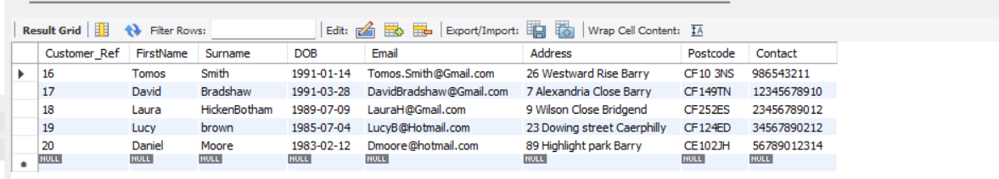
Figure 14 – Customer Data accepted

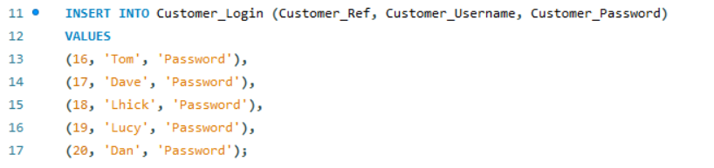
Figure 15 – Insert Customer Login command

At this stage I have had to temporarily drop a constraint, difficulties in introducing the data meant that the autoincrement feature pushed the customer reference above the table constraint of a reference of number 1-5. As documented below, the customer reference is now from 16-20
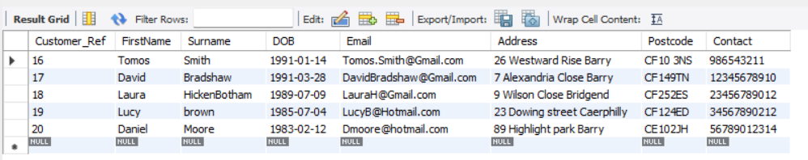
Figure 16 – Customer_login data accepted

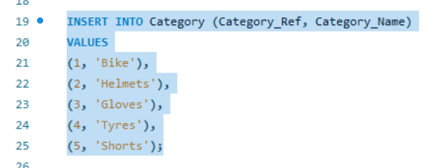
Figure 17 – Insert Category command
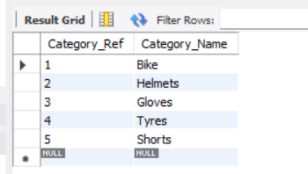
Figure 18 – Category data accepted
At this stage I have a differed from the schema. Initially I had noted that I would include a field for product references connected to each category, however, this would not allow to be normalised to the 3rd form and so I have removed this from the table.

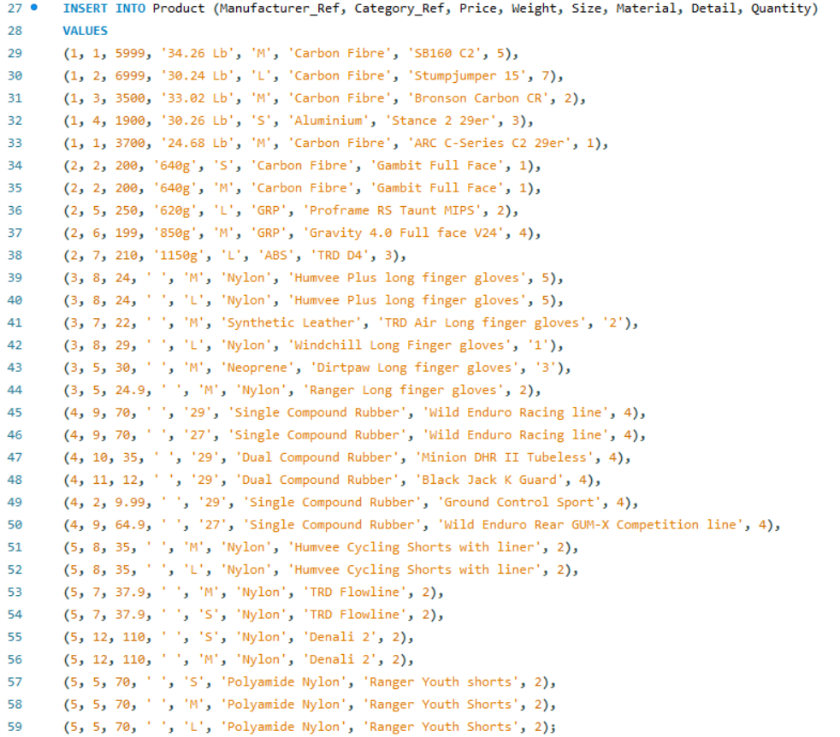
Figure 19 – Insert Product command
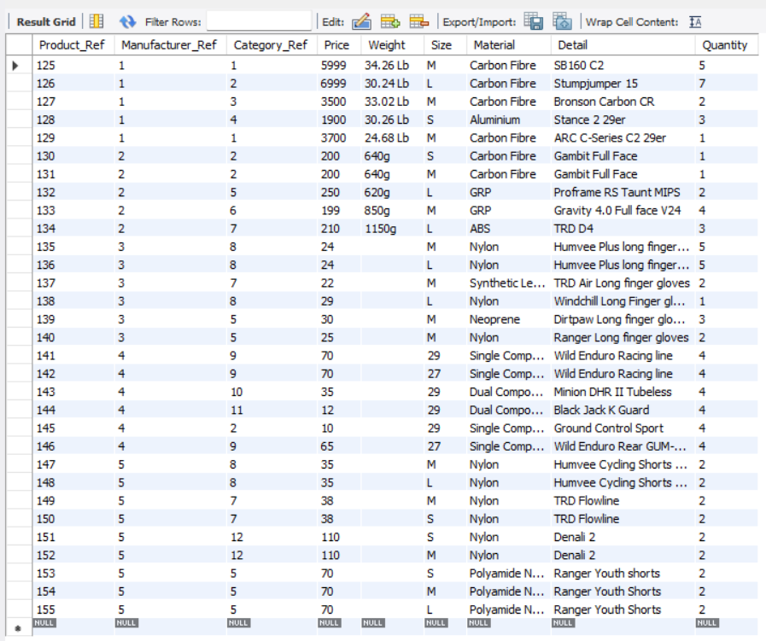
Figure 20 – Product data accepted

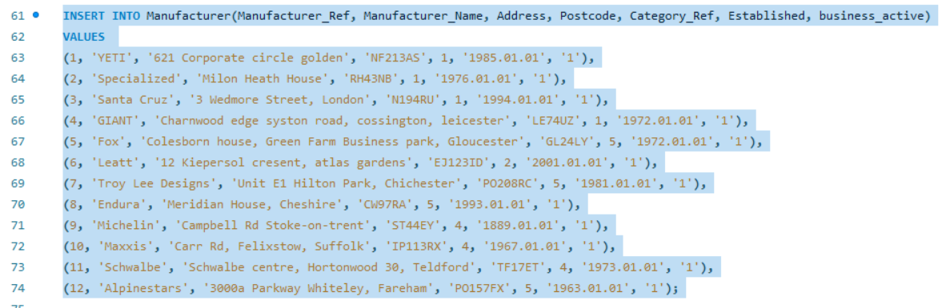
Figure 21 – Insert Manufacturer command

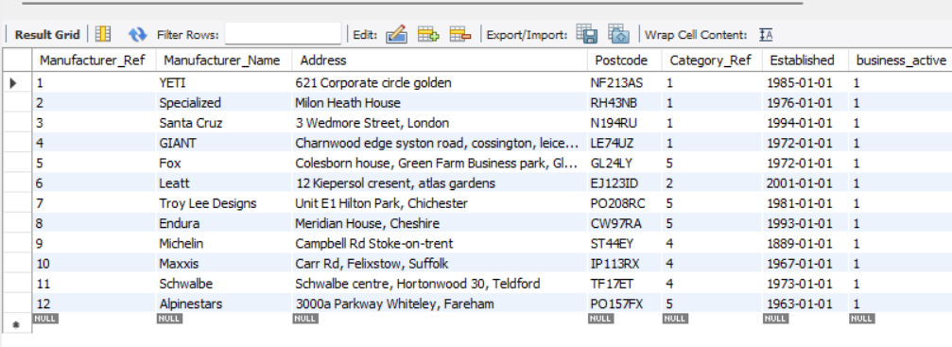
Figure 22 – Manufacturer data accepted
I have also encountered issues at this stage. Again I have been forced to removed some constraints and relationships due to being unable to get referential integrity to work. I had attempted to get around some elements by listing some suppliers multiple times (with a different supplier ref) for each area they cover, however, I was unable to get this to work.

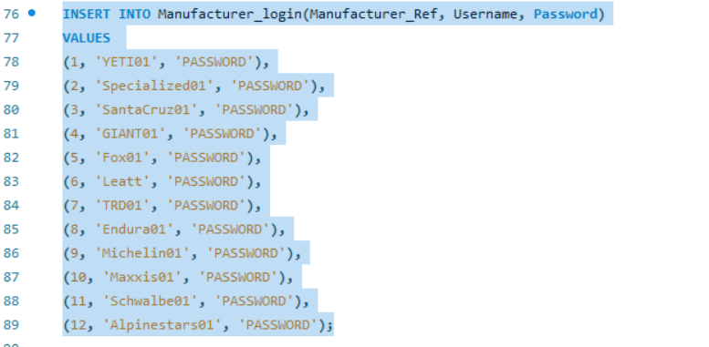
Figure 23 – Insert Manufacturer login command
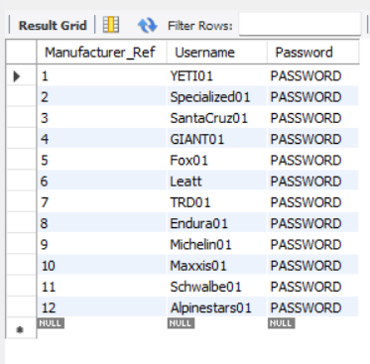
Figure 24 – Manufacturer login data accepted

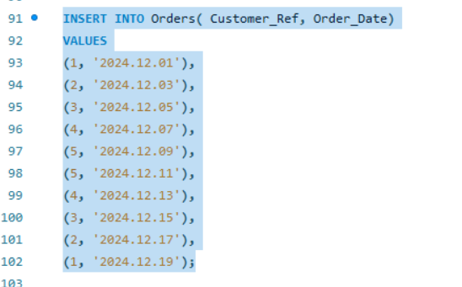
Figure 25 – Insert Order data command
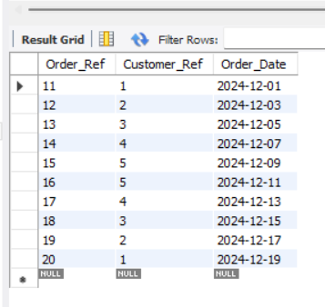
Figure 26 – Order data accepted

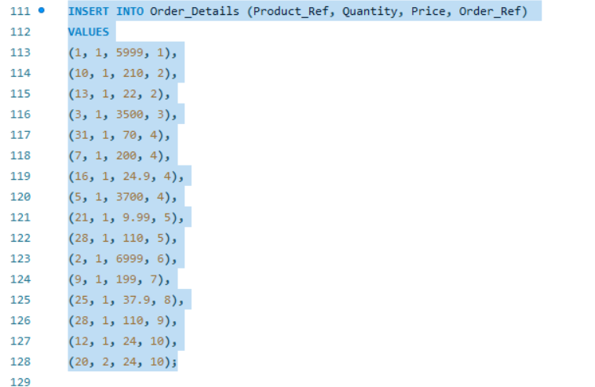
Figure 27 – Insert Order details data command
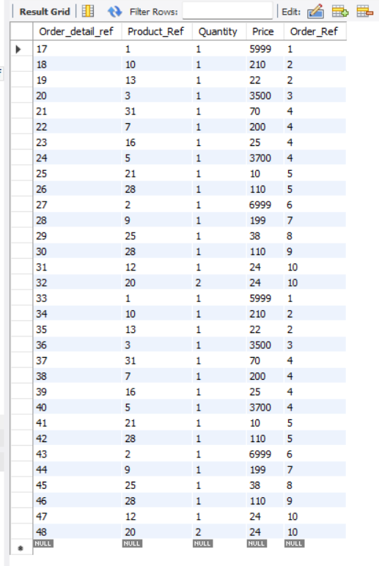
Figure 28 – Order details data accepted
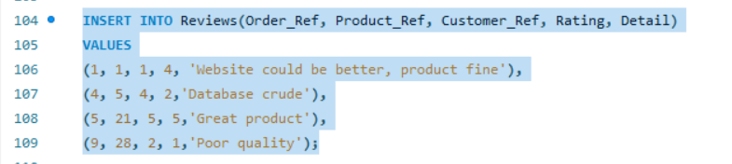
Figure 29 – Insert Reviews data command
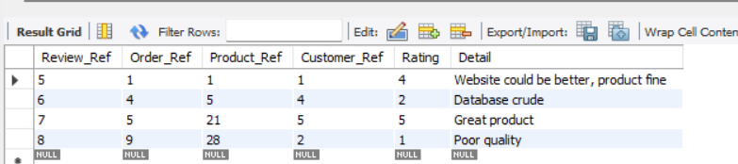
Figure 30 – Review data accepted

At this stage I have added an additional field for review rating which was initially missed out in the planning stage. The additional field allows for reviews to be provided a rating.

Testing constraints
I have added a constraint to the Reviews table, restricting the value of rating to 1-5. In the below example I demonstrate that in attempting to insert a value above this, it will fail. When the value is adjust back to within the accepted range, the data is accepted
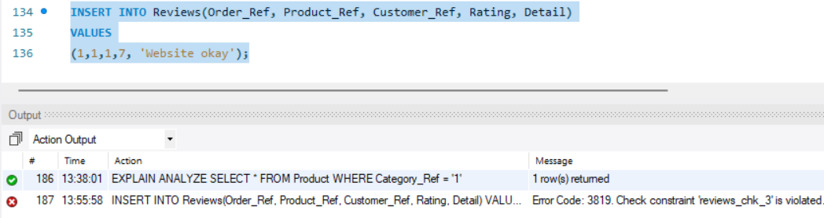
Figure 31 – Attempting to insert a figure above the constraint level – data rejected
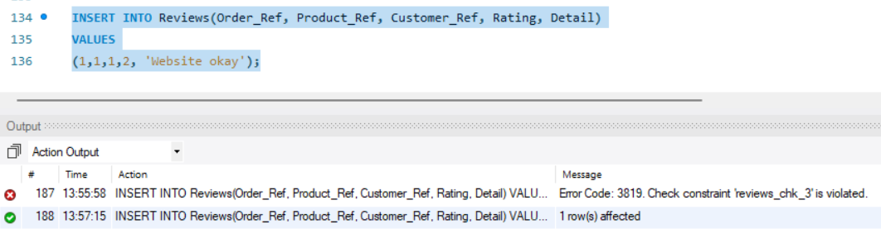
Figure 32 – Reducing the figure to within constraint parameters and data is accepted

Roll back and commit operations
I have created 3 transactions. Below I document a transaction to insert a new customer and their required login details, insert a new product from a manufacturer and a buying process, reducing the stock level and inserting records into the orders and order_details tables. Currently my transactions all require manual error handling before confirming rollback or commit. I would intend to utilise automated error handling before putting the database into effect.
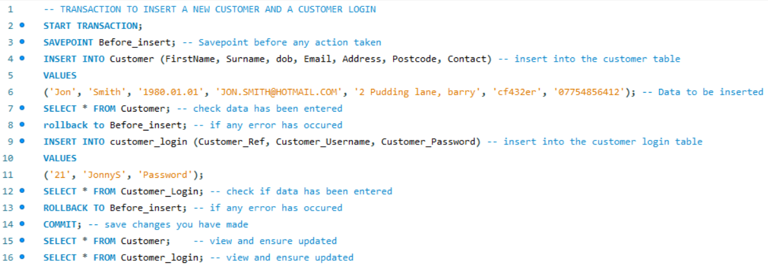Figure 33 – Transaction to insert a new customer and customer login
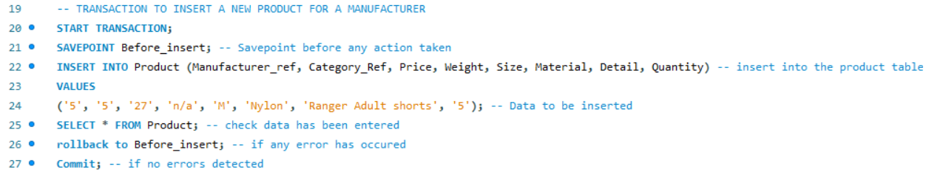
Figure 34 – Transaction to insert a new product for a manufacturer
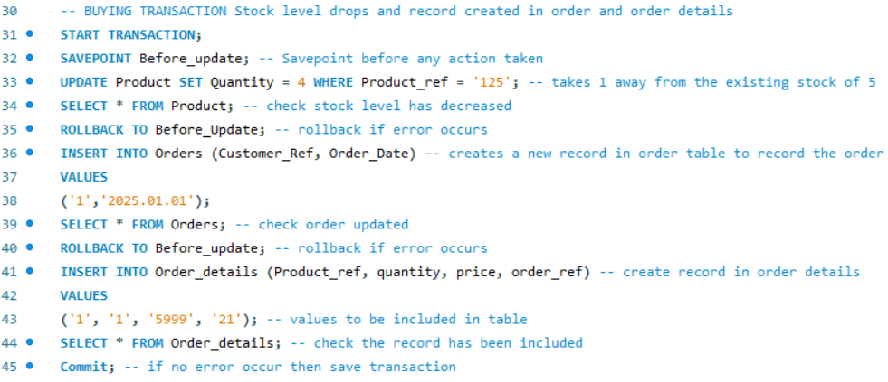
Figure 35 – Transaction to buy a product, reduce stock level and enter data into order and order_detail tables

Performance Tuning Enhancement
I have completed an ANALYZE function on the product table. As documented below I have completed a search on the product table returning all products which are labelled under bikes, which I have stored as ‘1’. I have then added an Index to the table, attached to the Category_Ref field. As displayed below, this appears to have decreased search time by ¼ ( 0.04 vs 0.03).
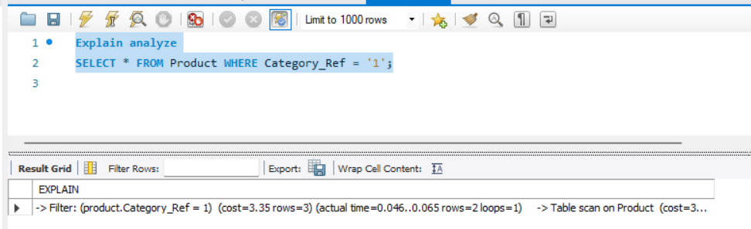
Figure 36 – Initial analysis of search time for all products in category ‘1’ (bikes)

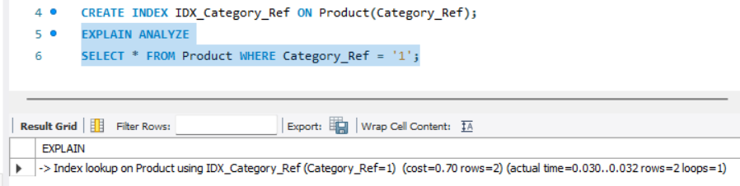
Figure 37 – Analysis once an index has been created showing an improvement from 0.04 to 0.03

Appendix
Microsoft Copilot utilised with the following prompts;
SQL how to amend a table check constraint
SQL how to find the name of a constraint
SQL how to drop field from a table
SQL how to drop a field from a table which is in a foreign key
SQL change column name
MYSQL COMMIT and ROLLBACK Transactions

