Iwan dyer p149128
Introduction M4x01163
This report will discuss the processes of making a sprocket and the metals that they can be made of. The report will then discuss the advantages of each one along with each methods disadvantages. Then will concluded with what is believed to be the best method of production for the part and what metal will be best for that method.
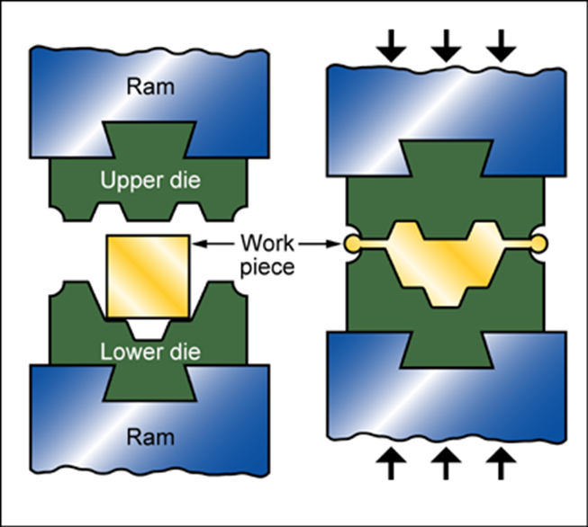
(ces, 2003)
Forging
Forging is a process of shaping that is when a metal ingot is squeezed in to shape by a dies that can be subjected to large amounts of plastic deformation. This is a very common way of producing steel components. In hot die forging most of the shaping will be done in one completion. Then then the product will be placed in a final or a secretion of dies to finish the part off. In cold die forging even tho the parts will start off cold they will heat up though the deformation proses and from the friction that the dies will produces when the part and the die are in contact. The part that we would be looking at is small and need to be fairly accrete so you would us closed die forging , there is a open mentored but it is a lot less accurate and is meant for massive parts that are over 20kg and go up to 5000kg.
Physical attributes of forged metals:
Mass range 0.01 - 5e3 kg
Range of section thickness 3 - 250 mm
Tolerance 0.2 - 1 mm

The mass range is dependent on the type of forging that is done but for this you would be looking at the smaller end of the mass range as the most a full cosset would ever weight is 5kg and that’s when there would be 12 gears and be large cogs for off roading.
The minim thickness is about right as the average gear on a cosset is approximately 5mm in thickness, however this is depending on material used in it.
The tolerance on the proses is massive in terms of parts which may be a problem as if the part is too large it may create unnecessary wear on other moving parts.
The biggest draw back in forging parts is that is the relatively high tooling cost and equipment cost witch is massive but because of this complexity of the tools and equipment it does make up for in the amount that it can produces in parts. Forging can make from 100 parts to 500 parts a hour which is why the cost is so high but then because there is a low amount of liber cost when comparted to other possesses it brings down the price of each part made.

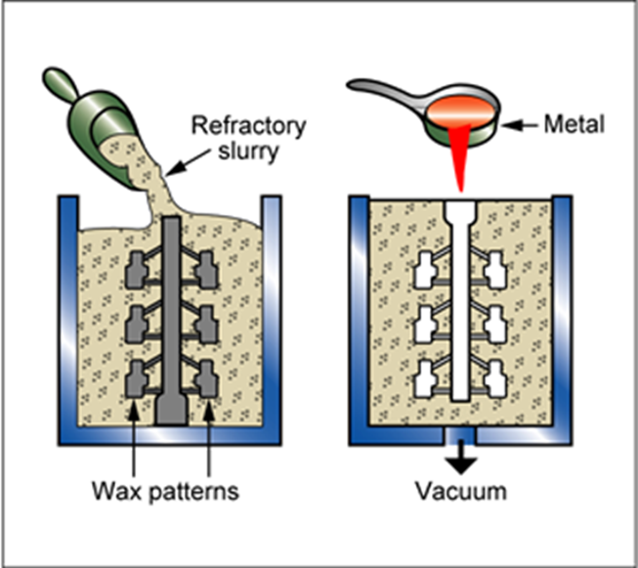
(ces, 2003)
Investment casting
Investment casting commonly known as lost wax casting is the proses where a die is made out of wax this can be for mutable repeats of the same part, then a super-hot metal or plastic is poured in to the mould where the die has been placed. Melting the wax and leaving a gap that the metal can work its way in to and then set becoming solid again. This form of casting can be traced back to the Egypt and Greece at about 1500bc where it was used to make jewellery. The metal that in placed in the cast must be below 2200C as anything higher may create a defect in the mould and make the part unusable.
Physical attributes
Mass range 0.001 - 100 kg
Range of section thickness 1 - 75 mm
Tolerance 0.05 - 0.25 mm
With investment casting it would allow the part to be fairly complicated and would also allow smaller more intricate parts to be made with little effort. However it does not allow for as massive parts as forging does. But this is made up by the smaller tolerance meaning the part made would be a lot more accurate than if it was forged. The tooling cost for the=is shaping presses is very low along with a medium equipment cost the main draw away from this proses would be the large labour cost and the low production rate witch is between 1 to 200 witch is fairly slow. (international, 2003)

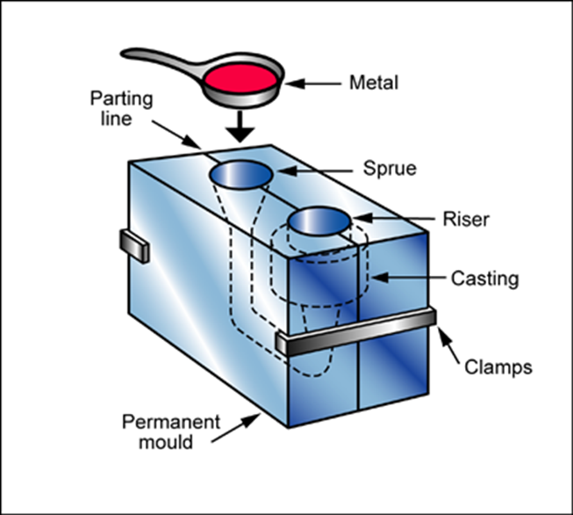
(ces, 2003)
Gravity die casting
Gravity die casting is also called permanent mould casting is when molten metal is poured in to a mould under gravity and stays there until it is a solid. The mould is then opened and the part is freed. The mould itself is normally cast iron as this has a high melting point, along with other reason. The shapes made though this mothered have to be simple, so they can be freed from the mould with relative ease.

Mass range 0.5 - 50 kg
Range of section thickness 5 - 45 mm
Tolerance 0.25 - 2 mm

Gravity die casting is has the correct range of mass that would allow them sprocket to be made in the mould with relative ease. The sprocket shouldn’t be over 4kgs as this would course a lot of stress on the freewheeling hub as when added with the mass of the cosset it would start to make a significant moment.
The smallest thickness the sprocket may course a small problem as it does become increasingly thin as it gets to the edges witch may drop below 5mm but this could be remedy by adding a extra process after the casting that would give the edges the thinner edge.
The accuracy of this part is impressive as a tolerance of 0.25 on this part would make sure that it would never make a part that would be unusable bring down the cost of production by a large amount.
(international, 2003)

Comparison on mentored

Each of the methods that have been disused have their own advantages and disadvantages, some of these are not significant and some are significant and must be considered in the production of the required part.
One of the biggest problems would be cost.
This graph shows the cost to produce one of the parts using one of the discussed methods are you can see investment casting is by far the cheapest method to set up and use then there is a fairly large jump to the cost of gravity die casting, this is down to the fact that each of the moulds will have to be made out of a strong, high melting point metal so that there head will dissipate out of the cast and that it is strong enough that breaks in the mould are not common. This makes the initial cost fairly high when compared to investment casting. Then finally the most expensive to set up is forging as the equipment and tooling cost is very high lucky the lack of liber means that this method after it is set up doesn’t require to many people to operate the plant where the part would be made unlike investment casting where a larger staff would be needed.

Another consider will be the rate that the part can be produced case you can see forging is by far the fasts for producing parts this can be anywhere from 100 parts an hour to 500 parts a hour making a part made every 7.2 seconds at its fastest rate witch is incredibly fast. Then there is investment casting witch can produce the biggest range in speeds witch can be from 1 part an hour to 200 parts a hour witch is on one side amazing and on the other pretty good but it’s still at its fastest only double the slowest speed of forging. Then lastly gravity die casting witch has neither the loosest spend or the fastest it sits at 5 unit to 50 a hour which means its upper limit is the slowest witch would have a massive impact on the cost per unit.

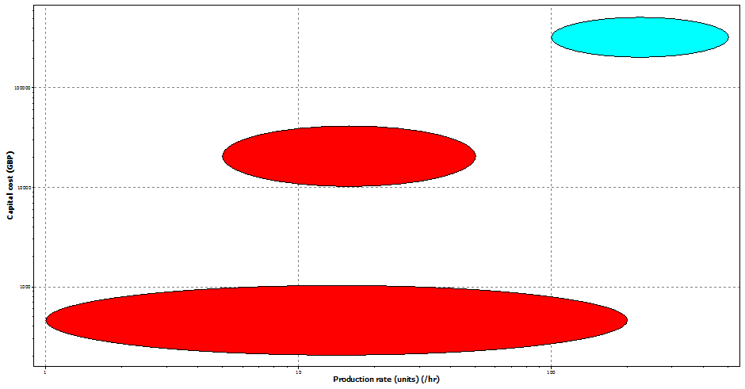
(ces, 2003)
This graph give a regimentation of the cost vs production rate so it is easy to see the cost to produce. (for reference the larges one is investment casting)

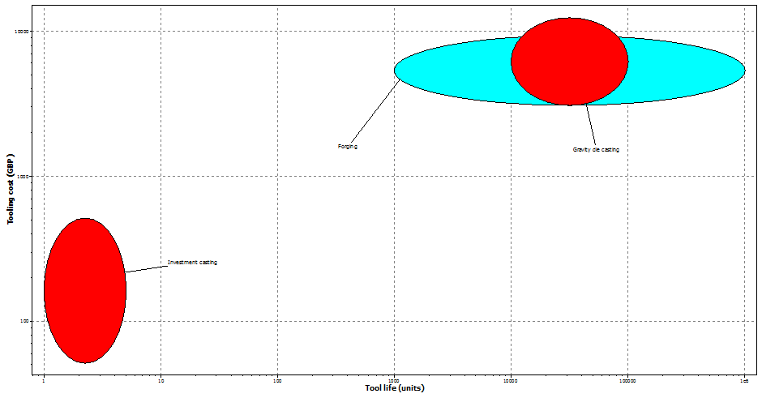
(ces, 2003)
Comparing the processes

There are clear benefits to each of the methods had have been discussed in this report but in would be more suitable for making a sprocket. This proses is forging, this is down to the fact that so many can be produced in a very fast manor. It is so fast that it could produce a part every 7.2 seconds with very little tooling needed after and a minor amount of staff needed to ensure that the forge is running correctly. This however does not mean that the proses of forging is perfect at, far from it in fact. This proses has one of the highest set up costs of any method of shaping and the cost of heating the metal till it is workable must be considered. if money was no object this method would probably be a lot more common in industry but at the moment they use cnc milling mechanism. Because they are efficient to set up and run that a massive forging complex and any alteration to a design it pretty easy to apply unlike with a forge. The one this that can be said for both forms of die casting is that they are comparatively very cheap to set up are they only require that the metal be moan and that there in a cast for that to set in which becomes very efficient.

Titanium alloys

Titanium would be a good metal for a sprocket as the highest alloys of titanium are substantially stronger than both steel and aluminium by weight it is approximately 25% stronger. Also they are used on plan turbines meaning that they would never get hot enough to miss shape the sprocket or make it weaker by reshaping the grain bounders. Of course for a sprocket it would not be effected to uses the highest grade of titanium alloy but even then most of the cheaper forms are stronger than steel and especially aluminium. This stranded price for titanium is about £15.8 per kg. (professor geoff hammond , craig jones, 2006)

Stainless steel
Stainless steel is an alloy of steel that is made from iron chromium and nickel. It is many used in proses where normal mild steel would corroded dew to there being high presses of H2O making normal steel rust away. Depending on the cooling proses and the metallic composition of the steel the strength can changes pretty drastically for stainless steel. Stainless steel is very cheap being about £4kg. And it is very easy to work as well making it perfect for small parts that may get weathered. (international, 2003)

Metal/ ceramic composites
The most widely used composite is an aluminium silicon composite. This report will focus on this as aluminium/ silicon carbide composite information is easy to find and it is a common form of this metal/ceramic composite. Aluminium/silicon carbide is a metal matrix material which means that it is a metal part that has been reinforces with a ceramic particles, this is normally to too effects, firstly it can reduces the weight or the part and it can greatly increases the overall strength of the part. Considering the price of just silicon carbide in it’s on the price for this matrix metal is fairly cheap only being £4 per kg witch when you look at its density is a lot of metal per kg. (britannica, 2018)
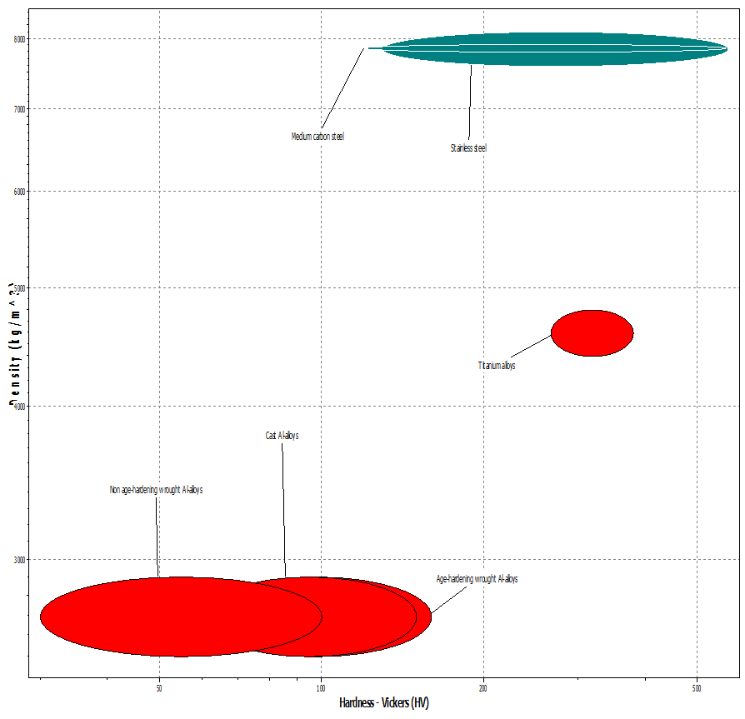
(ces, 2003)
This graph is some metals and matrix when the density is plotted ages the hardness vicker. It shows aluminium/ silicon carbide on the bottom left then titanium in the centre and finally steel on the top. It shows that aluminium/ silicon carbide is the lights but also the weakest and steel is the heist and can be the strongest but for its density titanium is the strongest but far.

Comparison
When compared these metals all have their advantages and disadvantages when it comes to being a sprocket. To start steel is one very cheap, is the most common metallic alloy on the plant, it is strong and easy to work with. Its beigest drawback is that it is so heavy so for bikes this may make a imbalance in the rear freewheeling hub if the full cossets is made from steel and may damage the bike if not fitted correctly. Titanium is strong and when compared to steel is light and just as strong, its biggest drawback is the price being up to 5 times more expensive than steel by mass. And finally aluminium/ silicon carbide it is as cheap as steel it is increasable light weighting at its lightest being 6 time lighter than steel per kg/M³. Its mean drawback is that it is not that hard when compared with the other two metals, it is relatively soft so wear would be a problem. Besides this however it is probably the best choice for high end cosset production as it is so light.

Conclusion
In conclusion this report shows that forging is the best proses for mass producing sprockets as so many can be produced per hour that it is more or less a constant flow of parts being made. Even tho there a cost involved in redesigning parts and getting models made it is of set by the rate of production. Even tho some other methods come close it’s still not quite enough to set off the rate of production and the quality of the parts. With the choice of metals there are two clear choices ether you pick steel and go for strength and loss the light weight aspect or you go for aluminium/ silicon carbide and have a fast wearing metal witch is not a massive problem as dew to the fact that people changes cossets regular.

References
britannica, 2018. sillicon carbide. [Online]
Available at: https://www.britannica.com/science/silicon-carbide
[Accessed 25 feb 2018].
ces, 2003. ces. wales: s.n.
institute, w., 2002. material intensity of materials, fuels,transport services. 2 ed. wuppertal: s.n.
international, a., 2003. asm metals handbook. 15 ed. ohio : s.n.
professor geoff hammond , craig jones, 2006. inventntory of carbon and energy. 1 ed. barth: s.n.

