INDEPENDENT PROJECT PROPOSAL

AI-Based Mental Health Detection and Risk Assessment
Using Natural Language Processing and Machine Learning

Programmer: BSc Cloud Computing
Module Title: Independent Project
Module code: ACCA6020
Student Name: Buba Tunkara Tunkara
Student ID: 2239608
Submission deadline: 2nd April 2026

Table of Contents
1. INTRODUCTION / BACKGROUND TO THE PROPOSED 3
1.1 Background and Literature Review 3
1.2 Rationale and Research Gap 3
1.3 Aim and Objectives 4
1.4 Expected Outcomes and Deliverables 5
2. PROJECT DESIGN 5
2.1 Project Design Overview 5
2.2 Data Collection Methods 5
2.3 Development Methods and Techniques 6
2.4 Risks, Limitations, Ethical and Legal Issues 6
2.5 Generalisability, Reliability and Validity 7
2.6 Data Analysis Plan 7
3. RESOURCES AND PLANNING 8
3.1 Resources Required 8
3.2 Project Planning Chart (Gantt Chart) 8
REFERENCES 10
APPENDIX A – ETHICS FORM 12

1. INTRODUCTION / BACKGROUND TO THE PROPOSED RESEARCH

1.1 Background and Literature Review
Mental illness is one of the biggest health concerns of the 21st century. The World Health Organization estimates that one billion people live with a mental disorder, and that more than 75% of people in low- and middle-income countries do not have access to proper treatment. The three most prevalent mental health disorders, depression, anxiety and post-traumatic stress disorder (PTSD), are often overlooked until they become severe.
The explosion of social media has produced a wealth of textual information that can be used as a potential indicator of users' emotional well-being. Research has shown that people with mental health problems may share their symptoms and emotional states on social media platforms like Reddit and Twitter. This presents an opportunity for researchers to gather and analyse this data using computational methods to detect early signs of mental health problems, and hopefully support early treatment.
Artificial Intelligence (AI) is a broad term that refers to the ability of machines to perform tasks that normally require human intelligence. Thanks to the rapid progress in deep learning, especially the introduction of transformer models like Bidirectional Encoder Representations from Transformers (BERT) and MentalBERT, a domain-adapted version of BERT, we are now able to grasp the meaning in the context of the text. Liu et al. found that models incorporating BERT achieved an accuracy of 87.3% in classifying depression-related posts on the social media platform Reddit, showing the potential for transformer-based models in the diagnosis of mental health issues.
However, previous work used traditional machine learning methods including Support Vector Machines (SVM), Logistic Regression and Random Forest. One of the first works in this area was done by Coppersmith et al, who examined language features in Twitter messages and found statistically significant differences in language usage between depressed and normal users. Although classical machine learning methods are fast and relatively interpretable, they typically require more features to be engineered and can be less capable of capturing more complex semantic text features.
So, although transformer models have the potential to perform well, we will compare classical machine learning and deep learning models to study whether the increased complexity of transformer models contributes to better performance when we classify multiple mental disorders.

1.2 Rationale and Research Gap
While earlier research has applied NLP methods to diagnose mental health issues, there are some drawbacks. Much of the research is limited to binary classification, which involves, for example, classifying whether a user is depressed or not, rather than classifying whether a user has anxiety, depression, or another mental health condition. This is because the language used to express different mental health conditions (such as anxiety, depression, and PTSD) can be highly similar.
Moreover, most research focuses only on either conventional machine learning techniques or transformer models. A limited number of studies report a comparative experimental setup using the same data set. Consequently, it is not clear whether the higher complexity and computational resources required by transformers are always worth investing for improved performance.
As such, this project seeks to fill this literature gap by experimenting with the application of traditional machine learning models and transformer-based NLP models for multi-class mental health diagnosis using social media text.

1.3 Aim and Objectives
Aim: To design, develop and evaluate an AI-based mental health detection system using Natural Language Processing and Machine Learning techniques applied to social media text
Table 1: SMART Objectives Summary
# | Objective | Method | Deliverable
OBJ 1 | To critically examine current NLP and ML solutions applied to detect mental health that have been published in 2019-2025. | Systematic literature review | Annotated review of 15+ academic sources
OBJ 2 | By Week 6, to gather, clean, and pre-process a publicly available mental health text data (Reddit/Twitter). | Dataset collection and Python scripting | Pre-processed dataset ready for model training
OBJ 3 | To plan and create multi-class mental health classification SVM, Random Forest and BERT-based evaluation on the comparative ML/NLP pipeline. | Model development using Python (scikit-learn, HuggingFace) | Trained ML and NLP models with performance metrics
OBJ 4 | To compare and critically assess model performance in terms of accuracy, F1-score, precision, recall and fairness scores and to comment on the ethical considerations of implementation. | Statistical analysis (confusion matrix, ROC curve, McNemar's test) | Final evaluation report with bias and fairness assessment

1.4 Expected Outcomes and Deliverables
- A functional AI-based mental health text classification system developed using Python.
- Trained and evaluated ML and NLP models with documented performance metrics.
- A final research report presenting analysis, findings, and recommendations.
- Evaluation of bias, fairness, and ethical considerations in AI-based mental health detection.

2. PROJECT DESIGN

2.1 Project Design Overview
The present project is based on the experimental evaluation design because it entails creation and comparative analysis of several computational models applied to a real-life dataset. The project is designed to be executed on four steps (1) Literature Review and Dataset Identification, (2) Data Pre-processing, (3) Model Development and training, and (4) Evaluation and Reporting. This method, as well as Design Science Research Methodology (DSRM) that is extensive in applied computer science research [14], is adopted.

2.2 Data Collection Methods
In this research, secondary data will be used in the form of an annotated social media data in the public domain. The first competitor is Reddit Mental Health Dataset, found on Kaggle and Zenodo under an open-access licence, consisting of labelled posts subdivided by various areas of mental health such as depression, anxiety, PTSD and no disorder [4]. No human subjects will be involved in collecting primary data; hence, ethical issues regarding direct interaction with human subjects will be reduced to a minimum.
Table 2: Data Collection Methods per Objective
Objective | Data Type | Source | Justification
OBJ 1 | Academic papers | Google Scholar, IEEE Xplore, PubMed | In order to base study on existing peer-reviewed literature.
OBJ 2 | Labelled text dataset | Reddit Mental Health Dataset (Kaggle/Zenodo) | Real world, annotated, large scale data that can be used in training performance.
OBJ 3 | Training/test data splits | Derived from OBJ 2 dataset | Needed to develop models and to cross-validate.
OBJ 4 | Model outputs and metrics | Generated during OBJ 3 | Necessary to carry out comparative assessment and analysis.

2.3 Development Methods and Techniques
For this project, Python will be used as the programming language given the plethora of machine learning and natural language tools available. It is the most widely used programming language in the AI community with systems in place for experimental research.
We will programme machine learning models such as Support Vector Machines, Random Forest and Logistic Regression models from the scikit-learn library. We will use these algorithms as they are examples of traditional classifiers that are used in text classification research and the results are easy to interpret.
We will implement transformers BERT and MentalBERT models using the HuggingFace Transformers library. They've been chosen because transformers have achieved state-of-the-art results in many natural language processing applications as they can learn long-term dependencies between words. MentalBERT has been pretrained on mental health data, and can help to extract mental health related information from text.
We will apply some basic preprocessing to the text using NLTK and spaCy to normalise and remove unwanted linguistic features. Processing like tokenisation, stop-word removal and lemmatisation will speed up training and add noise to the data.
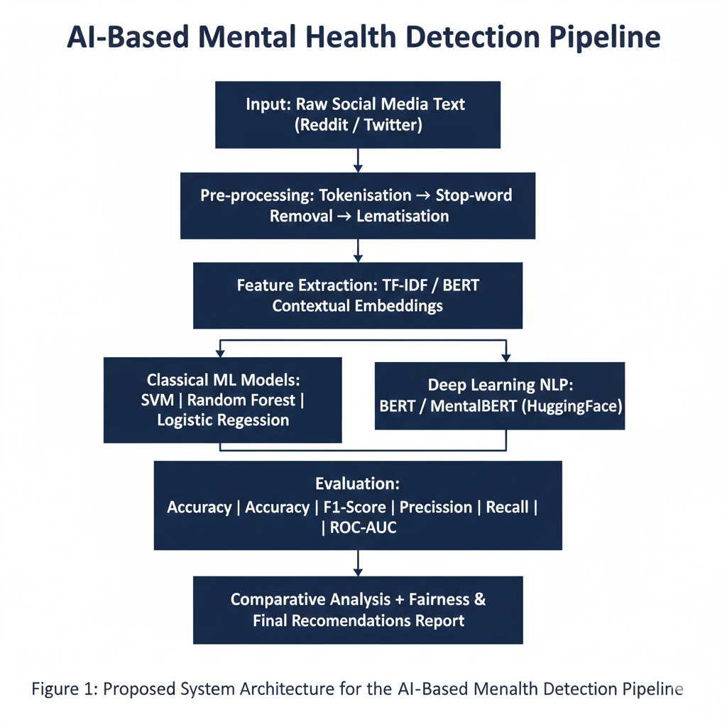
Figure 1: Proposed System Architecture for the AI-Based Mental Health Detection Pipeline

2.4 Risks, Limitations, Ethical and Legal Issues
The use of mental-health-related data raises several ethical considerations.There are several ethical considerations related to research with mental health data, including privacy and consent, and the misuse of predictive models. While the data sets used in this project are publicly available and anonymous, measures need to be taken to ensure that people cannot be identified via the indirect information in the text.
Another concern is the misuse of mental health systems. Machine learning models should not be used to make decisions and should only be used for diagnosis. The system proposed in this project will be adequately labelled as a research tool.
A further consideration is fairness of AI. Data from social media may not be representative of the population, and could result in biased predictions. This project will counter this by incorporating fairness metrics to measure model performance and knowledge of biases in the data.
The project will follow the British Computer Society Code of Conduct and responsible AI principles of transparency, accountability and privacy.
Table 3: Risk Assessment Matrix
Risk | Likelihood | Impact | Mitigation Strategy
Dataset unavailability or access restrictions | Low | High | Previously identify two backup datasets (CLPsych, SMHD).
Model overfitting on training data | Medium | High | Use dropout regularisation and cross-validation (population size): k.
Insufficient computational resources | Medium | Medium | Free GPU level- Marke put to use Google Colab; optimise batch sizes.
Ethical misuse of developed model | Medium | High | Evidently scope is out alone as screening tool; contain disclaimers.
Data privacy and anonymity concerns | Low | High | Only publicly available datasets that are anonymised and open-access will be used.
Project timeline slippage | Medium | Medium | Insert two week contingency buffer in planning schedule.

2.5 Generalisability, Reliability and Validity
The applicability of the results might also be restricted because of the utilization of the English-language social media data that might not be a complete representation of mental health expression in various cultures or languages. Standardised pre-processing pipelines and standardised reproducible code that will be kept in an open GitHub repository will be used to guarantee reliability. Stratified splits of data and manipulation of the experimental settings and conditions will ensure that internal validity is preserved, and the contextualisation of external validity will be made by comparing the acquired results with the existing literature.

2.6 Data Analysis Plan
The following quantitative measures will be used to assess model performance: Accuracy (overall classification correctness); Precision and Recall (to trade-off false positive and false negative); Macro and Weighted F1-Score (to consider the imbalance in the classes); ROC-AUC Score (to determine the discriminatory power in multiple classes); and Confusion Matrix (to visually analyse classification errors). The differences between models in terms of performance will be tested statistically using the McNemar test being a standard non-parametric test to compare two classifiers on the same data .
3. RESOURCES AND PLANNING

3.1 Resources Required

Table 4: Software and Hardware Resources
Category | Resource | Purpose
Hardware | Personal laptop (minimum 8 GB RAM) | Development environment
Cloud Computing | Google Colab (free GPU tier) | Training of deep learning models.
Programming Language | Python 3.x | Development and data analysis of the model.
ML Libraries | scikit-learn, HuggingFace Transformers | Development of classical ML and BERT models.
NLP Libraries | NLTK, spaCy | Pre-processing of the text and feature extraction.
Data Libraries | pandas, NumPy | Data cleaning and data manipulation.
Visualisation | matplotlib, seaborn | Result charts, confusion matrices, ROC curves.
Dataset | Reddit Mental Health Dataset (Kaggle/Zenodo) | Model training and evaluation Model training and assessment.
IDE | VS Code / Jupyter Notebook | Writing of code and experimentation.
Version Control | GitHub | Code management and reproducibility.
Literature Access | Google Scholar, IEEE Xplore, PubMed, ACM DL | Literature review and referencing.
Writing Tool | Microsoft Word | Formatting and writing of reports.
Referencing Tool | Zotero | Citation management numerically.

3.2 Project Planning Chart (Gantt Chart)
The plan of the project week-by-week is stated in Table 5. The schedule will take a span of 12 weeks with a 2-week buffer period during the last reporting period so as to cater to unexpected delays. Every task is associated with a particular project goal to provide the orderly development and responsibility.

Table 5: Gantt Chart – Project Timeline (Weekly)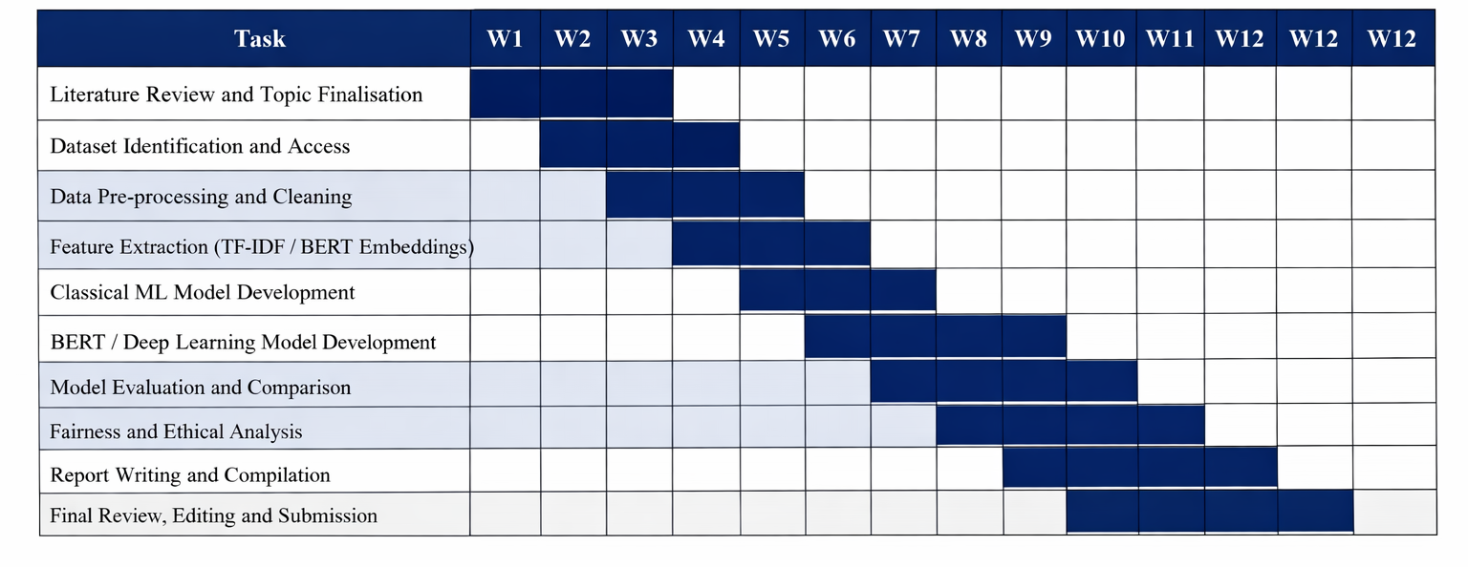

REFERENCES
[1] World Health Organisation, "World Mental Health Report: Transforming Mental Health for All," WHO Press, Geneva, 2022.
[2] S. Vigo, G. Thornicroft, and R. Atun, "Estimating the true global burden of mental illness," The Lancet Psychiatry, vol. 3, no. 2, pp. 171–178, 2016.
[3] M. De Choudhury, M. Gamon, S. Counts, and E. Horvitz, "Predicting depression via social media," in Proc. 7th Int. AAAI Conf. on Weblogs and Social Media, 2013, pp. 128–137.
[4] G. Turcan and K. McKeown, "Dreaddit: A Reddit dataset for stress analysis in social media," in Proc. 9th Workshop on Computational Approaches to Subjectivity, Sentiment and Social Media Analysis, 2019, pp. 214–223.
[5] J. Eisenstein, Introduction to Natural Language Processing. Cambridge, MA: MIT Press, 2019.
[6] S. Ji, C. Zhang, L. Ansari, J. Fu, W. Wei, and E. Cambria, "MentalBERT: Publicly Available Pretrained Language Models for Mental Healthcare," in Proc. LREC, 2022, pp. 7184–7190.
[7] R. Liu, Z. Zhang, X. Yu, J. Li, and Y. Liu, "Depression detection on social media with reinforcement learning," in Proc. IEEE Int. Conf. on Bioinformatics and Biomedicine (BIBM), 2021, pp. 1–6.
[8] A. Agrawal and N. An, "Unsupervised emotion detection from text using SVM and naive Bayes," in Proc. IEEE/WIC/ACM Int. Conf. on Web Intelligence, 2012, pp. 722–727.
[9] G. Coppersmith, M. Dredze, and C. Harman, "Quantifying mental health signals in Twitter," in Proc. ACL Workshop on Computational Linguistics and Clinical Psychology, 2014, pp. 51–60.
[10] K. Garg, D. Nakhate, and P. Rai, "A survey of NLP techniques for mental health disorder detection on social media," J. of Healthcare Informatics Research, vol. 7, no. 1, pp. 1–28, 2023.
[11] N. Chancellor and M. De Choudhury, "Methods in predictive techniques for mental health status on social media: a critical review," npj Digital Medicine, vol. 3, no. 1, pp. 1–11, 2020.
[12] P. Bonta, N. Kumar, and J. Luther, "A comprehensive study of emotion and sentiment analysis using deep learning," IJACSA, vol. 10, no. 7, 2019.
[13] British Computer Society, BCS Code of Conduct. Swindon: BCS, 2022. [Online]. Available: https://www.bcs.org/membership-and-registrations/become-a-member/bcs-code-of-conduct
[14] A. Hevner, S. March, J. Park, and S. Ram, "Design science in information systems research," MIS Quarterly, vol. 28, no. 1, pp. 75–105, 2004.
[15] T. Mitchell, Machine Learning. New York: McGraw-Hill, 1997.
[16] L. Lannelongue, J. Grealey, and M. Inouye, "Green algorithms: quantifying the carbon footprint of computation," Advanced Science, vol. 8, no. 12, 2021.

