
Module Name: Professional Career Development

Module Code: BMBS4005

Student Name: Gina Novac

Student Number: 2109384

Lecturer: Jemma Smith

Deadline: Monday 26th October 2026 23.59PM

AI Acknowledgement

I confirm that I have not presented any AI-generated text as my own work. I confirm that I have retained copies of drafts, notes, and resources used before and after the use of AI tools.

Contents
Element 1: Career Sector Investigation 3
1.1 My Chosen Sector or Business Area 3
1.2 Sector / Business Area Research 3
1.3 Skills, Qualities and Attributes Valued by Employers 3
1.4 Current Trends Affecting the Sector 3
1.5 Personal Career Fit 4
Element 2: Skills Audit and Professional Development Plan 5
2.1 Personal SWOT Analysis 5
2.2 Emotional Intelligence and Professional Behaviour 5
2.3 Applying Theories or Models 5
2.4 SMART Development Goal 6
Element 3: Recruitment Application Pack 7
3.1 Selected Job Role 7
3.2 Tailored Curriculum Vitae (CV) 7
3.3 Cover Letter 8
3.4 LinkedIn Profile 8
3.5 Application Rationale 8
Reference List 8

Element 1: Career Sector Investigation
My chosen career is office management in business area.

1.1 My Chosen Sector or Business Area
I have chosen office management business because I have the right skills and passion with natural ability to make decisions and manage the company. It gives me the opportunity to grow and improve myself by turning my strengths and knowledge into business. Office management business sharpens my skills and gives me the satisfaction I want for my future. This business will help me grow both personally and professionally by developing my skills and providing me with motivation to ambition myself to can achieve my goals.

1.2 Sector / Business Area Research
Office manager has the responsibility to ensure the office runs smoothly and everything being in order. There are a variety of office management jobs as: corporate office management, medical office management, legal office management and virtual office management. An office manager needs to take responsibility for providing resources as: materials, people and money. Office management needs to make sure that the company reaches its goals by planning organized meetings and, they need to be able to have good communication, digital skills and good motivation.

1.3 Skills, Qualities and Attributes Valued by Employers
Employers these days are looking more for personal skills and qualities because they shape on how a person behaves with its colleagues and managers. Personal skills are referring to the soft skills you bring at work, as for example: you communication and how problem-solving you are, they are referred as transferable skills. On the other hand, personal qualities are referring to your natural attributes that define your personality and behaviour such as integrity, empathy and how you approach your work and team workers or colleagues. The quality the employers are looking for more is the reliability by showing up on time and work efficiently shows how reliable and trustworthy you are. These qualities and skills are important because it can determine how successful you will be and for how long.

1.4 Current Trends Affecting the Sector
In office management artificial intelligence, it has benefits but also let downs, artificial intelligence can provide support by offering predictive maintenance by finding the issues quick and easier, it can offer sustainability and it can identify trends that may affect costs, but it can’t replace human judgement, relationships, negotiation and managing peoples through change. It can support the decisions but cannot replace experience and emotional intelligence. Digitalization provides ample jobs and wages by increasing the balance between high skilled and low skilled workers. According to Sun; Beibei; Tian; Robert, (2026-12), vol .32 (3-4), p.25, Article 25). National Pipeline advisory Group (NPAG) run a survey in (2024) showing that 32% of business they choose their major earlier during their education, but most of them did not choose accountability as their goals, this is showing that there is an accountability skills shortage in businesses these days. According to Dawkins; Mark. C; Dugan; Michael; Krehbiel; Joshua; Muriel; Leah, (2026-12), Vol.74, p.101035, article 101035.

1.5 Personal Career Fit
Office management can connect me with my interests and current skills in different ways, as I like to be more organised and come with new ideas this business can offer me the opportunity to develop my skills and knowledge on the future. I would like to develop more leadership skills can approach my goal as to open my own business as a CEO and this business it gives me the skills and information that are relevant to my objective. Office management can help me improve my communication and leadership skills; it can create career opportunities and build my confidence and independence.

Element 2: Skills Audit and Professional Development Plan

2.1 Personal SWOT Analysis
STRENGTHS  • Communication  • Coordination  • Problem-solving | WEAKNESSES / AREAS FOR DEVELOPMENT  • Patience  • Excessively reticent  • Conflicts
OPPORTUNITIES  • To get my certificate in business  • To achieve my goals  • To open my own business | THREATS / CHALLENGES  •Time management  • Patience  • Engage in conversations

The most important strengths and needs are communication, problem-solving, coordination. The areas that I need to develop are patience, confidence and how to delegate conflicts. These strengths will help me in the future on how to organize and coordinate meetings, to be a good communicator with my colleagues and employees. Being a problem-solving helps to understand the issues and find the solutions. I will need to develop my patience and confidence, by studying more and practice in daily life accordingly to Johari Window theory. These attributes and skills will help me to achieve the goal for my future. SWOT analysis it helped me to discover my strengths and weaknesses.

2.2 Emotional Intelligence and Professional Behaviour
Developing my emotional intelligence is essential in professional and personal life because it affects my behaviour and communication with the people around me. I believe that have the skill of emotional intelligence it improves my confidence and teach me patience. I recognise that in different circumstances I need to remain calm and listen carefully by talking in consideration different opinions. As example in our university group activities, I listen carefully to other opinions, stayed calm and then I have initiated an appropriate approach to our subject. Furthermore, I understand that professional and personal behaviour can affect the people and the work involved around me, my behaviour should inspire others by being reliable, respectful and responsible.

2.3 Applying Theories or Models

One theory that can support my personal growth is the Gibbs Reflective Cycle (Gibbs, 1988), this theory helps me reflect and improve on my personal strengths and weaknesses and identity’s my need for improvement areas. This model has six stages: description, feelings, evaluation, analysis, conclusion and action plan. Gibbs Reflective Cycle (Gibbs,1988) helps me to build up my confidence and improve on my weaknesses; it also gives me the opportunity to develop my skills and knowledge to build up my ambition to open my own business. Then there is another model that supports my personal development called Johari Window model, (Lufth and Ingham,1955), this model helps me understand the skills I need in the future and it gives me self-awareness. Johari Window (Lufth and Ingham,1955) theory helps me to understand myself better and make other people around me to know me. For example: I may think I can communicate effectively but others may see it differently, this theory helps me understand that feedback from other people helps you grow and improve your skills better in the future. In conclusion both theories give exceptional experience and better understanding on how to succeed for the future. Developing these skills helps me in my university and prepares me for my own business.

2.4 SMART Development Goal
Specific | I want to improve my confidence and achieve opening my own business.
Measurable | I will know that on my behavior and self-attitude. It will show by my actions and consistency.
Achievable | Studying more and doing research online, also coordinating my timing.
Relevant | It is very important because it will represent my personality and growth.
Time-bound | When will I complete or review this goal?  This goal I will complete it in time and review it in the future.

Element 3: Recruitment Application Pack

3.1 Selected Job Role
Job Title | Office Manager
Organisation | Concept Fabrications Cymru
Location | Canton, Cardiff
Where the vacancy was found | Indeed.uk
Job Role URL | https://uk.indeed.com/m/jobs?q=office+manager&I=cardifff&from=search-OnHP&sameQ=1&sameL=1&vjk=d22ff4ceedaf9f67

3.2 Tailored Curriculum Vitae (CV)
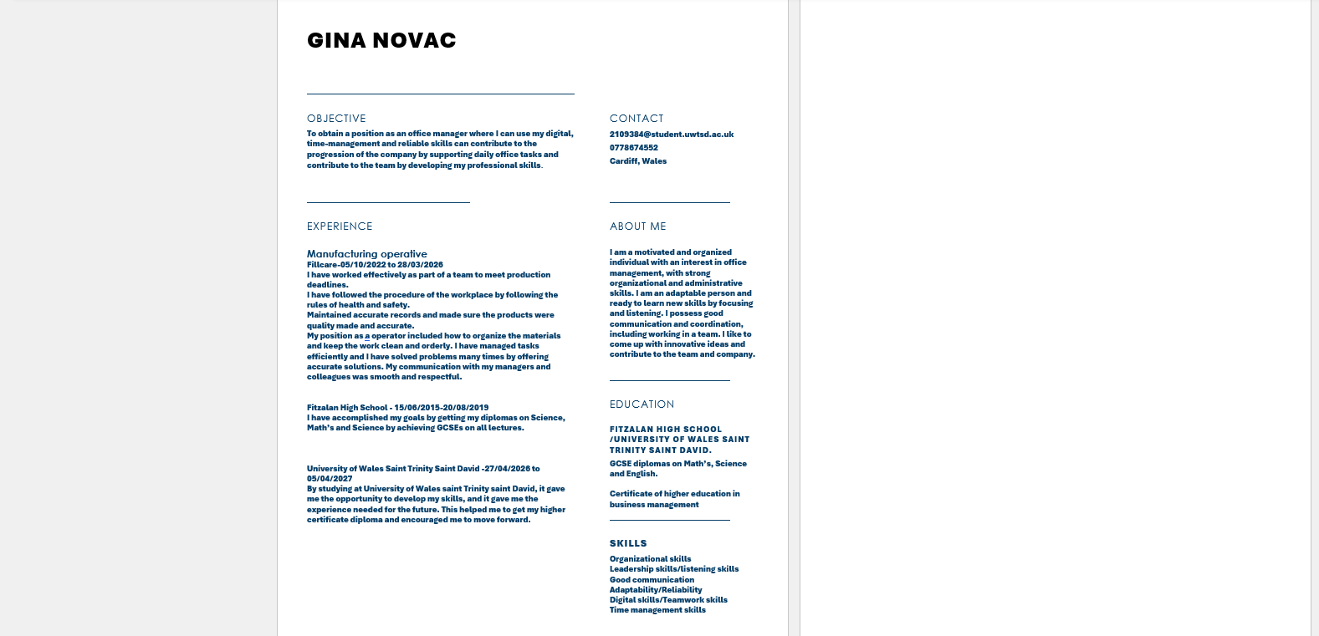

3.3 Cover Letter
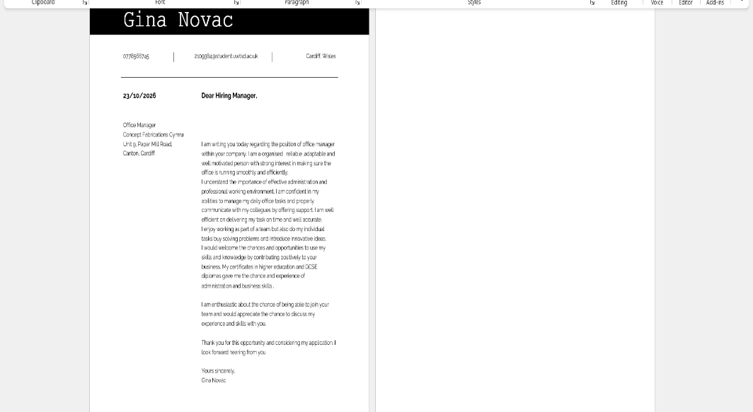

3.4 LinkedIn Profile

LinkedIn Profile URL | www.linkedin.com/in/gina-novac-38ab1543b
Professional Headline | LinkedIn Profile
Evidence / Screenshot | 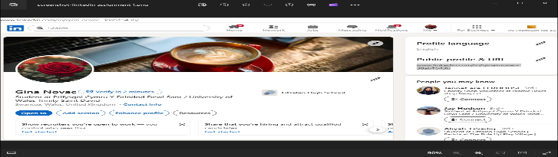

3.5 Application Rationale
I have tailored my application of my role as the office manager by focusing on my skills and qualities as an individual. I have given priority to my personal skills and professional attributes by explaining and including my skills such as coordination, confidence and teamworking and how can I approach and use these skills in office management administration. This has influenced my cover letter in a positive approach by highlighting the importance of being proactive. My cv was well structured and relevant to my skills by demonstrating my experience and abilities as an individual. My aim was to give a clear information and to make it easier for my employer to read and identify my abilities and skills. I have also considered my LinkedIn profile as a support for my abilities by using clear, simple professional headings and providing enough information. This helps me to create a professional online presence, and it allows my employers to see myself clearly and see my careers interests. Overall, I have tailored my cover letter, cv and update my LinkedIn profile to demonstrate my understanding of office management responsibilities and requirements. I aimed to present a professional, clear and credible profile that corresponds to the employers’ expectations. These will help me to increase my opportunities and possibilities of getting and achieving the office manager position. By tailoring all three documents it helped me to create a consistent and professional application. By giving more focus on the requirements of the actual job as office manager, it made it more understandable of the responsibilities and the position that an office manager has. Reflecting on the requirements on my applications, it gave clear and understandable requirements that helped me to focus and aim for delivering excellent skills and approachable attributes as: teamwork, reliability, adaptability and communication.

Reference List
Available at: https://resources.owllabs.com/blog/office-management accessed at 21/10/2026
Available at: https://competehigh.com/15-personal-skills-and-qualities-employer-look-for/ accessed at 21/10/2026
Available at: https://www.linkedin.com/pulse/impact-ai-office-management-facility-enhancing-operations-lazar-c1i4f/ accessed at 21/10/2026
Available at https://www.rewardgateway.com accessed 22/10/2026
Available at https://www.momentouslearning.co.uk accessed 22/10/2026
Available at https://www.abdn.ac.uk accessed 22/10/2026
Available at https://www.magic-office.co.uk/blog/roles-and-responsabilities-of-office-manager accessed 22/10/2026
Sun; Beibei; Tian; Robert; (2026-12), vol.32(3-4), p.25.article,25; Analyzing the influence of digitalization on labour market trends and social structure. https://link-springer-com.uwtsd.idm.oclc.org/article/10.1007/s10588-026-09443-7
Dawkins; Mark. C; Dugan; Michael; Krehbiel; Joshua; Muriel; Leah (2026-12), vol.74, p.101035, article 101035; Cultivating future accountants: The impact of high school accounting coursework. https://www-sciencedirect-com.uwtsd.idm.oclc.org/science/article/pii/S0748575126000333.
Gibbs, G. (1988) Learning by Doing: A guide to teaching and learning methods. Oxford: Further Education Unit, Oxford Polytechnic. Available at https://harvardreferencegenerator.co.uk accessed 222/10/2026

Luft, J.; Ingham, H. (1955). “The Johari Window, a graphic model of interpersonal awareness”. Proceedings of the western training laboratory in group development. Los Angeles: University of California, Los Angeles. https://www.hee.nhs.uk
Liebana-Cabanillas, Francisco; Irimia-Dieguez, Ana; Albort-Morant, Gema; Zarco, Carmen (Heidelberg), (2026-12), vol.12 (1), p.84, Article 84 Unlocking the future of pay tech: exploring biometric payment card adoption patterns https://link.springer.com/content/pdf/10.1186/s40854-025-00883-9.pdf

Li, Yan; Liu, Yangyang; Dai, Jing; Luo, Hong (2026-12), vol.19 (4), p.100503, Article 100503 Digital transformation, information advantage and managerial opportunism
https://www.elsevier.com/about/accesibility

Kassa, Erstu Tarko (2023-06), vol.14 (2), p.1033-1051 Exploring Employability of Business Graduates: Evidence from Woldia University https://link-springer-com.uwtsd.idm.oclc.org/article/10.1007/s13132-021-00856-0 accessed 22/10/2026

Neroorkar, Samiksha (2022-10), vol.64 (6), p.844-867 A systematic review of measures of employability https://www.proquest.com/docview/ accessed 22/10/2026

