Blockbusting Tutankhamun

Melisa Pak
1701689
HPAR6014
11/10/2019

Introduction –
- Aims: This dissertation will discuss and analyse contributing factors of blockbusting Tutankhamun from Herodotus’s visit to Egypt in 450BC to the 2019 Tutankhamun exhibition in the United Kingdom, with the hope to bring these contributing factors together.
- Objectives: To be able to achieve the aims, I will need access to a wide range of resources such as texts, journals and diary entries, for example, Howard Carters books on the discovery of Tutankhamun, The Tomb of Tut.Ankh.Amen.
- Themes: The dissertation will look at influencing areas such as museums, exhibition tours, educational purposes, religion and westerners. For example, the view of ancient Egypt was from outsiders and to see how this affected Egypt before the discovery of Tutankhamun and to compare the findings. From the literature, it is clear to see that during 1919 to 1950’s Egypt was involved in a political conflict on nationalism and who could profit the most from Egyptian antiquities. The dissertation will look at the period from 450BC to 2019AD to include Herodotus’s visit to Egypt , Napoleons expedition to Egypt, the discovery of Tutankhamun and the current Tutankhamun exhibition.
- Context: Tutankhamun was an Egyptian pharaoh during 1334-1325 AD, near the end of the 18th dynasty. Little is known about Tutankhamun and any information known is typically from the artefacts discovered from his tomb. When English archaeologist, Howard Carter, discovered Tutankhamun’s tomb in 1922, the world became obsessed and it could be argued to this day some people are still obsessed.
: In 2019 a Tutankhamun exhibition will be again making an appearance at the Saatchi Gallery in London, United Kingdom; it is being presented as the ‘last tour’.
- Importance: There are high amounts of information about how Tutmania and Egyptomania came about and what they are and their influencing factors but no combination of this information.
Literature review –
- The resources I have accessed are texts, journals, websites and diary entries, for example Contesting Antiquity in Egypt; Archaeologies, Museums & the Struggle for Identities from World War I to Masser. This book in particular is relevant to the dissertation because chapter one; Egyptology and pharaonism to 1930, discusses all themes that will be used in the dissertation. The chapter also contains many relevant images, tables and graphs (see appendix A). The book was published in 2015, which means the information is likely to be current.
Methodology –
- On the discovery and about Tutankhamun there is a wide range of literature. To narrow the search, it was essential to use key words that were relevant to the dissertation such as ‘Egyptomania’ and ‘Antiquities in Egypt’. All literature needed to be published in English, checking the date and credentials of the literature was also important because the information needed to be reliable and credible. The literature found so far dates from 1922 to present day, however the oldest piece of literature is Howard Carter’s field journal at the time of discovery Tutankhamun; Tutankhamun: Anatomy of an Excavation. Another older piece of literature that will be used is from 1923; Tutankhamun and the Discovery of his Tomb by the Late Earl of Carnarvon and Mr Howard Carter, along with many pieces of literature up to present day (see appendix B). Texts were also selected for relevance through indices, chapter headings and key words.
- Analysis: main themes identified and explored through critical discussion.
- A conclusion which summaries the key findings, will address the aims of the dissertation.
Expected outcomes –
- Before research, it was expected that the only influence on blockbusting Tutankhamun was the fact that he was found by a British archaeologist. However, from further readings so far it appears that there could have been many influential contributions of blockbusting Tutankhamun including aspects that were not previously considered such as religion and politics that predate the discovery of Tutankhamun in 1922.
Limitations –
- As mentioned above there is a wide range of literature about Tutankhamun, there is not enough time to read all these books.
- Not all the literature published is accessible because it is not in English.
- Some of the relevant literature may not be considered academic for example Carter’s field journal. However, this subjective information has some value when viewed alongside other academic sources.
Reflection/Evaluation –
- With lots of ideas and information for the dissertation, it is time to start to piece the information together and to build up an argument. When the information starts to be put together it will hopefully show me where I want my argument to go. My plan of action is in the appendices (see appendix C). The plan of action will unfortunately be compromised by the block teaching system. See appendix B for up to date reading list so far.
- I have some concerns that I may be exploring too many themes in the dissertation (Context and history, artefacts of Egyptomania, exploitation of Tutankhamun through education and sensationalization by the media, religion) which may result in some themes not being explored in sufficient depth, in result effecting my argument and conclusion of the aims.

Appendices
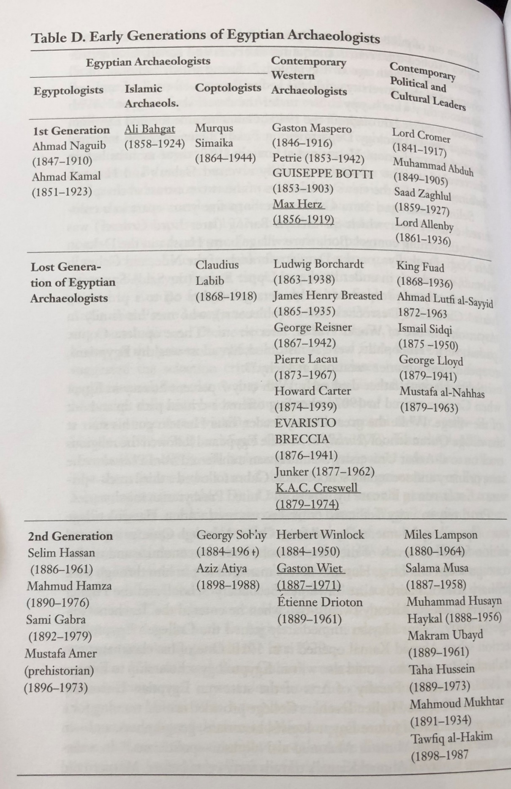
Appendix A. Illustrations. Reid, D. M. (2015) Contesting antiquity in Egypt: archaeologies, museums & the struggle for identities from world war 1 to Nasser. Cairo & New York: The American University in Cairo Press.

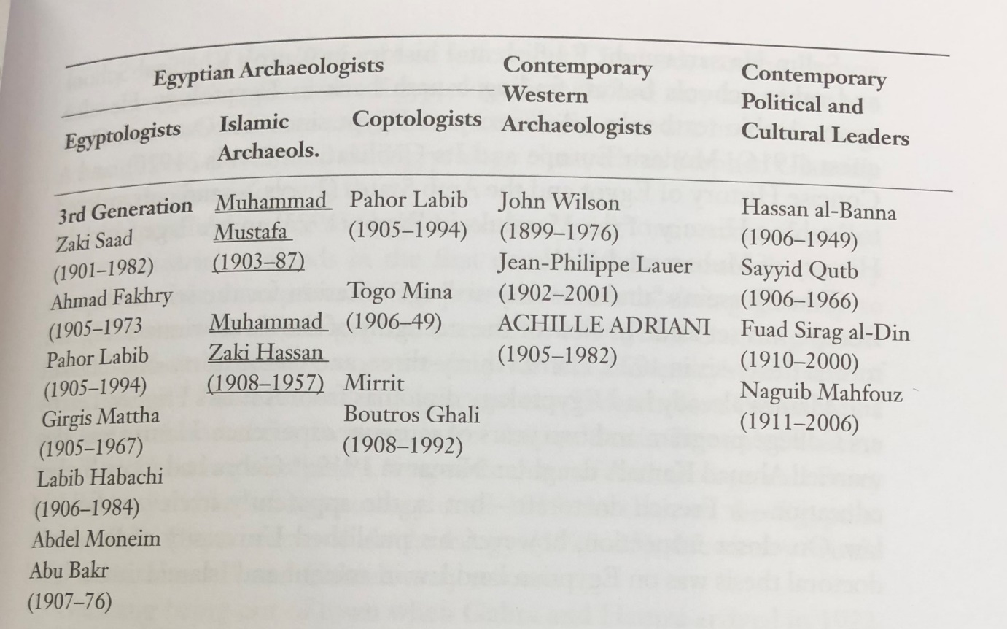
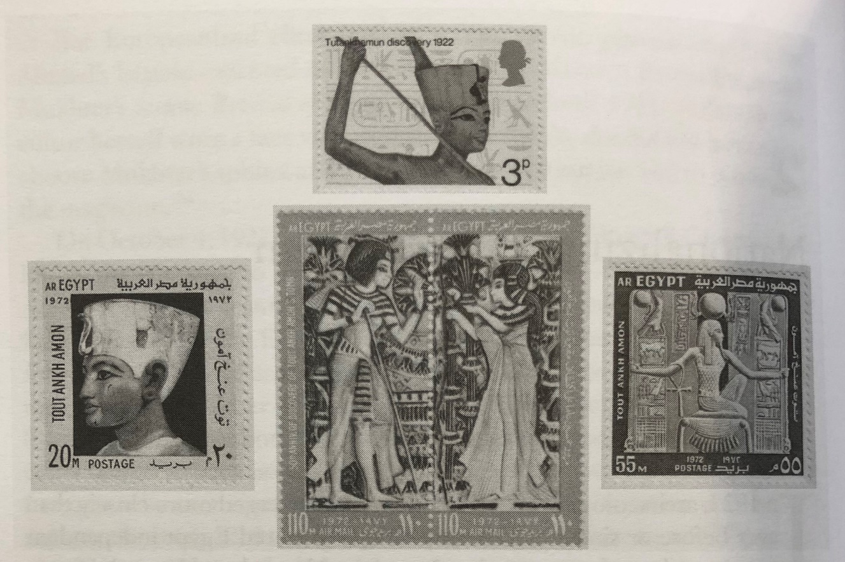

Appendix B. Up to date reading list for dissertation.
Arakaki, J. S. (1986) The Glint of Gold: Press Coverage of the Discovery of Tutankhamun’s Tomb. Unpublished PhD thesis, University of Redlands.
Anon. (2019) Behind the scenes as largest ever Tutankhamun exhibition moves to London. Available at: http://home.bt.com/news/behind-the-scenes-as-largest-ever-tutankhamun-exhibition-moves-to-london-91364399327709?playlistVideoId=6091137187001&utm_campaign=139799_Extended%20Hours%20Announced%21&utm_medium=email&utm_source=Tutankhamun%20London&dm_i=55SU,2ZVB,M0FAH,AUSB,1 [Accessed: 04/10/2019].
Bell, T. (2010) The Western Perception of Ancient Egypt: The Discovery, Spectacle and Exposition of King Tutankhamun. Unpublished PhD thesis, Newman University.
Brewer, D. J. & Teeter, E. (2007) Egypt and the Egyptians. 2nd ed. Cambridge: Cambridge University Press.
Brier, B. (2013) Egypt-omaina: our three thousand year obsession with the land of the pharaohs. 1st ed. New York: Palgrave Macmillan.
Carter, H. and Mace. A. C. (1923) The Tomb of Tut.Ankh.Amen. Volume one. Norwich: Jarrold and Sons Ltd.
Carter, H. (1927) The Tomb of Tut.Ankh.Amen. Volume two. Great Britain: Cassell and Company Ltd.
Carter, H. (1933) The Tomb of Tut.Ankh.Amen. Volume three. Frome and London: Bulter and Tanner Ltd.
Clayton, P. A. (1994) Chronicle of the Pharaohs: the reign-by-reign record of the rulers and dynasties of ancient Egypt. London: BCA.
Colla, E. (2007) Conflicted Antiquities Egyptology, Egyptomania, Egyptian Modernity. Durham and London: Duke University Press.
Collins, P. & McNamara, L. (2014) Discovering Tutankhamun. Oxford: Ashmolean Museum, University of Oxford.
Danton, W. (2019) Tutmaina: An Exploration of Western Portrayals of King Tutankhamun and Orientalism in Egypt. Unpublished PhD thesis, University of Puget Sound.
Desroches-Noblecourt, C. (1963) Tutankhamen: life and death of a pharaoh. London: Connoisseur and Michael Joseph Ltd.
Doyle, N. (2016) ‘The Earliest Known Uses of “L’Egyptomanie”/”Egyptomania” in French and English’, Journal of Ancient Egyptian Interconnections, 8, pp. 122-125. http://jaei.library.arizona.edu/ , [Accessed 18/06/2019].
Fritze, R. H. (2016) Egyptomania: a history of fascination, obsession and fantasy. London: Reaktion Books.
Fryxell, A. (2017) ‘Tutankhamen, Egyptomania, and Temporal Enchantment in Interwar Britain’, Twentieth Century British History, 28(4), pp. 516-542, doi:10.1093/tcbh/hwx056 [Accessed 27/07/2019]
Griffith Institute. (1922) Tutankhamun: Anatomy of an Excavation. Howard Carter’s diaries and journals. The first excavation season in the tomb of Tutankhamun. Part 1: October 28 to December 31, 1922. Available at: http://www.griffith.ox.ac.uk/gri/4sea1not.html [Accessed 10/10/19]
Hawass, Z. (2006) The golden king: the world of Tutankhamun. Cairo: American university in Cairo press.
Hollman, O. G. (2019) Coping Through Curse: Confronting British Metropolitan Identity Through The “Curse of Tutankhamen” (1923-1933). Unpublished PhD thesis, University of Kansas.
Ikram, S. (2010) Ancient Egypt: an introduction. New York: Cambridge University Press.
Janekowski, J. P. (2000) Egypt: a short history. Oxford: Oneworld.
Janot, F. (2010) The Royal Mummies Immortality in ancient Egypt. The American University in Cairo Press.
Jeffreys, D. G. (2003) Views of ancient Egypt since Napoleon Bonaparte imperialism, colonialism and modern appropriations. London: UCL Press London.
Kozloff, A. P. (2008) ‘Ancient Egypt in Museums Today’, in Wilkinson, R. H. (ed.) Egyptology Today. New York: Cambridge University Press.
Matthews, R., Roemer, C. & University College London. (2003) Ancient perspectives on Egypt. London: UCL Press.
Meskell, L. M. (2004) Object worlds in ancient Egypt: material biographies past and present. Oxford: Berg.
Moser, S. (2012) Wondrous curiosities: ancient Egypt at the British Museum. Chicago: University of Chicago Press.
Reid, D. M. (1985) ‘Indigenous Egyptology: The Decolonization of a Profession?’, Journal of the American Oriential Society, 105(2), pp.233-246. https://www.jstor.org/stable/601703?seq=1#metadata_info_tab_contents, [Accessed 18/06/2019].
Reid, D. M. (2003) Whose pharaohs? Archaeology, museums, and Egyptian national identity from Napoleon to world war 1. Berkeley: University of California Press.
Reid, D. M. (2015) Contesting antiquity in Egypt: archaeologies, museums & the struggle for identities from world war 1 to Nasser. Cairo & New York: The American University in Cairo Press.
Richmond, J. C. B. (1977) Egypt 1798-1952. London: Methuen & Co Ltd.
Saatchi Gallery (2019) Tutankhamun Treasures of the Golden Pharaoh. Available at: https://www.saatchigallery.com/art/tutankhamun.php [Accessed 03/10/19].
Shaw, I. (2003) The Oxford history of ancient Egypt. Oxford: Oxford University Press.
Shaw, I. (2004) Ancient Egypt A Very Short Introduction. New York: Oxford University Press Inc.
Simon, R. (?) Seeing More in Cabinets and Blockbusters: A Rhetorical Study of Museum Exhibits. Unpublished PhD thesis. Pennsylvania State University.
Slyomovics, S. (1989) ‘Cross-Cultural Dress and Tourist Performance in Egypt’, Performing Arts Journal, 11(3), pp. 139-148. https://www.jstor.org/stable/3245432?seq=1#metadata_info_tab_contents, [Accessed 27/07/2019].
Smith. G. E (1923) Tutankhamen and the Discovery of his Tomb by the Late Earl of Carnarvon and Mr Howard Carter. London: George Routledge & Sons Ltd
Stevenson, A. (2019) Scattered Find, Archaeology, Egyptology and Museums. London: UCL Press.
Tatomir, R. (2015) ‘Egyptomania in Antiquity and in Modern World Literature. Imaginary, Intercultural context and mentality’, Discourse as a Form of Multiculturalism in Literature and Communication, pp, 566-581. https://www.academia.edu/19750156/Egyptomania_in_Antiquity_and_in_Modern_World_Literature._Imaginary_Intercultural_Context_and_Mentality [Accessed 09/10/19]
Thompson, J. (2016) Wonderful Things: A History of Egyptology. Vol 2 The Golden Age: 1881-1914. The American University in Cairo Press.
Wood, M. (1998) ‘The Use of the Pharaonic Past in Modern Egyptian Nationalism’, Journal of the American Research Center in Egypt, 35, pp. 179-196 https://www.jstor.org/stable/40000469#metadata_info_tab_contents, [Accessed 27/07/2019]

Appendix C. Plan of action for dissertation work. M, Pak 2019.
 | October | November | December | January | February | March | April
Reading & notes
Planning
Writing
Contents
Editing
Printing
Bibliography
Illustrations

References
Arakaki, J. S. (1986) The Glint of Gold: Press Coverage of the Discovery of Tutankhamun’s Tomb. Unpublished PhD thesis, University of Redlands.
Anon. (2019) Behind the scenes as largest ever Tutankhamun exhibition moves to London. Available at: http://home.bt.com/news/behind-the-scenes-as-largest-ever-tutankhamun-exhibition-moves-to-london-91364399327709?playlistVideoId=6091137187001&utm_campaign=139799_Extended%20Hours%20Announced%21&utm_medium=email&utm_source=Tutankhamun%20London&dm_i=55SU,2ZVB,M0FAH,AUSB,1 [Accessed: 04/10/2019].
Carter, H. and Mace. A. C. (1923) The Tomb of Tut.Ankh.Amen. Volume one. Norwich: Jarrold and Sons Ltd.
Carter, H. (1927) The Tomb of Tut.Ankh.Amen. Volume two. Great Britain: Cassell and Company Ltd.
Carter, H. (1933) The Tomb of Tut.Ankh.Amen. Volume three. Frome and London: Bulter and Tanner Ltd.
Clayton, P. A. (1994) Chronicle of the Pharaohs: the reign-by-reign record of the rulers and dynasties of ancient Egypt. London: BCA.
Collins, P. & McNamara, L. (2014) Discovering Tutankhamun. Oxford: Ashmolean Museum, University of Oxford.
Fritze, R. H. (2016) Egyptomania: a history of fascination, obsession and fantasy. London: Reaktion Books.
Griffith Institute. (1922) Tutankhamun: Anatomy of an Excavation. Howard Carter’s diaries and journals. The first excavation season in the tomb of Tutankhamun. Part 1: October 28 to December 31, 1922. Available at: http://www.griffith.ox.ac.uk/gri/4sea1not.html [Accessed 10/10/19]
Janot, F. (2010) The Royal Mummies Immortality in ancient Egypt. The American University in Cairo Press.
Reid, D. M. (2015) Contesting antiquity in Egypt: archaeologies, museums & the struggle for identities from world war 1 to Nasser. Cairo & New York: The American University in Cairo Press.
Saatchi Gallery (2019) Tutankhamun Treasures of the Golden Pharaoh. Available at: https://www.saatchigallery.com/art/tutankhamun.php [Accessed 03/10/19].
Smith. G. E (1923) Tutankhamen and the Discovery of his Tomb by the Late Earl of Carnarvon and Mr Howard Carter. London: George Routledge & Sons Ltd
Tatomir, R. (2015) ‘Egyptomania in Antiquity and in Modern World Literature. Imaginary, Intercultural context and mentality’, Discourse as a Form of Multiculturalism in Literature and Communication, pp, 566-581. https://www.academia.edu/19750156/Egyptomania_in_Antiquity_and_in_Modern_World_Literature._Imaginary_Intercultural_Context_and_Mentality [Accessed 09/10/19]
Wood, M. (1998) ‘The Use of the Pharaonic Past in Modern Egyptian Nationalism’, Journal of the American Research Center in Egypt, 35, pp. 179-196 https://www.jstor.org/stable/40000469#metadata_info_tab_contents, [Accessed 27/07/2019]
Bibliography
Arakaki, J. S. (1986) The Glint of Gold: Press Coverage of the Discovery of Tutankhamun’s Tomb. Unpublished PhD thesis, University of Redlands.
Anon. (2019) Behind the scenes as largest ever Tutankhamun exhibition moves to London. Available at: http://home.bt.com/news/behind-the-scenes-as-largest-ever-tutankhamun-exhibition-moves-to-london-91364399327709?playlistVideoId=6091137187001&utm_campaign=139799_Extended%20Hours%20Announced%21&utm_medium=email&utm_source=Tutankhamun%20London&dm_i=55SU,2ZVB,M0FAH,AUSB,1 [Accessed: 04/10/2019].
Bell, T. (2010) The Western Perception of Ancient Egypt: The Discovery, Spectacle and Exposition of King Tutankhamun. Unpublished PhD thesis, Newman University.
Brewer, D. J. & Teeter, E. (2007) Egypt and the Egyptians. 2nd ed. Cambridge: Cambridge University Press.
Brier, B. (2013) Egypt-omaina: our three thousand year obsession with the land of the pharaohs. 1st ed. New York: Palgrave Macmillan.
Carter, H. and Mace. A. C. (1923) The Tomb of Tut.Ankh.Amen. Volume one. Norwich: Jarrold and Sons Ltd.
Carter, H. (1927) The Tomb of Tut.Ankh.Amen. Volume two. Great Britain: Cassell and Company Ltd.
Carter, H. (1933) The Tomb of Tut.Ankh.Amen. Volume three. Frome and London: Bulter and Tanner Ltd.
Clayton, P. A. (1994) Chronicle of the Pharaohs: the reign-by-reign record of the rulers and dynasties of ancient Egypt. London: BCA.
Colla, E. (2007) Conflicted Antiquities Egyptology, Egyptomania, Egyptian Modernity. Durham and London: Duke University Press.
Collins, P. & McNamara, L. (2014) Discovering Tutankhamun. Oxford: Ashmolean Museum, University of Oxford.
Danton, W. (2019) Tutmaina: An Exploration of Western Portrayals of King Tutankhamun and Orientalism in Egypt. Unpublished PhD thesis, University of Puget Sound.
Desroches-Noblecourt, C. (1963) Tutankhamen: life and death of a pharaoh. London: Connoisseur and Michael Joseph Ltd.
Doyle, N. (2016) ‘The Earliest Known Uses of “L’Egyptomanie”/”Egyptomania” in French and English’, Journal of Ancient Egyptian Interconnections, 8, pp. 122-125. http://jaei.library.arizona.edu/ , [Accessed 18/06/2019].
Fritze, R. H. (2016) Egyptomania: a history of fascination, obsession and fantasy. London: Reaktion Books.
Fryxell, A. (2017) ‘Tutankhamen, Egyptomania, and Temporal Enchantment in Interwar Britain’, Twentieth Century British History, 28(4), pp. 516-542, doi:10.1093/tcbh/hwx056 [Accessed 27/07/2019]
Griffith Institute. (1922) Tutankhamun: Anatomy of an Excavation. Howard Carter’s diaries and journals. The first excavation season in the tomb of Tutankhamun. Part 1: October 28 to December 31, 1922. Available at: http://www.griffith.ox.ac.uk/gri/4sea1not.html [Accessed 10/10/19]
Hawass, Z. (2006) The golden king: the world of Tutankhamun. Cairo: American university in Cairo press.
Hollman, O. G. (2019) Coping Through Curse: Confronting British Metropolitan Identity Through The “Curse of Tutankhamen” (1923-1933). Unpublished PhD thesis, University of Kansas.
Ikram, S. (2010) Ancient Egypt: an introduction. New York: Cambridge University Press.
Janekowski, J. P. (2000) Egypt: a short history. Oxford: Oneworld.
Janot, F. (2010) The Royal Mummies Immortality in ancient Egypt. The American University in Cairo Press.
Jeffreys, D. G. (2003) Views of ancient Egypt since Napoleon Bonaparte imperialism, colonialism and modern appropriations. London: UCL Press London.
Kozloff, A. P. (2008) ‘Ancient Egypt in Museums Today’, in Wilkinson, R. H. (ed.) Egyptology Today. New York: Cambridge University Press.
Matthews, R., Roemer, C. & University College London. (2003) Ancient perspectives on Egypt. London: UCL Press.
Meskell, L. M. (2004) Object worlds in ancient Egypt: material biographies past and present. Oxford: Berg.
Moser, S. (2012) Wondrous curiosities: ancient Egypt at the British Museum. Chicago: University of Chicago Press.
Reid, D. M. (1985) ‘Indigenous Egyptology: The Decolonization of a Profession?’, Journal of the American Oriential Society, 105(2), pp.233-246. https://www.jstor.org/stable/601703?seq=1#metadata_info_tab_contents, [Accessed 18/06/2019].
Reid, D. M. (2003) Whose pharaohs? Archaeology, museums, and Egyptian national identity from Napoleon to world war 1. Berkeley: University of California Press.
Reid, D. M. (2015) Contesting antiquity in Egypt: archaeologies, museums & the struggle for identities from world war 1 to Nasser. Cairo & New York: The American University in Cairo Press.
Richmond, J. C. B. (1977) Egypt 1798-1952. London: Methuen & Co Ltd.
Saatchi Gallery (2019) Tutankhamun Treasures of the Golden Pharaoh. Available at: https://www.saatchigallery.com/art/tutankhamun.php [Accessed 03/10/19].
Shaw, I. (2003) The Oxford history of ancient Egypt. Oxford: Oxford University Press.
Shaw, I. (2004) Ancient Egypt A Very Short Introduction. New York: Oxford University Press Inc.
Simon, R. (?) Seeing More in Cabinets and Blockbusters: A Rhetorical Study of Museum Exhibits. Unpublished PhD thesis. Pennsylvania State University.
Slyomovics, S. (1989) ‘Cross-Cultural Dress and Tourist Performance in Egypt’, Performing Arts Journal, 11(3), pp. 139-148. https://www.jstor.org/stable/3245432?seq=1#metadata_info_tab_contents, [Accessed 27/07/2019].
Smith. G. E (1923) Tutankhamen and the Discovery of his Tomb by the Late Earl of Carnarvon and Mr Howard Carter. London: George Routledge & Sons Ltd
Stevenson, A. (2019) Scattered Find, Archaeology, Egyptology and Museums. London: UCL Press.
Tatomir, R. (2015) ‘Egyptomania in Antiquity and in Modern World Literature. Imaginary, Intercultural context and mentality’, Discourse as a Form of Multiculturalism in Literature and Communication, pp, 566-581. https://www.academia.edu/19750156/Egyptomania_in_Antiquity_and_in_Modern_World_Literature._Imaginary_Intercultural_Context_and_Mentality [Accessed 09/10/19]
Thompson, J. (2016) Wonderful Things: A History of Egyptology. Vol 2 The Golden Age: 1881-1914. The American University in Cairo Press.
Wood, M. (1998) ‘The Use of the Pharaonic Past in Modern Egyptian Nationalism’, Journal of the American Research Center in Egypt, 35, pp. 179-196 https://www.jstor.org/stable/40000469#metadata_info_tab_contents, [Accessed 27/07/2019]

Tatomir, 2015, p. 571
Anon, 2019
Carter and Mace, 1923
Tatomir, 2015, p. 568
Reid, 2015: 51-109
Tatomir, 2015, p. 571
Wood, 1998, p. 189
Janot, 2010: 112
Saatchi Gallery, 2019
Clayton, 1994: 128
Smith, 1923: 16
Fritze, 2016: 222
Arakaki, 1986, p.2
Saatchi Gallery, 2019
Saatchi Gallery, 2019
Reid, 2015
Griffith Institute, 1922
Smith, 1923
Collins and McNamara, 2014: 19.

