Topophobia and domesticity in the visual culture.
Can contemporary artists challenge heteronormative power structures within domestic space that produces the notion of 'mental load'?

Alina Skorohoda: P150489
Submitted in partial fulfilment of the requirements for the degree of BA (Hons) Fine Art (Combined Media) University of Wales Trinity Saint David, Swansea.

Date of submission: 12th December 2018
TABLE OF CONTENTS

PAGE
List of illustrations .......................................................................................................2
Summary of topic.........................................................................................................3
Introduction ...............................................................................................................4
Chapter 1: Research..................................................................................................6
The Beauty Myth..........................................................................................................8
Disorders caused by the pressure of the feminine ideal…........................................11
The Social Panopticon...............................................................................................14
Chapter 2: Case Study............................................................................................17
Louise Bourgeois: Hysteria.......................................................................................17
Mona Hatoum: Topophobia and an uncanny connection to Panopticon...................21
Gluklya and Tsaplya : Motherhood............................................................................24
Martha Rosler : The language of domesticity...........................................................27
Michal Cole: Domestic Godless.................................................................................30
Conclusion.................................................................................................................34
Bibliography................................................................................................................36
Word count: 5060

LIST OF ILLUSTRATIONS

Figure 1 - Louise Bourgeois Three examples from the Femme Maison series, (1946–47)
Figure 2 - Louise Bourgeois Arch of Hysteria, 1993
Figure 3 - Louise Bourgeois Arched Figure Sculpture 1999
Figure 4 - Mona Hatoum Homebound, 2000
Figure 5 - A film by Gluklya and Tsaplya Three Mothers and a Chorus 2007
Figure 6 - Martha Rosler Semiotics of the Kitchen - (Short Film 6 mins) 1975
Figures 7, 8 and 9 - Michal Cole Domestic Godless 2017
Figure 10 and 11 - Michal Cole Neverland 2017

Summary of topic

This dissertation will examine the notion of Topophobia in relation to ‘mental load’ and the concept of psychological panoptical control associated with the unattainable ideals of femininity. This paper will explore feminist practice that demonstrates the mental pressures upon the female role. The investigation will be based on the social pressures of female identity in the research of Naomi Wolf, Judith Butler and Simone de Beauvoir and the feminist art practice of Louise Bourgeois, Mona Hatoum, Gluklya and Tsaplya, Martha Rosler and Michal Cole.

Introduction

Woman is shut up in a kitchen or in a boudoir, and astonishment is expressed that her horizon is limited. Her wings are clipped, and it is found deplorable that she cannot fly. Let but the future be opened to her, and she will no longer be compelled to linger in the present. (Beauvoir, 1997 p.616)

This dissertation will explore and analyse the works of Louise Bourgeois, Mona Hatoum, Gluklya and Tsaplya , Martha Rosler and Michal Cole in the context of female identity and domesticity. The investigation will centre on the social pressures placed upon female identity and will be contextualised in the research of Naomi Wolf, Judith Butler and Simone de Beauvoir.
This dissertation focuses on the unfamiliar term Topophobia in relation to domestic space. Topophobia refers to a fear of a specific space; in the context of this research the fear of place will be examined through feminist art practice which explores the power structures within domestic situations.

This dissertation will also adopt the phrase ‘mental load’ as a means to describe the increasing pressure on female identity to both strive for both equality and the feminine ideal. The phrase mental load has culturally been used to describe the mental pressures of a male’s experience at work and therefore appropriating this phrase becomes an interesting method to deconstruct this patriarchal association.
The term ‘mental load’ is only represented in comics and therefore becomes undermined by humour. In the example of the French comic sketch "You Should've Asked", French comic artist Emma illustrates the burden of the woman’s domestic management. She portrays ‘woman’ as a domestic manager that no one can substitute. (Emma, 2017) The artist illustrated the experience of mental load through humour and attracted the attention of women and created a discursive space for the subject.
The ‘mental load’ as a scientific concept exists within cognitive psychology that investigates the impact of stress in the working environment. Nevertheless, the wide body of research does not focus on the area of domesticity and its impact on women's wellbeing. This research addresses the need for research on the notion of ‘mental load’ and it will explore the work of various artists that address this notion.

Chapter 1: Research

The division between private (domestic) and public spheres exists in our society as a historical doctrine. The omnipresent nature of this hegemonic divide is illustrated in multiple proverbial forms.

Today this divide still persists and, although not as rigidly perhaps, it is still as damaging. An old Russian colloquialism, for example, says:

От хозяина чтоб пахло ветром,
От хозяйки дымом.
(Даль В. И., 2008 p.216)
The husband should smell of wind,
The wife should smell of smoke.
(Dal V.I., 2008 p.216) [author’s translation]

This division remains evident in contemporary society: Idealization of ‘the housewife’ is perpetuated by tradition, social media and the absence of critical discourse on the subject of ‘mental load’.
What about the New Woman, with her responsible full-time job? Economist Nancy Barrett says that “there is no evidence of sweeping changes in the division of labor force participation.” (Wolf, 2002 p.23-24)

Or: Though a women does full-time paid work, she still does all or nearly all the unpaid work that she used to. (Wolf, 2002 p.23-24)

Domestic roles remain a form of unpaid work. Wolf highlights that changes are very minimal if we look at the big picture. She states that:

Ninety percent of wives and 85 percent of husbands in the United States say the woman does “all or most” of the household chores. Professional women in the United States fare little better: Sociologist Arlie Hochschild found that the women in two-career couples come home to do 75 percent of household work. Married American men do only 10 percent more domestic work than they did twenty years ago. (Wolf, 2002 p.23-24)

Wolf describes the burden of responsibilities that still affect the majority of Western women:

The work week of American women is twenty-one hours longer than of men; economist Heidi Hartmann demonstrates that “men actually demand eight hours more service per week than they contribute.” In Italy, 85 percent of mothers with children and full-time paid jobs are married to men who share no work in the home at all. The average European woman with a paid job has 33 percent less leisure than her husband. (Wolf, 2002 p.23-24)

Regardless of women’s productivity success at work:

In Kenya, given unequal agricultural resources, women’s harvests equalled men’s; given equal resources, they produced bigger harvests more efficiently. (Wolf, 2002 p.23-24)
Hannah Hoch:- Der Maller- The painter 1920 (essay)

Hannah Hoch in her essay The painter comically illustrated the resistance to challenging the domestic and social divide:

Once upon a time there was a painter. (...) the painter was a modern painter—so his name was Heavenlykingdom. Unlike the real painters of earlier times, he was not asked to work only with brush and palette. This was his wife’s fault: she thwarted the boundless flight of his genius. At least four times in four years, he was forced to wash dishes – the kitchen dishes. The first time, actually, there had been a pressing reason. She was giving birth to the baby Heavenlykingdom. The other three times had not seemed absolutely necessary to Heavenlykingdom (...) (Hoch, 1920.)

The essay effectively illustrates the resistance of men to participate in domestic chores. The idea of the participation in domestic duties such as washing dishes, was considered by the character in the story as a violation of his rights. The character has rationalized one of the justifications - ‘’she was giving birth to the baby’’, but he could not rationalize the other three times his rights were violated.

The Beauty Myth
In The Beauty Myth, Naomi Wolf talks about the three areas in which women in contemporary society are expected to participate: work, home and beauty. Wolf argues that every time a woman reaches a higher level in society, she is given a new sets of obligations, such as ‘looking good’, performing a certain type of role well (etc).
Wolf talks about the economic underpinning of the myth of femininity and how the myth ‘naturalizes’ the behaviour through social persuasion:
An economy that depends on slavery needs to promote images of slaves that “justify” the institution of slavery. The contemporary economy right now on the representation of women within the beauty myth. (Wolf, 2002, p.18)

The same ideas may be applied to the representation of femininity in a domestic context: Economy promotes images of the housewife in order to stabilise the development of industry. Therefore, if women continue to consume the ideology and objects associated with the feminine, this identity is continually perpetuated.

Economist John Kenneth Galbraith offers an economic explanation for “the persistence of the view of homemaking as a ‘higher calling’”: the concept of women as naturally trapped within the Feminine Mystique, he feels, “has been forced on us by popular sociology, by magazines, and by fiction to disguise the fact that woman in her role of consumer has been essential to the development of our industrial society (Wolf, 2002 p.18)

Women embark on this mission of femininity as a rite of passage that attracts them with the promise of challenge and self-affirmation. This ‘’Behavior that is essential for economic reasons is transformed into a social virtue.” (Wolf,2002,p.18)

The ideal female consumer is ‘turning the wheels’ of the economic system and multiplying the domestic ideals that justify subserviency.

The artists that comment on the burden of gendered domestic responsibilities comment on the imbalance of the functionalist duties ascribed to woman.

The artworks highlight the need for a queer reconstruction of the discourse surrounding domestic burden and the need for a renegotiation of gendered domestic duties. The process of queering domestic responsibilities, arguably, could rebalance the heteronormative bias of domestic roles.

While working hard on delivering the stereotype of femininity to the world, women are also expected to compete on the same level with men in the workplace. In the workplace, the burden of delivering the stereotype of femininity arguably costs women time and money.
According to the Humphrey Institute of Public Affairs: “While women represent 50 percent of the world population, they perform nearly two-thirds of all working hours, receive only one-tenth of the world income and owns less than 1 percent of world property (Wolf, 2002, p.23)
It could be said that the ‘mission’ of femininity negatively affects various areas of a woman’s life and manifests itself in the form of a mental load.

Disorders caused by the pressure of the ideal of femininity

Judith Butler in her book Gender Trouble discusses Simone de Beauvoir (Second Sex) and the schemas to which young girls adapt their behaviour. These behaviours are unspoken cultural instructions passed from mother to daughter. Alongside these instructions, the anxieties and the ‘mental load’ is passed on. (Butler, 1999 p.43)

If there is something right in Beauvoir's claim that one is not born, but rather becomes a woman, it follows that woman itself is a term in process, a becoming, a constructing that cannot rightfully be said to originate or to end. As an ongoing discursive practice, it is open to intervention and resignification. (Butler, 1999 p. 43)

Butler comments on the Irigaray notion of gender masquerade:
Irigaray remarks in such a vein that "the masquerade... is what women do... in order to participate in man's desire, but at the cost of giving up their own".”(Butler,1999 p.60)

John Berger explains this notion of masquerade through the example of vision. He uses the analogy of surveillance and the policing of appearance that women participate in since childhood.

The surveyor of woman in herself is male: the surveyed female. [..]

From earliest childhood she has been taught and persuaded to survey herself continually. And so she comes to consider the surveyor and the surveyed within her as the two constituent yet always distinct elements of her identity as a woman. She has to survey everything she is and everything she does because how she appears to men, is of crucial importance for what is normally thought of as the success of her life. (Berger, 1972 p.46)

This self-policing and masquerade maintains the construction of the ideal of femininity.

The construction of the role of ‘woman’ within society arguably has a negative effect on women’s health and financial status. These ideas have been studied in various fields. In the case of the construction of female body image, studies been conducted in relation to eating disorders such as studies on bulimia and anorexia.

Anorexia is the biggest killer of American teenage girls. Disordered eating, which was undertaken to fit a disordered ideal, was one of the causes of the disease, and not necessarily, as popular opinion of the day held, a manifestation of an underlying neurosis. (Wolf , 2002 p.5)
The negative effects of the construction of the ideal image for women has been studied in relation to various eating disorders such as bulimia:

Bulimia Nervosa

Definition
Bulimia nervosa is a serious and sometimes life-threatening eating disorder affecting mainly young women. [...] The behavior often serves to reduce stress and relieve anxiety. Because bulimia results from an excessive concern with weight control and self-image, and is often accompanied by depression, it is also considered a psychiatric illness. [...] Bulimia nervosa is a serious health problem for over two million adolescent girls and young women in the United States.[...] One study found that mothers who are extremely concerned about their daughters' physical attractiveness and weight may help to cause bulimia. In addition, girls with eating disorders tend to have fathers and brothers who criticize their weight. (The Free Dictionary/Medical Dictionary, 2018)

The issue of ‘mental load’ is non-gender specific in itself; everyone needs to eat and buy groceries for example, but the inherent responsibility for these activities is assumed to belong to women.

Sedgwick talks about the idea of queer personality that does not conform to the monolithic gender construction. She refers to queer as:
the open mesh of possibilities, gaps, overlaps, dissonances and resonances, lapses and excesses of meaning when the constituent elements of anyone’s gender, of anyone’s sexuality aren’t made (or can’t be made) to signify monolithically. (Sedgwick,1993 p.8)

This notion of invisible inequality is the idea of an unfinished revolution of feminism that artists attempt to address.

The Social Panopticon

This paper will explore the psychological model of the panopticon rather than a literal physical parallel with Bentham’s structure.
The kitchen becomes the symbol of panoptic control: it isolates and controls woman at the same time. The place in woman’s mind becomes the open prison or the undertaking where she needs to sign in constantly. It is the inescapability from the self-surveilling place inside woman’s mind that creates topophobia.

The kitchen as panopticon operates in two ways: women are disciplined in terms of self-surveillance to fulfill their duties in an efficient manner; and the architecture of the kitchen is panoptical, because scientific management and efficiency of the kitchen has reduced it to a streamlined, one-worker space (Supski, 2007 p.140).

The kitchen becomes a space of psychological confinement.

The panopticon offers a particularly vivid instance of how political technologies of the body function. It is "a generalizable model of functioning; a way of defining power relations in terms of the everyday life of men […] (Foucault, 1975 p.205)

The physical design and culturally associated model of the kitchen is ‘a generalizable model of functioning’ (Foucault, 1975, p.205). This ‘generalizable model ‘ is associated with female gender and presumes functions that are idealized and promoted to sustain the gender binary.

The surveillant could as easily be observing a criminal, a schoolboy, or a wife (Bentham suggests, apparently without humor, that the panopticon would be an extremely effective arrangement for a harem, since it would cut down the number of eunuchs necessary to watch the women in the cells. (Foucault, 1984, p.19)

The psychological control of the panopticon is the unattainable ideal that creates an aspirational trap. In her book Bodies That Matter Butler describes the impossibility of conforming to an idealised constructed image ‘it is an assignment which is never quite carried out according to expectation, whose addressee never quite inhabits the ideal s/he is compelled to approximate’ (Butler, 2014 p.231).

The topic of domesticity is not a private one but is open to external judgement and scrutiny of the social duty imposed upon it.

In this form of management, power is not totally entrusted to someone who would exercise it alone, over others, in an absolute fashion; rather, this machine is one in which everyone is caught, those who exercise this power as welI as those who are subjected to it. (Foucault, 1984 p.156)

The social ideal of the housewife can be compared to the panoptic technology:

A particular rationality accompanies the panoptic technology: one that is self-contained and non theoretical, geared to efficiency and productivity. For Bentham, the panopticon had the advantage of being utilitarian, capable of service in a multitude of settings for a multitude of purposes. It seemed to pose no standard of judgment or to follow any particular program. It aimed to be a tool for distributing individuals in space, for ordering them in a visible way. Hence its potential for generalization. (Foucault, 1984, p.20)

Jennifer Craik in her book The Making of Mother: The Role of the Kitchen in the Home compares the kitchen to the panopticon :
The kitchen is the site and source of domestic power, and yet, like Bentham's prison, it is constrained by its very internalization and institutionalization. The kitchen has become the double-edged sword of domesticity, at once the metaphor for family life and the sign of domestic isolation.
(Craik, 1989, p. 48).
The panopticon can be paralleled to the feeling of ‘being watched’, the anxiety that is tied to the domestic sphere.

It may be argued that there is also a social panopticon at work in that society controls gender identity through its construction and the expectation of individuals’ conformity to those constructions.

Chapter Two: Case Study

Louise Bourgeois: Hysteria

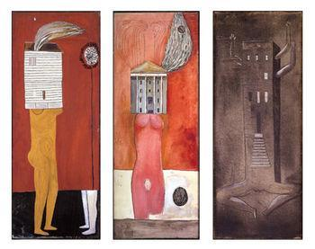
Figure 1
Louise Bourgeois
Three examples from the Femme Maison series, (1946–47)

Louise Bourgeois, one of the first seminal feminist artists, has explored the gendered constructions of women’s experience within designated gendered roles.

Femme Maison describes the experience of domesticity. These private experiences, when publicly exhibited, become public and political. Paintings simultaneously illustrate the entrapment and shelter of the domestic sphere.
In Femme Maison the house forms are dominating the female body.

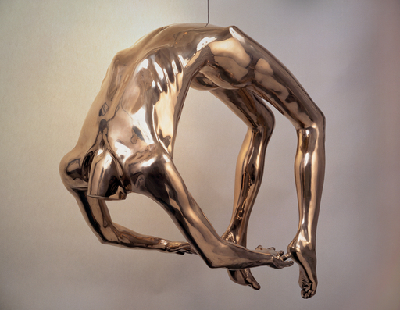

Figure 2
Louise Bourgeois
Arch of Hysteria, 1993

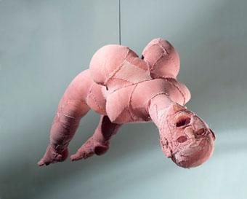

Figure 3
Louise Bourgeois
Arched Figure Sculpture 1999

Juliet Mitchell talks about the artist’s awareness of the gendering of hysteria in Bourgeois:
As well as her notes, the beautiful bronze male Arch of Hysteria (see Arch of Hysteria, 1993) which morphs into the ‘’ugly’’ rag-doll female Arch of Hysteria (see Arch of Hysteria, 2000) illustrates that an awareness of the ‘’gendering’’ of hysteria was important to Bourgeois. Hysteria is (and must be) an ungendered universal condition. (Mitchell, 2012 p.59)

The socially constructed nature of domestic roles and the gender attributions of hysteria imposed upon women, suggests heteronormative power dynamics at play. The heteronormative in this context references to the male as rational and female as irrational; they are complimentary counterparts.
With her head trapped inside the house and her legs vulnerable to exposure, yet strong enough to carry the weight of her domestic situation, Bourgeois’s Femme Maison came to represent the situation of being female, or more specifically of being a woman artist (Coxon, 2010 p.11)

Mona Hatoum: Topophobia and uncanny connection to Panopticon
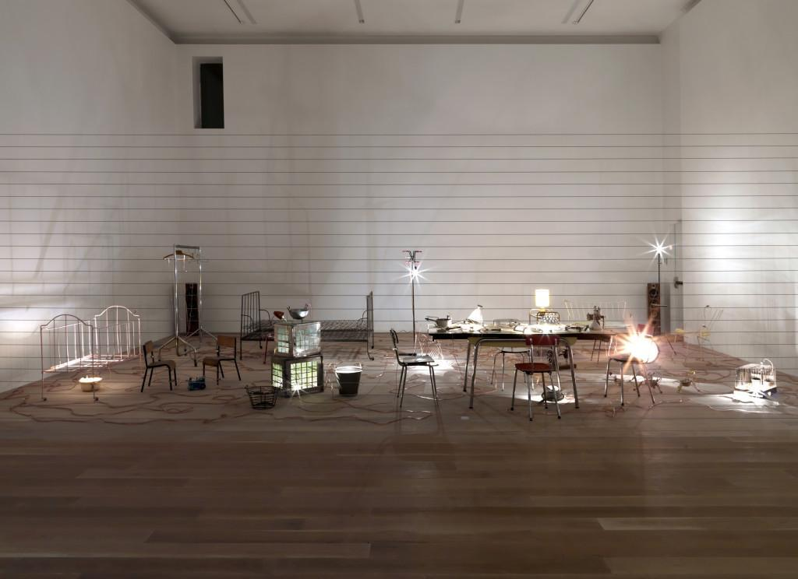
Figure 4
Mona Hatoum
Homebound, 2000

Hatoum’s Homebound installation explores the oppression of women in the home environment. The installation places the viewer in the overwhelming experience produced by lighting bulbs that surround kitchen utensils domestic objects that produces an overpowering and disturbing sound that is impossible to escape.
The sense of oppression and entrapment is produced by a wire fence surrounding the installation (Weerasekera, 2016).

Hatoum talks about the Freudian concept of ‘uncanny’, which translates into the unhomely. She discusses objects that have been homely and then became unhomely due to some form of trauma (Terra Infirma, 2017).

The uncanny according to Freud’s analysis, therefore, derives its terror not from something externally alien or unknown but from something strangely familiar which defeats our efforts to separate ourselves from it. A panoptical effect on women within domestic space may be described as an ‘uncanny’ experience in that women cannot describe but only can experience.

For example; the space of the kitchen may be experienced by a child as a space of pleasure and play, whereas this space may be a site of oppression when viewed through the discursive space of gender identity.

The work can be said to create a certain claustrophobic effect on the viewer that may be related to the wider experience of topophobia. Topophobia is ‘a neurotic dread of or related to a particular place or locality’ (Medical Dictionary, 2011) Topophobia is related to the fear of domestic burden and can be related to the ‘uncanny’ experience that ’ occurs when something that is familiar is alienated, through a process of repression, and then returns to us in an uncanny form’ (Grenville 2001 p.20).

Mental load is the psychological phenomenon that has no discursive power. The discursive power around the topic of the mental load is impeded by social implications such as alienation, stigma or peer rejection.

Hatoum’s work references domestic violence, fear of objects of everyday life and how objects become ‘uncanny’.

Gluklya and Tsaplya : Motherhood

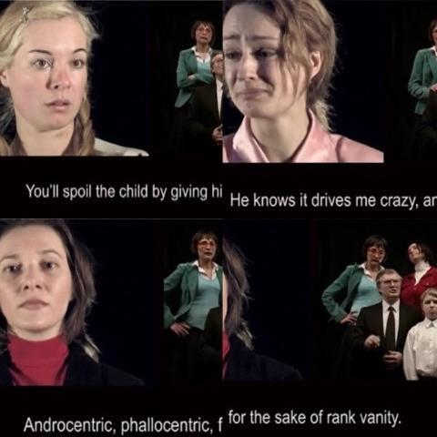
Figure 5
A film by Gluklya and Tsaplya Three Mothers and a Chorus, 2007

The video work Three Mothers and a Chorus by Russian contemporary artists Gluklya and Tsaplya explores the burden of social pressure on the mother figure. The video is presented in the style of a Greek chorus with the figure of the mother accompanied by the choir, singing out the social judgements that surround motherhood. The characters of the choir sing a stereotypical critique that mothers internalise. The video portrays three different scenarios of motherhood:

Various archetypical comments of social judgement are sung at the mother:

You are a bad mother!
- The highest calling of the woman is motherhood and home! You’ve quit your duty for the vanity!
- Poor you, poor you! You have rejected your own child and cowardly ran away!
- Poor child!
- You are a bad mother! That’s it!
- Mummy, you are the best!
- The duty of the mother is to stay at home and look after the child, and the father should earn the money! Odious feminism! (transl. From Russian in Schurko 2012)

Mothers are arguably judged upon how they should perform the role of the mother. The advice mothers receive is often contradictory and creates an experience of this vicious cycle. Mothers internalise the discourse around motherhood and it becomes a daily mantra which subsequently becomes ‘mental load’.

Gluklya and Tsaplya use the analogy of Greek chorus.

Greek chorus is a chorus in a classical Greek play typically serving to formulate, express, and comment on the moral issue that is raised by the dramatic action or to express an emotion appropriate to each stage of the dramatic conflict (Merriam Webster)

The Greek chorus represents public opinion, social pressure and the stigma surrounding motherhood. Greek chorus “is a homogeneous, non-individualised group of performers, who comment with a collective voice on the dramatic action.’’(Pavis 1998:53) The work portrays the pressure of public opinion that gets internalised by a contemporary mother.
The choir analogy helps to illustrate the overwhelming pressure of social judgement that does not require an actual person to enact a judgement; the judgement is already inscribed in the self-policing nature of the mental load. This self-policing nature can be linked to the omnipresent surveillance effect of the Panopticon.

Martha Rosler: language of domesticity

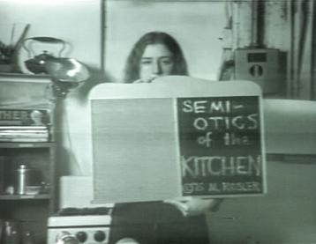
Figure 6
Martha Rosler
Semiotics of the Kitchen -Short Film 6 mins, 1975

In Semiotics of the Kitchen, the artist sarcastically demonstrates the subjective language of kitchen utensils. Martha Rosler’s video parodies the Julia Child cooking TV show from the 1960s. (MoMa 2018). Rosler describes the kitchen utensils in alphabetical order in the style of an ABC lesson. This film mimics the ABC lesson model reflecting upon the layers of instruction used in the popular cooking programme: the descriptive layer of the cooking itself and the layer in which the manner of private (domestic) behaviour is constructed.

Simone de Beauvoir in her interview (de Beauvoir, 1975) mentions the book “What are little girls made of?” by Elena Gianini Belotti, that explores the early conditioning of women. Berlotti states that: “A child has an inborn capacity to play, but the rules and objects are undoubtedly the product of culture.” (Belotti, 2003).

Cultural conditioning into the heteronormative roles can be traced in the nursery rhyme for example. The 19th century nursery song What are little boys made of? describes girls as ‘’sugar and spice’’ and "all things nice" instructing young girls about the identity traits of femininity.

What are little boys made of?
What are little boys made of?
Snips and snails
And puppy-dogs' tails
That's what little boys are made of
What are little girls made of?
What are little girls made of?
Sugar and spice
And everything nice [or "all things nice"]
That's what little girls are made of
(Opie, 1997 p.100–101)

Rosler presents the kitchen utensils with aggressive, militant gestures. She presents domestic language as a weapon. She ironically reflects upon the culturally constructed non-violent language of domesticity and the impossibility to protest within the language of the domestic. With this ironic violent gesture Rosler arguably comments on the dulled language of the everyday violence of domestic burden. When Rosler presents the objects, she does this with an unemotional, impenetrable facial expression and robotic voice; this contrasts with the violent gestures of the presentation. The lifeless voice of Rosler is authoritative, well paced and didactic. Rosler arguably describes the dogmatic internalised language of the mental load and contrasts it with the affirmative language of the housewife stereotype portrayed through TV Shows. Rosler reflects on the domestication of women through the language of domesticity:

I was concerned with something like the notion of 'language speaking the subject,' and with the transformation of the woman herself into a sign in a system of signs that represent a system of food production, a system of harnessed subjectivity. (Rosler, 2018)

The film Semiotics of the Kitchen arguably portrays the ‘‘assignment which is never quite carried out according to expectation’’ (Butler, 2014 p.231); the ideal of the housewife is arguably never achieved yet it is constantly rehearsed.

The certain element of performance (pretension) is arguably inherent in the playing the role of the housewife. This pretension, enforced by cultural ideals of domesticity, arguably calls upon the commitment to this constructed role. This constructed role may be considered to form the experience of mental load. This paper suggests that the dominant domestic discourse perpetuates mental load and produces topophobia of the domestic territory.

Michal Cole: Domestic Godless

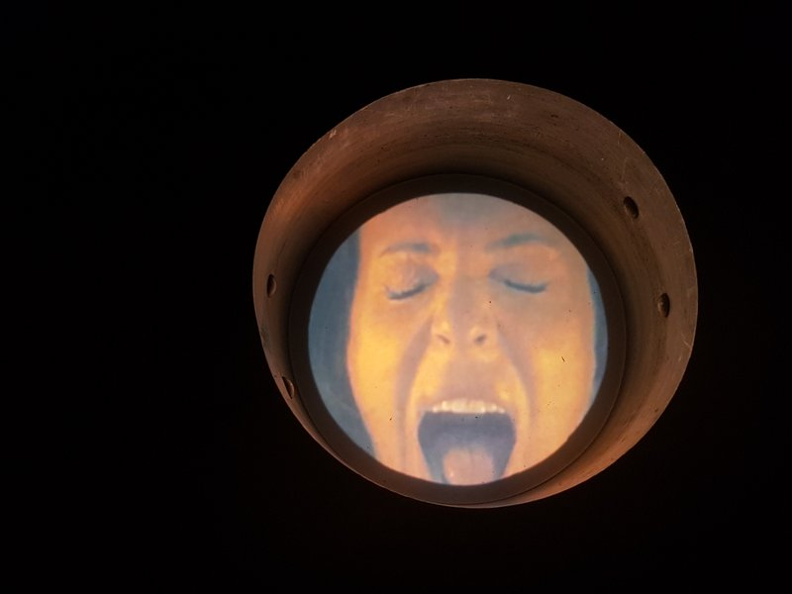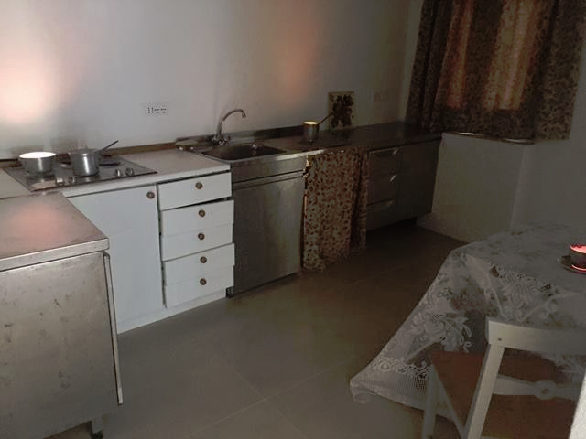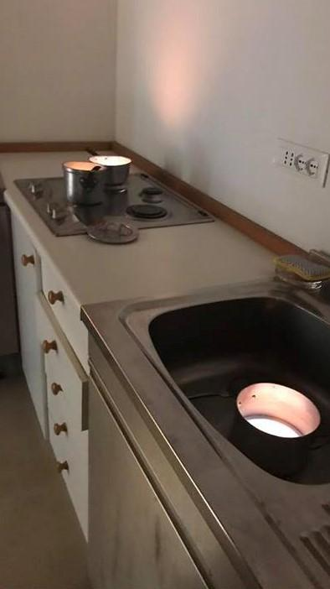

Figure 7,8 and 9
Michal Cole
Domestic Godless
2017

Michal Cole explores the demanding nature of the domestic environment. Her installation, Domestic Godless was exhibited in the collaborative installation Objection inside a tranquil Venetian villa with a view of the Grand Canal. The installation Domestic Godless consisted of various domestic objects that were subverted in some way. The kitchen installation consisted of pots that contained videos of screaming women inside them. (Cadwell, 2017). The ‘screaming’ utensils arguably expressed the effect of ‘mental load’ and women’s confinement inside domesticity. These screaming utensils anthropomorphically illustrate the experience of topophobia. An ‘uncanny’ atmosphere is created by ‘screaming’ projections inside ordinary kitchen pots. The projections are filtered through orange/red tones, suggesting a ‘hellish’ context. The ‘hellish’ arguably represents the scorching experience of the ‘internalised trauma’ of the domestic burden/mental load. This internalised experience of mental load can be compared to the more external manifestation of hysteria in the 19th Century. The concept of hysteria may be translated into the experience of contemporary woman, but arguably does not have a same response from the male audience.

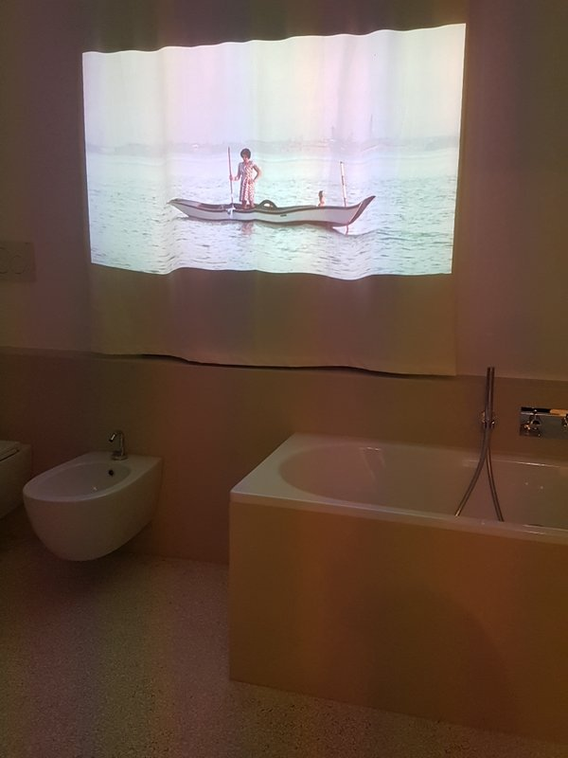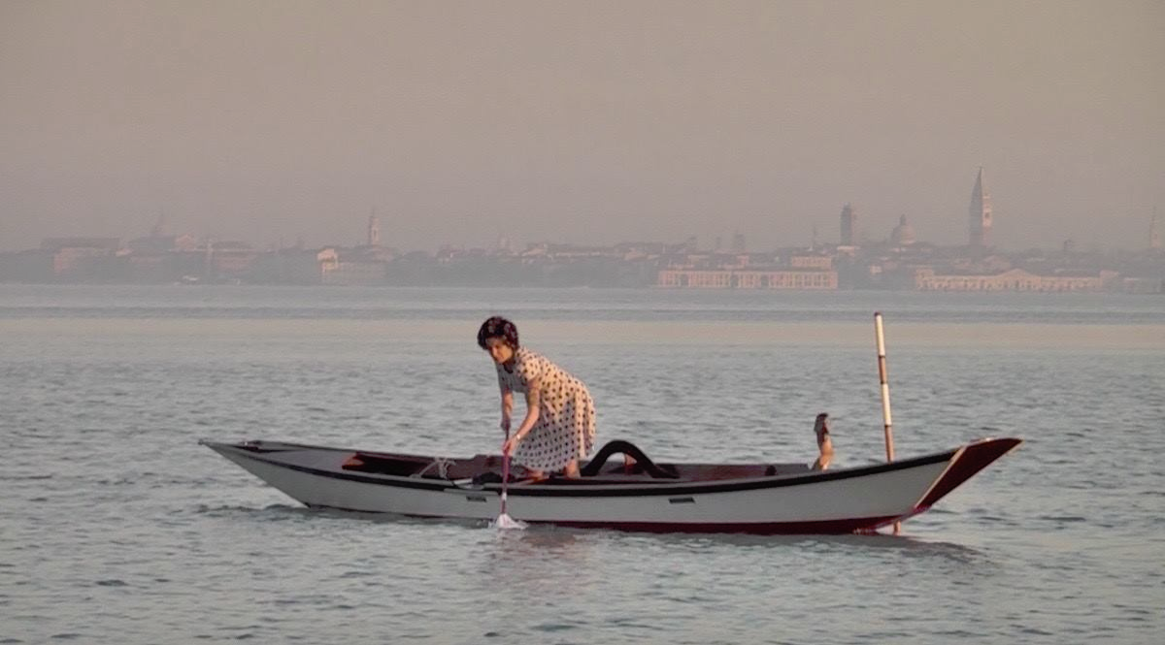
Figure 10 and 11
Michal Cole
Neverland
2017

Another artwork in the installation Neverland portrays a woman trying to mop the sea. (Cadwell, 2017). Neverland illustrates the never-ending undertaking of the domestic burden.

The panoptical psychological confinement of the kitchen or other private spaces such as a bathroom as in the Neverland artwork refers to a private (domestic) space that heteronormatively confines woman to the experience of mental load and topophobia that is arguably not shared with the ‘other sex’ (male).

The female character in the film is wearing a stereotypical 1950s housewife costume reflecting upon a historical, traditional female identity. The longevity of this ideal is portrayed in Michal Cole’s film Neverland.

Like a project that never ends, femininity and domestic ideals outlive their protagonists.
Hence, gender is an act which has been rehearsed, much as a script survives the particular actors who make use of it, but which requires individual actors in order to be actualized and reproduced as reality once again. (Butler,1988 p.526.)

Conclusion

This paper has demonstrated that contemporary feminist art practice can address
heteronormative power structures within a domesticity that produces the notion of 'mental load'. Naomi Wolf demonstrated that there is still an imbalance in the functionalist duties ascribed to the ideals of femininity. These ideals directly influence a woman’s well-being and unpaid domestic work may be said to cause real risk to women's health (bulimia, anorexia). The paper has defined the nature of the arbitrary roles and ideals of femininity and their relation to domesticity through the conceptions of a performative concept of gender and the constructed nature of femininity in the writings of Simone de Beauvoir and Judith Butler.

With the use of case studies this dissertation has defined the notion of Topophobia in relation to ‘mental load’ using the concept of a psychological panoptical control in relation to the unattainable ideals of femininity. The work of Louise Bourgeois, Mona Hatoum, Gluklya and Tsaplya, Martha Rosler and Michal Cole has been used to interpret the pressures placed upon female identity through the context of domesticity referenced in their practice

This dissertation has developed the term Topophobia in connection with the domestic space and the ‘dominant’ domestic discourse (Western gender construction). Louise Bourgeois portrayed the experience of domesticity and the psychological entrapment of the woman in the domestic (private) role. Hatoum portrayed how the mental load of domesticity can create the feeling of the ‘uncanny’ and produce topophobia. By portraying an oppressive environment and the confining panoptical effect of domestic space she produces a discursive space for gender identity. Hatoum expressed the heteronormative domestic oppression of women by exposing the uncanny nature of domestic space. Rosler’s work Semiotics of the Kitchen portrayed the way in which the language of domesticity and dominant domestic discourse can perpetuate the experience of mental load and therefore produce topophobia of domestic territory.

Gluklya and Tsaplya effectively portrayed the internalised social judgements of motherhood manifesting itself in the self-policing panoptical surveillance and subsequently producing mental load. Michal Cole portrays the topophobia produced in the domestic environment by the mental load that in its turn perpetuates the unattainable domestic ideals of femininity.

This paper has attempted to strengthen the position of the discourse which suggests that the notion of mental load exists for contemporary women and requires further investigation and therefore the artists considered in this dissertation are challenging the heteronormative power structures that exist within domestic space.

Bibliography
Butler, J. (2014), Bodies That Matter: On the Discursive Limits of "Sex", Routledge, p. 231

Butler, J,(Dec., 1988), Performative Acts and Gender Constitution: An Essay in Phenomenology and Feminist Theory, The Johns Hopkins University Press, Theatre Journal, Vol. 40, No. 4 , p 526.
Butler, J., (1999), Gender Trouble, Routledge, p.43
de Beauvoir, S., 1997, The Second Sex.transl. and ed. Parshley.,H.M. London:Vintage, p.616

Berger, J., 1972 Ways of seeing. London: Penguin, p.46

Belotti E.G., 2003, IN, Cviková J., One Is Not Born a Woman or a Man: Sex
and Gender, Aspekt, Bratislava, 1st edition, 2003.(English translation by Eva Riečanská) (online) www.ruzovyamodrysvet.sk/chillout5_items/4/1/2/412_92f5e9.pdf

Coxon, A. (2010) Louise Bourgeois. London: Tate Publishing. P.11.
Dal V.I., [ Proverbs of the Russian people, "Azbuka" Publishing House, 2008, p. 216]
Даль В. И.,Пословицы русского народа, Издательство "Азбука", 2008., c. 216

Emma, You should’ve asked, 2017 May 20
Online: https://english.emmaclit.com/2017/05/20/you-shouldve-asked/ -accessed 29/04/2018

Foucault, M., (1984), IN, Rabinow, P. ,1984, The Foucault Reader, Pantheon Books, New York, p.19; 20.
Foucault,M.(1977),The Eye of Power , in Power/Knowledge, p. 156.

Foucault,M.(1975) ,Discipline and Punish ; New York: Vintage Books,
(1979) p. 205

Grenville, B. 2001, The Uncanny: Experiments in Cyborg Culture, arsenal pulp press, p.20

Hoch H., (1920), Der Maller- The painter 1920 (essay)(online)
https://artinfiction.wordpress.com/2017/01/05/hannah-hoch-der-maler-1920-the-painter/?fbclid=IwAR1GY5HOe_NKkUMZbIgrVVB3KQeL6DO8M8TcOrS4tc7qZZrc_IZ0aqC-4ug accessed 11/11/18

Mitchell J., (2012)The Sublime Jealousy of Louise Bourgeois. Louise Bourgeois:The return of the Repressed. Ed. Larratt-Smith, P. Vol.1.London: Violette Editions. p.59.
MoMa 2018 Gallery label from Counter Space: Design and the Modern Kitchen, September 15, 2010-March 14, 2011. 2018 Martha Rosler. Courtesy Electronic Arts Intermix (EAI), New York. (online): https://www.moma.org/collection/works/88937-accessed 09/11/28

Opie, P.; Opie, I. (1997). The Oxford Dictionary of Nursery Rhymes (2nd ed.). Oxford: Oxford University Press. pp. 100–101.

Pavis, P. 1998, Dictionary of the Theatre: Terms, Concepts, and Analysis. Trans. Christine Shantz. Toronto and Buffalo: U of Toronto P. 53

Rosler, 2018, IN, MoMa 2018 Gallery label from Counter Space: Design and the Modern Kitchen, September 15, 2010-March 14, 2011. 2018 Martha Rosler. Courtesy Electronic Arts Intermix (EAI), New York. (online): https://www.moma.org/collection/works/88937-accessed 09/11/28

Sedgwick, E. (1993), Tendencies ,Duke University Press, p.8

Supski, S., (2007), It Was Another Skin: The Kitchen in 1950s Western Australia, Peter Lang, p.140

Schurko T., 2012, Three mothers and a Chorus, Online journal: New Europe 19 Sept. 2012 (in Russian)
(online): http://n-europe.eu/article/2012/09/19/tri_materi_i_khor - accessed 21/11/2018

Wolf, N. (2002). The Beauty Myth, New York: Perennial, p. 23-24; 18; 5.

Weerasekera E., Mona Hatoum at Tate Modern, June 29 2016, The Saatchi Gallery Magazine Art & Music, - online magazine: http://artmag.saatchigallery.com/mona-hatoum/-accessed 21/11/2018

Online interviews and documentaries:

de Beauvoir, S., 1975, IN, Interview - Questionnaire:Simone de Beauvoir
(online):https://www.bing.com/videos/search?q=simone+de+beauvoir+interview&&view=detail&mid=EAA3119DEA5DAE5AE0F7EAA3119DEA5DAE5AE0F7&&FORM=VRDGAR intervju -accessed 03/11/2018

Mona Hatoum: Terra Infirma, The Menil Collection, Published on 25 Oct 2017
https://www.youtube.com/watch?v=H-xKU_v6Qc4- accessed 21/11/2018

Dictionaries:

Greek Chorus- 2018 Merriam-Webster, Incorporated
(online): https://www.merriam-webster.com/dictionary/Greek%20chorus - accessed 21/11/2018

Bulimia nervosa- The Free Dictionary/Medical Dictionary, 2003-2018 Farlex (online)
https://medical-dictionary.thefreedictionary.com/bulimia+nervosa-accessed 09/11/2018

