

The Human Cost of Policing: Analysing the Rise of On-Duty Assaults against Police Officers and Their Short – and Long – Term Impacts

Name: Amy Askew
Student Number: 2222446
School: UWTSD Swansea
Degree: BSC(Hons) Professional Policing Practice

Acknowledgements
To begin with, I would like to thank my parents and my partner for always believing in me and pushing me to achieve more than what I think I am capable of. Their support, love and encouragement has been unwavering since the beginning of my degree and I will forever be grateful for that.
Secondly, I would like to thank my C-Relief shift. Their humour, patience and support has kept me going at times when I have wanted to give up. I am thankful to have had them in my corner and cheering me on, whether it was through the checks-ins, the laughs or the distractions when I needed a break.

Declaration
This work has not previously been accepted in substance for any degree and is not being concurrently submitted in candidature for any degree.
Signed Date: 22nd November 2024
STATEMENT 1
This dissertation is being submitted in partial fulfilment of the requirements for the degree of BA.
Signed: Date: 22nd November 2024

STATEMENT 2
This dissertation is the result of my own independent work/investigation, except where otherwise stated. Other sources are acknowledged in the Reference Section.
Signed: Date: 22nd November 2024

STATEMENT 3
I hereby give consent for my dissertation, if accepted, to be available for photocopying and for interlibrary loan, and for the title and summary to be made available to outside organisations.
Signed: Date: 22nd November 2024

STATEMENT 4
I hereby give consent for my dissertation, if accepted, to be available on the university’s IT system to those who have consent to use the system.
Signed Date: 22nd November 2024

Abstract
This dissertation will examine the increasing number of assaults on Police Officers, whilst on duty, and what the long term and short-term impacts of these incidents have on individual officers. Using a combination of already existing statistical and qualitative data, this study will examine the scale of the issue, the physical and psychological effects that officers face in the aftermath and offer recommendations on what can be done to reduce this.

Table of Contents
Chapter One – Introduction]
1.1 Background .....................................................................6
1.2 Rationale .....................................................................6
1.3 Aims and objectives .....................................................................6
1.4 Structure .....................................................................
1.5 Conclusion .....................................................................8
Chapter two – Literature Review
2.1 Introduction.....................................................................9
2.2 Assault Statistics......................................................................9
2.3 Definition of Assaults.................................................................9
2.4 Short Term Impacts............................................................11
2.5 Long Term Impacts.............................................................12
2.6 Reducing the Impacts of Assaults........................13
2.7 Conclusion............................................14
Chapter three – Research Methodology
3.1 Introduction.....................................................................15
3.2 Research Strategy..............................................15
3.3 Data Collection........................................................16
3.4 Data Analyses...................................................16
3.5 Limitations and Potential Problems..............................16
3.6 Conclusion........................................17
Chapter four – Analysis of results
4.1 Introduction.....................................................................18
4.2 Questionnaire Findings.................................................18
4.2.1 Number of Assaults Whilst on Duty...................................18
4.2.2 Recording the Assaults..................................18
4.2.3 The Short-Term Impacts.........................19
4.2.4 The Long-Term Impacts........................................................20
4.2.5 Organisational Support......................................21
4.2.6 Reducing the Number of Assaults.........................22
4.3 Conclusion..........................................................23
Chapter five – Conclusions and recommendations
5.1 Introduction.....................................................................
5.2 Summary of Main Findings........................................................24
5.3 Research Objectives..........................................................................24
5.4 Reccomdenations......................................................................25
5.5 Limitations and Future Research...................................................26
Bibliography …………………………………………………………………
Appendix 1 – Blank Questionnaire...........................................................31
Appendix 2 – Results of Questionnaire .......................................................33

Chapter 1 - Introduction

The purpose of this chapter is to provide a rationale and background for the study, by outlining the context and purpose of the research. It will present the aims and objectives, along with a detailed description of the dissertation’s structure.

1.1 Background

Policing is often considered a high-risk profession as officers are regularly exposed to more traumatic and stressful incidents compared to other occupations (Valmari, 2021, p. 1135). Although every profession has a combination of mental health issues within the workplace, police officers are frequently exposed to inherently dangerous situations which requires an increased level of physical and mental resilience to respond effectively (Anshel, 2000, p.375). Among these incidents is the risk of on-duty assaults whilst performing their everyday frontline duties. Not only does can affect police officers physically, but it can also have a profound long-term effect on their mental health and wellbeing. The potential of violence on officers, and the unpredictability of such violence differentiates the role of police officer compared to other professions. To ensure that police officers are adequately supported after being assaulted it is necessary to understand the long- and short-term effects on their wellbeing in and outside of the workplace (Davidson et al, 2023).

1.3 Rationale

By assessing both the short- and long-term impacts of being assaulted whilst on duty, this research can help with providing a comprehensive understanding of the challenges faced by officers following such incidents and the effectiveness of current support systems.

The findings of this study can aid in offering police forces valuable insights relating to how they can offer support to officers who have been assaulted. The evidence gathered can be used to develop policies, strategies and interventions to assist in mitigating any adverse effect on the mental and physical well being on officers.

1.3 Aims and Objectives

In light of the documented rise of assaults on police officers, this dissertation aims to investigate the physical, psychological and emotional effects of such incidents on frontline officers.

The objectives are as follows:

- Objective 1: To examine and analyse current available research that is published regarding the impacts of assaults on police officers. This includes effects on officers’ physical and mental well-being, including conditions such as anxiety, depression and PTSD.

- Objective 2: To examine the difficulty in defining the term ‘assault on a police officer’ and to explore how these definitional challenges impact the understanding and analysis of the rising numbers of assaults on police officers.

- Objective 3: To choose an appropriate method of research for investigating and understanding the experiences of frontline officers following assaults, as well as any existing support mechanisms used in mitigating the adverse effects of being assaulted.

- Objective 4: To conduct an analysis of the collected date to identify and examine trends in the long term and short-term impacts of assaults and the effect this has on officers conducting their duties in the workplace.

- Objective 5: To provide a conclusion of results and provide recommendations on what can be done to help reduce the immediate and long-term negative impacts on officers following being assaulted

1.4 Research Structure

For the objectives of this research to be met, the dissertation will contain five chapters.

Chapter one has provided a background and rationale to the research, including the reason for the research and what the aims and objectives of the research are.

Chapter two presents a literature review which critically analyses existing research into statistics supporting the increased number of assaults on police officers and the impacts of assaults this has. This will offer a comprehensive overview of existing studies, and in turn will help provide an understanding of the topic. Research gaps within the topic will also be explored within this chapter.

Chapter three will demonstrate what research methodology will be used to collect the data and why these specific methods have been chosen.

Chapter four will analyse the data that has been collected in order to identify and trends or patterns from the participants of the research.

Chapter five will synthesis the research aims and objectives, providing a complete summary of the key findings and their implications. It will discuss the studies limitations and offers recommendations for future research.

  - Conclusion

This chapter has introduced the background and rationale for the research and explained the aims and objectives. The next chapter will provide a literature review, which will delve deeper into current research, offering an essential integration of existing research to contextualise and inform the study.

Chapter 2 – Literature Review

2.1 Introduction

Police officers are regularly exposed to high-stress incidents and physical assaults whilst on duty. The result of this can lead to both immediate, and long term psychological and physical effects. This chapter of the dissertation aims to evaluate and critically analyse previous research that has been conducted on this topic and any gaps in previous research that have not yet been explored.

The objective of this chapter will be achieved by using The University of South Wales (UWTSD) library database which provides a number of academic articles, journals, and textbooks which in turn will enable me to identify any gaps in research relating to the rising number of assaults towards police officers and the psychological, emotional and physical impact of this.

2.2 Assault Statistics
In England and Wales, assaults on police officers are recorded and released by the Office for National Statistics (ONS) which are published on an annual basis (Home Office, 2022) and in recent years the frequency of such assaults has risen, with officers being the targets of violence. At the end of March 2021 it was found that there were 36,969 assaults on police officers with 11,235 being with injury on a constable and 25,734 being without injury on a constable (Home Office, 2022). This is an 8% increase from March 2016. In the year ending March 2023 there were 40,330 assaults on police officers, which averages to 110 assaults daily (Police Federation, 2023). These figures are emphasised again by The Metropolitan Police (2021) who also stated at least 25 of their officers are assaulted by being spat at, hit, stabbed or abused every day. This highlights how the number of assaults on police officers are on the rise and it represents an ongoing problem within the United Kingdom police forces. However, the reliability of these statistics may be questioned due to inconsistencies in the reporting, definitions and understanding of the term ‘assaults on police officers’. This can obscure the true extent of the issue and it’s rising impact on police officers by not capturing the full scale and severity of the issue.

2.3 Definition of Assaults

In order to understand the prevalence and impact of assault on police officers, there needs to be a clear definition as to what is considered is assault. However, this proves difficult due to varying interpretations between police forces, members of the public and even police officers themselves. In the United Kingdom, the term ‘assault on a police officer’ is used in both legal and operational context, yet its interpretation and application remain ambiguous. This subsection will explore the challenges associated with clearly definition what constitutes an assault on a police officer by drawing on existing research and legislation.

Legislation not only shapes how assaults are classified but governs how these offences are recorded and prosecuted in the United Kingdom. The Police Act 1996 (c. 89) states that ‘any person who assaults a constable in the executing of his duty, or a person assisting a constable in the execution of his duty, shall be guilty of an offence’. This offence carries a sentence of up to six months imprisonment and/or a fine. However, this offence was replaced by the Assaults on Emergency Workers Act 2018 which was created to recognise emergency workers are there to protect society and deliver services to society, and therefore the offence should be punished more severely (CPS, 2025). This offence carries a sentence of up 2 years imprisonment and/or a fine (Home Officer, 2019) and was created to encourage officers to report the assaults as there would be greater consequences to the suspect.

Although there is existing literature which provides insight into the impact of assaults on police officers, there remains a gap in research investigating why officers choose not to report such incidents. Research often focuses on statistical trends and legal definitions (Home Officer, 2020; College of Policing, 2023) with limited emphasis on personal, cultural and organisational influences on reporting assaults.

Despite the limited research that exists into why police officers choose not to report assaults, Johnson (2023) found that it can be dependent on individual officers’ decision making and definitions of assault. Officers may base this decision around the nature of the assault, the intention of the suspect, the capacity of the suspect and any injuries caused. Not only this, but the perceived opinions of colleagues and the perceived outcome of a court result can also influence the way assaults are reported.
‘Operation Hampshire’ was created in 2022 following a number of recommendations from the Officer and Staff Safety Review (2022) and it is “a national project providing a comprehensive response to police assaults, incorporating key themes of supervision, wellbeing, communication, investigation and criminal justice” (College of Policing, 2022). Operation Hampshire intends to ensure the impact of every assault is considered regardless of injury, all victims of assaults are taken seriously, officers are offered long term well-being support and there is continuous learning and improving when it comes to responding to officer assaults (Oscar Kilo, 2024). The aim of Operation Hampshire was to reduce the number of assaults against police officers, increase awareness of the types of crimes against police officers and encourage officers to report assaults to standardise and improve data accuracy (College of Policing, 2024). However, there is a lack of research to suggest whether Operation Hampshire has been successful with improving the accuracy of reporting assaults again police officers.

In conclusion, there can be inconsistencies in reporting assaults due to how assaults are recorded and responded to, dependent on local policies, risk assessments and reporting systems. This can have an impact on internal force statistics and national statistics. There remains a gap in qualitative research addressing motivations behind officers not reporting assaults.

2.4 Short Term Impacts

This next section will focus on the short impacts on police officers following being assaulted, encompassing physical injuries and psychological response.

Whilst there is research as to why police officers are assaulted, such as the suspects being under the influence of drinks and drugs (Johnson, 2023; Willits, 2014), there is a lack of in-depth research examining what the short-term impacts of being assaulted are. Existing research has highlighted that being subject to violent assaults can increased perceived stress, emotional exhaustion and increased psychological distress (Santos et al, 2009, p. 137; Wolter et al 2019).

Davidson et al (2023) conducted a qualitative 12 semi structured interview to explore the impact of repeat assaults on an individual’s mental and physical health and how this has affected their work and everyday lives. During these interviews, several participants stated that they would experience high levels of anxiety in the immediate after math of being assaulted, questioning how and why they had been assaulted. Their anxiety would also be increased due to hyper vigilance whilst outside of the work, and lack of confidence when attending calls inside of work. These findings are supported by research conducted by Leino (2013) where participants explained how being assaulted increased their feelings of anxiety, stress and fear of future assaults. This fear and anxiety can have a negative impact on the decision-making process within the job and increase hesitation at calls, affecting overall performance whilst on duty. There has also been research to suggest that being the victim of on duty assaults, changes police officers’ attitudes and perceptions in the immediate aftermath of assaults as there is a cognitive fear that they would be assaulted again (Ellrich and Baier, 2016).

Although this study gave an understanding on the impacts on police officers following assaults, the research did not specifically distinguish the difference between short term and long-term impacts. It focused on general psychological and physical impacts instead.

2.5 Long Term Impacts

Similarly to short term impacts on police officers following assaults, the long term emotional, psychological and occupational impacts following assaults are also not explored often. Existing research has emphasised that immediate negative emotional welfare includes feelings of anxiety and depression, burnout and negative work performance (Davidson et al, 2023) however there is a lack of research demonstrating what long-term impact this have on officers’ overall wellbeing.

As explained in the short-term impacts, research conducted by Davidson et al (2023) also explored the long-term impacts. They found that one long term stressor following an assault was awaiting a court trial once the suspect had been charged. Participants explained how the court process would ‘hang over them’ and how it was draining for them to re live the assault whilst awaiting a trial or sentence, and even then, the outcome of the sentence fell far below what was expected considering the impact the assault had on officers’ wellbeing. Legal proceedings have also contributed to an increased risk of officers experiencing post-traumatic stress disorder (PTSD) due to the fear of job loss, criticism or blame if the officer is convicted of any wrongdoing whilst exercising their duties (Ellrich and Baier, 2017, p. 331). However, when it comes to PTSD following assaults, there is still a lack of research as studies tend to focus on nonviolent incidents (Bowler et al 2010; Marmar et al 1996).

Just under half of the participants in research conducted by Davidson et al (2023) discussed experiencing long lasting physical pain which is a constant reminder of the incident and then has a knock-on effect of other parts of life, such as taking time off work and being on restricted duties. Ellrich and Baier (2016) found a correlation between officers taking extended time off work and increased negative emotional impacts.

Another factor explored within the research conducted by Davidson et al (2023) is the effect that being assaulted has when it comes to personal relationship between the victim and their friends and family. Following certain assaults, such as spitting or being assaulted with a needle, officers felt scared and anxious about showing physical affection to family members due to concerns on passing on contracted diseases prior to blood results coming back negative. As well as this, participants stated their family have become strained due to them isolating themselves following feelings of depression and embarrassment. This research is supported by Redman (2016) who highlights that stress and anxiety have an impact on relationships with their colleagues and families as they also feel the emotional repercussions of these assaults. Similarly, Ellrich and Baier (2016) found that one in seven officers stated their personal relationships was negatively affected as a direct consequence of being assaulted.

2.6 Reducing the Impact of Assaults

Trauma Risk Management (TRiM) can be offered to police officers who “have witnessed or been affected by a traumatic event or repeated exposure to trauma within their working environment” (NHS Scotland, 2024). TRiM was created to support employees following trauma by reducing stigma around mental wellbeing and encourage those to seek help when needed (Watson and Andrews, 2018, p.348). However, there are only a small number of studies which research the impact of using TRiM with police personnel. The limited research that does exist suggest that those who participated in TRiM lowered the likelihood of experience PTSD, compared to those who did not engage with it (Watson and Andrews, 2018, p.350).

There is existing research that suggests that the level of support provided by colleagues and supervisors contributes as a coping mechanism to reduce the long-term impacts on police officers (Foley et al, 2022). This is corroborated by research conducted by Davidson et al (2023) found that lack of support from supervisors and peers heightens the negative impact of assaults. For example, some participants found that when they have taken time off work they feel as they are pressured into coming back even though they may not feel ready.

Whilst some organisations offer mental health resources and support following assaults the uptake of these resources are inconsistent (Watson and Andrews, 2018). This could be due the pressure to return to work or due to cultural norms and stigma within policing around resilience. Participants in the study conducted by Davidson et al (2023) explained how some officers still have the belief that being assaulted is part of the job and therefore this creates stigma around speaking up about struggling after being assaulted. They also believe that the court outcome minimizes the assaults as they are not being taken seriously.
Conclusion
Whilst existing literature does provide an insight into the effects that on-duty assaults have on police officers, their remains a noticeable lack of in-depth research the specific long term and short-term impacts.
There is also a significant gap in research as to why officers may not report the assaults which in turn, obscures the real statistics. Further qualitative and quantitative research is needed to understand what support gave be offered to police officers to reduce the e
Negative impacts of being assaulted and improve the support strategies offered by the organisation.

3. Chapter Three: Research Methodology
3.1 Introduction
This chapter will explain what research I am going to conduct and my method and reasoning as to why I am conducting this research.
Research methodology can be defined as “the systematic plan and approached employed in a study to answer research questions or test hypotheses” and it defines the techniques, tools and procedures which will be used to collect and analyse the data (Hassan, 2024)
The literature review has identified that there is a lack of research exploring the short term and long-term impacts on police officers following assaults, with research primarily focusing on the general psychological impacts. The goal of the research is to address the gaps in already existing research by gathering the relevant data through questionnaires.

3.2 Research Strategy
The research method that is going to be used will be a questionnaire. A questionnaire is ‘a tool used to collect information from people by asking them a series of questions’ (Lindemann, 2023). This method has been chosen as it is easily accessible for participants and has the ability to reach a broad population which enables an efficient gathering of information (Kuphanga, 2024). In addition to this, questionnaires can be completed online and delivered electronically which will encourage more people to complete due to the efficiency of completing it (Rainwater, 2025). Questionnaires also can guarantee participants anonymity which gives them the opportunity to provide honest accurate answers and reduces the impact from the researcher as participants will not be influence by the preconceived idea of what answer they are expected to give (Rainwater, 2025).

The questionnaire will use both quantitative and qualitative style questions. Quantitative research is “the process of collecting and analysing numeral data” (Bhandari, 2023) and qualitative data is descriptive information that is gathered through open ended questions and captures the essence of experiences, emotions and opinions (Hassan, 2024).

Quantitative data is beneficial as it can capture data faster than other research strategies. Furthermore, quantitative approaches also provide a high level or accuracy and objectivity (Carmines and Zeller, 1979). On the other hand, unlike quantitative data, qualitative data is not limited to just number and figures (Adam, 2024). Therefore, material can be evaluated in greater detail and provides opportunity for in depth detail during analysing results (Gaille, 2024). Qualitative data is also based on human experiences (Gaille, 2024) which is beneficial to this research as human emotions can be identified and effects of the rising number of assaults on police officers can be examined in greater detail.

3.3 Data Collection
The data will be collected using the website ‘Microsoft Forms’. Microsoft Forms is a ‘web-based application that lets you design and analyse online forms, surveys, quizzed and polls’ (Microsoft, 2025). The questionnaire will be made up of 11 questions to explore how serving police officers’ report assaults and why they may not record the assault as a crime. It will also ask open ended questions about the short term and long term impacts they faced after being assaulted. This questionnaire will be distributed via email to various departments within the service. This will allow police officers with a range of different experiences and lengths of service to complete the questionnaire. There will also be no bias as I will not be selecting the participants myself.

3.4 Data Analysis
Data analysis is important as ‘it processes raw data to meaningful insights’ (Saqib, 2025). Results can be improved by revealing identifiable patterns and trends and fills the gap between theory and practice (Saqib, 2025).
The quantitative data will be analysed by using statistical software, such Microsoft Excel, and this data can then be presented using graphs for clear understanding and to identify any trends or correlations within the data collected.
Qualitative data will be analysed by comparing answers between participants and identifying any trends between respondents’ answers.

3.5 Limitations and Potential Problems
There may be limitations by using a questionnaire as the effects of assaults on police officers is a sensitive topic and there is a lack of depth of information when completing questionnaires compared to in person interviews (Lindemann, 2023). Furthermore, although the participants are anonymous response bias may affect results. Response bias refers to how participants interpret and respond to questions due to feeling compelled to provide a certain answer which would be considered more desirable, rather than an accurate representation of experiences and feelings (Lindemann, 2023).
3.6 Conclusion
This chapter has outlined the research methodology that will be used for this study and explained how both quantitative and qualitative data will be used to collect participants’ responses and identify any trends in data. This will capture both measurable trends and person experiences from police officers.
Microsoft Forms will be used to both create and distribute the questionnaire across departments of the police service and the research intends to ensure participants stay anonymous to encourage honest responses. However, the use of questionnaires does have limitations due to the sensitive nature of the topic and response bias.
Overall, the aim of this method of research is to provide an insight into data, contributing to addressing the existing gap in research when it comes to the long term and short-term impact of on-duty assaults on police officers.

4.0 Chapter Four – Analysis of Results
4.1 Introduction
Chapter 3 outlined the research methods and explained how the data would be collected for this research. This chapter will analyse the data obtained through the primary research that has been conducted through an online questionnaire.

4.2 Questionnaire Findings
4.2.1 Number of Assaults Whilst on Duty
Out of the 50 participants surveyed, 47 (97%) reported experiencing at least one assault whilst being on duty. This demonstrates the prevalence of assaults among frontline officer as only 3 participants stated they had never been assaulted. Out of these 3 participants, one of them had less than 6 months service, one of them had 1 to 2 years’ service and one of them had 3 to 4 years’ service. This may suggest that likelihood of assault increases with time served as a response officer. However, out of the 50 participants 11 (22%) of them reported having over 6 years of services. The frequency of the assaults in this category are as follows:
- 4 officers (36%) reported being assaulted 10 or more times
- 2 officers (18%) reported being assaulted 4-6 times
- 1 officer reported being assaulted 7-9 times
- 4 officers (36%) reported being assaulted 1-3 times

Whilst a proportion of these officers reported a high number of assaults, the same amount reported being assaulted fewer times. This indicates that there is no direct correlation between length of service and frequency of assaults and rather it is based on individual officers. These figures support the fact that violence against police officers is on the rise, as highlighted by Home Officer (2020) and Johnson (2023).
4.2.2 Recording the Assaults
The participants were asked how times they had recorded the assaults. 22 participants (44%) recorded these as a crime. When asked why they had not been recorded, numerous reasons were given. 7 participants stated that the results were too minor or caused no injury and therefore it did not seem proportionate to report it. 10 participants stated they felt as if there was ‘too much paperwork’ involved for no actual ramifications for the offender, with some describing it as a ‘waste of time’ as there is no prospect of a meaningful prosecution. Other reasons given, included participants feeling like it is ‘part of the job’, that the assault occurred as the suspect was resisting an arrest rather than it being a targeted act of violence on the officer, or because the suspect was in a mental health crisis and lacked the capacity to understand what they were doing. This supports existing research by Johnson (2023) which has been highlighted in the literature review that officers may base their decision to report the crime around the nature of the assault, the capacity of the suspect or the perceived court result.
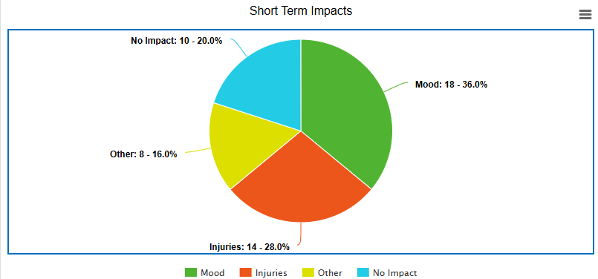
4.2.3 The Short-Term Impacts
Figure 2: Short term impacts
Figure two displays the categories use to group the most common responses: Mood, injuries, no impact and other impacts. This shows that only 10 participants felt no impact after being assaulted.
18 respondents reported having a decline in their mental wellbeing and mood. Responses included feelings of anxiety, guilt and a loss of morale when returning to work. The guilt would come from having time off and leaving the shift short, which then made them fear resentment from other officers. Officers stated it would demoralise them and they would question if the job was worth it. Participant 21 (P21) stated,
“It is emotionally draining, but low-level assaults are now expected as the norm”
Confidence was also affected in the aftermath, especially when attending calls of violence as there is a fear of it happening again. Participant 13 expressed feelings of reduced confidence, stating they were less willing to attend incidents, particularly alone.
14 respondents reported that injuries also had a short-term impact on them. This is due to having bruises and cuts over their bodies which they felt impacted their day-to-day life. Some participants also stated they had to seek medical attention which caused them having to have time off work, which was an inconvenience to them/
Additional responses highlighted feelings of being underappreciated and team morale being reduced as officers who witness the assault also experience the associated emotional impacts.
4.2.4 The Long-Term Impacts
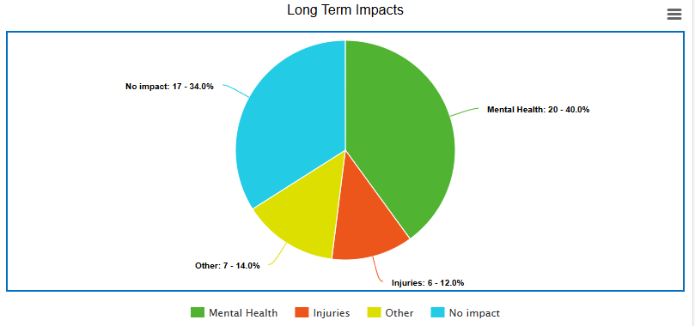
Figure 3: Long Term Impacts
Figure 3 displays the most frequently answers when respondents were asked about the long-term impacts following assaults.
The 20 respondents who said that mental health was affected short term, explained that they would often re live it and it would play on their mind. They stated they would constantly expect to be assaulted, causing the assault to play on their minds whenever attending a call. These feelings of anxiety were also described as being present due to the fear of attending court and being criticised for their actions. Only 2 participants out of 50 stated they suffered with PTSD and 3 have taken long term sickness off work.
P21 stated,
“There was an impact on my mental health, being worried about being single crewed. This impacts my sleep from secondary and direct trauma.”
Only 6 officers described being injured as being a long-term impact, which is a notable decrease compared to the short-term impact. Due to these injuries, it can cause officers to be on restricted duties. P23 explained that they had to have 6 months of blood test following an assault and he spent this time concerned about being around his family, mainly his children, in case he gets cut.
Other impacts include having to attend counselling sessions, an overall decline in job satisfaction, and the way risk is perceived inside and outside of work. P45 stated,
“I was aggravated for 4 hours whilst babysitting them in custody after the assault, with a tirade of remarks regarding my weight. For the next 6 months, I lost 3 stone as I did not want to give another suspect a reason to abuse me based on my weight.”
4.2.5 Organisational Support
35 out of the 50 participants (70%) of them stated they had been offered some sort of support from the organisation.
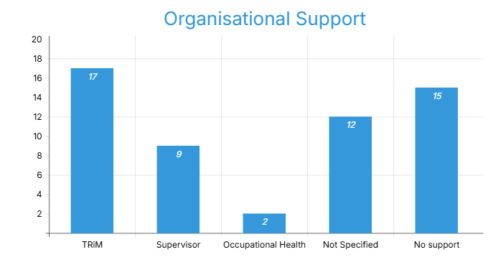
Figure four: Types of support offered by the organisation

Figure four highlights the support that has been offered to participants, with TRiM emerging as the most common. Although 17 participants were offered TRiM, only 7 of them actually utilised this. Some participants stated that it felt as this was a ‘tick box’ exercise rather than genuine concern for their welfare, whereas others felt as if there was still a stigma around accepting support for such incidents, supported by research conducted by Davidson et al (2023). Participants also stated a lot of the post-assault support came from their colleagues rather than formal organisation channels. P27 stated,
“Yes, support was offered. I found talking to colleagues and laughing about it was better than occupational health and Sargent support”.
This aligns with the research undertaken by Foley et al (2022) who also found that peer support reduced the negative impacts of assaults on officers.
4.2.6 Reducing the Number of Assaults
Figure 5: What could be done to reduce the number of assaults?
Figure five presents the most frequent responses from participants when asked what measures could be implemented to reduce the number of responses on officers. 50% of participants stated that being double crewed when attending calls would reduce the number of assaults as it would allow a second person to help diffuse a situation, call for assistance of help restrain a suspect. P9 stated,
“There is safety with two officers there, people may feel like there is less opportunity to assault an officer if there are multiple officers at scene.”
Participants also highlighted the fact that harsher sentences for the suspects would deter assaults against officers due to fear of repercussions. They felt as if the sentences given in court do not reflect the actual crime itself, with participants feeling as if the Crown Prosecution Service let them down as victims.
The responses also indicated that the training given to officers is inadequate, especially due to the lack of officers who carry tasers. P11 stated,
“Training at the moment is poor and outdated. Officers aren’t fit enough and there’s limited option as to what tools they can carry when dealing with conflict”
Furthermore, respondents stated training needs to be improved to make officers more confident when using force and being self-assured in their decision making.
4.3 Conclusion
This chapter has analysed the findings of the questionnaire and has provided an insight into the experiences and impact of officers who have been assaulted whilst on duty. 1
Short term impacts identified from the questionnaire closely mirror findings from Davidson et al (2023) and Leino (2013) with the majority of participants experiencing anxiety, loss of confidence, fear of future violence and reduced morale.
The long-term effects also substantiate existing research with participants reporting reduced job satisfaction, PTSD like symptoms, and a negative impact on personal relationships (Redman, 2016; Davidson et al, 2023).
Collectively, these results reinforce that officer wellbeing must be addressed to protect them and mitigate both the long term and short-term impacts of being assaulted. It has also highlighted opinions from officers on what can be done to reduce these assaults.

Chapter 5 – Conclusion and Recommendations
5.1 Introduction
This chapter aims to meet the final objective:
To provide a conclusion of results and provide recommendations on what can be done to help reduce the immediate and long-term negative impacts on officers following being assaulted

5.2 Summary of Main Findings
The aim of this research was to examine the short and long term physical and emotional effects on police officers, in order to understand the effectiveness of support that is offered to them and how this can be improved. A literature review was included as well as data collected through a questionnaire to provide an insight into this topic.
The findings highlight the prevalence of assaults against police officers, with 97% of respondents confirming they had been assaulted at least once. The underreporting of such incidents is underlined as only 44% of these assaults were officially recorded under the Assaults on Emergency Workers Act (2018). The main barriers to accurate reporting were detailed due to it being ‘part of the job’, the excessive paperwork for little consequences for the offender and due to the injuries being minor.
The data collected also found that the majority of participants experience both long term and short-term impacts. In the short term, participants reported emotional distress, a decline in confidence, physical injuries and a decline in morale. The long-term effects included poor mental health, with feelings of anxiety and depression due to the fear of future assaults and in some cases PTSD. Physical injuries were not as prevalent in the long-term impacts.
Even though organisational support was offered, such as TRiM, the acceptance of this was limited with many participant’s stating they felt as if they did not need it or were resistant to partake in it due to the stigma attached to it. Officers concluded that they found the most beneficial support came from their colleagues rather than formal organisational methods.
Participants suggested that double crewing, stronger sentences and more effective officer training would reduce the number of assaults indicating that there is a systematic issue in resource management and operational training.

5.3 Research Objectives
The dissertation has achieved all five research objectives.
- Objective 1: A literature review recognised existing bodies of research that detailed emotional and physical impacts of assaults. This review found that there was a lack of research within this field, with the majority of research being focused on Police Officers welfare in general, rather than specifically focusing on the short term and long impact of assaults.
- Objective 2: The study has explored the ambiguity around the definition of ‘assault on a police officer’, revealing the varied interpretations between officers. The literature review, and questionnaire data illustrated the difficulties in recognising assaults and how the recording of assaults may not be accurate dependent on how they are perceived.
- Objective 3: The methodology was suitable for gather both quantitative and qualitative data. This approach allowed respondents to anonymously detail their own experiences.
- Objective 4: The analysis of the questionnaire data showed the long term and short-term impacts on police officers, with individual factors influencing the response to being assaulted and the reporting of such assaults.
- Objective 5: A conclusion of results has been provided and Participants gave recommendations to reduce the number of assaults. This included better practical training to increase officer confidence, double crewing officers to prevent assaults from happening and increased sentencing for offenders to deter them from committing future assaults.

5.4 Recommendations
It is clear from both the literature review and primary findings that officers do not consistently report assaults against them. The underreporting of such assaults distorts national statistics and in turn the issue of assaults again police officers is not understood to it’s full extent. Police forces should provide consistent guidance and encouragement to report these assaults, regardless of severity of the assault or the intent of the suspect. They should encourage initiatives, such as Operation Hampshire, to influence officers to take all assaults seriously.
Despite 70% of participants stating they were offered organisational support, many saw this as a tick box exercise rather than a genuine concern for their welfare. This organisation support needs to be responsive to individual needs and support avenues. Programs such as TRiM should be promoted to reduce stigma around reaching out for help. Supervisors should follow up assaults to monitor officer recovery and genuine concern should be given to officers feel confident enough to ask for help when they feel like they need it.
Training in conflict and defence tactics should be routinely prioritised and updated sp officers feel confident in managing conflict. All officers should also be adequately equipped to reduce confrontation and assaults, through the use of taser and combat tactics. This training should also include how to manage psychological impact for trauma to help reduce the effects and increase awareness on the topic.
Many participants stated they felt the punishment for being assaulted is not harsh enough and does not defer suspects from repeatedly doing it again. Police forces should communicate with the Crown Prosecution Service and officers should be regularly updated of the progress of the case. Reviews of outcomes of assaults should be completed by police forces to improve accountability and get successful outcomes.
The recommendations are proposed to address both the practical and cultural elements of underreporting and support following assaults on police officers. Reducing the short term and long-term impacts of assaults requires a comprehensive approach from organisational support, clear reporting structures, cultural change and a stronger partnership between the police service and the criminal justice system.
5.5 Limitations and Future Research
Whilst this research provides an insight into the short term and long-term impacts of assaults on police officers, it is important to acknowledge limitations within this study.
The sample size of participants in relatively small and only consists of participants from one police force. This may limit the findings across a wider policing area and does not give a generalised view of impact of assault against police officers across the United Kingdom.
The use of questionnaire may also produce a response bias due to the sensitive topics of mental health and the stigma surrounding this within the police force. The use of in-depth interview may have been more useful in exploring the impacts as it would give a more in-depth insight into the emotional and psychological effects. This would have also been more practical due to the limited word count on this dissertation.
Future research would benefit from a larger and more diverse sample size as well as a more in-depth evaluation into the use of TRiM and Operation Hampshire to understand the long-term effectiveness of these intervention and supporting officer wellbeing and reducing the number of assaults.

Bibliography
- Adam, R (2024) 10 advantages and disadvantages of quantitative research. Available at https://helpfull.com/blog/10-advantages-disadvantages-of-quantitative-research (Accessed on 4th March 2025)

- Alikotis, A (2024) Understanding the Psychological Effects: Exploring the Impact on Mental Health, available at https://medshun.com/article/what-are-psychological-effects (Accessed 10th June 2025)

- Anshel MH (2000) ‘A conceptual model and implications for coping with stressful
events in police work.’ Criminal Justice Behaviour, 27:3, pp. 375–400.

- Bhanadari (2023) What is Quantitative Research? Definition, Uses and Methods. Available at https://www.scribbr.com/methodology/quantitative-research/ (Accessed on 6th March 2025)

- Bowler et al (2010) ‘Gender differences in probable posttraumatic stress disorder amont police responders to the 2001 Trade Centre Terrorist Attack’ America Journal of Industrial Medicine, 53, pp. 1186-1196

- Brewin CR, Miller JK, Soffia M, Peart A, Burchell B (2022) ‘Posttraumatic stress disorder and complex posttraumatic stress disorder in UK police officers.’ Psychological Medicine. ‘;52(7):1287-1295. DOI:10.1017/S0033291720003025

- College of Policing (2022) App will record assaults on police to improve officer wellbeing. Available at https://www.college.police.uk/article/app-to-record-assaults-on-police (Accessed on 21st January 2024)

- College of Policing (2023) Assaults on police – culture, legitimacy and risk. Available at https://www.college.police.uk/article/assaults-police-culture-legitimacy-and-risk (Accessed on 11th December 2024)

- College of Policing (2024) Operation Hampshire – strategic prevention of assaults on police officers and staff. Available at https://www.college.police.uk/support-forces/practices/operation-hampshire-strategic-prevention-assaults-police-officers-and-staff (Accessed on 25th January 2025)

- Complex Trauma Responses (2025) Peritraumatic Reaction. Available at https://www.complextrauma.org/glossary/peritraumatic-reaction/#:~:text=Distress%20occurring%20during%20or%20in%20the%20immediate%20aftermath,and%20degree%20to%20which%20coping%20resources%20are%20exceeded. (Accessed on 18th January 2025)

- CPS (2025) Assaults on Emergency Workers Act 2018, available at https://www.cps.gov.uk/legal-guidance/assaults-emergency-workers-offences-act-2018 (Accessed on 10th June 2025)

- CPS.GOV (2018) Assaults on Emergency Workers Act 2018. Available at https://www.cps.gov.uk/legal-guidance/assaults-emergency-workers-offences-act-2018 (Accessed on 11th December 2024)

- Davidson, L et al (2023) ‘I don’t want to be a victim again: the impact of repeat assaults on police officers’ Frontiers in Psychology, 14, DOI: 10.3389/fpsyg.2023.1145944

- Ellrich, K. and Baier, D (2017) ‘Post-traumatic stress symptoms in police officers following violent assaults: a study on general and police-specific risk and protective factors’ Journal of interpersonal violence, 32(3), pp.331-356. DOI: 10.1177/0886260515586358

- Foley, J, Hassett, A. and Williams, E (2022) ‘Getting on with the job: a systematised literature review of secondary trauma and post-traumatic stress disorder (PTSD) in policing within the United Kingdom (UK)’ The police journal, 95(1), pp.224-252

- Gaille, L (2024) 23 advantages and disadvantages of qualitative research. Available at https://vittana.org/23-advantages-and-disadvantages-of-qualitative-research (Accessed on 7th March 2025)

- Hassan (2024) Qualitative Data – Types, Methods and Examples. Available at https://researchmethod.net/qualitative-data/#:~:text=Qualitative%20data%20encompasses%20descriptive%20information%20obtained%20through%20observations%2C,captures%20the%20essence%20of%20experiences%2C%20emotions%2C%20and%20opinions (Accessed on 6th March 2025)

- Home Office (2022) Annex: Statistics on the number of police officers assaulted in the year ending March 2021, England and Wales. Available at https://www.gov.uk/government/statistics/police-workforce-england-and-wales-31-march-2021/annex-statistics-on-the-number-of-police-officers-assaulted-in-the-year-ending-march-2021-england-and-wales (Accessed on 11th December 2024)

- Home Officer (2019) Assault on emergency workers in the Police, Crime, Sentencing and Courts Bill: Equalities Impact Assessment, available at https://www.gov.uk/government/publications/police-crime-sentencing-and-courts-bill-2021-equality-statements/assault-on-emergency-workers-in-the-police-crime-sentencing-courts-bill-equalities-impact-assessment (Accessed on 10th June 2025)

- Johnson, L (2023) ‘Assaults on police – culture, legitimacvy and risk’ Research on the risk and impact of violence against police officers, pp. 1-7

- Kuphanga, D (2024) Questionnaires in Research: Their Role, Advantages, and Main Aspects. Available at https://www.researchgate.net/publication/378868278_Questionnaires_in_Research_Their_Role_Advantages_and_Main_Aspects (Accessed on 6th March 2025)

- Legislation.gov.uk (2020) Police Act 1996. Available at https://www.legislation.gov.uk/ukpga/1996/16/section/89 (Accessed 11th December 2024)

- Legislation.gov.uk (2023) Assaults on Emergency Workers Act 2018. Available at https://www.legislation.gov.uk/ukpga/2018/23 (Accessed on 11th December 2024)

- Leino, T (2013) ‘Work related violence and its associations with psychological health: a study of Finnish patrol officers and security guards’ People and Work Research Reports, (98)

- Lindemann, N (2023) 12 advantages and disadvantages of questionnaires. Available at https://pointerpro.com/blog/questionnaire-pros-and-cons/ (Accessed on 2nd March 2025)

- Marmar et al (1996) ‘Stress response of emergency services personnel to the Loma Prieta earthquake interstate 880 freeway collapse and control traumatic incidents’ Journal of Traumatic Stress, 9, pp. 63-85

- Microsoft (2025) Mircosoft forms, available at https://www.microsoft.com/en-gb/microsoft-365/online-surveys-polls-quizzes (Accessed on 1st June 2025)

- NHS Scotland (2024) TRiM - trauma Risk Management. Available at https://www.nhsscotlandnorth.scot/networks/trauma/trim-trauma-risk-management (Accessed 18th January 2025)

- Oscar Kilo (2024) Operation Hampshire. Available at https://www.oscarkilo.org.uk/services/operation-hampshire (Accessed on 25th January 2024)

- Purba, A., and Demou, E. (2019). ‘The relationship between organizational stressors and mental wellbeing within police officers: a systematic review.’ BMC Public Health, 19(1286). DOI: 10.1186/s12889-019-7609-0

- Rainwater (2025) The Advantages of a Questionnaire Research Project. Available at https://classroom.synonym.com/types-descriptive-research-methods-11404067.html Accessed on 7th March 2025)

- Santos, A., Leather, P., Dunn, J., and Zarola, A. (2009) ‘Gender differences in exposure to co-worker and public-initiated violence: assessing the impact of work-related violence and aggression in police work.’ Work Stress, (23), pp. 137–154. DOI: 10.1080/02678370903087934

- Saqib, N (2025) Why data analysis is essential in research. Available at https://navidsaqib.com/why-data-analysis-is-essential-in-research/ (Accessed on 2nd March 2025)

- Sentencing Council (2018) Assault offences explained. Available at https://www.sentencingcouncil.org.uk/news/item/assault-offences-explained/ (Accessed on 11th December 2024)

- SurveyMonkey (2025) SurveyMonkey home page. Available at https://www.surveymonkey.com/?msockid=2df7fdbd6f736009110ceedd6e23612c (Accessed on 2nd March 2025)

- Watson, L., & Andrews, L. (2018) ‘The effect of a Trauma Risk Management (TRiM) program on stigma and barriers to help-seeking in the police’ International Journal of Stress Management, 25(4), pp. 348–356. https://doi.org/10.1037/str0000071

- Wolter, C et al. (2019) ‘Job demands, job resources, and well-being in police officers—a resource-oriented approach.’ Police Crim. Psychol (34), pp. 45–54. DOI: 10.1007/s11896-018-9265-1

Appendix
Appendix 1 – Blank Questionnaire
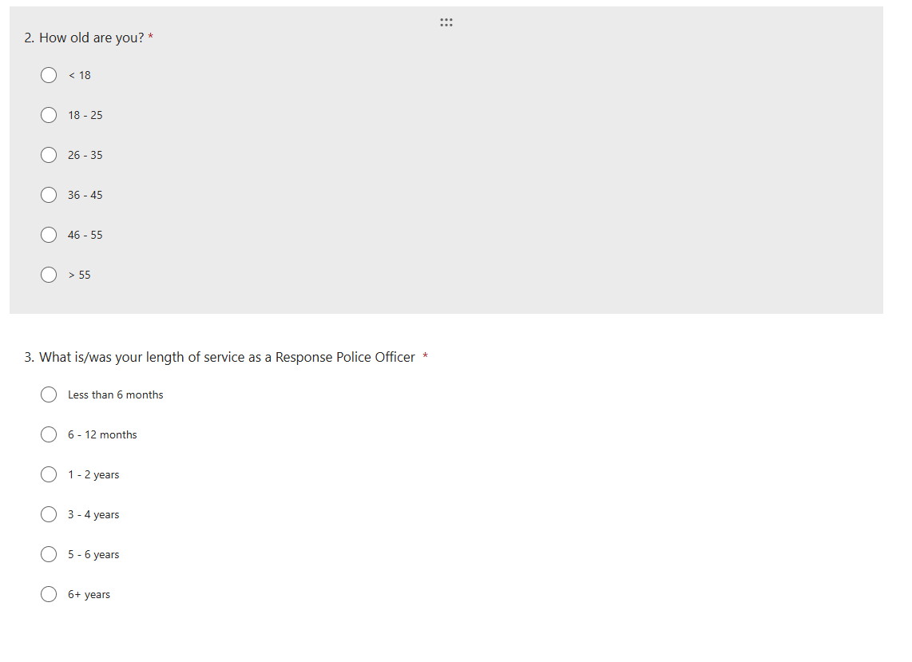
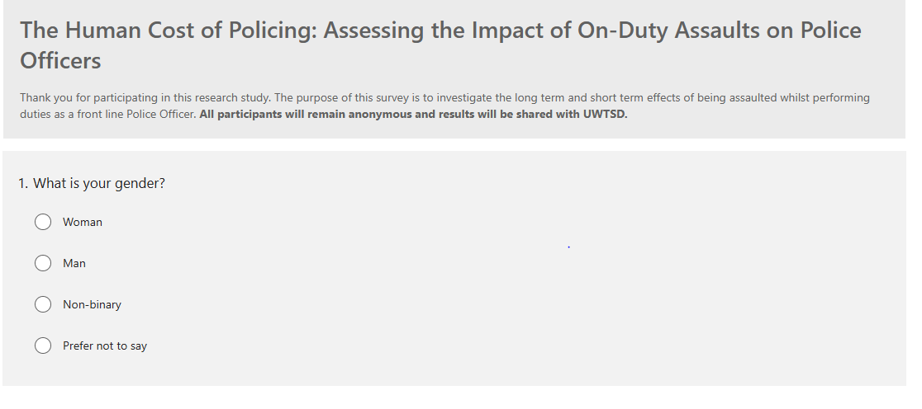

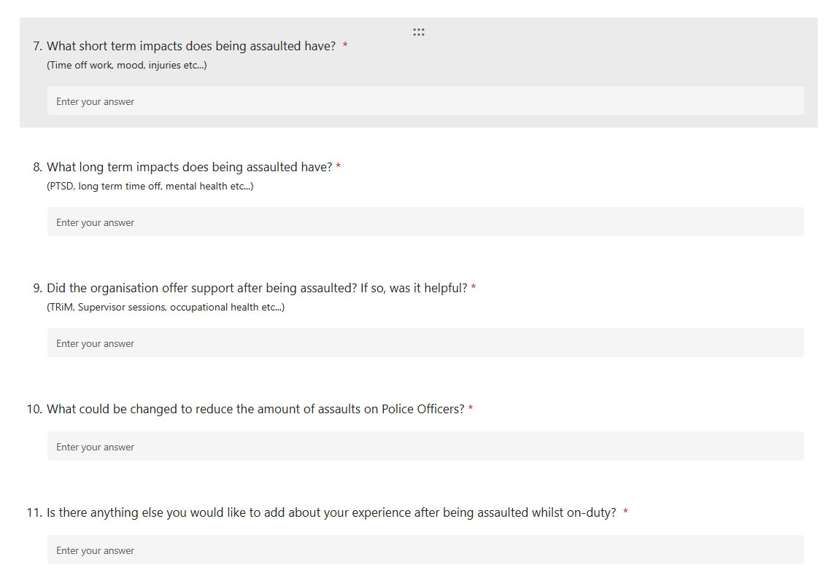
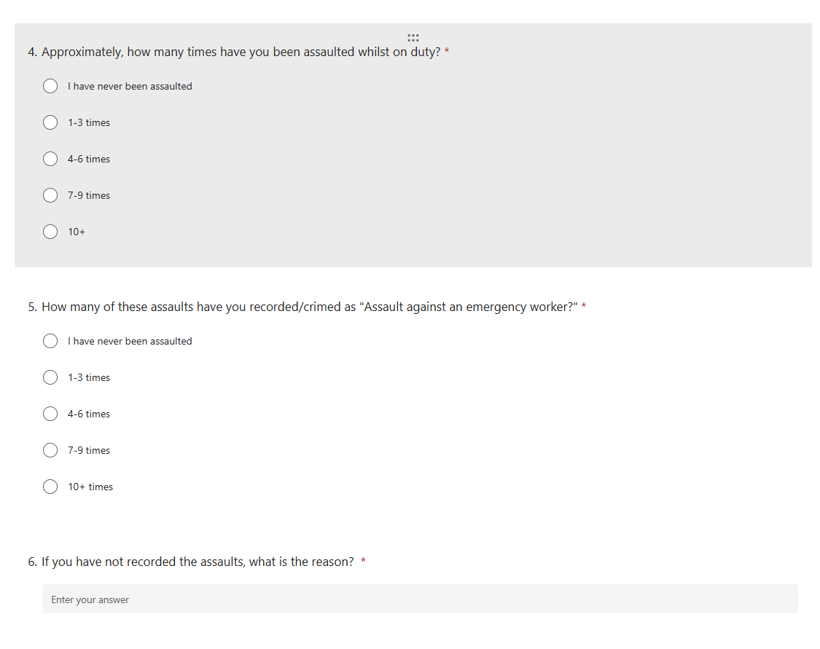
Appendix 2 – Results of questionnaire



