The Between

Swansea University
MA Glass
Paul Mitchell
2023

CONTENTS

Page

INTRODUCTION 3
CONSCIOUSNESS 4
CRITICAL FACTOR / THE FILTER 7
HETEROHYPNOSIS & HYPNOSIS 11
BANDLER, GRINDER AND NLP 13
NLP PERCEPTUAL POSITIONS 14
NLP SUBMODALITIES 16
METHODOLOGY FOR HYPNOSIS 18
SELF HYPNOSIS SCRIPT 18
PERSONAL SYMBOLS 20
ARTISTS 22
VISUAL SUBMODALITY: CONNECTING WITH TOUCH 24
CONCLUSION 29
REFERENCES 31
BIBLIOGRAPHY 34

INTRODUCTION

" The purpose of art is mystery." Rene Magritte
(www.quotemaster.org, n.d.)

To delve into one’s own creative psyche is the process of ultimate discovery, the fundamental of all truths. It requires fortitude, drive. It will undermine that which you believe yourself to be. It can seem like illusion born from dreams but believe it is the true.
It was with excitement that I first indulged into this quagmire of seeking. The more I delved, the more obscure the answers became. It was heading towards a peace, towards a kind of meditation and though my own guided effort was becoming harmonised with the creative process.
The difficulty manifest itself in trying to objectify the thought into a ‘real’ object. An attempt at thinking in a way that was both totally immersive but also able to withdraw at points to make a drawing, an object. To be able to translate that thought into an external object I decided to learn techniques which would allow this to take place. Hypnotherapy and Neuro Linguistic Programming are useful tools to this end and so I qualified in both around twenty years ago.
This combination of psychological approaches allowed access to the subconscious creativity in a direct and visceral way and further allowed at chosen points, to reflect upon and construct these images. I investigated the critical factor (between the conscious and subconscious) and through guided hypnosis was able to bypass this to gain access to the subconscious. The sculptures and works in this report are a manifestation of this critical factor this filter.
Prior to my investigation into glass, I have created work inspired by the subconscious and have used mainly stone in this consideration. When carving stone, free carving (carving without preconceived ideas), the subconscious is at flow. The sculptures are as if carving themselves - the physicality opens the pathway to the subconscious, akin to the Surrealist idea as described by Breton in his Manifesto of Surrealism,
‘Pure psychic automatism ... the dictation of thought in the absence of all control exercised by reason and outside all moral or aesthetic concerns’. (Tate, 2017)

My intention in this research project is to reference touch in the sense of experiencing the connection with the subconscious (as I had done with carving), but primarily as a thought process leading to the making of work in a different material (glass).
Various forms of hypnosis techniques were experimented with and rejected until I was able to focus in on what seemed to be the most productive path for my own journey.
In the following essay I have considered certain theories behind thinking strategies and designed techniques for myself to access the subconscious to illicit images which I have then constructed. The more mainstream thinking is considered and described, as well as contemporary thoughts in hypnotherapy - the most effective connection with subconscious creativity.
I have been influenced by artists who have explored a similar path - the path of connection with the subconscious. The Portfolio should be referenced alongside this report as descriptions and ideas for the pieces of work are more fully explored.

CONSCIOUSNESS
Consciousness means many different things to different factions. It can mean the underlying awareness of the environment, an invisible intelligence, or the degree that we, as a species have developed ourselves as beings knowingly. To be conscious is to have an awareness of one’s environment and one’s own existence, sensations, and thoughts. It is having present knowledge or perception of oneself, one’s acts and surroundings. (NLP World, 2021.)

Consciousness as such involves three main aspects to understanding:
Conscious, Subconscious (also referred to as Unconscious) and Preconscious.

Psychology author Kendra Cherry [2023] reviews Freud’s model of the mind:
The famed psychoanalyst believed that behaviour and personality were derived from the constant and unique interaction of conflicting psychological forces that operate at three different levels of awareness: the preconscious, conscious, and unconscious. He believed that each of these parts of the mind plays an important role in influencing behaviour. (Cherry, 2023)
Considering Freud’s three ‘parts’ to thinking and awareness, Cherry [2023] continues:
CONSCIOUS MIND:
This contains all the thoughts, memories, feelings, and wishes of which we are aware at any given moment. This is the aspect of our mental processing that we can think and talk about rationally. This also includes our memory, which is not always part of consciousness but can be retrieved easily and brought into awareness.

PRECONSCIOUS:

‘This consists of anything that could potentially be brought into the conscious mind.’ [Cherry, 2023]

The term preconscious was first described by the Scottish jurist Henry Lord James, although it would later become a key concept in Sigmund Freud's theory of psychoanalysis. An important aspect of our thinking often overlooked and essential in our decision-making process.
SUBCONSCIOUS MIND:
‘This is a reservoir of feelings, thoughts, urges, and memories that are outside of our conscious awareness.’ [Cherry, 2023]
“Our Subconscious is all the life-giving processes of our body, all we have learned, our past experiences, and all that we might notice, but do not, in the present moment”. [O’Connor & Seymour, 1993, P.7]
In psychoanalysis, preconscious is the loci preceding consciousness. Thoughts are preconscious when they are unconscious at a particular moment, but are not repressed. Therefore, preconscious thoughts are available for recall and easily 'capable of becoming conscious'—a phrase attributed by Sigmund Freud to Josef Breuer.^{[1]} (Wikipedia 2023)

This ‘preconscious’ element in Freuds theory has been identified by various psychologists under differing titles.
Jung also understood the role of the Pre-Conscious, although having differing opinions as to the structure of personality he none the less accepted the existence of an ‘intervenor’ place between conscious and subconscious. This preconscious can interrupt creative flow. According to Schaverien (1992, P21):
‘Yung encouraged some of his patients to paint in order to escape the censor of the conscious mind: “In cases of high degree of conscious cramp…the hands alone can fantasy; they model and draw figures that are often foreign to the conscious mind”. Yung and Wilhelm (1931:94)’
In Archetypes and the Collective Unconscious, C G Jung describes his own attempts at producing his works from the unconscious:
While painting them the picture seems to develop out of itself and often in opposition to one’s conscious intentions. It is interesting to observe how the execution of the picture frequently thwarts one’s expectations in the most surprising way. C.G. Jung [1969] (Farah, 2019)

This point is drawing reference to the subconscious being allowed to flourish creatively whilst not hampered by resistance. To allow this to take place there needs to be methodology to allow access directly to subconscious creativity bypassing interference from the preconscious.
The renowned psychologist Hypnotherapist NLP Master practitioner Ledowchowski has focussed upon this preconscious intermediary place.

CRITICAL FACTOR / FILTER
The Ledochowski approach is focussing on the subconscious and the various changes that could be made there through guided intervention (hypnosis).
Describing Hypnosis Ledowchowski states-
Hypnosis can be understood in many different ways. It is both a science and an art, with a heavy subjective element: it relies on peoples experience of it to make it worthwhile. (Igor Ledochowski, 2003. Pg v)
It is important to understand that to enable communication with the subconscious to happen his methodology (and all hypnotherapy) employs the focussing upon and by-passing this preconscious place which he named the Critical Factor. This essentially an intermediary space of active thinking between the two thinking states of conscious and subconscious. According to Ledochowski (2018)-
If you look at the critical factor as a metaphor, the role of the critical factor is to keep things the same. To maintain the status quo. That means accepting things that already exist and rejecting things that challenge the way they think their world currently works.

For the sake of convenience and clarity in this essay I would call this critical factor the Filter as fundamentally this is what it does. As well as blocking what could be perceived as non-important or a threat to the subconscious it is also vital in building a foundation for continued learning.
I just don’t want the critical factor to get in the way. That’s the kind of balance I’m always looking for. Ledowchowski (2018)

The Filter will also affect how we perceive what is experienced in the conscious - subconscious. If we have a negative association (possibly derived from cognitive experience in childhood) from witnessing an event, then this information could affect our thoughts the next time we see or experience it. The subconscious will ‘learn’ through the filtered information received to remember this negativity and feedback through the filter to the conscious thoughts.
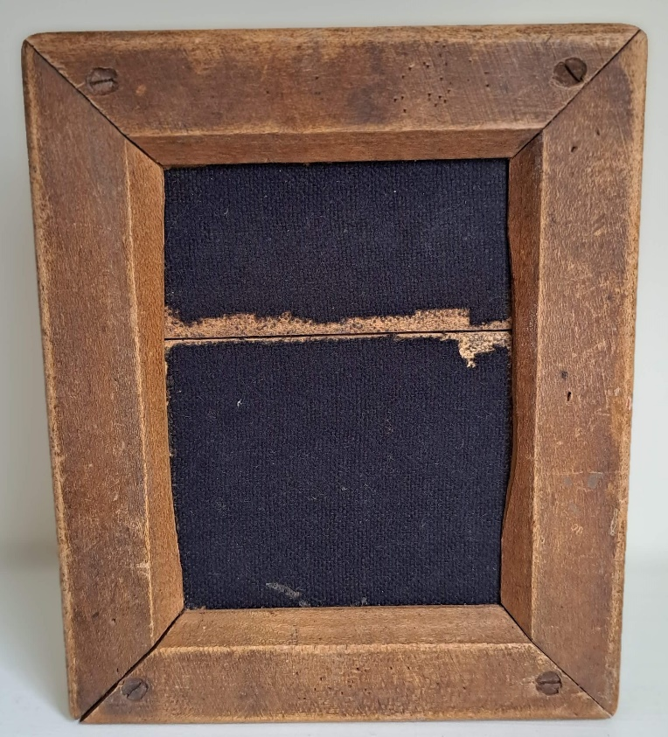
Fig. 1 2023 THE THREE . Mitchell, P. wood glass textiles. 13 X 15 cms
Found object- wood frame- printed interior depicting Conscious, Filter (centre line) and Subconscious

The Filter is unique to each individual and has evolved by various cognitive experiences in the persons development-
‘The Critical Factor (Filter) functions as a filtering mechanism that prevents unwanted junk from making its way into our belief system and unconscious mind. It compares stuff coming in from our senses with our knowledge base of the universe and throws out anything that does not fit’. [Trance, M. 2021]

Hartland (Waxman & Hartland 1989) propounds that the Conscious mind is possessing of the critical factor or filter. In his book Medical and Dental Hypnosis (PG 23) he says-
1 The power of criticism is largely restricted to the conscious mind.
2 It is by virtue of this alone that the conscious mind possesses the ability to reject any suggestions that may be made.
3 When suggestions by the conscious mind, as they do under hypnosis, they penetrate directly to the subconscious mind which, being able to exercise little or no power of criticism, is quite unable to reject them, and the individual is bound to act upon them. [Waxman, D 1998 p23]
Ledochowski (2018) however argues that the critical factor is existing as a separate entity- connected however to both the conscious and subconscious factors. According to Ledowchowski (2018) ‘it works if you think of the critical factor as a truism. Your hypnosis gets better when you bypass it. Your hypnosis gets worse when you don’t’.

Each mind state cannot survive without the other - an endless stream of information flowing between these three parts. The resultant influence could perceivably manifest as blocking creative flow for example. Hypnotherapy is by far the most effective way to allow this bypassing.
The aim in my case is to open direct access to the subconscious as a methodology for producing creative imagery.
Through the teachings and approaches of Neuro Linguistic Programming (NLP) Ledochowski developed the idea of a more direct link to the subconscious by studying and implementing techniques by the master hypnotherapist Milton Erickson. Milton Erickson was a foremost pioneer of hypnotherapy. He developed a methodology which utilised the use of vague language to access the subconscious. His approach was non-direct and aided avoiding the ‘resistance’ to hypnosis observed by experimentation in the therapist’s room.
LEDOWCHOWSKI CARDS
Hypnosis being the most readily effective way to bypass the Filter inevitably involves (amongst other strategies) the use of words. To aid this process of access to the subconscious, Ledochowski has developed a series of statements, words, phrases based upon the Erickson approach which utilises non-specific language. This enables the practitioner whether self-directed or through Heterhypnosis (directed by a hypnotherapist) to facilitate access to the subconscious. The idea of non-specific language is that these statements, words, and phrases are common to all and therefore each individual will assign their own meaning and structure to each. This means that there is little point in the filter creating ‘resistance’ if there is nothing from an outside input (hypnotherapist or otherwise) which is not of a perceived threat or discomfort to the individual. In my own case these phrases are utilised to promote the allowing of the creative sub conscious part, to become manifest in the form of creative ideas. They are words which aid bypassing of this filter directly.
Following examples of Ledochowski Cards showing linking words within hypnosis to allow formation of hypnosis script:
Ledowchowski words Hypnotic Linguistic identification
Gradually …….. (Anticipation Builders)
You don’t have to …….. (Negation)
Suppose …….. (Imagination)
As you…I wonder if you realise that… (Assumption)
As you….. So you …. (Linkage)
Imagine …… (Imagination)
The More…. , The More…… (Pseudo Logic)
Find Yourself …… (Awareness)
(Ledowski 2003)
These words/ phrases are used in the context of a hypnosis script allowing sub conscious communication to take place. Some of the hypnosis words, phrases and NLP approaches I have included in the formation of my own self-hypnosis script.

HETEROHYPNOSIS AND HYPNOSIS
Hypnosis directed by a hypnotherapist is known as heterohypnosis, there is also self-directed or self-hypnosis. For many decades it was believed that all hypnosis was self-hypnosis, and it was certainly true that Milton Erickson believed this to be the case.
THEORY THAT ALL HYPNOSIS IS SELF HYPNOSIS
According to Eason (2012) Erickson, Kroger, Spiegel & Spiegel are among the supporters of this theory.
‘Erickson identified that hypnosis and self-hypnosis are the same process. From a research point of view Shor 1979 wrote that all hypnosis is self-hypnosis’.
‘However it was the comprehensive study of Erika Fromm & the Chicago group Shor 1979 that started to challenge the previously dominant idea that all hypnosis is self-hypnosis’. (Eason 2012)

Fromm and Khan (1990) showed that imagery in self-hypnosis was found to be rich, sequenced, and/or segmented. They found imagery apparent in self-hypnosis was greater in quantity than in heterohypnosis and was deemed subjectively to be more meaningful.
The Chicago Paradigm by Fromm and Kahn (1990) states,
“Perhaps the greatest single advancement made in the scientific study of hypnosis has been the realization that the ability to enter hypnosis is largely a skill of the patient, combining elements of focused attention, fantasy, and suspended belief. The role of the therapist working with the patient to use his or her hypnotic ability is to provide a context in which the patient can willingly express aspects of this cognitive skill…”

The heterohypnosis technique will work if the client (or oneself) is more amenable to the notion of an authority figure- as in cultures who subscribe to the idea of holy man shaman etc. or in our culture dentists’ doctors etc.
Having looked at these differing approaches and my own training in hypnotherapy confirmed my decision to employ self-hypnosis as opposed to heterohypnosis.
One could argue that each theories have their merits however from a personal point of view based upon my own experimentation with the Ledochowski methodology I tend to disagree with Erickson that self-hypnosis and heterohynosis are the same. However, his hypnotherapeutic approaches using metaphors seem to produce a more effective result regarding the emergence of subconscious imagery if used as part of the Ledowchowski approach.
From a therapeutic viewpoint Ericksons approach of indirect and vague metaphorical language will produce results (accessing subconscious) in around half of clients. ‘An Erickson hypnotherapist strives to be artfully indirect in all suggestions and interventions’. (Lankton, P251)
However, each person is different and finding the most appropriate approach whether a direct or indirect for one’s own preference is relevant to advancement of understanding how one thinks.
‘Self-hypnosis is most likely to be effective when taught as an independent self-directed skill and when it involves at least 3 practice sessions before participation in a trial. Experience of heterohypnosis does not seem to be essential in producing an effect for self-hypnosis’. Eason, A. D. & Parris, B. A. (2018, October 29)

A good hypnotherapist whether dealing with oneself or a client will understand the importance in adjusting the hypnotherapeutic approach to suit each client or oneself.
Hammond (1990, P 22) referencing Holroyd, 1980; Nuland & Field, 1970: ‘hypnosis may be more effective when it is individualised and takes into account the unique motivations, personality, interests and preferences of the patient.’

According to Waxman and Hartland (1989, P70) Hypnosis ‘must be additionally tailored to meet to problems and the needs of the individual patient’. Therefore the hypnotherapy script that I have written for my own use later is utilising elements which are of relevance to my own thinking.

BANDLER, GRINDER AND NLP
Neuro Linguistic Programming (NLP) was formulated by the American psychologists Bandler and Grinder in the 1970s. Together they formed a series of approaches to address what they considered inappropriate interventions in psychology.
‘NLP deals with the structure of human subjective experience, how we organise what we see, hear and feel, and how we edit and filter the outside world through our senses. It also explores how we describe it in language and how we act, both intentionally and unintentionally, to produce results’ (O Connor and Seymour 1990. P3-4]
They ‘modelled’ people who were talented in any specialised field to analyse their internal dialogue, patterns of thinking etc. From this they were able to formulate strategies which enabled anyone to become more flexible in their thinking. Revell and Norman (1997) described NLP as:
a collection of techniques, patterns and strategies for assisting effective communication, personal growth and change, and learning. It is based on a series of underlying assumptions about how the mind works and about how people act and interact. [p14]
The hypnotherapeutic strategies in particular were (as Ledowchowski) emulated and developed from the work of Milton Erickson.
At the time these approaches to therapy and thinking were deemed anti-established thinking, almost radical, but over time have become accepted. Indeed, many of the applications have become incorporated into mainstream learning. The field of Neuro Linguistic Programming (NLP) is vast, so in addition to hypnosis I wanted to draw attention to another aspect of NLP that I apply to the creative process. That being the consideration of perceptual positions.

NLP PERCEPTUAL POSITIONS
In this journey of focussing on thought travel it became important to become objective at certain points. These could be referred to as stopping points on the journey. That is to observe the occurrence of one’s own thinking to enable it to be recorded in a form of art. Therefor using the strategy of taking ‘third position’ as described following seemed most appropriate. Further to this, taking the third position strategy alongside self-hypnosis not only allows objective thinking but to also bypass interference from the filter. From this one can formulate the resultant images into a physical object.
To aid this process I introduce a keyword and am able to observe the image that is forthcoming from the subconscious ready to construct.
‘Perceptual positions’ developed in Neuro Linguistic Programming (NLP) as illustrated here by Mulder (2019) helps an individual in many different situations from negotiation to a therapeutic capacity and an extremely useful tool in increasing flexibility of thinking.
One of the purposes of the NLP technique following is to allow people to put themselves in an observational role regarding their thinking and therefor disassociate from distracting emotional content.

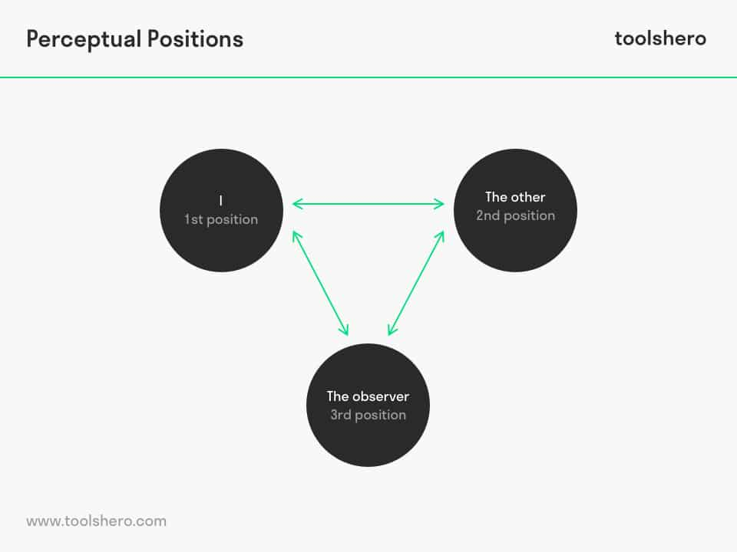
Fig 2. Perceptual Positions
(toolshero, 2019)

Step 1

1st Position
Considering things from your own point of view
STEP 2
2nd Position
‘Considering the situation from the point of view of being the other person’.
After taking the time for the first step (1st position), the person will observe themselves in a situation from an observational point of view.

Step 3
3rd Position
Having awareness of things from the point of view of an un-involved observer who is outside the situation. From the 3rd position of the perceptual positions, one can observe oneself thinking and allow an objective viewpoint to be utilised. These points of observation allowed conscious realisation of the subconscious images to become apparent and subsequently works to be made.
This strategy of taking third position I incorporated into the self-hypnosis experience, to allow the observational position to take place.

NLP SUBMODALITIES
Throughout my journey into the subconscious, I have utilised the effectiveness of modalities and submodalities. Of the following definitions, the most effective for myself seemed to be a combination of Visual and Kinaesthetic. These submodalities are focussed upon as part of the self-hypnosis script I developed-
The concept of submodalities arose in the field of neuro-linguistic programming, explaining that human beings ‘code’ internal experiences using aspects of their different senses.
We have five basic senses: visual, auditory, kinaesthetic (touch etc) , olfactory and gustatory. In NLP, these are referred to as representational systems or modalities. For each of these modalities, we can have finer distinctions. We could describe a picture as being black and white or colour, or it could also be bright or dim. Sounds could be loud or soft, or coming from a particular direction. Feelings could be in different parts of the body or have different temperatures.
Smells could be pleasant or offensive, strong or light. Taste could be sweet or bitter or strong or mild. These finer distinctions are called submodalities and define the qualities of our internal representations . Generally, we work with only three modalities — visual, auditory and kinaesthetic. However, you be working with a client on an issue where the olfactory or gustatory submodalities play a major role e.g., a food issue or someone who is a chef. [Elston, T. 2012]

REPRESENTATION SYSTEMS EXAMPLES OF SUBMODALITIES

VISUAL Size
(Sight, images, spatial) Distance
Brightness
Colour or monochrome
Framed (see below)
2D or 3D
Clear or fuzzy
Shape
Moving or Still

AUDITORY

Mono/stereo
Rhythm
Volume
Voice

KINAESTHETIC
Somatic sensation
Movement
Pressure
Texture
Temperature
(NLP World, 2012)
Following construction of the glass and mixed media of the sculptures, I experimented with a visual submodality (as described above) and the addition of a black frame seemed to produce the most effective emotional shift- not positive or negative but non the less significant. It should be noted that each of us will possess our own combinations of modalities/ submodalities.

METHODOLOGY FOR HYPNOSIS
‘In the universe, there are things that are known, and things that are unknown, and in between them, there are doors.’ Blake, William. (www.goodreads.com, n.d.)

To enable the methodology to be productive it was important to develop a hypnotherapeutic script of my own which is relevant to my own functioning thoughts and patterns. Part of the script I have created is slightly different for each time it is utilised, within it are included changeable key words which allow the imagery to become clearer and more apparent.
These key words or markers form part of the hypnotic journey. For making another piece I introduce another, different marker. This will produce another quite different image.
The resultant images are documented with the intention of visually depicting the filter.

SELF-HYPNOSIS SCRIPT (abridged)

Following focus upon breathing here is extract from the script I have developed to access the subconscious. It includes some of the words used in the Ledowchowski approach:
‘Gradually seeking dream state…imagine finding myself within complete relaxation…. supposing that the flowing or sensation of stillness…. gazing over the horizon of calmness…. having awareness through not seeking it….’
At this point I allow myself to be open to the communication with the subconscious. It is where I introduce the keyword which I want to focus on. For example, in the image below I used the word STRING. The image was realised in my conscious thought process directly from the subconscious. I was then able to construct the sculpture. Fuller explanation in the portfolio.

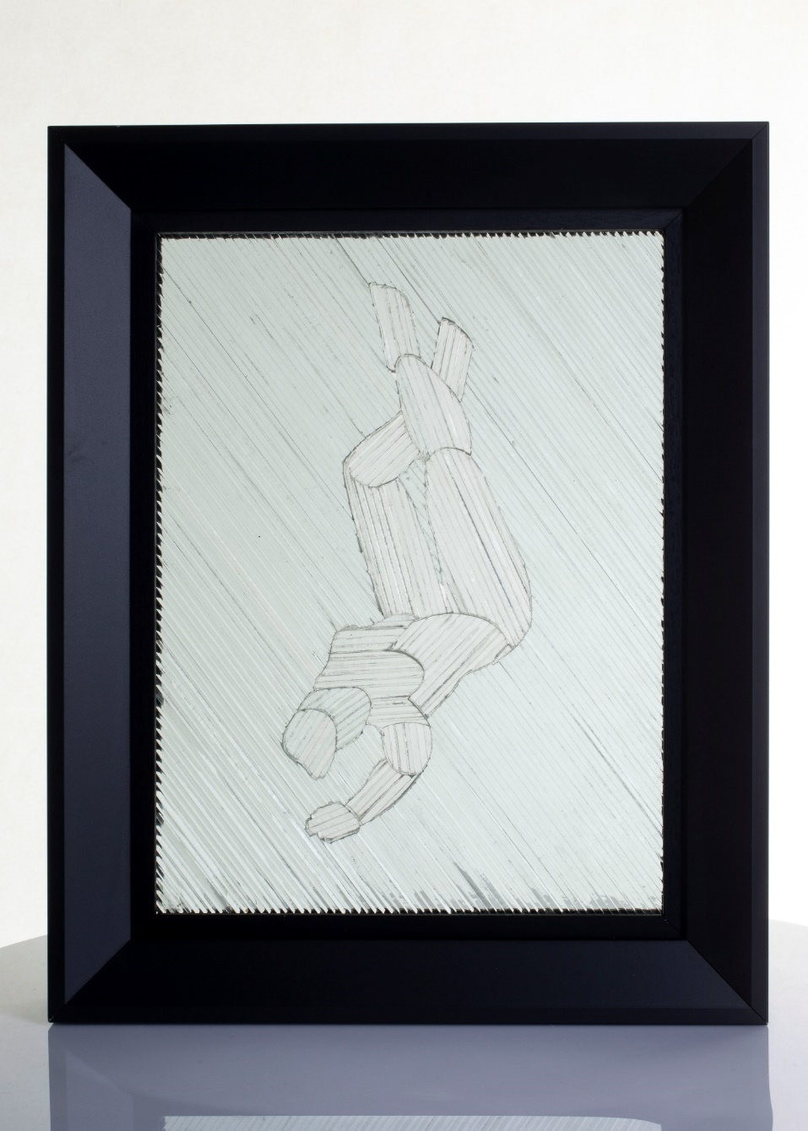
Fig. 3. STRING. Mitchell P, 2023 Glass Wood (50 x 40 x 10cms)

The process of realisation of the images does not follow the same path each time and will often be obscured or not completely clearly defined. Each keyword is different prior to each image.
It follows that I have no idea what the image for potential making will appear and am fascinated by what the subconscious will produce - images that are not previously anticipated.
Through this experimentation I discovered unfamiliar shapes/symbols came forward, manifest, often repeated. I understood these symbols to have a deep-rooted personal resonance with my own patterns of thinking and experience.
I decided therefor to look more carefully at the notion of personal symbols.

PERSONAL SYMBOLS
Man’s ultimate concern must be expressed symbolically because symbolic language alone is able to express the ultimate. Paul Tillich (www.psychologytoday.com, n.d.)
It is through symbols that man consciously or unconsciously lives, works and has his being. Thomas Carlyle (www.psychologytoday.com, n.d.)
Symbols of a Cross, Dots - (used in my work as metaphors for thoughts), Touch (skin, Leather etc), Gold etc are symbols which are repeated within my creative journey, a direct link with the subconscious in the same way that Ledowchowski’s words are intended to be. It should be noted at this point that the images often do not have a descriptive facility they can only be constructed to illustrate.
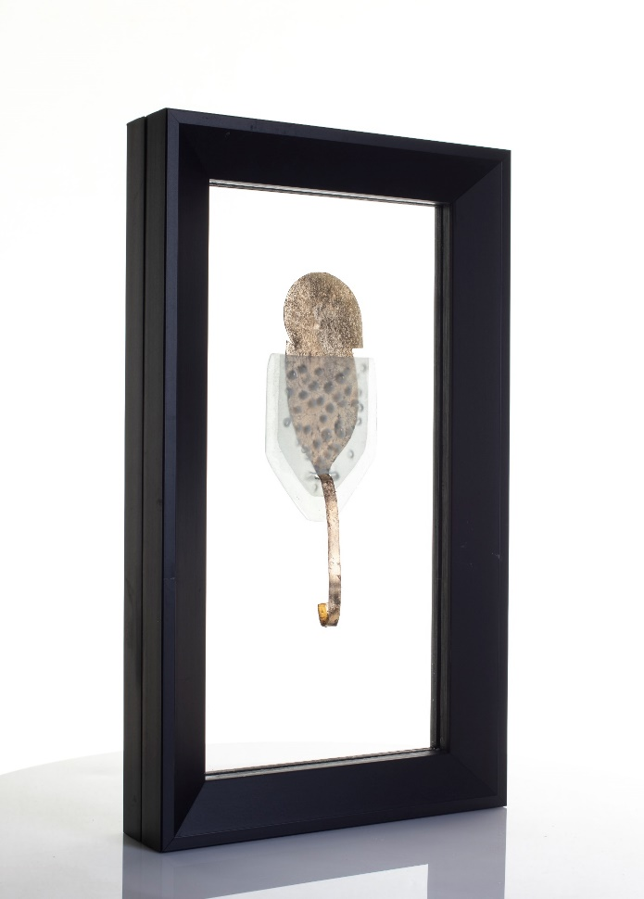
Fig.4. OPTIC THREE. Mitchell, P. 2023. Glass, copper, gold leaf, wood. (50 x 30 x 10cms)
The above image Optic - manifest as a personal symbol, obtained guided self-hypnosis as previously described. Following this elicitation, it has become when visualised as a part of the hypnosis strategy, a very effective methodology for gaining more rapid access to further imagery in the subconscious.
The meaning/ origin of these symbols is often not something with which I am fully aware - the mystery of their origin is part of its power.
Carl Jung defined a symbol as-
‘a term, a name or even as a picture that may be familiar in daily life, yet that possesses specific connotations in addition to its conventional and obvious meaning’ (Jung and Marie-Luise Von Franz, 1968, p20)

Jung’s Archetype is the metaphor for a universal language. It is entirely possible that these symbols and each of our own (as part of a subconscious collective) lend themselves to this idea of the archetype. It is understood that certain patterns or sculptural pieces or certain paintings will speak to us, will have a resonance with our own selves as cultural beings, universally. In his book THE REVEALING IMAGE, Joy Schaverien (1992, p99) refers to Jung’s interpretation of symbols:

Water is the commonest symbol for the subconscious…psychologically. Water means spirit has become subconscious’ (Jung 1959;18). In addition to this, the circle in Jungs work is often understood as a symbol of the self, of consciousness, or as the Mandela which contains chaos.

The target is to utilise my own revealed symbols to create a shift of thinking as an aid to turning imagery into a physical form. The purpose is a revealing of thinking and creativity which I have not seen consciously or reflected upon before. Creating a connection to an affinity with the unknown mostly consciously forgotten subconscious impression.

ARTISTS
The following artists I feel not only have a clear access to their own subconscious imagery but also allow the spectator to access their own subjective unconscious experiences.
Mark Rothko’s possible intention is for the onlooker to view his work immersed within the experience of the visual connection with the subconscious. He worked without the aid of the preformed. He invites this journey so that the onlooker will experience within his own mind, find without his direction, his own self.
‘His work went beyond pure abstraction, he ‘tried to make his paintings into experiences of tragedy and ecstasy, as the basic conditions of existence’. (Sandler, 1970, p17) ‘Their explanation must come out of a consummated experience between picture and onlooker’. (Ibid.,7)
A reference to mutual subjective experience of interaction with a painting.
"Time slows down," said Janet Bishop, curator of painting and sculpture at the San Francisco Museum of Modern Art "I'm enveloped. The painting I'm looking at isn't the painting anymore. It becomes this place that's entirely other from itself." (Winn, 2007)

Therefore the interaction of the works with the onlooker is of primary concern. He is possibly anticipating that the onlooker will experience a connection with their subconscious through viewing his connection. The work is a language of mutual communication through visual approach and subjective experiencing.

Rothko’s language of understanding the attainment of the purity of subconscious experience is in stark contrast to the work of glass artist Thomas Denny. Denny seeks to reference parables, myths, and legends in order to attain this ‘spiritual plain’, providing a potential guide for the spectator. His work evokes the notions of the religious and therefor by suggestion the spiritual arena, into a form which is beyond the confines of the canvas. The glass windows serving as a filter both practically and metaphorically between the onlooker and a distorted view of the world beyond. His work always needs to be read as a depiction of religious endeavour, however.

With this approach to his religious experience, it is understandable that Denny would progress from painting on canvas to the painting on glass - its qualities lend themselves far better to the idea of the ethereal than of paint. Denny describes his process:
‘It’s a little bit stubborn to insist on using these materials, but I think the awkwardness of the medium is quite interesting; the painting marks are less important than removing them. One works back to light because light is more visible than the dark. You’re plucking light out of the dark’. (Image Journal, n.d.)

Denny is possibly introducing light as a metaphor to reaching for his religious awakening - his search for enlightenment. His approach is also multilayering sections of glass which produce a living breathing approach to the inexplicable. He wants us to understand the complexity of a belief he profoundly perceives.
‘One stands back from most of the great glass monuments of the past. Thomas Denny’s don’t just let the light into the space around, they illuminate the soul’. (Johnson et al., 2016)

The religious quest as Denny describes in his work could arguably be paying homage not to the world of the supernatural but of a journey into his own subconscious. The introduction of light - drawing with light - carving light into a surface - could be considered a metaphor for opening the gateway to subconscious imagery. This idea of carving light - to illuminate from darkness is the basis for his windows. The connection with the subconscious is entirely possible.

The act of carving is a kinaesthetic (touch) endeavour. Therefor a connection with touch and experience of the subconscious is explored by many artists.

Taking an object, a symbol, understood in its context of usage and consciously allow subconscious creativity to take place, to find new ways of understanding it, new ways for it to exist. An affinity of thinking perhaps with David Smith who when describing his works:

Forms in function are often not appreciated in their context except for their mechanical performance. With time and the passing of these functions and the separation of these parts, a metamorphic change can take place permitting a new reality. (Smith and Gray, 1988, p74)

Smith (1988) goes onto say:
Sometimes they (artworks) are atmospheres from which a sculpture is unconsciously selected during the labour process of producing form - then again they may be all statements of my identity and come from the constant work stream. (Ibid.,104)

Smith is describing possibly his notion of deconstruction of a reality and allowing the fluidity of a new composition to take place, a new reality of unconscious manifestation. It is by the process of deconstruction (both physically and mentally), then reconstruction of what we understand, enlightens the journey into unconscious creativity. He is creating his own symbols through the connection with the kinaesthetic.

VISUAL SUBMODALITY- CONNECTING WITH TOUCH
The Neuro Linguistic Programming modalities of visual and of touch (kinaesthetic) are important aspects for gaining access to the subconscious through bypassing the filter. Touch is vital as one of the first sensations we experience. There is no doubt therefor that this sensation is vital/primary in the formation of our conscious, subconscious, and therefor pivotal in the formation of the filter.
The contemporary ceramicist artist Beverley Bell-Hughes 2023 describes this process in her work when I interviewed her recently -
I work directly into the clay with no conceived ideas of what I am making. An intuitive making with the flow of the material by pinching and feeling through your fingers to make the work thin and flowing, as is the natural world. The work is highly textured so the public can feel and experience the work. The sense of touch and the feel of the material work together in harmony, a self-exploration of touch. (Hughes,2023)

I have over many years explored this idea, that by the physicality of touch something of a connection may be formed with one’s own subconscious manifest in the piece Blue Pinch. The wax original (prior to casting in glass) was not formed by conscious design or visual referencing but by touch alone - by pure touch connection with the subconscious.
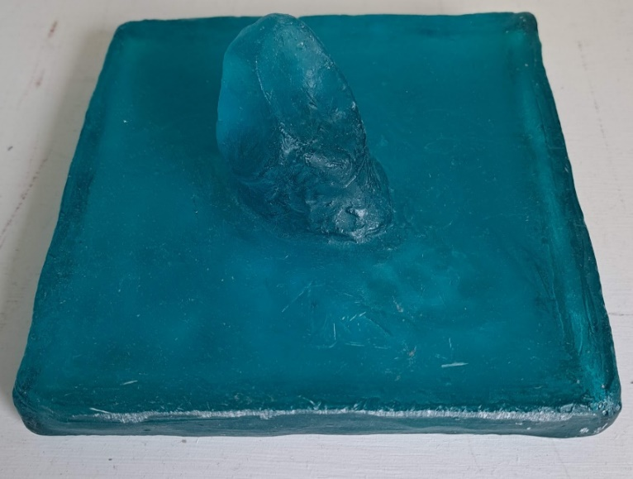
Fig. 5. BLUE PINCH. Mitchell, P. 2023. Blue glass. (15 x 15 cms)

In her exhibition showing at Tate Modern 2023, Magdalena Abakanowicz’s work exemplifies this notion of touch as a connection with the subconscious. The forms she makes are a living embodiment of our memory of the sensation and evocation of touch.
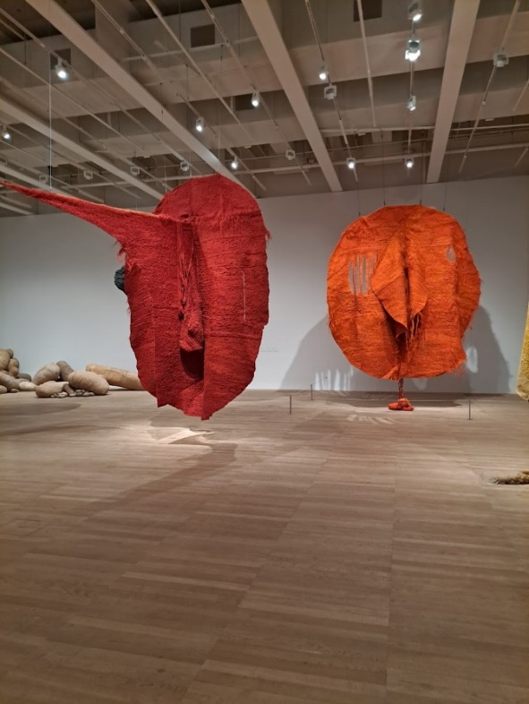
Fig 6 Abakans 2023 TATE MODERN
The Abakanowicz pieces, known as Abakans, in soft fibrous material also further promote the notion of artwork possessing the ability to describe, through visual means, touch, without the experience of the touch itself. Conveying a direct connection with thought and experience. Touch as a very real and important sensation in understanding our world, is communicated in her work.
That through touch one might enter a further realm of existence - one which cannot be entered into without this collaboration, this understanding.

According to Wikipedia (2002)
Abakanowicz never fully accepting Constructivism, she searched for her own "artistic language and for a way to make her art more tactile, intuitive, and personal." As a result, she soon adopted weaving as another avenue of artistic exploration.
She sought the “total obliteration of the utilitarian function of tapestry” and demonstrated the capacity of fibre to produce forms that were soft yet structured and complex.

If a spectator is viewing a work which invites the experience of touch and then is prevented within the gallery setting, then the ‘Point’ (hypnotic strategy Keyword) sculpture enhances this idea by enveloping the skin with a layer of prevention/protection - the glass. There are obviously very real and appropriate reasons for this in a gallery strategy, as a result the exhibits could be understood as objects of scientific study to be observed without further experience - a potential sense of disconnect.

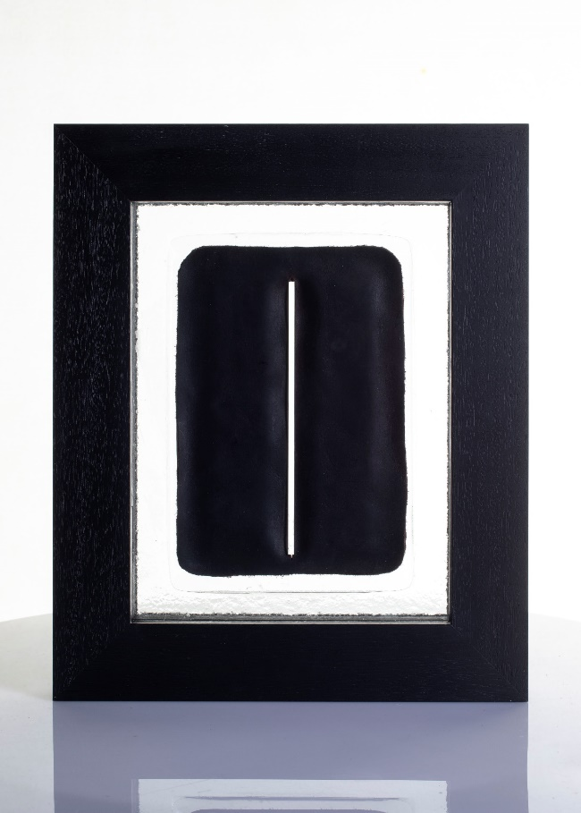
Fig 7. POINT. Mitchell, P. 2023. Leather, Glass, Wood 2023 (40 x 30 x 6cms)

The artist Stephen Cox work seems able to tap into this ‘universal cultural harmony’ and evoke through sculptural forms the primitive, the visceral. They seem as icons, symbols, the monolith
"On the idea that these things still have primordial power over men". Clark (2011)
They evoke touch almost as an invitation to participate in a ritualistic endeavour - not of a conscious logical experience but being immersed in the phenomena of the sculptures- a form of subconscious trance state.
Even though the material of Coxs sculptures is metal as opposed to the soft fabric of Abakanovich, they nonetheless possess the similar invitation. The scale of both makers work compared to our own bodies allows us to become as an infant experiencing our first contact with the world.

Fig 8. Stephen Cox, sculpture [bronze]

CONCLUSION
The essay could be viewed as a document in which the strategies followed could allow anyone to reach into their own creative subconscious and allow their creative ideas to flow.
I have referenced psychologists work as a way of formulating a personal working methodology for accessing imagery from the subconscious.
I have also used references to other artists using varying materials even though my work is predominantly glass. It is a shift that I am looking for in experiencing their work- (by that I mean a shift emotionally in one way or another) and it is this shift I am seeking by making my own. Glass allows movement, it allows different perspectives to exist beyond the surface, it allows one to become aware that there is another state of thinking and experiencing.
Glass is more akin to how we internally/externally view the world and how we understand it - from all aspects. When we view glass, we are in a state of movement - we are looking at and through at the same time - a constant state of adjustment of perception - akin to how we obtain understanding of the world around us. Glass therefor I believe more akin to sculpture and our understanding of the space outside and the space within ourselves.
The pieces I have made are both of a physical filter - through their passing of light and of a metaphorical manifestation of the filter between the conscious and subconscious. Hence the title of the report as The Between. These pieces, these filters are interrupting our perception of the image beyond – landscape, room etc. The image observed beyond (through the glass) is a metaphor for viewing the subconscious- when observing, we take the position of conscious awareness. The image through the glass is altered/interrupted by the glass sculpture. So too is our perception of the subconscious altered by the filter when taking this viewpoint. It is the by-passing of this filter (possibly through hypnosis) that the Subconscious can be experienced and consciously communicated with.
It should be noted that this Filter is vital in the process of thinking, it filters out that which is unnecessary or harmful etc (based upon personal subjective experiences) - it is mutable, organic, and active constantly.
The process of creativity is similar for most people, they mention ‘being in the zone’ this is trance state- they have bypassed the filter and are experiencing direct subconscious communication. I tend to have more of an affinity with artists who explore their own subconscious and the flow between the states described in this essay.
It is by doing that we understand. By making with a material, I have been unfamiliar with (glass), has forced a new way of understanding from my own viewpoint on making work, thinking is dramatically altered when glass is used instead of the familiar stone - the consideration of light within and through as opposed to on the surface.
Using creative connection with the subconscious thinking, then the use of glass, seemed obvious. Of course, the theme is subjectivity- the way one thinks, experiences, and understands the world and a material which allows one to view the interior of a sculpture (interior of thinking) then glass seems at present the most appropriate.

REFERENCES

D Corydon Hammond (1990). Handbook of hypnotic suggestions and metaphors. New York: Norton.
Fromm, E., & Kahn, S. (1990) Self-hypnosis: The Chicago paradigm. New York: Guildford Press.
Hughes B.B (2023). Telephone conversation and subsequent Email. Mitchell, P. 4/5/2023
Johnson, A., Denny, T., Reed, J., Cazalet, M., Davies, J.O., Lane, R. and Lund Humphries (2016). Glory, azure and gold: the stained-glass windows of Thomas Denny. London: Reed Contemporary Books, In Association with Lund Humphries.
Jung, C.G. and Marie-Luise Von Franz (1968). Man and his symbols.
Lankton, S.R. (2015). The Answer Within. Routledge.
O’connor, J. and Seymour, J. (1990). Introducing neuro-linguistic programming: psychological skills for understanding and influencing people. London: Element.
Ravell.J.and Norman,S. (1997). In Your Hands. NLP in EFT. London, Saffire press
Sandler, I. (1970). The Triumph Of American Painting. Westview Press.
Schaverien, J. (1999). The revealing image: analytical art psychotherapy in theory and practice. London ; Philadelphia: Jessica Kingsley Publishers.
Smith, D. and Gray, C. (1988). David Smith by David Smith sculpture and writings. London Thames And Hudson.
Waxman, D. and Hartland, J. (1989). Hartland’s Medical & Dental Hypnosis. Bailliere Tindall Limited.

Electronic Sources Referenced

Clark, A. (2011). A room of my own: Stephen Cox. The Guardian. [online] 6 Nov. Available at: https://www.theguardian.com/lifeandstyle/2011/nov/06/room-own-stephen-cox-sculptor [Accessed 7 May 2023].
Cherry, K. (2023). The preconscious, conscious, and unconscious minds. [online] Verywell Mind. Available at Citizen of the Eason, A. (2012). Theory of Self-Hypnosis: Looking at the Options. [online] Adam Eason. Available at: https://www.adam-eason.com/theory-of-self-hypnosis-looking-at-the-options/ [Accessed 9 Jan. 2023].
Eason, A. D., & Parris, B. A. (2018, October 29). Clinical Applications of Self-Hypnosis: A Systematic Review and Meta-Analysis of Randomized Controlled Trials. Psychology of Consciousness: Theory, Research, and Practice. Advance online publication. http://dx.doi.org/10.1037/cns0000173
Eason, A. (2012). Theory of Self-Hypnosis: Looking at the Options. [online] Adam Eason. Available at: https://www.adam-eason.com/theory-of-self-hypnosis-looking-at-the-options/ [Accessed 23 Apr. 2023].
Farah, S. (2019). Archetypes and the Collective Unconscious: by C. G. Jung. [online] Appliedjung. Available at: https://appliedjung.com/archetypes-and-the-collective-unconscious/.
Fromm, E .(1981) psycnet.apa.org. (n.d.). APA PsycNet. [online] Available at: https://psycnet.apa.org/record/1982-04960-001 [Accessed 14 March. 2023].
www.goodreads.com. (n.d.). A quote by William Blake. [online] Available at: https://www.goodreads.com/quotes/258575 [Accessed 23 February. 2023].
Image Journal. (n.d.). Walking Man: The Art of Thomas Denny. [online] Available at: https://imagejournal.org/article/walking-man-art-thomas-denny/# [Accessed 23 Apr. 2023].
www.japan-experience.com. (n.d.). The concept of ‘ma’ | Japan Experience. [online] Available at: https://www.japan-experience.com/plan-your-trip/to-know/understanding-japan/the-concept-of-ma [Accessed 23 Apr. 2023].
Ledochowski, I. (2018). Conversational Hypnosis Q&A: Igor Ledochowski Answers Your 6 Biggest Questions To Reveal The Mystery Behind Hypnosis. [online] Hypnosis Training Academy. Available at: https://hypnosistrainingacademy.com/conversational-hypnosis-igor-ledochowski-questions/ [Accessed 9 March.2023].
Mulder, P. toolshero. (2019). 3 Perceptual Positions - a Powerful NLP exercise explained. [online] Available at: https://www.toolshero.com/personal-development/perceptual-positions/. Perceptual Positions technique, a NLP exercise explained (toolshero.com)
NLP World. (n.d.). NLP Conscious | NLP World - Glossary. [online] Available at: https://www.nlpworld.co.uk/nlp-glossary/c/conscious/#:~:text=Conscious%20in%20NLP%20is%20that%20of%20which%20we [Accessed 23 Dec. 2022].
NLP World. (2012). Submodalities. [online] Available at: https://www.nlpworld.co.uk/nlp-glossary/s/submodalities/.
“Preconscious.” Wikipedia, 28 Feb. 2023, en.wikipedia.org/wiki/Preconscious.
psycnet.apa.org. (n.d.). APA PsycNet. [online] Available at: https://psycnet.apa.org/doiLanding?doi=10.1037%2Fcns0000173 [Accessed 23 Apr. 2023].
www.psychologytoday.com. (n.d.). The Inner Language of the Subconscious | Psychology Today. [online] Available at: https://www.psychologytoday.com/us/blog/in-flux/201301/the-inner-language-of-the-subconscious.
www.quotemaster.org. (n.d.). The purpose of art is mystery. Rene Magritte. [online] Available at: https://www.quotemaster.org/qd6cf466a18b7de9d25277856e8cb6dde [Accessed 8 May 2023].
Shor, R.E. and Easton, R.D. (1973). A Preliminary Report on Research Comparing Self- and Hetero-hypnosis. American Journal of Clinical Hypnosis, 16(1), pp.37–44. doi:https://doi.org/10.1080/00029157.1973.10403649.
Tate (2017). Automatism – Art Term | Tate. [online] Tate. Available at: https://www.tate.org.uk/art/art-terms/a/automatism. [Accessed Nov 13 2022]
Trance, M. (2021). Critical Factor: What It Is And 3 Easy Ways To Take It Out. [online] Max Trance. Available at: https://maxtrance.com/critical-factor/ [Accessed 23 Apr. 2023].
UK College of Hypnosis & Hypnotherapy - Hypnotherapy Training Courses. (n.d.). Donald Robertson. [online] Available at: https://www.ukhypnosis.com/author/donaldr/ [Accessed 23 Apr. 2023].
Wikipedia. (2022). Magdalena Abakanowicz. [online] Available at: https://en.wikipedia.org/wiki/Magdalena_Abakanowicz.
Winn, S. (2007). What happens to us when art connects to the unconscious. [online] SFGATE. Available at: https://www.sfgate.com/entertainment/article/What-happens-to-us-when-art-connects-to-the-2591269.php#:~:text=The%20connections%20that%20paintings%20and%20dance%20performances%2C%20movies [Accessed 23 Apr. 2023].

BIBLIOGRAPHY PSYCHOLOGY
Alman, B.M. and Lambrou, P. (2013). Self-Hypnosis. Routledge.
Bandler, R., Grinder, J. and DeLozier, J. (1975). Patterns of the Hypnotic Techniques of Milton H. Erickson, M.D. Meta Publications.
Bargh, J. A., & Chartrand, T. L. (1999). The unbearable automaticity of being. American psychologist.
Bolstad, R. (2002). Resolve. Crown House Publishing.
Chomsky, N. (1972). Language and mind. New York: Harcourt Brace Jovanovich.
Dobson, D.J.G. and Dobson, K.S. (2018). Evidence-based practice of cognitive-behavioural therapy. 2nd ed. New York: The Guildford Press.
Eason, A. (2013). The Science Of Self-Hypnosis: The Evidence Based Way To Hypnotise Yourself. Awake Media Productions.
Freud, S. (2005). The unconscious. Penguin classics
Freud, S. (1924). A general introduction to psychoanalysis, trans. Joan Riviere.
Greenwald, A. G., & Banaji, M. R. (1995). Implicit social cognition: attitudes, self-esteem, and stereotypes. Psychological review
Haley, J. (1993). Uncommon therapy: the psychiatric techniques of Milton H. Erickson, M.D. New York ; London: W. W. Norton.
Igor Ledochowski (2003). The deep trance training manual. Carmarthen, Wales ; Williston, Vt: Crown House Pub.
James, T. and Flores, L. (1999). Hypnosis. Crown House Publishing.
James, T. and Woodsmall, W. (2017). Timeline Therapy: and the basis of personality. La Vergne: Crown House Publishing.
Levitin, D.J. (2019). This is your brain on music: understanding a human obsession. London: Penguin Books.
Milton Hylaud Erickson and Rosen, S. (1991b). My voice will go with you : the teaching tales of Milton H. Erickson, M.D. New York, N.Y. ; London: Norton & Company.
Seth, A. (2021). Being You. Faber & Faber.
Shin, S. and Vickers, B. (2021). Altered States. London: Ignota Books.
Silvester, T. (2010). Cognitive Hypnotherapy: What’s that about and how can I use it? Matador.
Stroop, J. R. (1935). Studies of interference in serial verbal reactions. Journal of experimental psychology.
Tulving, E. (1972). Episodic and semantic memory. In E. Tulving & W. Donaldson (Eds.), Organization of Memory New York: Academic Press.
Wilson, T. D. (2004). Strangers to ourselves. Harvard University Press
BIBLIOGRAPHY ARTISTS

Albers, J. (2013). Interaction of colour. New Haven, Conn.: Yale Univ. Press.
Bacon, F., Armin Zweite, MüllerM., BürgerP. and Kunstsammlung Nordrhein-Westfalen (Germany (2006b). Francis Bacon : the violence of the real. London: Thames & Hudson.
Baal-Teshuva, J. and Rothko, M. (2003). Mark Rothko, 1903-1970: pictures as drama. Köln London: Taschen.
Benjamin (2022). Gerhard Richter. MIT Press.
Hajo Düchting (2012). Paul Klee: painting music. Munich; London: Prestel.
Gilles Deleuze (2005). Francis Bacon: the logic of sensation. London: Continuum.
Gooding, M. (2002). Ceri Richards. Cameron and Hollis
Hartley C (2016), Realisation: Recent works by Susan Aldsworth & Jane Dixon. Fitzwilliam Museum
Kapoor, A. (2008). Anish Kapoor. Anish Kapoor.
Kapoor, A, Baume, N., Boston, A. and Al, E. (2008). Anish Kapoor : past, present, future [exhibition] Institute of Contemporary Art, Boston, 30 May-7 September 2008]. Boston, Ma: Institute of Contemporary Art, Boston.
Kapoor, A., Poddar, S. and Deutsche Guggenheim Berlin (2008). Anish Kapoor. Guggenheim Museum Publications.
Jean-Michel Basquiat, Hoffman, F., Mayer, M., Brooklyn Museum, Los, A. and Houston (2010). Basquiat. Paris: Flammarion.
Scoates, C. and Eno, B. (2013). Brian Eno : visual music. San Francisco, Ca: Chronicle Books.
Smith, L. (2023a). Action / Gesture / Paint: A Global Story of Women and Abstraction 1940-70.
Zweite A, Müller M., BürgerP. and Kunstsammlung Nordrhein-Westfalen (Germany (2006). Francis Bacon: the violence of the real. London: Thames & Hudson.

ATTENDED EXHIBITIONS
Action, Gesture, Paint: Women Artists and Global Abstraction 1940-70 (2023) [Exhibition]. Whitechapel Gallery, London. 9 February – 7 May 2023
Arnolfini, Bristol. Paula Rego 11/12/22
Biennale Venice (2022) [Exhibition]. 23 April- 27 Nov. Visited 12 and 13 Oct
Biennale Glass Stroud (2022) [Exhibition]. 23-27 April. Visited 28/8
On Form Burford (2022) [Exhibition]. 11 June- 10 July.
Oxford (2022) [Exhibition]: Citizen of the Universe. Visited 30/6
Royal West of England (2022) [Winter Show] Visited 11/12/2022
Sainsburyy Arts Center Norwich (2022) [Group Exhibition] Visited 26/6/2022
Stained Glass Museum Ely [Permanent Exhibition]. Visited June 2022
Tate St Ives (2022) Barbara Hepworth and Art and Life 23/12/2022
Wei Wei. Kettles Yard Cambridge. Visited July 2022

FIGURES
Fig. 1 2023 THE THREE . Mitchell, P. wood glass textiles. 13 X 15 cms
Found object- Fig 2. Perceptual Positions. (toolshero, 2019)
Fig. 3. STRING. Mitchell P, 2023 Glass Wood (50 x 40 x 10cms)
Fig.4. OPTIC. Mitchell, P. 2023. Glass, copper, gold leaf, wood. (50 x 30 x 10cms)
Fig. 5. BLUE PINCH. Mitchell, P. 2023. Blue glass. (15 x 15 cms)
Fig 6 Abakans 2023 TATE MODERN (own photograph)
Fig 7. POINT. Mitchell, P. 2023. Leather, Glass, Wood 2023 (40 x 30 x 6cms)
Fig 8. Stephen Cox, sculpture [bronze] bing.com

