REFLECTIVE REPORT ON PERSONAL CAREER DEVELOPMENT

Prepared for
University of Wales Trinity Saint David
Prepared by: Florentina Mihaela Popescu
Student reference number:1908807

Submission date: 21-02-2020
Student number:1908807
File name: Reflective report on personal career development
Word count: 2929
Character count: 16856

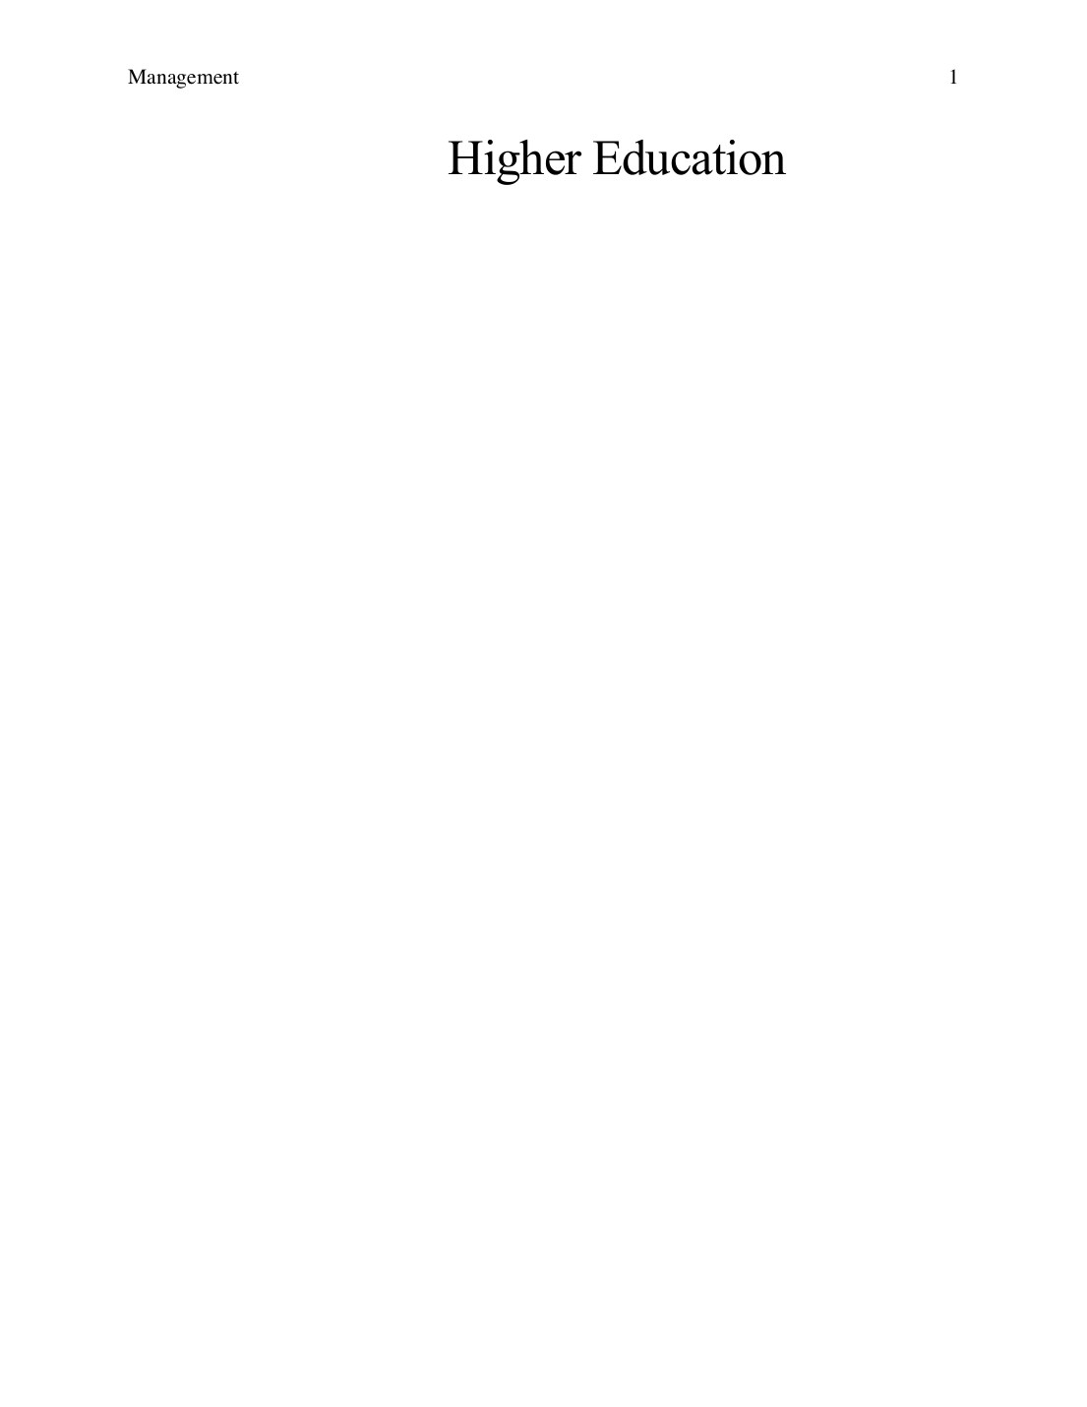
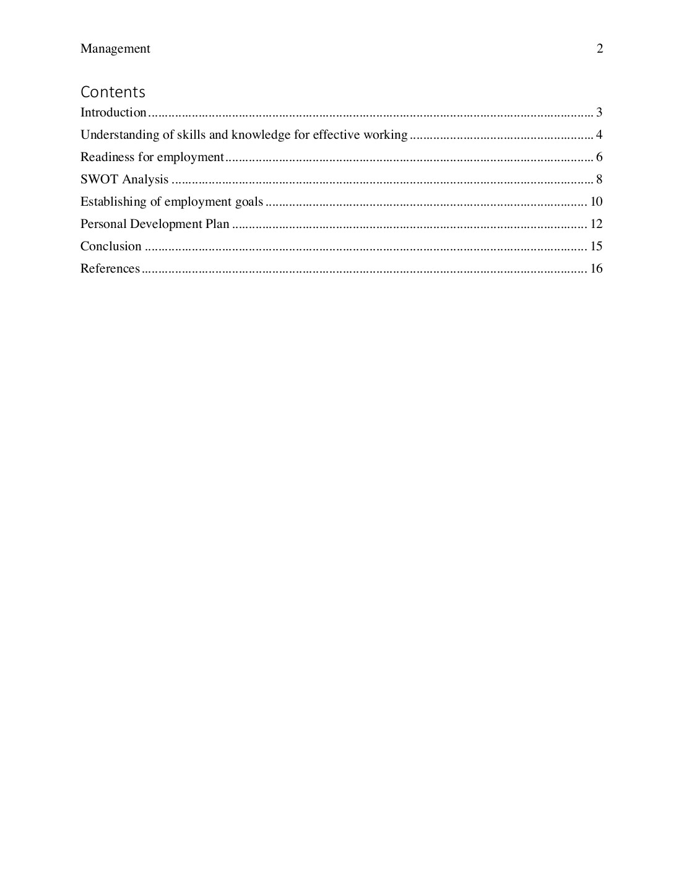
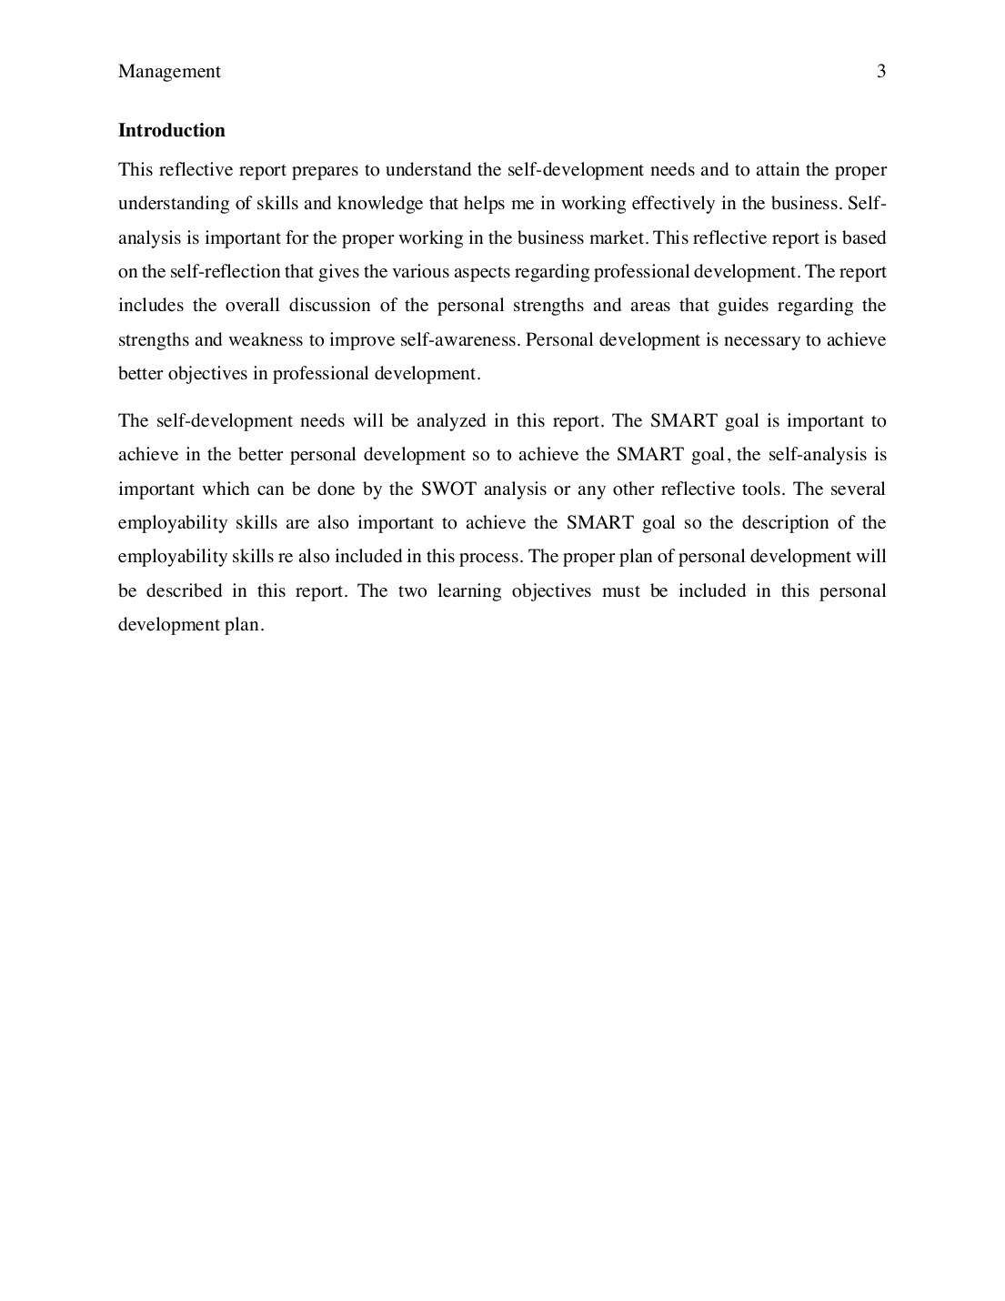
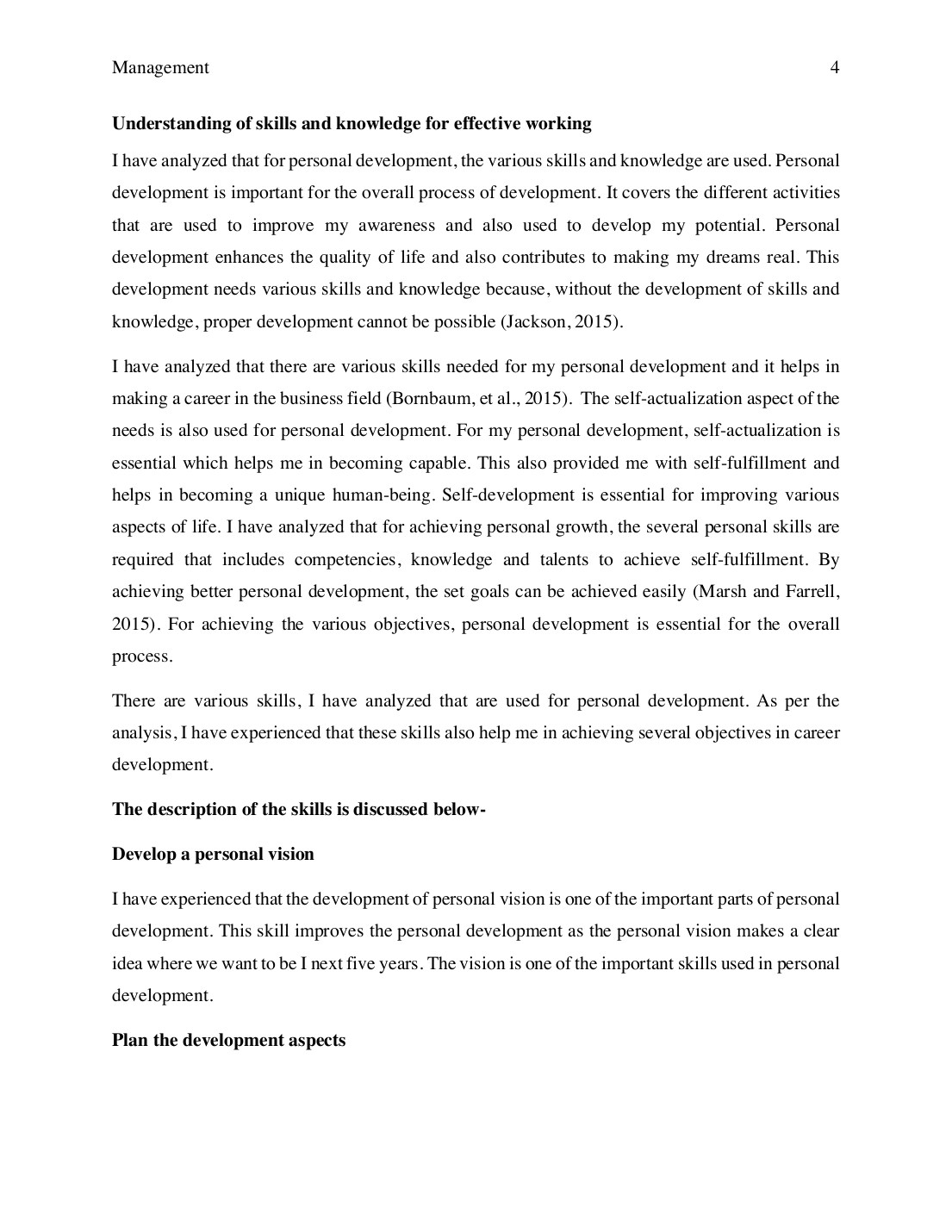
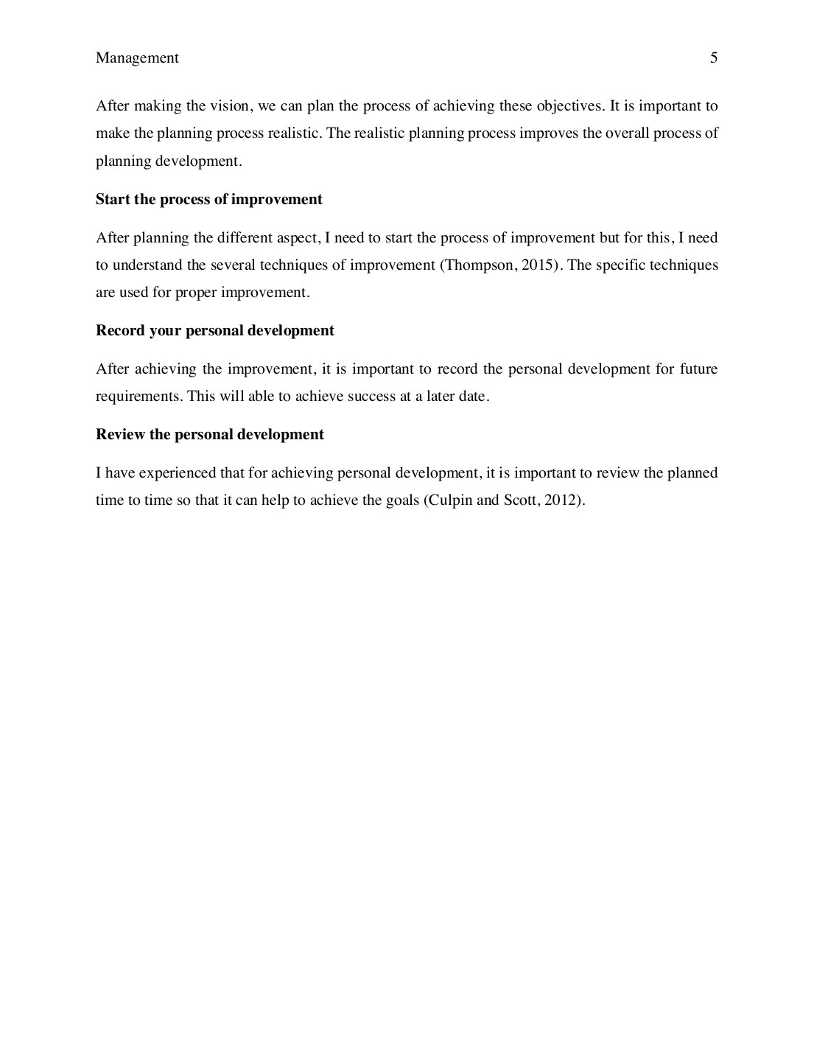
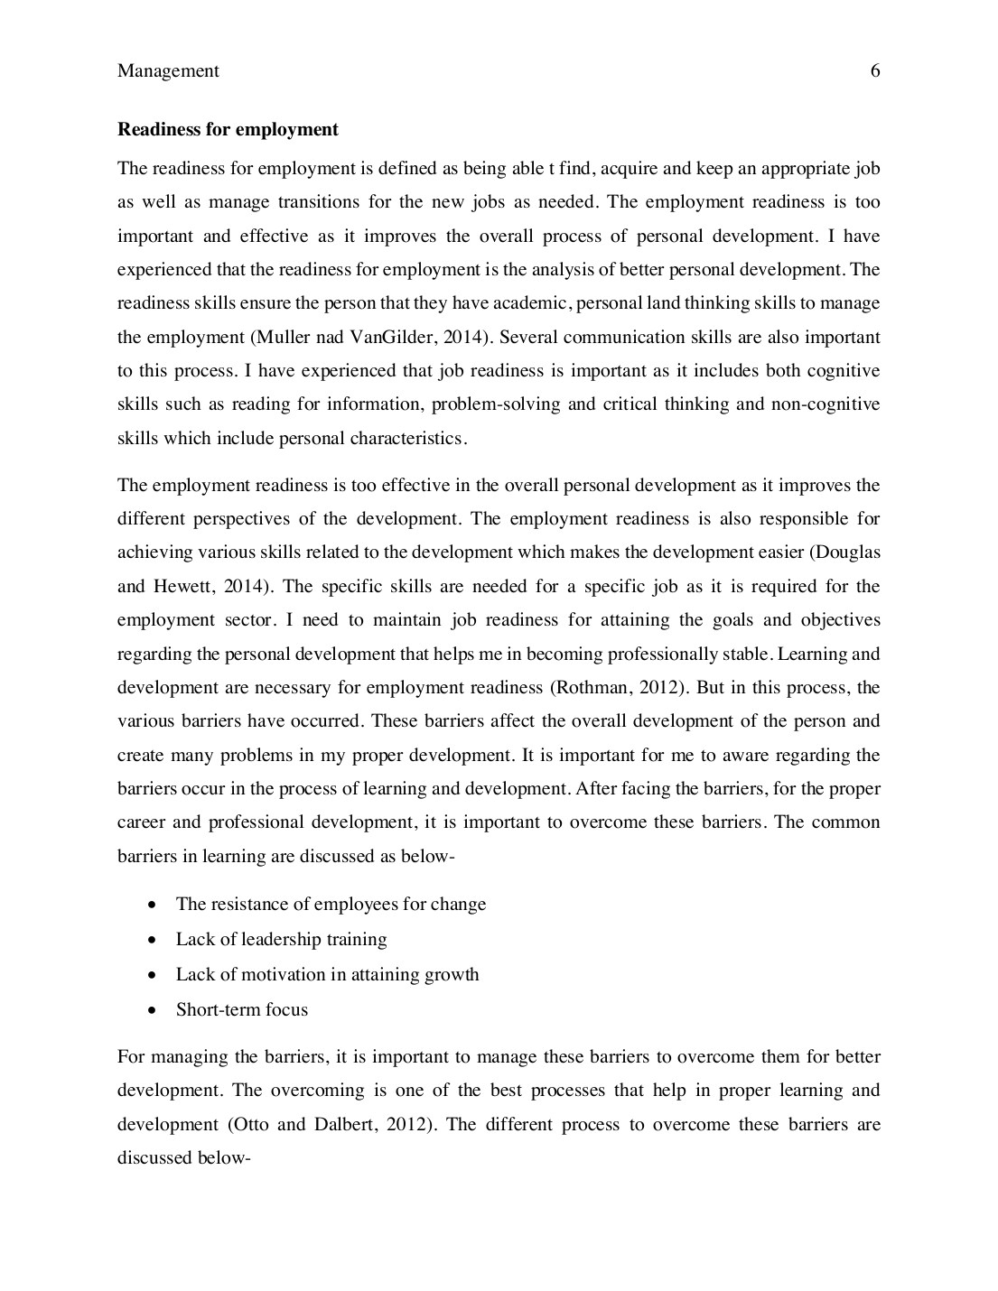
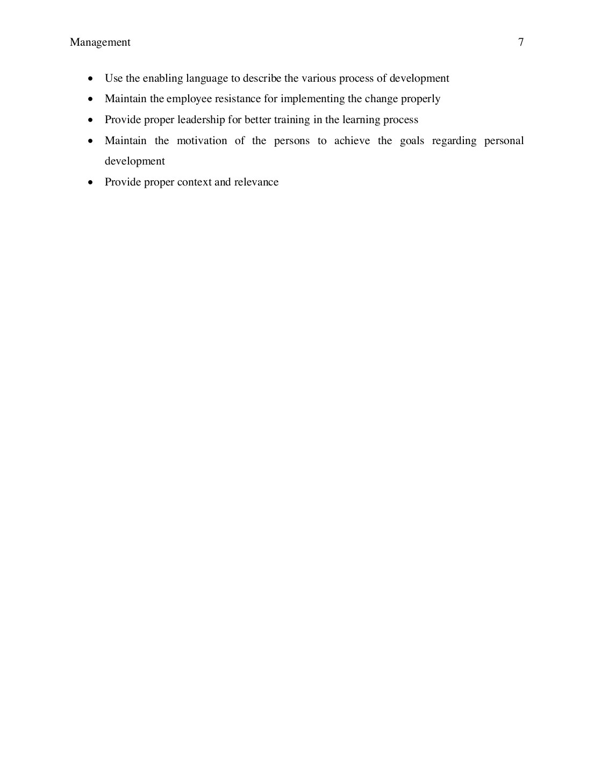
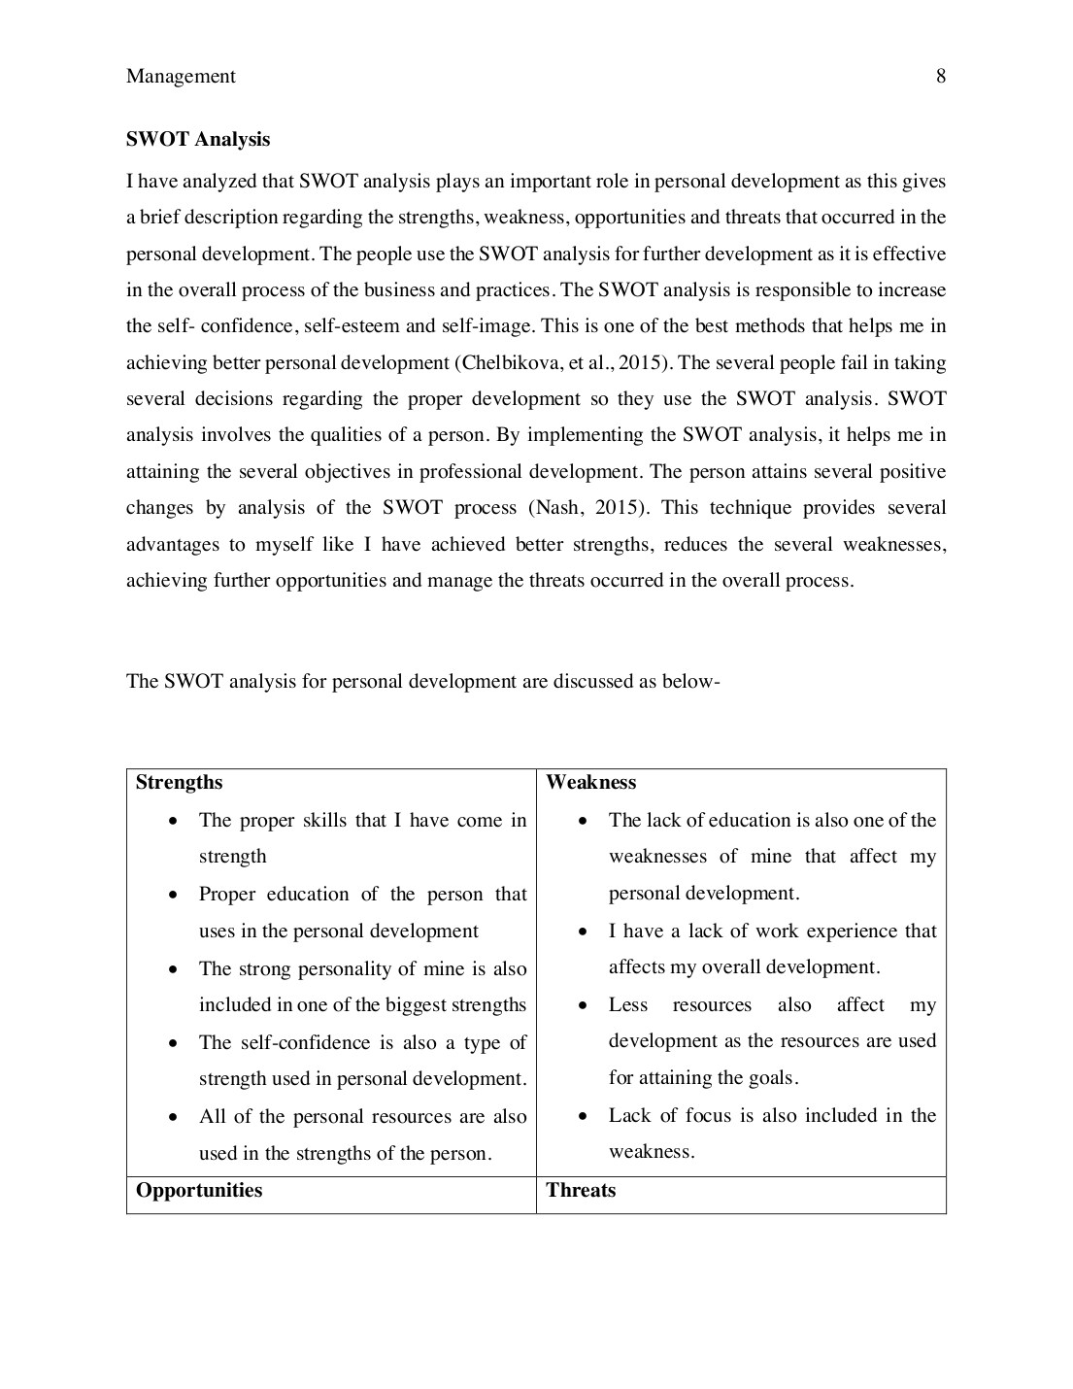
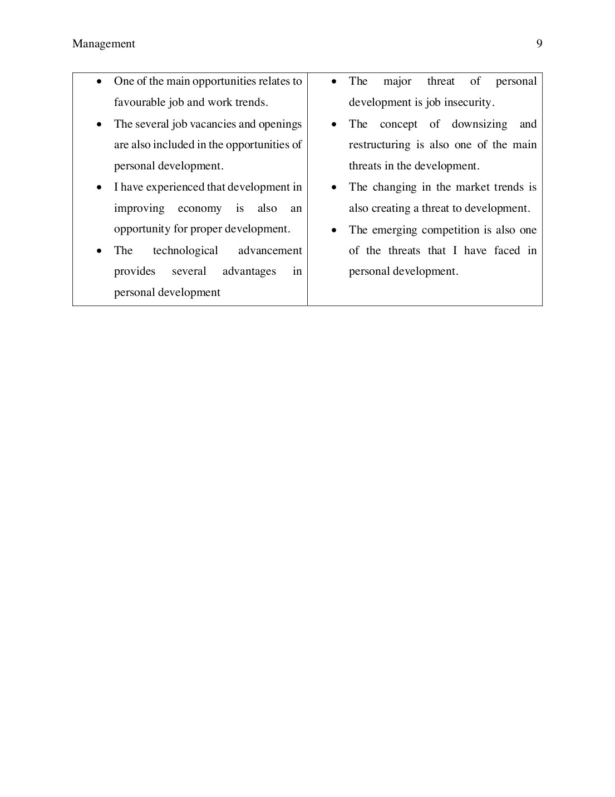
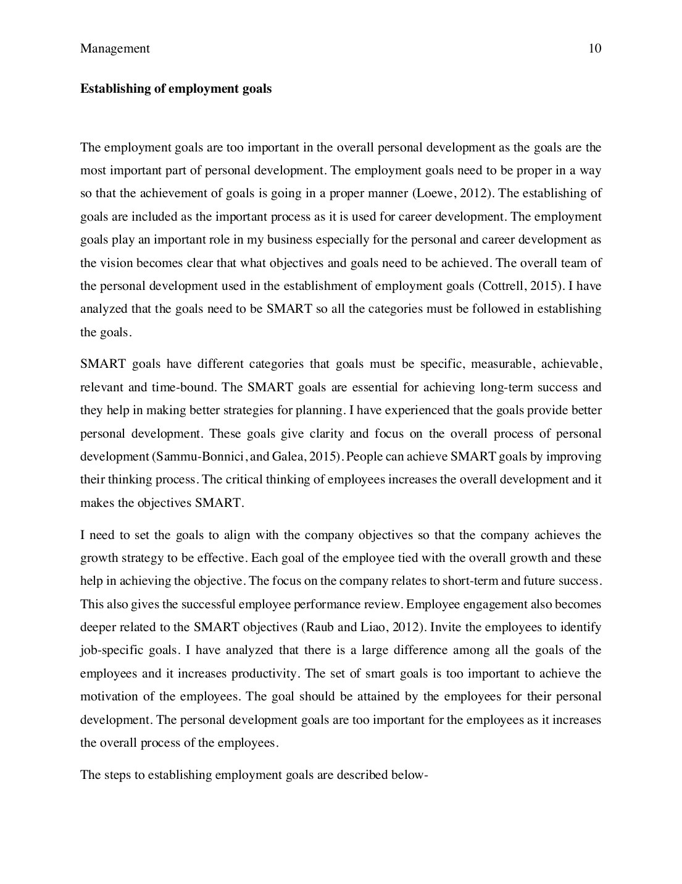
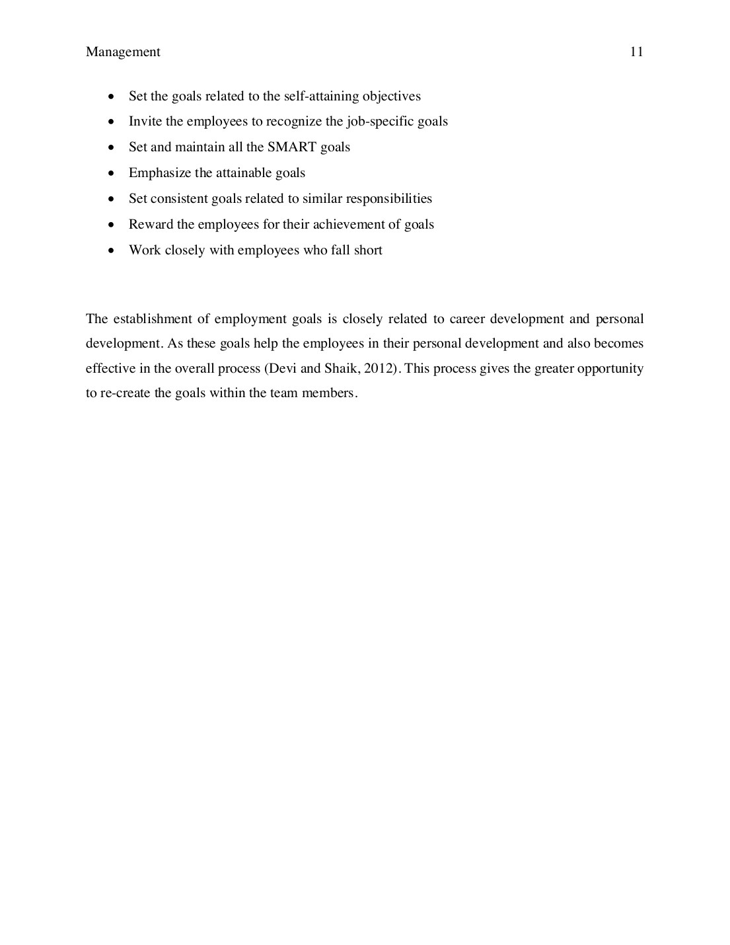
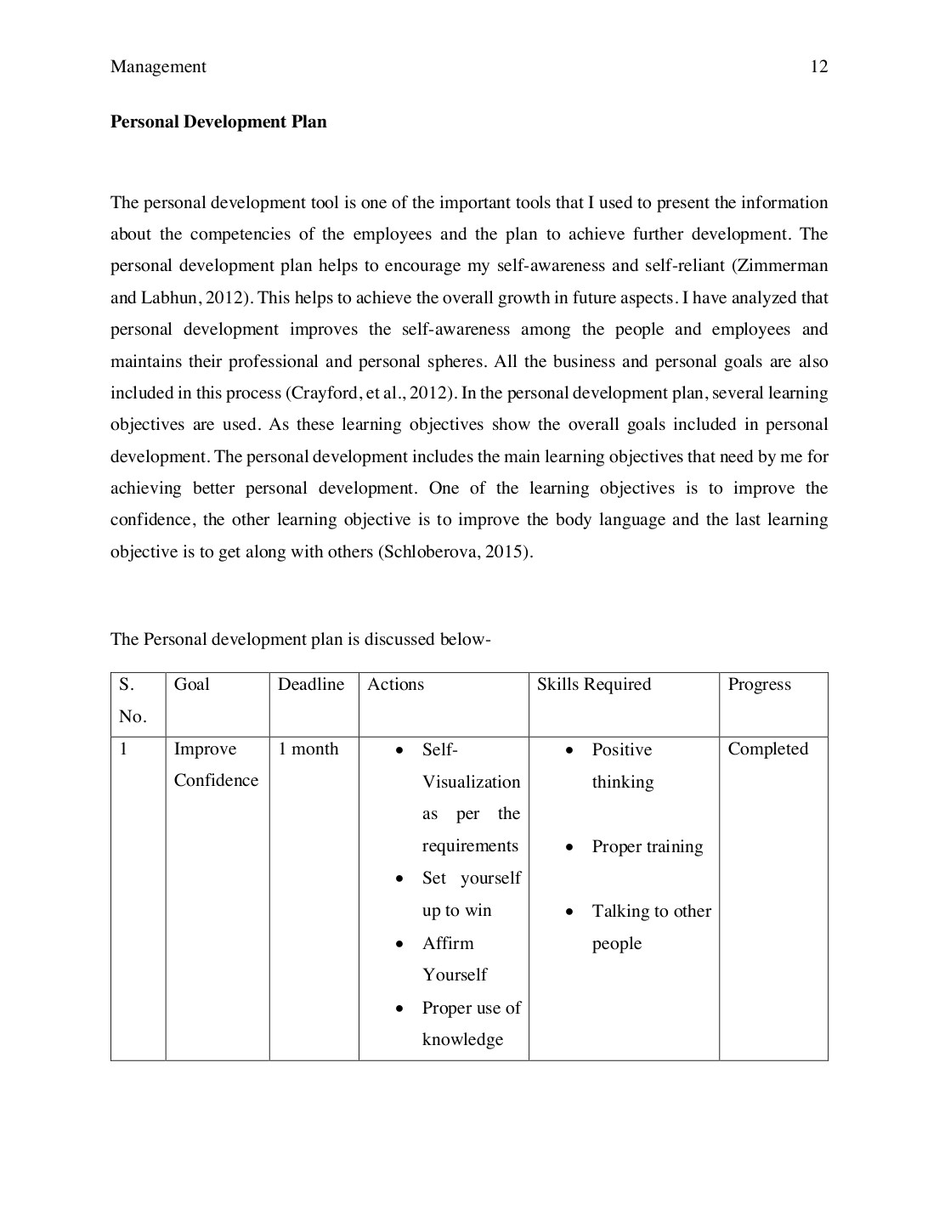
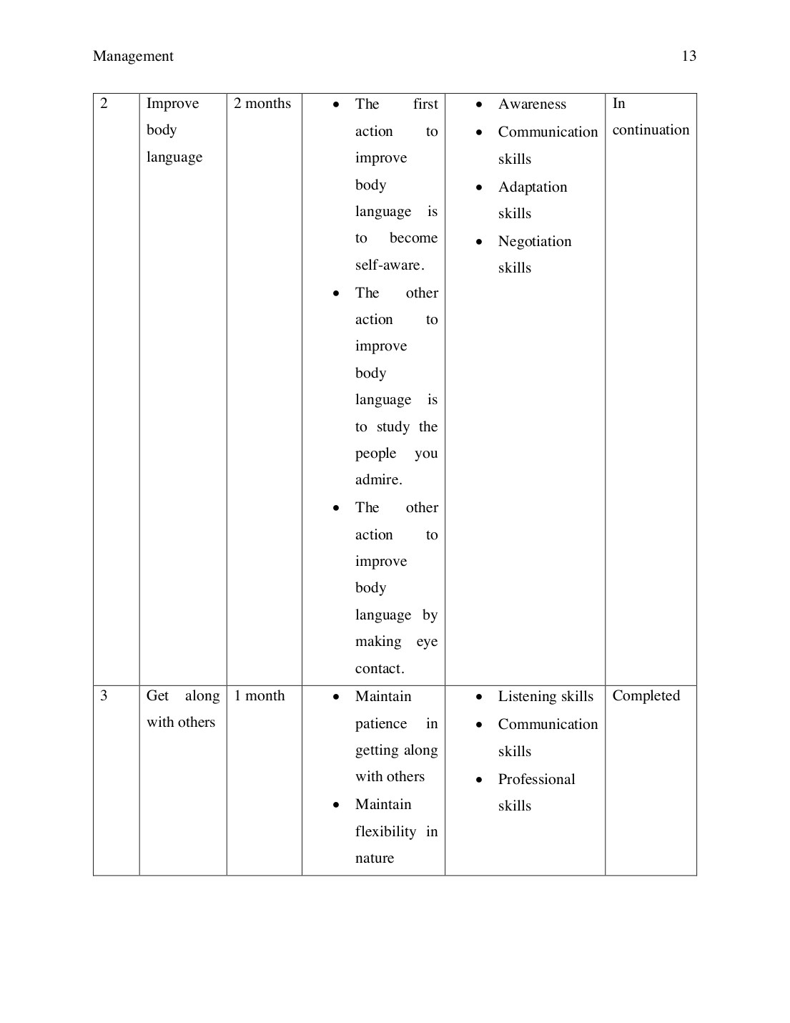
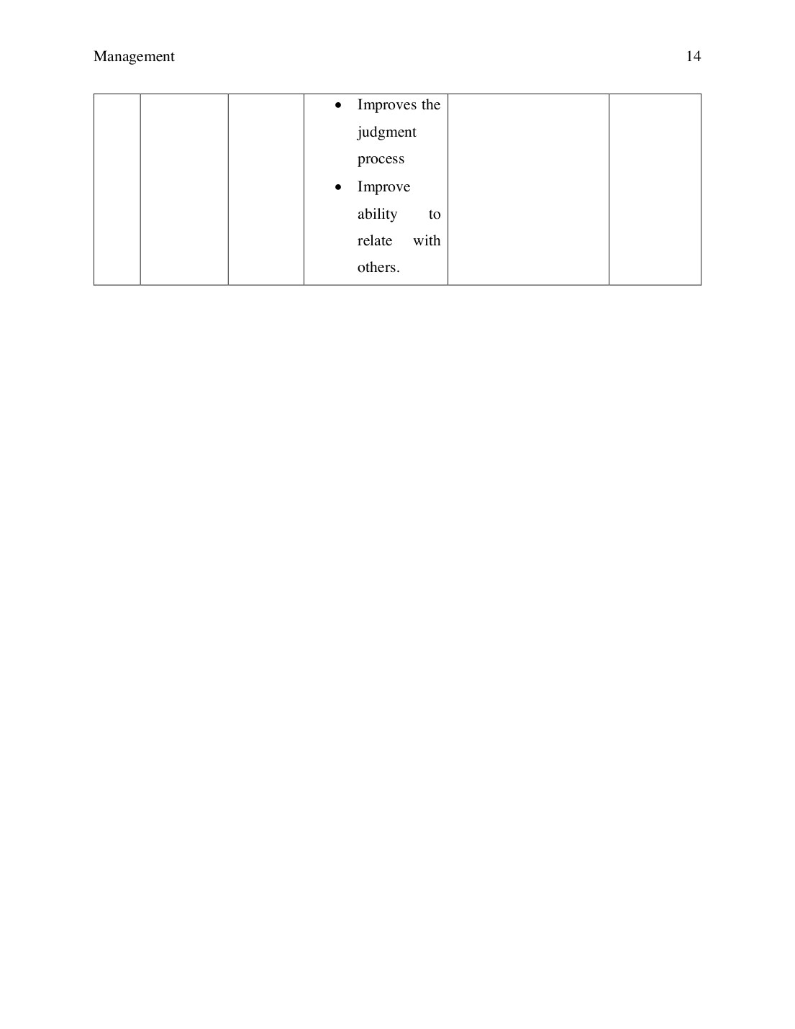
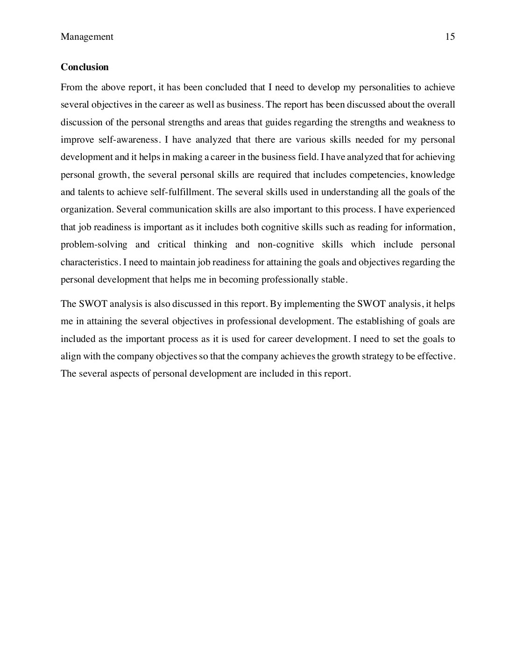
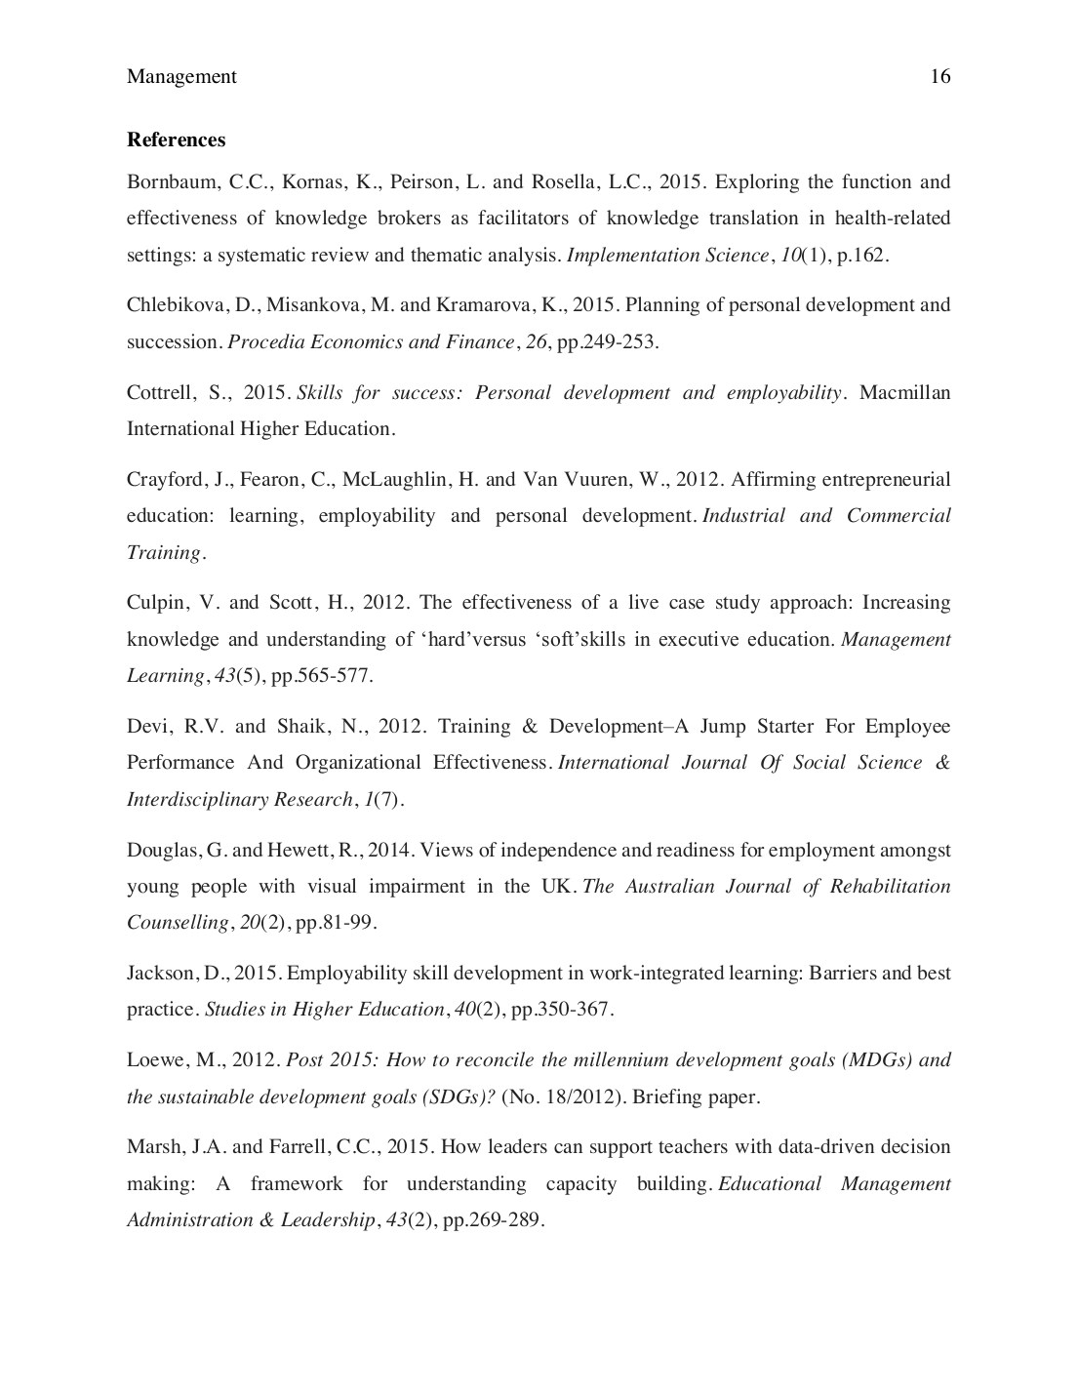
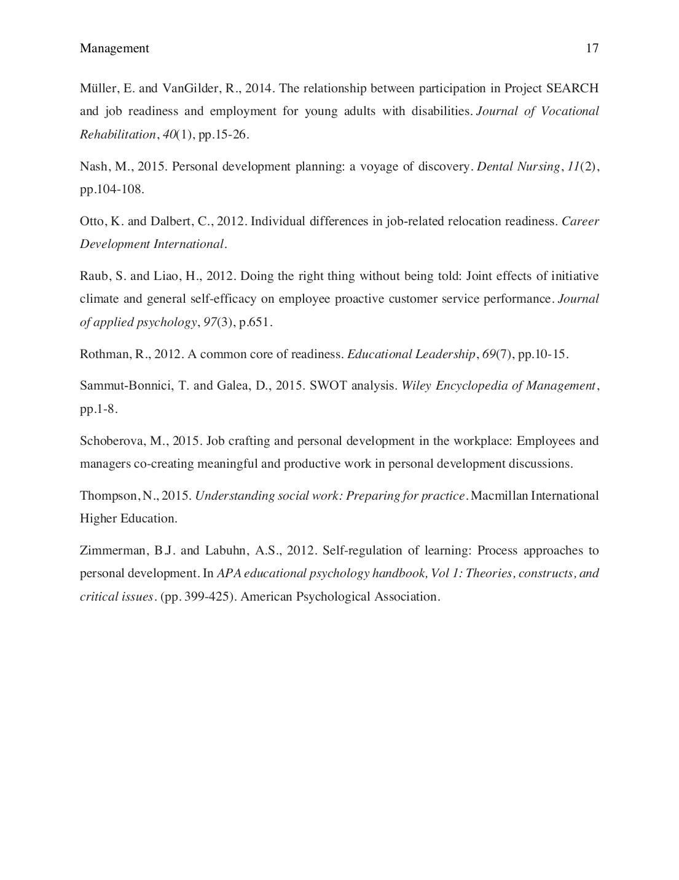

1194180_921467_3921484.docx

ORIGINALITY REPORT

6% 2% 1% 5%
SIMILARITY INDEX INTERNET SOURCES PUBLICATIONS STUDENT PAPERS
PRIMARY SOURCES
lakshminarayan.com 1  Internet Source | 1%
Maureen N. Short, Yolanda Keller-Bell. "chapter 2  9 Essential Skills for the 21st Century  Workforce", IGI Global, 2019  Publication | 1%
Submitted to Online Education Services  3  Student Paper | 1%
Submitted to Louisiana State University  4  Student Paper | 1%
algerie-recrutement.com 5  Internet Source | <1%
Submitted to Middlesbrough College  6  Student Paper | <1%
Submitted to Napier University  7  Student Paper | <1%
Submitted to University of Sunderland  8  Student Paper | <1%
Exclude quotes On Exclude matches Off
Exclude bibliography On

