Programme: BA Business Management
Module: Marketing Fundamentals
Module code: LCBB4004
Assignment Title: Assessment 2 Marketing
Fundamentals Analysis and Evaluation
Student name: Elena Ivanova Goranova
Student ID: 2122365

Table of Contents
Introduction 3
Overview of Reckitt Benckiser 3
Internal analysis of Reckitt Benckiser 4
SWOT analysis of Reckitt 4
Strength factors 5
Weaknesses of Reckitt Benckiser 6
Opportunities for Reckitt Benckiser 7
Threats factor 7
Porter's Generic value model analysis of Reckitt Benckiser 8
Primary activities 8
Supporting activities 10
External analysis 10
PESTLE analysis of Reckitt Benckiser 10
Michael porters five forces analysis of Reckitt Benckiser 11
Competitive rivalry in the market 12
Threats of new entrants and substitution 12
Bargaining power of buyers 13
Bargaining power of suppliers 13
The overall impact of COVID-19 on the performance of Reckitt Benckiser 13
Conclusion 15
Reference list 16

Introduction
The Coronavirus impact has brought challenges for companies and businesses all over the world. They have struggled to continue operation, maintain the supply chain, enhance the value chain process, and distribute goods to the consumer bases. This particular report is created to conduct an internal and external analysis of Reckitt Benckiser, which provide health and hygiene products to almost 200 countries across the world (Reckitt, 2022). The author first briefly portrayed the history of the company. Later, an internal analysis was conducted using SWOT and the value chain model framework. The external analysis was conducted using the PESTLE and Porter's five forces model.

Overview of Reckitt Benckiser
Reckitt Benckiser is a British multinational FCMG company headquartered in Slough, England. The company started its journey back in 1999 with a merger between British company Reckitt and Colman PLC and Benckiser N.V. in 2021 (Reckitt, 2022). The company changed its name from RB to Reckitt and interviews it's a new logo with a visual identity. The motto of the company is to provide health, hygiene, and home products to its local customers (Seekingalpha.com, 2022). The company is the home of supplying popular consumer goods. It has many large brands like Dettol, Disprin, Veet, and Airborne. The company also produced many baby foods under the umbrella of Mead Johnson, Air wick. It also has other brands and products like Calgon, Client Bang, Durex, Lysol, Mycil etc.
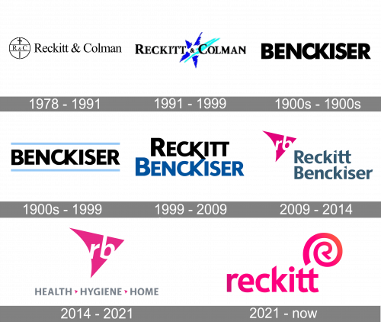
Figure 1: Evolution of Reckitt (Reckitt, 2022)
Reckitt is involved in providing skin care, personal care, nutrition, cleaning agents, and consumer health care products which made it one of the largest consumer groups provider around the world. In 2021, It generated revenue of 13.234 billion pounds (Statista, 2022). Around the world, it has more than 43,000 employees who passionately work for providing hygiene products to the interior for the good health of its consumers. The group mainly offer it in North America, Europe, Australia, New Zealand, and other developing countries around the world. It operates in more than 60 countries and its products are available in nearly 200 countries (Reckitt, 2022). Having these large markets share, the company is often influenced by various internal and external factors that shape its operation. Covid-19 has had a significant impact on its operation and market share. As a marketing manager of Reckitt, the author conducted the following internal and external analyses to show how the global factors have impacted its operation.

Internal analysis of Reckitt Benckiser
Internal analysis is the thorough examination of a particular company’s internal process, assets, and structure. These analyses analyse both tangible and intangible factors of a company like its resources, processes, and assets that define the strength and opportunities it can avail of (Tatyana et al., 2020). By conducting this analysis, companies can identify its weakness and challenges that may affect them in the long run. To conduct is internal analysis, SWOT and value chain model have been used.

SWOT analysis of Reckitt
SWOT framework is mostly used to analyse the strengths, weaknesses, opportunities and threats factors of a particular organization. By analysing through this framework, companies can use their strength to avail of the opportunities and face the challenges.
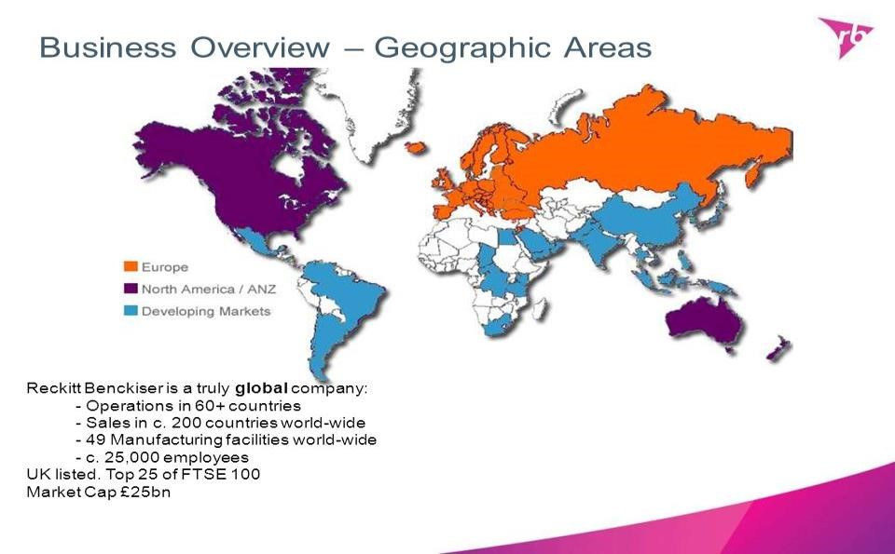
Figure 2: Market domination of RB (Seekingalpha.com, 2022).

Strength factors
First of all, Reckitt has strong goodwill in the market due to its health and hygiene products. The company also owns many successful brands including Harpic, Dettol, Lysol, Clearsil, Vanish etc. These brands are accessible by the middle and upperclass customers that helping the company to reach a large section of the consumer base in its global market (Proactiveinvestors UK, 2022). As a result, the brands have become the house name that facilities gain higher brand equity and goodwill.
Another major strength factor for Reckitt is its economies of scale. As Reckitt has a large number of customers all over the world, it has to produce a high volume of goods and services to satisfy the market demand. As a result, it has to focus on the large production that led to economies of scale (Lubis and Firmansyah, 2021). Such factors significantly as its production cost led to achieving economies of his skill in the production.
Products from Reckitt are also available in 200 countries that provide a strong distribution network throughout the world. The company also has global leadership in multiple categories that lead to the development of top brands across the market (Ding and Li, 2020). Some of its brands are dominating the existing competitive market with a strong brand image.

Besides, it has made many acquisitions in the East Asian and North American markets. This acquisition was possible due to its strong financial ability and focus on the market expansion. Reckitt Benckiser also has a diversified portfolio, strong social responsibility, strategic resources, a skilled workforce, a focus on the market dynamic etc.

Weaknesses of Reckitt Benckiser
Besides having many strength factors, Reckitt has many weaknesses that are expected to hamper the organizational model. In 2017, the company faced severe leadership problems when four of its executives step out of their positions (Naidu, 2022). The simultaneous resignation indicates that the company facing challenges regarding retaining executives and employees.
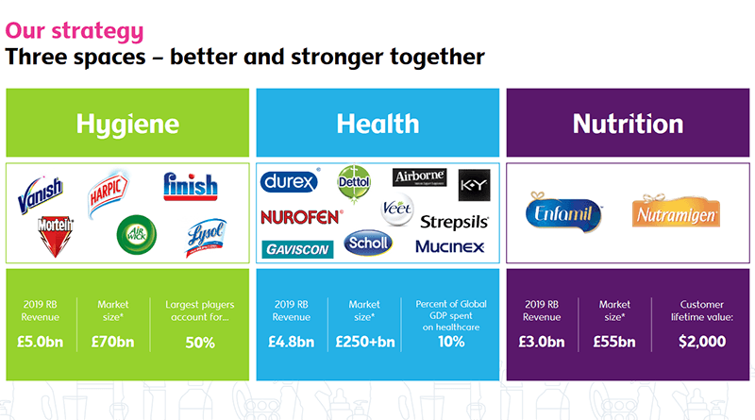
Figure 3: Major brands of RB (Reckitt, 2022)
In some cases, the company is largely dependent on the top 18 brands that contribute more than 40% of its total sale (Naidu, 2022). Dependency is not a good practice as it kind of organizational culture of innovation. Practices may have a long term impact on the competitive position of the company.
As the company Target the middle and the lower-middle-class consumer, it ended up having a lower profit margin that reduce its total profit margin. It had to spend 18 million pounds to take over an infant nitration domain company that may turn out to be a disaster in the company does not have any activities in the infant nutrition. So, these weakness factors may hamper the long term growth of the company.

Opportunities for Reckitt Benckiser
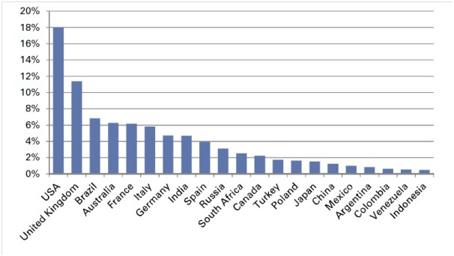
Figure 4: Market share and availability of RB (Ludi Koekemoer, 2020).
One of the major opportunities for the company is to expand its operation to new marketers in the BRIC countries. It can also expand its operation in that countries where the demand for its products is rising rapidly. The consumer income level ultimately provides an opportunity to increase its profit margin (Castia, 2021). Besides focusing on the local countries, it needs to position its brands in the developed countries to increase revenue and profit margin. After the global pandemic, many companies are facing challenges in continuous operations. Reckitt group can take this opportunity and after more businesses expand its global termination (Blais, 2012). Demand for health and hygiene products is rising rapidly that opening new opportunities for the business.

Threats factor
One of the major challenges comes from the increasing domination of its close competitors like Unilever, Procter and Gamble, SmithKline Beecham etc.
As the company's target market is the developing countries; it sometimes faces challenges in maintaining its sales volume as demand in the countries is always uncertain. It also makes a barrier to maintaining stabilized income that imports manager challenges for the business (Baniya and Potts, 2020). Also, the political spectrum of the world is facing changes that may restrict the company from continuing operations in certain parts of the world. The adverse impact from the global pending also suffered its operation and hinder organizational growth.

Porter's Generic value model analysis of Reckitt Benckiser
As part of the internal analysis of the Reckitt group, the value chain model is used to show how the company create value while providing goods and services to the consumers. The model is comprised of two types of activities - primary and supporting activities (Sharma et al., 2020). These activities show how the company add value to inbound logistics and provides product and services to each large consumer Base.
So, the model is described broadly below.
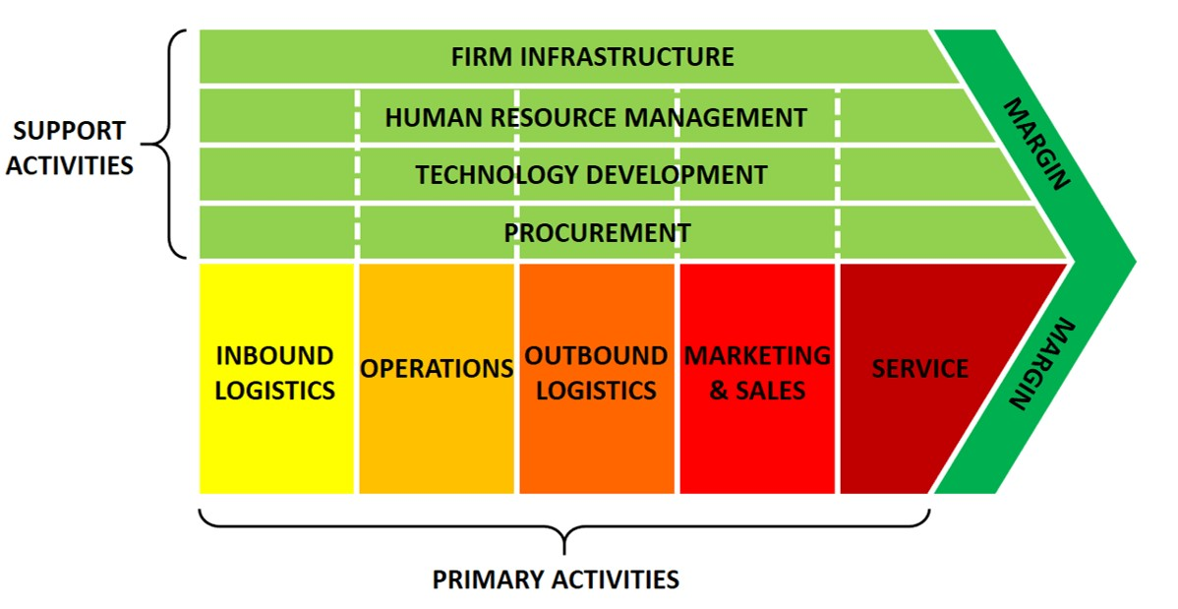
Figure 5: Porter's Generic value model (Wiedemann, 2013).

Primary activities
Primary activities are comprised of fundamental activities that are needed to add value to the organizational process (Tatyana et al., 2020). The primary activities include inbound logistic management, operation, outbound logistic management, marketing and sales, providing post-sale services to the consumers etc.
Inbound logistics: In the case of Reckitt Benckiser, inbound logistics include handling raw materials, warehouse management, supply chain management, inventory data etc. This part of the primary activities enables the company to manage what types of materials are needed to carry out operations, where the particular materials are located. During the global pandemic, the company has suffered in maintaining a supply chain due to disruption and unavailability of raw materials for production (Seekingalpha.com, 2022). That has been a problem with identifying demand and inventory as the market factors have been changing.
Operation: The operational process is conducted to deal with real-time sales and inventory. It also includes identifying the quality of the raw materials, managing organizational factors to start the operation, and a line production with market demand (Tatyana et al., 2020). The primary focus of this step is to produce products that can effectively satisfy the customers.
Outbound logistics: Outbound logistics include the final product that will be delivered to the customers to satisfy their demand. After the operation, it requires proper planning who make the product ready to be delivered to the market. Outbound logistics deal with that delivery procedure to make the products ready to go.
Marketing and sales activities: One of the major steps of this model is marketing and sales activities. It comprised of pricing, communication, promotion, branding etcetera. Reckitt Benckiser has to determine the price of its product (Kotler and Armstrong, 2016). Later on, it has to communicate with the consumers to introduce its product in the market and educate them about the abilities of such products (Proactiveinvestors UK, 2022). Then, it has to promote to make the customer interested and persuade them to buy a particular product. The company has to invest a lot in running these activities that simplify the process of delivering products to the consumers. During the pandemic, it has to increase its investment in marketing as the demand for its health and hygiene products has risen insignificantly (Naidu, 2022).
Services: Services are the last step of the primary activities where the company deliver the order products to the consumer, provides them after-sale services and monitors the market. In the case of Reckitt Benckiser, it has developed delivery points accessible by its large consumer base, providing them with after-sale services to increase the usability of its product. It also communicates with the consumers to develop products that may satisfy them more.

Supporting activities
Supporting activities are focused on supporting the organizational process to add value and deliver products or services to the customers. This type of activity also develops the infrastructure and provides the necessary support to continue its main operation (Kahn, 2011). Supporting activities include firm infrastructure, human resource management, technology development, and procurement.
Reckitt has to manage its employees and collect funds to use as capital. It also has to plan to go with the current market changes. During the pandemic, the company had to bring changes in its planning to allow the employees to work from home (Lubis and Firmansyah, 2021). Changes were necessary to cope with the market dynamics.
It also has to perform human resource management to onboard employees who can conduct operations. The activities of human resource management include onboarding, recruiting, rewarding, training and development etc. Besides, the company has to enhance its organizational development to make a more integrated supply chain and collect market information (Britain, 2014). Cutting edge technologies are also needed to achieve economies of scale and increase operation. Lastly, the company has to keep track of its inventory, communicate with the suppliers, and supply materials for production (Lubis and Firmansyah, 2021). The procurement process has been affected during the pandemic as The supply chain got disrupted.

External analysis
External analysis is conducted to show how various external factors impacted Reckitt Benckiser's operation during the pandemic.

PESTLE analysis of Reckitt Benckiser
Political and economic factors: The political condition has been very uncertain for the last couple of years. Volatile political condition, new political forces, and unstable government has impacted its operation. For example, agreements between Poland and UK stopped free market trade that affected the company in this region (Lubis and Firmansyah, 2021). Like this, governments in many parts of the world have come up with me restrictions to face the COVID inducing a disruption in the trading activities.
Economic factors have also been very volatile. An increase in inflation and interest rate significantly affected it. Consumer spending on goods has been created due to an increase in unemployment and a decrease in job opportunities (Britain, 2014). During the pandemic, people spent only on the necessities that affected his operation. Also, the demand for health and hygiene products increased significantly during this period as people become more about their health. The company also witnessed a boost in its market operation and sales in developing countries.
Social and technological factors: Social factors have harmed the operation of the company. During the pandemic, a large number of people died that decreased its market share and number of consumers. On the other hand, demand for its health and hygiene products has increased due to health consciousness (Kahn, 2011). Customers become more concerned about their health and have focused on hygiene products. Technological factors also create opportunities and challenges for the business. The competitors are using advanced technology for most products creating a comparative disadvantage to the business. But, Reckitt has many other advantages in using social media platforms to attract customers, higher investment for research and development, and strategies to bring technological changes to cope with the current market trend (Blais, 2012).
Legal and environmental factors: During the pandemic, the company had to comply with many legal measures to continue its operation. It has to comply with the health and safety laws, and employment laws. Changes in tax and regulation also bring challenges to the company’s global operations. As the company has a global operation, it has to comply with different types of rules and regulations imposed by various governments (Lubis and Firmansyah, 2021). The rising concern regarding employment laws and workplace conditions also brings challenges for working bankers. Rising concern about environmental degradation is a major challenge for the company. It has to be changed in his production facilities to decrease waste and take a green policy. It also installed technologies to enhance its recycling process and waste management.

Michael porters five forces analysis of Reckitt Benckiser
Five forces analysis is a strategic framework that is used to analyse the present completely the position of a particular company (Baniya and Potts, 2020). Following are the five forces analyses of Reckitt bankers that show how competitive the market is and how the company has been positioning itself.
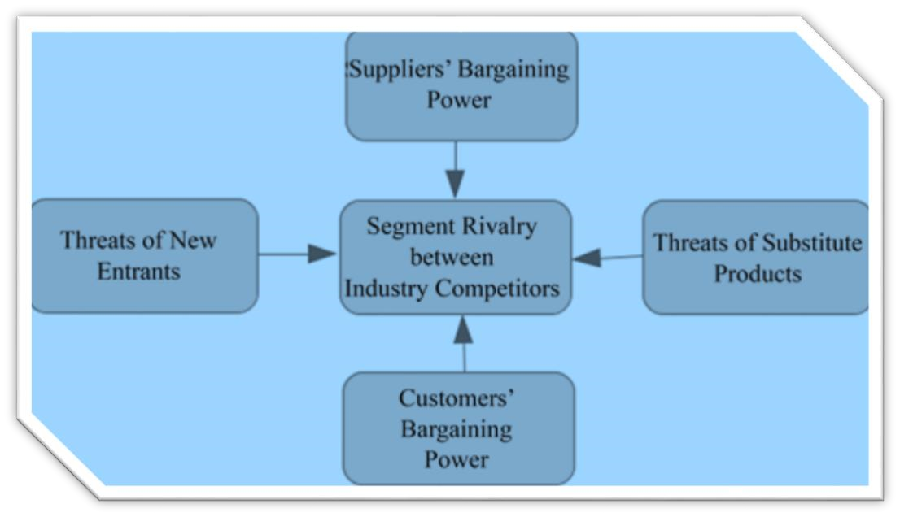
Figure 6: Porter's five forces Model (Britain, 2014).

Competitive rivalry in the market
The degree of competitive rivalry in the market is very high for Reckitt bankers as many competitors offer similar products at a competitive price. The major competitors of Reckitt bankers are Unilever, Procter and Gamble, and Henkel (Proactive investors the UK, 2022). The consumer goods of this company are available at a low cost that creating a low entry barrier for the computers. Some of its competitors have higher markets here with higher revenue. As a result, the market is strongly competitive for Reckitt bankers.

Threats of new entrants and substitution
The threat of new entrants is moderately lower for Reckitt Benckiser as the entry barrier is much higher. The existing companies in the sector are providing goals at a much lower rate that is not possible by new companies (Sharma et al., 2020). The existing companies also achieved economies of scale that helped to reduce production costs. Also, creating a relationship with suppliers and distributors takes more time that will not provide a scope for the new companies to grab market share from the existing players.
The threat of substitutions is also lower as the products offered by these consumer goods companies are necessary for the consumers (Naidu, 2022). Also, there are few alternatives available to them. The companies are providing this product at a reasonable price that will not allow the consumers to move to another product category by paying higher prices. The company is also achieved higher brand loyalty and has a strong brand image that indirectly discouraged the consumers to move to other substitutes.

Bargaining power of buyers
The bargaining power of the consumers is relatively high in the sector as there are many options available to them (Castia, 2021). Consumers can easily choose a product from the other computers that provide similar products at a similar price. Also, there is less product differentiation which makes the process easier for the consumer to choose from other options. The switching cost is also less as they have more information about the market that enables them to take a convenient decision. As a result, the performance of the companies in this sector is significantly influenced by consumer buying decisions.

Bargaining power of suppliers
The bargaining power of suppliers is low because there are a large number of suppliers available to the sector. Companies like Reckitt Benckiser get their supplies, raw materials, and packaging items from various suppliers. The suppliers are also ready to get purchases ordered in bulk quantity Which makes them loyal to their clients. As a result, the consumer goods companies have significant influence by the relationship between suppliers.

The overall impact of COVID-19 on the performance of Reckitt Benckiser
The performance of Reckitt Benckiser has been very volatile during the pandemic period. From the upper analysis, it is now known that the company operate in the health and hygiene sector. During the pandemic, the demand for health and hygiene products increased dramatically which was a blessing for the companies that produce such products.
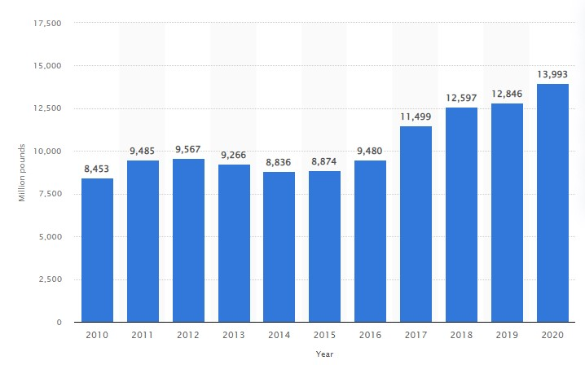
Figure 7: Reckitt Benckiser's net revenue worldwide (Statista, 2022)
According to Statista, the worldwide revenue of the company increased in 2020 while the revenue of its close competitors decreased over the same period (Statista, 2022). In 2019, revenue was 12,846 million pounds which increased to 13,993 million pounds by 2020. The number shows a favourable performance by the company that leads to higher revenue. But, The revenue growth decreases from 2020 to 2021. The major reason for this decrease is the shortage in raw materials and disruption in the supply line (Ding and Li, 2020). The company could not supply as per the demand in the market. Also, the operating cost of the company has increased significantly during that period as the company has to bring changes in its organizational procedure and structure to cope with

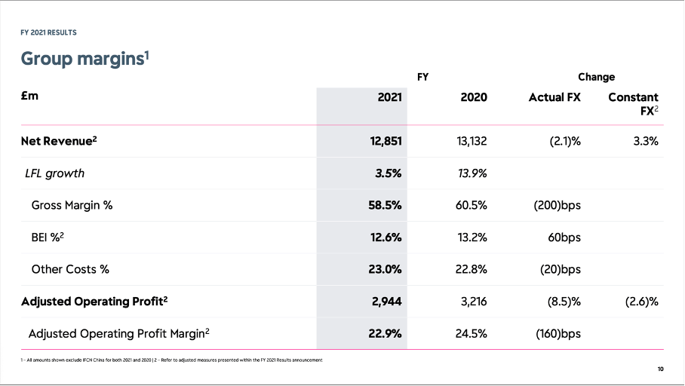

Figure 8: Reckitt Benckiser: Undervalued Stock Meets Improving Business
(Seekingalpha.com, 2022)
COVID disrupted the situation. Its net revenue decreased by almost 300 million. Its LFL growth came down to 3.5% from 13.9%. also, its gross margin decreased to 58.5% in 2021 from 60.5% in 2020 (Seekingalpha.com, 2022). Its adjusting operating profit came down to 2,944 million pounds from $3, 216 million pounds in 2020. So, the pandemic induce sales increase in drama tickets the underlying cost of operation also rose. As a result, the company has suffered to maintain its operating profit growth.

Conclusion
So, every company and business have suffered from the brunt of the corner virus pandemic. The internal and external analysis of Reckitt shows that it has many strong factors that helped it to continue its operation during the pandemic. Duo to operation in the health and hygiene sector has successfully produced and distributed its product to the consumers. The company has also faced challenges during the pandemic from domestic and international factors.

Reference list
Baniya, S. and Potts, L. (2020). Valuing Expertise During the Pandemic. Journal of Business and Technical Communication, 35(1).
Blais, S. (2012). Business analysis: best practices for success. Hoboken, N.J.: Wiley. Britain, G. (2014). Business analysis. Wokingham, Berkshire: Kaplan Pub.
Castia, M. (2021). Reckitt Benckiser’s hygiene growth boosts results. [online] MarketWatch. Available at: https://www.marketwatch.com/story/reckitt-benckisershygiene-growth-boosts-results-2021-04-28.
Ding, A.W. and Li, S. (2020). National response strategies and marketing innovations during the COVID-19 pandemic. Business Horizons, 64(2).
Kahn, K.B. (2011). Product planning essentials. Armonk, N.Y.: M.E. Sharpe.
Kotler, P. and Armstrong, G. (2016). Principles of marketing. 16th ed. Boston:
Pearson.
Lubis, T. and Firmansyah, F. (2021). BUSINESS BEHAVIOR AND BUSINESS
PERFORMANCE OF BATIK ENTREPRENEURS DURING THE COVID PANDEMIC
19. Journal of Business Studies and Mangement Review, 4(2).
Ludi Koekemoer (2020). Marketing communication: an integrated approach.
Claremont, South Africa: Juta.
Naidu, R. (2022). Reckitt sees higher sales and margins as it weathers inflation storm. Reuters. [online] 17 Feb. Available at: https://www.reuters.com/business/retailconsumer/reckitt-quarterly-sales-beat-estimates-boosted-by-hygiene-products-202202-17/#:~:text=Reckitt%20said%20it%20was%20targeting [Accessed 16 Apr. 2022].
Proactive investors UK. (2022). Reckitt reports revenue ahead of expectations and forecasts growth for 2022. [online] Available at:
https://www.proactiveinvestors.co.uk/companies/news/974370/reckitt-reportsrevenue-ahead-of-expectations-and-forecasts-growth-for-2022-974370.html [Accessed 16 Apr. 2022].
Reckitt (2022). Our story l Our heritage l Our future… | reckitt.com. [online] Reckitt.com. Available at: https://www.reckitt.com/newsroom/latestnews/news/2021/february/our-story-l-our-heritage-l-our-future/.
Seekingalpha.com. (2022). Reckitt Benckiser Is Growing - And Not Just Due To COVID-19 (OTCMKTS:RBGLY) | Seeking Alpha. [online] Available at:
https://seekingalpha.com/article/4396825-reckitt-benckiser-is-growing-and-not-justdue-to-covidminus-19 [Accessed 16 Apr. 2022].
Sharma, P., Leung, T.Y., Kingshott, R.P.J., Davcik, N.S. and Cardinali, S. (2020). Managing uncertainty during a global pandemic: An international business perspective. Journal of Business Research, [online] 116. Available at: https://www.sciencedirect.com/science/article/pii/S0148296320303258.
Statista. (2022). Reckitt Benckiser’s net revenue worldwide 2009-2019. [online] Available at: https://www.statista.com/statistics/316953/reckitt-benckiser-s-netrevenue-worldwide/.
Tatyana, Gennady, Tatyana, Yana and Aelita (2020). Performance of Credit Obligations by Business Entities during the COVID-19 Pandemic. International Journal of Economics and Business Administration, VIII(Issue 4).
Wiedemann, L. (2013). Business strategies and value chain management.
Authorhouse.

