

L7: Data Security, Governance and Compliance
(ACCA7028)

Apply the Principles of Data Security, Governance and Compliance to a Given Scenario

MSc Data and Artificial Intelligence

Wales Institute for Science and Art (WISA)
University of Wales Trinity Saint David

January 3th, 2022

Contents:

1. Introduction 3
2. Frameworks and Models 3
2.1 ITIL 3
2.1.1 The development of the ITIL 3
2.1.2 Theoretical framework of ITIL 3
2.2 ISO27000 series standard system 5
2.2.1 ISO27000 content framework analysis 5
2.2.2 ISO27000 series standard system evaluation 5
2.3 PDRR 6
2.3.1 PDRR framework 6
2.3.2 PDRR model evaluation 7
2.4 PDCA 7
2.4.1 PDCA framework 7
2.4.2 PDCA model evaluation 8
3. CoffeeBlue Information security management system construction 8
3.1 System Design 8
3.2 Risk Assessment 9
3.3 Risk Management 10
3.4 Risk Test 12
3.5 Solution Improvement 12
3.6 Contingencies Planning 13
3.7 Strengthen the training of information security personnel 14
4. Conclusion 15
Reference list 16

1. Introduction
In recent years, with the continuous advancement of enterprise informatization, enterprise information security incidents have occurred frequently, which has brought huge security risks to the normal operation of enterprises. Nowadays, enterprises pay more and more attention to information security, and information security risk management has also become a focus of enterprise information security management. Therefore, the importance of research in this field cannot be ignored.

2. Frameworks and Models
2.1 ITIL
2.1.1 The development of the ITIL
The first ITIL concept was developed by the Central Computer and Telecommunications Agency in 1980. The primary purpose at the time was to adapt to the growing dependence of business needs on IT and align IT with business goals, but the industry slowly found its usefulness and generated a set of ITIL best practices. The real mass adoption came with the release of ITIL Version 2 in 2001, which focused on the process-based practice of IT service management, matching different aspects of IT management, applications and services. Since then, the practice has been adopted by a large number of enterprises as the primary reference standard for IT service management, and is slowly being regarded as the "de facto standard" for global IT service management.

2.1.2 Theoretical framework of ITIL
The core of ITIL theoretical framework[1] is composed of two parts: service support and service provision, each containing five management processes.
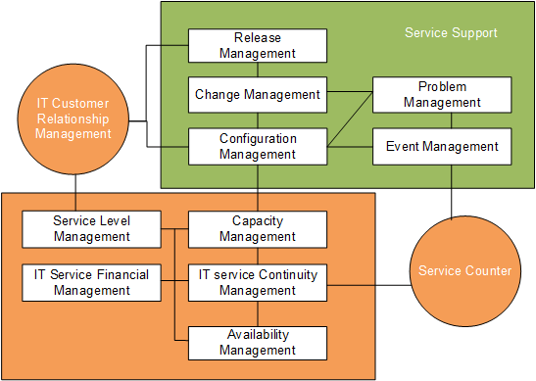
FIG. 1 ITIL Theoretical Framework
Among ITIL's 10 management processes, the five major processes in the service support section are the core processes frequently used in operation and maintenance management.
(1) Release management is the process of packaging and releasing the code that has passed the user test from the test environment to the production environment and formally providing services to users. It is the specific implementation and delivery of changes.
(2) Change management covers all changes related to IT resources, such as software version release, patch repair, storage expansion, hardware maintenance, etc.
(3) Configuration management is the core component of the whole ITIL theoretical framework, usually in the form of CMDB to manage the IT resources in the entire organization, IT registers the basic information of these resources and the association between resources, and changes, events and other processes interact closely.
(4) Problem management focuses on discovering and solving root problems and improving IT infrastructure to improve services and reduce the number of incidents.
(5) Event management is a process of responding to, analyzing, processing and filing all the events reported by users or obtained by monitoring means that have or will have adverse effects on IT business system.

2.2 ISO27000 series standard system
2.2.1 ISO27000 content framework analysis
ISO27001 standard is based on the PDCA cycle of continuous improvement of the original, the information security management work is decomposed into risk assessment, safety design and implementation, safety inspection and reassessment of four processes. The standard emphasizes the importance of risk management for information security work, put forward the enterprise risk assessment are needed to determine the risk points, refine risk control method, and the risk points to design information security work, strengthen management, through the improvement to eliminate risk, and then evaluate enterprise risk spiral way to continuously improve enterprise's information security situation, improve the management level. For more details see [2], [3].
The standard puts forward the main steps of information security management as follows:
- Define information security policies
- Define the scope of information security operation and maintenance
- Information security risk assessment
- Information security risk management
- Determine risk management objectives and countermeasures.
- Information Security Statement

2.2.2 ISO27000 series standard system evaluation
As one of the most important files in ISO27000 standard family ISO27001 began to be implemented in 2013, and improve the positioning of the standard. Compared with the 2005 version, it is more standardized and flexible in terms of framework, structure, content, logic and requirements. And the content is also more close to life, but also relatively strong operation:
(1) Complete structure
It's much better structured than the 2005 version. Mainly to the three chapters after the adjustment, including planning, operation, inspection and improvement.
(2) Flexible positioning
In the information security management, the old version of the management is used to carry out information security management, in the new version, is by the highest manager to carry out information security management, positioning will be more flexible.
(3) Comprehensive coverage
ISO27001 in 2005 version of the 11 control domain, there are 133 control elements, there are 39 security categories, in 2013, the version of the innovation, add control domain, delete individual security categories and control elements, named ISO27002. This version has 14 control domains, 113 control requirements, and 35 security categories.

2.3 PDRR
2.3.1 PDRR framework
PDRR model is a mature network security model [4], which consists of protection, Detection, Response and Recovery, and constitutes a dynamic information security cycle.
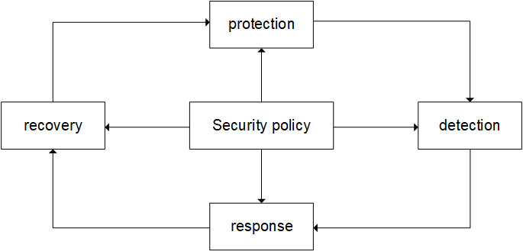
FIG. 2 PDRR model

2.3.2 PDRR model evaluation
PDRR model emphasizes the final form or result of information security and belongs to the goal-oriented system model, but it does not pay attention to the process of system construction and the way and method to achieve the goal. In addition, the model focuses on technical factors and ignores management factors.

2.4 PDCA
2.4.1 PDCA framework
PDCA model is an improvement on PDRR model as shown in [5], consisting of Plan, Do, Check and Action. The basic structure is shown in the figure below.
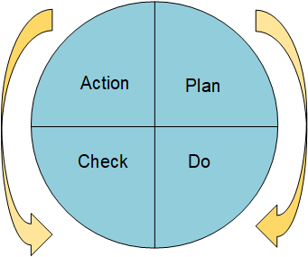
FIG. 3 PDCA model
The model emphasizes that at each stage of P, D, C and A, the principle of PDCA is carried out in accordance with the principle of PDCA, forming A virtuous cycle of big ring setting small ring and small ring pushing big ring, so as to achieve the purpose of continuous improvement.
PDCA cycle, also called quality cycle, is a general model in management. The cycle was first conceived by Walter A. Shewhart in 1930. In 1950, Dr. Edwards Deming, an American quality management expert, re-proposed the PDCA improvement cycle and applied it in the process of continuously improving product quality. Later, PDCA cycle is widely used in all walks of life, not only has a great impact on industrial production, but also become an important idea to guide enterprise management.

2.4.2 PDCA model evaluation
In the PDCA cycle, the whole enterprise, enterprise internal departments at all levels, and even everyone turn around the overall goal of the risk control, through the loop makes each work organically combined, synergy and promote each other, avoid the independent individual, individual departments and individual steps become islands of information security risk management, which leads to cannot produce synergies between each other. Therefore, Task2 will use PDCA cycle model to build CoffeeBlue information security management system.

3. CoffeeBlue Information security management system construction
3.1 System Design
Based on the research of the framework and model in Task1, the design scheme of CoffeeBlue information security risk management system is proposed. The system is a closed-loop management system with risk assessment, risk treatment, risk inspection, scheme improvement and emergency plan as the basic contents. The framework of the system is shown in the figure.
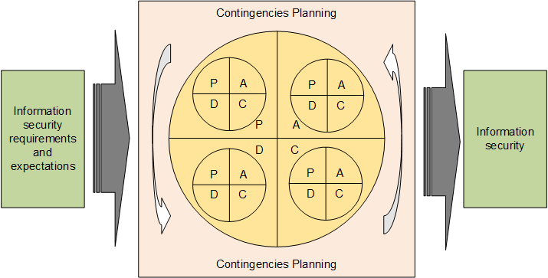
FIG. 4 Information security risk management system framework of CoffeeBlue Company
CoffeeBlue detects and evaluates vulnerabilities and threats of information assets in P stage to realize risk detection and evaluation and judge whether security requirements are met. Design and implement the solution in phase D based on security requirements and risk assessment results. In phase C, on the one hand, the solution of the previous phase is monitored and reviewed for effectiveness; On the other hand, determine whether there are new changes, including changes in business, organizational structure, goals, systems, technology platforms, policies and standards, etc. In stage A, the scheme is improved according to the inspection results to meet the information security needs and expectations.
The system emphasizes that each stage of P, D, C and A are carried out in accordance with the principle of PDCA cycle, that is, several small cycles are carried out in A large cycle at the same time, so as to cycle dynamically and continuously improve the level of risk detection and assessment.
Risk emergency plan is the internal protection mechanism of the closed-loop system, and it is the concrete improvement of PDCA cycle management theory applied to information security risk management. Even if the effective risk assessment, treatment, inspection and program improvement measures can not completely avoid information security accidents, therefore, it is necessary to treat the possibility of information security accidents rationally. Through the perfect risk emergency plan, the correct use of risk emergency plan, quickly and effectively respond to information security accidents. Risk emergency plan is a necessary part of information security risk management system.

3.2 Risk Assessment
Risk assessment belongs to the Plan part of the risk management system. Information security risk management relies on the results of risk assessment to determine the subsequent risk treatment plan and approve supervision activities. Risk assessment enables CoffeeBlue to accurately target risk management strategies, practices and tools, to focus security activities on important issues, and to select cost-effective and appropriate security countermeasures.
According to different evaluation stages and backgrounds [6], formulate corresponding evaluation programs, including evaluation scope, evaluation method, data collection, evaluation standard and safety assurance degree, participants, work flow, schedule, budget and other important contents. In addition, evaluation programs should be adapted to requirements, laws and regulations, while taking into account both effectiveness and efficiency.
Threats include situations, events, or people that could result in data leakage or tampering, system sabotage, or denial of service. That is, the threat could be a specific environmental condition, such as flood, fire, earthquake, or an event, such as a system change, or a human-made threat, such as a hacker.
Risk assessment methods are widely studied by scholars at home and abroad. Various effective risk assessment methods, such as flow chart method, environmental analysis method, decomposition analysis method, financial statement analysis method, wavelet neural method, information entropy theory method and so on, have been proposed by scholars.

3.3 Risk Management
Risk treatment belongs to Do link of risk management system, namely implementation link. When dealing with risks, we should first classify risks according to the results of risk assessment and the negative impact of risks. Secondly, according to the risk level and risk level demand, clear risk treatment objectives. Finally, choose the treatment method for risk treatment.
According to the hierarchical protection principle of information security management, the risk assessment results are graded. Risk levels can generally be divided into five levels, as shown in the following table.
Table 1 Risk grade table
Risk level | Mark | Describe
1 | highest | Without any risk control measures, the occurrence of risks will have serious negative economic/social impacts.
2 | higher | Risk control is random and decentralized, without complete control strategies and processes, and without institutional norms, the occurrence of risks will have a great economic/ social impact.
3 | medium | Comprehensive risk management and control, but lack of effective methods, or absence of safety responsibilities, risk occurrence will have a certain economic/social negative impact.
4 | lower | Carry out relatively comprehensive risk control measures, clarify information security risk management responsibilities, take effective management methods, the economic/social negative impact of risk occurrence is low.
5 | lowest | Information security risk management system is sound, comprehensive control, effective methods, measurable and audit, risk occurrence of economic/social negative impact is very small.
Develop risk treatment plan according to risk grade, risk acceptability and risk management objectives. Risk treatment methods mainly include:
- Risk appetite
- Risk aversion
- diversification
- Risk shifting

3.4 Risk Test
Risk inspection belongs to the Check link of the risk management system. Risk testing is the monitoring and assessment of the risk management process in accordance with the policy, objectives and risk management requirements, and the reporting of the inspection results. The purpose of risk testing is to strengthen, modify and improve the identified and implemented safety programs to ensure that control measures are operating effectively and in accordance with expectations.
Risk testing is mainly carried out from three aspects, one is to test whether the planned treatment plan is strictly implemented in the process of risk treatment; Second, check whether the results of plan implementation meet expectations and whether the quality of risk treatment meets the requirements of the standard; Third, whether actual conditions have changed. If the risk situation deviates, the reason for the deviation must be analyzed in time and countermeasures should be taken.
The following situations generally occur in risk testing:
(1) The risk treatment effect reaches the established goal and the risk treatment scheme is feasible;
(2) The risk treatment effect has not reached the established goal, and the risk treatment plan needs to be improved;
(3) Risk analysis should be conducted in case of significant changes or new risks, and risk assessment should be conducted immediately if necessary;
(4) Trigger the emergency mechanism when an emergency risk occurs.

3.5 Solution Improvement
Program improvement belongs to the Action link of the risk management system, that is, the Action link. Program improvement is based on the work results and experience of the first three parts of this cycle to make improvement decisions to improve risk control. The basic principle is to continue to maintain effective safety control and improve inappropriate control measures. This stage reflects the inherent advantage of dynamic improvement of PDCA model.
After entering this stage of a cycle, information security risk assessment, treatment and inspection scheme should be improved by integrating information security objectives of the organization, information security risk management policy, risk treatment and inspection results, risk monitoring and analysis and risk prevention measures. The successful experience should be affirmed, and part of the method process should be standardized, and the lessons of failure should be summed up to accumulate experience for the next cycle. The next PDCA cycle will continue to solve unsolved problems, and so the cycle goes up, optimizing and improving.
In the information security risk management system based on PDCA cycle, the improvement stage is not the end, but to put forward practical improvement plan, and on this basis, after this stage into the next cycle, promote and promote the benign operation of the information security risk management system. Therefore, the program improvement stage not only plays a summary role, but also plays an important role of cohesion and promotion.

3.6 Contingencies Planning
Emergency plan is an emergency handling mechanism for special events and emergencies. Since the use of the most perfect risk management system and the best risk management methods cannot completely resist risks and avoid information security accidents, CoffeeBlue also needs a mature mechanism to deal with information security accidents in addition to dealing with information security risks to avoid security accidents. Emergency mechanism includes emergency plan, emergency rules, emergency procedures, emergency drills and so on.
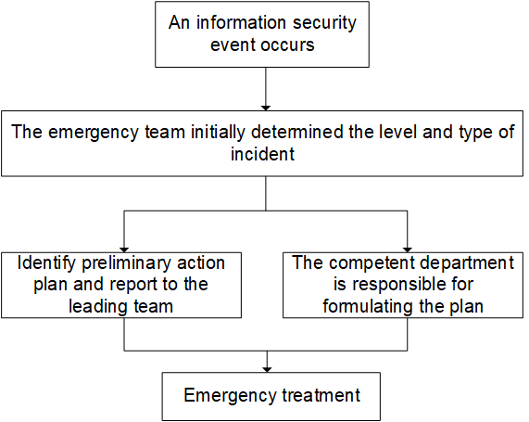
FIG. 5 Emergency processing flow of major information security accidents
The emergency mechanism goes beyond emergency response to include follow-up work. CoffeeBlue shall immediately organize the relevant personnel to form an incident investigation team, collect the data, identify the cause and conduct a comprehensive analysis of the incident handling process. CoffeeBlue should also count the property losses, assess the impact of the accident, analyze the recovery and reconstruction capacity, formulate recovery plans and organize their implementation.
Emergency planning involves planning, processes and technical measures, as well as advocacy training and emergency exercises. Establish an emergency team before the occurrence of a safety accident, consider emergency needs, formulate basic emergency plans, do a good job in technical reserve and support, and keep emergency documents, software and equipment. Be able to deal with safety incidents effectively once they happen. When the accident is properly handled, a comprehensive investigation of the relevant system, make accident analysis report and summary report, avoid similar accidents to happen again, improve the information security risk management level of telecom operators, so as to improve the information security level.

3.7 Strengthen the training of information security personnel
Having high-quality professional information security personnel is the core driving force to promote information security risk management. For more details see [7]. At present, there is still a lack of professional talents in the field of information security. CoffeeBlue should strengthen the talent reserve of information security and cultivate professional talents. Should not only master the basic theory and professional knowledge of information security field, but also master the methods and skills related to information security, and understand the development frontier of information security technology. The training of information security talents should not only pay attention to the professional technical ability of talents, but also pay attention to the management level and innovation ability of talents. The information security talent team with excellent comprehensive ability is the key to deal with the complex and changeable information security risks, and also the key to improve the overall management level of CoffeeBlue.

4. Conclusion
Firstly, this paper studies the information security standard system and model, including ITIL, ISO27000 series, PDRR, PDCA. Their system framework and advantages and disadvantages are studied, which lays a foundation for CoffeeBlue to build information security risk management system.
Secondly, the CoffeeBlue information security risk management system based on PDCA cycle constructed in this paper is a scientific system that meets the needs of CoffeeBlue risk management. The main contents of this system are risk assessment, risk treatment, risk inspection, scheme improvement and contingencies planning. Contingencies plan is not a part of PDCA cycle model, but it plays an important role in the cycle system and is the last protection mechanism to ensure information security. Risk management is to avoid information security accidents through risk management, contingencies planning is in the information security accident before the occurrence of the assumption that the accident has occurred and developed a set of protection mechanism, in order to reduce the harm of the accident.
Reference list

- E. Yamami, K. Mansouri, M. Qbadou, E. H. Illoussamen. “Introducing ITIL Framework in Small Enterprises: Tailoring ITSM Practices to the Size of Company,” International Journal of Information Technologies and Systems Approach, vol. 12, no. 1, pp. 19, 2019.
- K. C. Lee, C. H. Hsieh, L. J. Wei, C. H. Mao, J. H. Dai, Y. T. Kuang. “Sec-Buzzer: cyber security emerging topic mining with open threat intelligence retrieval and timeline event annotation,” Soft Computing, vol. 21, no. 11, pp. 2883-2896, June. 2017.
- J. Shin, H. Son, R. Khalil ur, G. Heo. “Development of a cyber security risk model using Bayesian networks,” Reliability Engineering & System Safety, vol. 134, no. 14, pp. 208-217, Feb. 2015.
- S. B. Xing, H. F. Xue, G. Li. “Honeypot Protection Detection Response Recovery Model for Information Security Management Policy,” Asian Social Science, vol. 6, no. 12, pp.50, Dec. 2010.
- R. L. Mendell, “Using the Common Criteria for IT Security Evaluation,” Security Management, vol. 48, no. 11. American Society for Industrial Security, Arlington, p. 108, 2004.
- O. T. Arogundade, A. Abayomi-Alli, S. Misra. “An Ontology-Based Security Risk Management Model for Information Systems,” Arabian Journal for Science and Engineering, vol. 45, no. 8, April. 2020.
- A. M. Y. Chu, M. K. P. So. “Organizational Information Security Management for Sustainable Information Systems: An Unethical Employee Information Security Behavior Perspective,” Sustainability, vol. 12, no. 8, pp. 3163, April. 2020.

marking criteria and Student FEEDBACK

This section details the assessment criteria. The extent to which these are demonstrated by you determines your mark. The marks available for each criterion are shown. Lecturers will use the space provided to comment on the achievement of the task(s), including those areas in which you have performed well and areas that would benefit from development/improvement.

Common Assessment Criteria Applied (Assignment 1) | Marks available | Marks  awarded
1. Engagement with Literature Skills
Extent of research and/or own reading, selection of credible sources, application of appropriate referencing conventions.
You have engaged with the literature/research aspect. However, some areas could be more referenced. Key concept discussed. (Grade mark: 73.33%) | 15 | 11
2. Knowledge and Understanding Skills
Extent of knowledge and understanding of concepts and underlying principles associated with the discipline.
You have demonstrated understanding of the research. (Grade mark: 73.33%) | 15 | 11
3. Cognitive and Intellectual Skills
Analysis, evaluation and synthesis; logic, argument and judgement; analytical reflection; organisation of ideas and evidence
Your discussion incorporates the case study and research aspect. Your conclusion can be improved; it should summarise your key areas of the report and conclude with the relation to case study. Future work would be good as well. (Grade mark: 75.00%) | 40 | 30
4. Practical Application Skills
Deployment of methods, materials, tools and techniques; application of concepts; formulation of innovative and creative solutions to solve problems.
You have design and explain the security framework design. Other tables and figures were done but you need to number and name them. (Grade mark: 80.00%) | 20 | 16
5. Transferable Skills for Life and Professional Practice
Attributes in professional practice: individual and collaborative working; deployment of appropriate media; presentation and organisation.
Your work is presentable and flow. (Grade mark: 70.00%) | 10 | 7

Assignment Mark (Assessment marks are subject to ratification at the Exam Board. These comments and marks are to give feedback on module work and are for guidance only until they are confirmed. ) | Late Submission Penalties (tick if appropriate) |  | 75%
 | Up to four weeks late |  | 75%
 | First Attempt? |  | 75%

