By Kyle Ramcke P150658

STRATEGIC MANAGEMENT
A REPORT ANALYSING THE COMPETATIVE STRATEGY ADIDAS HAS IMPLEMENTED

TABLE OF CONTENTS

1 EXECUTIVE SUMMARY 4
2 INTRODUCTION 5
2.1 REPORT REMIT 5
2.2 DEFINING STRATEGY 5
2.3 BRIEF HISTORY OF ADIDAS 6
3 MAIN BODY 6
3.1 PORTERS GENERIC STRATEGIES 6
3.1.1 COST LEADERSHIP 7
3.1.2 DIFFERENTIATION 7
3.1.3 STRENGTHS AND WEAKNESSES 8
3.2 ADIDAS’S STRATEGIC CHOICES 9
3.2.1 SPEED – HOW ADIDAS WILL DELIVER 9
3.2.2 CITIES- WHERE ADIDAS WILL DELIVER 10
3.2.3 OPEN SOURCE- HOW ADIDAS WILL CREATE 10
3.3 ACCELERATORS FOR STRATEGY 11
3.3.1 REVIEWING PORTFOLIO 11
3.3.2 IMPOROVING POSITION IN NORTH AMERICA 11
3.3.3 ONE ADIDAS 11
3.3.4 DIGITAL 11
4 CONCLUSION 12
5 RECCOMENDATIONS 12
6 REFERENCE LIST 12
7 BIBLIOGRAPHY 14
8 LIST OF FIGURES 17
8.1 FIGURE 1 17
8.2 FIGURE 2 17
8.3 FIGURE 3 17

EXECUTIVE SUMMARY
The purpose of this report is to firstly define what strategy and the subcategories of strategy are. This will support in recognising what strategic approach Adidas has taken to gain competitive advantage. The report will analyse this approach identifying in detail the actions Adidas have taken to incorporate the strategy. Additionally, critically evaluating the choices the organisation has made with reference to leading strategy theorists and market leading professionals.
Adidas is a multinational organisation whose primary focus is manufacturing sporting footwear, apparel, accessories and hardware. Adidas operate in 75 countries hiring over 57,000 employees across 6 continents. Due to their globalisation, Adidas are the largest manufacturing company in Europe and second in the world turning over 21 billion U.S dollars worldwide.
The report has referred to Porter’s generic strategies which assists in analysing the business strategy Adidas has executed. The generic strategies consist two distinctions; differentiation and cost leadership. It measures an organisation grasp of business from narrow to broad with insight into how each process can attain competitive advantage. Adidas used differentiation strategy and focuses on niche markets within the sporting industry to create new trends in specific geographical locations. Although the theory suggests to logically recognise Adidas’s strategy, there are criticisms of the theory which provoke questions. It’s also suggested that cost leadership is merely a status of an organisations position in the market. Companies can also opt to lower costs after differentiating their products without intending to claim back investment costs (Hooley. G, Piercy. N. F and Nicoulaud. B 2012).
Adidas have chosen to sub categorise their strategic blueprint into three channels; speed, cities and open source. Speed associates with the organisations resolve to improve manufacturing systems which will result in getting the product to the customer significantly faster. The reduction of time would also be cost effective. The company hopes to focus on six cities initially which will act as launch pads for promoting new product ranges. London, Paris, Shanghai, Tokyo, New York and Los Angeles. Adidas hopes to capitalise on emerging trends in these locations which will send shockwaves throughout social media platforms. Open source initiates the company’s collaborative and innovation incentives to lead the market through diversification.

INTRODUCTION

REPORT REMIT
The purpose of this report is to identify the competitive strategy adidas has implemented to advance their position amongst their competitors. The specifications of this chosen strategy will be dissected and analysed to outline the requirements for this strategy to be achieved. The report will also offer a critical analysis of adidas’s competitive strategy which will highlight any advantages or disadvantages which could be instrumental in the success given the current business environment. Based on the analysis of the strategy imposed by adidas, this report aims to offer future recommendations which can be advantageous for adidas in their competitive market and progress as a company.

DEFINING STRATEGY
There have been many offers to define strategy by respected strategy theorists such as Alfred chandler of Harvard business school and henry Mintzberg of McGill university, who describe imperative elements of strategy differently. Chandler proclaims strategy is “the definition of the long-run goals and objectives of an enterprise and the adoption of courses of action and the allocation of resources necessary for carrying out these goals” (Alfred. D and Chandler Jr (1969). Mintzberg offers a more ephemeral definition stating it as “A pattern in a stream of decisions” (Mintzberg. H (2007).
Strategy can consist of various sub-categories which organisations may Implement internally. Corporate level strategy is the comprehensive view of an organisation underlining the organisations primary purpose, goals and objectives. Corporate level strategy requires a consistent communication of decision making throughout all branches of the business which may have specific individual strategies. Corporate level strategy would summarise the importance of every department outlining the vision statement and mission statement of the organisation and what direction them decisions will take the company (Weaver. J 2018).
Business level strategy aim to implement specific strategy based various subdivisions within the organisation. The strategy would aim to conclude a plan of action on how to approach the market in which the divisions products or services are placed. Business level strategy would evaluate the competitive approach the organisation should take to further develop their market positioning.
(West. D, Ford. J and Ibrahim. E 2010).
Functional strategy involves the direction which functional departments of an organisation would intend to improve efficiency and resources. The functional strategies would be overshadowed by the business level and corporate level strategies of an organisation, focusing primarily on activities which improve performance. This strategy would entail the decision-making process of outsourcing these activities or conducting them internally (Gleeson. P, 2018).

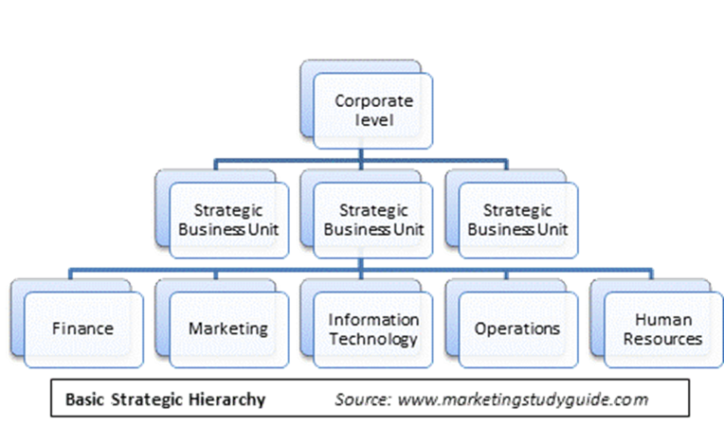

FIGURE 1

BRIEF HISTORY OF ADIDAS
Adidas was first founded by Adolf “Adi” Dassler in Herzogenaurach, Germany in 1949 where the company’s headquarters are based. Adidas are long term partners with the Olympic games stemming back to when Adolf partnered with brother Rudolf in establishing a shoe company whom gained tremendous success after sponsoring an Olympic winning medallist wearing their revolutionary studded boots. A family dispute separated the brothers during world war two which resulted in Adi creating Adidas and Rudolf creating Ruda which changed to Puma shortly after (Success Story 2018).
Today Adidas is the largest manufacturing company in Europe and second in the world, specialising in foot ware, activewear, accessories and hardware. The company is highly regarded as a leader in their market, generating net sales of 21.2 billion US dollars worldwide. Adidas employs over 57,000 people across the globe with the multinational corporation trading with Reebok, Taylor made and Runtastic united within the Adidas group. The company produced of 403 million pairs of footwear and 404 million sporting garments across the world in 2017 which emphasises their strong branding in today’s market. The companies strapline is “Impossible is Nothing” which salutes their collaboration with leading sport figures and teams. Adidas boasts a loyal customer base worldwide most notably in north America with over 40 percent of U.S population using Adidas as their choice of brand (Statista 2017).

MAIN BODY

PORTERS GENERIC STRATEGIES
Harvard business professor Michael Porter concluded that businesses could achieve competitive advantage by implementing four generic strategies. Competitive advantage is when a company achieves higher profits than their competitors often through differentiating their products to offer more value to customers, or by leading costing. These strategies measure the scope of an organisation, contrasting either broad or narrow focused markets with the intention to differentiate its products or services in a competitive market. Differentiation comprises an organisation creating a unique difference within the product or service of their offer resulting in the customer identifying added value. An organisation can implement differentiation in several ways from design, technology to customer service (Johnson. G 2017).
By gaining a competitive advantage, customers will identify superior value and quality of products or services an organisation offers. Organisations who attempt to adopt more than one of Porter’s generic strategies could find themselves in what is referred to as strategic wilderness. This is when a company is attempting to bind characteristics of one strategy into another which can be extremely detrimental to the success otherwise achieve by opting for one alone.

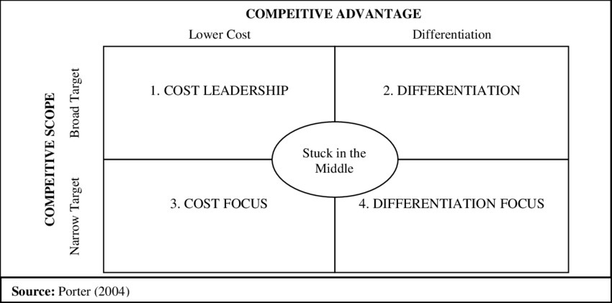

FIGURE 2

COST LEADERSHIP
This strategy focuses on high volume sales for low costing products. The lower costs create competitive advantage by increased sales offering similar products for cheaper prices. There are four significant cost drivers which ensure cost leadership is accomplished; input costs, economies of scale, experience and product. Companies would be at a risk of being undercut by competition. Unless a company is achieving the cheapest market prices, achieving cost leadership, being second cheapest would be considered a disadvantage. Products would be produced in the cheapest manner if profitability is to be achieved. Furthermore, the quality of products or services ought not to be entirely overlooked as there is a standard required for customers to recognise value (Thompson. J and Martin. F 2010).

DIFFERENTIATION
Adidas uses differentiation focus by targeting large markets and achieve significant economies of scale. Adidas use innovative methods to differentiate from their competition, investing largely in technological advances in performance equipment, foot ware, clothing and hardware. Adidas’s product positioning is tailored to the match the geographical distribution and collaborate with leading sport athletes and musicians to target their demographics. Customers relate to the brand through inspiration and remain loyal to the brand which enables Adidas to request premium prices for their products. Customers would in turn, received added value through leading technology, design and performance enhancement (Basin. H (2017).
For adidas to achieve high market share and maintain their competitive advantage, investments to innovate would need to be consistent. Durability throughout the production and distribution processes are necessary to prevent competitors gaining advantages. If investments were to subside, other organisations applying the differentiation focus strategy would inevitably capitalise. Adidas would need to be aware of the risks of taking innovation too far beyond what their demographics can comprehend. Introducing new and exciting elements of products can gain many new customers but can also lose customers if the modernisations are too bold or difficult to conceive. This approach is extremely expensive for an organisation to take as it requires significant investment in manufacturing, research, data analysis, marketing and globalisation on a consistent basis. This would elevate adidas brand recognition and reputation creating more loyal customers which may relieve this concern (Thompson. J and Martin. F 2010).

STRENGTHS AND WEAKNESSES
Although Porters generic strategies have encompassed business models ever since its introduction, there have been companies who have achieved success by adopting more than one such as Japanese zip manufacturer combining cost leadership and differentiation. This contradiction questions the validity of Porter’s claim. The theory is also challenged by John Hendry who explains cost leadership is more describing of a company’s position amongst its competitors in the shared market instead of a strategy. Management would take accountability for the companies costing but remaining different at the same time (Asch. D and Bowman. C 1989).
Differentiations assignment is to add value to the product, but companies may have to recover costs through premium pricing. A corporation may choose to lower their prices and loose the costs required from differentiation to gain wider customer base. The theory doesn’t consider the implications of revolutionary technologies which are transforming the industries landscape which questions the narrow and broad focus aspect of the generic strategies. For Adidas, their “creating the new” campaign aims to identify emerging niches instantaneously which could differ to the scope measured by Porter’s generic strategies. (Adams- McIntosh. K 2017)

ADIDAS’S STRATEGIC CHOICES
On Thursday 26th March 2015, Adidas unveiled to investors their five-year corporate strategy business plan which culminates in 2020. Part of the blueprint saw Kasper Rorsted installed as new CEO to further push the strategy, referred to as ‘Creating the new’ which aims to achieve unprecedented growth in both top line and bottom line. Adidas hopes to increase brand desirability by using three key strategic choices; Speed, Cities and open source. By focusing on these strategic choices, adidas hopes to experience high single digit growth per annum which is in comparison to the figures released in 2015. The choices are induced to emphasis brand desirability (Adidas 2018).

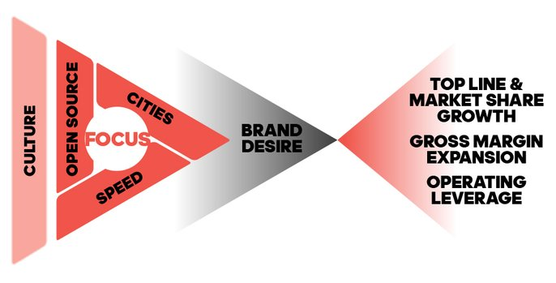
FIGURE 3

SPEED – HOW ADIDAS WILL DELIVER
Speed outlines how Adidas will deliver their product to market. Customers being at the forefront of the organisations focus, Adidas aspires to reduce production time which will allow the product to be distributed faster, making products more accessible. This choice is developed from an active incentive named ‘neo’ which is has been in effect since 2016. Adidas hopes to develop this concept across all segments of business allowing customers to be exposed to various new products and experience renewed interest and brand recognition. Competition would be oppressed by this innovative approach stimulating increased sales revenues. Stock management would improve by the reduction of over manufacturing different products specified for time frames. Products will be more relevant to the customers wants and desires. There will be less emphasis on sale periods where the company would look to offset stock at a cheaper price, resulting in more products sold at full price (Adidas 2018).
Adidas’s speed notion is projected across all market segments in three different fundamentals which comprise products never being out of stock. Customers will always be able to have access to their desired garments. Production speeds improving result in stock replenishment when required.
Planned responsiveness underlines the businesses used of data acquired from previous time frame which contrast with seasonal trends. By using data Adidas can forecast supply and demand and release products during seasons.
In season creation of products allows Adidas to adapt to trends in the market by developing products later in the seasons. The company can gain advantage over is competitors and drive customer desire for more appropriate products. By using the speed initiative, Adidas has experienced change across the whole business since its introduction. This element of strategy will compliment other elements as progression continues.

CITIES- WHERE ADIDAS WILL DELIVER
Most of the world’s population are situated in major cities across the world which coincides with these cities influencing the worlds gross domestic products (GDP). Adidas focuses on six cities to launch new products using customers experiences as a promotion for brand recognition on social media platforms. London, Paris, New York, Los Angeles, Tokyo and Shanghai are the organisations initial focal locations with the possibility to extent to other major cities. Since shifting geographical focuses from countries to cities, adidas has been able to pinpoint trends relating to cultures and environment. This component promotes intimacy with its customers and trends, gaining advantage on competition by being at the source of innovation, impacting global markets effectively.
The city emphasis aims to bring the brand to the door step of customer activities using additional preferences to the sporting environments within the cities. As an example, Adidas collaborated with the U.S soccer foundation and New York City football club which will create 50 soccer fields in underprivileges districts throughout the duration of Adidas’s five-year corporate strategy business plan.
In 2016 adidas launched new exclusive product lines Ultraboost, Uncaged Parley and Alexander wang x adidas originals collections which were strategically released in the six cities of focus. These successes have required heavy marketing investments and distribution developments. (Stork. U, Kubis. N and Kleiner. A 2018).

OPEN SOURCE- HOW ADIDAS WILL CREATE
Adidas aspires to create closer relationships with customers and celebrity ambassadors. Collaborations and efforts to Innovate will become paramount for the success of the strategy executed. Adidas will have to appreciate how different cultures and governments could become inhibiting whilst introducing new technologies whilst preparing for further investments into training and educating the workforce in adopting these innovations (Morrison. J 2011). Kanye west is a star celebrity endorsed by adidas and is constantly making headlines which is great for publicity and brand awareness, but he also shares radical views regarding politics and other controversial topics which could shine a negative light on the brand image. Adidas CEO Kaspar Rorsted acknowledged the risk factor West brings but remained calm stating "Of course, we look upon what do they bring to the table and do they represent certain views that are not aligned with our values,". (Green. D 2018).

ACCELERATORS FOR STRATEGY

REVIEWING PORTFOLIO
Adidas review their portfolio by identifying key performance indicators within their infrastructure to maintain high levels of progression. By measuring successes and failures, accountability can be assigned to employees. They are then rewarded by added bonuses to complement their achievements. The business would evaluate on a quarterly basis which departments are underperforming and will in turn, action a resolution (Adidas 2018).

IMPOROVING POSITION IN NORTH AMERICA
Adidas boasts an impressive foothold in north American at 40 percent market share. This also indicates the highest promise of growth. Adidas’s presence in north America has become more prominent with investment into product placement, social media marketing and overall business activities. Adidas has experienced significant growth in north America since the appointment of chief executive Kaspar Rorsted in 2016. The targeted demographics have responded well to the growth strategy, eclipsing predominant competitors Nike in growth margins (Thomasson. E 2018).

ONE ADIDAS
One Adidas purpose is to focus on the global internal functions. The company aims to work more meticulously with all branches of business. Previously the organisation was operating with countries creating their own systems. This has now been merged so that all countries can be communicated with as one collaborative unit. An example of this is the intranet systems going from 50 in different countries to one which allows messages to be communicated in a more clear and direct fashion.

DIGITAL
In the past there has been inadequate attention to digital aspects of business which has been identified as an area of development. New teams have been assembled to improve systems as the company innovates their customer personalisation possibilities. Adidas has always gathered silos of data based on customers activities and behaviours but was not effective due to its separation. Adidas rectified this conundrum by using Neo technology and graph databases effectively reducing time, costs of production and creating closer bonds with customers and celebrity ambassadors. Tremendous investment into E-Commerce has increased brand desirability and allows a platform which customisation can be achieved. (Pigott. M 2016).

CONCLUSION
Adidas has formulated a strategy which is ambitious but effective to date in their approach. The strategy introduced is enabling Adidas to gain customer loyalty through expanding on E-Commerce, focusing on cities instead of their previous approach of countries signifying their intention to create stronger relationships with customers and athletes. Personalisation also is a contributing factor to the organisations innovative ambitions which are fundamental in gaining competitive advantage through differentiation. There are weaknesses to the approach which highlight the investments which Adidas will have to commit to at a sustainable level. the company is also willing to take risks, collaborating with Kanye West and identifying his controversial ethos. The company has experienced impressive growth since the input of the strategy which reflects their actions and emphasised their ambitions. Their willingness to take risks appear to be safeguarded but holds no guarantees of brand image remaining intact.

RECCOMENDATIONS
To further Adidas progression globally, there are several recommendations to take into consideration which could further grow the company’s market share and competitive advantages. These recommendations will also prove to achieve sustainability in achieving their goals.

Adidas will need to carefully invest in markets in markets which have greater potential of growth in the market share. Since the beginning of the five-year strategy, Adidas has significantly invested in north America and E-Commerce which has proven to raise their growth percentages, but this will need to be maintained at a sustainable level. The company should consider investments further in the far east, china and Russia.

Due to the nature of the execution of the strategy, all of Adidas employee and management should be resilient to changes required in the market environment. Adidas has conducted closer working relationships within the organisation for process to become more efficient. Training and recruitment will require attention.

Adidas new strategy has created high levels of pressure to innovate new technologies into their products, manufacturing and marketing. By differentiation, Adidas need to continue to introduce new trends in the market to lead in product value but also it is imperative for it to be sustainable.

The organisation has identified through the strategy that there is a lot to gain from being more personal and geographically present, by this they will achieve more brand loyalty through customers, but this process will be ongoing and the larger the scope of this tactic of bringing the product to the forefront, the more challenging it will be to maintain.

REFERENCE LIST

Alfred. D and Chandler Jr (1969). Strategies and Structure: Chapters in the History of American Enterprise. MIT Press (October 1969). “the definition of the long-run goals and objectives of an enterprise and the adoption of courses of action and the allocation of resources necessary for carrying out these goals” P13.

Asch. D and Bowman. C (1989) Readings in Strategic Management. Palgrave MacMillan. (1st November 1989).

Hooley. G, Piercy. N. F and Nicoulaud. B (2012) Marketing Strategy and Competitive Positioning (5th Edition)., London: Prentice Hall

Johnson. G (2017). Exploring Corporate Strategy: Text and Cases (11th Edition). Harlow; Pearson Education Limited.

Mintzberg. H (2007). Tracking Strategies: Toward a General Theory. Oxford University Press. (8th November 2007). “A pattern in a stream of decisions” P3.

Morrison. J (2011) The Global Business Environment: Meeting the Challenges (3rd Edition). Palgrave, McMillan.

Thompson. J and Martin. F (2010). Strategic Management: Awareness and Change (6th Edition). London: Thomson

West.D, Ford. J and Ibrahim. E (2010). Strategic Marketing: Creating Competitive Advantage (2nd Edition). Oxford University Press

Adams- McIntosh. K (2017). Strengths and Weaknesses of a Differentiation Strategy. (Online). (26th September 2017). Available at: https://bizfluent.com/info-8385815-strengths-weaknesses-differentiation-strategy.html. Accessed On 21th November 2018

Adidas (2018) Corporate Strategy. (Online). (19th November 2018). Available at: https://www.adidas-group.com/en/investors/group-strategy/#/strategische-saulen/. Accessed On 19th November 2018.

Adidas (2018) Adidas Group to Accelerate Growth Until 2020. (Online). (19th November 2018). Available at: https://www.adidas-group.com/en/media/news-archive/press-releases/2015/adidas-group-accelerate-growth-until-2020/. Accessed On 19th November 2018.

Adidas (2018) Strategy. (Online). (19th November 2018). Available at: https://www.adidas-group.com/en/group/strategy-overview/. Accessed On 19th November 2018.

Bhasin. H (2017). Marketing Strategy of Adidas. (Online). (15th December 2017). Available at: https://www.marketing91.com/marketing-strategy-of-adidas/. Accessed On 21th November 2018.

Gleeson. P (2018). Functional Business Strategy. (Online). (26th June 2018). Available at: https://smallbusiness.chron.com/functional-business-strategy-61991.html. Accessed On 21th November 2018.

Green. D (2018). Adidas CEO Explains Why He Doesn’t Worry About Kanye West Being Bad for Business. (Online). (11th October 2018). Available at: http://uk.businessinsider.com/adidas-ceo-on-kanye-west-collaboration-2018-10. Accessed On 21th November 2018.

Pigott. M (2016). Adidas Strategy for 2020: Personalization, Relationships and Restructured Data. (Online). (25th January 2016). Available at: http://www.incite-group.com/brand-marketing/adidass-strategy-2020-personalization-relationships-and-restructured-data. Accessed On 21th November 2018.

Statista (2017). Adidas Statistics (Online). Available at: https://www.statista.com/. Accessed On 20th November 2018.

Stork. U, Kubis. N and Kleiner. A (2018). Leading a Company That Wants to Change Lives Through Sports. (Online). (10th October 2018). Available at: https://www.strategy-business.com/article/Leading-a-Company-That-Wants-to-Change-Lives-through-Sports?gko=8c756&utm_source=itw&utm_medium=20181011&utm_campaign=resp. Accessed On 19th November 2018.

Success Story (2018). Adidas AG Success Story. (Online). (2018). Available at: https://successstory.com/companies/adidas-ag. Accessed On 22nd November 2018.
Thomasson. E (2018). Adidas Shares Jump as North America Growth Outpaces Nike. (Online). (9th August 2018). Available at: https://uk.reuters.com/article/uk-adidas-results/adidas-shares-jump-as-north-america-growth-outpaces-nike-idUKKBN1KU0LS. Accessed On 20th November 2018.

Weaver. J (2018). Breaking Down the Three Levels of Strategy in Any Business. (Online). (5th April 2018). Available at: https://www.clearpointstrategy.com/levels-of-strategy/. Accessed On 22nd November 2018.

JOURNALS
Hendry. J (1990) European Management Journal. Vol 8, Issue 4

BIBLIOGRAPHY

BOOKS
Alfred. D and Chandler Jr (1969). Strategies and Structure: Chapters in the History of American Enterprise. MIT Press (October 1969). “the definition of the long-run goals and objectives of an enterprise and the adoption of courses of action and the allocation of resources necessary for carrying out these goals” P13.

Asch. D and Bowman. C (1989) Readings in Strategic Management. Palgrave MacMillan. (1st November 1989).

Dibb. S and Simkin. L (2008) Marketing Planning. London: Cenpage
Drummond. G, Ensor. J and Ashford. R (2007) Strategic Marketing: Planning and Control
(3rd Edition). Oxford, Butterworth Heinemann

Hooley. G, Piercy. N. F and Nicoulaud. B (2012) Marketing Strategy and Competitive Positioning (5th Edition)., London: Prentice Hall

Johnson. G (2017). Exploring Corporate Strategy: Text and Cases (11th Edition). Harlow; Pearson Education Limited.

Johnson, G, Scholes, K and Whittington, R (2017) Fundamentals of Strategy (4th Edition). London: Prentice Hall

Mintzberg. H (2007). Tracking Strategies: Toward a General Theory. Oxford University Press. (8th November 2007). “A pattern in a stream of decisions” P3.

Morrison. J (2011). The Global Business Environment: Meeting the Challenges (3rd Edition). Palgrave, McMillan.

Porter. M. E (2004) Competitive Advantage – Creating and Sustaining Superior Performance, London: Harper Collins

Thompson. J and Martin. F (2010). Strategic Management: Awareness and Change (6th Edition). London: Thomson

West.D, Ford. J and Ibrahim. E (2010). Strategic Marketing: Creating Competitive Advantage (2nd Edition). Oxford University Press

WEBSITES
Adams- McIntosh. K (2017). Strengths and Weaknesses of a Differentiation Strategy. (Online). (26th September 2017). Available at: https://bizfluent.com/info-8385815-strengths-weaknesses-differentiation-strategy.html. Accessed On 21th November 2018

Adidas (2018) Corporate Strategy. (Online). (19th November 2018). Available at: https://www.adidas-group.com/en/investors/group-strategy/#/strategische-saulen/. Accessed On 19th November 2018.

Adidas (2018) Adidas Group to Accelerate Growth Until 2020. (Online). (19th November 2018). Available at: https://www.adidas-group.com/en/media/news-archive/press-releases/2015/adidas-group-accelerate-growth-until-2020/. Accessed On 19th November 2018.

Adidas (2018) Strategy. (Online). (19th November 2018). Available at: https://www.adidas-group.com/en/group/strategy-overview/. Accessed On 19th November 2018.

Bhasin. H (2017). Marketing Strategy of Adidas. (Online). (15th December 2017). Available at: https://www.marketing91.com/marketing-strategy-of-adidas/. Accessed On 21th November 2018.

Gleeson. P (2018). Functional Business Strategy. (Online). (26th June 2018). Available at: https://smallbusiness.chron.com/functional-business-strategy-61991.html. Accessed On 21th November 2018.

Green. D (2018). Adidas CEO Explains Why He Doesn’t Worry About Kanye West Being Bad for Business. (Online). (11th October 2018). Available at: http://uk.businessinsider.com/adidas-ceo-on-kanye-west-collaboration-2018-10. Accessed On 21th November 2018.

Hobbs. T (2016). Adidas Details ‘Revolutionary’ Three-Pillar Strategy as it Aims to Reclaim Lost Ground. (Online). (19th July 2016). Available at: https://www.marketingweek.com/2016/07/19/adidas-details-revolutionary-three-pillar-strategy-as-it-aims-to-reclaim-lost-ground/. Accessed On 20th November 2018.

Ind. N, Iglesias. O and Schultz. M (2015). How Adidas Found its Second Wind. (Online). (24th August 2015). Available at: https://www.strategy-business.com/article/00352. Accessed On 20th November 2018.

Ind. N (2017). Doing Strategy: How Adidas is Creating the New. (Online). (10th November 2017). Available at: https://www.koganpage.com/article/how-adidas-is-creating-the-new. Accessed On 21th November 2018.

Pigott. M (2016). Adidas Strategy for 2020: Personalization, Relationships and Restructured Data. (Online). (25th January 2016). Available at: http://www.incite-group.com/brand-marketing/adidass-strategy-2020-personalization-relationships-and-restructured-data. Accessed On 21th November 2018.

Pratap. A (2018). Business Strategy of Adidas Group. (Online). (10th June 2018). Available at: https://www.cheshnotes.com/business-strategy-of-adidas-group/. Accessed On 21th November 2018.

Statista (2017). Adidas Statistics (Online). Available at: https://www.statista.com/. Accessed On 20th November 2018.

Stork. U, Kubis. N and Kleiner. A (2018). Leading a Company That Wants to Change Lives Through Sports. (Online). (10th October 2018). Available at: https://www.strategy-business.com/article/Leading-a-Company-That-Wants-to-Change-Lives-through-Sports?gko=8c756&utm_source=itw&utm_medium=20181011&utm_campaign=resp. Accessed On 19th November 2018.

Success Story (2018). Adidas AG Success Story. (Online). (2018). Available at: https://successstory.com/companies/adidas-ag. Accessed On 22nd November 2018.

Thomasson. E (2018). Adidas Shares Jump as North America Growth Outpaces Nike. (Online). (9th August 2018). Available at: https://uk.reuters.com/article/uk-adidas-results/adidas-shares-jump-as-north-america-growth-outpaces-nike-idUKKBN1KU0LS. Accessed On 20th November 2018.

Weaver. J (2018). Breaking Down the Three Levels of Strategy in Any Business. (Online). (5th April 2018). Available at: https://www.clearpointstrategy.com/levels-of-strategy/. Accessed On 22nd November 2018.

JOURNALS
British Journal of Management
Hendry. J (1990) European Management Journal. Vol 8, Issue 4
Harvard Business Review

LIST OF FIGURES

FIGURE 1

Available at: https://www.clearpointstrategy.com/levels-of-strategy/)

FIGURE 2

Available at: https://www.researchgate.net/figure/Porters-generic-strategies_fig1_325795099

FIGURE 3
Available at: https://www.adidas-group.com/en/group/strategy-overview/

