Name: Sophie Foyle

Student Number: 2506393

WORKSHEET 5 – TESTING (Hunting for Treasure)

For this worksheet, the program can be implemented in a number of different ways and demonstrate different features.
Create your own test set to demonstrate strengths and/or limitations of your solution. Use as many of the template boxes below as you need.
Original Code
map = [ 0, 0, 0, 0, 0, 0, 0, 0, 0, 1, 0, 0, 0, 0, 0, 0 ]
print (map)
print ("Enter a position (1-16)")
guess = int(input())-1 #if user enters 1 its position 0
while guess <0 or guess > 15:
print ("Guess is out of range, please try again")
guess = int(input()) - 1
guesses = 0
maxGuesses = 5
while map[guess] != 1 and guesses < maxGuesses:
print("Sorry, no treasure here. Try again")
map [guess] = 7
print (map)
guesses = guesses + 1
if guesses < maxGuesses:
guess = int(input())-1
while guess < 0 or guess > 15:
print("Guess is out of range, please try again")
guess = int(input()) - 1
if guesses == maxGuesses and map[guess] != 1:
print("You're out of guesses! Game over.")
else:
guesses = guesses + 1
print ("You found the treasure!")
print ("The final map is", map)
print ("You found the treasure in", guesses, "guesses")
Validation
- Guess position 0
- Guess position D
- Enter blank guess
- Try and make 6 guesses
- Duplicate guess – e.g Position 2, then guess position 2 again

Test: A. Guess position 0

Screenshot(s) of output:

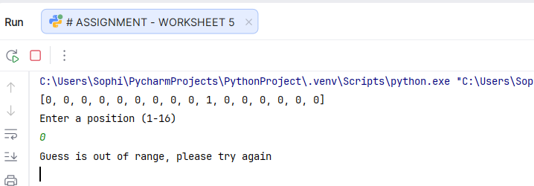
Result: Did the programme behave as expected ie syntactically and logically correct?
YES. The program correctly identified this entry is out of the valid range of 1-16. Python lists start at position 0, but the program asks the user to guess between 1–16. To ensure the users guess matches the list position, the program subtracts 1 from the user’s guess to convert it to the correct list position. This means a user guess of 1 becomes position 0. A guess of 0 is invalid because it becomes -1, which is outside the Python list.

Test: B. Guess position D
Screenshot(s) of output:
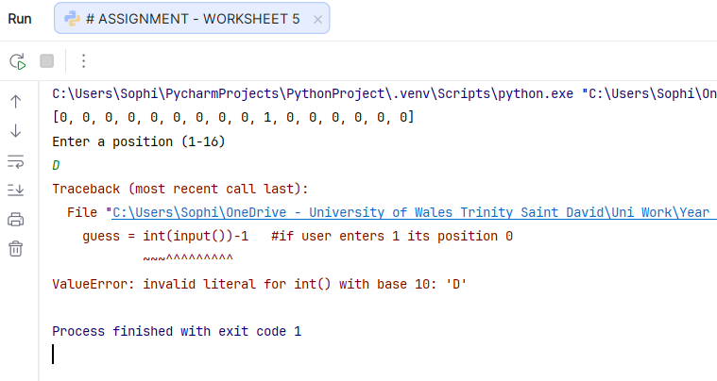
Result: Did the programme behave as expected ie syntactically and logically correct?
NO. The program is set up to accept integers only, however the above shows a program error, rather than a user-facing error message. As the program can’t complete the function, it crashed. Validation would need to be input to display a user-facing error message and request the user to re-try and enter a number instead.

Test: C. Enter a blank guess.

Screenshot(s) of output:
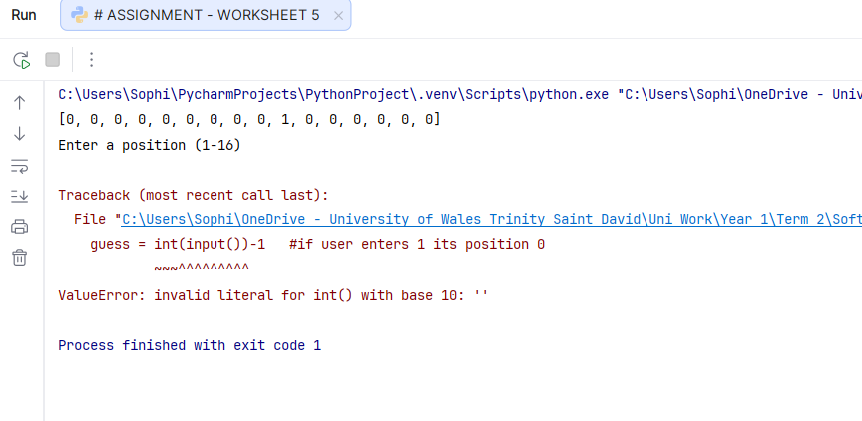
Result: Did the programme behave as expected ie syntactically and logically correct?
NO. Inputting a blank guess produced a program error and no user-facing error messages were displayed. Additional validation would be needed to detect blank entries and prompt the user to try again

Test: D. Make 6 guesses

Screenshot(s) of output:
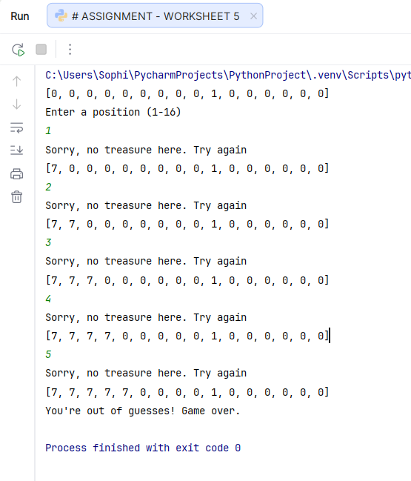
Result: Did the programme behave as expected ie syntactically and logically correct?
YES. The program correctly identified that 5 incorrect guesses had already been made and displayed the relevant user-facing message confirming the maximum number of guesses had been reached. It did not allow a sixth guess, showing the validation allowing a maximum of 5 guesses was successful.

Test: E. Duplicate guess – e.g Position 2, then guess position 2 again
Screenshot(s) of output:
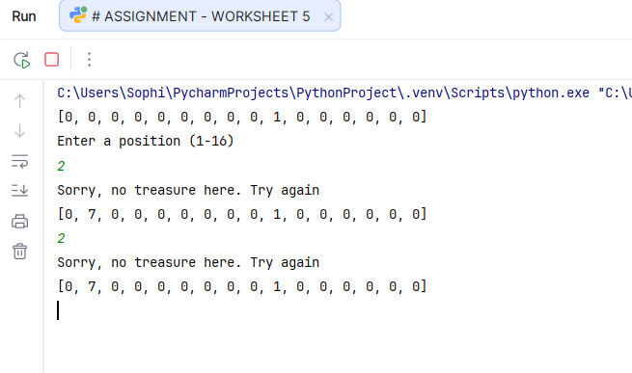
Result: Did the programme behave as expected ie syntactically and logically correct?
NO. Whilst the output is correct for the entry, the program has not identified a duplicate guess. Validation would need to be input to highlight it is a duplicate, and request the user try again with a different number.

Final code:

def getGuess():
guess = input()
while guess =="":
print ("Input cannot be blank, please try again")
guess = input()
while not guess.isdigit():
print ("Input must be a number, please try again")
guess = input()
guess = int(guess)-1
return guess
map = [ 0, 0, 0, 0, 0, 0, 0, 0, 0, 1, 0, 0, 0, 0, 0, 0 ]
print (map)
print ("Enter a position (1-16)")
guess=getGuess()
while map[guess] == 7:
print("You have already guessed this position, please try again")
guess = getGuess()
while guess < 0 or guess > 15:
print("Guess is out of range, please try again")
guess = getGuess()
guesses = 0
maxGuesses = 5
while map[guess] != 1 and guesses < maxGuesses:
print("Sorry, no treasure here. Try again")
map[guess] = 7
print(map)
guesses = guesses + 1
if guesses < maxGuesses:
guess = getGuess()
while map[guess] == 7:
print("You have already guessed this position, please try again")
guess = getGuess()
while guess < 0 or guess > 15:
print("Guess is out of range, please try again")
guess = getGuess()
if guesses == maxGuesses and map[guess] != 1:
print("You're out of guesses! Game over.")
else:
guesses = guesses + 1
print("You found the treasure!")
print("The final map is", map)
print("You found the treasure in", guesses, "guesses")

