

Details | Information
Programme Name | Master of Business Administration (MBA)
Module Name and Code | International Business Concepts (LCMB7034)
Assessment Name | International Business Consultancy Report
Assessment Title | Report
Internal Verifier | Vasilios Tavlaridis & Hoang Dang Nguyen
Student’s Name and ID | Name: Mahfuz Ahmed Sizan  Student ID: 2432238
Date of Submission | 15-12-2025
Word Count | 5,115

Executive Summary
The report is an analysis of the functioning of Samsung as a huge multinational corporate entity in the world markets. It describes the global growth of Samsung and the reasoning behind its adoption of certain entry modes in certain countries. The report also compares various advantages and obstacles that Samsung encounters when undertaking their operations in most parts of the world. It uses OLI as a guideline to understand why India is a promising destination in long-term growth of Samsung. The paper also examines the impact of cultural differences between South Korea and India on how Samsung is managed and marketed. Such cultural aspects influence the communication, leadership, teamwork and the expectation of customers in the Indian market.
The report suggests a number of strategic changes in the Standard Operating Procedures of Samsung in India. These suggestions aim at enhancing the flexibility of supply chain, increasing sustainability and modifying leadership to fit the Indian cultural expectations. It is found in the analysis that the market opportunities, availability of skilled labour and favourable government policies exist in India. However, Samsung has to balance between rigid global systems and the local determination to be competitive. The long-term success in India requires cultural intelligence, effective communication, as well as flexibility in operations. Generally, the report concludes that Samsung can improve its performance by relying on global capabilities, in combination with good local understanding. The strategic changes will aid the long-term growth and enhance the competitive edge of Samsung in the dynamic Indian technology competition.

Table of Contents

Executive Summary 1
1. Introduction 4
2. Benefits and Challenges of International Operations 5
2.a. Why Samsung Is an MNC/TNC 5
2.b. Type of Global Operations at Samsung (Value Chain Perspective) 6
2.c. Entry Modes Used by Samsung 8
2.d. Key Benefits of Samsung’s International Operations 9
2.e.Challenges of Samsung’s Global Operations 10
3. OLI (Ownership–Location–Internalisation) Framework Analysis – Samsung in India 11
3.a. Ownership Advantages 11
3.b. Location Advantages (India) 12
3.c. Internalisation Advantages 13
3.d. Impact of OLI Factors on Samsung’s Entry Mode in India 13
4. Cultural Impacts on Samsung’s Market Strategy 14
4.a. Power Distance 14
4.b. Individualism vs. Collectivism 15
4.c. Uncertainty Avoidance 15
4.d. Long- vs. Short-term Orientation 16
4e. Communication Style 16
4.f. Strategic Implications at Samsung in India. 17
5. Recommended SOP Adjustments for Samsung in India 17
5.1 SOP Adjustment 1: Strengthening Supply Chain Flexibility and Local Integration 18
5.2 SOP Adjustment 2: Implementing Sustainable Operations and Circular Economy Practices 19
5.3 SOP Adjustment 3: Leadership, Communication, and Workforce Management Aligned with Indian Culture 20
6. Conclusion 22
Reference 23

Table of Figures
Figure 1: Samsung office 5
Figure 2: Global Operations Analysis 6
Figure 3: Challenges of Global Operations 10
Figure 4: The Integration- Responsiveness Framework of Samsung 11
Figure 5: Supply Chain Management Strategy 18

1. Introduction
Samsung is a major multinational company in the world, which is recognised to have a good representation in the global electronics and technology industry. The company was established in South Korea and has spread its operations to over eighty countries with massive production, research centres and a massive network of sales. Samsung is a core of global value chains due to the variety of its operations in various key business sectors such as smartphones, semiconductors, home appliances, and digital technologies (Abdeen et al., 2025).
This report analyses the international business activity of Samsung and reasons why Samsung is a successful multinational organisation. It also assesses the entry mode of Samsung into the foreign markets and how the OLI (Ownership, Location and Internalisation) model affects the entry of Samsung to developing economies like India. Another area that the report addresses is the cultural differences between South Korea and India and how these differences influence the management and marketing strategy of Samsung. Lastly, the report gives major Standard Operating Procedure (SOP) modifications that Samsung requires when it wants to succeed in the long-term in India in the dynamic and competitive Indian market.

2. Benefits and Challenges of International Operations

2.a. Why Samsung Is an MNC/TNC
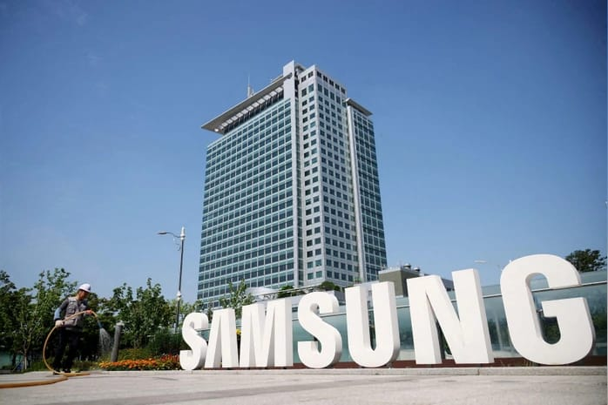
Figure 1: Samsung office
(Source: Business-Standard, 2024)
Samsung is a multinational and transnational company, since it has activities in numerous countries and deals with numerous activities worldwide. The company owns factories, research and development centres and distribution channels in Asia, Europe, Africa, and the Americas (Cavusgil et al., 2014). This global presence indicates that Samsung is well involved in the world markets. Another characteristic of MNCs is, Samsung also conducts business with various governments, suppliers, and partners.
The other aspect that makes Samsung a TNC is that it integrates international effectiveness with local responsiveness. The global strategy adopted by the company is technology development, which is modified to meet local customer needs (Hill, 2008). As an illustration, Samsung innovates to develop budget-friendly smartphone models in the emerging markets and develops high-end gadgets in the countries with high incomes. Such a flexible strategy is closely associated with transnational strategy.
Samsung has a global labour force too. The workforce has an enormous diversity of cultures, and the corporation has huge international design, software, and manufacturing teams (Collinson et al., 2020). This talent system is an international system that assists Samsung to compete in the rapidly changing markets like the electronics market.
More importantly, according to some researchers, Samsung did not expand globally, and South Korean industrial policies bolstered the expansion of this company instead of the power of pure market forces. This implies that the success of Samsung is a combination of nationalist assistance and international approach (Stocker, 2024). Nonetheless, the overall operations of Samsung are evidently fitting the definitions of both the categories of MNC and TNC.

2.b. Type of Global Operations at Samsung (Value Chain Perspective)
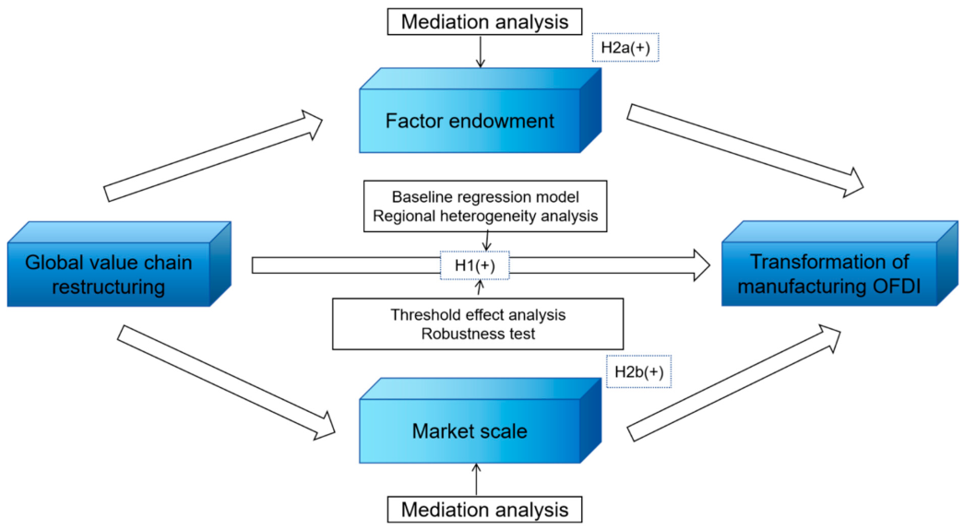
Figure 2: Global Operations Analysis
(Source: Wang et al., 2025)
The value chain of Samsung activities in the global market is very organised as it encompasses research, sourcing, production, sales and financing. Through this global value chain, Samsung is able to remain competitive in the volatile markets (Grant, 2021).
Research and Development (R&D)
Samsung spends greatly on research and development in order to facilitate smartphone, semiconductor, and artificial intelligence innovations. It has research laboratories in South Korea, the United States, the United Kingdom, India and Vietnam (Horner, 2021). These centres specialise in the areas of software development, hardware design and digital technologies. India is significant since the Bengaluru centre is a major R&D centre of Samsung globally.
One of the points that can be critically noted is that Samsung achieved success in its R&D through creative imitation and followed by innovation, which is a learning process typical of latecomer companies in technology (Min, 2021). The approach also enabled Samsung to expand at a faster rate by upgrading the already existing technologies instead of beginning on a blank slate.
Sourcing and Supply Chain
Samsung has a global sourcing strategy and has thousands of suppliers all over the world. To minimise the reliance on a single country, the company purchases raw materials, including chips, batteries, displays, and rare minerals, among others, in several nations (Radić, 2021).
Nonetheless, the global sourcing spreads Samsung to geopolitical risks. As an example, the relationship between South Korea and Japan has been strained at some point in the past, which influenced the supply of life-sustaining materials. This demonstrates that even powerful value chains may be interrupted.
Production and Manufacturing
Samsung has international manufacturing units in South Korea, India, Vietnam, China, Brazil and Indonesia. One of the largest smartphone manufacturing facilities in the world is the Noida factory of India (Lasserre and Monteiro, 2022). Local production will assist Samsung in saving on import taxation and high demand.
Samsung exports smartphones to Vietnam, which is a major centre, and South Korea produces more semiconductors. The diversification of the company in terms of the location of factories in regions assists the company in cutting costs and minimising the risks.
More importantly, heavy automation and advanced technology are also strengths of Samsung, as they have enabled it to manufacture. This brings efficiency, but in some cases, it will lead to low employment locally, and this can be negatively perceived by governments (Stocker, 2024).
Sales, Marketing, and Distribution
Samsung markets its products in retail shops, telecommunication firms, online and its Samsung Experience Stores (Anjani and Warsito, 2023). The marketing strategies vary among nations. In India, Samsung employs the use of regional language advertising. In Europe, more attention is paid to technology and style of life.
The distribution channels of Samsung are good both in city and rural markets. This is a vast coverage that contributes to market share expansion in various economic segments.
Financing and Investment
Samsung uses a big percentage of its income in research and development and growth. This is due to the fact that the company has global sources of revenue as it markets a variety of electronics across the world (Canton, 2021). This financial power enables Samsung to grow even in the periods of economic recessions.

2.c. Entry Modes Used by Samsung
Some of the entry modes adopted by Samsung include wholly owned subsidiaries, joint ventures and greenfield investments. This will depend on the amount of control required and the prevailing market environment (Collinson et al., 2020).
Wholly-Owned Subsidiaries
Samsung has a tendency to have wholly-owned subsidiaries in order to have complete control over the technology and operations. These are Samsung India Electronics and Samsung Vietnam (Hill, 2008). This mode of entry secures the intellectual property held by Samsung, which is very crucial in the electronics market.
Joint Venture and Partnerships
Another strategy to gain local knowledge is the joining of ventures by Samsung in the markets where it requires local knowledge. Samsung has collaborated with companies in China where it has collaborated in developing displays and batteries (Cavusgil et al., 2014). Such alliances enable Samsung to adjust to the regulatory conditions and local demands.
Greenfield Investments
Samsung would rather construct new plants in the developing nations than buy out an existing organisation. Samsung greenfield plants are large in India and Vietnam (Radić, 2021). Through this strategy, Samsung can control all the design, layout, and technology.
Importantly, others claim that through greenfield investments, Samsung obtains government incentives, which can cast some doubts on excessive dependence on the support of the host countries (Stocker, 2024). Nonetheless, this product is what has assisted Samsung to conquer numerous markets.
Dominant Mode
All in all, the predominant entry mode by Samsung is the wholly-owned subsidiaries alongside the green field investment, since these modes facilitate technology protection and mass production (Hill, 2008).

2.d. Key Benefits of Samsung’s International Operations
Access to Large Markets
International operations allow Samsung to reach such giant markets as India, Brazil, and Indonesia (Grant, 2021). These markets enable Samsung to spread its streams of revenue.
Economies of Scale
The ability to manufacture millions of devices on a monthly basis enables Samsung to cut down on the expenditure. This index assists Samsung in countering the inexpensive brands in the international market (Horner, 2021).
Risk Diversification
Samsung is able to be exposed to political and economic risks in any given market, given that it operates in various areas (Anjani and Warsito, 2023). This stabilises earnings.
Innovation Advantages
The global R&D centres allow Samsung to unite global knowledge and customer feedback (Min, 2021). This enhances the quality and innovation speed of the product.

2.e.Challenges of Samsung’s Global Operations
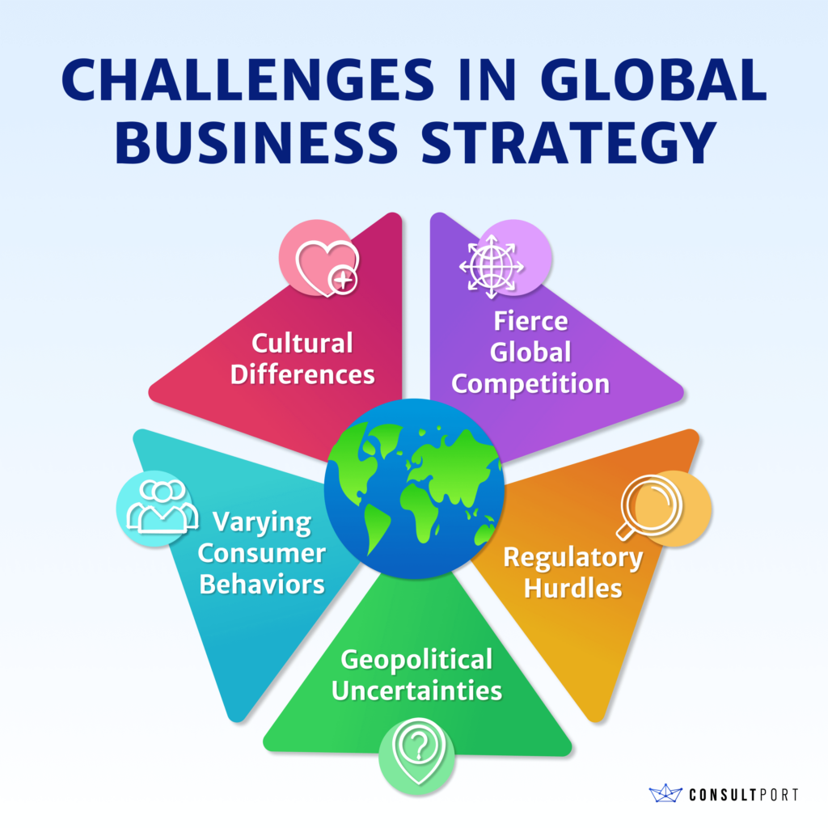
Figure 3: Challenges of Global Operations
(Source: Consultport, 2025)
Regulatory Complexity
Different countries possess different regulations with reference to taxes, data security, and imports (Canton, 2021). These policy variations make Samsung constantly change policies and raise compliance expenses.
Supply Chain Disruptions
Geopolitical tensions, shortages, or pandemics can influence the global supply chain of Samsung (Radica, 2021). These interruptions reduce production pace and cause delays, which spoil customer satisfaction in all corners of the world.
Intense Competition
Samsung in the emerging markets faces low-cost brands such as Xiaomi and Vivo (Hill, 2008). These formidable rivals can decrease the market share of Samsung through the provision of low-cost substitutes to consumers.
Cultural Differences
Tastes of consumers differ. Samsung will have to tailor marketing, features, and types of communication to each country (Collinson et al., 2020). Inability to adjust positively can undermine customer confidence and diminish product receptiveness in different markets.

3. OLI (Ownership–Location–Internalisation) Framework Analysis – Samsung in India
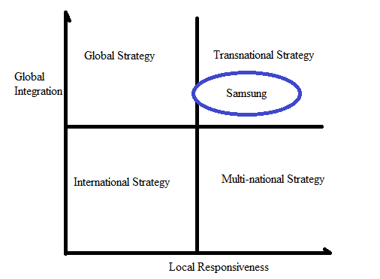
Figure 4: The Integration- Responsiveness Framework of Samsung
(Source: StudyCorgi, 2023)
The international strategy of Samsung in India can be explained more through OLI. The model proposes why a company goes international and the selection of entry modes depending on major competitive strengths (Narula, 2010). Samsung has employed this strategy in a systematised manner, involving robust domestic capacity alongside prospects in the Indian rapidly digitalising and manufacturing ecosystem (Sen et al., 2024).

3.a. Ownership Advantages
The benefits of Samsung as its owners are rooted in a solid technological base, brand name, and extensive networks of innovation across the whole world (Buckley, 2018). The firm has one of the largest portfolios of patents in the electronics sector, a factor that enhances its competitiveness in smartphones, semiconductors, and display technology. These capabilities allow Samsung to ensure high product quality and create innovative models quickly than the competitors (Kuzel and Kola-Bezka, 2023).
Samsung India has powerful R&D centres, where products are localised. As an example, the company created Make for India features like S-bike mode and regional language interfaces that add engagement to the users among local consumers (McWilliam et al., 2023). These advantages as an owner also justify the swiftness with which Samsung can respond to price-elastic markets, as Samsung generates high-budget to high-end products (Porto et al., 2021).
More importantly, Samsung has good brand equity, and this is a competitive advantage against the local and Chinese businesses. Nevertheless, this brand power needs consistent investment in innovation and marketing to keep customers loyal to the company in a market that is evolving (Giroud and Bonilla-Feret, 2025). Nevertheless, the ownership assets of Samsung continue to be the key determinant of its performance in the global and Indian markets.

3.b. Location Advantages (India)
There are a number of location benefits that Samsung is drawn to in India. These consist of the fast-growing population of the middle classes, rising online consumption, and state initiatives like the programmes Make in India that are stimulating foreign investment in manufacturing (Ott, 2024). The smartphone market in India is one of the largest in the world, and with increasing internet adoption as well as cheap data packages, its demand is on the rise. The size of the market renders India a good long-term investment destination (Narula, 2010).
The fact that India has a huge labour force also offers cost cost-effective environment in terms of manufacturing. Samsung can advantageously enjoy lower labour costs, which enable it to competitively produce smartphones and consumer electronics (Sen et al., 2024). These are also benefits that enable Samsung to export Indian manufactured devices to other markets and enhance the regional supply chain of the company (McWilliam et al., 2023).
A critical analysis reveals that the market potential in India is associated with risky supply chain effects as well as uncertainty of policies. Nevertheless, Samsung has been able to address these threats by opening various manufacturing and assembly lines in the country, one of the largest mobile factories in the world, located in Noida (Porto et al., 2021). Such a plan minimises the reliance on imports and enables quick reaction in the market.
India becomes more attractive due to government incentives, talented engineers and the development of local suppliers. All these reasons justify why Samsung still has a sizeable production and R&D base in India (Giroud and Bonilla-Feret, 2025).

3.c. Internalisation Advantages
R&D, design, and component production are some of the key activities that Samsung internalises in order to control technology and quality. Internalisation also assists Samsung to reduce transaction risks that could be posed by the dependence of the external suppliers on strategic components, including semiconductors and displays (Buckley, 2018). This control will enable it to be cost-efficient and enhance its competitive edge in the international markets.
Internalisation is also apparent in India following Samsung's move to manufacture its products instead of outsourcing the production. This enables the organisation to protect intellectual technologies, besides being able to guarantee product uniformity even within markets (Narula, 2010). Internalisation also assists Samsung in keeping sensitive data and intellectual property safe and secure, which is vital in the electronics industry that is highly competitive (Sen et al., 2024).
The distribution and after-sales services by Samsung are also affected by the internalisation strategy. To maintain high customer satisfaction, the company has a huge network of services and training centres. Such internal systems enhancing brand loyalty can be achieved, especially in markets where after-sales services are central in their purchasing decisions (McWilliam et al., 2023).
Critical analysis has shown that complete internalisation is costly to invest in. But Samsung has experience and financial capabilities worldwide that can cover these expenses with long-term stable operation (Porto et al., 2021). Consequently, internalisation would still be useful in retaining technological and customer experience control.

3.d. Impact of OLI Factors on Samsung’s Entry Mode in India
Wholly owned subsidiaries were the primary entry mode favoured by Samsung in India due to the OLI factors. Direct investment was the most suitable approach that Samsung should use to ensure that it had competitive control due to its ownership capabilities, namely technology, patents and brand strength (Kuzel and Kola-Bezka, 2023). This strategy gave Samsung a chance to control production, marketing and product development, which is aligned with global standards and go (Buckley, 2018).
The high market size and favourable manufacturing policies in India made location a key factor that warranted Samsung to invest heavily in production plants. Such benefits prompted Samsung to intensify its activities by manufacturing millions of smartphones each year, both in the local and global markets (Ott, 2024).
The strategy of Samsung was influenced by internalisation advantages as well. With manufacturing and distribution held in-house, Samsung was not reliant on external partners but instead allowed it to innovate quickly in an exceptionally competitive environment (Sen et al., 2024).
Imperatively, the convergence of OLI factors enabled Samsung to record a good market share in India regardless of the coming Chinese brands. This is the reason why Samsung remains in India to extend ownership and production capacity, as well as to maintain growth in the long term (Giroud and Bonilla-Feret, 2025).

4. Cultural Impacts on Samsung’s Market Strategy
The market entry strategy and long-term success of Samsung is largely impacted by the cultural differences between South Korea and India. These variations influence leadership, communication, teamwork, consumer behaviour, as well as decision making. These cultural differences should be learned as Samsung needs to change its organisational culture to fit into the diverse Indian surroundings (Hofstede et al., 2010). The two nations cherish hierarchy yet differ in the tendency to communicate, emotional expression, and work demands, which may influence how Samsung will respond to the Indian market (Trompenaards and Hampden-Turner, 2022).

4.a. Power Distance
South Korea values power-distance culture; workers want strict direction and organised leadership. Power distance is also high in India, although power is shown in a more relational fashion depending on social statuses (Hofstede et al., 2010). This similarity aids Samsung to fit in with Indian expectations very easily since Korean managers are already accustomed to a hierarchical structure. Nevertheless, leaders should demonstrate empathy and personal care, which is not always the case in Korea because Indian employees tend to be much more formal (Meyer, 2016).
Most importantly, Samsung should know that Indian employees will learn more when leaders establish personal relationships prior to giving instructions. In the absence of such a relational approach, there can be gaps in communication, and delays in decision-making can occur. Thus, leadership training of Samsung India should focus on emotional intelligence and interpersonal sensitivity (Atwater et al., 2021).

4.b. Individualism vs. Collectivism
South Koreans are collectivistic, and they believe in group harmony and loyalty. India is collectivistic as well as more family-focused, and decisions made are affected by community and extended networks (Thomas and Inkson, 2021). The similarities are beneficial to Samsung as both cultures are used to working in teams. However, Indian collectivism puts emphasis on social relations; business deals are usually denominated by trust and prolonged personal interaction (Meyer, 2016).
As such, Samsung will have to give Indian distributors and suppliers more time to build relationships. Korean managers might opt to grab an agreement fast, yet the Indian partners will expect to discuss a lot before committing themselves. More importantly, the inability to honour this process may undermine partnerships or reduce the growth of Samsung. Samsung can also enhance its social trust networks by adjusting its approach to negotiation to become stronger in the market (Kim and Kim, 2023).

4.c. Uncertainty Avoidance
South Korea exhibits high uncertainty avoidance, whereby employees wish to have directives, routine processes and predictability. India has moderate levels of uncertainty avoidance, where people embrace ambiguity and improvisation easier as compared to Koreans (Budhwar and Pereira, 2022). This variation poses a problem since Samsung in Korea is heavily standardised and rule-based culture, whereas Indian workwear adjusting rules to the environment is a common practice (Trompenaars and Hampden-Turner, 2022).
In the case of Samsung, this is that training systems need to be structured without being too rigid. Adaptability is also highly appreciated in a busy technology market where Indian employees work. More importantly, in case Samsung implements excessively strict processes, the local teams are unlikely to react promptly to market surprises. Alternatively, excessive flexibility could cost Samsung its quality uniformity, which is the main ingredient of its international brand (Hung and Siti-Nabiha, 2024).

4.d. Long- vs. Short-term Orientation
Korea, the long-term orientation in South Korea is high, and it is Confucianism. The culture focuses on long-term stability, constant improvement and rigid future saving. India has a combination of long-term objectives and short-term objectives influenced by social mobility and blistering economic change (Hofstede et al., 2010).
This cross-cultural has an impact on consumer behaviour. Indian consumers are oriented to instant value and emotion, whereas the consumers in Korea can be more concerned with stability and long-term gains. Thus, Samsung needs to develop marketing in India that places emphasis on fast exploitation: price- disagreeableness, battery duration and quality of the camera, other than reduced durability (Meyer, 2016).
Most importantly, the long-term planning strategy used in Samsung is effective with the production and R&D strategies, but requires modification in front-line marketing. The technology market in India is highly dynamic, and swift product release is essential. The long-term orientation enables Samsung to focus on innovation, but the company needs to adopt short-term responsiveness in order to stay competitive with local and Chinese brands (Thomas and Inkson, 2021).

4e. Communication Style
The communication style adopted by South Korea is high context-based and relies a lot on indirect messages, tone and mutual understanding. India utilises indirect communication as well, but is more communicative and emotional in their daily life (Meyer, 2016). These similarities assist Samsung in the cases of not being misinterpreted significantly, yet the cultural nuances remain. Indian communication focuses on respect, courtesy, and explanations rather than on conflicting with senior managers (Atwater et al., 2021).
More importantly, the Korean managers might view Indian politeness as assent in a situation where employees are escaping confrontation. This will lead to miscommunication at the factory and the sales teams. Samsung ought to educate managers to pose clarifying questions and promote risk-free feedback. Enhanced communication minimises mistakes in the operations and enhances employee involvement (Kim and Kim, 2023).

4.f. Strategic Implications at Samsung in India.
The South Korean and Indian cultures influence the success of Samsung in the Indian market in a very direct manner. In both countries, power distance is high and encourages hierarchical style management, but Samsung needs to use a warmer style of leadership in India to create loyalty (Hofstede et al., 2010). Relationship-based collectivism implies that the company will have to dedicate time to building trust with suppliers, retailers and distributors.
The moderate uncertainty avoidance in India expects Samsung to combine structure and flexibility. Such a combination contributes to better decision-making and enables quicker adaptability in competitive markets (Trompenaars and Hampden-Turner, 2022). The variations in long-term orientation impact marketing as Samsung needs to emphasise short-term advantages whilst maintaining the long-term technological advance.
Lastly, the subtleties of communication require the training programmes to show the Korean managers the ways to interpret the Indian words, politeness, and indirect communication (Meyer, 2016). In the absence of these changes, there is a risk that Samsung can undergo misunderstandings that compromise the team's performance. All in all, cultural intelligence can turn into a potent competitive advantage that helps Samsung operate without friction and establish meaningful relationships in the dynamic Indian market environment (Thomas and Inkson, 2021).

5. Recommended SOP Adjustments for Samsung in India
Samsung operations in India need some strategic changes to succeed in the long term, as they are quite different in culture and have OLI factors mentioned above. Standard Operating Procedures (SOPs) should also be developed in line with sustainability, digital transformation, supply chain resilience and leadership practices appropriate to the Indian context. These shifts will enhance the competitiveness of Samsung and its response to any risk related to a massive and diversified emerging economy (Stratton et al., 2023). The differences in culture, like the style of communication and relationship-based business norms, also necessitate Samsung to adapt internal practices to create full operational efficiency (Mammadov, 2024).

5.1 SOP Adjustment 1: Strengthening Supply Chain Flexibility and Local Integration
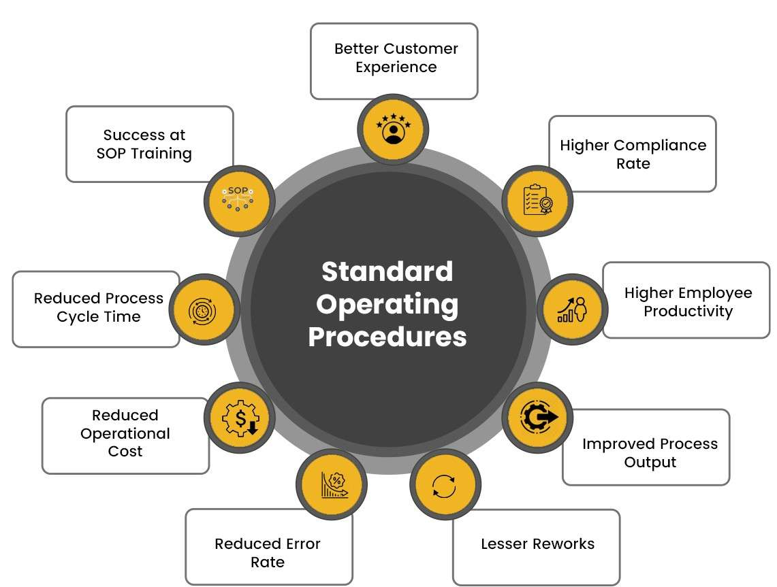
Figure 5: Supply Chain Management Strategy
(Source: ACTE, 2025)
The supply chain that Samsung uses in India should be more digital and locally integrated. The Indian market is dynamic; thus, Samsung should have systems that react fast to consumer demand and regulatory changes. A more flexible SOP enhances the resilience and limits disruption risks and has a potential impact on large economies where regional differentiation influences logistics (Christopher, 2022).
The infrastructure in India is also on the rise, but unevenly distributed. Hence, Samsung needs to revise its SOPs to establish better alliances with local suppliers and logists.
This is useful in minimising transport delays as well as maintaining constant inventory levels. Most importantly, the geographical diversity in India necessitates a decentralised decision-making process, unlike the centralised structure of Samsung in Korea (Gereffi et al., 2022).
The use of digital solutions, including real-time monitoring, predictive analytics, and automated forecasting, will be beneficial in making decisions. There is increased precision and minimisation of wastage in data-driven supply chains, a crucial factor in a market with swiftly changing demand. Digitalisation also enhances transparency and enables Samsung to identify the bottlenecks early, and the reaction is proactive (Tiwari et al., 2024).
There is also a need to have a more local sourcing strategy. Higher local sourcing saves, decreases imports, and is in line with the Indian policy of Make in India. Local sourcing also helps Samsung to gain a competitive advantage as it reduces lead times and responsiveness to the local tastes (Lu et al., 2024).
Nevertheless, further localisation will involve increased training of the Indian suppliers by Samsung. The quality standards have to be within global Samsung expectations, and thus better SOP instructions would focus on frequent auditing, joint problem solving and shared innovation programmes. Such efforts decrease risks associated with unequal quality of products and enhance the capability of suppliers (Liu and Huo, 2021).
In general, the increased supply chain flexibility is more consonant with an uncertain market situation in India and allows Samsung to stay stable in cases of external shocks, like geopolitical tensions or a supplier crisis (Sharma and Singla, 2021). This modification is also conducive to the long-term sustainability states in terms of waste minimisation and efficiency in operations (Hong, 2024).

5.2 SOP Adjustment 2: Implementing Sustainable Operations and Circular Economy Practices
To respond to the growing sustainability, resource efficiency, and environmentally responsible attitude in India, Samsung needs to change its SOPs. Indian consumers are increasingly inclined towards a brand that shows itself to be ethical and sustainable. This changes demand that Samsung integrates the concept of the circular economy into production, packaging, and waste disposal (Lu et al., 2024).
The sustainable SOP must have an emphasis on emission reduction, energy efficiency and more recycling in factories. Such technologies as automation and smart manufacturing are already used in Samsung and have to adjust to the environmental standards and consumer preferences in India (Chaidir et al., 2024).
Designing better products that have longer life cycles and are easily repaired is an important aspect. India is an emerging market in terms of repair markets, and thus, Samsung can gain trust by providing cheap service programmes and the supply of spare parts. This is also aimed at minimising electronic waste, which is a serious issue in developing economies (Karelis, 2024).
SOPs can contain digital sustainability tools like AI-controlled energy optimisation schemes and blockchain-powered material tracking. These tools enhance transparency and can assist Samsung to fulfil environmental performance reporting requirements. AI can also identify inefficiencies and minimise production waste, that helps in enhancing both sustainability and cost performance (Gupta et al., 2023).
Samsung should also pursue a training initiative among the staff in India to learn about sustainability standards. In India, cultural values teamwork and the well-being of the community, thus effective sustainability communication boosts the social reputation of Samsung (Stratton et al., 2023).
More importantly, sustainability practices not only help Samsung to comply but to be differentiated competitively as well. Among the Indian consumers, environmentally responsible brands gain popularity, particularly with electronics, where the issue of energy use and recycling is significant. Hence, sustainable operations incorporated into SOPs enhance the long-term competitiveness of Samsung and minimise risks of operating in the Indian regulatory setting (Abdeen et al., 2025).

5.3 SOP Adjustment 3: Leadership, Communication, and Workforce Management Aligned with Indian Culture
The leadership SOP of Samsung should be able to fit into the cultural expectations of India. The management style used in South Korea is formal, hierarchical and efficiency-oriented. India is also highly esteemed for hierarchy, but more about relationships, empathy, as well as clarity of communication (Meyer, 2016).
Thus, Samsung needs to amend its SOPs to incorporate leadership training with a focus on emotional intelligence, cultural sensitivity and communication skills. In India, managers have to be aware of indirect communication as Indians would not confront a colleague to preserve harmony. Korean managers can interpret politeness as an agreement without cultural awareness and therefore make operational mistakes (Trompenaars and Hampden-Turner, 2022).
India favours a more participative type of leadership, particularly among the younger employees who appreciate encouragement, feedback and rewards. Revising SOPs to include frequent feedback and open communication channels and team problem-solving enhances morale and productivity (Atwater et al., 2021).
Samsung ought to change the HR-related SOPs with an emphasis on high employee engagement as well. India cherishes collectivism and stability; hence, initiatives like mentoring at the workplace, team incentives, and long-term development schemes are useful to enhance stronger loyalty. These contribute to better retention in the Indian competitive technology job market (Thomas and Inkson, 2021).
Also, Samsung should revise its SOPs to enhance cross-cultural training of the Korean expatriates. There are numerous functioning problems when foreigners believe that Indian business behaviour is similar to that of the Korean behaviour. Training also aids in fewer interruptions of conflict, stronger relations, and smoother interaction between various departments (Kim and Kim, 2023).
More importantly, the adaptations of leadership are not completely cultural but also strategic demands. Well-managed workforce will enhance the dynamic capabilities of Samsung, and it can be more responsive to the market and faster in innovating. Effective leadership also enhances productivity and causes less friction in operations, reinforcing the long-run competitive advantage in India (Abdeen et al., 2025).

6. Conclusion
This report has reviewed the way Samsung is a global multinational company that allows it to perform effectively in various markets, particularly in India, within the context of its strategies. It was analysed that Samsung enjoys extensive international diversification, effective technological capacity, and a developed global value chain. The company can compete in the developed and emerging economies using these strengths. Still, a number of challenges were pointed out in the discussion, such as the complexity of regulatory aspects, cultural differences, and supply chain risks that need to be controlled thoughtfully.
The frame OLI was useful in justifying how Samsung has strength as an owner, the location benefits of India, and why Samsung prefers internal control to contribute to its entry strategy. These aspects come in combination to favour steady growth in a big and competitive new market. Cultural differences assessment revealed that communication patterns, hierarchy degree, and relationship-oriented business norms in India affect market behaviour as well as organisational practices. To be efficient, develop trust and effectively engage consumers, Samsung needs to be aware of these cultural aspects.
On the insights of these, the proposed changes in the SOP were based on flexibility of the supply chain, sustainable operations, and culturally aware leadership. These interventions will enable Samsung to be more resilient, less uncertain and establish more meaningful relations with local consumers and employees. They also make sure that Samsung is competitive in an environment that is rapidly expanding and is becoming more demanding.
In sum, Samsung can succeed in India because of its capacity to neutralise global advantages with local insights. Using the findings of this report, Samsung will be able to proceed on its expansion in India and improve on its long-term strategic performance in the global markets.

Reference
Abdeen, H., De-Pablos-Heredero, C., Cosculluela-Martinez, C. and Montes-Botella, J.L. (2025) ‘Strategic leadership and its impact on dynamic capabilities and sustainable competitive advantages’, Management Decision.
ACTE (2025) SOP for Supply Chain Management Strategy: How to create an SOP for supply chain management. Available at: https://www.acte.in/how-to-create-sop-for-supply-chain-management (Accessed: 22 November 2025).
Anjani, N.R. and Warsito, T. (2023) ‘The factors driving success in South Korean exports: A case study of Samsung Electronics’, Jurnal Ilmiah Dinamika Sosial, 7(1), pp. 77–86.
Atwater, L., Yu, J., Tawse, A., Fields, L.H., McFarren, J.A. and Nae, E.Y. (2021) ‘Relevance of culture in studies of leadership: ignored or dismissed?’, Asia Pacific Journal of Management, 38(2), pp. 687–708.
Buckley, P.J. (2018) ‘Internalisation theory and outward direct investment by emerging market multinationals’, Management International Review, 58(2), pp. 195–224.
Budhwar, P. and Pereira, V. (2022) Doing Business in the Middle East. Routledge.
Business-Standard (2024) ‘Samsung Electronics’ union set to stage 1st walkout over pay in South Korea’, Business Standard, 7 June. Available at: https://www.business-standard.com/companies/news/samsung-electronics-union-set-to-stage-1st-walkout-over-pay-in-south-korea-124060700092_1.html (Accessed: 2 December, 2025)
Canton, H. (2021) ‘Organisation for Economic Co-operation and Development—OECD’, in The Europa Directory of International Organizations 2021. Routledge, pp. 677–687.
Cavusgil, S.T., Knight, G., Riesenberger, J.R., Rammal, H.G. and Rose, E.L. (2014) International Business. Pearson Australia.
Christopher, M. (2022) Logistics and Supply Chain Management. Pearson UK.
Collinson, S., Narula, R. and Rugman, A.M. (2020) International Business. Pearson UK.
Consultport (2025) ‘Beyond Borders: Strategies for Navigating the Complexity of Global Business’, Consultport Blog.
Gereffi, G., Bamber, P. and Fernandez-Stark, K. (2022) ‘China’s evolving role in global value chains: upgrading strategies in an era of disruptions and resilience’, in China’s New Development Strategies. Singapore: Springer Nature, pp. 1–29.
Giroud, A. and Bonilla-Feret, S. (2025) World Investment Report 2024: Investment Facilitation and Digital Government. United Nations Conference on Trade and Development.
Grant, R.M. (2021) Contemporary Strategy Analysis. John Wiley & Sons.
Gupta, S., Modgil, S., Choi, T.M., Kumar, A. and Antony, J. (2023) ‘Influences of artificial intelligence and blockchain technology on financial resilience of supply chains’, International Journal of Production Economics, 261, 108868.
Hill, C.W.L. (2008) ‘International business: Competing in the global marketplace’, Strategic Direction, 24(9).
Hofstede, G., Hofstede, G.J. and Minkov, M. (2010) Cultures and Organizations: Software of the Mind. McGraw-Hill.
Hong, T.K. (2024) Reviewing the impact of Industry 4.0 on Samsung’s new product development.
Horner, R. (2021) ‘Review of: Gereffi, G. (2018) Global Value Chains and Development’, International Journal of Contemporary Business and Entrepreneurship.
Hung, C. and Siti-Nabiha, A.K. (2024) ‘The design and use of performance management systems in China’s innovative start-ups using GLOBE cultural and leadership elements: a conceptual framework’, International Journal of Business Excellence, 32(4), pp. 413–432.
Karelis, S. (2024) Factors of Foreign Direct Investment Attractiveness in Central Eastern and Southeastern Europe During and After the Transition Period: A Qualitative Comparative Approach [in Greek].
Kim, U. and Kim, J. (2023) ‘Understanding the software of the mind, self and culture’, Psychology and Developing Societies, 35(2), pp. 347–391.
Kuzel, M. and Kola-Bezka, M. (2023) ‘Global cities and multinational enterprises: integrating existing concepts for future research’, Bulletin of Geography: Socio-Economic Series.
Lasserre, P. and Monteiro, F. (2022) Global Strategic Management. Bloomsbury Publishing.
Liu, C. and Huo, B. (2021) ‘How does supply chain integration impact performance?’, in International Conference on Operations and Supply Chain Management. Singapore: Springer Nature, pp. 24–35.
Lu, H., Zhao, G. and Liu, S. (2024) ‘Integrating circular economy and Industry 4.0 for sustainable supply chain management’, Production Planning & Control, 35(2), pp. 170–186.
Mammadov, R. (2024) ‘Strategic integration of logistics and supply chain management for successful global business operations’, IMAQ Journal.
McWilliam, S., Nielsen, B.B. and Kottaridi, C. (2023) ‘Global value chains and liability of international connectivity: MNE strategy post COVID-19’, European Journal of International Management, 21(1), pp. 121–139.
Meyer, E. (2016) The Culture Map. PublicAffairs.
Min, B. (2021) Latecomer Firms’ Technological Learning Strategies for Creative Imitation, Innovation, and International Licensing-Out [Doctoral dissertation, Seoul National University Graduate School] [in Korean].
Narula, R. (2010) ‘Keeping the eclectic paradigm simple’, Multinational Business Review, 18(2), pp. 35–50.
Ott, J. (2024) ‘World Bank world development reports’, in Encyclopedia of Quality of Life and Well-being Research. Cham: Springer, pp. 7858–7859.
Porto, T.C., Lee, K. and Mani, S. (2021) ‘The US–Ireland–India linkages in IT services’, Eurasian Business Review, 11(1), pp. 59–82.
Radić, M. (2021) ‘Business strategy and management method on the example of Samsung’, International Journal of Contemporary Business and Entrepreneurship, 2(2), pp. 33–49.
Sen, B., Jain, R. and Srivastava, D.K. (2024) ‘Revisiting the eclectic paradigm in the era of digital globalisation’, SSRN Working Paper.
Sharma, E. and Singla, J. (2021) ‘Sustainable supply chain practices and organisational performance’, Operations and Supply Chain Management, 14(4), pp. 456–466.
Stocker, M. (2024) Strategy and International Business.
Stratton, R., Zeng, M., Yeong, A. and Alsharief, T. (2023) ‘Sustainable operations management’, in Sustainable Management. Routledge, pp. 362–390.
StudyCorgi (2023) ‘Samsung International Business Strategy’. Available at: https://studycorgi.com/samsung-companys-international-strategy/ (Accessed: 5 December 2025).
Thomas, D.C. and Inkson, K. (2021) Cross-Cultural Management: An Introduction. Sage Publications.
Tiwari, M.K., Bidanda, B., Geunes, J., Fernandes, K. and Dolgui, A. (2024) ‘Supply chain digitisation and management’, International Journal of Production Research, 62(8), pp. 2918–2926.
Trompenaars, F. and Hampden-Turner, C. (2022) Riding the Waves of Culture. McGraw-Hill.
Wang, C., Xu, F., Lu, C. and Liu, T. (2025) ‘The impact of global value chain restructuring on the OFDI transformation of manufacturing industry’, Sustainability, 17(12), p. 5448.

