ACMA4027: Problem-Solving Techniques
Scrabble Algorithm

Table of Contents
Introduction 1
Task 1: Requirements 1
Rules of Scrabble 1
MoSCoW Requirements Prioritization 2
Task 2: Implementation 3
Variable Identification and Description 3
Flowchart Algorithm 4
Pseudocode for Sub-processes 5
Conclusion 7
References 8
Appendix 9

Introduction
Scrabble, a popular board game created by Alfred Mosher Butts in 1938 has been a popular pastime in homes across the globe for many years. In the game, the players are supposed to form words on the board which is matrix like and each letter tile has a point value attached to it. This report seeks to assess Scrabble and develop a computer-based application for the said game. This report will point at the rules of the game, define MoSCoW for the digital version, and describe the main aspects of the implementation. This report will describe the key features of the game, the considerations for the game design, as well as the beginning approach towards the automated Scrabble system.

Task 1: Requirements

Rules of Scrabble
Scrabble is typically played by two to four players. The game begins with each player drawing a letter tile to determine the order of play, with the player drawing the letter closest to 'A' going first (Maglio et al., 2020; Puranik and Lonigan, 2011). The game board consists of a 15x15 grid with various bonus squares. Each player receives a rack to hold seven letter tiles, drawn randomly from a bag containing 98 letter tiles and two blank tiles (Khaira et al., 2021).
On their turn, a player must form a word using their letter tiles, placing it on the board to read either left to right or top to bottom. The first word must cover the center star square. Subsequent words must connect to or intersect with existing words on the board, similar to a crossword puzzle. Players can also add letters to existing words to form new words (Qatrunnada and Zuhriyah, 2024). After placing a word, the player draws new tiles to replenish their rack to seven tiles. Players can choose to exchange some or all of their tiles instead of playing a word, forfeiting their turn. The game continues until all tiles have been drawn and one player uses all of their remaining letters, or until no more plays are possible.
Points are awarded based on the letter values and any bonus squares covered. Each letter has a point value, ranging from 1 for common letters like 'E' and 'A' to 10 for rare letters like 'Q' and 'Z'. Bonus squares on the board can double or triple the value of a letter or the entire word. Players also receive a 50-point bonus for using all seven tiles in a single turn, known as a "bingo" (Edley and Williams, 2009).
The game ends when all tiles have been drawn and one player uses their last letter, or when no more plays are possible. At this point, each player's score is reduced by the sum of their unplayed letters, while the player who went out adds the sum of the other players' unplayed letters to their score. The player with the highest final score wins the game (Sabila et al., 2023).

MoSCoW Requirements Prioritization
The MoSCoW method is another categorization technique used in management and software development to get the stakeholders’ consensus on which requirements are mandatory, optional, or out of scope for the project (Hudaib et al., 2018; Ahmad et al., 2017). The features for this computer-based Scrabble solution will be grouped into four possibilities as Must-have, Should-have, Could-have and Won’t-have.
hese are the features that are mandatory for the proper functioning of the game and must be incorporated for the solution to be considered feasible. Some of these are; a digital game board, letter tiles handling, word placement and checking, score keeping, turns, and game completion features. The screen of the digital game board should have the 15×15 scrabble grid with all the special squares. Randomization of tiles for the distribution to the players as well as tile restocking for the next turn is also done in letter tile management. Word placement and validation are functions that enable the player to place words on the board and check if they are legal in relation to an official Scrabble dictionary. The scoring system should just assign points according to the letters and for the squares that have bonuses. Turn based system is a method of controlling the game where one player takes his turn and then the other player takes his turn. Thus, end game detection is responsible for determining when a game is over and figuring out the final scores.
Should have features improve the usage and the interactions with the game but are not vital to the basic functionalities of the game. These are the user interface for tile rack management, word definition lookup, undo/redo, a basic AI opponent, and save/load game state. The user interface should allow the players to choose the tiles they want to play easily and arrange them in a proper manner. Word definition lookup allows players to check the meaning of played words, enhancing the educational aspect of the game. Undo/redo functionality gives players the ability to reverse or replay their moves before finalizing their turn. A basic AI opponent with rudimentary word-forming capabilities enables single-player games. The game state save/load feature allows players to save a game in progress and resume it later, adding convenience for longer game sessions.
Could-have features would provide additional value and enhance the product but are not as crucial as the must-have or should-have items (Kravchenko et al., 2022). These include advanced AI opponents with varying difficulty levels, multiplayer online functionality, statistics tracking, customizable game rules, and a tutorial mode. Advanced AI opponents could challenge players of different skill levels, while multiplayer online functionality would allow play against other human players over the internet. Statistics tracking could record and display player statistics such as highest score, average score, and most valuable word. Customizable game rules would offer options to modify certain game parameters, such as board layout or scoring system. A tutorial mode could provide an interactive guide to teach new players the rules and strategies of Scrabble.
Won't-have features are acknowledged as potential future enhancements but are explicitly excluded from the current development plan to maintain focus and meet project constraints. These include voice recognition for word input, 3D graphics or animations, social media integration, multiple language support, and real-time simultaneous gameplay. While innovative, voice recognition for word input is beyond the scope of the current project. The focus is on gameplay rather than advanced visual effects, so 3D graphics or animations are excluded. Social media integration for sharing scores or challenging friends is not a priority for the initial release. The initial version will focus on one language (e.g., English) to simplify development and word validation. Lastly, the traditional turn-based format will be maintained, excluding real-time simultaneous gameplay.

Task 2: Implementation

Variable Identification and Description
In developing the Scrabble algorithm, several key variables and constants need to be identified and described. The game board is a fundamental element, represented as a 15x15 grid. This can be implemented as a two-dimensional array, with each cell containing information about the letter placed and any bonus multipliers (Purnama and Putri, 2022). The letter bag is another crucial variable, initially containing 98 letter tiles and two blank tiles. As the game progresses, this bag will be depleted, so a dynamic data structure like a list or queue would be appropriate.
Player information is vital and can be stored in a player object or structure. This would include the player's name, current score, and their tile rack. The tile rack is a dynamic display or a list of, at most, seven letters. We also require a variable to keep the record of which player’s turn is to be played next. A data type such as a dictionary or a set will be required for word screening since it will include all Scrabble-permissible words.
These are the parameters of our implementation: the board size is 15×15, the initial number of tiles is 100, the size of the playing rack is 7, and the point values for each letter are the standard ones. The positions of bonus squares on the board are also constants and they should also be stored in another data structure for easy access during the scoring process. The 50-point bonus of scoring for using all seven letters in a turn in one go (referred to as bingo) is another constant that is worth mentioning.
Others include the state of the game whether it is still ongoing or has concluded, the number of consecutive passes in order to determine when the game has come to an end, and a history of the moves in the game for the enablement of features such as undo and redo. For AI opponents, there may be a need to include other variables to store information on the strategies or the level of the difficulty.

Flowchart Algorithm
The flowchart of the proposed approach for the Scrabble game is presented in Appendix which shows the first step as game initialization. This includes formation of the board, mixing and dealing of tiles to the players and deciding on the first player. The primary game loop then starts, and it runs until an end game state is reached.
The first decision point is the check if the game should be stopped. This happens when there is no tile left in the tile bag and a player has no more tiles on his rack or when a particular number of times players have passed their turn without playing any tile. If the game has not ended, then we proceed to the turn of the current player.
The process of a player turn is divided into several sub-processes. First, the player has three options; to place a word on the board or to exchange some of the letters for new ones or to pass. If playing a word, the word placement and validation process will be triggered. This involves confirming if the word is not here in the dictionary, if it fits in relation to the other words on the board, and if the tiles on the player’s rack have been utilized appropriately. If the word is valid, then the scoring calculation starts and then the board is updated along with the player’s score.
Once the turn is over and the player has made a proper move, new letters are given to the player to replace the ones they used up. The flowchart then jumps back to check for the game end condition and then goes to the next player turn. If a player decides to exchange tiles, he or she removes tiles to be returned to the pool, take new ones and that round is over. If they pass it then the pass counter increases.
The decision points of the flowchart are to check for game over situations, checking words, and if the move made by player is legal or not. A game logic flow will make sure that all the implemented rules of the game are correctly adhered to, the scores are well calculated, and that the state of the game is well updated after every move.
The main procedures in the flowchart are word check, scoring, tile restocking, and game status change. These processes help in the advancement of the game following the Scrabble rules while keeping a correct score and status of the game.

Pseudocode for Sub-processes
The player turn logic can be represented in pseudocode as follows:
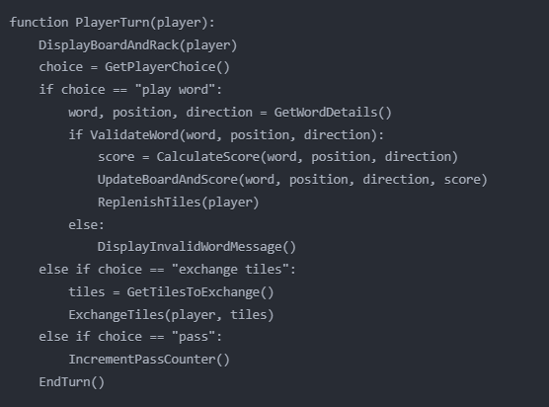
The word validation process pseudocode might look like this:
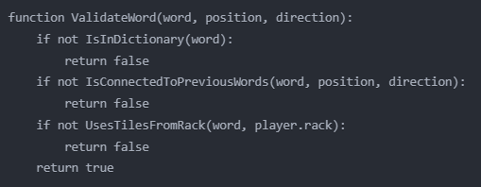
For the scoring calculation, the following pseudocode will be used:
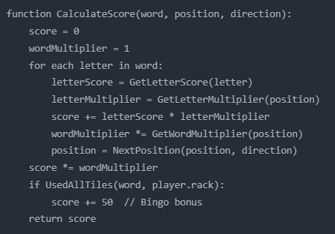
These pseudocode snippets outline the core logic for managing player turns, validating words, and calculating scores in our Scrabble algorithm. They provide a structured approach to implementing these key game processes.

Conclusion
This report has introduced the basic principles of the game Scrabble and identified the features that are most important for a computer version of the game using the MoSCoW method. We pinpointed essential variables and constants for the game’s digital implementation, described the general structure of the game algorithm in the form of a flowchart, and suggested a pseudocode for critical subprocesses. This report has been able to decompose the intricate game of scrabbles into several parts through this systematic method that has provided a firm base for creation of a digital version. The next steps would involve translating this design into actual code, with a focus on implementing the must-have features first, followed by should-have and could-have features as resources allow.

References
Ahmad, K.S., Ahmad, N., Tahir, H. and Khan, S. (2017) Fuzzy_MoSCoW: A fuzzy based MoSCoW method for the prioritization of software requirements. In 2017 International Conference on Intelligent Computing, Instrumentation and Control Technologies (ICICICT) (pp. 433-437). IEEE.
Edley, J. and Williams, J. (2009) Everything Scrabble. Simon and Schuster.
Hudaib, A., Masadeh, R., Qasem, M.H. and Alzaqebah, A. (2018) Requirements prioritization techniques comparison. Modern Applied Science, 12(2), p.62.
Khaira, M., Ritonga, M. and Halim, S. (2021) The effectiveness of scrabble game media in improving learning outcomes. In Journal of Physics: Conference Series (Vol. 1933, No. 1, p. 012128). IOP Publishing.
Kravchenko, T., Bogdanova, T. and Shevgunov, T. (2022) Ranking requirements using MoSCoW methodology in practice. In Computer Science On-line Conference (pp. 188-199). Cham: Springer International Publishing.
Maglio, P.P., Matlock, T., Raphaely, D., Chernicky, B. and Kirsh, D. (2020) Interactive skill in Scrabble. In Proceedings of the twenty-first annual conference of the cognitive science society (pp. 326-330). Psychology Press.
Puranik, C.S. and Lonigan, C.J. (2011) From scribbles to scrabble: Preschool children’s developing knowledge of written language. Reading and writing, 24, pp.567-589.
Purnama, D. and Putri, R.F. (2022) The Effect of Using Scrabble Games towards Students’ Achievement in Vocabulary. Indonesian Journal of ELT and Applied Linguistics, 1(2), pp.71-76.
Qatrunnada, F.H. and Zuhriyah, M. (2024) The Effectiveness of Using Scrabble Game to Teach Vocabulary. Pioneer: Journal of Language and Literature, 16(1), pp.18-31.
Sabila, I. and Niswa, K. (2023) Using Scrabble Word Game to Improve Students' Vocabulary Mastery. English Teaching and Linguistics Journal (ETLiJ), 4(1), pp.35-38.

Appendix




