Assignment 1 – Bev – Rhys Treharne

Here is my context diagram
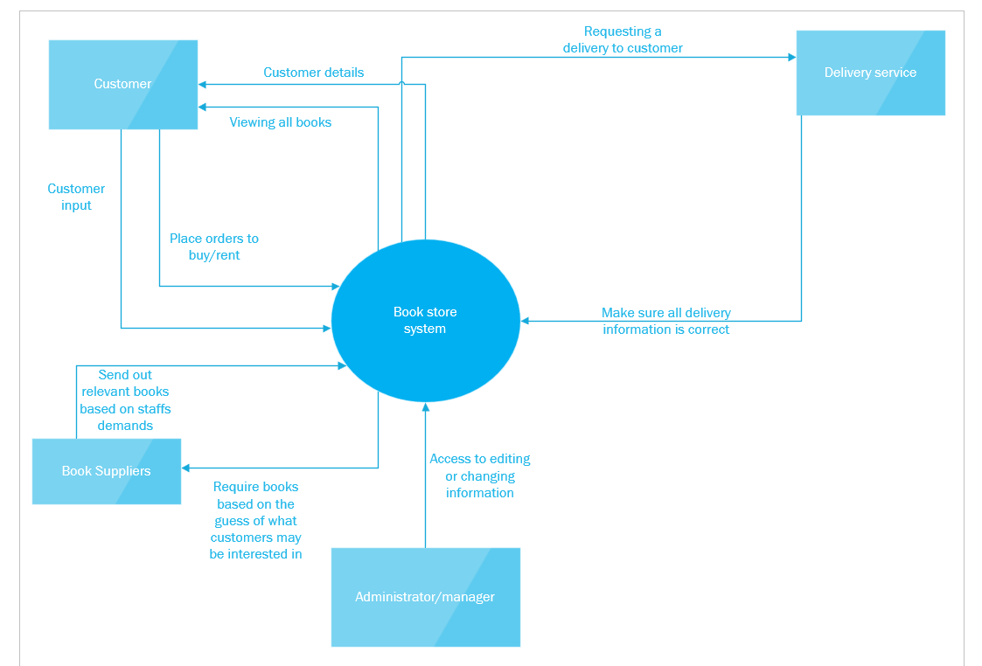

The purpose of the context diagram would be to map out the system. In the diagram you can see what areas of the system deals with what. As the related subject is the bookstore, here is how I have mapped out my idea for the bookstore system. To begin with the system would need to priorities the customers and the order requests. So, the user would input their details, and this would be implemented into the system. The user would be given the option to buy or rent the book, this would also be implemented into the system. In the specifications of the system requirements, it states that the bookstore places orders with external suppliers (from book collectors or publishers). So, there is going to have to be a section of the system that allows the staff to place orders for incoming books. Another important section would be the delivery service because we need this to be able to send off the orders to customers. The system will allow us to enter the customer details, address and what book is going out etc. There needs to be an administrator account that can have access to every section and can have access to add, delete and change any information.

Level 0 DFD
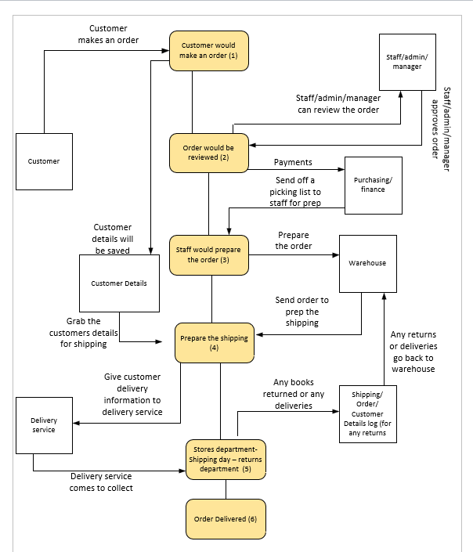

The purpose of the level 0 data flow diagram (DFD) is to understand how the process of the system will work. Another purpose of the level 0 data flow diagram is to not show the complicated side to the system, this diagram is meant to be simple for people to have a first grip on what the system is meant to do. At the beginning of the process, the customer would put through an order. This would include the customers details, if the customer requires the order to be delivered, they will need to enter their address/postcode etc. Once the customer has put their order through, the order will then be reviewed by a member of staff. Once they are satisfied with the order, the order will then be passed over to the finance department so they can deal with the payment side of the process. Once they have completed the payment aspects, they can then give an invoice and a picking list through, so they can start the prep work for the order. To start the prepare work they will need to access the warehouse/inventory to get what the customer requested. Once they have received the book requested, they can then move the order to the shipping/stores department. In this stage they will need to collect the customers details from the system, so the staff in stores can then put a request through with the delivery service for them to pick an order up and deliver to the required destination. The next stage would be then for the delivery service to come and collect the package and deliver accordingly. There is also a process for returns, once the returns have been returned it would go straight back through into the warehouse.

Entity relationship Diagram
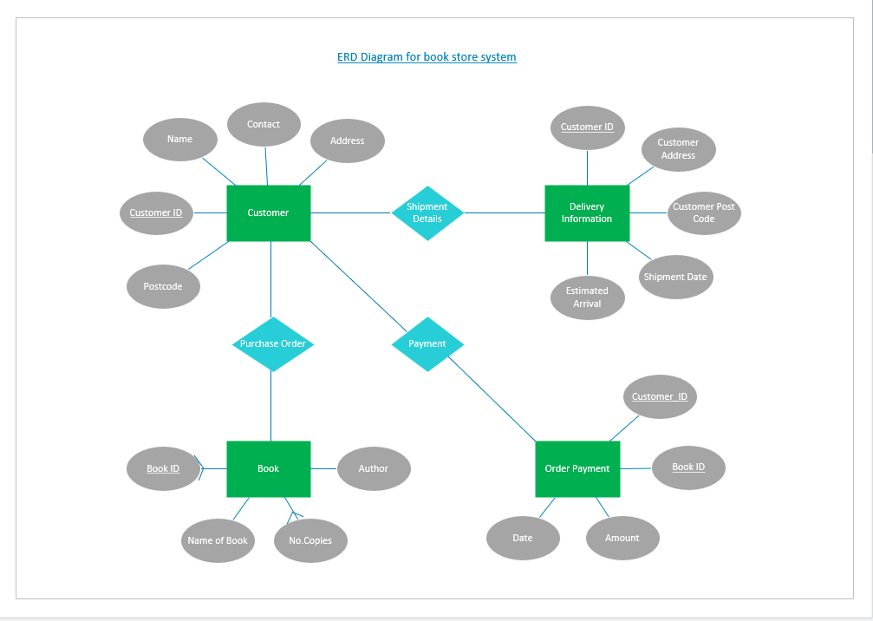

The diagram above is an entity relationship diagram. The purpose of this diagram is to show the entities and how the entities are linked across the database. You might find that you have an entity in one table, and you will find it in another table, these can be linked up by a relationship. There are 3 different types of relationships, you have one to one, one to many and many to many. The definition of one to one is when if you have two tables, you’ll only have the one record that relates to another. One to many is when there could either only be one relationship between the tables or there could be more. Many to many relationships is when there are multiple different relationships in between multiple tables. There are multiple relationships within the ERD diagram I have made, for example, Customer ID appears in a lot of the entities. The reason why they appear is because with a customer ID it can outline who’s linked with what order, delivery and payment. Another example would be the book ID, this appears in both entities which is Book and Order payment. This would help the member of staff understand which payment is related to which book.
The Final Database
Suitable Tables
Within the database I have created tables that holds information of customers, customer details, book search, delivery service, newsletter, orders and returns. The purpose of these tables is to control what the user can type. For example, look at this image below:
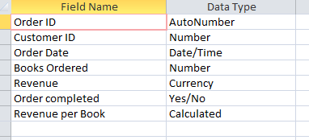
Within the data type this can control what the user can input. The idea of the system is, the tables were set up to control what the user inputs, then a form would be the interface the user uses to enter new data. These tables hold relationships, as you can see in the screenshot below:
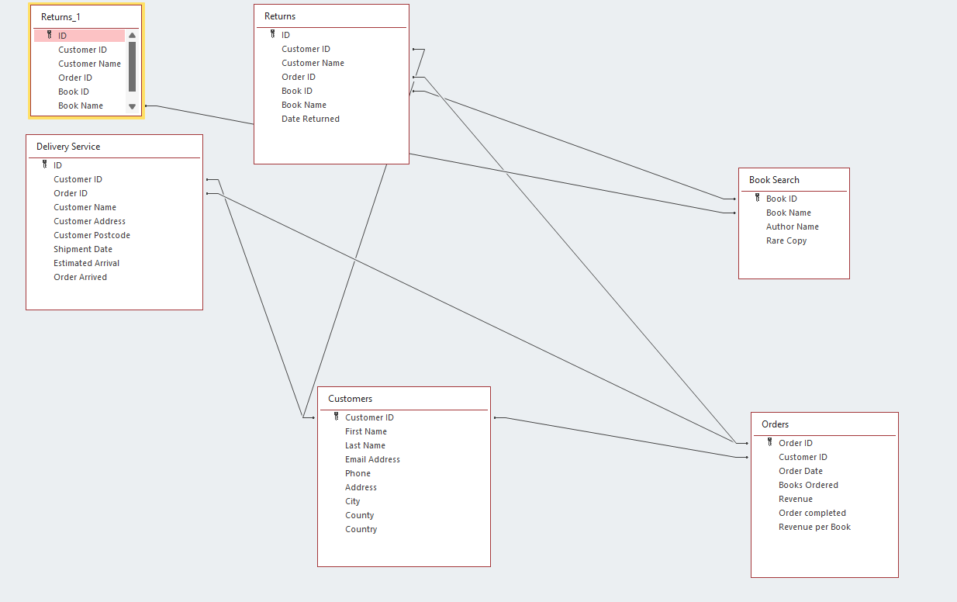
These are the main relationships; the purpose of these relationships is to show what data is linked with what. I have created suitable fields within the tables. This is an important part of the database because by the fields this will tell the user what to enter for any information. For each table, here are the fields and data types:
Book search:
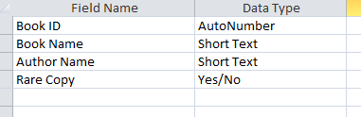
Customer Details Sheet:
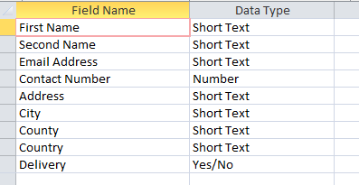
Customer:
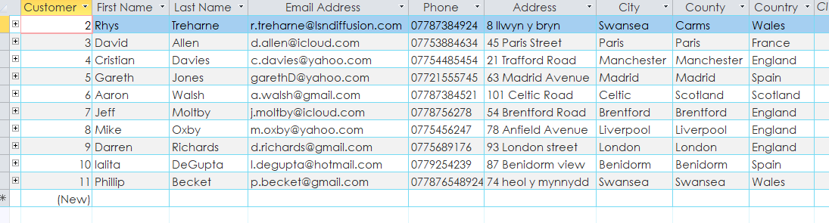
Delivery Service:
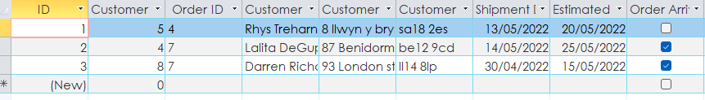
Newsletter:
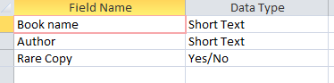

Returns:
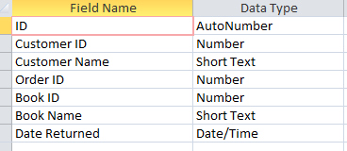
Foreign keys
Foreign keys are put in place to help have relationships between multiple tables. The benefit of having the foreign keys is that it can help prevent repeating data consistently, it saves the developer time. For example, the customer ID is a prime example because you can use the customer ID in my database to show that customers name etc. That customer ID can save time, its more beneficial for users of the database because instead of searching for their names etc, then inputting the information again, the customer ID can pull all of that information through the functions of foreign keys. Here is an example below:
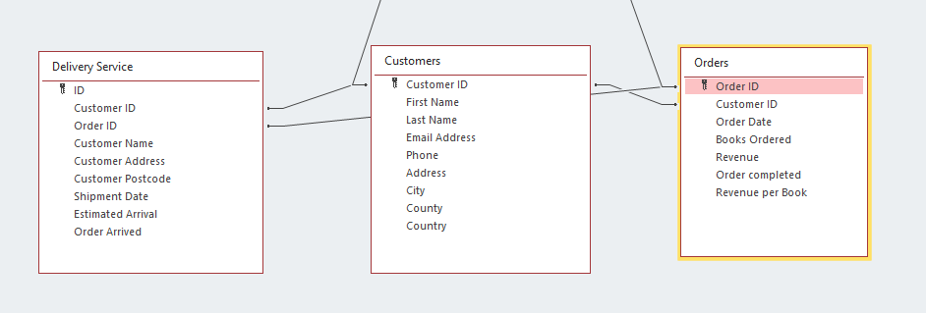
These three tables all link together because all the information is linked together across the 3 tables. For instance, an order needs to be shipped and the shipping department needs to check the shipping details are correct. So, they can use the customer ID or Order ID, and this will pull up the customer information and order information. Again, this saves the member of staff digging through customer names/orders to find the correct details, when they can just input the customer ID and order ID and grab the details from there within an instant.

Relationships
As I have explained what relationships are in the ERD diagram section above, I will continue with the relationships that are in place within my database. Within my tables there are multiple relationships that link tables with each other. I will show which fields links with which table below:
To begin with I will be highlighting the customers table, the customer ID field is the main filed within that table, as you can see the customer ID is linked with the orders table as the order table will need to know the customer ID, it is also linked with the delivery service as the delivery service will need to know the customer ID so they can make sure the right customer is linked with the delivery information. Also, the customer ID is linked with the returns because if a customer needs to return an order, we can see in the returns table which customer is returning what product.
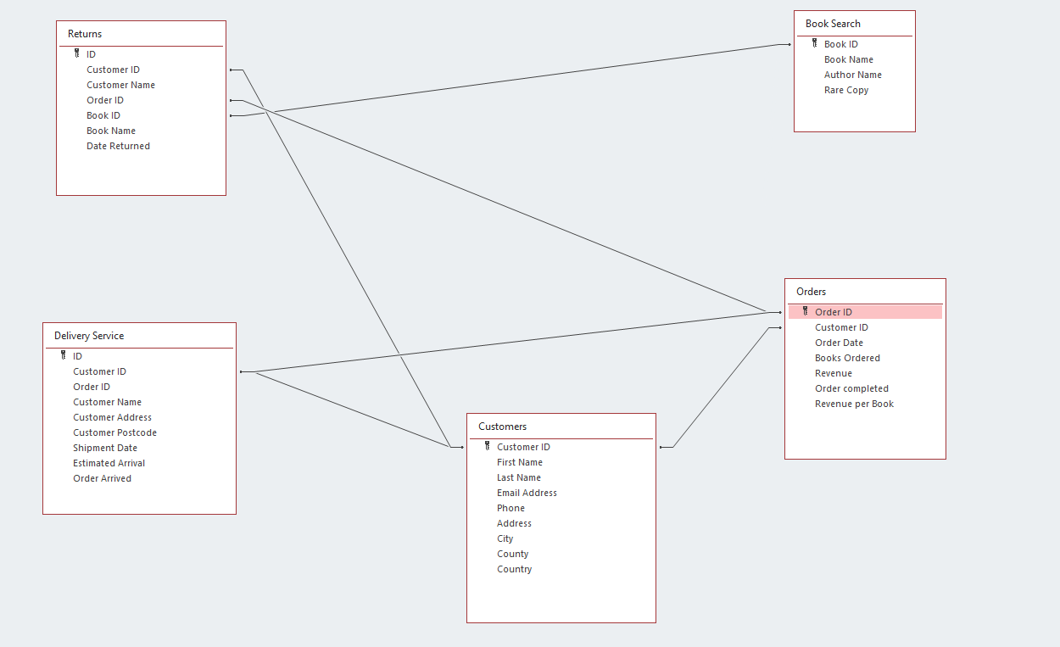

Next, I will be focused on the Delivery Service table. The Delivery service table is linked with the customer ID as they will need to know which customer is linked with what shipping arrangements. Delivery Service is also linked with the order ID, as the delivery service will need to know what they are shipping and to make sure the order is correct.

The next table we are looking at will be the Orders table. The orders table is a very important table because it will contain key information about the customer, product and revenue. The links that the order table link to are the customer ID because this will pull up any information on the customers information. It is also linked with returns, because if the customer wants to return anything they will need the order ID to retake the order back. The orders table is also linked with the delivery service table because when the order is ready to be shipped, they will need the order ID to make sure that they have the correct order.
The next table we will need to look at will be the Book Search table. The book search table is linked with the returns table, because if the customer wants to return a book, they can find the book by its book ID and all of the information about that book will appear, as it’s linked with the ID.
The final table we will look into is the Returns table. This table is about the ability for the customer to send a book back to the shop. The returns table is linked with the customer ID, this is because when the customer sends a request in for a book to be returned the customer ID can bring up the customers information. It is also linked with the book ID, so we can identify which book the customer will want to return. The final link will be the order ID. The member of staff will need to know where the book came from, how much the order came to and where the book is coming from.
Tables linked correctly
It is crucial that the tables are linked correctly because if they aren’t it will cause the database not to work correctly. An example of my tables working would be the order form in the database. I have linked the customer details table with the orders table. The reason why I did this was because it can save time inputting data repeatably, and it allows member of staff to see two sets of relevant data in one form and there is a report for this form available too. Here is the form below:
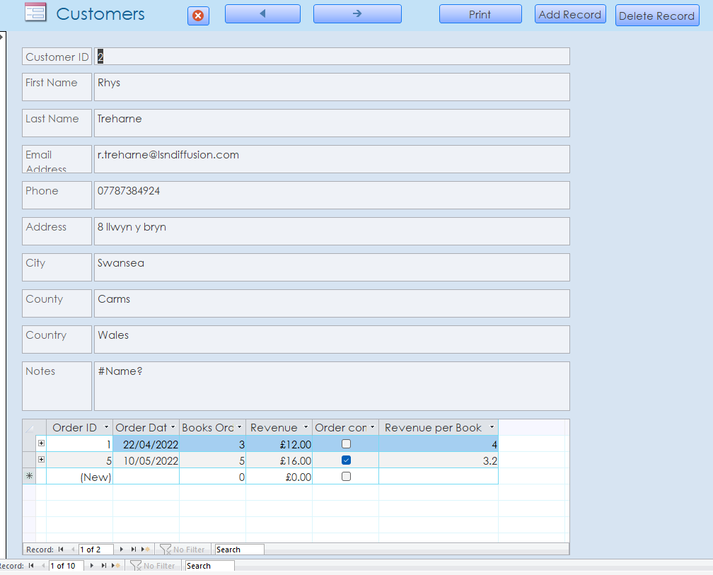
As you can see in the screenshot above, this form allows the user to create new records or delete any records. The user can input new customer details and input any new orders coming through. This is why it’s important for the tables to be linked correctly because when they are it makes the system much more user friendly to use.

Design meets user requirements
Here are the user requirements:
- Staff place orders with suppliers (publishers and collectable book dealers). This is carried out mainly by intuition and guessing what the customers may be interested in.
- Customers will also place orders for copies of books, both popular titles and rare first editions.
- They have many customers outside the Swansea area and for many years they have operated a mail order service. The release a newsletter once every three months, detailing current interesting stock etc.
- They have on small computer used for word processing and what could loosely be termed as a data base (a collection of names and addresses of customers typed into one document which isn’t update regularly)
[1]

- Staff place orders with suppliers

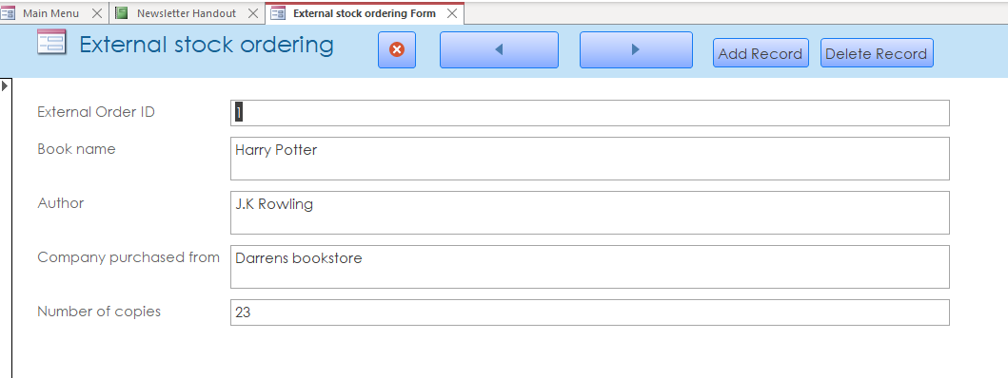
Here is where staff can place orders to bring in book stock. This can also be viewed in a report:

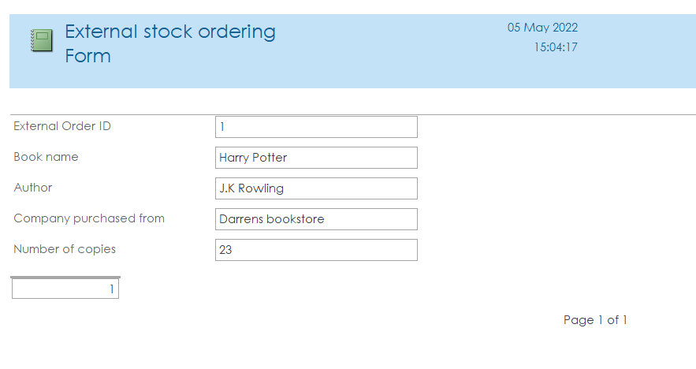

- Customers can place orders
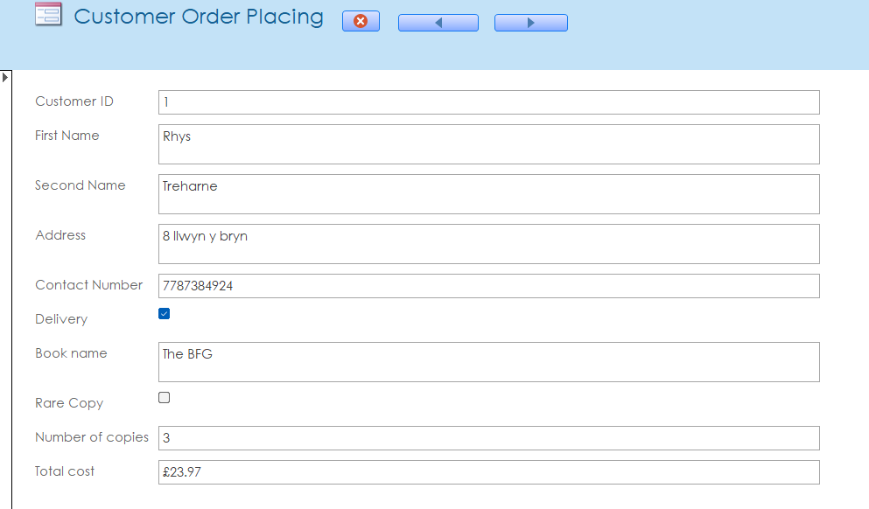
Here is where customers can place orders, they input their information in, and it will do a calculation at the end giving them the total cost.
This can also be put into a report for staff to use:
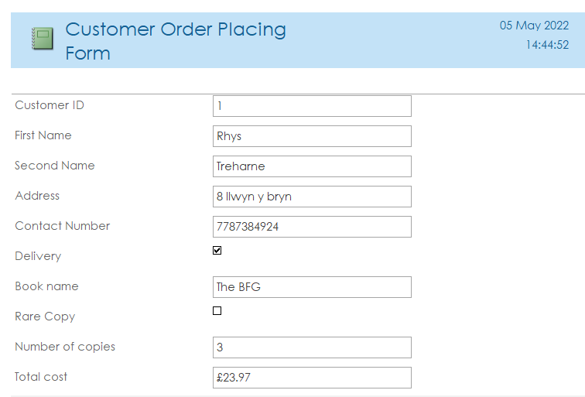

- Mail service

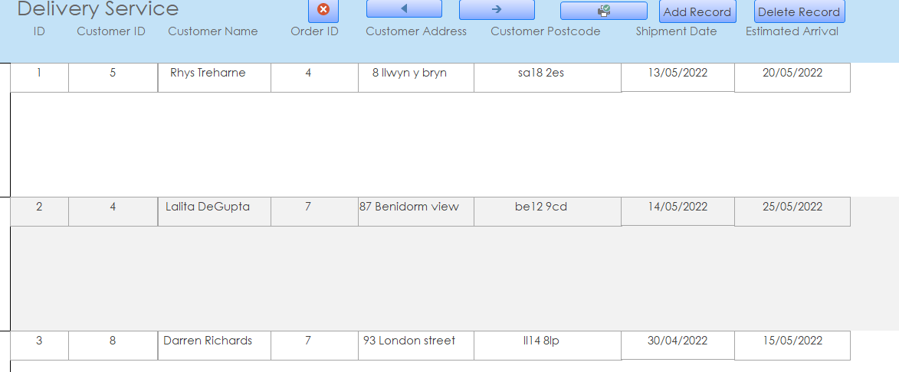
Delivery service where users can add, edit and delete deliveries. This can also be viewed in a report too:
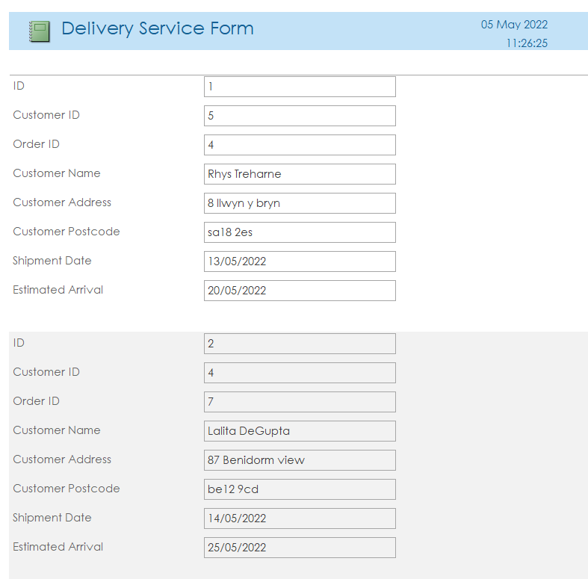

- Collection of Names and Addresses
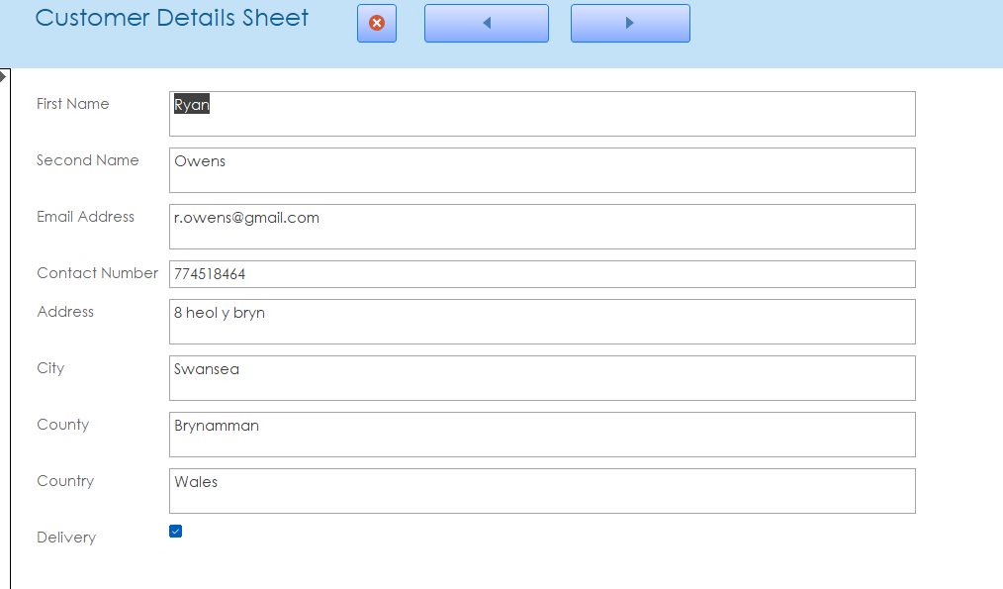
This will allow the staff to see the customer details section, this will allow the staff member to flick through customer details that are saved. This can also be viewed in a report:
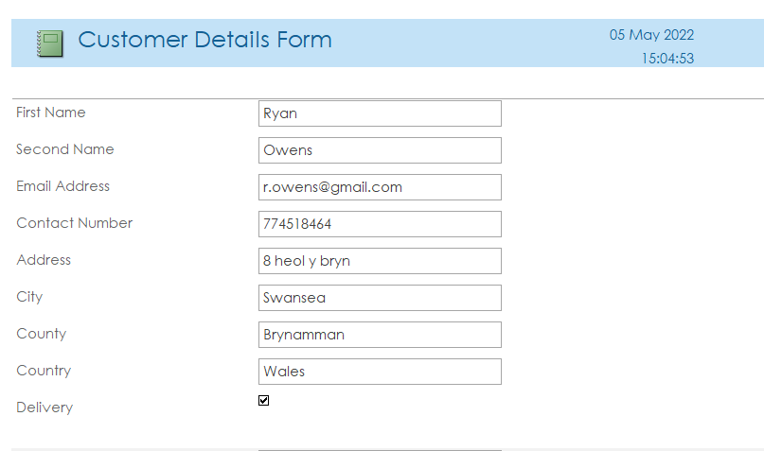

Reference for the image I used in the bookstore menu: [2]

Bibliography

[1] | B. Holland, "Assessment specification," [Online]. [Accessed 5 May 2022].
[2] | "Image of cartoon books," [Online]. Available: https://png.pngtree.com/png-clipart/20190117/ourlarge/pngtree-cartoon-book-notes-stationery-png-image_424364.jpg. [Accessed 5 May 2022].

