University of Wales Trinity Saint David
Wales Institute of Science and Art


2D Diffusion Equation Model Using the Explicit Finite Difference Method

Computational Methods | ACMA6012

Morgan Davies
2205285
April 2025

Contents

1 Introduction 2
2 The Constitutive Equation of the Problem 3
3 Explicit Finite Difference form of the Equation 4
4 The Initial Boundary Conditions and Analytical Solution 5
5 Code Details and Explanations 6
6 Validation of the Model 7
7 Sensitivity Analysis 10
7.1 Grid Spacing 10
7.2 Time Step 12
7.3 Tolerance 14
8 Model Limitations 15
8.1 Numerical Limitations 15
8.2 Code Limitations 16
9 Future Developments 16
10 Conclusion 17
11 Reference List 18
12 Appendix 19

Introduction
This report presents a numerical study of transient heat conduction through a two-dimensional aluminium plate using the Explicit Finite Difference Method (EFDM). The simulation, implemented in MATLAB, models heat transfer under user-defined parameters such as grid spacing and time step, along with specified boundary conditions. The aluminium plate is defined by its thermal conductivity, specific heat capacity, and density. EFDM is used to approximate the temperature distribution over time, with results validated against an analytical solution at thermal equilibrium derived from the same boundary conditions.
The report is structured into the following sections: the governing heat equation, discretisation using EFDM, boundary and initial conditions, detailed code explanation, model validation, sensitivity analysis, limitations, and suggested improvements. The main aim is to develop a computational model that accurately simulates the temperature distribution and determines the time taken to reach equilibrium. Primary objectives include maintaining numerical stability, visualising the temperature distribution through contour maps, validating results against analytical solutions, and examining the impact of numerical errors such as truncation and round-off. This structured approach allows for a thorough evaluation of the model’s performance and highlights areas for refinement.

The Constitutive Equation of the Problem
Heat conduction is a process by which thermal energy is transferred through a material due to a temperature gradient, from a hot region to a colder region. In solid materials, such as metals, heat conduction is the primary mode of heat transfer. The equation that describes heat conduction in a medium is the heat equation. The governing equation is a partial differential equation (PDE) which was first formulated by Jean-Baptiste Joseph Fourier in 1807, during the composition of his memoir titled The Propagation of Heat in Solid Bodies which was submitted to the Paris institute on December 21st within that same year (Advancing Physics, 2024).
The heat equation is used to mathematically describe how temperature changes within a material over time due to thermal conduction. It provides an analytical method to predict the temperature distribution within a space and time period, based on a material’s properties and set boundary conditions of a system. The heat equation is essential to engineers as it enables the simulation and analysis of thermal behaviour in solid structures. This is utilised in numerous applications of engineering, which includes thermal management in electronics, structural safety assessments under thermal loading, and the design of heat exchangers and insulators. In this study, heat transfer is modelled by a two-dimensional transient conduction problem within an aluminium plate with specified boundaries. These include fixed temperatures at the north (top) and south (bottom) edges and insulated conditions at the east and west boundaries. The typical form of the two-dimensional heat equation is:
$$\frac{∂^{2}T}{∂x^{2}}+\frac{ ∂^{2}T}{∂y^{2}}=\frac{ρ∙cp}{k}.\frac{∂T}{∂t}$$
Equation 1.0- The Heat Equation (Chang and Ma, 2001)
Where $T$ is the temperature, $t$ is time, $x$ and $y$ are spatial coordinates and α is the thermal diffusivity of the plate calculated by the following:
$$α=\frac{k}{ρC_{p}}$$
Equation 1.1- Thermal Diffusivity Equation

Usually, analytical solutions are used to carry this out using similar equations to equation 1.0, however, using a numerical method such as MATLAB is a much more efficient way to implement a similar outcome. The partial differential equation being solved in this study is the heat equation shown in equation 1.0. The definitions of each component of the equation is shown where: $T(x,y,t)$ is the temperature distribution over a specific time and space, $ρ$ is the density (kg/m3) of the aluminium plate, $cp$ is the specific heat capacity (J/Kg.K) of the plate and $k$ is the thermal conductivity (W/m.K) of the plate. These physical properties determine the plate’s thermal diffusivity α, which influences how quickly heat spreads through the material. The accuracy and stability of the numerical solution depends on correctly applying boundary and initial conditions and selecting suitable user defined parameter inputs. This model follows appropriate heat conduction theory which assumes isotropic, homogeneous material behaviour, as described in previous work such as the Fundamentals of Heat Transfer by Incropera et al. (2016).

Explicit Finite Difference form of the Equation
To numerically solve the two-dimensional transient heat conduction problem described by the heat equation, an explicit finite difference method (EFDM) is implemented. The starting point for the discretisation process, ensuring MATLAB implementation of the heat conduction problem, is the Taylor series expansion. This expansion is used to approximate the partial derivatives to the first and second order, which are required to discretise the heat equation. Using the Taylor series the forward, backward and central differences can be derived. In this study, the forward difference approximation is used to discretise the initial temporal derivative, and the central difference approximation is used to discretise the second order spatial derivatives. These approximations are necessary to formulate the finite difference expressions used in the code. The EFDM scheme replaces the temporal first derivative in the heat equation by using a forward difference approximation and the spatial derivatives in the heat equation are replaced by central differences. Substituting in the Fourier number, this produces the formula:
$$T_{P}^{t+∆t}=Fo(T_{E}^{t}+T_{W}^{t}+T_{N}^{t}+T_{S}^{t}-\left(4-\frac{1}{Fo}\right).T_{P}^{t})$$
Equation 2.0- Explicit Finite Difference Formula (Vreugdenhil, 1989)

This discretised form of the EFDM is implemented in the MATLAB code, where the indices represent spatial location and denotes the time step. To discretise the spatial domain, the plate is divided into a uniform set of grid points based on a user defined parameter. This should be chosen to provide a structured mesh to suitable for numerical computation, while also remaining small enough to accurately compute the behaviour of the solution. Furthermore, to discretise the temporal domain, the time interval is divided into a sequence of discrete time steps. A suitable time step chosen by the user should be proportional to the grid spacing used and small enough to maintain the stability of the solution. This is carried out by ensuring a condition in the MATLAB code based on the Fourier number, that the time step input cannot be greater than the maximum time step allowance shown by the formula:
$$dTmax=\frac{h^{2}}{4×α}$$
Equation 2.1- Fourier Number Calculation

The Initial Boundary Conditions and Analytical Solution
To numerically solve the heat equation, boundary conditions must be applied. This model uses both Dirichlet and Neumann conditions to define the thermal environment. Dirichlet conditions are applied to the north and south boundaries, where the user inputs the temperature at the north edge. The code then mirrors this by assigning the negative of that value to the south edge, for example, a north input of 50°C results in –50°C at the south. Although not a typical physical setup, this configuration creates a clear vertical temperature gradient and supports symmetrical comparison with the analytical model. Applying the same conditions to both numerical and analytical models ensures that any differences arise from numerical error rather than inconsistent boundaries. Neumann conditions are applied to the left and right edges of the plate to simulate insulation, maintaining a zero heat flux. In the code, this is handled using ghost nodes: at the left boundary (j = 1), the value T1(i, j-1) is replaced with T1(i, j+1); at the right (j = NC), T1(i, j+1) is replaced with T1(i, j-1). This mirrors the internal temperatures across the boundaries and enforces an adiabatic condition (see figure 1.0).

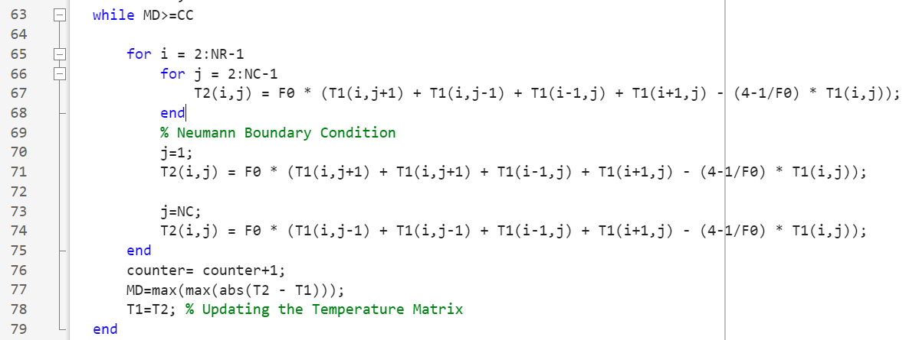
Figure 1.0- MATLAB Code Showing Neumann Boundary Conditions

These boundary conditions are applied consistently in both models to ensure direct validation. As a result, any discrepancies in output can be assumed to be due to numerical limitations such as round-off or truncation errors, rather than boundary inconsistency. These same boundary conditions are also used in the analytical solution, shown in equation 3.0. This solution, derived from the 2D heat equation using a Fourier series, provides a method for validating the numerical model. Once equilibrium is reached in the simulation, temperature results are compared directly with the analytical output. Contour plots and error matrices reveal the degree of agreement, helping assess how well the numerical method approximates the analytical solution under ideal conditions.

$$T\left(x,y\right)=T0+\frac{2.T0}{Ydim}.y+\sum_{k=100}^{∞}{(\frac{1}{100.k.π}.\left[1-{\left(-1\right)}^{k}\right].\frac{\sin\left(\frac{k.π.y}{Ydim}\right)}{\sinh\left(\frac{k.π.Xdim}{Ydim}\right)}.\left[\cosh\left(\frac{k.π.x}{Ydim}\right)-\cosh\left(\frac{k.π.\left(x-Xdim\right)}{Ydim}\right)\right])}$$
Equation 3.0- Analytical Solution of Temperature at Thermal Equilibrium (Chang and Ma, 2001)

Code Details and Explanations
The code used to simulate temperature distribution, shown in the appendix, solves two-dimensional heat conduction using an explicit finite difference method (EFDM). The process begins by clearing the MATLAB environment using clc, clear, and close, ensuring previous variables and figures do not interfere with the new simulation. The thermal properties of the aluminium plate, thermal conductivity, density, and specific heat capacity are then defined and used to calculate thermal diffusivity.
User-defined parameters follow, including the plate’s X and Y dimensions and the grid spacing, which determines spatial resolution. Input validation is performed using while loops to ensure values are positive and compatible with the discretisation process. The final set of user inputs consists of the boundary temperature and time step. The time step must satisfy the explicit method’s stability condition, validated using the rearranged Fourier number formula:
$dT=\frac{h^{2}}{4×α}$
Equation 4.0- Re-arrangement of Fourier’s Equation
Where h, dT and α are grid spacing, time step and thermal diffusivity respectively.
Once inputs are confirmed, the code calculates the number of nodes in both directions and initialises a temperature matrix (T1) using the zeros function. Dirichlet boundary conditions are then applied: the north edge is fixed at T0, and the south at –T0, creating a vertical temperature gradient. The EFDM is implemented within a while loop that updates internal nodes based on surrounding values. Neumann boundary conditions are applied to the east and west edges, assuming insulation by mirroring adjacent nodes. The loop runs until convergence is reached, defined as the point where the maximum absolute difference between iterations (T2 – T1) falls below a threshold (0.01), balancing accuracy and computational time. Once equilibrium is achieved, the resulting temperature field is visualised using a contour plot with jet colour mapping. To validate the numerical model, an analytical solution based on a Fourier series is also computed, allowing comparison between numerical and theoretical temperature distributions.

Validation of the Model
To validate the numerical model, the code uses the analytical solution, based on a Fourier series approach. It uses nested loops to generate the theoretical temperature distribution at equilibrium, calculated at every node in the grid. This solution assumes ideal boundary conditions and provides a comparison with the numerical results for validation. Fabbri (2011), used a similar method when validating the heat transfer model when simulating a hot-air-based treatment for an eggshell using a simplified finite element model, which highlights the importance of comparing calculated and expected theoretical results to a numerical model to assess the accuracy of the 2D numerical simulation used in their study (FABBRI, et al., 2011). The numerical solution of the aluminium plate is shown in figure 2.0 and the analytical solution in figure 2.1, showing the maps contain a smooth temperature gradient from high to low temperatures along the vertical axis, indicating that the EFDM successfully captures the overall heat flow trend. The maximum temperature difference between the two matrices is achieved using a 5mx5m plate, a grid spacing of 1m, boundary temperature of 50˚C, a time step of 3600 seconds and tolerance of 0.01. The contour plot of the temperature difference shown in figure 2.2 shows that the maximum temperature difference occurs at row nodes 2m and 5m, and the maximum difference was calculated to be 0.0174˚C. This miniscule difference in maximum temperature difference validates the numerical model and implies it is suitable to be used as a simulation as it isn’t a large difference when compared to the analytical model.
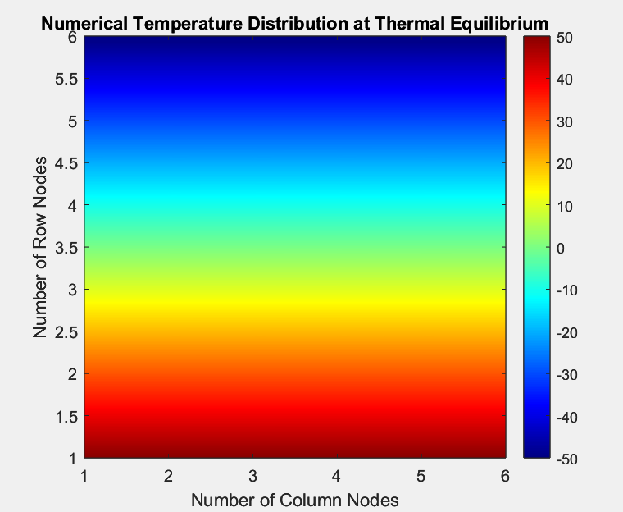
Figure 2.0- Numerical Temperature Distribution
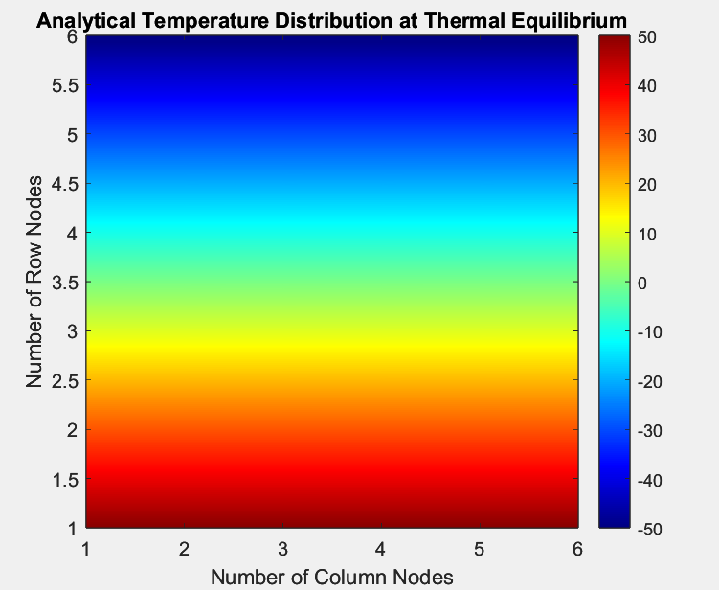
Figure 2.1- Analytical Temperature Distribution

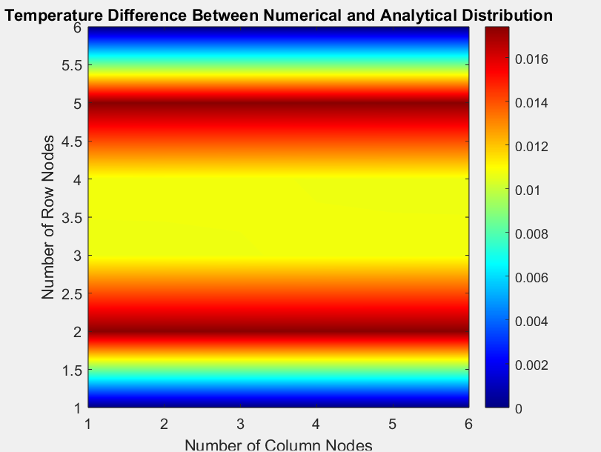
Figure 2.2- Error Between Numerical and Analytical Solution

Sensitivity Analysis

Grid Spacing
A sensitivity analysis of the grid spacing was carried out to assess the impact of the grid spacing on the time taken for the plate to reach thermal equilibrium. This is carried out using a 12x12m plate, while keeping a boundary temperature of 50˚C, a time step of 150 seconds and a maximum tolerance (convergence criterion) of 0.001˚C constant. The time taken to reach thermal equilibrium is shown in table 1. Figure 3.0 highlights that as the grid spacing increases, the time taken to reach thermal equilibrium increases also. This is because increasing the grid spacing, increases the node count which results in increasing temperature values being calculated by MATLAB per iteration. This leads to longer runtimes as the simulation takes more steps to reach thermal equilibrium. Larger grids compute more quickly due to fewer nodes; however, they capture thermal gradients less accurately. A fixed time step and convergence threshold further influence this, as finer grids produce smaller temperature changes, requiring more iterations to meet convergence.
Although the time step is selected to satisfy the explicit method’s stability condition $∆t{≤ }_{4∝}^{h^{2}}$​​, finer grids still require significantly more iterations. This is demonstrated by the increase in time to reach equilibrium as spacing narrows from 4.0 m to 0.5 m, with the most significant rise between 2.0 m and 3.0 m. However, within 0.5 m the accuracy improvements diminish, which highlights a fundamental trade-off between computational efficiency and numerical accuracy. This trade-off reflects guidance from literature such as Ferziger Milovan Peric (2002) and Almohammadi, K.M (2013), who highlight the importance of optimising the mesh design for performance and stability. The results confirm the model’s robustness and its suitability for engineering applications.

Table 1- Table of Sensitivity on Grid Spacing
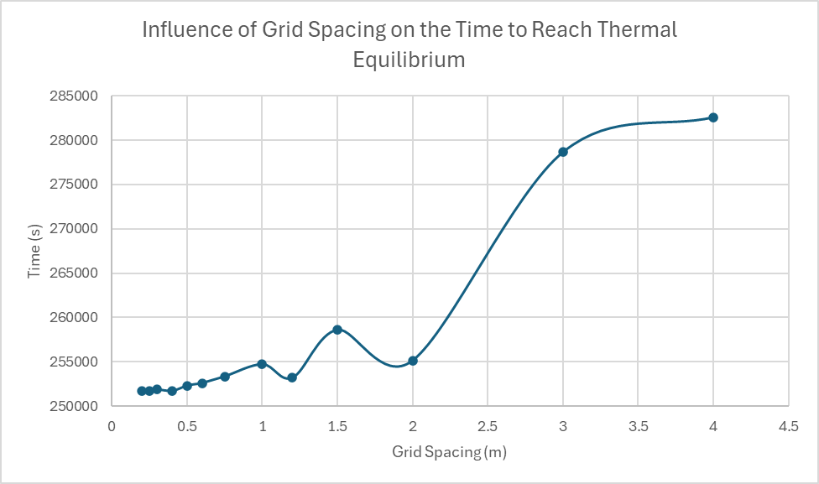
Figure 3.0- Graph showing Sensitivity of Grid spacing

Time Step
A sensitivity analysis of the time step was carried out to assess the impact on the time taken for the plate to reach thermal equilibrium. This is carried out using a 12x12m plate, while keeping a boundary temperature of 50˚C, a grid spacing of 0.75m and a maximum tolerance (convergence criterion) of 0.0001˚C constant. The time taken to reach thermal equilibrium is shown in table 2. Figure 3.1 shows that as the time step increases the time to reach thermal equilibrium increases at a decreasing rate, highlighting a trend that follows a nonlinear, asymptotic curve, where increases in the time step result in progressively increasing smaller gains in computational efficiency.
This analysis highlights how time step size impacts the performance of the explicit finite difference method. Larger time steps reduce temporal resolution, introducing greater numerical errors and slowing convergence due to increased oscillations and numerical diffusion. However, smaller time steps improve accuracy and allow the simulation to reach thermal equilibrium more efficiently, although more iterations are required. The explicit method's first-order accuracy in time makes it particularly sensitive to step size, as stated by Ferziger Milovan Peric (2002), who advises against excessively large steps that degrade solution quality. Despite all tested time steps being stable, convergence becomes less efficient at higher values. The results indicate that time steps below 400 seconds significantly improve convergence, with diminishing returns observed under approximately 100 seconds (see figure 3.1). Therefore, a range between 100 and 400 seconds can be assumed to be a suitable balance between accuracy, stability, and computational efficiency. These findings align with established principles in heat transfer modelling, highlighting the importance of selecting appropriate time steps for reliable and efficient transient simulations.

Table 2- Table of Sensitivity on Time Step

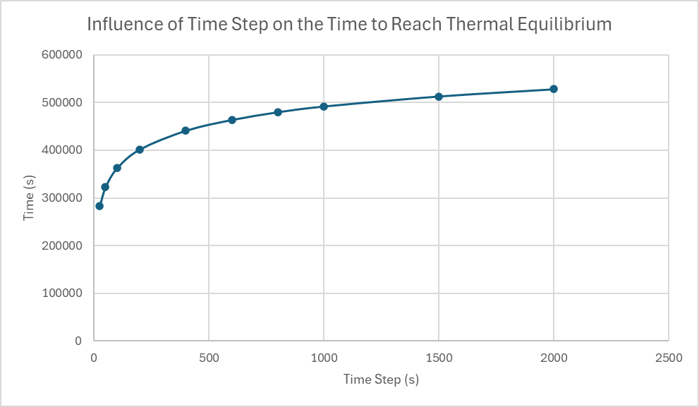
Figure 3.1- Graph showing Sensitivity of Time Step

Tolerance
A sensitivity analysis of the time step was carried out to assess the impact on the time taken for the plate to reach thermal equilibrium. This is carried out using a 12x12m plate, while keeping a boundary temperature of 50˚C, a grid spacing of 1m and a time step of 500 seconds constant. The time taken to reach thermal equilibrium is shown in table 3. Figure 3.2 shows that as the tolerance increases when near zero to 0.01, the time to reach thermal equilibrium decreases sharply from 723500 seconds to 324000 seconds. The time till equilibrium then decreases at a steady rate until a tolerance of 0.01 is reached. This behaviour highlights the nature of iterative solvers in finite difference methods. Stricter tolerances require smaller differences between temperature values in successive iterations, which increases the number of iterations and prolongs the simulated time to reach equilibrium. While this enhances accuracy, it significantly raises computational cost, especially in the final stages when temperature changes are minimal. As Ferziger Milovan Peric (2002) demonstrate, overly strict criteria can result in diminishing accuracy gains. The data shows a plateau at tolerances of 0.01 and 0.001, where further refinement does not reduce iteration count, indicating sufficient accuracy was already achieved. Only tolerances below 0.0001 lead to noticeable increases in simulation time.

Table 3- Table of Sensitivity on Tolerance
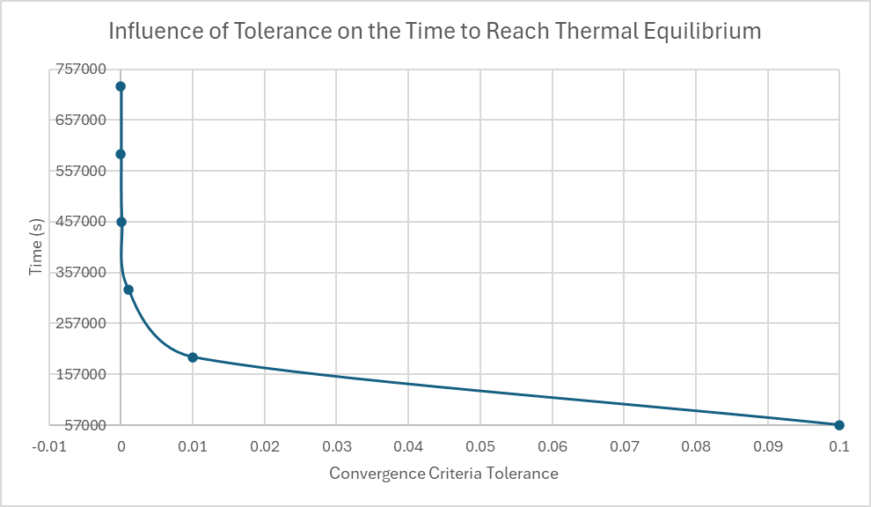
Figure 3.2- Graph showing Sensitivity of Tolerance

Model Limitations

Numerical Limitations
The limitation of the simulation is in the explicit finite difference method. Although it’s simple to implement, this method is highly likely to produce round-off errors due to limited computational precision. Over many iterations, particularly when small time steps or strict convergence tolerances are used, these small discrepancies can accumulate and affect overall solution accuracy, as highlighted by Smith (1985). Truncation error is another numerical drawback. This error results from approximating derivatives using finite differences, reducing solution reliability. The method applied in this study offers first-order temporal and second-order spatial accuracy, which may not be suitable to capture sharp thermal gradients or fast transient solutions.
Furthermore, the model assumes a rectangular geometry with uniform grid spacing. This restricts its applicability to real-world domains, excluding realistic geometries with curves or irregular features. Ferziger Milovan Peric (2002) states that more complex shapes often require unstructured or adaptive meshes, which is something not supported by traditional finite difference methods. Lastly, the explicit method is bound by a strict stability condition: ${dt≤}_{4α}^{h^{2}}$ ​, where h is the spatial step and α is thermal diffusivity. This limits the allowable time step, especially for fine grids, and often imposes simulations to run with small time steps, which can significantly increase runtime. Unlike implicit schemes, explicit methods require careful parameter selection to maintain stability without compromising efficiency (Smith, 1985).

Code Limitations
In addition, multiple code limitations are produced from the implementation of the thermal convergence logic. In this study, thermal equilibrium is assumed when the maximum absolute difference between two successive temperature matrices falls below a fixed tolerance. Although this is convenient during programming, it does not necessarily represent true thermal equilibrium, which is defined by a stable, time-independent temperature distribution.
The use of a single global tolerance also introduces rigidity. If the tolerance is too strict, the simulation may continue long after practical equilibrium has been reached, which reduces computational efficiency and increases the necessary time to solve the simulation. However, a high tolerance may cause premature termination, missing critical results in thermal distribution. This uniform criterion is applied across the entire plate, despite varying local behaviour. As Ferziger Milovan Peric (2002) suggests, more advanced solvers use adaptive or region-specific convergence checks to reflect spatial variation more accurately. Together, these coding simplifications, while functional, reduce the physical realism and efficiency of the simulation, particularly in more demanding industrial applications.

Future Developments
To improve the accuracy and practicality of the current heat conduction model, several improvements can be made. One major drawback of the explicit finite difference method is its conditional stability, which imposes the use of small time steps and increased runtime. This could be resolved by implementing an implicit method such as the Alternating Direction Implicit (ADI) scheme or a fully implicit formulation, both of which are unconditionally stable and allow larger time steps without reducing the accuracy. Smith (1985) highlights the ADI method as particularly efficient for two-dimensional transient problems.
The model’s use of a structured grid also limits its ability to simulate complex geometries. This could be addressed by adopting more flexible numerical methods like the Finite Element Method (FEM), Finite Volume Method (FVM), or Boundary Element Method (BEM). FEM is useful for handling irregular domains and variable material properties, FVM ensures conservation laws are met in heat and fluid flow, and BEM is suited for infinite or semi-infinite domains with reduced computational cost (Majumdar, 2020). Additionally, the current convergence check oversimplifies thermal equilibrium. A more physically meaningful approach, such as a residual-based or energy-balance criterion, would better reflect true equilibrium across the domain (Li et al., 2015).

Conclusion
This report successfully developed and analysed a two-dimensional heat conduction model using the Explicit Finite Difference Method, implemented in MATLAB. The model simulated transient thermal distribution in an aluminium plate by applying user-defined parameters and set boundary conditions, with validation achieved through comparison to a derived analytical solution. Results from both the numerical and analytical models demonstrated strong agreement, confirming the reliability and stability of the EFDM when applied under suitable conditions. A detailed sensitivity analysis highlighted the influence of grid spacing, time step, and convergence tolerance on model performance, highlighting trade-offs between computational efficiency and numerical accuracy. The results supported existing literature and reinforced the importance of optimal parameter selection for stable and precise simulations.
Despite its effectiveness, the model is limited by the constraints of the EFDM, including round-off and truncation errors, rigid geometry handling, and strict stability requirements. Simplified convergence criteria also introduced limitations in representing true thermal equilibrium. Future improvements should focus on implementing implicit schemes, using flexible numerical methods like FEM or FVM, and incorporating more physically representative convergence checks. Overall, this study provides a solid method for simulating heat transfer problems and offers potential future development in both academic and industrial contexts.

Reference List
- Advancing Physics (2024). March 21, 1768: Birth of Jean-Baptiste Joseph Fourier. [online] Aps.org. Available at: https://www.aps.org/archives/publications/apsnews/201003/physicshistory.cfm [Accessed 08/04/2025].
- Almohammadi, K.M., Ingham, D.B., Ma, L. and Pourkashan, M. (2013). Computational fluid dynamics (CFD) mesh independency techniques for a straight blade vertical axis wind turbine. Energy, 58, pp.483–493. doi:https://doi.org/10.1016/j.energy.2013.06.012.
- Chang, C.-Y. and Ma, C.-C. (2001). Transient thermal conduction analysis of a rectangular plate with multiple insulated cracks by the alternating method. International Journal of Heat and Mass Transfer, 44(13), pp.2423–2437. doi:https://doi.org/10.1016/s0017-9310(00)00292-1.
- Ferziger Milovan Peric. (2002). 111ferzigerperic2002computationalmethodsforfluiddynamics.
- FABBRI, A., CEVOLI, C. and GIUNCHI, A. (2011). VALIDATION OF A SIMPLIFIED NUMERICAL MODEL FOR HOT-AIR TREATMENT OF EGG SHELL SURFACE. Journal of Food Process Engineering, 35(5), pp.695–700. doi:https://doi.org/10.1111/j.1745-4530.2010.00615.x.
- Hughes, T. (2021). The finite element method : linear static and dynamic finite element analysis : Hughes, Thomas J. R : Free Download, Borrow, and Streaming : Internet Archive. [online] Internet Archive. Available at: https://archive.org/details/finiteelementmet0000hugh/page/n707/mode/2up [Accessed 06/05/2025].
- Incropera, F, et al. (2016). Fundamentals Of Heat And Mass Transfer Frank P Incropera : Free Download, Borrow, and Streaming : Internet Archive. [online] Internet Archive. Available at: https://archive.org/details/FundamentalsOfHeatAndMassTransferFrankPIncropera/page/n1/mode/2up?view=theater [Accessed 06/05/2025].
- Li, J., Yu, B., Zhang, X. and Wang, Y. (2015). An improved convergence criterion based on normalized residual for heat transfer and fluid flow numerical simulation. International Journal of Heat and Mass Transfer, [online] 91, pp.246–254. doi:https://doi.org/10.1016/j.ijheatmasstransfer.2015.07.106.
- Majumdar, A. (2020). 50 years of CFD in Engineering Science, A Commemorative Volume in Memory of D. [online] Springer. Available at: https://www.nasa.gov/wp-content/uploads/2024/04/gfssp-finitevolumeprocedureforthermofluidsystem-2020.pdf [Accessed 06/05/2025].
- Smith, G. D. (1985). Numerical Solution of Partial Differential Equations. Science Research, 3.
https://doi.org/10.1017/CBO9780511812248
- Vreugdenhil, C.B. (1989). Explicit Finite-Difference Methods. Springer eBooks, pp.23–29. doi:https://doi.org/10.1007/978-3-642-95578-5_5.

Appendix
clc
clear
close all
format short

%% Defining Properties of Aluminium Plate
kc= 143;
rho= 2800;
SH= 795;
TD= kc/(rho*SH);

%% User Inputs For Spatial Consideration
% X and Y Dimensions
Xdim= input('State the x dimension of the plate in metres: ');
Ydim= input('State the y dimension of the plate in metres: ');

while Xdim <= 0 || Ydim <= 0
disp('Your x and y coordinates need to be a positive number');
Xdim = input('State the x dimension of the plate again: ');
Ydim = input('State the y dimension of the plate again: ');
end

% Grid spacing
h= input('State the grid spacing (h) of the plate in metres: ');

while h <=0 || h >= Xdim || h>=Ydim || rem(Xdim, h)~=0 || rem(Ydim, h)~=0
disp(['Your h value needs to be a positive number, less than the x and y dimensions ' ...
'and x and y values need to be directly divisible by h value: ']);
h= input('State the grid spacing (h) of the plate again: ');
end

%% Computing the Number of Rows and Columns
NR= round(Ydim/h+1);
NC= round(Xdim/h+1);

%% Tempertaure Matrix T1
T1= zeros(NR,NC);
%Choosing Boundary Temperatures and Conditions
T0= input('State the temperature of the boundary in degrees celsius (°C): ');

T1(1,1:NC)=T0;
T1(NR,1:NC)=-T0;

%% Time Step for Temporal Consideration
dT= input ('Input a time step in seconds: ');
MdT= h^2 / (4 * TD);

while dT<=0 || dT>MdT
fprintf(['Time step does not satisfy the stability criterion. Time step ' ...
'needs to be positive and be less than %g. \n'], MdT);
dT= input ('Input another time step in seconds: ');
end

%% Initialising Temperature Matrix T2
T2=T1;
% Fourier Number
F0= (TD*dT)/h^2;
% Convergengence Threshold
CC= 0.01;
MD= CC+1;
% Finite Difference Method
counter= 0;
while MD>=CC

for i = 2:NR-1
for j = 2:NC-1
T2(i,j) = F0 * (T1(i,j+1) + T1(i,j-1) + T1(i-1,j) + T1(i+1,j) - (4-1/F0) * T1(i,j));
end
% Neumann Boundary Condition
j=1;
T2(i,j) = F0 * (T1(i,j+1) + T1(i,j+1) + T1(i-1,j) + T1(i+1,j) - (4-1/F0) * T1(i,j));

j=NC;
T2(i,j) = F0 * (T1(i,j-1) + T1(i,j-1) + T1(i-1,j) + T1(i+1,j) - (4-1/F0) * T1(i,j));
end
counter= counter+1;
MD=max(max(abs(T2 - T1)));
T1=T2; % Updating the Temperature Matrix
end
fprintf('Numerical Tempertaure Distribution at Thermal Equilibrium- \n');
disp(T2);

% Total time taken to reach equilibrium
TT= dT*counter;

%% Plotting T2 Temperature Distribution
figure;
contourf(T2, 250, 'Linecolor', 'none');
colorbar;
colormap(jet(250));
axis equal;
xlabel('Number of Column Nodes');
ylabel('Number of Row Nodes');
title('Numerical Temperature Distribution at Thermal Equilibrium');
clim([-T0,T0]);

%% Analytical Solution
% Converting Row and Column Vectors into X and Y Coordinates
for r= 1:NR
for c= 1:NC
x=(c-1)*h;
y=(r-1)*h;

% Calculating Sum
s=0;
for k= 1:100
s= s+ 1/(100*k*pi)^2 * (1-(-1)^k) * sin(k*pi*y/Ydim)/sinh(k*pi*Xdim/Ydim) * ( cosh(k*pi*x/Ydim)-cosh(k*pi*(x-Xdim)/Ydim) );
end

TA(r,c)= (-T0+((2*T0)/Ydim)*y) +s;
end
end

%% Displaying Results
% Analytical Solution
TAResult= flip(TA);
fprintf('Analytical Temperature Distribution at Thermal Equilibrium- \n');
disp(TAResult);

figure;
contourf(TAResult, 250, 'Linecolor', 'none');
colorbar;
colormap(jet(250));
axis equal;
xlabel('Number of Column Nodes');
ylabel('Number of Row Nodes');
title('Analytical Temperature Distribution at Thermal Equilibrium');
clim([-T0,T0]);

% Difference of Analytical & Numerical Solution
TAmT2= abs(T2-flip(TA));
fprintf('Temperature Difference Between Numerical Distribution and Analytical Distribution- \n');
disp(TAmT2);

% Maximum Value Difference
MVD= max(abs(T2-flip(TA)),[],'all');
fprintf('Maximum Temperature Difference Value Between Numerical and Analytical Distribution- \n');
disp(MVD);

% Figure Showing the Difference of Analytical & Numerical Solution
figure;
contourf(TAmT2, 250, 'Linecolor', 'none');
colorbar;
colormap(jet(250));
axis equal;
xlabel('Number of Column Nodes');
ylabel('Number of Row Nodes');
title('Temperature Difference Between Numerical and Analytical Distribution');
clim([0,MVD]);

% Returning Time Taken in More Suitable Format
if TT>86400
fprintf('The time taken to reach thermal equilibrium is %.2f days\n',TT/86400);
elseif TT>3600
fprintf('The time taken to reach thermal equilibrium is %.2f hours\n',TT/3600);
elseif TT>60
fprintf('The time taken to reach thermal equilibrium is %.2f minutes\n',TT/60);
else
fprintf('The time taken to reach thermal equilibrium is %.2f seconds\n',TT);
end

