Telecommuting
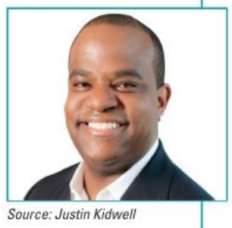
Isabella Castillo, vice president of professional services at a consulting company that helps IT organizations deliver better service to their customers, needs help with her professional staff of sixteen consultants, who all work from home. Her problem: dealing with the realities of telecommuting-lack of direct interaction, lack of camaraderie, feeling isolated and out of the loop, etc. For their type of business, remote work makes good business sense, but how can she connect and engage her employees?
What advice would you give Isabella?
I would focus on a few things:
- Making people development a strategic goal
- Semiannual retreats
- Leveraging technology
Embedding people development into the performance measurement equation ensures interaction and teaming. The semiannual retreats provide a bonding environment and opportunity to gain buy-in to management priorities. Collaborative tools make phone-only meetings obsolete.
Discussion questions:
- Do you agree with the answer provided?
- How do you implement the answers?

Source: Robbins, S., and Coulter, M. (2021) Management, Global Edition. 15th edn. Pearson. Pp. 321

