What to do when your Apps turn grey
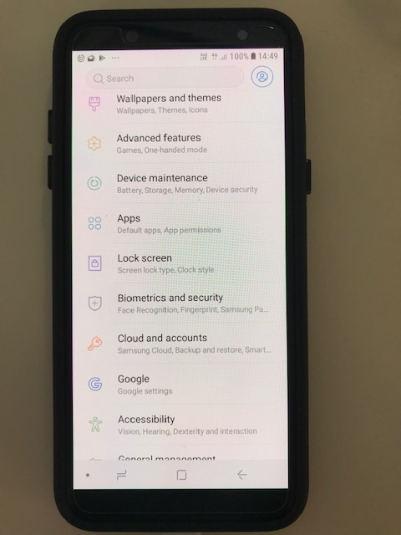
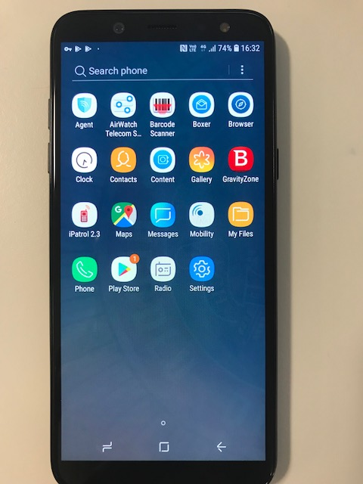
Settings

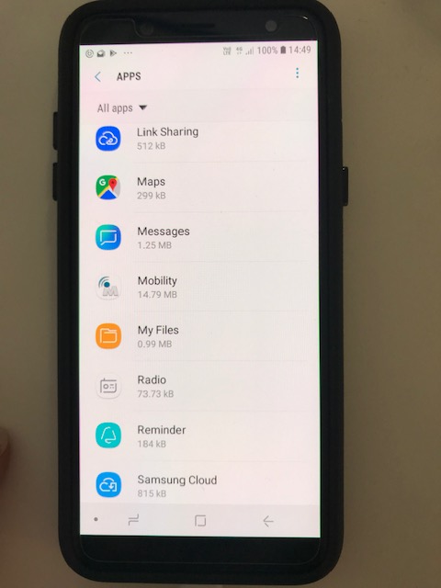

Apps

Scroll down to Mobility (Maybe shown as Netmotion Mobility)

Storage

Press Clear Cache
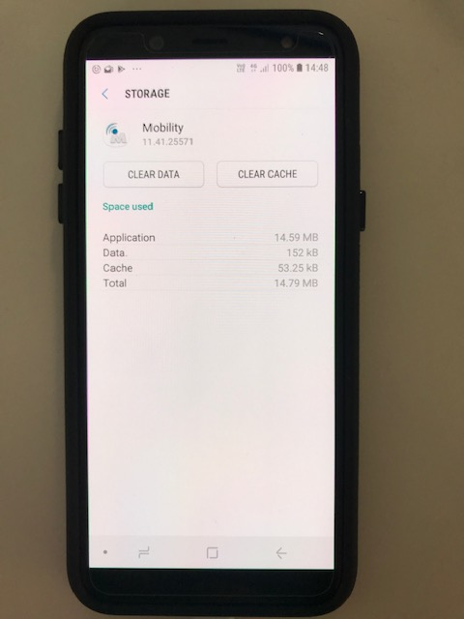
Press Clear Data

Press the home button, and go back into Agent

Agent

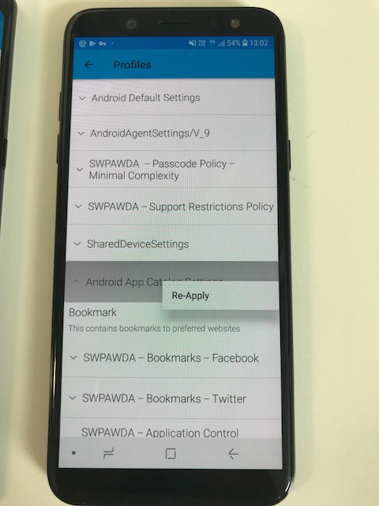
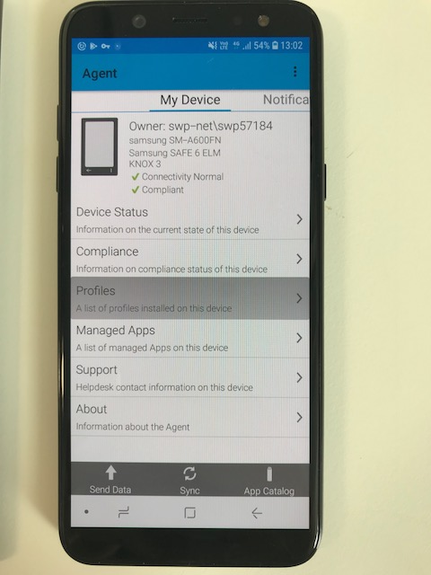


Profiles Android App Catalogue Settings
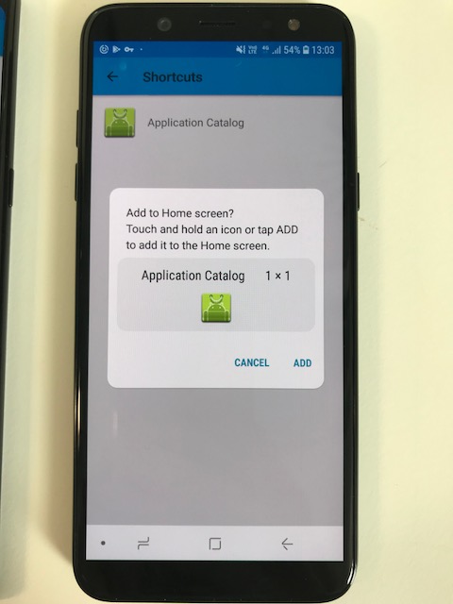
(Press and Hold) Press Reapply

Press ADD

