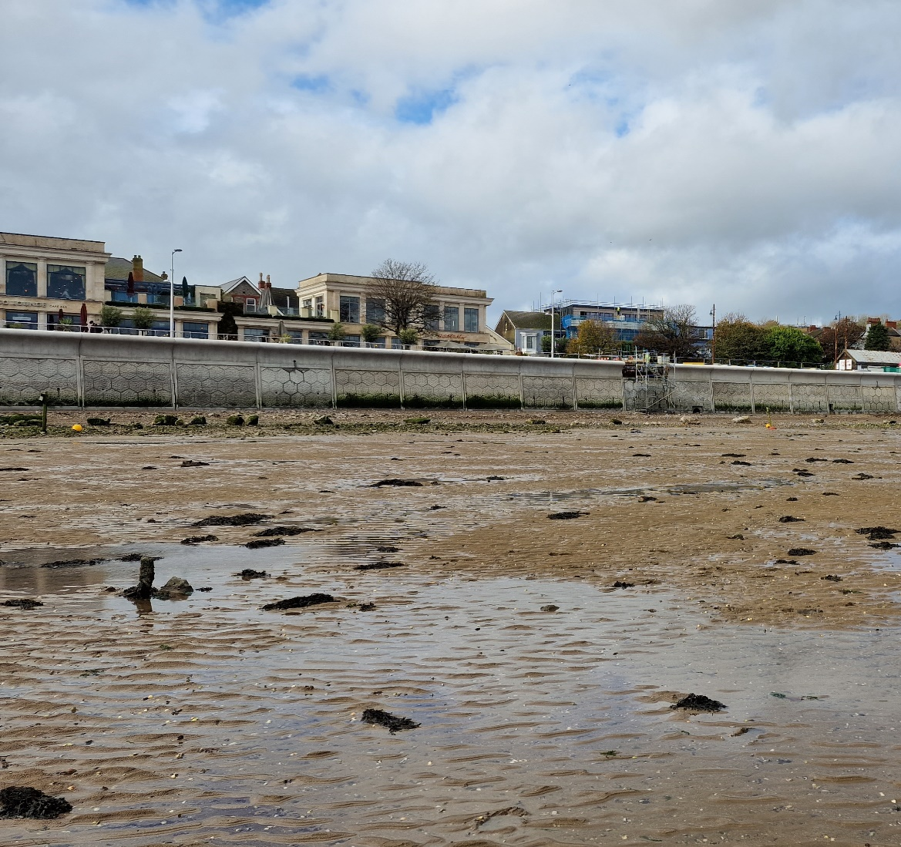

The Mumbles Coastal Protection Projects Effect on the Coastal Landscape

Ioan Jeffries | Coastal, Marine and Wildlife Conservation

Contents
1. Introduction 2
2. Methodology 3
2.1 Site Background 3
4
2.2 Survey Methods 4
3. Results 6
3.1 Quadrat Results 6
3.2 Visual Survey 7
3.3 Samples Collected 8
3.4 Water Quality 8
4. Discussion 9
5. Conclusion 11
6. References 12

Introduction
Global sea level rise is a big problem all around the world and is causing many coastal towns and cities to take steps to protect themselves from the encroaching tides and the effects these can have. One of the biggest threats to these towns which is directly linked with the rising sea levels is coastal erosion (Leatherman, Zhang and Douglas, 2000). There are many different ways to prevent coastal erosion but the one that will be discussed in this report is the use of coastal sea wall defences. These are large coastal walls often constructed from stone or concrete and are designed to create a barrier between the land and sea water. This is the chosen method being used in Mumbles near Swansea to prevent erosion. The Welsh government allocated £1,556,464 to Swansea council for their Coastal Risk Management Programme (CRMP) in order to construct a new sea defence (www.gov.wales, 2024). When developing this new project there are multiple factors that needed to be considered, one of which is its environmental impact on local marine ecosystems. This is because structures such as sea defence wall and other anthropogenic structures can have devastating effects on marine ecosystems if not implemented correctly (Cooper, O’Connor and McIvor, 2016).
The mumbles is a seaside town located around the coast from Swansea city located on the Gower peninsula. Like many seaside towns it is vulnerable to coastal problems such as erosion and rising sea levels. In order to protect the town from these issues, in the 19th century the sea defences were first built. These have been maintained all throughout the 19th and 20th century (Swansea Council, 2024). However, due to climate change the sea levels rapidly rising, the sea defences need to be improved upon to be fit for purpose. In 2015 the local authorities started to investigate how the area can be better protected. It was decided that the old and deteriorating mumbles sea wall needed improving. This led to the Mumbles Coastal Protection Project to begin construction in 2023 with an expected completion date of 2025. (Swansea Council, 2024)
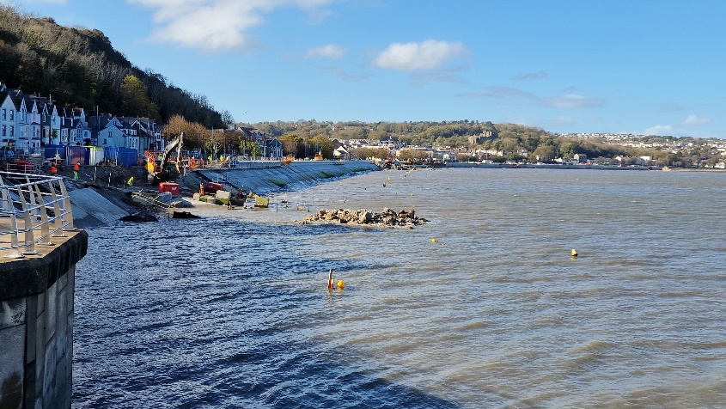
Figure 1 Mumbles sea wall under construction Oct 2024
The goal of this report is to assess the current biodiversity at the sea wall and to look at the different levels of species richness and how the sea wall might affect the marine ecosystems within the area. The data collected can hopefully be used to look at future projects and how they can minimise the effects on local ecosystems.

Methodology

Site Background
Biodiversity surveys were conducted along the site on the 25th of October and the 4th of November 2024 within a 20m radius of the following sites along the Mumbles sea defence wall. The total area that is being sampled is 0.24km2 (figure 2).
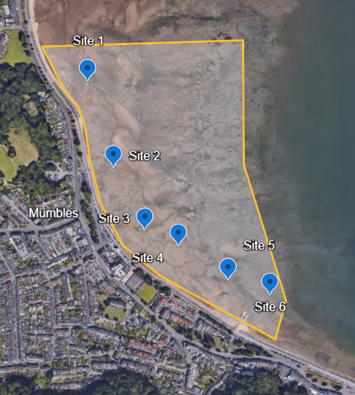
Figure 2. 6 Site locations and sample area along the sea wall (Google earth)
Unfortunately, due to construction work being done to build the wall, samples and data was not able to be collected along the sea wall. However samples were taken as close to the wall as was safe. In total there were 6 sites surveyed. This gives good coverage of the length of the sea wall. The habitats along the beach vary with sites 1 and 5 being very rocky with lots of pools and shelter while the other 4 sites were mostly mud with a layer of sand about an inch thick over the top.

The sea wall has been constructed out of large concrete sections with a hexagonal pattern across its face. These hexagons are textured and so are not completely flat in order to promote the growth of organisms (Bradford et al., 2020).

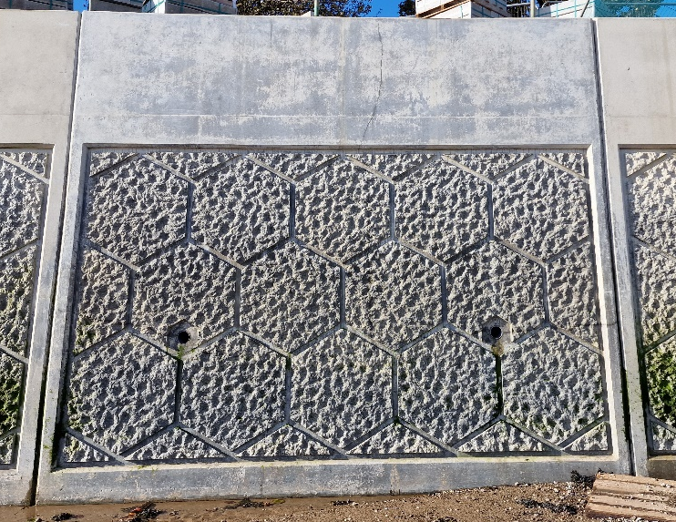

Figure 3 Image of the Mumbles sea wall

Survey Methods
In order to accurately measure the biodiversity of the area, several survey methods were used. In order to remain consistent throughout the survey, a quadrat square was used. A random location was chosen at each site. The quadrat square was then placed on the ground and all shells and species within the square were counted and noted down. With this data the following formula can be used in order to calculate the total population in a given area;
Population Density = Total Found in Quadrat/Size of Quadrat
Total Population = Population Density * Area of Site
(Caughley, 1977)
The sample size of each site was about 20m in every direction from the centre of the site. For the calculation of total population, the area of each site was estimated to be 1256m². Once the data for each site has been calculated, the average number of all the sites will be used to calculate a rough estimate of the entire area.
This will give a rough estimate to the amount of total population in a given area. In this report the total area that will be measured is the foreshore which extends all the way up to the sea wall. In total, 10 different quadrat samples were taken across the whole area. In order to increase the accuracy of this estimate more quadrats could be placed down, increasing the amount of data collected. It is worth noting that the species counted within the quadrat was the remains of species like their shells. Most species remains that were encountered, such as Cerastoderma Edula. Live below the sand and so is not as easily quantified (Fish and Fish, 1997). Therefore, the number of remains atop the sand was used instead.
Alongside the use of quadrats there was also a visual survey were members of the team walked around within a 20m vicinity of the site and noted down all the different species that were found including different shells, seaweeds and other invertebrates along with how common they were. This could give us an indication to the presence of any other less common species that may not have fallen into the quadrat. With this method as well as using the quadrat data, the DAFOR scale can be used. The DAFOR scale allows you to estimate which species are most dominant in an area and which are less common. The DAFOR scale works as follows;
D - Dominant = 50% - 100%
A - Abundant = 30% - 50%
F - Frequent = 15% - 30%
O - Occasional = 5% - 15%
R - Rare = <5%
Samples were also taken at each site to be analysed. Samples were collected by taking 3 trowel scoops of sediment and sifting it through a 2mm sieve to filter out the fine sand particles. Once these samples were collected, they were brought back to the university to dry and sift through smaller and smaller sieves in order to fully separate the sediment. This was done in order to take a look at and identify the different organisms that were present. A sand sample was also taken near the first site in order to determine the sediment size range of the mumbles beach. This could potentially give more insight into the kind of habitat the mumbles coast provides. In order to identify any species found, the book Seashore Safaris (Oakley, 2011) was used unless noted otherwise.
Water quality samples were also taken from the ocean at the sea wall. These can give useful insight into the quality of the water and how well it is able to sustain marine life. The measurement that were taken include;
- Salinity
- PH
- Dissolved Oxygen levels
These measurements need to be within specific ranges in order to sustain certain species and ecosystems. Some species are more sensitive to differences in these levels while some can be a lot more resilient. Using these measurements, it can be determined what kind of species are able to thrive in these waters and how these levels differ from similar locations around the UK.

Results

Quadrat Results
Once the quadrat data was collected and sorted into tables this was the final results:
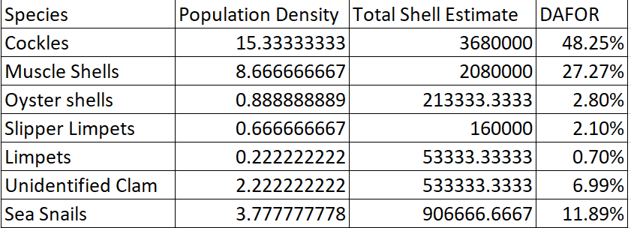
Figure 4 Data Collected from the quadrats
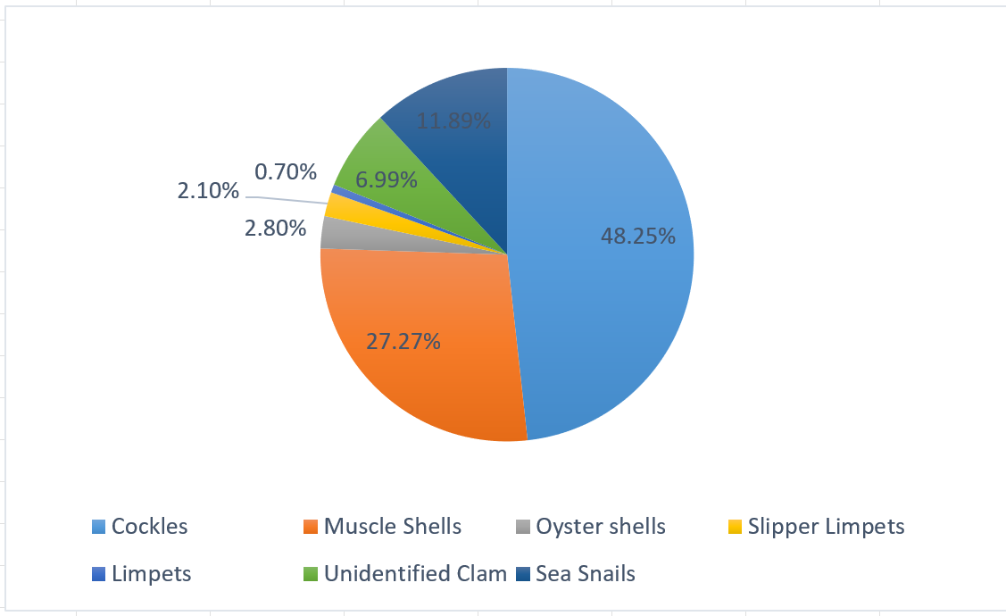
Figure 5 Pie chart of the total shell estimates %
As you can see from the data cockles are the most abundant species remains on site, followed by muscles which are frequent in the environment. The remaining species fell into either the occasional or rare categories. Most species noted in the quadrats were only the remains of species. The most abundant live species found in the quadrats were sea snails (Littorina saxatilis).

3.2 Visual Survey
There were a number of other species that were identified on the site that unfortunately did not fall into one of the quadrat squares. These species were not very common and so would have fallen into the rare category but were present. These organisms are as follows:
- Razor Clam shells
- Sea Urchins
- Sea Anemone
- Crabs
- Chitons (lepidochitona cinerea)
- Rag Worms (Hediste Diversicolor)
- Sand Mason Worms (Lanice Conchilega)
- Wading Birds
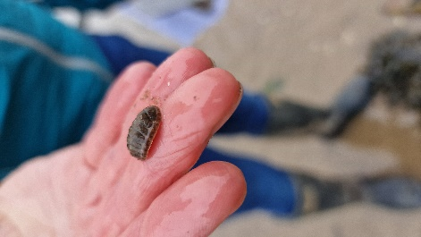
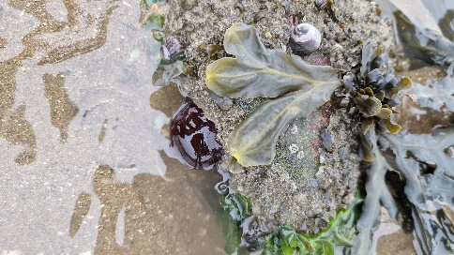
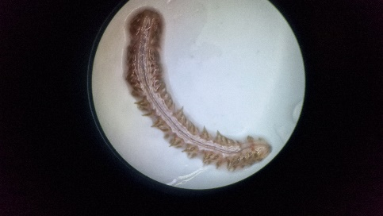
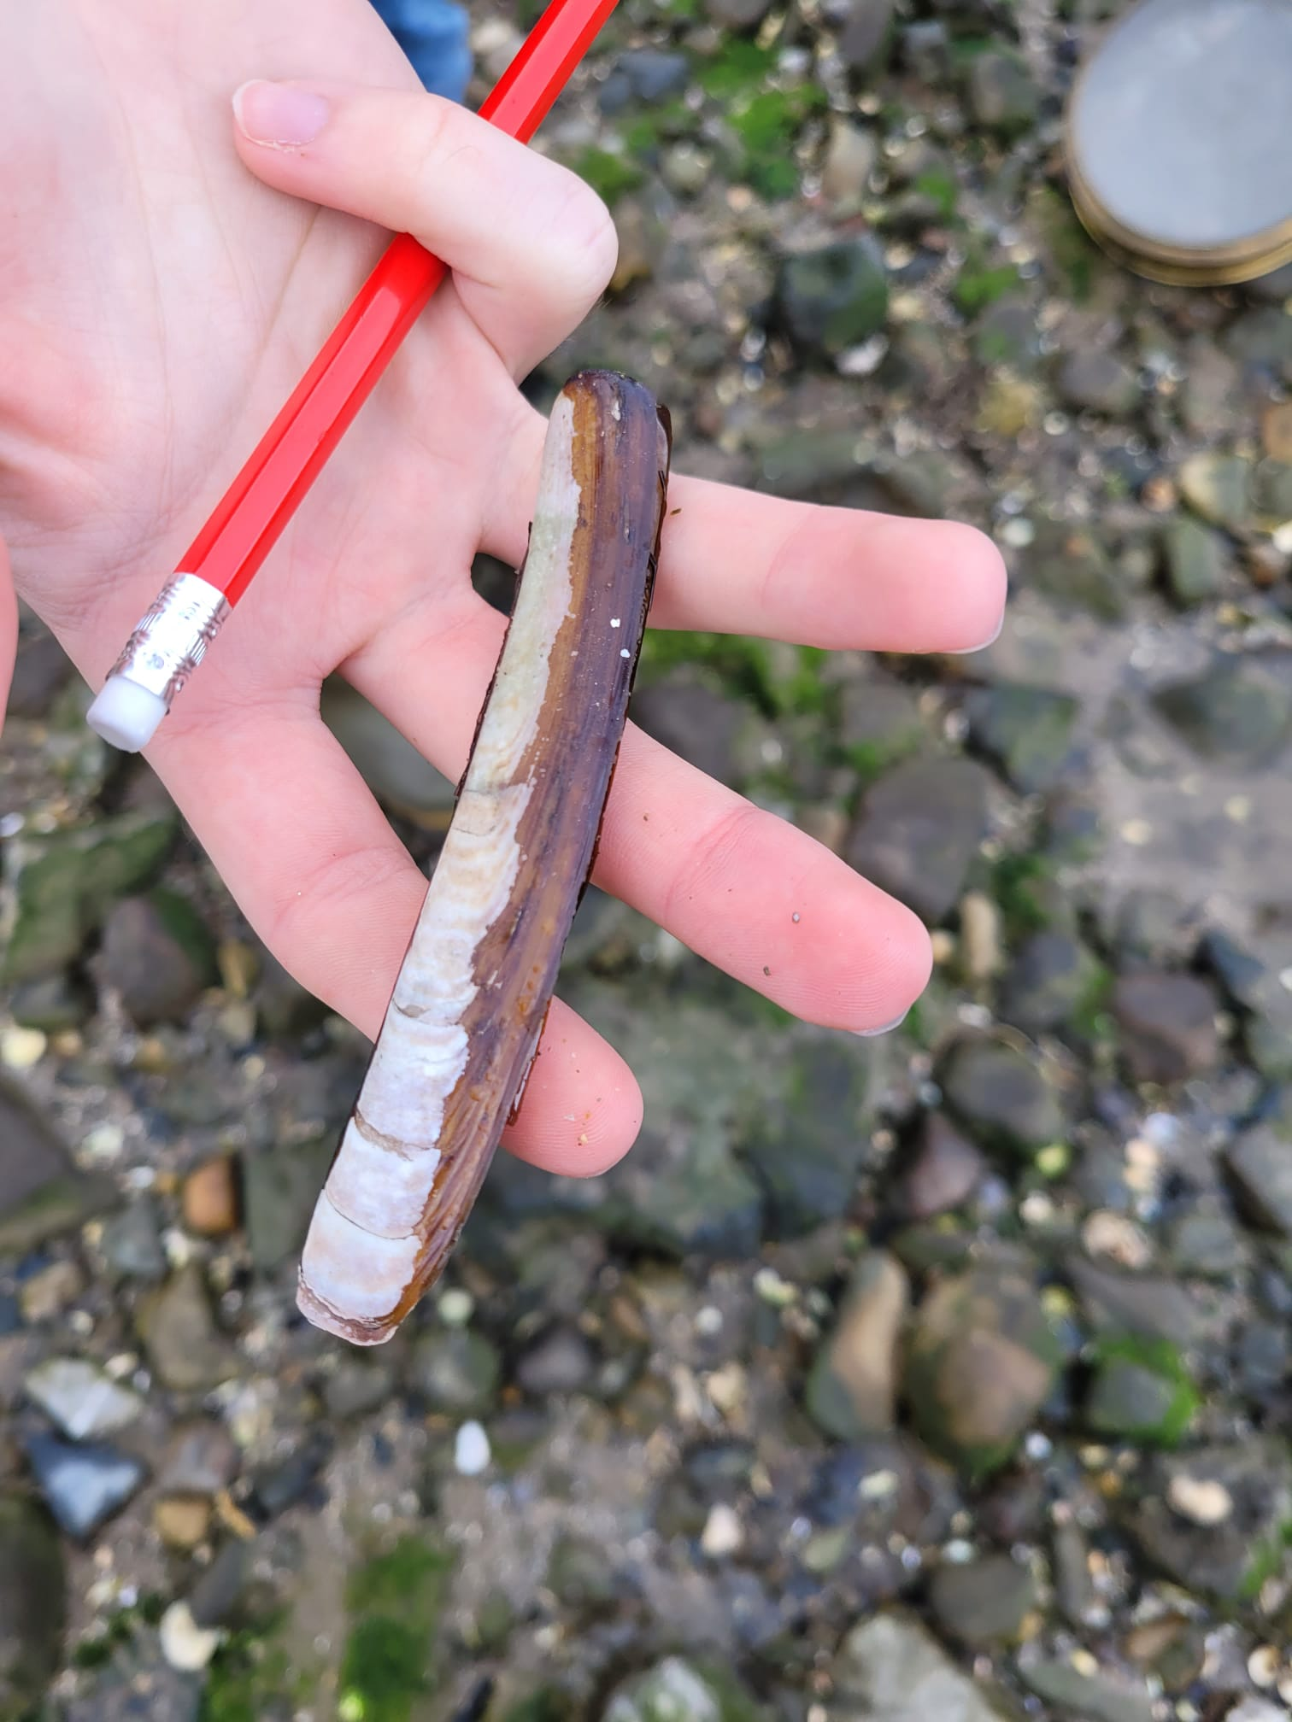

Figure 6 Images of Species found including Anemone, Rag Worm, Razor Clam shells and Chiton

Samples Collected
Once the sand sample was collected, dried and sorted these were the results:
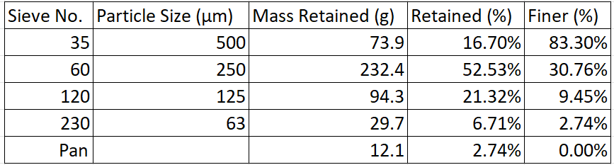
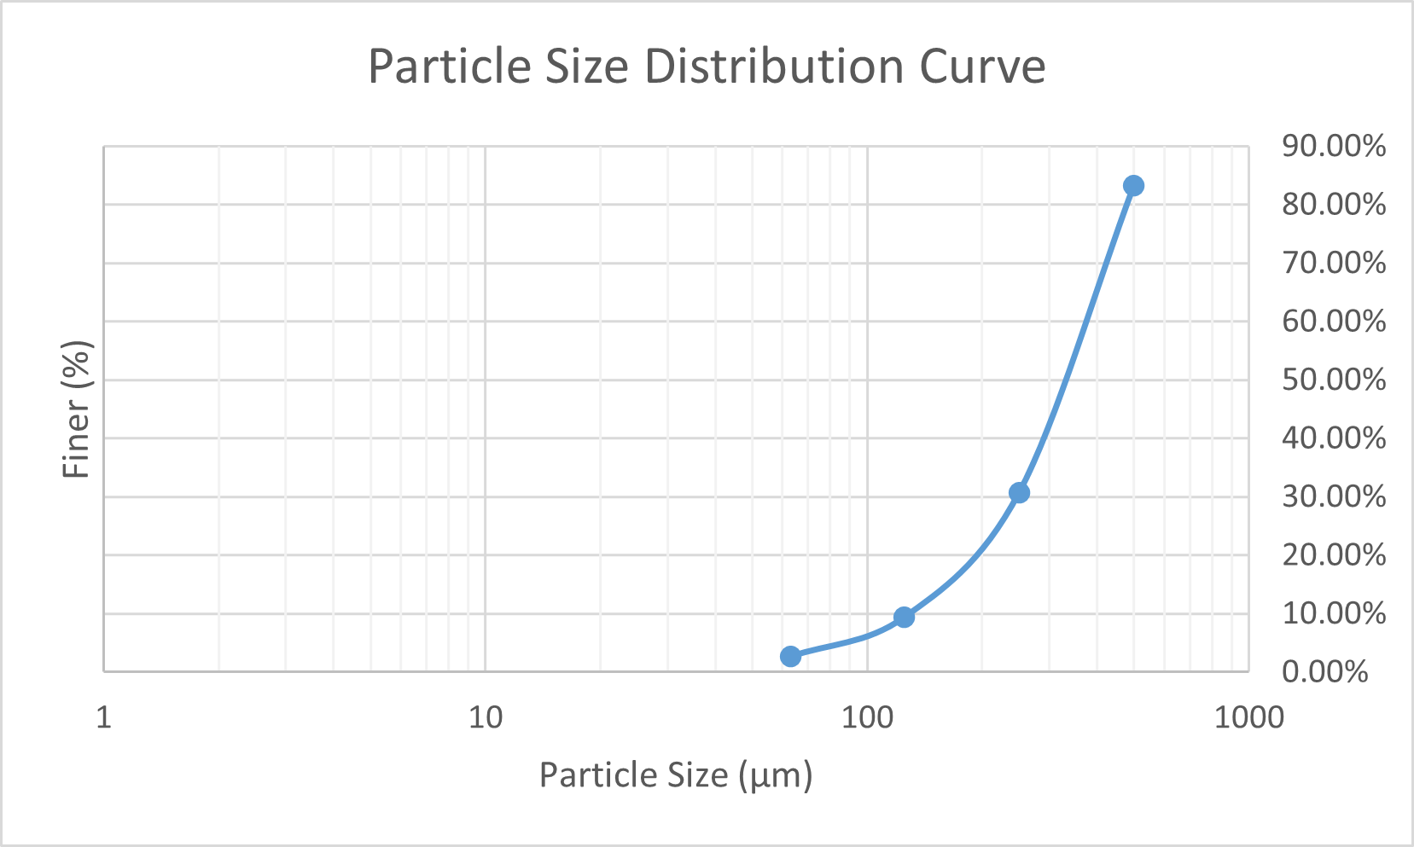
Figure 7 Particle Distribution Data and Curve

Water Quality
The Water quality samples that were collected were as follows;
PH | 8.4
Dissolved Oxygen | 8mg
Salinity | 34ppt
Figure 8 Water Quality Measurements

Discussion
Sea walls and other manmade structures do not encourage the growth of biodiversity in the area they are in as well as natural habitats do. The abundance of high mobility species is significantly lower around anthropogenic structures such as sea walls and harbours due to the lack of suitable habitat available for either the species themselves or other resources such as food or shelter (Chapman, 2003). In order for a sea wall to promote the growth of organisms like epifauna, the structure must be textured (Bradford et al., 2020). Making sure the sea wall also has shaded areas is also incredibly beneficial to marine wildlife in intertidal zones as it protects them from exposure from the sun and other environmental hazards (Strain et al., 2017). The Mumbles sea wall provides both texture and shade through the textured hexagonal design as well as the channels between them.

Using this information it is possible to look at the different species that were found on the site and how the design of the sea wall can support their growth. One of the more common species found on the site were sea snails (Littorina saxatilis). This species of snail tend to live in on the littoral fringe of the intertidal zone on rocky surfaces (Ballerstedt, 2017) which is where the sea wall is located. This means that the sea wall can provide great habitat for sea snails. It can also create habitat for Chiton (Lepidochitona cinerea), which was identified on site. Chiton also live in the intertidal zone and benefit greatly from sheltered areas with less exposure to the elements (Moreira, Chapman and Underwood, 2007) which the sea wall can provide. Lepidochitona cinerea and other chiton species are very beneficial to biodiversity in the marine environment as they feed on algae, therefore controlling the populations and allowing for a more diverse range of epifauna such as barnacles (Coleman et al., 2006).

It is also useful to look at the kind of beach that makes up the intertidal zone of Swansea bay in order to determine the kind of species that can live in the sands. By looking at the sediment sample collected (Figure 7), the dominant grain size for the beach is medium sand or ¼ mm. The particle size distribution curve shows that this particular beach is a well-sorted beach. Studies show that beaches with well-sorted sediment are more stables in terms of their morphology (Udhaba Dora et al., 2012). This is great habitat for Sand mason worms (Lanice Conchilega) which live on sandy beaches towards the lower shore (Fish and Fish, 1996).

There are other worm species present at the site including Ragworms (Hediste Diversicolor). These worms live in more muddy areas compared to Lanice Conchilega (Fish and Fish, 1996) which is most likely why it was found at site 6 which was the site with the most mud compared to the 6 other. Both worms are prey to sea birds which were spotted on site (Fish and Fish, 1997). The exact species of bird was not identified as it had flown away before the team were able to identify the species but it was noted that it was a kind of wading bird due to them feeding near the shallows. This indicates that there is more marine intertidal species present as these birds were still observed visiting and feeding on site.

Another way to promote ecological activities around sea defences are with the use of certain designs of revetments. Studies have shown that certain revetments like rock revetments and designs that are able to retain water are very beneficial to benthic organisms such as barnacles as well as other species such as fish due to the increased habitat for prey to live (Sanitwong-Na-Ayutthaya et al., 2023).

It is worth looking at the area around mumbles due to its exceptionally large tidal range. The Bristol channel, which is where mumbles is located, has one of the largest tidal ranges in the world (Archer, 2013). There is evidence to suggest that areas that have high levels of hydrodynamic activity are more resistant to anthropogenic activity. As there is such a large tidal range in the area, the species that are present are more resistant to human activity (Callaway, Fairley and Horrillo-Caraballo, 2020). The large tidal ranges of Swansea bay means that the environment is highly dynamic and so is a lot more resistant to any disturbances caused by any human activities. This means that the construction of the sea wall should have a lesser effect on the species present in the area compared to a place with less extreme tidal conditions.

Conclusion
The mumbles sea wall highlights the importance of considering not just the need to protect towns and cities from the effects of erosion and climate change, but the need to safeguard marine ecosystems and habitats surrounding these structures. Sea defences are a necessity in order to protect coastal towns and cities. However they must be created with biodiversity in mind to minimise their ecological effects. Anthropogenic structures are generally worse for ecosystems than natural habitats but when it is necessary it is important to try to mimic the environment as close as possible.
The mumbles sea wall uses many innovative features such as the textured sloped walls as well as crevices in order to promote the growth of marine life and epifauna. Allowing for the growth of species on the wall will increase the species richness and will allow the ecosystems to grow a lot better than on a flat featureless wall. It also benefits from being in an environment with such high hydrodynamic activity, meaning that species are more resilient to anthropogenic disturbances.

References
Archer, A.W. (2013). World’s highest tides: Hypertidal coastal systems in North America, South America and Europe. Sedimentary Geology, 284-285, pp.1–25. doi:https://doi.org/10.1016/j.sedgeo.2012.12.007.
Ballerstedt, S. (2017). MarLIN - The Marine Life Information Network - Rough periwinkle (Littorina saxatilis). [online] Marlin.ac.uk. Available at: https://www.marlin.ac.uk/species/detail/1649.
Bradford, T.E., Astudillo, J.C., Lau, E.T.C., Perkins, M.J., Lo, C.C., Li, T.C.H., Lam, C.S., Ng, T.P.T., Strain, E.M.A., Steinberg, P.D. and Leung, K.M.Y. (2020). Provision of refugia and seeding with native bivalves can enhance biodiversity on vertical seawalls. Marine Pollution Bulletin, 160, p.111578. doi:https://doi.org/10.1016/j.marpolbul.2020.111578.
Callaway, R., Fairley, I. and Horrillo-Caraballo, J. (2020). Natural dynamics overshadow anthropogenic impact on marine fauna at an urbanised coastal embayment. Science of The Total Environment, [online] 716, p.137009. doi:https://doi.org/10.1016/j.scitotenv.2020.137009.
Caughley, G. (1977). Analysis of vertebrate populations. p.234.
Chapman, M. (2003). Paucity of mobile species on constructed seawalls: effects of urbanization on biodiversity. Marine Ecology Progress Series, 264, pp.21–29. doi:https://doi.org/10.3354/meps264021.
Coleman, R.A., Underwood, A.J., Benedetti-Cecchi, L., Åberg, P., Arenas, F., Arrontes, J., Castro, J., Hartnoll, R.G., Jenkins, S.R., Paula, J., Santina, P.D. and Hawkins, S.J. (2006). A continental scale evaluation of the role of limpet grazing on rocky shores. Oecologia, 147(3), pp.556–564. doi:https://doi.org/10.1007/s00442-005-0296-9.
Cooper, J.A.G., O’Connor, M.C. and McIvor, S. (2016). Coastal Defences versus Coastal ecosystems: a Regional Appraisal. Marine Policy, 111. doi:https://doi.org/10.1016/j.marpol.2016.02.021.
Fish, J.D. and Fish, S. (1996). A student’s guide to the seashore. London: Unwin Hyman.
Leatherman, S.P., Zhang, K. and Douglas, B.C. (2000). Sea level rise shown to drive coastal erosion. Eos, Transactions American Geophysical Union, 81(6), p.55. doi:https://doi.org/10.1029/00eo00034.
Moreira, J., Chapman, M.G. and Underwood, A.J. (2007). Maintenance of Chitons on Seawalls Using Crevices on Sandstone Blocks as Habitat in Sydney Harbour, Australia. Journal of Experimental Marine Biology and Ecology, 347(1-2), pp.134–143. doi:https://doi.org/10.1016/j.jembe.2007.04.001.
Oakley, J. (2011). Seashore Safaris. Graffeg,Peter Gill & Associates (Acc).
Sanitwong-Na-Ayutthaya, S., Saengsupavanich, C., Ariffin, E.H., Ratnayake, A.S. and Yun, L.S. (2023). Environmental impacts of shore revetment. Heliyon, [online] 9(9), p.e19646. doi:https://doi.org/10.1016/j.heliyon.2023.e19646.
Strain, E.M.A., Olabarria, C., Mayer-Pinto, M., Cumbo, V., Morris, R.L., Bugnot, A.B., Dafforn, K.A., Heery, E., Firth, L.B., Brooks, P.R. and Bishop, M.J. (2017). Eco-engineering urban infrastructure for marine and coastal biodiversity: Which interventions have the greatest ecological benefit? Journal of Applied Ecology, 55(1), pp.426–441. doi:https://doi.org/10.1111/1365-2664.12961.
Swansea. (2024). Mumbles coastal protection project. [online] Available at: https://www.swansea.gov.uk/article/9250/Mumbles-coastal-protection-project.
Udhaba Dora, G., Sanil Kumar, V., Johnson, G., Sajiv Philip, C. and Vinayaraj, P. (2012). Short-term observation of beach dynamics using cross-shore profiles and foreshore sediment. Ocean & Coastal Management, 67, pp.101–112. doi:https://doi.org/10.1016/j.ocecoaman.2012.07.003.
www.gov.wales. (2024). Flood and Coastal Erosion Risk Management Programme 2024 to 2025 [HTML] | GOV.WALES. [online] Available at: https://www.gov.wales/flood-and-coastal-erosion-risk-management-programme-2024-2025-html.

