Character animation
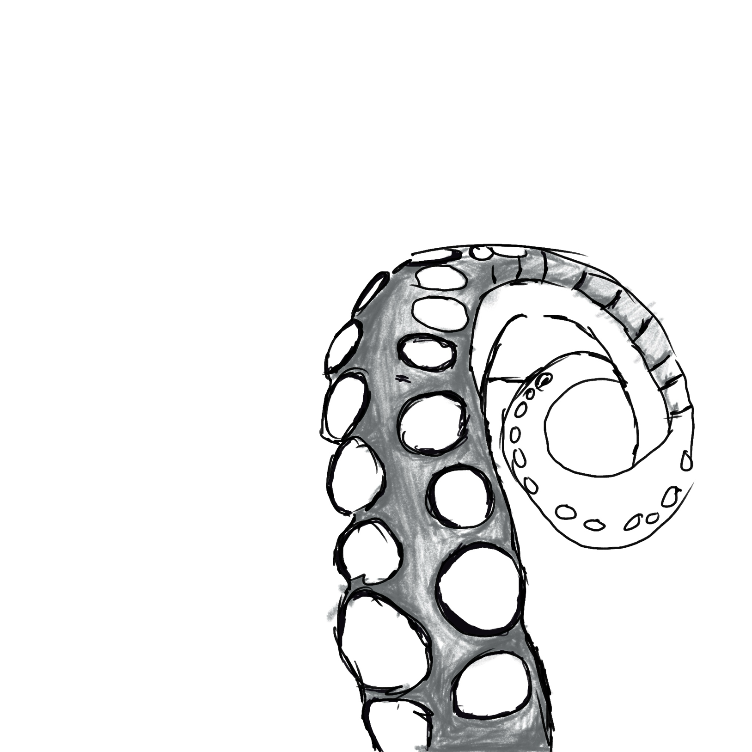
My character is a kraken in this animation
I have a few bits that I used towards this final project

This is a sketch I did of a tentacle while I was researching tentacle movement
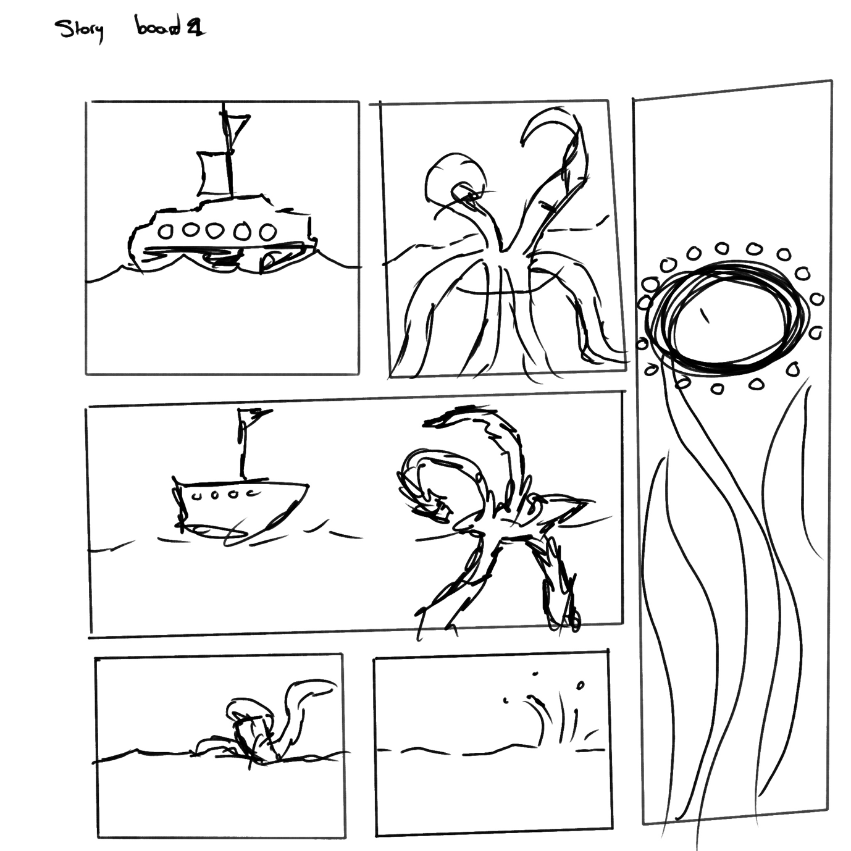

This is a simple story board I created while planning out the idea for this

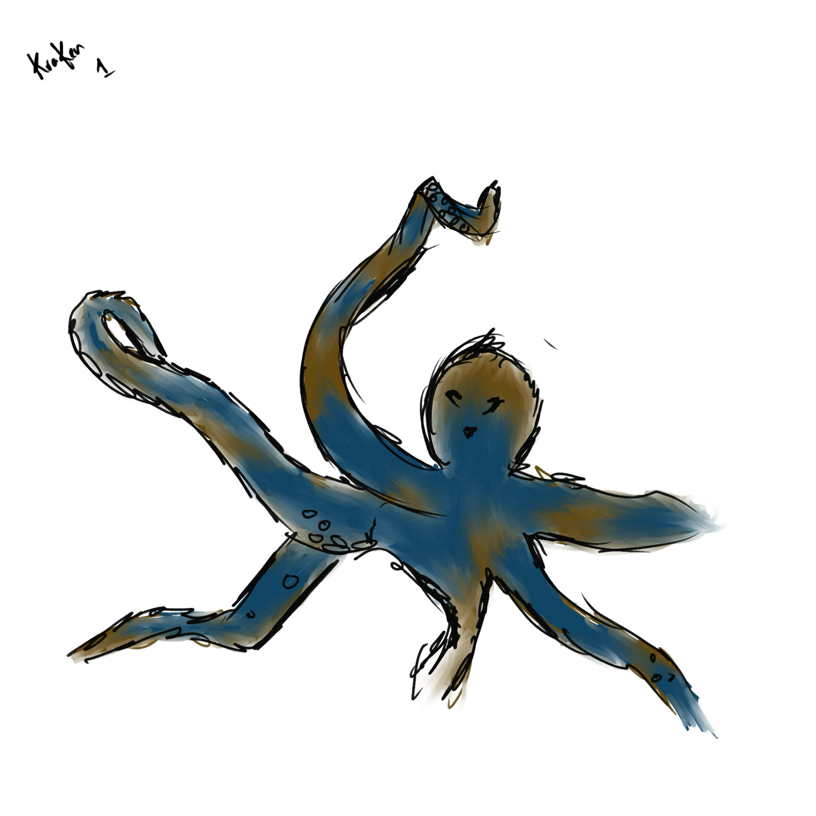

This is a slight idea of what I wanted the kraken to look like in its final state

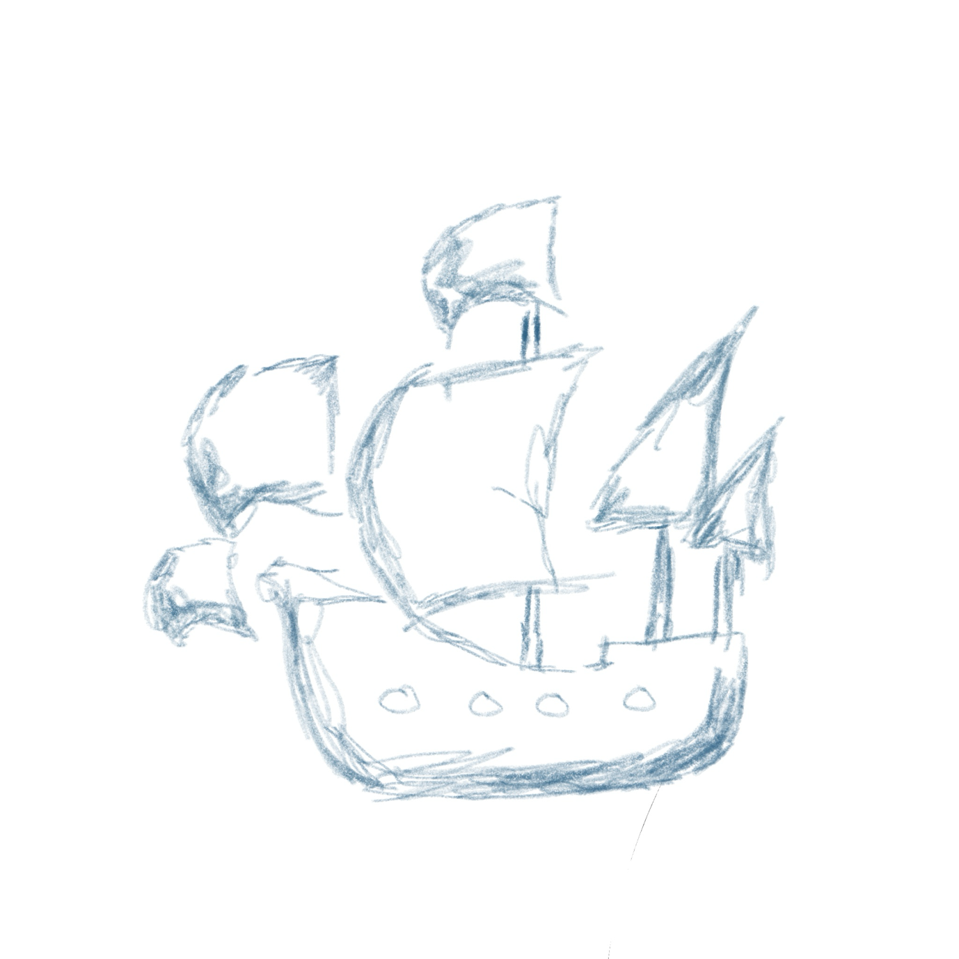

And here was my original sketch for the boat

Hers the link to my final animation from my google drive. It’s in black and white and has a sketch effect as I wanted to follow an old pirate story book approach to this almost as if to leave it up to the viewers imagination.
https://drive.google.com/drive/folders/1EB-oxj4S8VkLs1knAtxvyjyvmp8VjaFM

