ERD
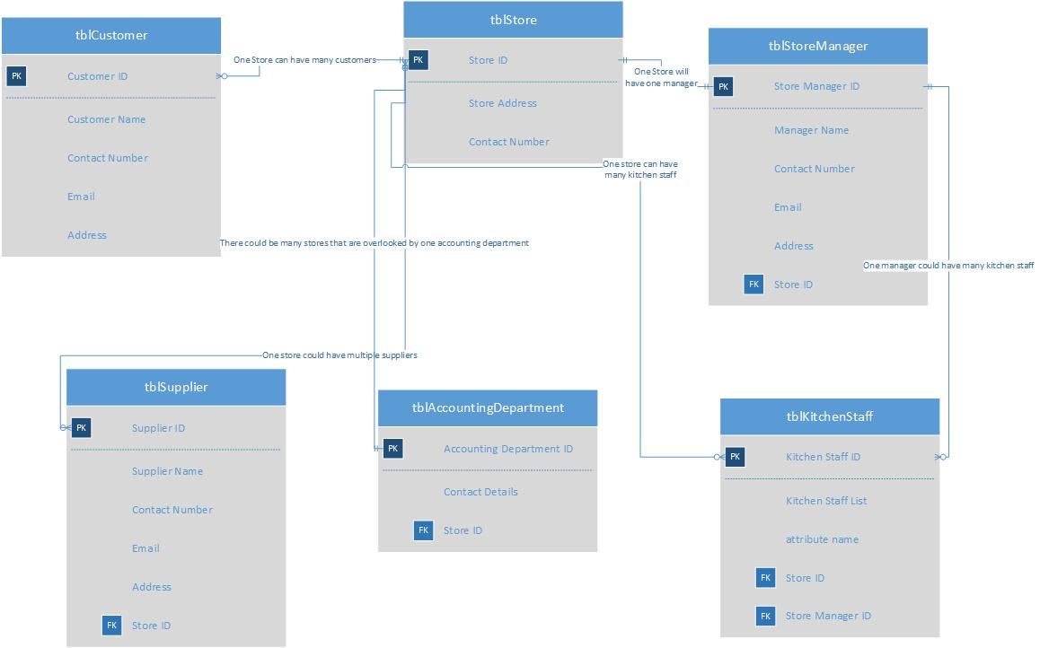
Above you can see the ERD that I have created for a catering business. This shows the relationships between the entities within the system.

Context Level Diagram
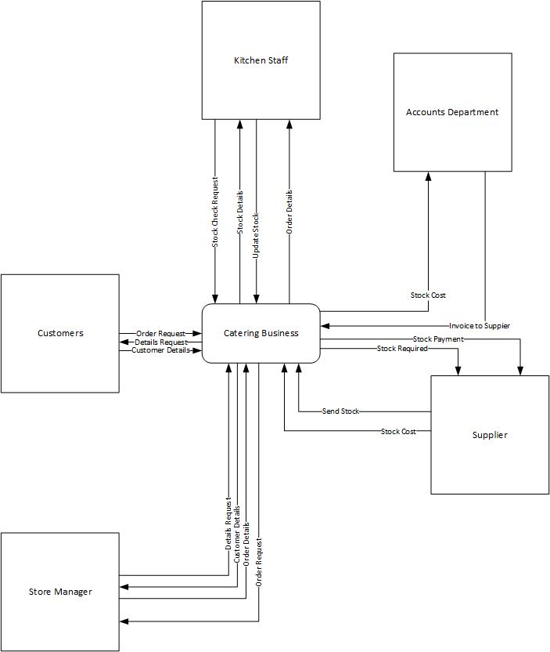
Above you can see the context level diagram I have created for a catering business. This shows the process at which all of the entities go through as part of this system.

Level-0
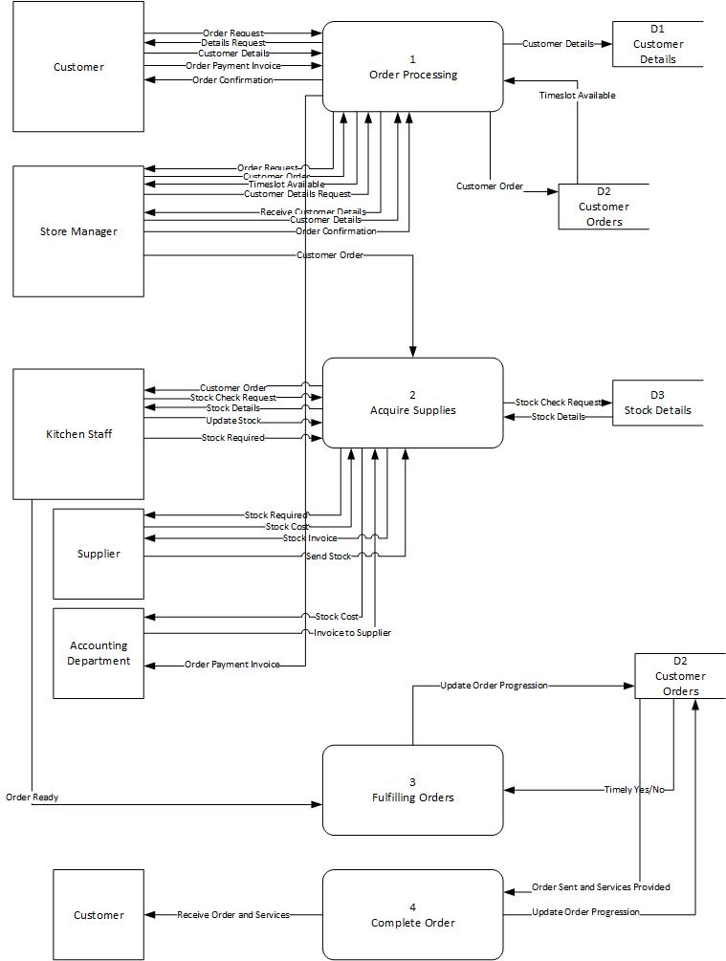
Above you can see the level-0 diagram I have created for a catering business. This shows a further expanded version of the processes each entity goes through as part of this system.

Level-1
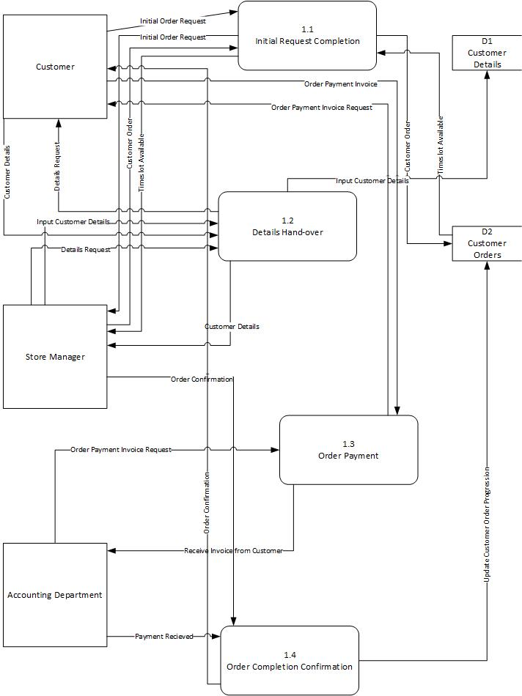
Here you can see the level-1 diagram I have created for a catering business. This shows a more in depth look at process 1 of my level-0 diagram, showing the subprocesses of the larger process.

