Effect of Manipulating an Air Fuel Ratio on NOx Emissions and Performance of an Internal Combustion Engine.

By Iwan Thomas (P147756)
Supervisor: Pedro Monteiro Ferreira
Abstract
According to critics, the transport sector accounts for 26% of the UK’s greenhouse emissions rising by 2% since 2016 according to Josh Gabbatiss from the Independent. As Josh Gabbatiss stated, “The majority of Britain’s greenhouse gas emissions now come from transport” (Gabbatiss, 2018). The Vehicle Certification Agency states that the UK government must reduce vehicle emissions by at least 34% by 2020 and 80% by 2050 (Vehicle Certification Agency, 2017). As global emissions rise, emission regulations become more stringent. Currently, Euro 6 regulations state that vehicles must comply by the 130g/km CO₂ explains Frost and Sullivan Authors (Frost and Sullivan, 2016) but with Euro 7 standards looming, vehicle manufacturers are having to clamp down on their emission outputs. Frost and Sullivan predict that Euro 7 regulations, released in 2020 will drop the CO₂ emission output of vehicles by 35g/km down to 95. This is due to the increasing effect emissions has on human health and on global warming causing the increasing weather extremities throughout the world, especially in the last decade. Global warming has become a visible effect and to combat this, the automotive industry is developing compact, powerful engines to replace their larger, less economical engines. Due to the stringent regulations on NOx emissions manufacturers are finding it ever more difficult to reduce their overall NOx emissions to a suitable level. This project will discover the effect different air/fuel ratio’s has on NOx emissions and exhaust gas temperatures resulting in a change in engine performance.
The hypothesis for this project is that as the air fuel ratio increases, the exhaust gas temperatures will decrease ever so slightly. This would be due to the increase in the amount of atomized fuel injected into the cylinders producing a cooling effect within the cylinders. As a result of the decrease in exhaust gas temperatures due to the increase in fuel, the output of NOx emissions will also increase because of the extra fuel within the cylinder. It’s believed the exhaust gas temperatures will be lower due to the fact that a flame will burn quicker, the higher the presence of oxygen. Therefore, a richer air fuel ratio will produce less heat from the exhaust as well as less NOx. As the air fuel ratio increases, the NOx will begin to increase as well as the exhaust gas temperatures.

Contents
1.0 Figures and Tables Page 4
2.0 Introduction Page 5
3.0 Literature review
3.1 Harmful Gasses Page 7
3.2 Performance Page 8
3.3 Vehicle Calibration Page 9
3.4 Previous Experimentation Page 11
3.5 Seat Leon 1.9 TDi pd Page 12
3.6 MAHA MSR 500/2 Car 4wd Dynamometer Page 13
4.0 Experiment
4.1 Equipment used Page 14
4.2 Procedure
4.2.1 Set up Page 14
4.2.2 Gathering Results Page 15
4.3 Test Plan Page 16
4.4 Operating Conditions Page 18
5.0 Results Gathered
5.1 NOx Page 19
5.2 Power and Torque Increase Page 23
5.3 Other Resulting Alterations Page 28
5.4 NOx Emissions Reduction Page 31
6.0 Conclusion Page 34
7.0 Project Analysis Page 35
8.0 Acknowledgements Page 35
9.0 Appendix Page 36
10.0 References Page 39
1.0 Figures and Tables
Figure 1: Size Difference between Downsized and Big Block Page 6
Figure 2: Emissions at Different Air Fuel Ratios Page 7
Figure 3: Share of NOx Emissions by Sector Group Page 7
Figure 4: Change in Vehicles over Time Page 8
Figure 5: Forced Induction Systems Page 8
Table 1: Lambda air/fuel ratio’s Page 9
Figure 6: Seat Leon 1.9 TDi pd Page 11
Figure 7: MAHA MSR 500/2 Car 4wd Dynamometer Page 12
Table 2: 1st Test plan Page 16
Figure 8: Previous test graph Page 16
Table 3: 2nd Test Plan Page 17
Table 4: Operating Conditions Page 18
Figure 9: NOx at Idle Page 19
Figure 10: NOx at the Base Map Page 20
Figure 11: NOx at Map 1 Page 21
Figure 12: NOx at Map 2 Page 22
Figure 13: Power and Torque Base Map Page 23
Figure 14: Power and Torque Map 1 Page 24
Figure 15: Power and Torque Map 2 Page 25
Figure 16: Map’s Power Curves Page 26
Figure 17: Map’s Torque Curves Page 27
Figure 18: Intake Manifold Pressure Page 28
Figure 19: Air Quantity Page 29
Figure 20: Power Loss Page 30
Figure 21: Power Loss Equation Page 30
Figure 22: Exhaust Gas Recirculation Page 31
Figure 23: Injection Timing Page 32
Figure 24: Split Injection Page 33
Figure 25: Exhaust Gas Temperature Page 36
Figure 26: Test 1 Remainder Graphs Page 36
Figure 27: Test 2 Remainder Graphs Page 37
Figure 28: Test 3 Remainder Graphs Page 38
2.0 Introduction
This is a technical report discussing the impact increasing the air fuel ratio has on emissions and performance output of an internal combustion engine. The significance of this question relates to manufacturers downsizing their engines whilst producing extraordinary amounts of power for the engine size, as well as the upcoming stringent transition from Euro 6 to Euro 7 regulations. The aims of this project are as follows:
- Discover the impact a manipulated air fuel ratio has on vehicles power output and emissions, focussing on NOx emissions.
- Explore whether exhaust temperature has a significant impact on NOx emissions and how they are related to one another.
- Discover a way of reducing NOx emissions.
There is a growing realisation worldwide that vehicle emissions are depleting the natural environment, but internal combustion engines have dominated the transport sector for decades. The legislation surrounding the formation of greenhouse gasses through exhaust emissions are leading vehicle manufacturers to reduce their carbon footprint and reduce global warming. Constant efforts are being made by manufacturers to reduce their impact on the environment through the reduction in fuel consumption and increase the efficiency of the powertrain; engine downsizing is considered the most effective strategy for this according to Chinmay Patil et al (Patil et al, 2017). Euro 6 regulations in 2014 stated that petrol powered passenger vehicle emissions must comply by the 130 g/km and the predicted Euro 7 regulations have dropped to around 95 g/km, this is a reduction of 27% states Frost & Sullivan authors (Anon, 2016). Manufacturers are tackling this by downsizing their engines and adding a forced induction system. Andy Goodwin from car keys explains that Ford have downsized their 81bhp, 1.25 litre Fiesta that produces 122 g/km of CO₂ to a 1.0 litre Ecoboost that produces 99bhp and 99 g/km of CO₂ (Goodwin, 2016); this almost complies with the predicted Euro 7 emission regulations and also provides an improvement in power. Euro 6 standards are very stringent on NOx emissions due to their toxicity and have dropped 84% since Euro 3. NOx regulations have dropped from 0.15 g/km down to 0.06 g/km, according to Chris Ebbs from Auto Express (Ebbs, 2018). More information on NOx can be found in section 3.1 of the literature review.
Many other manufacturers have downsized their engines much the same as Ford have. The latest Cayman from Porsche has had a reduction in engine capacity from a flat-six naturally aspirated 3.4 litre engine to a 2.5 litre turbocharged flat 4 says Antony Ingram. Mercedes has also followed the downsizing trend converting the naturally aspirated 6.2 litre V8 engine down to a 4.0 litre twin turbo which has proven to be just as powerful as the original engine (Ingram, 2017).

Jordan Katsianis states for Evo magazine, Toyota are taking a completely different approach with their Yaris; they’re upsizing. Where the original 1.3 litre engine made 98 bhp, Toyota has decided to increase its capacity to 1.5 litres producing an extra 12 bhp whilst using a clever VVT-IE system that changes between the Otto and Atkinson cycle to produce the optimum efficiency and performance (Katsinais, 2017).
Figure 1: Size difference between downsized and big block (Patil et al, 2017)
Companies are focused on the use of forced induction to aid in the downsizing of their engines; turbocharging or supercharging. The same power can be maintained after downsizing by forcing compressed air into the cylinder along with additional fuel despite the lower displacement. Unlike a turbocharger that uses the exhaust gasses to compress the air, a supercharger will be driven mechanically by the power of the crankshaft explains Chinmay Patil et al (Patil, 2017). The image to the left demonstrates an example of the difference in size between a big block naturally aspirated engine and a downsized turbocharged engine.
During the testing stage of the project, the reduction of NOx emissions will be the main focus. The experimental procedure below will discuss how these emissions will be measured. It’s believed exhaust temperatures have an effect on NOx emissions, therefore, this will also be investigated in this project. NOx emissions have been chosen due to the formation of smog which can become a serious health issue in enclosed areas such as cities. NOx emissions have also been known to create acid rain as well as being central to the formation of particulate matter (Anon, n.d.). A literature review will also be included discussing the papers and books already read.
3.0 Literature Review
3.1 Harmful Gasses
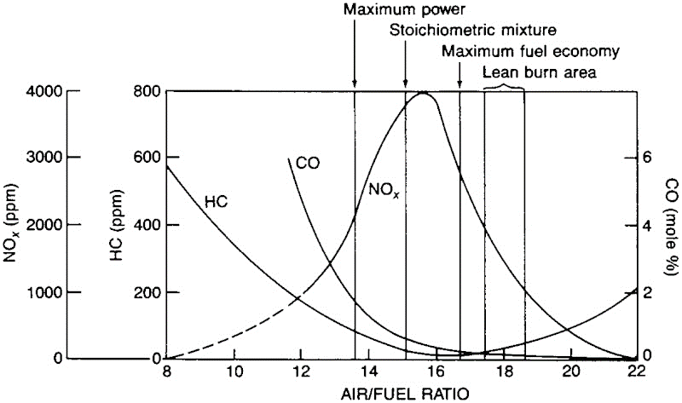
To reduce emissions, according to John H Johnson from Michigan Technological University, a more fuel efficient vehicle must be created using a 17:1 air/fuel ratio to produce maximum fuel economy. An air/fuel ratio of 17.5:1 can cause a misfire and slow down the speed of the flame fronts causing an increase in Hydrocarbons (Johnson, n.d.).
Figure 2: emissions at different air fuel ratios (Johnson, n.d.)

As seen in the graph above, it demonstrates what John H Johnson explained. As the air/fuel ratio increases to around 16:1, the NOx emissions are at their highest. This is close to the stoichiometric mixture. As the air/fuel ratio increases NOx emissions reduce but the Hydrocarbon and Carbon Monoxide begin to rise. For maximum fuel economy, 17:1 is the ideal mixture but for maximum power, 13.5:1 is the best mixture to use.
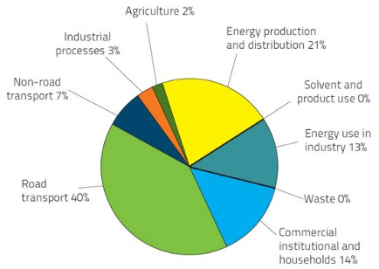
Nitrogen Dioxide and Nitric Oxide are together known as NOx, is one of the more toxic gasses exiting the exhaust causing near fatal side effects. NOx is an irritant gas that causes inflammation of the airways if inhaled in high concentrations. NOx is produced due to the reaction of nitrogen and oxygen in the air during combustion according to Icopal-noxite authors (Icopal-noxite, n.d.). As seen in the pie chart to the right, road transport equates to an enormous 40% of the EU’s NOx emissions as of 2011 due to the considerable health issues caused. NOx is one of the main contributors to acid precipitation, in turn, causing dramatic effects to the quality of soil and water in the surrounding area.
Figure 3: Share of emissions sector by group (Icopal-noxite, n.d.)
This will have a significant effect on aquatic ecosystems in the rivers and lakes and will cause lasting damage to forests and vegetation (Anon, 2010). Vehicle NOx emissions are caused by high temperature combustion fuels where the combustion temperature exceeds 1300ºC, oxidising some of the nitrogen in the air, subsequently producing NOx gasses. Diesel engines tend to produce more NOx emissions due to the fuel and air being compressed about twice as much as a petrol vehicle, generating heat and causing the fuel to spontaneously ignite when being injected.
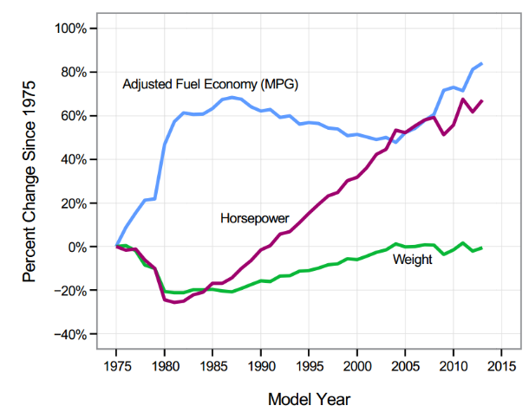
3.2 Performance
Figure 4: Change in Vehicles (Lafayette, n.d.)
The graph to the left demonstrates the dramatic decline in engine power and the sudden increase in fuel economy, this is due to the decline in big bore engines due to the safety concerns in the late ‘70s explains Lafayette authors. Due to the increase in safety regulations a couple of years later, vehicle performance began to rise again. The technology wasn’t as sophisticated as it is today due to the decrease in fuel economy until 2005. Vehicles have begun to rise steadily in weight since the 80’s meaning power rises equally. (Anon, n.d.). According to Joann Muller from Forbes, since 2013, SUV sales have increased by 87% globally and car sales drop by 8% (Muller, 2018).
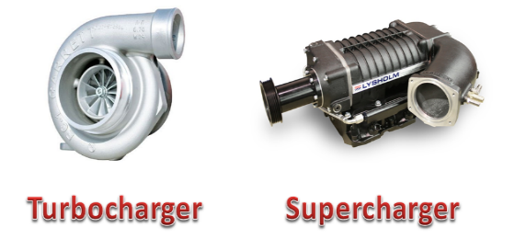
Increasing performance can be acquired with the addition of a forced induction system to the engine. Turbocharges provide the engine with air at high pressure through the use of exhaust gasses spinning a turbine. This turbine is connected via a shaft to the compressor side of the turbo, where the air gets compressed and enters the cylinder. Higher the compression of the air, the more air can fit into the cylinder, where in turn, more fuel will be added causing larger combustion explains Chris Woodford from Explainthatstuff.com (Woodford, 2018). Superchargers provide the same overall effect as that of a turbocharger except for the use of the engines power to compress the air rather than the use of the exhaust gasses (Anon, n.d.).
Figure 5: Forced Induction systems (Mishra, 2017)
The basic principles of increasing performance are to pump more air and fuel into the cylinder at a specific air/fuel ratio as well as having a free flowing path for the exhaust gasses to exit. A performance air intake will improve the volumetric efficiency of an engine due to the less restrictive path the air has to take reducing turbulence within the intake according to Jim Smart from Mobil (Smart, n.d.). Cylinder head porting can be a great way to increase volumetric flow according to Jim Smart. To increase airflow, valve and port sizes can be modified to provide a higher velocity path for the air to enter the cylinder (Smart, n.d.).
A tuned vehicle can then cause more complication to air fuel mixtures due to the change in compression ratios and boost pressures subsequently affecting the ideal air fuel mixture in the cylinder at any one point. Nowadays due to modern fuel injection and a good tune on the car, the air fuel ratio can be manipulated depending on how the car is being driven.
3.3 Vehicle Calibration
The principle of calibration is overwriting the ECU’s default configuration with a new software tailored to the improvement trying to be achieved. Remapping can improve engine performance and fuel economy. After remapping for performance, there will be a noticeable improvement in the speed and power of the vehicle. According to Kevin Pratt, “Some remappers claim an increase in horsepower of between 30 and 40bhp and in torque of up to 80nm.” (Pratt, 2017). Altering the amount of fuel entering the cylinders is controlled by the engine’s ECU, but this can be overwritten and the mixture can be changed to a rich mixture, lean mixture or a standard stoichiometric mixture. To complete the fuel change on the university dyno software, the standard rendition of the air/fuel ratio has to be converted into lambda. The table below demonstrates the difference in lambda values to the standard air/fuel ratio for petrol and diesel powered vehicles.

Lambda | Petrol | Diesel
0.60 | 8.8 | -
0.65 | 9.6 | -
0.70 | 10.3 | 10.2
0.75 | 11.0 | 10.9
0.80 | 11.8 | 11.6
0.85 | 12.5 | 12.3
0.90 | 13.2 | 13.1
0.95 | 14.0 | 13.8
1.00 | 14.7 | 14.5
1.05 | 15.4 | 15.2
1.10 | 16.2 | 16.0
1.15 | 16.9 | 16.7
1.20 | 17.6 | 17.4
1.25 | 18.4 | 18.1
1.30 | 19.1 | 18.9
1.35 | 19.8 | 19.6
1.40 | 20.6 | 20.3
1.45 | 21.3 | 21.0
1.50 | 22.1 | 21.8
1.55 | 22.8 | 22.5
1.60 | 23.5 | 23.2

Table 1: Lambda air/fuel ratio’s (Anon, n.d.)
As seen above a stoichiometric air/fuel ratio has a lambda of 1, a very lean mixture will have a lambda of 0.6 and a rich mixture will have a lambda of 1.6. A lean air/fuel mixture contains a relatively low proportion of fuel compared to the amount of air entering the cylinder, whereas a rich air/fuel ratio contains a considerably higher amount of fuel than air. “When idling, the fuel is below peak temperatures, resulting in incomplete combustion and fuel residue build-up on cylinder walls and spark plugs. Consequently, this build-up can significantly diminish the efficiency of an engine” states Saber Fallah from the University of Surrey (Fallah, 2014). An incorrect air/fuel ratio could cause this build up on the cylinder walls and spark plugs to become even worse.

3.4 Previous Experimentation
A test was undertaken by the University of Central England which is similar to the test that will be conducted following this paper. A. Smith and D. T. Tidmarsh performed their first test at 30mph and 2000rpm (2 bar bmep) recreating an urban drive cycle with the speed and load upon the engine. Smith and Tidmarsh discovered the effect this speed has on NOx emissions, Particulate matter and Hydrocarbons. They completed a second run at 75mph and 2750rpm (5 bar bmep) representing high speed, extra urban conditions recreating the loads upon the engine whilst testing the same emissions. “At each of the two speed and load points the start of injection timing and EGR rate were varied from the manufacturer’s tune point” states Smith and Tidmarsh (Smith and Tidmarsh, 1998).
A similar experiment was conducted by Will F. Colban and Paul C. Miles where they were discovering the effect intake pressure has on vehicle emissions and performance. Colban and Miles performed only one experiment during their testing where the engine was set at 1500rpm and injection pressure were monitored and kept at a constant 860bar (12473 psi). The engine used in this experiment was a General Motors four cylinder, 1.9 litres accompanied by a 4 valve head with each valve positioned at 2º from vertical. The experiment consisted of testing a number of different emissions such as unburned hydrocarbons in the exhaust port. The probe was located 25mm from the exhaust stem. Soot exiting the exhaust was also measured where the sample was taken downstream of the exhaust plenum.
An experiment was conducted by a group of engineers concerned about the emissions output of the most common means of transport in Asia; a motorcycle. They discovered that 77% of the world’s motorcycles were located in Asia as of 2012. The motorcycle in question used was a 4 stroke twin spark engine producing 32kW of power. The motorcycle has port injection and a compression ratio of 10.5. Initially, the engine was run at a stoichiometric air fuel ratio below 60% engine load and a λ of 0.85 when the engine load was equal to or greater than 60%. The test was run from 3000rpm up to 7250rpm where the bike in question redlined. Due to combustion instability, the engine only reached a speed of 5000rpm whilst operating at a lean mixture. During all tests, the engine speed was monitored and kept within 1% of the set speed. The experiment set up was rigorous, the environment temperature was set to 25ºC with an allowable fluctuation of 1 degree.
3.5 Seat Leon 1.9 TDi pd

Figure 6: Seat Leon 1.9 TDi (Dredge, 2017)
As seen above, this is the vehicle that will be used on the dynamometer to complete the testing phase of this project. This vehicle is a turbocharged 1.9 litre, four cylinder Seat Leon producing 108 bhp at 4150 rpm and 235 Nm for torque at 1900 rpm when the car was stock and brand new; also has a compression ratio of 19.5:1. Since then, the Leon has been tuned and modified by the owner and is currently producing more power. The car will be returned to as close to stock power as possible prior to testing. The Leon is a front engine vehicle with a transversely mounted engine providing all the power to the front wheels. The Leon would’ve lost some power over the years but the vehicle isn’t currently at stock power. The Leon houses a single overhead camshaft featuring 2 valves per cylinder which has a bore and stroke of 79.5 x 95.5mm; a bore/stroke ratio of 0.83. When new the Leon featured a 115 mph top speed with a blistering 0-60 mph time of 10.7 seconds. The vehicle weighs 1239 kg prior to modifications meaning the vehicle when new had the power to weight ratio of 87.17 bhp/tonne (Anon, 2013).
To complete the changes that will be made on this vehicle, the ECU will have to be overwritten and returned to original power after testing has been completed. This project will be safe for the vehicle and nothing will be damaged.

3.6 MAHA MSR 500/2 Car 4wd Dynamometer
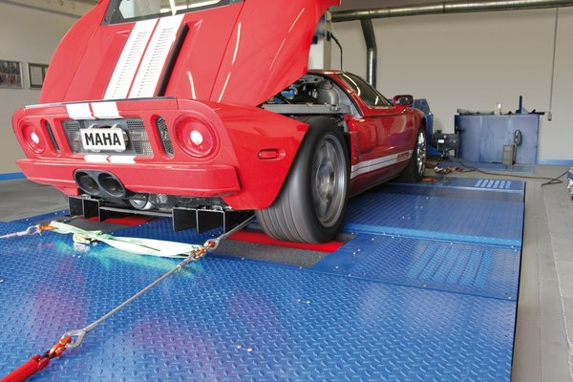
Figure 7: MAHA MSR 500/2 Car 4wd Dynamometer (Anon, n.d.)
The image above shows the same dynamometer that’s installed in university and the dynamometer that the Seat Leon will be strapped to and the testing procedure is undertaken. This dyno is capable of speeds up to 300km/h (185mph) which is completely ample for the Leon. There’s an extensive variety of operating modes provided with this dyno such as static power measurement at a constant rpm, constant speed or at a constant tractive force. The dyno can simulate a load upon the vehicle as well as an optional driving simulation. The max power that can be handled on both rollers of this dyno is approximate 1300bhp providing an accuracy of 2%. The two rollers are adjustable therefore allowing them to move closer together or further away from each other. The closest they can be together is 2200mm which is perfect for the Leon seeing as its wheelbase is 2578mm. The maximum tractive force that can be applied to both the rollers of this dyno is 7000N (Anon, n.d.). Another feature the dyno incorporates and will be used during testing is the installed lambda measurer. This will be used alongside the Bosch Oscilloscope to discover the air fuel ratio of the Seat Leon.
4.0 Experiment
4.1 Equipment Used
During this testing, a number of different equipment will be used. To start with the most important piece of equipment is the vehicle; a Seat Leon 1.9 TDi pd will be required to complete all testing and used to gather results. Secondly, the MAHA MSR 500/2 Car 4wd Dynamometer will be required to run the Leon on and produce the numbers required. To change the air fuel ratio, lambda will be adjusted. A table of lambda values can be seen in Table 1 on page ten. The dyno incorporates a feature whereby the lambda can be read through the dyno, therefore, that’s how the lambda will be read. To assist the dyno, the Bosch Oscilloscope will be used to read lambda as a ‘double check’ to ensure the results coming from the dyno are correct. The Bosch Oscilloscope will also read the NOx emissions of the vehicle at different air fuel ratio’s as well as the exhaust gas temperatures exiting the vehicle. An ECU already fitted to the vehicle will be used to tell the vehicle to change how much fuel enters the cylinders. In order to tell the ECU what to do, a laptop with the correct software to modify the ECU will be required and this will be provided by the owner of the vehicle. In order to change the air fuel ratio’s, the assistance of the dyno technician will be required as he’ll know exactly how and the best possible way to go about changing the required parameters to find the best air fuel ratio for NOx and exhaust gas reduction on a non-dpf diesel.
4.2 Procedure
4.2.1 Set up
Strapping the vehicle down to the dyno is the most important part of any dyno session due to the health and safety aspects of the procedure. Having all the correct equipment is key. Tyre chocks should be used for the rear tyres (the vehicle is front wheel drive), axle straps are also required as well as up to 6 car tie downs, for this testing, only 4 will be used. Once all the equipment is checked, measure the wheelbase of the vehicle and adjust the length of the dyno accordingly before driving the vehicle on the rollers. Once the vehicle is on the rollers, it must be ensured that the vehicle is completely perpendicular to the rollers otherwise the vehicle will begin to snake on the dyno and this can be very dangerous. Having a car driving over 100 mph on the dyno produces a lot of forward thrust pulling on the straps; so tying the car down correctly is extremely important. Firstly the straps must be attached to the loops that are normally located in the concrete at the front and rear of the dyno. A safe and secure mounting point then must be located underneath the vehicle that has enough strength to withstand the forces acting upon the vehicle. Make sure the straps aren’t impeding with any non-structural components such as brake lines or rotating axles. The hooks on the end of the straps will then be attached to these locations and the straps ratcheted tightly but evenly across all four corners of the vehicle to ensure the wheels remain centred on the rollers. It’s always a good precaution to have someone else check the straps on the vehicle are attached correctly and that they are secure enough to proceed. Once the straps have been checked, drive the vehicle slowly on the dyno, ensuring the rollers are turning also. This will test if the computer is reading the dyno correctly, if the straps are attached securely enough and if the laptop with the software can read the ECU accurately. If all the above points are completed and checked, the vehicle is safe and ready to be tested on the dyno at full speed.
Once the dyno is set up correctly and has been double checked set up the exhaust extraction at the rear of the car to extinguish any harmful fumes out of the building. Ensure that the extraction pipe is safe and stable and won’t fall off halfway through testing. The exhaust gas temperature probe from the oscilloscope can be inserted in the exhaust and the correct channel uploaded on the Bosch Oscilloscope computer. Finally, the lambda sensor from both the MAHA dyno and the Bosch oscilloscope can be turned on and start recording. Both are being used to get a more accurate reading and ensure all testing is done as precise as possible.
4.2.2 Gathering Results
Once all the above precautions have been reviewed and completed, the vehicle can now begin the testing phase. A base run will be completed to discover the maximum torque and power of the vehicle at a stock map; this will be considered as the base map. The test will begin with the first air fuel ratio of 10.2:1 (lambda 0.7) and will change 11 more times. The air fuel ratio on the laptop will have to be altered until the dyno and the oscilloscope read the same figure and this figure is correct for the test being completed. During each test, the oscilloscope computer will record the results and the NOx and exhaust gas temperature will be read and the value recorded. The NOx reading may vary slightly, therefore, the most consistent number will be read.
4.3 Test Plan
Test | Air/Fuel Ratio - Diesel | Lambda | NOx Output (ppm) | Exhaust Gas Temp (ºC)
1 | 10.2:1 | 0.70
2 | 10.9:1 | 0.75
3 | 11.6:1 | 0.80
4 | 12.3:1 | 0.85
5 | 13.1:1 | 0.90
6 | 13.8:1 | 0.95
7 | 14.5:1 | 1.00
8 | 15.2:1 | 1.05
9 | 16.0:1 | 1.10
10 | 16.7:1 | 1.15
11 | 17.4:1 | 1.20
12 | 18.1:1 | 1.25
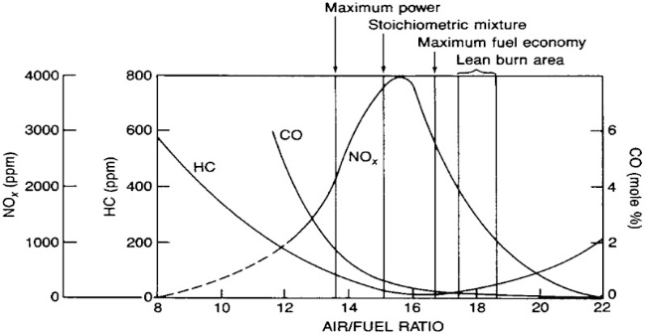
Table 2: 1st Test plan (Thomas, 2019)

Figure 8: Previous test Graph (Johnson, n.d.)

As seen in Table 2 above, this is the first iteration of the test plan for the day of testing. The plan states that 12 runs will be completed across a number of different air fuel ratios. The test will be completed with the Seat Leon at max torque point of the stock vehicle. Prior to completing the NOx testing, the maximum torque will have to be discovered and at what rpm, this is found. The dyno will require lambda numbers, therefore, each air fuel ratio has also been converted to a lambda figure to ensure the dyno will understand the requirements.
The air fuel ratios range from a very rich mixture to a lean mixture. The first test will be completed on 10.2:1 which is equivalent to lambda of 0.70 all the way through to an air fuel ratio of 18.1:1 which is equivalent to lambda of 1.25. The stoichiometric mixture for this test will be at 14.5:1 (diesel) and lambda of 1.
The image above demonstrates what has previously been tested and this is what’s believed to happen to NOx when the air fuel ratio changes. For this test, exhaust gas temperature will also be measured and added to the graph but hydrocarbons and carbon monoxide won’t be tested. This project will discover whether this graph is correct and whether the maximum power produced is around the 13.7:1 area, completed in test number six and the maximum fuel economy around the 16.5:1 area, completed in test number nine and ten.
The plan has changed slightly from the first iteration due to possible damage to the engine with such large quantities of fuel and air entering the cylinder as well as time constraints. The original plan was to also do twelve sets of testing; providing a wide range of air fuel ratios. This would’ve also provided a wider range of results to analyse and discover which air fuel ratio is the optimum for power and the optimum ratio for fuel economy.
Due to time constraints and availability if the dyno, this wasn’t possible. Three runs were completed at different lambda settings as well as a power run on a base map to discover the figures at a standard map. Also, the lambda values couldn’t be kept constant as the lambda values will fluctuate across the power range. Instead of keeping the vehicle at a set rpm, the driver produced a power run in fourth gear for each of the three lambda settings whilst discovering the power at the crank as well as the wheels, torque, power drag, intake manifold pressure and air quantity. The table below will demonstrate the second iteration of the test plan.
Lambda | Power Crank | Power Wheel | Torque | Average NOx
1.541
1.386
1.099
Table 3: 2nd Test Plan (Thomas, 2019)

4.4 Operating conditions
The operating conditions on the day of testing will be recorded due to the change in atmosphere can interfere with the results. Air temperature, humidity and pressure vary from day to day, therefore, the conditions will be recorded and measured throughout the testing; the test will be conducted on Tuesday 9th of April. Research has been conducted, discovering whether the weather has an effect on NOx emissions and the research conducted states that the weather effects the results of NOx. Research has been conducted but not verified that the tendencies in NOx concentrates reduce as the moisture in the combustion air increases. The researchers believe this is due to the inert water in the air reduces the flame temperature and slows the flame front. Researchers also conducted an experiment whereby they discovered that the NOx emissions will increase as the atmospheric air temperature increases. “NOx production is favoured by high temperatures. Local flame temperatures and NOx concentration will increase as the temperature of the combustion air increases.” (Bussman et al, 2009). This research has also been confirmed by a different source.
Air Pressure (hPa)  Table 4: Operating conditions (Thomas, 2019) | 1008.4
Air Temperature (ºC) | 19.2
Air Humidity (%) | 60
Intake Air Temperature (ºC) | 15.8
Ferris explains “Where temperatures exceeding 1200°C occur, such as in a fuel combustion chamber, Nitrogen and Oxygen do begin to react to form ‘Thermal NOx’. The rate of Nitric Oxide formation also increases as a function of increased temperature. This explains why diesel compression engines, which ‘run hotter’ create more NO than petrol spark engines” (Ferris, 2016). Below is a table displaying the operating conditions on Tuesday 9th of April at 9 am; air temperature, moisture and pressure will be read.
The air pressure on the 9th of April at 10:30 am peaked at 1008.4 hectopascal which equates to 100.84 kilopascal which is slightly below average for a sea level environment and the air temperature was a steady 19.2ºC which is a stable operating temperature for a diesel engine. The air humidity was rather low considering the university is next to the sea where the average pressure is approximately 80%. The intake temperature is lower than the air temperature due to the dyno cooling fan.

5.0 Results
5.1 NOx
Below are the results of the NOx emissions at different air fuel ratios discovered from the day testing was completed.
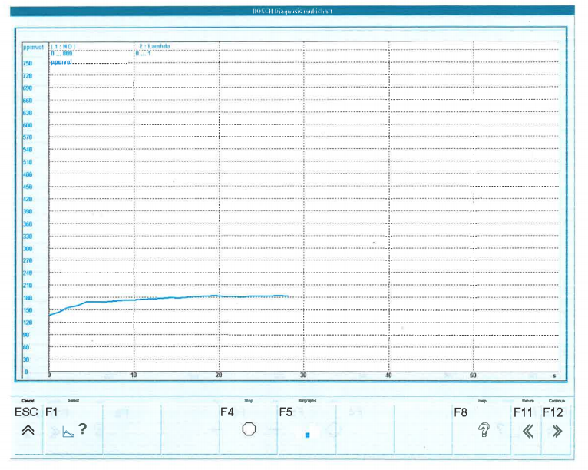
Figure 9: NOx at Idle (Thomas, 2019)
The graph above demonstrates the NOx values at idle. After cranking, the NOx values rise up to approximately 180 ppm vol and stay there throughout the test whilst the car is idling. Even as the vehicle increases in temperature, the idling NOx values remain the same. The idling rate for the Seat Leon tested is 830 rpm and even at idle this car produces a considerable amount of NOx. Many sources including Crypton state that “NOx levels on acceleration will typically read significantly higher than those measured at cruise and during deceleration. Typically, the NOx readings at idle will be close to 0 PPM” (Anon, n.d.) which means even at idle this vehicle is producing too much NOx emissions. This could be due to the vehicle not having a diesel particulate filter (DPF) installed which catches soot and emissions trying to exit the exhaust.

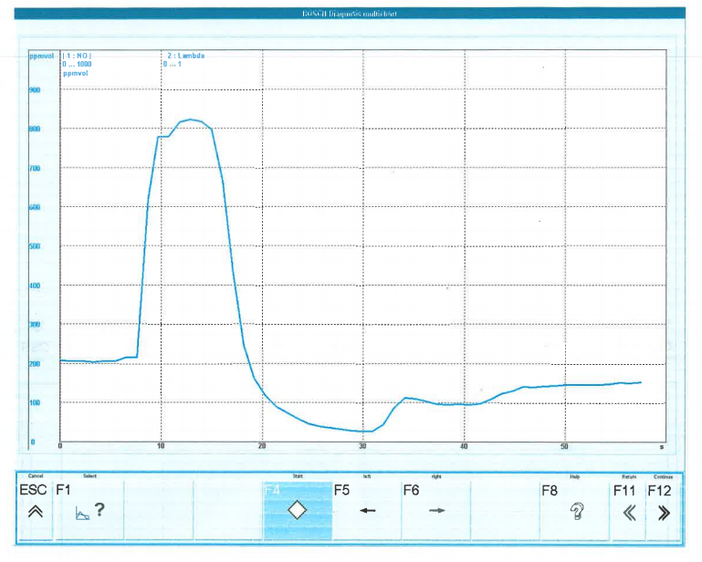
Figure 10: NOx at the base map (Thomas, 2019)
As seen in the graph above, the vehicle’s base map, the NOx values rise under acceleration but don’t stay high for very long before they begin to decline. This is due to the vehicle producing the most NOx during acceleration and cruising phase of the drive and produces the least during idle and deceleration. The test was completed with the vehicle at 100% throttle, therefore, the maximum amount of air and fuel will enter the cylinders for the vehicles map. The NOx values reach a high of approximately 810 ppm which is rather high considering Carslaw et al from King’s College London states that a stock vehicle will have NOx emissions of between 50 and 1000 ppm exiting a diesel exhaust (Carslaw et al, 2011). Again, this could be due to the vehicle not having a DPF installed. After the vehicle has stopped accelerating and is in the decelerating phase, the NOx emissions reduce right down to approximately 40 ppm before slowly rising back up to the idling value, this is due to the fuel being cut off until the vehicle returns to the idling speed of 830 rpm. The same trend happens with CO₂ concentrations as discovered by the faculty of mechanical engineering at the University of Ljubljana, Slovenia (Oprešnik, 2018). This base map run had lambda of 1.541 (air fuel ratio of approximately 22:1) produced 157 bhp at the crank and 317 Nm of torque.

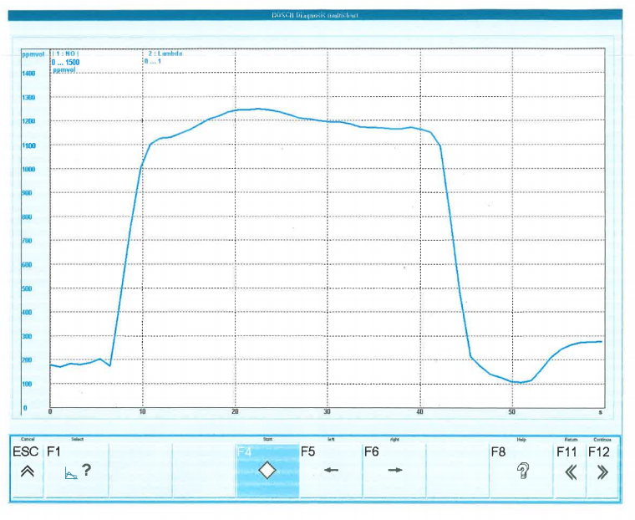
Figure 11: NOx at map 1 (Thomas, 2019)
Figure 11 demonstrates the NOx values at the 1st modified map applied to the vehicle. Compared to the base map, the NOx remained very high for a longer period of time; the NOx emission values reached approximately 1250 ppm which is extremely high for the vehicle which is understandable due to the lambda value is higher in this setup. The average lambda value of this test is approximately 1.684; an air fuel ratio of approximately 25:1. An average lambda value has had to be used due to the air fuel ratio constantly changing in a diesel engine whereas they change less frequently in a petrol powered engine. The trend of this graph is the same as the trend of the base map. This map produced less power than the first standard map producing 143 bhp at the crank, this would be due to the vehicle receiving too much fuel on each compression stroke. By comparing the two graphs, it displays that the more fuel the vehicle receives, the higher the NOx emissions which is what was thought in the hypothesis of this project. This set up produces more torque than the last set up also due to the excess fuel entering the cylinder which wasn’t originally expected in the hypothesis; the vehicle produces 347.1 Nm on this set up which is 30 Nm more torque than the last set up. This is opposite to what was discovered by Tiew Chee Wee from the University of Malaysia. He states that “With the increase of λ, torque output is getting smaller because the amount of combustible vapour in the cylinder reduces. With the decrease of λ, although the amount of combustible vapour increases, torque is still getting smaller because of incomplete combustion” (Wee, 2015).
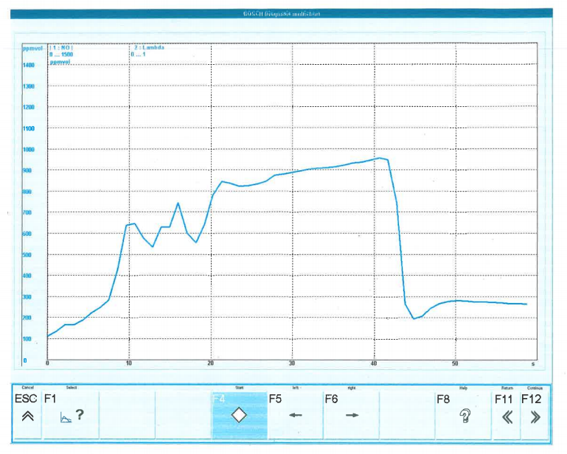

Figure 12: NOx at map 2 (Thomas, 2019)
During this map, there was too much fuel being injected at the start of the power run. This is why there’s a lot of inconsistencies towards the start of the test. The fuel needed to be gradually injected rather than all dumped in at once. This map was the richest out of the three maps, yet there are still these inconsistencies at the beginning of the test. This could be due to the vehicle not receiving enough fuel to idle smoothly, therefore there may be a fluctuation in the idling speed which in turn will cause more emissions than a smooth, constant idle. An air fuel ratio that is too rich can produce an abundance of carbon and NOx emissions from the exhaust causing numerous other environmental complications. After the inconsistency at the beginning of the test, the remainder of the graph is very similar to the previous lean mixture but at the same time producing fewer NOx emissions. This map produces approximately 300 ppm fewer NOx than the previous test; this test produced approximately 950 ppm at its highest point. Correspondingly to the previous two lambda maps, on deceleration, the ECU cut the fuel supply to the engine as seen in the red circled area. This happens to improve emissions output by the vehicles and it improves fuel economy. The deceleration fuel cut off occurs due to the engine not needing any fuel as the rpm is on the decrease and as soon as the driver begins to accelerate again, the fuel automatically begins to flow again and the vehicle accelerates as the driver demands of it. General Motors state that their fuel cut off can increase the vehicles fuel economy by up to 2% (Loos, 2011).
5.2 Power and Torque Increase
Figure 13: Power and Torque Base Map (Thomas, 2019)

As seen in the graph above for the base map applied to the vehicle, the vehicle’s power continues to rise until 3945 rpm where it hits a peak power of 92.1 bhp; resulting in a loss of slightly under 16 bhp as previously researched on page 12. This would result in a power loss of over one bhp a year since this vehicle was registered. This is normal for vehicles to lose power over the years due to wear and tear on the internal components. For an engine to run well, it requires the correct amount of fuel, the correct amount of clean air and free flow for exhaust gasses to escape; these three key attributes can get compromised over time which can lead to a vehicles power loss. The Seat Leon on its base map produced max torque of 316.7 Nm at 3805 rpm; this is a gain of 81 Nm meaning there may be a few modifications on the vehicle that increased this number. As a base setting, this is a very strong set up for the vehicle to be improved upon and modified accordingly. The graphs below demonstrate how the power and torque have changed through different setups.

Figure 14: Power and Torque Map 1 (Thomas, 2019)

During the second set up, as seen in the graph above, the max power and torque peaked early compared to the base map of the vehicle. The power curve of the base map peaked at 3945 rpm but the power curve on the second test peaked at 3370 rpm which is 600rpm sooner. By producing the peak power 600 rpm sooner, 6 bhp has been lost; 86.51 bhp. The power run got completed twice due to the spike in the data at the circled point but kept repeating the same trend. This was due to the smoke limiter of the vehicle being hit as the lambda values of the vehicle were too high. The same trend happens in the torque curve. Whereas in the last set up the vehicle produced maximum torque at over 3800 rpm, the maximum torque was acquired at 1975 rpm in the second set up. This is due to the lambda value being higher than a normal, stoichiometric mixture.

Figure 15: Power and Torque Map 2 (Thomas, 2019)

Just the same as the last map, the power and torque curve have an issue towards the beginning as seen in the circled area. This is due to the fact that the air fuel ratio is too rich in this map therefore too much fuel is entering the cylinders. The base map applied to the vehicle produced a max power of 92.1 bhp at 3945 rpm. Due to the engine receiving too much fuel on this map, the vehicle has managed to produce 123 bhp at 3210 rpm. More power was produced due to the increase in fuel and this will correspond with the graph on page seven (Figure 2); whereby an air fuel ratio of approximately 13.5:1 will produce maximum power for the vehicle. This rich map ended up producing 31 bhp more than the base map applied to the vehicle, 735 rpm sooner. This map also produced more torque than the base map on the vehicle. This map produced 361.8 Nm of torque at 2030 rpm, which is approximately 45 Nm of torque more at a whole 1000 rpm sooner. With a bit of tweaking and a gradual increase in fuel injection, this would be a very good map for the vehicle. Currently, the map wouldn’t perform very well due to the circled area on the graph.

Figure 16: Map’s Power Curves (Thomas, 2019)
Test 2: 86.51 BHP
Test 3: 123.01 BHP

The graph above demonstrates the power curves of all three of the maps applied to the vehicle. By looking at the three curves, it’s only the base map that provides a smooth curve. This is due to the first map hitting the smoke limiter as the map was too lean and the second map producing an air fuel ratio that was too rich. With a bit of calibration, the first and second map would be able to produce a smooth curve similar to that of the base map and could produce slightly more power. Despite the base map producing a smooth curve, it doesn’t produce the most amount of power. The least amount of power is produced by the first modified map applied to the vehicle due to this map being too lean. The second was the base map of the vehicle and the most amount of power was produced by the third rich map. This corresponds to figure two found on page seven.

Figure 17: Map’s Torque Curves (Thomas, 2019)
Test 2: 347.1 Nm
Test 3: 361.8 Nm

This graph displays the torque increase across the three maps. Similarly to the power curves, the base map produced a smooth curve throughout the rpm range whereas the other two maps produced issues towards the start. With some calibration, these maps would be able to be smoothed out and possibly a bit more torque produced. Even though the base map had a smooth torque curve, it still produced the least amount of torque across the rpm range. Just the same as the power curves, the second map produced a not very smooth map but produced the second highest torque numbers. The rich air fuel mixture produced the max amount of power out of the three runs as well as the maximum torque. Ford has used a rich air fuel mixture in their ford EcoBoost 3 cylinder engines. Ford uses a stoichiometric mixture during idle and low engine speed and loads but the fuelling changes as the engines speed and load increases. Ford has applied this in order to reduce engine temperatures during high engine speeds and load. The additional fuel will remain unburned but is injected into the cylinders to absorb heat through evaporation, in turn, reducing the temperatures in the combustion chamber (Anon, n.d.).

5.3 Other Resulting Alterations
Figure 18: Intake Manifold Pressure (Thomas, 2019)

The graph above demonstrates the three different map’s intake manifold pressure. Just the same as the last graph. The blue line demonstrates test one, the green line test two and the orange line demonstrates test three. The intake manifold pressure is at its highest on the base map of the vehicle due to the fuelling of the first map. In a naturally aspirated spark ignition engine, the intake manifold pressure is often an indication of the throttle position; more pressure means less throttle has been applied. In general, the more throttle applied, the less pressure will occur in the intake manifold resulting in more torque. In a naturally aspirated compression ignition engine, the intake manifold pressure doesn’t vary nearly as much as a spark ignition engine; this is due to a diesel engine generally not having a throttle valve according to Scott Dunnington from Louisiana State University. In turbocharged engines, like the one used in this testing, intake manifold pressure will increase with the engine speed or power up to a maximum but doesn’t correlate with engine torque. Intake manifold pressure is often useful to the ECU to calculate fuelling in a boosted engine (Dunnington, 2017).

Figure 19: Air Quantity (Thomas, 2019)

The graph above demonstrates the air quantity entering the cylinders across the three maps. A trend is beginning to happen across these graphs; they all demonstrate that the base map is a smooth curve and the rest have issues at the beginning. This means that all these graphs analysed are affected by the quantity of air and fuel entering the combustion chamber. As seen in this graph, the most amount of air entering the cylinder occurs in the base map. On the day of testing, the air humidity was rather low therefore the results gathered for the intake of air would vary depending on the humidity of the environment as well as the ambient and intake air temperatures; all weathers effects the quantity of air entering the combustion chambers. After the little issue at the beginning of the two modified maps, the air quantity rises progressively whereas the air quantity of the base map rises rather suddenly and flattens off towards the top. Towards the end of each power run, the quantities of air are in the same order as the power and torque produced. This demonstrates that the more power produced by the map, the more air required to complete the run.

Figure 20: Power Loss (Thomas, 2019)
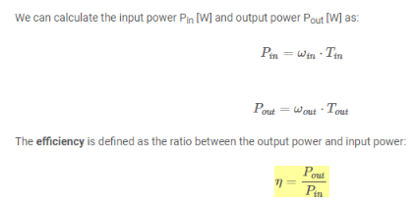
The graph above demonstrates the power lost between the crank and the wheels for each run. Strangely, towards the end of the runs, the base map loses the most amount of power but is a very smooth, continuous graph as seen in previous graphs. At the beginning of the third run, the Seat Leon loses the least amount of power but after approximately 1900 rpm, the second run loses the most amount of power. The power loss occurring in these graphs tends to be due to the vehicle’s drivetrain. On average the power loss will be approximately 15% for a front wheel drive vehicle. The image below shows a formula used to discover the drivetrain efficiency of a vehicle due to the fact it varies slightly for each vehicle, depending on age and wear on components.
Figure 21: Power Loss Equation (Thomas, 2019)

The equation states that to discover the power input, the input speed must be subtracted from the input torque and the power output can be calculated by subtracting the output speed by the output power. These two answers can then be divided by each other and used to discover the efficiency ratio between the output power and the input power of the vehicle; each vehicle will have a different drivetrain efficiency. Power loss on the dyno is commonly known to calibrators as dyno drag; loss of power between engine and wheel but also takes into consideration any losses through the dyno itself.
5.4 NOx Emissions Reduction

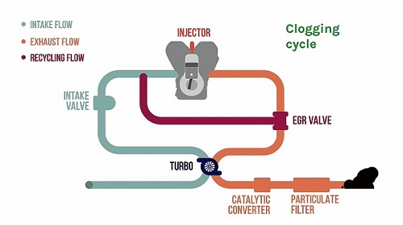
The pressing question facing a lot of engineers today is; how do we reduce emissions? NOx emissions can be drastically reduced by changing a number of things within the Otto cycle of the engine. To begin with, the reduction of the combustion temperature within the cylinders will help reduce the NOx levels exiting the exhaust. Combustion chamber temperature can be reduced by applying exhaust gas recirculation (EGR) to the system. EGR works by recirculating some of the exhaust gasses back into the combustion chamber and re-burning the gasses and unburnt fuel. During the EGR process, there’s less oxygen within the gas due to the previous combustion so the flame front will be quicker and smaller. Also, compared to air, the exhaust gasses have a larger heat capacity, therefore, requiring more time to heat up. But there is a downside to EGR. Due to the reduction in combustion temperature, the power will drop as well as the fuel economy which isn’t ideal for day to day use (Anon, n.d.). The image below demonstrates a diagram showing how EGR works.
Figure 22: Exhaust Gas Recirculation (Anon, n.d.)

A new technology that has been incorporated in many vehicles today use cylinder deactivation. The benefits and limitations of cylinder deactivation for diesel engines were investigated by Jean-Paul Zammit from Jaguar Land Rover. Zammit was discovering whether the addition of cylinder deactivation would significantly reduce NOx emissions from a turbocharged diesel engine. During this test, a four cylinder turbocharged engine was tested and two cylinders were deactivated. Zammit discovered that at light loads applied to the engine (approximately 2 bar BMEP) cylinder deactivation had no significant effect on NOx emissions produced by the engine. Even though NOx wasn’t greatly reduced, cylinder deactivation allowed the fuel rail to run at higher pressures which reduced soot emissions whilst maintaining low Hydrocarbons and Carbon Monoxide. During higher load testing (3 bar BMEP), cylinder deactivation lowered HC and CO but unfortunately raised the exhaust gas temperatures by approximately 120ºC; in turn, unfortunately, increasing NOx emissions (Zammit, 2013).
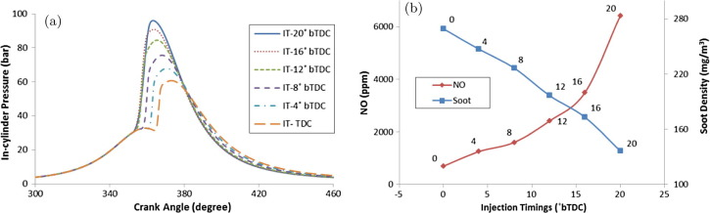
Figure 23: Injection Timing (Sindhu et al, 2018)

As the leftmost graph above demonstrates, as the injection timing is 20º before top dead centre the in-cylinder pressure is at its highest. As the angle decreases, the cylinder pressure follows. The graph on the right displays as the injection timing is advanced to 20º before top dead centre, the NOx emissions rise to just over 6000 ppm but the soot emissions drop as the injection timings are advanced. There’s a ‘happy medium’ between the soot emissions and the NOx emissions; this is at approximately 14º before top dead centre (Sindhu et al, 2018).
A technology known as split injection can be incorporated to reduce NOx emissions as well as improve the fuel economy of the vehicle. Split injection lowers the amount of fuel that is injected in the first pulse whereas in a normal case, 100% of the fuel is injected in a single injection. The split injection is injected and the remainder of the fuel is injected later with a certain injection pulse, known as dwell period after the initial injection.
“The combustion of fuel from the initial pulse creates conducive environment for the later injected fuel. This reduces the ignition delay of the second pulse of fuel making the combustion predominantly mixed-controlled. This restrains the peak heat release rate and delays a major portion of combustion shifting the combustion event away from TDC” states Sindhu (Sindhu et al, 2018).
A test was conducted by these engineers perfecting the split injection, determining how much fuel to add in the first pulse and how much in the second pulse. Two tests were conducted; the first 25/75 represents 25% of the fuel injected in the first pulse and 75% of the fuel injected in the second pulse and the second 75/25. The graphs below demonstrate the benefits of these two different pulses acting upon heat release rate, the mass of fuel injected and the temperature within the cylinder.
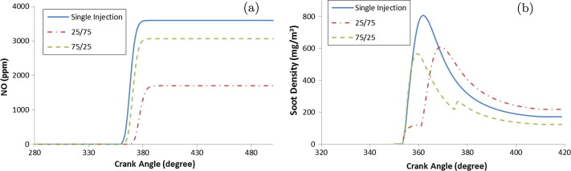
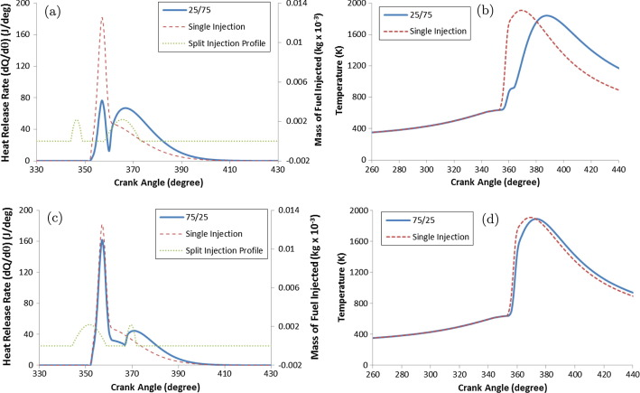
Figure 24: Split Injection (Sindhu et al, 2018)
By splitting the injection, the graphs on the right display the heat is produced a lot later in the crank angle compared to that of a single injection and by looking at the graph, the heat is also reduced slightly thus assisting in the reduction of NOx. The rate of heat release in the 25/75 is greatly reduced compared to that of the single injection; this result will be a drop in temperature in the combustion chamber also reducing the formation of NOx emissions. The 25/75 injection profile can be seen in the graph and the spike in temperature twice. “As the amount of fuel injected in the first pulse increases, resident time of burnt charge at high combustion temperatures increase, increasing the tendency of NO formation.” (Sindhu et al, 2018). From the bottom graphs, it can be observed that the 25/75 injection formation has decreased the NO incredible amounts compared to the single injection and even the 75/25 injection. As the NO decreasing, the soot density exiting the exhaust dramatically decreases as seen in the graph above.
6.0 Conclusion

The ever increasing greenhouse gasses excreted from vehicles today will keep depleting our natural environment unless engineers begin to find a solution. Stringent targets are being enforced upon the emissions emitted from a vehicle. An EU fleet-wide average emissions target of 95 g/km of CO₂ has been set. This is a reduction in carbon dioxide emissions of 23.5 g/km since the last target set in 2017. The emissions targets set to manufacturers are set according to the average mass of the vehicles produced (Anon, n.d.). Through completing the research associated with this paper, it’s been discovered that the hypothesis set at the beginning of the project was correct. As the air fuel ratio transfers along the scale from rich to lean, the NOx emissions output will decrease up until a stoichiometric mixture where it will begin to rise again as the air fuel ratio becomes lean. As researched in figure 25 in the appendix, the set hypothesis was proved wrong. As the lambda values increase, the exhaust gas temperatures decrease due to the quantity of fuel being injected into the cylinders, cooling down the flame front. It can’t be emphasised enough how much NOx emissions affect human and environmental health. Breathing in high concentrations of NOx can irritate and cause damage to the human respiratory system, causing diseases and inflammation of the airways, making breathing extremely difficult. Even short time exposure to NOx emissions can cause asthma and irritate the airways, causing an itching sensation, coughing, wheezing or difficulty breathing. NOx emissions standards have been set in areas of high population and manufacturers are attempting to tackle these issues head on by using some of the techniques discussed in the paper above along with new techniques discovered as more research into the issue is undertaken. The techniques discussed above are only a few out of a handful of approaches that can be undertaken to reduce NOx emissions throughout the world and there may be better approaches.

7.0 Project Analysis
On the whole, this project went well but like any project, there were complications present. The main complication was to locate a vehicle to use on the dyno. The original plan was to use the university’s Volkswagen Lupo as a fellow student had wired up a standalone ECU to the vehicle and this would’ve been perfect for my testing. Due to unforeseen circumstances, the Lupo wasn’t cooperating with his project, therefore, another vehicle had to be used for his project and this project was back at square one without a vehicle. Luckily, Pedro had a vehicle available with a standalone ECU that was able to be used for the series of testing required, therefore, on the 9th of April the dyno was booked and the testing was able to commence. There was only one complication encountered on the day of testing and that was that the Bosch oscilloscope wasn’t able to read the Lambda values from the exhaust, therefore, the built in emissions tester on the dyno had to be used. The probe that’s used to test the emissions ended up being broken on the dyno, therefore, this had to be fixed first and then the testing could commence. Once these complications had been rectified, there weren’t any more on the day of testing. From the day of testing onwards, this project has gone very smoothly without any issues or complications.
If I had more time to complete this project, I would change a few things. Firstly, I would produce more results at different air fuel ratios to get a more detailed set of results. Also, instead of doing power runs, I would set the vehicle at its max torque and produce the results from there whilst also measuring exhaust gas temperatures at each lambda.

8.0 Acknowledgements
During this project, I had assistance from Pedro Monteiro Ferreira for being my project supervisor and assisting in coming up with a viable project to complete. I also had the chance to use Pedro’s personal vehicle to complete the testing undertaken in this project. Along with Pedro, I had assistance by Mark Fall the dyno technician and Barry John the workshop technician on the day of testing ensuring the dyno session went smoothly without coming across any issues along the way.
9.0 Appendix
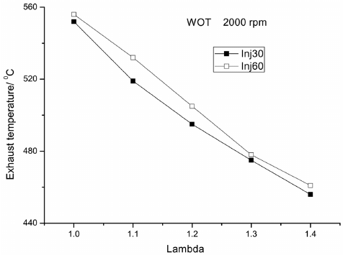
Figure 25: Exhaust Gas Temperature (Haeng and Bang, 2009)

Figure 26: Test 1 Remainder Graphs (Thomas, 2019)

Figure 27: Test 2 Remainder Graphs (Thomas, 2019)

Figure 28: Test 3 Remainder Graphs (Thomas, 2019)
10.0 References
Anon (2013). 2007 Seat Leon 1.9 TDI Specifications. [Online] Carfolio.com. Available at: https://www.carfolio.com/specifications/models/car/?car=102014
Anon, (n.d.). Air-fuel ratio, lambda and engine performance. [Online] X-Engineer. Available at: https://x-engineer.org/automotive-engineering/internal-combustion-engines/performance/air-fuel-ratio-lambda-engine-performance/
Anon (n.d.). Conversion Table – Lambda to Air/Fuel Ratio. [Online] Partssa. Available at: http://www.partssa.com/downloads/2040198/Conversion+Table+lambda+air+fuel+ratio.pdf
Anon, (n.d.). Drivetrain losses (efficiency). [Online] X-Engineer. Available at: https://x-engineer.org/automotive-engineering/drivetrain/transmissions/drivetrain-losses-efficiency/
Anon, (n.d.). EGR Valve. [Online] FlexFuel. Available at: https://www.flexfuel-company.com/egr-valve?lang=en
Anon (2016). European Emission Regulations – Will Stringent Emission Regulations Choke Automotive Industry Or Will OEMs Find Their Way Out? [Online] Frost & Sullivan. Available at: https://ww2.frost.com/frost-perspectives/european-emission-regulations-will-stringent-emission-regulations-choke-automotive-industry-or-will-oems-find-their-way-out/.
Anon (n.d.). MAHA MSR 500/2 Car 4wd Dynamometer. [Online] maha.com. Available at: https://www.maha.co.uk/single-roller-dynamometer-msr-500-2-car-4wd.htm?agreement=true&cookie_button=OK
Anon (n.d.). Nitrogen Oxide (NOx) Pollution - Health Issues - Icopal. [Online] Icopal-noxite.co.uk. Available at: http://www.icopal-noxite.co.uk/nox-problem/nox-pollution.aspx.
Anon (2010). Nitrogen Oxides (NOx) emissions. [Online] eea.europa.eu. Available at: https://www.eea.europa.eu/data-and-maps/indicators/eea-32-nitrogen-oxides-nox-emissions-1
Anon, (n.d.). NOx (Oxides of Nitrogen). [Online] Crypton. Available at: http://www.crypton.co.za/Tto%20know/Emissions/NOx.html
Anon, (n.d.). NOx emissions – formation, reduction and abatement. [Online] Clean-carbonenergy. Available at: https://clean-carbonenergy.com/nox-emissions.html
Anon (n.d.). Performance and Fuel Economy Trends – Internal Combustion Engines. [Online] Sites.lafayette.edu. Available at: https://sites.lafayette.edu/egrs352-sp14-cars/performance-and-fuel-economy-trends/
Anon (n.d.). What are Superchargers? | Working, Types, Advantages, Limitations – MechStuff. [Online] MechStuff. Available at: http://mechstuff.com/how-superchargers-work-types-advantages-limitations/
Banglin Deng, Qing Li, Yangyang Chen, Meng Li, Aodong Liu, Jiaqi Ran, Ying Xu, Xiaoqiang Liu, Jianqin Fu, Renhua Feng (2018). The effect of air/fuel ratio on the CO and NOx emissions for a twin-spark motorcycle gasoline engine under wide range of operating conditions. [Online] Sciencedirect.com. Available at: https://www-sciencedirect-com.ezproxy.uwtsd.ac.uk/science/article/pii/S0360544218324794
Bussman W, Baukal C and Zink J, (2009). Ambient conditions impact CO and NOx emissions: part II. [Online] Digitalrefining. Available at: https://www.digitalrefining.com/article/1000637,Ambient_conditions_impact_CO_and_NOx_emissions__part_II.html#.XKcvakhKiUk
Carslaw D, Beevers S, Westmoreland E, Williams M, Tate J, Murrells T, Stedman J, Li Y, Grice S, Kent A and Tsagatakis I, (2011). Trends in NOx and NO₂ emissions and ambient measurements in the UK. [Online] Uk-air.defra. Available at: https://uk-air.defra.gov.uk/assets/documents/reports/cat05/1108251149_110718_AQ0724_Final_report.pdf
Dredge R (2017). Used Seat Leon buying guide 2005 – 2013 (Mk2). [Online] Carbuyer.com. Available at: https://www.carbuyer.co.uk/tips-and-advice/154685/used-seat-leon-buying-guide-2005-2013-mk2
Dunnington S, (2017). What is the relation between intake manifold pressure and torque in an internal combustion engine? [Online] Quora. Available at: https://www.quora.com/What-is-the-relation-between-intake-manifold-pressure-and-torque-in-an-internal-combustion-engine
Dutton, J. (n.d.). Products of Combustion | EGEE 102: Energy Conservation and Environmental Protection. [Online] E-education.psu.edu. Available at: https://www.e-education.psu.edu/egee102/node/1951.
Ebbs, C. (2018). Euro 6 emissions standards: what do they mean for you? [Online] Auto Express. Available at: https://www.autoexpress.co.uk/car-news/consumer-news/90816/euro-6-emissions-standards-what-do-they-mean-for-you
Fallah, S (2014). Electric and Hybrid Vehicles - Technologies, Modeling and Control: A Mechatronic Approach. [Online] Researchgate.net. Available at: https://www.researchgate.net/figure/Effect-of-air-fuel-ratio-on-gasoline-vehicle-emissions_fig6_260878177
Ferris L, (2016). Blog: Nos Emissions | A Pollutant Focus. [Online] Envirocare. Available at: https://envirocare.org/nox-emissions/

Gabbatiss, J. (2018). Transport is UK's most polluting sector as greenhouse gas emissions fall. [Online] The Independent. Available at: https://www.independent.co.uk/environment/air-pollution-uk-transport-most-polluting-sector-greenhouse-gas-emissions-drop-carbon-dioxide-a8196866.html.
Goodwin, A. (2016). What is engine downsizing, and why should you care? - Car Keys. [Online] Car Keys. Available at: https://www.carkeys.co.uk/news/what-is-engine-downsizing-and-why-should-you-care
Ingram, A. (2017). Is engine downsizing finally falling out of fashion?. [Online] Evo. Available at: https://www.evo.co.uk/features/18753/is-engine-downsizing-finally-falling-out-of-fashion.
Johnson, J. (n.d.). Automotive Emissions. [Online] Michigan Technological University. Available at: https://www.ncbi.nlm.nih.gov/books/NBK218144/
Katsianis, J. (2017). 2017 Toyota Yaris gets sharper looks and smarter engines. [Online] Evo. Available at: https://www.evo.co.uk/toyota/yaris/18820/2017-toyota-yaris-gets-sharper-looks-and-smarter-engines.
Loos K, (2011). GM says deceleration fuel cutoff in Cruze increase fuel economy by up to 2%. [Online] Green Car Congress. Available at: https://www.greencarcongress.com/2011/06/dfco-20110624.html
Oprešnik SR, Seljak T, Vihar R, Gerbec M and Katrašnik T, (2018). Real-World Fuel Consumption, Fuel Cost and Exhaust Emissions of Different Bus Powertrain Technologies. [Online] University of Ljubljana. Available at: file:///C:/Users/p147756/Downloads/energies-11-02160.pdf
Patil, C., Varade, S. and Wadkar, S. (2017). A Review of Engine Downsizing and its Effects. [ebook] INPRESSCO. Available at: http://inpressco.com/wp-content/uploads/2017/06/Paper75319-324.pdf
Pratt, K. (2017). What is 'remapping' - and is it worthwhile? [Online] Moneysupermarket.com. Available at: https://www.moneysupermarket.com/car-insurance/articles/what-is-remapping-and-is-it-worthwhile/
Smart, J. (n.d.). How to increase engine performance | Mobil™ Motor Oils. [Online] Mobiloil.com. Available at: https://mobiloil.com/en/article/car-maintenance/basic-car-maintenance-tips/how-to-increase-engine-performance
Sindhu, R., Amba Prasad Rao, G. and Madhu Murthy, K. (2018). Effective reduction of NOx emissions from diesel engine using split injections. Alexandria Engineering Journal, 57(3), pp.1379 - 1392.
Smith, A., Tidmarsh D.T. (1998). The Effect of Engine Tune on the Emissions Performance of a Modern High Speed Direct Injection Diesel Engine. [Online] SAE Mobilus. Available at: https://saemobilus-sae-org.ezproxy.uwtsd.ac.uk/content/980175/
Tiew Chee Wee, (2015). Design and Development of Efficient Hydrogen Fueled Engine with Optimum Air Fuel Ratio. [Online] Research Gate. Available at: https://www.researchgate.net/figure/The-influence-of-air-fuel-ratio-on-torque-output-using-ethanol-gasoline-blended-fuels_fig5_285057384
Woodford, C. (2018). How do turbochargers work? | Who invented turbochargers? [Online] Explain that Stuff. Available at: https://www.explainthatstuff.com/how-turbochargers-work.html
Zammit JP, (2013). Benefits of cylinder deactivation on a diesel engine and restrictions due to low boost. [Online] Researchgate. Available at: https://www.researchgate.net/publication/285445079_Benefits_of_cylinder_deactivation_on_a_diesel_engine_and_restrictions_due_to_low_boost

