

The Future of Mobile E-commerce: A study of technologies to guide future business.

Benedict Micheal Gibson
BA Business and Management
2024

- This work has not been previously accepted in substance for any degree and is not being concurrently submitted in candidature for any degree.

- This dissertation is being submitted in partial fulfilment of the requirements for the degree Business and Management.

- This dissertation is the result of my own independent work and investigation, except where otherwise stated.

- Other sources are acknowledged by footnotes giving explicit references. A reference list is appended.

- I hereby give consent for my dissertation, if accepted, to be available for photocopying and for interlibrary loan, and for the title and summary to be made available to outside organisations.

Signed

Benedict Micheal Gibson

Acknowledgements

I hereby wish to thank all those involved with the development of this independent research, both directly and indirectly.

I would like to thank my supervisor, Roisin Mullins, for her guidance, and her teaching in relation to the research topic presented.

I would like to give thanks to the 111 participants of the survey who were kind enough to anonymously take the time to complete the survey by way of questionnaire.

I would like to conclude my thanks by way of thanking my family, friends, fellow students and the University for their continued support and motivation throughout.

Abstract
The rise of business to customer retail Application uptake within the mobile E-commerce environment is increasing at a high rate, however existing notable research falls short in its examination of the differing characteristics of each which influence this rise, how historical technological utilization, current practices, potential future technologies, and cognitive biases could influence the usage of each, and what values consumers attribute to separate retail technologies.
This independent research aimed to review existing research and theory, as well as current successful examples of the technologies through literature, with intent to expand insights and knowledge, find correlations and additional data through the means of a quantitative survey, where closed ended questions were posed to examine a cross section of demographics and ranking of given values attributed to the differing technologies, with a view to provide guidance for future sustainable business in the medium.
Through the analysis of 111 survey participants, correlating and building upon existing research, and theory, a guidance to sustainable business to customer e-commerce retail was deduced, where it was found that Applications and websites have significantly differing values ranked by the consumer, which, when evaluated with the literature review, transcribe as a need to utilize a retail Application with a function or platform that is pre-established, and continue to maintain its functions usefulness, until such time as adaption is required to adopt a new function or disruptive technology.
Contents
List of Figures 6
Introduction 8
Purpose of research 9
Research Question 9
Overview of structure 9
Literature review 10
Introduction 10
Innovation in e-commerce 10
Technology within 12
Consumer Behaviour, Ethics, and trust 13
Business review 15
Literature Review Summary 15
Methodology 16
Findings 19
Data presentation 19
Findings Overview 30
Analysis 31
Analysis Overview 35
Discussion and Guidelines 36
Guidance 38
Conclusion 39
Further research 39
References 40
Appendices 47
Appendix 1: Exploring Apps or Web browsers survey questionnaire 47
Appendix 2: Questionnaire results correlation heatmap, and key. 60
Key 60
Heatmap 61

List of Figures

Figures | Name and reference | Page Number
Figure 1 | Rogers’ proposed categorization of adopters based on the average time to adopt (x) and the standard deviation (sd) (Singer, 2016) | 9
Figure 2 | Figure 2: Successive S-curves in technological development. The dotted line shows the overall growth trajectory produced by component technologies Adapted from Christensen (1992) (Preistley, Sluckin, & Tiropanis, 2020) | 10
Figure 3 | Exploring the Depths of Research Design: Revealing the Layers of the Research Onion (Ellul, 2023) | 15
Figure 4 | Urban / Rural residence | 19
Figure 5 | Education levels | 19
Figure 6 | Employment status | 20
Figure 7 | Marital status | 20
Figure 8 | Place of work | 20
Figure 9 | Choice of web browser | 20
Figure 10 | Reading reviews before first use of technology | 21
Figure 11 | Review trust and inclusivity | 21
Figure 12 | App over Website choices | 22
Figure 13 | Website over App choice | 22
Figure 14 | Browser, App and Website choice methods | 23
Figure 15 | e-commerce values | 23
Figure 16 | Mean App and Website validity checks out of last 10 accessed | 24
Figure 17 | Reviews read within a technology | 24
Figure 18 | Continue to browse before payment internally | 24
Figure 19 | Continue to browse before payment externally | 25
Figure 20 | Behaviours in technology | 25
Figure 21 | Has trust in technology changed? | 25
Figure 22 | Trust change levels by technology | 26
Figure 23 | Average perceived spend App / Website | 26
Figure 24 | Offline retail values | 27
Figure 25 | Changed volume of online retail | 27
Figure 26 | Technology usage change | 27
Figure 27 | Perceived advertising presence online | 28
Figure 28 | Cookie interaction Effects | 28
Figure 29 | Marketing interaction effects in retail by technology | 29
Figure 30 | Values of retail overall | 29
Figure 31 | Pearson product moment correlation coefficient formula (Microsoft) | 31
Figure 32 | Spearman rank correlation formula (Cheusheva, Spearman rank correlation formula, 2023) | 31
Figure 33 | Customer values attributed to Browsers, Apps, and websites, analysed | 32
Figure 34 | The most shared given values of Apps and Websites | 33
Figure 35 | Preference between Apps and Websites | 34
Figure 36 | Choice dependent of subject matter vs ownership of relevant App | 35
Figure 37 | Spearman tests | 35

Introduction
In 2007 a piece of innovative technology burst onto the market and changed the landscape of interacting with the world wide web. The iPhone, although not the first smart phone, revolutionised portable technology (Larbi, 2022) and as Eadicicco of Time magazine tells us, “upended the Tech industry”, adding that there is only “before and after the iPhone” (2017). Their success, according to Hughes, was arguably through its simplicity and user orientation, which became the blueprint for such technologies (2023), and presented the commercial world with an incredible opportunity, to market, literally, into the consumers hands. Shopping on an internet platform has changed through vastly increased accessibility and simplicity, and so have the opportunities to economise this new avenue of technological advancement.
There were, as of 2023, approximately 1,106,671,903 websites in existence, although down 2.7 million from 2022, (Netcraft, 2023) with an estimation of 12-24 million of those being retail (Shepherd, 2024). There were, as of 2024, over 7 million Apps across all platforms (Iqbal, 2024), and although over 88% of time spent by the average American smartphone user was on apps, only 7% of these Apps were Shopping apps, however, App revenues and downloads showed a steep upward trajectory (Flynn, 2023). Valued at $21.1 Trillion in the US alone in 2023, with a projected growth of 27.16% by 2032 according to a report by imarc (2023), Electronic Commerce, or e-commerce, is a vast economy, demonstrating the scope of potential and competition in this marketplace, and the importance of a business’ presence and consumer access to it.
Mobile commerce, or Mcommerce, through a mobile device such as an iPhone, according to Perkins’ report, accounts for almost 60% of internet purchases, statistics which were compounded by a search for consumer savings (2023), suggesting that mobile devices were the primary access point for internet interaction, reinforced by the Operating System dominance of Android above any other Operating System in 2024 (Statcounter, 2023). Mcommerce was, by the growth projections and dominance of point of internet access, the future of e-commerce, a technologically dependent genre of commerce, and with technological innovation comes innovation of marketing. With increasingly innovative marketing tactics comes a question of ethics, an unknown of sorts, into whether these innovative marketing tactics and advertising methods are known by consumers and whether they influence their decisions, for example, the ‘cookie law’ for websites bought into law by the EU (Brexnitz & Palermo, 2013) and its use’, or non-use’, effects on consumer perceptions across all Mcommerce technologies.
Applications, or Apps, introduced in 2008, allow for third party applications to be installed (Hughes, 2023), are individual programmes or applications which have a specific function, and, owing to their ability to enable the user to do virtually anything, according to Britt, are “must haves” (2012), demonstrating their established position some twelve years ago. Unlike websites, Apps can make use of the mobile devices’ inherent functions of its smart device, such as GPS for maps, or the camera, as characterised by Al‐Nabhani et al., where an App’s’ limited usefulness is a contributing factor for its continued use (2022), have differing regulations in terms of such things as ‘cookies’ awareness (Lee, 2021), and are younger in terms of innovation, suggesting an advantage to this more capable platform for retail. Despite this advantage, there is still strong website use, comparatively lesser App development, and the web browser, through speed of accessibility to almost endless choice and alternatives, offer far greater potential for freedoms of choice.
Apps are conceivably in competition with websites for revenue, and there are benefits for both platforms, where the speed of open information attainable through the website appears to be competing with the functionality of the App, therefore, considering the potential technological advances of mobile devices, App’s appear to have the upper hand. With that said, this mixed use, and the differing benefits of each, suggests that the behavioural choices of consumers between the technologies determine their success, where choice is affected by the individual’s needs and preferences, and that there are differing factors affecting choices beyond the face value offerings of each.

Purpose of research
Although studies on uptake and retention of Apps have been carried out, such as (Junghwan, 2012) and (Tafradzhiyski, 2023), there lacked specificity in research on consumer choice between the subjective technologies, guidance for businesses in todays mixed marketplace, and approaches for financially sustainable e-commerce behaviour.
The additional purpose of this research was to examine existing successful e-commerce business, their comparative approaches to market, examine existing research within the fields, with the addition of researching consumer choice, between websites and apps as channels for accessing e-commerce, and the influencing factors of consumer behaviour when an individual interacts with the internet, in order to identify attributes that enable organisational sustainability.
Previous research has been undertaken in this field with focus on one technology or the other, a study solely apps, or solely website’s (Al-Shamaileh & Sutcliffe, 2023) (Bart, Shankar, Sultan, & Urban, 2005) (Lou, Ba, & Zhang, 2012), however, with Apps being an established feature of the mobile smart device, despite the freedoms of the website, and Al‐Nabhani et al.’ view that App’s have limited continued use, there has been a surge in uptake of Apps. This necessitated, a better understanding of consumer behaviour and choice, in terms of specific internet channel choice for B2C e-commerce, and, alongside existing research, justifies the following’ into the way in which apps may become the dominant choice for business to customer retail.

Research Question
The question shaping the research is as follows:
How are Apps becoming the dominant choice for business-to-consumer, B2C, retail?
In order to fulfil the research’ purpose, the following research investigated consumer engagement, and answered this research question, through interpretation of information gathered from both a literature review and observational survey findings.
Boundaries were set for the scope of this research, as mobile use was the dominant point of access to the internet, only Mcommerce retail in the form of B2C were researched, where Personal Computers were not included. There were also limitations on the reach of the survey, as explained in the methodology section below.

Overview of structure
A review of literature was undertaken to allow for understanding of the research subject matter, and directed the route, analysis, and interpretations of findings. This review studied the technologies presented, their innovation, use, and relevant theories, as well as the associated ethics, trust, and consumer behaviours aspects. There was also a review of existing business which successfully utilises the subject matter technologies.
It was of importance to identify the existing factors that influenced consumer behaviours and theories associated with the mediums presented, the values in consumer choice of Apps, and the success of previous technology application. Methodological planning was utilised to undertake empirical evidence gathering following a literary review, through the use of a consumer survey, was approached quantitively, and data analysed. This analysis is discussed together with the literary findings, where these steps were, and are, carried out to the following objectives, to provide structure:
- Review the literature relevant to the technologies, studying the areas of App and Website usage and choice, and how Apps have become a dominant choice for B2C digital Retail.
- Investigate consumer engagement and choice of Apps over Websites for digital retail purchases and standards.
- Report on consumer analysis, and discussion of key findings.
- Propose a set of guidelines to promote consumer engagement and trust in using retail apps as expected standards that retailers adhere to.

Literature review

Introduction
This chapter establishes some familiarity and understanding of the existing research, literature, theory, evidence of behaviours, as well as technological advancements in the relevant field, their uses, and theories behind their uptake. There will also be a section looking at existing business in this field which utilised both technologies in question.
The following was obtained through research of relevant books, journals, articles, and with careful consideration, websites with intent to obtain factual integrity amongst the information obtained, or accredited theories as applicable.
This reviews’ scope considers three elements, technological innovation, technology within, and consumer behaviour, to create an overview of the factual details and theoretical framework surrounding this phenomenon and considered their presenting relevance.

Innovation in e-commerce
As innovation is the key to success (Freeman C. , 1989) (Tohidi & Jabbari, 2012) there is little doubt that uptake of the technologies that enabled the impact of these Mcommerce channels were key to their success. Innovation is, as Springer paraphrases Rogers, the perception of a new idea and its adoption (2016), and continues, that it is diffused by channels of communication and social structure, where its adoption categorisation is determined by time. In order to map an innovations diffusion and acceptance, or adaptation, Rogers presented his theory of the Innovation Adoption Curve in 1962, also known as the Diffusion ‘S’ Curve, where the levels and volume of adopters can be plotted on a curve in stages, finding that futility lies in attempting to beat the curve in terms of mass early uptake (2003) see Figure 1, where Rogers depicts 5 stages of diffusion.
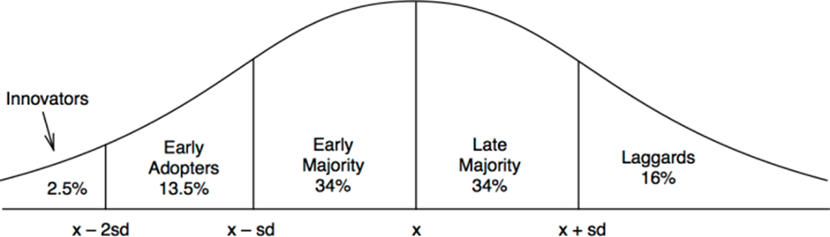
Figure 1: Rogers’ proposed categorization of adopters based on the average time to adopt (x) and the standard deviation (sd) (Singer, 2016)
Whilst the internet changed the market landscape for e-commerce, its overall usage diffusion surpassed the laggards’ phase, as per Figure 2, on multiple occasions, with overlapping S curves as new technology was introduced (Priestley, Sluckin, & Tiropanis, 2020).
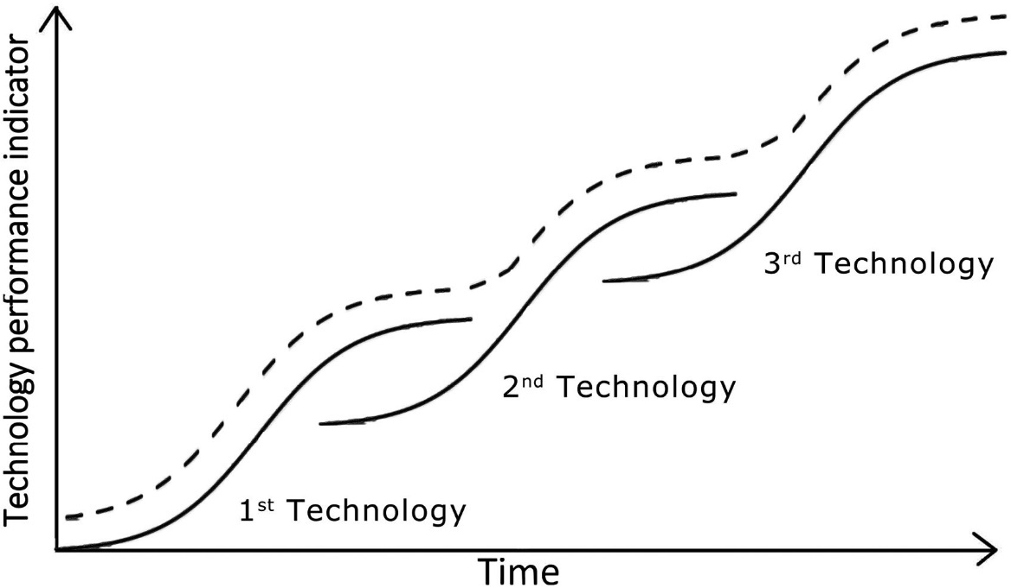
Figure 2: Successive S-curves in technological development. The dotted line shows the overall growth trajectory produced by component technologies Adapted from Christensen (1992) (Preistley, Sluckin, & Tiropanis, 2020)
This theoretically demonstrates the internet’s ability to evolve whilst remaining static in form, for Apps however, are viewed as somewhat different, as, according to Zhou et al. an individual App is considered for its own innovative values, as opposed to Apps as a whole genre (2020). This also tells us that, together with the Apps ability to use the smart devices inherit features, an App is not limited by the static form or functionalities of websites, but has agility in form, comparably dependant on its individual usefulness (Al‐Nabhani, Wilson, & McLean, 2022), and by association, its individually valued characteristics by the consumer or consumer group.
Apps, have the ability to define themselves by a new technology, and limit themselves, if required, to a characteristic that led to the success of the iPhone, convenience through simplicity. Free from the complexities of a web browser or the internet as a whole, they offer a focussed purpose, where digital innovation is fuelled by technological growth, doubling in capacity every 18-24 months according to moors law (1965). As people are relatively quicker to adopt popular innovation compared to business slower abilities to deliver it, otherwise known as ‘crossing the chasm’ between the early adopters to majority (Wang, 2010), it is the App that has the agility and ability technologically to adopt and update more wholly and readily for uptake.
Whilst AI will be considered as a ‘Technology within’ below, it can be assumed that it is with keen anticipation in 2024 that Web and App developers are utilising the latest in smartphone features, where the largest smartphone market share holder, Samsung, embraced this new technology provided by Google, where their new devices’ Artificial Intelligence, AI, “introduces meaningful intelligence aimed at enhancing every part of life” (2024). This however is not the first time technological innovation has attempted to impact such an ingrained part of a consumers daily landscape, where in 2009, according to Beren, Television manufactures found opportunity through the popularity of 3D movies in theatres, such as the then highest grossing movie of all time, Avatar, and introduced the same technologies to the home (2023). As above, the television manufacturers attempted to beat the curve, and unfortunately, although early adoption was initially good, the supporting business behind the 3D technology, and its limited libraries, was not sufficient to uphold the innovation, and as such, by 2016, Beren continued, the manufacture of 3D TVs had ceased, 3D TV had failed to ‘cross the chasm’. AI, in contrast, has been in use in increasing complexities as technology advances, for, simply typing into a web browser demonstrates AI by predicting words and phrases, so in this respect, there has not been an attempt to beat the curve, and it remains as a question, in what ways can developers innovate in a way that diffuses sufficiently, and if Apps are more suited to this level of technological adoption, what guidelines and characteristics would support sustainable business.

Technology within

Whilst Apps and websites are technologies in themselves, there are advancing technologies in use within them. According to Hart and Sutcliffe, choice of technology is dependent on the contextual task (2019), and it is the technologies that enable these tasks, their uptake and perception by users, that could define the Mcommerce channels functions individually, or influence the consumer. There are sufficient studies allowing the identification of the differences in terms of function between both market entry methods, showing that a websites primary function is for delivery of information, and Apps are to perform a specific function (Dutta & Sarma, 2020) (Al-Shamaileh & Sutcliffe, 2023).
As established, one such function for both Apps and Websites is of particular interest through its present upward trajectory on the innovation curve, AI, an innovation that, with the help of technological advances, has entered the majority phase of the curve in Figure 1, which, according to Josiah, utilises enough features to make it a potential market changer (2023). With AI’s advancements, it is each platform that has the ability to adopt its use within in different ways. Googles latest innovation, also adopted by Samsungs 2024 mobile devices, incorporates the circle to search function (Google, n.d.), an evolution of its multimethod search capabilities. Ritter and Pedersen, however, tell us that a business’ increased availability of data, and its use, of which AI is a clear leading example, cannot operate in isolation and must collaborate with its other functioning partners (2020). This suggests necessitating the use of the device’ inherent processing power, relevant software and physical attributes such as its camera, and touch screen, and would allow for the functionality and simplicity that the consumer associates with Apps, as opposed to uploading an image onto a website and allowing the additional permissions, giving future App’s a clear advantage; however, this technologies influence on Mcommerce, in terms of Apps over websites, would depend on its point of access for the consumer and retailers, the links it provides through the search results, and its usability long term. As such it is important to gain understanding of consumer choice to better the organisational approach.
Mcommerce also utilises data gathering technologies of consumer behaviour, primarily known as cookies. Cookies are pieces of information, or analytical data, gathered about an internet user as they are interacting with an internet platform allowing for tracking and user targeted advertising (Lee, 2021), and it is this information that has enabled valuable lines of digital marketing and analytical tools. The data captured can be fed into a variety of tools and can be invaluable in formation of strategic approaches to business, the dominant technological advantage this recording of data enables is the efficiencies and complexities of modern innovative marketing. The analytical data captured through user interaction can provide insights for effective marketing, such as the best times of day for advertising exposure, and for which target markets (Google, n.d.). This data can also provide insights into click rates of your existing advertising so that real data metrics efficacy can be measured. These tools can be outsourced to organisations such as Google Ads, where an eco-system of advertising is generated and monitored through software tools they provide, including such tools as PPC, Pay Per Click advertising, and SERP, Search Engine Results Page optimisation, where the search terms and keywords of individual internet users can prompt an automated bidding of sorts of advertisers, and the consumer will begin to be advertised to personally and relatively, and the search results order will be manipulated by Google (Google Ads, n.d.). Further still, if a consumer searches for an item on google, then views it on Amazon, not only will the advertising within Amazon have pre-existing knowledge, but Amazon can also adjust its pricing, accordingly, using Dynamic Pricing (Hwang & Kim, 2006).
The gathering of data to market in this manner without consent of the user prompted legislation in the EU to necessitate user consent for websites for the desired levels of interaction (Acquisti, Taylor, & Wagman, 2016), however, although the intentions were well meaning, according to Breznitz and Palermo, this caused an opposite effect, where more inventive and effective methods of tracking technologies were incentivised (2013) demonstrating the power of innovation. These marketing methods are evident within both technologies, however, are more evident to the consumer on the journey to a website, where websites depend on consumers finding their pages for e-commerce through web browsers, and often search engines, as such, websites and the technologies interacted with on route can, and often do, market using these methods in a variety of ways, however, if travelled to directly using a saved link, the consumer may only notice internally advertised items. Contrastingly, such is the nature of Apps that they bypass the prerequisite for website search engines and web browsers, as such, marketing methods are less evident, although Apps do rely on keyword searches in App stores. Marketing tools and their usage also depend on the nature of the commerce platform, for example, as Amazon and Airbnb are multisided and sharing platforms, they may market differing items from differing sellers, or sharers, within, and in differing ways. This too highlights a differing view of each medium, as Apps are not required to interact on this level, and once installed, there is no necessity to repeatedly communicate use of cookies within an app in this manner. However, as Lee and Love highlight, Google have pledged to phase out cookie use through their Chrome browser platform (Lee, 2021) (Love, 2023), suggesting an intended future levelling of sorts with Apps in terms of cookie bias, which, again, shows that Website or App Mcommerce sustainability will depend on function and user experience as opposed to its visible behaviour targeting marketing.

Consumer Behaviour, Ethics, and trust

Existing research shows the necessity for trust, security, and relationship management between organisation and consumers is of high importance (Morgan & Hunt, 1994) (Mattila, 2004), and that from a social perspective, Legal systems, such as a contract of sale, were designed to, according to Eisenstadt’s quotation of Bluhm, “guarantee or secure trustworthy conduct” (1989). This required level of relationship management supports such approaches as Freemans stakeholder theory (1984), and demonstrates, as Pires et al. find, that the consumer, through technological advancements allowing for greater information and communication, has great and uncontrollable power in contributing to an organisations sustainability (2006). It is the adoption of technologies, according to Calantone et al.’ findings, that results from a consumer’s learning willingness and abilities (2002), suggesting that consumers are inquisitive through technology, allowing for, as Lemon et al. finds, influence of expected and anticipated future relevance of the product or service (2002). This aligns with Hosmer’ findings, where trust of an organisation is of an individual’s perspective and ability to judge that an organisations ethical and moral behaviour benefits society, and the expectation of this behaviour on an individual level (1995), and tells us that management of an organisations communications channels can give some control back to the organisation. This is a strong argument for adoption of technology in ways that can communicate positive society benefitting ethics and morals, as, whilst technological tools exist to create value within an organisation, such as the afore mentioned AI, and its existing use in chat-bots to replace the customer service human beings with a more cost effective technology, according to Mero (Järvinen), it is the perception by a consumer of the ability to engage in a two way conversation on an e-commerce platform has a positive effect in relationship management (2018).
The customer review is, according to Sprague, not attributed to a single organisation, however, it is presented, despite the source’s unacademic nature, that it was the introduction of a review feature by the Yellow Pages and City Search in 2001 that pushed reviews into general platforms (Sprague, 2019). Reviews are a communication about an organisation by a third party, which can be difficult to control, and online, are considered as the “digitisation of word of mouth” (Dellarocas, 2003). Reviews are tools for marketing and building trust, allow for a speedy view of peer experiences and views, and coupled with the above need for two-way engagement, it would suggest by acceptably replying to a negative review in a way that aligns your ethics with an engaging consumer would be beneficial above the negative review. Both Apps and Websites generally utilise reviews internally about their products, however, there is comparatively less direct exposure to reviews of websites themselves without searching for independent sources such as Trust Pilot, whereas Apps have readily available reviews from their marketplaces, such as the Apple App store, which could potentially impact the consumers decision to install the App.
Communicating through advertising is an intentional tool that, in its nature, raises questions about ethics and trust as is pressed upon individuals without choice, ethical alignment, or consent (Denisova, 2021) (Aribarg & Scwhartz, 2020). Historically there has been little advertising relevancy targeting toward the consumer, and blanket marketing was normalised through such things as printed, radio, and Television advertising (1999), however, with the internet’s digital marketing capabilities and intelligence, with technological tools such as the afore mentioned cookies, and modern social media, advertising can be exponentially increased in terms of relevant targeting and reach. Although, as established, there is pre-existing research on the impacts of marketing, there remains a question of the perceived impact of advertising by an individual on whether this differs between Apps and Websites, and whether any differences collate with the decision making between the two technologies for engagement in Mcommerce.
When faced with a situation where rapid response is required, such as a snap decision on purchases or trustworthiness, Heuristics are often relied on. Heuristics, according to Chaiken, are subconscious shortcuts to simplify making decisions, which cuts limits the amount of information required (1980). Whilst this appears positive, it is, according to Wilke and Mata’s paraphrasing of Tversky and Kahneman, purportedly flawed through cognitive bias, and is “the tendency to selectively search for or interpret information in a way that confirms one's preconceptions or hypotheses” (2012). In terms of the decisions made in choosing between Apps or Websites for Mcommerce, it can be assumed that cognitive biases are at an individual level and are influenced by the information that individual has gathered or experienced with the respective technology. Whilst, if both Apps and websites may utilise the same features, the permissions given by a user may differ based on individuals’ choice, trust, and biases, for example, searching for accommodation via App, permission for location services have already been granted once upon installation, whereas, according to Bornschein et al., giving the same permissions to a website may be viewed in a different way (2020).
Consumer needs, or behaviour and choice, is hard to predict, and it is of little surprise that Siegel describes its prediction as the proverbial “Holy Grail” of commerce (2023). Although technological advancements in software and hardware have led to increasingly innovative methods of capturing consumer data, analysis, and trend prediction, there will always be an element of unknown, for there will always be a large part of the iceberg of competencies (motivation) that is unseen (McClelland, 1973), however, there presented a question about the ethical values that apply to each channel individually, and if there are any influencing values, biases or characteristics that differ for either contributing to a sense of preference for Apps.

Business review

When reviewing examples of both Apps and Websites, Amazon had the most successful examples of each. Amazons E-commerce website has been in existence since 1995, began by selling books from Bezos’ garage (Waters, 2026), is considered to owe its success to its use of the supply chain during its revolution (Alimahomed-Wilson, 2019) (Moody, 2020), and its third party commerce platform (Feger, 2024). In 2023 the most visited UK retail website, Amazon, had an estimated 397.3 million visitors, over 150 million more than its closest rival eBay (Nicasio, 2024), and in the US, larger than the next 15 largest ecommerce retailers combined (Feger, 2024). Amazons’ app ranks 1st on Google platforms, and 3rd on Apple (similarweb, 2024).
This research sought the differences between the two technologies, and values consumers apply to each, in order understand the reasoning. In terms of the website used for comparison, as e-commerce on a mobile device was the focus of this study, Amazons Mobile website was examined. The M-commerce website, at the time of this research, was notably different from that of a personal computer website in design, simplified, aligning with the size of the average device used and the characteristics that led to the success of the smartphone. On first glance there appeared to be no notable difference between mobile website and App, except for a few menu locations, which could be considered as a response to the inherent design and layout of mobile web browsers. Upon further inspection, there were subtle differences, such as the website’s landing page, where a series of sub sections allow for quick navigate to the desired area, books for example. Contrastingly, the App’s equally located sections offer services which are largely provided by their other app services such as Video, and Music. In terms of product page and ordering, both App and Mobile website were alike, however, there was one difference, where the Website was of more use for the organisational aspects of Amazon, of Contact, information, and account management. Many of these functions did appear within the App in a more simplistic manner, however, the Website appeared to be more complex and tailored to an information site, where the nature of the technology exists to deliver information, and the App of function, and where the App could be considered tailored to the function through its limitation of complexity, and usefulness in ease of access to other Apps.

Literature Review Summary

This review provided understanding of the technological innovations surrounding the M commerce B2C Apps and websites, the technology within, the consumer behaviours and ethics associated, and an examination of existing business utilising both mediums, and in doing so has achieve objective one.
The findings from the literature were as follows:
- Apps were valued differently from websites, where websites were considered as information providers, and apps as functional.
- Apps had greater ability to utilise inherent device capabilities, and greater agility to adopt innovation.
- Cookie law requirements for EU websites, or similar marketing behaviours, were potentially influencing consumers.
- Communication alignment of ethics influences consumer behaviour.
- The consumer has power over the success of the organisation.
- The inquisitive nature of human beings encouraged technological adoption and promoted information seeking and choice.
- There presents a question through observation, where no distinction was been made between web browser and app, as although the web browser is an application, it is the access point to the website. Comparisons will be drawn by including this technology in the surveys.

Methodology
Objective one was considered in the literature review, which identified the existing advances and associated features surrounding Apps over websites, examining relevant theory as well as existing literary research and review to explain the upward trajectory of Applications above websites for B2C e-commerce.
From the literature review, it was found that organisational sustainability necessitates appeasing the consumer as a stakeholder, and there remains a lack of research regards values influencing consumers choice between the technologies for accessing Mcommerce channels, how they differ with each, and whether increased exposure and awareness of the technologies mentioned above effect the consumer opinion of the technologies.
Objective two is addressed in this chapter, where the subject matter was investigated with the use of Sanders Research Onion (Saunders, Lewis, & Thornhill, 2007), shown in Figure 3, which was adopted to guide the required research, with the addition of ethical considerations and research limitations.
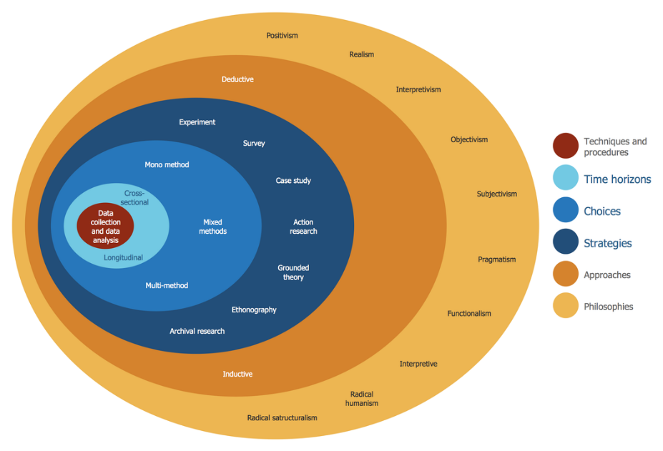
Figure 3: Exploring the Depths of Research Design: Revealing the Layers of the Research Onion (Ellul, 2023)

The framework utilises the following layered properties:
Philosophies
This research was ontological, sought an objective, studied the reality of consumer choices, with use of theory to identify solutions.
Approaches
Data was obtained in a top-down fashion, by finding the overriding factors, then deconstructing and finding understanding behind them through discussion and further research (Wirsch, 2014), initially by literary review. Additional data was obtained in a quantitative methodological approach through cross sectional survey (UKRI, 2022), which will be included in the appendices for reference.
Strategies
Review of existing literature relating to the phenomena was conducted through a variety of contemporary and historical books, journals, articles, and websites, as well as examining existing market leading examples of both App and Website. Findings and further data requirements were supported and acquired through a structured survey seeking real data, where a survey allowed for a cross section of a larger sample of participants in a current period of time, and more impartial results, compared to that of questionnaires, despite their ability to provide deeper insights (Johanek, 2000).
Choices
Following the Literature and existing business reviews, where a phenomenon was sought to be disproven, quantitative research allowed for the analysis of real data in order to do so, as opposed to the interpretation of literature through qualitative research which seeks to identify phenomena. In this respect, the most appropriate use of study for this research was of quantitative, and due to the current relevancy of technological uptake in question, a survey allowed for a deduction of cross-sectional data and was the sole method.
Time horizons
Gathering data in a cross-sectional manner allows for observations of variables from a fixed point in time (Ellul, 2023), which, due to the time constraints and the varied nature of the populus interacting with the technology, was more appropriate than a Longitudinal method.
Techniques and Procedures
Survey design
Using the software of Microsoft forms, which allowed for presenting of multiple question types to the respondents, and easy transfer of data to analytical capable or specific software. Participants of the survey were given closed ended questions, where the responses could be managed to remain of relevance to the phenomena, as multiple choice, Likert, and ranking questions allowed for scales of values. The relevant technologies were presented equally in the scope of this research, including an additional, the web browser, allowing for its influence to be measured. The questions, guided by the findings of the literature review, also allowed for additional measurement of factors such as monetary and time values spent, ethical values of the consumers, the influence of ethical behaviours relevant, and demographics of the users, but were limited in scope to those of M-commerce B2C consumers to allow for focussed results.
Influence for the design of the survey and of question coding was sought through such research as Al-Shamaileh and Sutcliffe’ research on overall app choices (2023), Bart et el.’ Study of consumer website trust (2005), and following the surveys pilot, allowing for adjustments for better comparisons of data, sought to add to and reinforce the findings from the literature review. The blank survey will be included in the appendices for reference.

Data collection
The Survey questionnaire was uploaded to social media, as the platforms with the most reach, which, as internet and smart device dependant platforms, were relevant to this field of research. The survey was also distributed through existing personal and professional networks through other digital channels, allowing for a variety of, and larger quantity of respondents.

Sampling,
This survey was sampled in the method of Nonprobability, which, according to Shively, has four sub sections, convenience, snowballing, judgemental, or quota, and purposive (Shively, 2011). Of these sub sections, small-scale convenience sampling was used initially, and as is also referred to by Shively as “haphazard” due to the risk of bias, where the initial surveys were distributed through the convenient channels available to the researcher, enabled the intended method of data sampling, Snowball, where the sharing of the survey was encouraged to reach a random, further reaching, and large sampling of respondents. This sampling was to be terminated once reached the target of one hundred and fifty respondents, where a minimum of one hundred are required to ensure reliability (Pearson & Mundform, 2010), however timescale dictated the termination at 111 responses.

Analysis approaches
The data gathered through the questionnaire survey was coded and statistically analysed through the use of Microsoft excel, allowing for operationalising of data, and formulation of it to find correlations.
As this research sought to provide insight into consumer values and choice in order to guide sustainable business approaches, it can be considered as prescriptive analysis, where patterns are deduced to prevent issues (Cote, 2021).
Ethical Consideration
UWTSD’s ethical standards were adhered to throughout the research process, and the relevant permissions obtained from the research supervisor through a completed ethics form. Ethical considerations were made in all parts of this research as highlighted by Baker & Charvat (2008), for the questionnaire, Participants were informed on the welcome page of the survey of their right to withdraw at any time, that the survey was voluntary and fully anonymous, any data gathered securely stored, and that participation should be carried out in a safe manner by those who are deemed as non-vulnerable adults.
Limitations
Wilke and Mata describe Bias as the directing of research to fulfil a predetermined outcome (2012), therefore, in conducting this research, consideration was made to this through un biased research surrounding the phenomena, allowing the literature to guide the process, and designing a survey which will allow for uninfluenced responses where possible. Although the initial distribution of the survey through convenient channels may be considered as biased sampling, this was offset by the subject matter being uninfluenced by the association with any relationships with the researcher, and the intended snowballing effect that followed.
Considerations were given to the limitations of quantitative data over qualitative due the subject matter requiring measurement of participants values. Owing to the need to survey a large proportion of people of multiple technological platforms, the values were given in the form of a ranked question, allowing them to be measured equally across multiple subject matters.

Findings
The following presents the data obtained from the results of the survey in a mixture of written and visual forms from 111 responses to the survey.
The raw data was first coded to represent numerical values allowing for analysis and findings will be shown in the order as surveyed. These findings, as are above 100 responses, are considered a reliable representative sample of the population (Pearson & Mundform, 2010).
To visually represent the results of Likert and ranked survey questions they were scored, fairly and where required, to show their ranked response position or value. For Likert questions, the strongest responses were scored at double value, and the neutral at 0 value, and for ranked questions, the final positions were used to score the responses value in accordance with the total number of responses, in explanation, where there were 10 questions, the top ranked choice was scored 10 and the lowest 1. The x axis’ criteria were not ranked when presenting results from Likert and ranked questions in order provide continuity when correlating and viewing relationships visually, and only the Likert was unranked in creation of the results heatmap in appendix 2.
As some questions allowed for less participation in some areas, the results were up weighted to allow for visual representation only, the analysis to follow was carried out on the un-weighted data. To achieve the up weighted values, V, the number of response choices, X, were divided by the response count, C, and the resulting Figure multiplied by the Response score R. In short:
V = (X/C) x R
Where questions were presented several times to gain an equal view of each technology, some of the responses were grouped for presentation.

Data presentation

When surveyed, the mean age resulted as 38, and the mean monthly income was £1965.

The respondents’ areas of residence were an almost even split of Urban to Rural.
The education levels of respondents were of higher education majority, where 81 of the 111 are university graduates or above.

Figure 6: Respondents majority were full time employed.

Figure 7: Marital status observed was also a good distribution but found to have a larger proportion of respondents in relationships.

Figure 8: The majority of respondents work at a place of work.

Figure 9: When presented with the options describing choice regarding approach to web browser choices, there was evidence of respondents’ high utilisation of the device’s inherent browser.

Figure 10 shows that when asked if reviews were read before initial use of a technology, there were differences between technologies.

Figure 11 shows respondents’ views on reviews and their inclusivity of them within their online purchasing decision making, resulting in a clear indication that reviews are included in this process, despite low belief in their accuracy.

Figure 12 shows the responses given when asked questions about App over website preference, as well as some preference parameters, in a Likert format. This suggests a link between technology choice retail parameter, and whether the relevant App is available.
Figure 13 shows the responses when given the same questions but in reverse, websites over Apps. Although the results appeared to have only moderate correlations, it is noteworthy that the preferences alter when asked from separate points of view.

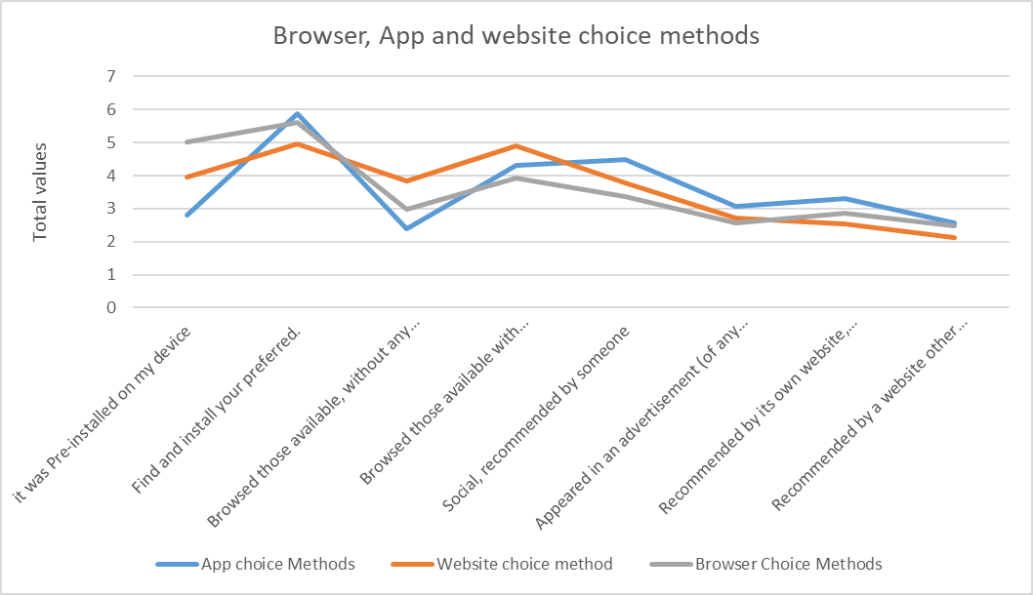
When asked how a Browser Website or App are generally chosen, Figure 14 shows the responses. This shows that there were identifiable methods associated with technology choice.
Figure 15 shows the scored values that the respondents gave when given Browser, Website and App values to rank as scale questions. There were clear value defenitions, where although trendlines appeared similar, there were also clear differences in values for all technologies.
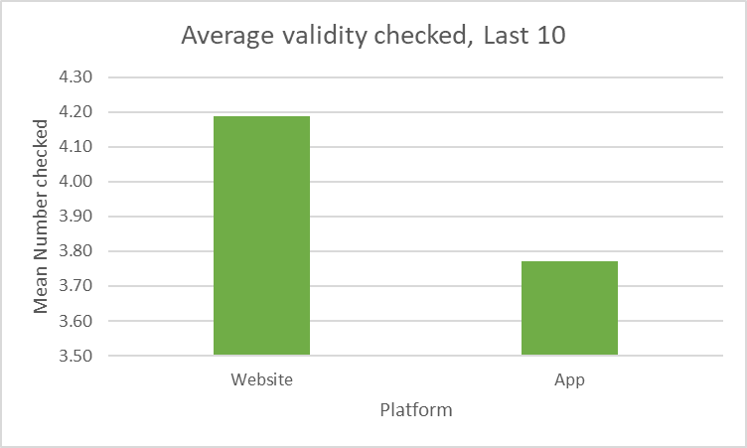
When asked about the number of websites, or Apps, out of ten, where checked for validity before using or installing, the mean results were as per Figure 16, showing not only a higher level of trust towards Apps, but a moderate level of trust towards websites.

Figure 17 shows whether reviews were read once within an e-commerce space, and there is a clear result that they are.

Figure 18 shows the responses to the questions regarding continuing to browse before finalising purchase within the same technology. The mean values scores for continued browsing within the same technology, where 0 is neutral, and positive numbers show likelyhood to continue browsing, were:
Websites: 66
Apps: -75
Figure 19 shows the responses to the questions regarding continuing to browse before finalising purchase to another technology. The mean values scores for continued browsing outside of the technology, where 0 is neutral, and positive numbers show likelyhood to continue browsing, were:
Websites: -9
Apps: -48

Three behaviour questions were asked to establish time spent in the technology weekly, impulse buy levels and levels of home deliveries to deepen knowledge over associated behaviours, the results can be seen in Figure 20.

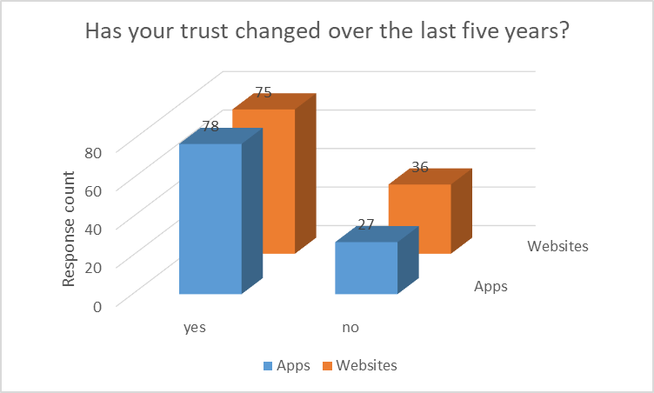
Figure 21 shows how the respondents Level of trust changed over the last five years for Apps and websites.

Of those that responded yes to the previous question on trust, Figure 22 shows if the change was more or less trust.

Figure 23 shows the mean values of perceived spending, with App spend recorded, reinforcing Apps as dominant.

Figure 24 shows the scored responses by respondents to describe their offline purchasing values.
Figure 25 shows the respondents’ perceived changes in retail habits in terms of online or offline, and Figure 26 shows how this changed in terms of Apps or Websites.

When asked where the most advertising is present online, the responses in Figure 27 were recorded.
The mean value attributed to the welcomeness of advertising, by respondents, is 3.81, where 5 is very unwelcome and 0 is very welcome.

When asked about the effects of marketing on retail interactions, the following results in Figure 28 were recorded.

When asked about awareness of marketing tactics, the following results were recorded in Figure 29

When asked about knowledge of the use of cookies within Apps, as well as websites, 78 of 111 respondents said that they were not aware, and of those 78, 39 stated that this awareness affected their opinion of the technology. When asked how welcome digital marketing tactics are over both technologies, where 0 is very welcome, and 5 is very unwelcome, a mean score of 3.6 was given.

The final question on the survey was a ranked question of values of shopping overall through any channel, offline and online. Figure 30 presents the results.

Findings Overview
A summary of findings:
Apps were preferred to consumers for retail over websites.
The use of Apps for retail was dependent on the availability of the app for the intended purchase.
Values of online spend, where the mean monthly income of respondents is £1965, the mean total spend online was £79, of which £56 was spent through Apps, and 81 of 111 respondents used apps more.
Respondents were more trusting of Inherent device’ web browsers than the three technologies surveyed, where 90 of 111 respondents only, or jointly, used the browser supplied with the device, supported by the use of reviews before installing.
Whilst there was moderate acceptance of the accuracy of reviews, they were strongly included in the decision process, where 99 of 111 respondents “agree”, or “agree a little”, on their use in this way.
Impulse buys and hours spent were almost the same for both platforms, as was purchased item’ delivery data.
There was retention in App use over website in terms of continuing to browse before finalising purchase, where the scored results on a scale yes 200 to no -200, an often likelihood of continued browsing website to website of 66 was found, occasional -9 for website to App, -75 occasional App to website, and -48 occasional App to App.
After scoring the Likert responses, the use of cookies and interaction with them had a negative effect, and it was the pop up on the websites that made people aware, to a moderate degree. However, with the respondents’ trust in technologies markedly increasing over the last few years, it was not trust that these cookies are affecting overall.
Although the choice method for all technologies was similar, where consumers seek their preferred experience, values ranked closer overall between Apps and web browsers.
There were some distinct shared values associated with Apps and websites, where the shared highest ranked value is of “convenience”, however the second highest ranked value for websites was “better pricing” followed closely by “familiarity”, whereas Apps joint second highest values were “familiarity” and “trust”.
The associated values of Websites and Apps ranked:

Analysis
The closed ended questions asked in the survey have been presented and selected relevant findings from the results were evaluated using statistical analysis formula through Microsoft Excel. Responses were compared in order to find correlations of data, and the linear correlations strength measured using a Pearson’s correlation coefficient measurement, r value, Figure 31 (Microsoft, n.d.), and Spearman Rank Correlation, ρ, measuring the monotonic relationship between ranked data sets, Figure 32 (Cheusheva, 2023), both allowing for two independent groups of data to be compared for correlations under a null hypothesis, where the absence of an ‘no significant difference’ result, results in its logical contradiction proven true (English & English, 1958).

Formulas:
Pearson
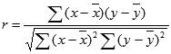
Spearman
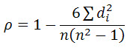
The tests used a significance level of 0.05 to determine significant correlations or differences and resulted in values between 1 and -1, where 1 represented a perfect correlation, 0 was indication of no correlation, and -1 a perfect negative correlation. Increments of .01 are equal to 1%, where according to Schober et al. results above 90% correlation would be very strong (2018), therefore results of significance for this research were set at above 95% correlation.
A null hypothesis (Ho) signifies that relationship between the data groups has no statistically significant difference, therefore null is accepted. (Nickerson, 2000)
An alternative hypothesis (Ha) signifies that there is no significant relationship, rejecting the null hypothesis and accepting the alternative (Nickerson, 2000).
Following the data presentation and overview, the following were analysed:
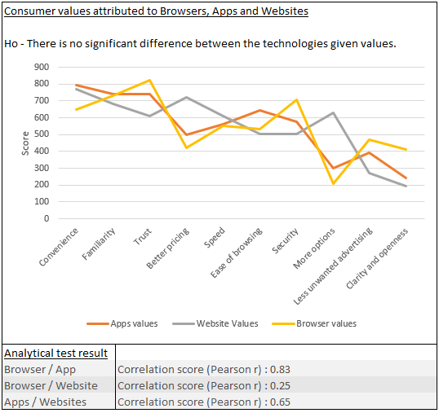
Figure 33 shows that although there was a closer correlation between Browser and App, Ho is rejected, and Ha accepted, there was no significant correlation between the values.
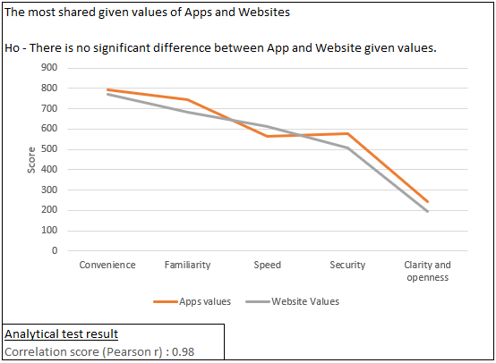
Figure 34: Ho was accepted as the resulting score indicated a significant correlation between the technologies’ selected values held by respondents.
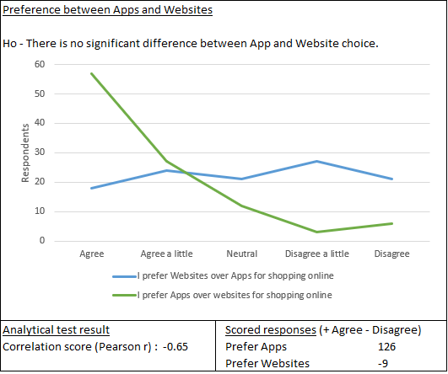
Figure 35: Following analysis of choice between App and Website, Ho was rejected as there was significant difference between the results, and whilst a moderate negative correlation presented, this was also not significant, therefore Ha adopted.
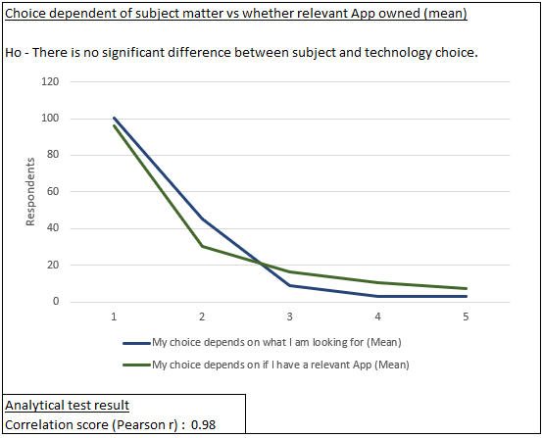
Figure 36: When analysing the data given regards choice based on retail subject matter and relevant App ownership, once the responses were scored, Ho was adopted. There was significant correlation between the linear results.
Selections of Spearman tests were also used to evaluate correlations with potentially relevant data sets:
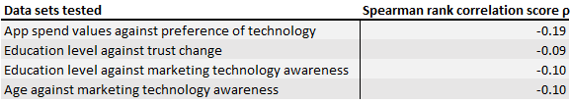
All results in Figure 37 returned low negative ρ correlations, and as such, all adopted the Ha hypothesis where no significant relationships were found.

Analysis Overview
The analysis found that there was no significant correlation between the technologies when examining the full range of scored values confirming a significant overall difference. As a result of this test, a further hypothesis was raised that some of the values did correlate, and after removing the most extreme differentiating values, the results returned a statistically significant correlation between the levels given to the remaining values in both technologies as shown.
Regards the preference of Apps over websites, due to the closed nature of the question, there was expectation to return a significant negative correlation considering the highly scored response of the green lined App preference, however the results returned the alternative hypothesis. Following this, an investigation was undertaken to establish whether, due to the gap between posing the initial preference question and its opposite, that there were other questions between that prompted respondents to re-consider the question when presented in an opposite form. This returned a significant correlation between the retail subject matter and whether the relevant App is owned which explains the differing response.
In order to further identify correlations between participants demographics as well as their choices, a correlation heatmap was created, see Appendix 2, Heatmap, for which, the Likert were not scored. The result of this returned two significant correlations, firstly, a strong R value of 0.99 between the respondent’s scored values for Web Browsers and methods adopted for their choice, secondly, an R value of 0.95 between the scored values for App choice, and the fact that the respondent uses Apps for retail. Although these are significantly scored, the resulting conclusion is a false positive, that associated values for each are only linked due to the respondent’s indication of choice of interaction with the technology, and as such, no additional significant links were found, and no significant links between Web browsers and website or app choices.

Discussion and Guidelines

The above analysis and presented results, together with the literary review findings, are discussed further below in order to achieve objectives 3 and 4:
3. Report on consumer analysis, and discussion of key findings.
4. Propose a set of guidelines to promote consumer engagement and trust in using retail apps as expected standards that retailers adhere to.
At the onset of this research, the question was posed: How are Apps becoming the dominant choice for business-to-consumer, B2C, retail? In order to answer this question, the literature review found that Apps and websites were valued differently, and these findings were expanded through further research by way of survey in order to assess which values were held in highest regard, in order to achieve objective 4, a set of guidelines for businesses. The analysis of the data confirmed a significant statistical difference between the values overall, but some shared values, as such the focus this discussion section will be on the top 3 values attributed to Apps and Websites in descending order.
Convenience
The shared highest value for both Apps and Websites, convenience, was not reviewed in detail in the literature review, and its level of significance prompted further literary research. The descriptor in terms of traditional retail, convenience store, has been in use for some time in the US, and is a term similarly used in the UK as a corner shop, where the key features are of ease of accessibility and variety of key products on offer relative to its demographics or customer base’ needs (Haider, 2020). In terms offline retail, there are studies such as Kelly and Reimers et al. that find time convenience as the most distinct influencing factor over consumers (Kelly, 1958) (Reimers & Clulow, 2009), and as the highest value ranked by respondents for both Apps and Websites, there is little doubt that that, due to the nature of m-commerce’ innovative success over PC e-commerce, and the success of the smartphone, that the key attribute for any retail through the technology would need to be sympathetic in nature to its technologies founding attribute, convenience through simplicity. This is reinforced by the ‘one-click checkouts’ trend, which, according to Simpler.com, removes the inconvenience that the final steps of purchase pose (2023), and the relatively contemporary focus on outcome based selling (Golod, 2023), where the marketing of a convenient outcome to the consumer could imprint cognitive bias, as the forced interaction with cookies, as per the research findings, do not significantly affect the consumers opinion of the website, but could be considered to cause an inconvenience.
Familiarity & better pricing
The second highest values were familiarity for Apps and better pricing for Websites. The separation in these values ranks reflects the literary findings that the technologies are considered differently, the App for its function, and the website for its information (Dutta & Sarma, 2020) (Al-Shamaileh & Sutcliffe, 2023). Where App familiarity is a single familiar function, and better pricing would be the information provided on a website about product pricing. Further still, as the survey findings found that a larger proportion of website users would continue to browse on other websites before final purchase over App users, this also reinforces the theoretical consideration of the internet as a whole apposed to its individual function. In contrast to the browsing behaviour findings, Orimoloye et al.’ study finds that the contemporary abandoned shopping cart trend is through “goal-driven and hedonic motivations” (2020), however, the study does not view Apps and websites separately, and as the internet, and by extension the website, has continually successfully re-innovated as technology advanced (Priestley, Sluckin, & Tiropanis, 2020), and the App is considered as a single valued familiar function, this survey finds that it is the consumers view of the website as the internet that promotes the abandoned shopping baskets.
Trust and Familiarity
Apps third ranked value was found to be Trust, and Websites Familiarity. Whilst the value of familiarity is shared, the definition of this value is of alternate meaning. Websites are, as above, considered as an internet technology as a whole according to Zhou et al. (2020), therefore familiarity would translate to familiarity of its overall function and highest values, convenience, and better pricing. Whilst trust in both technologies has been found to increase, it is also found that markedly more validity checks are made on websites than Apps, showing a higher level of distrust. This value ranking separation further reflects the overall separation of values between the technologies and suggests that the App’ purpose for installation and interaction is through the established level of trust, familiarity, and convenience of the Apps function, which together suggest an establishment of value alignment before ownership of App, in contradiction to the advantage given by their ability to adopt new technologies in the literature review.
Ease of adoption
Whist the literature review found that Apps have greater agility in adoption of new technologies there are limitations, the comparable cost of technology development, where Apps, according to Srivastava, is £30,000-£200,000+ (2024), and Websites, according to Leonard, £16,000- £60,000 (2023), depends on complexity, and both sources state relative maintenance costs. There is also time to consider, where both sources state that time is relative to complexity, it is the App that is more complex to develop, as reflected by the cost. This tells us that True flexibility lies within the website and suggests that sustainability of either platform with mitigated risk requires established infrastructure or preexisting platforms, in Amazons case, as per the examination earlier in this report, the App mimics the website, and both are the same multisided platform. Alternatively, you could implement this familiar multisided platform in an alternative form, such as a sharing economy, such as that of Airbnb (Reinhold & Dolnicar, 2017), so long as the function and respective values to the consumer remain.

Guidance
Guidance for businesses in todays mixed marketplace and approaches for sustainable e-commerce behaviour, based on the findings from the literature review, the survey findings, and the discussion:
Sustainability of retail in each researched technology is dependent its inherently valued characteristic. Apps should provide a focussed, convenient, familiar function which remains ‘useful’, and Websites should provide a convenient method for ease of information gathering in a familiar way.
Websites must ensure its information is easily obtained through such things as the established importance of search engine optimisation (Berman & Katona, 2013), are in a familiar format, and show ease of comparative outcome benefit to prevent abandoned shopping carts, such as the highlighting of fast delivery, and a genuine reflection of aftersales through visible reviews (Dellarocas, 2003).
Apps are the preferred method of retail, however, must be established on an element of trust and value alignment before the successful adoption of the App by consumers. Due to the cost and time constraints of development, this can be most efficiently undertaken in one of two ways; to deliver a trusted, convenient, and familiar function, already established through a successful website, or introduce a new approach on an existing or established platform format and ensure maximised visibility to the consumer, possibly through a website, and App market search engine optimisation (Berman & Katona, 2013).
Continued consumer participation of technologies, sustainable business, is dependent on an organisation’s communicated behaviours and maintenance of trust with the consumer, the continued alignment with these key values, which, as a cross sectional analysis of current behaviour values, are subject to potential change in a linear manner with society and may differ based on an organisations targeted market, demographic or customer base (Nancholas, 2023).
Current key values:

In summary, long term successful Business to Customer Mobile retail and e-commerce is dependent on the diffusion of a retail App until it is no longer valued for the function for which its successful engagement was originally established. New functions of retail should be pre-established through website adoption, an App adaptation increasing the websites usefulness, its retention, or to utilise a new technology.

Conclusion
Through this research a comprehensive understanding of how Apps are becoming the dominant choice for business-to-consumer, B2C, retail using the research objective structure.
Despite the varying demographics surveyed, the values attributed to the technologies of Apps and Websites were found to support, correlate with, and build on, the reviewed theoretical literature, as opposed to the potential impacts of variances of time, education, and residence. However, although this literary theory presented a clear agility advantage for Apps, it is the establishment of their associated values pre diffusion that is of most relevance to its sustainable success.
Clear guidance was deduced, and presented above, to allow businesses to benefit from this research in regard to sustainable e-commerce behaviours through mobile devices, to assist in the development of an App dominated retail marketplace.

Further research
Although this research has provided a comprehensive view of values attributed to each technology researched, there remains a question of the good sought by the consumer has correlative affect on these values, or if any additional values arise from open ended surveying. Additionally, the introduction of increased AI technology’ effect on the mobile e-commerce market is yet to be established. Future research could conduct a further mixed research study, qualitative to allow for the emergence of potential alternative value associations, and quantitative to measure the effects of AI.

References
Acquisti, A., Taylor, C., & Wagman, L. (2016). The Economics of Privacy. Journal of Economic Literature, 54(2), 442-495. Retrieved from http://www.jstor.org/stable/43966740
Alimahomed-Wilson, J. (2019). Unfree shipping: the racialisation of logistics labour. Work Organisation, Labour & Globalisation, 13(1), 96-113. Retrieved from https://www.jstor.org/stable/10.13169/workorgalaboglob.13.1.0096
Al‐Nabhani, K., Wilson, A., & McLean, G. (2022). Examining consumers' continuous usage of multichannel retailers' mobile applications. Psychology & Marketing, 39(1), 168-195.
Al-Shamaileh, O., & Sutcliffe, A. (2023, February). Why people choose Apps: An evaluation of the ecology and user experience of mobile applications. International Journal of Human-Computer Studies, 170. doi:https://doi.org/10.1016/j.ijhcs.2022.102965
Al-Shamaileh, O., & Sutcliffe, A. (2023). Why people choose Apps: An evaluation of the ecology and user experience of mobile applications. International Journal of Human-Computer Studies, 170(Februrary). Retrieved from https://www.sciencedirect.com/science/article/pii/S1071581922001835#bib0065
Aribarg, A., & Scwhartz, E. M. (2020). Native Advertising in Online News: Trade-Offs Among Clicks, Brand Recognition, and Website Trustworthiness. Journal of Marketing Research, 57(1), 20-34.
Baker, & Charvat. (2008). Ethical Considerations. In Research Methods in Child Welfare. Colombia, USA: Columbia University Press. Retrieved from http://www.jstor.org/stable/10.7312/bake14130.9
Bart, Y., Shankar, v., Sultan, F., & Urban, G. L. (2005). Are the Drivers and Role of Online Trust the Same for All Web Sites and Consumers? A Large-Scale Exploratory Empirical Study. Journal of Marketing, 69(4), 133-152. Retrieved from https://doi.org/10.1509/jmkg.2005.69.4.133
Beren, D. (2023, 07 31). The Rise and Fall of 3D TVs. Retrieved from History-computer: https://history-computer.com/the-rise-and-fall-of-3d-tvs/
Berman, R., & Katona, Z. (2013). The Role of Search Engine Optimization in Search Marketing. Marketing Science, 32(4), 644-651.
Bluhm, L. H., & Eccles, R. G. (1989). Price, authority and trust: From ideal types to plural forms. Annual Review of Sociology(15), 97-118.
Bornschein, R., Schmidt, L., & Maier, E. (2020). The Effect of Consumers’ Perceived Power and Risk in Digital Information Privacy: The Example of Cookie Notices. Journal of Public Policy & Marketing, 39(2), 135-154. Retrieved from https://www.jstor.org/stable/26993223
Brexnitz, D., & Palermo, V. (2013). Privacy, Innovation and Regulation: Examining the Impact of the European 'Cookie Law' on Technological Trajectories. SSRN. Retrieved from https://papers.ssrn.com/sol3/Delivery.cfm/SSRN_ID3136789_code2845028.pdf?abstractid=3136789&mirid=1
Britt, P. (2012). Mind the Apps. Independant Banker, 62(4), 16-19.
Calantone, R. J., Cavusgil, T. S., & Zhao, Y. (2002). Learning orientation, firm innovation capability, and firm performance. Industrial Marketing Management, 31(6), 515-524. doi:https://doi.org/10.1016/S0019-8501(01)00203-6
Chaiken, S. (1980). Heuristics Versus Systematic Information Processing and the Use of Source Versus Message Cues in Persuasion. Journal of Personality and Social Psychology, 39(5), 752-766. doi:https://doi.org/10.1037/0022-3514.39.5.752.
Chen, K., Esseogene, O., Lamour, T., & Rahaman, M. (1999). The History of Advertising. ESL 91 Net Project. Retrieved from https://kccesl.tripod.com/ESL91NetProject.grprojs.html
Cheusheva, S. (2023, 03 16). How to do Spearman correlation in Excel. Retrieved from Ablebits.com: https://www.ablebits.com/office-addins-blog/spearman-rank-correlation-excel/
Cheusheva, S. (2023, 03 16). Spearman rank correlation formula. How to do Spearman correlation in Excel. Retrieved from https://www.ablebits.com/office-addins-blog/spearman-rank-correlation-excel/
Cote, C. (2021, 11 02). WHAT IS PRESCRIPTIVE ANALYTICS? 6 EXAMPLES. Retrieved from Harvard Business School Online- Business Insights: https://online.hbs.edu/blog/post/prescriptive-analytics
Dellarocas, C. (2003). The Digitization of Word of Mouth: Promise and Challenges of Online Feedback Mechanisms. Management Science, 1275-1444. doi:https://doi.org/10.1287/mnsc.49.10.1407.17308
Denisova, A. (2021). Research Evidence. In A. Denisova, Fashion Media and Sustainability: Encouraging Ethical Consumption via Journalism and Influencers (pp. 9-27). Westminster: University of Westminster Press. Retrieved from http://www.jstor.org/stable/j.ctv1kmj7g8.5
Duchamp. (1917). The theory behind the readymade. The Blind Man(2).
Dutta, D., & Sarma, M. K. (2020). APPS vs. WEBSITES: END USERS’ PREFERENCE IN A CONTINUOUSLY INNOVATING DIGITAL WORLD. Pacific Business Review International, 12(9). Retrieved from https://www.researchgate.net/publication/342864586_APPS_vs_WEBSITES_END_USERS%27_PREFERENCE_IN_A_CONTINUOUSLY_INNOVATING_DIGITAL_WORLD_Pacific_Business_Review_International_ISSN_0974-438X_Volume_12_Issue_9
EADICICCO, L. (2017, 06 29). This Is Why the iPhone Upended the Tech Industry. Retrieved from Time: https://time.com/4837176/iphone-10th-anniversary/
Ellul, D. B. (2023, 07 05). Exploring the Depths of Research Design: Revealing the Layers of the Research Onion. Retrieved from Linken in: https://www.linkedin.com/pulse/exploring-depths-research-design-revealing-layers-onion-borg-ellul
English, H. B., & English, A. C. (1958). A comprehensive dictionary of psychological and psychoanalytic terms. New York: David McKay.
Feger, A. (2024, 01 31). A guide to Amazon: A powerhouse of retail, advertising, and technology. Retrieved from Insider Intelligence: https://www.insiderintelligence.com/insights/amazon-revenue/
Flynn, J. (2023, 03 20). 40 FASCINATING MOBILE APP INDUSTRY STATISTICS [2023]: THE SUCCESS OF MOBILE APPS IN THE U.S. Retrieved from Zippia: https://www.zippia.com/advice/mobile-app-industry-statistics/
Freeman, C. (1989). R&D, technical change and investment in the UK (F.Green ed.). London: Harvester Wheatsheaf.
Freeman, E. R. (1984). A stakeholder approach to strategic management. Cambridge: Cambridge University Press.
Golod, E. (2023, 06 06). The Science of Closing Deals: Applying Outcome-Based Selling Techniques. Retrieved from Linked in: https://www.linkedin.com/pulse/science-closing-deals-applying-outcome-based-selling-techniques
Google. (n.d.). [UA] Google Ads Hour of Day. Retrieved 02 19, 2024, from Support.Google/Analytics: https://support.google.com/analytics/answer/1247859
Google Ads. (n.d.). Home. Retrieved 01 30, 2024, from Google Ads: https://ads.google.com/home/
Google. (n.d.). Search your screen with Circle to Search. Retrieved 02 19, 2024, from Support.google/websearch: https://support.google.com/websearch/answer/14508957
Haider, A. (2020, 03 25). A cultural history of the beloved corner shop. Retrieved from BBC.com: https://www.bbc.com/culture/article/20200325-a-cultural-history-of-the-beloved-corner-shop
Hart, J., & Sutcliffe, A. (2019, October). Is it all about the Apps or the Device?: User experience and technology acceptance among iPad users. International Journal of Human-Computer Studies, 130, 93-112. doi:https://doi.org/10.1016/j.ijhcs.2019.05.002
Hosmer, L. T. (1995). Trust: The Connecting Link between Organizational Theory and Philosophical Ethics. The Academy of Management Review, 20(2), 379-403.
Hughes, N. C. (2023, 11 15). How the iPhone changed the world in 15 years. Retrieved from cybernews: https://cybernews.com/editorial/how-iphone-changed-world-in-15-years/
Hwang, S. B., & Kim, S. (2006). Dynamic Pricing Algorithm for E-Commerce. Advances in Systems, Computing Sciences and Software Engineering, 149-155. doi:https://doi.org/10.1007/1-4020-5263-4_24
imarc. (2023). E-Commerce Market Report by Type (Home Appliances, Apparel, Footwear and Accessories, Books, Cosmetics, Groceries, and Others), Transaction (Business-to-Consumer, Business-to-Business, Consumer-to-Consumer, and Others), and Region 2024-2032. IMARC. Retrieved from https://www.imarcgroup.com/e-commerce-market
Iqbal, M. (2024, 01 08). App Download Data (2024). Retrieved from Business off Apps: https://www.businessofapps.com/data/app-statistics/
Johanek, C. (2000). A CONTEXTUALIST RESEARCH PARADIGM: An Illustration. Composing Research: A Contextualist Paradigm for Rhetoric and Composition, 119-163.
Josiah, R. (2023, 08 03). AI's Rapid Rise: Applying Diffusion of Innovation Principles to Your Business. Retrieved from Linked in: https://www.linkedin.com/pulse/ais-rapid-rise-applying-diffusion-innovation-your-raven-josiah-
Junghwan, K. (2012). The Effect of Design Characteristics of Mobile Applications on User Retention: An Environmental Psychology Perspective. AMCIS 2012 Proceedings(13). Retrieved from https://aisel.aisnet.org/amcis2012/proceedings/HCIStudies/13
Kelly, E. J. (1958). The Importance of Convenience in Consumer Purchasing. Journal of Marketing, 23(1), 32-38.
Larbi, F. (2022). Marketing Management Theory and Method Apple's iPhone Launch: A Case Study in Effective Marketing. International Journal of Recent Research in Thesis and Dissertation (IJRRTD), 3(1), 113-121. doi:https://doi.org/10.5281/zenodo.6624395
Lee, A. (2021). What Happens When the Web’s Cookies Crumble. WWD: Women’s Wear Daily, 2. Retrieved from https://search-ebscohost-com.ezproxy.uwtsd.ac.uk/login.aspx?direct=true&db=bth&AN=149156649&site=bsi-live
Lemon, K. N., White, T. B., & Winer, R. S. (2002). Dynamic Customer Relationship Management: Incorporating Future Considerations into the Service Retention Decision. Journal of Marketing, 66(1), 1-14. doi:https://doi.org/10.1509/jmkg.66.1.1.18447
Leonard, K. (2023, 06 19). How Much Does A Website Cost? (2024 Guide). Retrieved from Forbes: https://www.forbes.com/uk/advisor/business/software/how-much-does-a-website-cost/
Lou, j., Ba, S., & Zhang, H. (2012). The Effectiveness of Online Shopping Characteristics and Well-Designed Websites on Satisfaction. MIS Quaterly, 36(4), 1131-1144. Retrieved from https://doi.org/10.2307/41703501
Love, J. (2023, 05 19). Google to Phase Out Cookies for 1% of Chrome Users in Early 2024. Bloomberg. Retrieved from https://web-p-ebscohost-com.ezproxy.uwtsd.ac.uk/bsi/detail/detail?vid=13&sid=36666520-a409-4f76-81df-0db298137caf%40redis&bdata=JnNpdGU9YnNpLWxpdmU%3d#db=bth&AN=163825310
Mattila, A. S. (2004). The impact of service failures on customer loyalty: The moderating role of affective commitment. International Journal of Service Industry Management, 15(2), 134-149. doi:https://doi.org/10.1108/09564230410532475
McClelland, D. (1973). Testing for competence rather than for 'intelligence.'. American Psychologist, 28(1), 1-14. doi:http://dx.doi.org.ezproxy.uwtsd.ac.uk/10.1037/h0034092
Mero (Järvinen), J. (2018). The effects of two-way communication and chat service usage on consumer attitudes in the e-commerce retailing sector. Electron Markets(28), 205-217. doi:https://doi.org/10.1007/s12525-017-0281-2
Microsoft. (n.d.). PEARSON function. Retrieved 03 04, 2024, from Support.Microsoft.com: https://support.microsoft.com/en-gb/office/pearson-function-0c3e30fc-e5af-49c4-808a-3ef66e034c18
Microsoft. (n.d.). Pearson product moment correlation coefficient Formula. PEARSON function. Retrieved 03 04, 2024, from https://support.microsoft.com/en-gb/office/pearson-function-0c3e30fc-e5af-49c4-808a-3ef66e034c18
Moody, K. (2020). Amazon: Context, Structure and Vulnerability. (J. A.-W. Reese, Ed.) The Cost of Free Shipping: Amazon in the Global Economy, 21-34. doi:https://doi.org/10.2307/j.ctv16zjhcj.8
Moore, G. E. (1965). Cramming more components. Electronics. Retrieved from http://cva.stanford.edu/classes/cs99s/papers/moore-crammingmorecomponents.pdf
Morgan, R. M., & Hunt, S. D. (1994). The Commitment-Trust Theory of Relationship Marketing. Journal of Marketing, 58(3), 20-38. doi:https://doi.org/10.1177/002224299405800302
Nancholas, B. (2023, 08 21). How to identify target markets and create meaningful engagement. Retrieved from University of Lincoln: https://online.lincoln.ac.uk/how-to-identify-target-markets-and-create-meaningful-engagement/
Netcraft. (2023, 06 30). June 2023 Web Server Survey. Retrieved from netcraft: https://www.netcraft.com/blog/june-2023-web-server-survey/
Nicasio, F. (2024, 01 22). Top 10 Ecommerce Sites in the UK. Retrieved from ecommerce guide: https://ecommerceguide.com/top/top-10-ecommerce-sites-in-the-uk/
Nickerson, R. S. (2000). Null Hypothesis Significance Testing: A Review of an Old and Continuing Controversy. Psychological Methods, 5(2), 241-301. doi:I0.1037//1082-989X.S.2.241
Orimoloye, L. O., Kukar-Kinney, M., Carlson, J. R., Scheinbaum, A. C., & He, H. (2020). Motivations Behind Consumer Online Shopping Cart Use and Abandonment: An Abstract. Micro to Macro: Dealing with Uncertainties in the Global Marketplace. AMSAC, 383-384. doi:https://doi.org/10.1007/978-3-030-89883-0_100
Pearson, R., & Mundform, D. (2010). Recommended Sample Size for Conducting Exploratory Factor Analysis on Dichotomous Data. Journal of Modern Applied Statistical Methods, 9(2), 359-368. doi:10.22237/jmasm/1288584240
Pearson, R., & Mundform, D. (2010). Recommended Sample Size for Conducting Exploritory Factory Analysis on Dichotomous Data. Journal of Modern Applied Statistical Methods, 9(2), 359-368.
Perkins, C. (2023). UK Mcommerce Forecast 2023. Insider Intelligence. Retrieved from https://www.insiderintelligence.com/content/uk-mcommerce-forecast-2023/
Pires, G. D., Stanton, J., & Rita, P. (2006). The internet, consumer empowerment and marketing strategies. European Journal of Marketing, 40(9/10), 936-949. doi:https://doi.org/10.1108/03090560610680943
Preistley, M., Sluckin, T. J., & Tiropanis, T. (2020, 04 11). Successive S-curves in technological development. The dotted line shows the overall growth trajectory produced by component technologies. Adapted from Christensen (Citation1992). Innovation on the web: the end of the S-curve? Retrieved from https://www.tandfonline.com/cms/asset/f3a99a95-0e16-4720-8e44-612bc7139fbe/rint_a_1747261_f0002_b.jpg
Priestley, M., Sluckin, T. J., & Tiropanis, T. (2020). Innovation on the web: the end of the S-curve? Digital Technology, Culture, Society, 4(4), 390-412. doi:https://doi.org/10.1080/24701475.2020.1747261
Reimers, V., & Clulow, V. (2009). Retail centres: it's time to make them convenient. International Journal of Retail and Distribution Management: Incorporating Retail Insights, 37(7), 541-562. Retrieved from https://www.emerald.com/insight/content/doi/10.1108/09590550910964594/full/html
Reinhold, S., & Dolnicar, S. (2017). The Sharing Economy. In S. Dolnicar, Peer-to-peer accommodation networks: pushing the boundaries (pp. 15-26). Oxford: Goodfellow Publishers Limited.
reviewinc. (2021, 09 07). A History of Online Reviews. Retrieved from reviewinc: https://reviewinc.com/2021/09/07/a-history-of-online-reviews/
Ritter, T., & Pedersen, C. L. (2020). Digitization capability and the digitalization of business models in business-to-business firms: Past, present, and future. Industrial Marketing Management, 86(April), 180-190. Retrieved from https://doi.org/10.1016/j.indmarman.2019.11.019
Rogers, E. (2003). Diffusion of Innovations (5th ed.). Free Press.
Samsung Newsroom. (2024, 01 18). Enter the New Era of Mobile AI With Samsung Galaxy S24 Series. Retrieved from Samsung Newsroom: https://news.samsung.com/global/enter-the-new-era-of-mobile-ai-with-samsung-galaxy-s24-series
Saunders, m., Lewis, P., & Thornhill, A. (2007). Research Methods for Business Students (6th ed.). London: Pearson.
Schober, P., Boer, C., & Schwarte, L. A. (2018). Correlation Coefficients: Appropriate Use and Interpretation. Anesthesia & Analgesia, 126(5), 1763-1768. doi:10.1213/ANE.0000000000002864
Shepherd, J. (2024, 01 11). 21 Essential eCommerce Statistics You Need to Know in 2024. Retrieved from Social_Shepherd: https://thesocialshepherd.com/blog/ecommerce-statistics
Shively, G. (2011). Sampling: Who, How and How Many? (A. Angelsen, H. O. Larsen, J. F. Lund, C. Smith-Hall, & S. Wunder, Eds.) Measuring Livelihoods and Environmental Dependence: Methods for Research and Fieldwork, 51-70. Retrieved from http://www.jstor.org/stable/resrep02120.11
Siegel, E. (2023, 03 24). How Machine Learning Can Improve the Customer Experience. Retrieved from Harvard Business Review: https://hbr.org/2023/03/how-machine-learning-can-improve-the-customer-experience
similarweb. (2024, 02 03). Top Apps Ranking. Retrieved from similarweb: https://www.similarweb.com/top-apps/google/shopping/
Simpler.com. (2023, 07 20). What is one-click checkout and how can it benefit your business? Retrieved from Simpler.com: https://www.simpler.so/e-commerce/what-is-one-click-checkout
Singer, L. (2016, 12). On the Diffusion of Innovations: How New Ideas Spread. diffusion-of-innovations-how-new-ideas-spread-adoption-curve. Retrieved from https://i0.wp.com/leif.me/wp-content/uploads/2016/12/diffusion-of-innovations-how-new-ideas-spread-adoption-curve.png?resize=720%2C206&ssl=1
Sprague, D. (2019, 12 20). The History of Online Reviews and How They Have Evolved. Retrieved from Shopper Approved: https://results.shopperapproved.com/blog/the-history-and-evolution-of-online-reviews
Springer, L. (2016, 12). On the Diffusion of Innovations: How New Ideas Spread. Retrieved from Dr. Leif Springer: https://leif.me/on-the-diffusion-of-innovations-how-new-ideas-spread/
Srivastava, S. (2024, 02 13). How Much Does It Cost to Build An App in The UK? Retrieved from Appinventiv: https://appinventiv.com/blog/how-much-does-it-cost-to-build-a-mobile-app-in-uk/
Statcounter. (2023, 11). Operating System Market Share Worldwide. Retrieved from statcounter: https://gs.statcounter.com/os-market-share
Tafradzhiyski, N. (2023, 12 06). Mobile App Retention. Retrieved from Business of Apps: https://www.businessofapps.com/guide/mobile-app-retention/
Tohidi, H., & Jabbari, M. M. (2012). Innovation as a Success Key for Organisations. Procedia Technology(1), 560-564.
UKRI. (2022, 03 31). What is social science? Retrieved from UK Research and Innovation: https://www.ukri.org/who-we-are/esrc/what-is-social-science/quantitative-research/
Vallone, F. (2021, 03 15). 5 Inspiring Marketing Success Stories That’ll Change Your Brand. Retrieved from Gamerseo: https://gamerseo.com/blog/marketing-success-stories-a-few-lessons-to-learn/
Wang, P. (2010). Chasing the Hottest IT: Effects of Information Technology Fashion on Organizations. MIS Quarterly, 34(1), 65. Retrieved from https://doi.org/10.2307/20721415
Waters, J. (2026, 02 06). Amazon.com. Retrieved from Encyclopedia Britannica: https://www.britannica.com/topic/Amazoncom
Wilke, A., & Mata, R. (2012). Cognitive Bias. Encyclopedia of Human Behaviour (Second Edition), 531-535. doi:https://doi.org/10.1016/B978-0-12-375000-6.00094-X
Wirsch, A. (2014). Analysis of a Top-Down Bottom-up Data Analysis Framework and Software Architecture Design. Cambridge, MA: Massachusetts Institute of Technology. Retrieved from https://web.mit.edu/smadnick/www/wp/2014-08.pdf
Zhou, L., Lin, J., Li, Y., & Zhang, Z. (2020). Innovation Diffusion of Mobile Applications in Social Networks: A Multi-Agent System. Sustainability, 12(7), 2884. doi:https://doi.org/10.3390/su12072884

Appendices

Appendix 1: Exploring Apps or Web browsers survey questionnaire

6 Mar 2024
This survey is designed to explore our choices between Apps, Websites, and Web browsers for shopping online through our mobile devices.
Welcome
This survey is to explore any possible links with consumers and their choices of internet channels for online shopping, specifically for smart device shopping. This is where consumers would choose between an App such as Amazon shopping and Vinted, or Web browsers for shopping on Websites, either directly or through search engines such as google or Bing.
In order to make sure this survey is for you, please only participate if you purchase items on your mobile or smart device such as a smart phone or tablet and are buying in the UK.
I am sorry, but if you are under the age of 18, vulnerable, or at risk in any way, then this survey is also not for you.
By participating in this survey, you are consenting to our use of the anonymous information you provide, you have ensured that you are in a safe and responsible environment, that you are choosing to answer the questions freely, and that you are aware that you can stop participating in the survey at any time without having to give a reason.
This survey is solely for the use of an academic study, will be analysed for use as part of student B. Gibson's University of Wales Trinity St David independent research project, and has no affiliation with any other organisations.
*Please note that some of the questions have multiple choices that may only be visible on a smaller screen if you scroll or swipe across.

* Required
Demographics
This section is all about you, but no personal information is required or should be given.
1. What is your age? (over 18's only please) *

The value must be a number

2. Of the choices below, how would you describe your area of residence? *
- Urban (over 10,000 residents)
- Rural (10,000 residents or less)

3. Of the options below, what is your highest level of education or academic achievement? *
- School
- College
- University Graduate
- Postgraduate (Masters or Doctorate)

4. What is your current marital status? *
- Married/ Civil partnership
- Co-Habiting
- Single/ Divorced/ Widowed

5. How many children or dependants do you have? *

The value must be a number

6. What is your current employment status? *
- Full time employed
- Part time employed
- unemployed
- Student
- Other

7. What is your approximate monthly income after taxes in pounds sterling?
Please include any benefits or incomes other than salaries. *

The value must be a number

8. Where do you work? *
- at a place of work
- from home
- a hybrid of the above
- are unemployed

Web browsers
A web Browser is a programme or an application, on your computer or mobile device which gives you access to the internet in the familiar way, that is to view web pages. On smart devices, Web browsers, as they will be called in this survey, can be from many companies, for example, Samsung devices have "Samsung Internet" pre-installed, and apple devices have "Safari". You can install your own Web browser, and this section begins by asking if or how you choose your Web browser.
9. Please select what best describes you from the following: *
- I only use whatever Web browser my device comes with
- The pre-installed Web browser is my preferred choice.
- I delete the pre-installed Web browser and only use my own choice.
- I use both the pre-installed and my own choice of Web browsers

10. How do you generally choose a Web browser for shopping online?
Please move the choices below in order to show how relevant they are, where the top is the most relevant, and bottom the least. *
- it was pre-installed on my device
- Find and install your preferred Web browser, for example Google Chrome.
- Browsed those available, without any in mind
- Browsed those available with something in mind
- Social, recommended by someone
- Appeared in an advertisement (of any kind)
- Recommended by its own website, for example, the Google website recommended Google Chrome we browser.
- Recommended by a website other than itself, such as a comparison site.

11. When you think about the specific web Browser you use for shopping online, what do you value the most?
Please move the choices below in order to show how relevant they are, where the top is the most relevant, and bottom the least. *
- Convenience
- Familiarity
- Trust
- Better pricing
- Security
- Less unwanted advertising
- More options
- Ease of browsing
- A preferred experience
- Clarity and openness

12. Before using a web Browser for the first time, would you read reviews about it? *
- Yes
- No
- Sometimes

13. Please choose your responses to the following statements about any online reviews: *
 | Agree | Agree a little | Neutral | Disagree a little | Disagree
I believe that all reviews are accurate
I base my decisions solely on reviews
I include the reviews in my decision making along with other factors

14. Do you use mobile phone applications, other than a web browser, for purchasing online, such as Amazon shopping, eBay, Next app, Vinted etc? *
- Yes
- No

Apps
An App, short for application, is a bit of computer software that is designed to perform a specific function or task, like a torch App, or a game App. On a smart device they are the small square icons, and most of the devices App's are installed by the user (you). This section explores your choice and usage of Apps other than a web browser, which you use to shop online.

15. Please select an answer which you think best fits the following statements: *
 | Agree | Agree a little | Neutral | Disagree a little | Disagree
I prefer Apps over websites for shopping online
My choice depends on what I am looking for
My choice depends on if I have a relevant App
When I am shopping for a specific item, I start looking in an App first
When I am browsing, I start looking in an App first

16. How do you generally choose an App for shopping online?
Please move the choices below in order to show how relevant they are, where the top is the most relevant, and bottom the least. *
- Pre-installed on device (when you bought the device)
- Preferred shopping App (you already have installed)
- Browsed new apps available with NO previous knowledge of the company or the
App.
- Search new apps available WITH previous knowledge of the company or the App.
- Social, recommended by someone
- Appeared in an advertisement (of any medium)
- Recommended by its own website
- Recommended by a website other than itself

17. Of the last 10 Apps you installed, roughly how many would you say you looked at in depth to make sure that they are the genuine app you are looking for before installing? This includes things like reading the description or 'about me' section, checking the security icons and any other details to make sure they are, for example, the real 'Boots' App. *

The value must be a number

18. Do you look for reviews about an App before installing or using it? *
- Yes
- No
- Sometimes

19. Once in the App, do you read their products reviews before purchasing? *
- Yes
- No
- Sometimes

20. Once you have decided on the item to buy in an App, would you generally, look in another App before completing the purchase? *
- Yes
- No
- Often
- Occasionally

21. Once you have decided on the item to buy in an App, would you generally, look on a Web browser before completing the purchase? *
- Yes
- No
- Often
- Occasionally

22. In an average week, roughly how many hours do you spend on a shopping App? *

The value must be a number

23. Of your 10 most recent App purchases, how many would you say were impulsive? *

The value must be a number

24. Of your 10 most recent App purchases, how many were home delivered? this includes digital delivery, delivered to a neighbour, or a gift delivery. *

The value must be a number

25. When you think about the Apps you use for shopping online, what do you value about shopping in this way?
Please move the choices below in order to show how relevant they are, where the top is the most relevant, and bottom the least. *
- Convenience
- Familiarity
- Trust
- Better pricing
- Security
- Less unwanted advertising
- More options
- Ease of browsing
- Speed
- Clarity and openness

26. Over the last 5 years, would you say that your level of trust has changed in Apps? *
- Yes
- No

27. How has this trust changed?
- less trust
- More trust

Websites
This section explores your access and use of websites to shop online.
Websites are the pages we look at which are accessed through the web browser mentioned previously, and for this section, search engine websites such as Google or Bing are included in the term "Website", for example, the statement "When I am browsing, I start looking on a Website first" also includes searching on search engine Websites such as Google or Bing.
28. Please select an answer regarding the following statements: *
 | Agree | Agree a little | Neutral | Disagree a little | Disagree
I prefer Websites over Apps for shopping online
My choice depends on what I am looking for
My choice depends on if I have a relevant App
When I am shopping for a specific item, I start looking on a Website first
When I am browsing, I start looking on a Website first

29. How do you generally choose a Website to shop with online?
Please move the choices below in order to show how relevant they are, where the top is the most relevant, and bottom the least. *
- Pre-saved on device, for example, it’s the first website you reach when you open a
web browser or a favourite already on your device, including pages like Bing, google,
Microsoft or Apple store.
- I go to a preferred Website that you have already saved or favourited.
- Search or browse with NO previous knowledge of a company or the website
- Search with knowledge of a Website or company in mind.
- Social, the Website was recommended to you by someone you know.
- The Website appeared in an advert
- You shop from a website recommended by another website, for example a review
Website
- You shop from a website recommended by itself, a Website you already use told
you about another section of itself, for example, Next clothing also have a home
department.
30. Of the last 10 Websites you bought from, how many would you say you looked at in depth to make sure that they are the genuine Website you are looking for before buying? This includes behaviours like reading the description or 'about me' section, checking the security icons and any other details to make sure they are, for example, the real 'Boots' Website. *

The value must be a number

31. Do you read reviews about a Website before buying from or using it? *
- Yes
- No
- Sometimes
32. Once on the Website, do you read their products reviews before purchasing? *
- Yes
- No
- Sometimes
33. Once you have decided on the item to buy on a Website, would you generally look on another Website before completing the purchase? *
- Yes
- No
- Often
- Occasionally

34. Once you have decided on the item to buy on a Website, would you generally look in an App before completing the purchase? *
- Yes
- No
- Often
- Occasionally

35. Of your 10 most recent Website purchases, how many would you say were impulsive? *

The value must be a number

36. Of you 10 most recent Website purchases, how many were delivered? this includes digital delivery, delivered to a neighbour, or a gift delivery. *

The value must be a number

37. In an average week, approximately how many hours do you spend shopping on Websites? *

The value must be a number

38. When you think about the Websites you use for shopping online, what do you value about shopping in this way?
Please move the choices below in order to show how relevant they are, where the top is the most relevant, and bottom the least. *
- Convenience
- Familiarity
- Trust
- Better pricing
- Security
- Less unwanted advertising
- More options
- Ease of browsing
- Speed
- Clarity and openness

39. Over the last 5 years, would you say that your level of trust has changed in Websites? *
- Yes
- No

40. How has this trust changed? *
- less trust
- More trust

Spending
This section will help us see spending behaviours on the internet.
41. Where do you believe you spend the most money when you shop
online? *
- Offline (not on the internet)
- Online, on a Website
- Online, through an App

42. What is your estimated weekly online shopping spend? £ *

The value must be a number

43. Of this spend, what is your estimated weekly spend through Apps alone? This includes ordering by phone IF you found the number after looking on the App (if you don't use shopping Apps, please type 0) £ *

The value must be a number

44. In terms of Offline shopping (not on the internet), what do you value about shopping in this way?
Please move the choices below in order to show how relevant they are, where the top is the most relevant, and bottom the least. *
- Convenience
- Familiarity
- Trust
- Better pricing
- Security
- Less unwanted advertising
- More options
- Ease of browsing
- Speed
- Clarity and openness

45. Putting cost aside, how would you describe your amounts, or volume, of online shopping has changed over the last few years, compared with your offline shopping. How much you purchase online compared offline. *
- Increased a lot
- increased a little
- not changed
- decreased a little
- decreased a lot

46. Do you feel that your online shopping habits have changed in terms of App use over web browser? *
- Yes, I use apps more
- Yes, I use Apps less
- No, nothing has changed

Marketing and Consumer Behaviour
47. Across the below internet platforms, where do you believe there is the most advertising?
Please move the choices below in order to show how relevant they are, where the top is the most relevant, and bottom the least. *
- Apps
- Websites
- Search engines, such as google or bing.
- email
- Social Media

48. How welcome is advertising to you overall when shopping on the internet, in both Apps and Web browsers? *
- Very welcome
- welcome
- Neutral
- unwelcome
- Very unwelcome

49. Cookies:
In case you didn't know, Cookies are bits of behind-the-scenes digital information taken about your internet behaviour when in a particular place online, for example a specific Website, which allow them to do things such as; store your login information, see what you have been looking at, tailor what they show you, among much more. This also allows certain behaviour information to be shared or sold to other interested companies online, for things like advertising, so if you search for a toaster on one website, you may see lots of adverts for toasters on another.
The "Cookie Law" stems from a modification to the EU Privacy and Electronic Communications Directive, which took place in November 2009, and requires websites to let users know that the site uses cookies and tells users how to disable them.
Please choose your response to the following statements about cookies: *
 | Agree | Agree a little | Neutral | Disagree a little | Disagree
The use of cookies negatively affects where I choose to shop
How I can interact with cookie choices affects my opinion of the seller
The cookies choice's given by the seller is what made me aware that they exist.

50. How aware are you of marketing technologies generally in Websites? For example, do they use advertising, use cookies, or other technology monitoring your behaviour?
Please choose a response to the following statements. *
 | Agree | Agree a little | Neutral | Disagree a little | Disagree
I am confident that I am fully aware of all technology used
I am aware that they advertise but not of anything else
I have not noticed any marketing

51. How aware are you of marketing technologies generally in Apps? For example, do they use advertising, use cookies, or other technology monitoring your behaviour?
Please choose a response to the following statements *
 | Agree | Agree a little | Neutral | Disagree a little | Disagree
I am confident that I am fully aware of all technology used
I am aware that they advertise but not of anything else
I have not noticed any marketing

52. Did you know Apps often also use cookies in the same way as websites, just don't legally have to tell you about them or how to turn them off every time you use the App? *
- yes
- no

53. Now that you know this, does it change how you feel about using Apps?
- Yes
- No

54. How welcome to you are all digital marketing tactics overall when shopping on the internet, such as the use of Cookies or recommended search results, in both Apps and Web browsers?
- Very welcome
- welcome
- Neutral
- unwelcome
- Very unwelcome

55. When buying anywhere online, through any channel, what do you value the most?
Please move the choices below in order to show how relevant they are, where the top is the most relevant, and bottom the least.
- Convenience
- Speed of delivery
- Customer service
- Openness
- Price
- Quality
- Choice
- Security
- Trustworthiness
- Your Privacy

Appendix 2: Questionnaire results correlation heatmap, and key.

Key

Heatmap
Please Zoom into the heatmap on the following page to view the data.

